Developing Workplace Critical Thinking
Module Code: BMSK5001
Submitted by- Sufian Thareque Immon
Student Number- 1706493

Table of Contents
1. Introduction 1
2. Impact of management theory on individual beliefs, attitudes and values 2
2.1 Maslow’s Hierarchy of Needs 2
2.2 McGregor’s Theory X and Theory Y 5
2.3 Reinforcement Theory 7
3. Impact of beliefs, attitudes and values on own workplace behaviour 9
3.1 Herzberg’s Two Factor Theory 9
3.2 Hawthorne Study 11
3.3 Contingency Theory 12
4. Recommendation 14
5. Conclusion 15
6. References 16

1. Introduction
Individual beliefs, values and attitudes are very complex issues which different significance for various aspects of our life. The role that that beliefs, values and attitudes play in organisational context is anything but insignificant. There is hardly any alternative to understanding the concepts and aspects of beliefs, values and attitudes in order for ensuring professional development. A well understanding of the interrelationships of these complex issues is also necessary for leading a workforce (Brooks, 2009). As the performance of employees is largely dependent on the beliefs, values and attitudes of employees within the workplace, it is very crucial that managers know how to influence the beliefs, values and attitudes of their subordinates. This paper focuses on the impact of management theories on individual beliefs, values and attitudes. The classical school of management put emphasis on how individual beliefs, attitudes and values within an organisational context can be influenced (Greenberg and Baron, 2013). This report would discuss the link of the value, ethics and beliefs of the organization with the value and the principles of the individual. How the value of the industry would affect the value of the people and the value of the people would influence the workplace behaviours of the individual will be discussed too. The discussions are based on my personal experiences as a store manager in Asda and how my workplace behaviors are affected based on the management theory and my own beliefs and attitudes. Asda is one of the leading retailers in the UK headquartered in Leeds, West Yorkshire (Asda, 2018). After the assessment of impact of management theories on individual beliefs, values and attitudes, the paper proceeds to assessing the role individual beliefs, values and attitudes can play in influencing the behaviour of individuals in organisational context.

2. Impact of management theory on individual beliefs, attitudes and
values
Individual beliefs, attitudes and values have long central issue of focus in management studies due to the significance they hold for human motivation. Belief can be referred to as the state of mind in which an individual considers something to be true even when there is no empirical evidence proving or disproving the case (Greenberg and Baron, 2013). Attitude, on the other hand, refers to an individual’s predisposition towards a person, an event or an idea (Brooks, 2009). Finally, values are a person or society’s belief about what should be considered as proper and acceptable and what should be considered as bad and inappropriate in social and organisational context (Locke and Henne, 2016). Although the beliefs and attitudes of individuals within an organisation can vary significantly, they can be influenced and altered. There are various management theories focusing on these key issues. The classical school of management put emphasis on how individual beliefs, attitudes and values within an organisational context can be influenced (Robbins et al., 2013). The discussions below focus on some of the key classical management theories used for influencing my own beliefs, attitudes and values while performing my role as a store manager of Asda. As a Store manager in Asda, I have to maintain my workplace behaviors according to the business objectives and the culture of the company. But in certain time, my own values and culture may interrupt on managing my own workplace bahaviors. The management theories and concept would affect my belief and attitude towards the workplace responsibility.

2.1 Maslow’s Hierarchy of Needs
Abraham Maslow, in his theory of human motivation, introduced the hierarchy of needs theory. Maslow’s hierarchy of needs can be referred to as a motivational theory of human psychology which states that there are five stages in human needs which are fulfilled in hierarchical levels. According to this theory, the five stages of needs for every human being are physiological, safety, love and belonging, esteem and self-actualisation (Vaidya, 2012). Individual needs of lower tiers must be fulfilled prior to the development of upper tier needs. As a store manager, I have found this theory to be quite explanatory of my changing beliefs, values and attitudes at Asda. The discussions below focus on the implications of hierarchy of needs theory for my role as a store manager at Asda.
In the hierarchy of needs proposed by Abraham Maslow, physiological needs have been identified as the most fundamental human needs and these needs are regarded as the foundation for human motivation in management studies. Physiological needs incorporate human needs which are instrumental to human survival (Greenberg and Baron, 2013). Without the presence of these physiological needs, it is less likely that an individual would be willing to play particular roles in an organisation. For instance, food and shelter are regarded as the most basic physiological needs. I surely wouldn’t be thinking of pursuing a career in retail management if it didn’t satisfy these basic physiological needs of mine.

Figure 1: Maslow's Hierarchy of Needs
(Source: Brooks, 2009)
Once the physiological needs of individuals are fulfilled, then upper tier needs arise among which the need for safety comes first (Vaidya, 2012). The safety and security needs may vary from person to person. However, they usually incorporate financial security, health and wellness and safety against accidents and injuries (Robbins et al., 2013). Although one of the key reasons I am working as a store manager at Asda is for supporting my basic needs like food and shelter, safety is undoubtedly a crucial factor for which I have joined there. I have found that Asda, compared to other retail organisations, has higher alignment with safety rules and regulations thus providing a safe and secure working environment which resulted in a change in my attitude I held towards various retail brands as a place for career development.
After the physiological and safety needs of individuals are met, needs from the upper tier arise. At this point, the desire for love and belongingness is the most acute. Some of the common social needs include but not limited to the need for love, friendship, family, social groups and community groups (Locke and Henne, 2016). When I first joined Asda as a sales assistant, social needs weren’t in my list. However, I have found myself to face problems like loneliness, depression, and anxiety without fulfilment of these needs. This has changed my values and attitudes significantly while playing the role of a store manager. Now I emphasise on developing a workplace environment which promotes social bonding and attachments among the employees. Such fulfilment of needs, in turn, affects the values and perception of employees working under me towards their individual role at Asda. Asda manages to provide the reward and the bench mark for the target. The motivation techniques in Asda have helped me to develop my communication skill, learning and abilities for maintaining the quality performance. The values of Asda although created the conflicts but I had to manage the value and the ethics of the company to motivate myself for the quality productivity. At the fourth tier, Maslow incorporated the esteem needs referring to individuals’ needs for appreciation and respect. Esteem needs start to play a prominent role in motivating individual behaviour at workplace when all the lower tier needs are fulfilled (Brooks, 2009). When an individual is attached to a particular workplace for long time or is at a top level position, the respect and appreciation of others in the workplace is a major motivating factor (Robbins et al., 2013). I, for instance, craved the most for community bonding with my colleagues during my initial days at Asda. However, after some time and being promoted as the store manager, the drive for having respect and appreciation from both seniors and subordinates at the organization became more prominent. With the process of fulfilling these needs, there have been significant transformations in my values and attitudes as well.
The need for self-actualisation has been positioned at the very peak of Maslow’s hierarchy of needs. Individuals, when all other needs have been fulfilled, aim at reaching their full potential. Simply speaking, at this level of motivation, the drive for achieving everything that an individual is capable of is the most motivating factor (Locke and Henne, 2016). Self-actualisation needs are the most varying needs which can be different from person to person. Where someone may pursue becoming an ideal parent, other may try to seek happiness (Schermerhorn, 2015). As I have been partially successful in meeting my esteem needs, self-actualisation needs are yet to play any role at my current position as a store manager in Asda.

2.2 McGregor’s Theory X and Theory Y
Douglas McGregor developed two crucial theories of human motivation in the 1960s the essence of which was that the leadership style of a particular manager is under large influence of the manager’s perception about how the subordinates are motivated (Greenberg and Baron, 2013). These theories have contrasting assumptions regarding the motivation of employees in the workplace and hence suggest different methods and strategies for leaders for keeping the employees motivated. While there is no arguing that Theory X and Theory Y are influential of individual beliefs, values and attitudes, I have found these theories to be more useful while managing my subordinates at Asda.
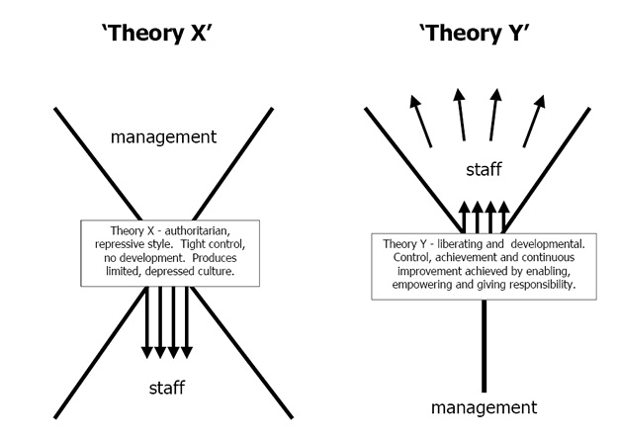
Figure 2: McGregor's Theory X and Theory Y
(Source: Locke and Henne, 2016)
According to Theory X, employees in a workplace usually dislike work and are most likely to avoid them if possible. Hence, it is the responsibility of the manager to forcefully get the works done by the subordinates (Robbins et al., 2013). As employees, according to Theory X, have little ambition and intend to avoid responsibility, the manager has higher roles with regards to directing them. As a store manager, I have found Theory X to be quite representative of my workplace. I have faced the difference in the values and the beliefs of the company while I prefer the flexibility in the workplace. Even, my workplace behaviors were demanding skills and abilities to maintain my responsibility and performance in Asda. I have found a significant portion of employees to dislike their work although they have sufficient knowledge and skills in retail sales. Initially I tried to motivate them by providing them with positive motivational tools which, however, didn’t live up to the expectation. Later I understood that liberating management is not suitable for all and for some employees there is no better leadership style than autocratic leadership. As I had to get my works done within the given deadline and fulfil the sales targets using any measures, be it rewarding or punishing employees, I found negative motivational factors to be more effective for this particular employee group who were motivated by fear and lack of money and job security than by the desire of self-development and individual contribution to the organisational growth. Although autocratic leadership style is largely criticised in management studies, it worked well for my work averse subordinates at Asda (Schermerhorn, 2015). To support my statement, I can point towards an event involving a group of work averse employees at Asda. They were provided with the responsibility of attaining particular sales target within a week for which I clarified them the significance of their role and the urgency of the task. However, my positive support didn’t work much. Later the same team was effective in reaching the target prior to the deadline just because they were threatened of severe punishment for failure.
While Theory X is emphasises on autocratic leadership, Theory Y states that participative management style is best suited for ensuring optimum motivation for the employees (Greenberg and Baron, 2013). One of the key assumptions of Theory Y is that employees are self-motivated and they like their work. Such workers seek and accept responsibility which is why they need little direction from their supervisor (Schermerhorn, 2015). When faced with recognition and opportunity, these employees are highly creative and try to fulfil individual goals while keeping focus on organisational goals as well (Mullins, 2017). As a stor manager in Asda, I have adopted Theory Y much more than Theory X because of the fact that major portion of the employees working in my Asda store are self-motivated and enjoy doing their work. For this employee group, I have followed the participative management style in which employees are highly incorporated in organisational decision making. For instance, while planning on strategies for enhancing store sales or customer satisfaction, I incorporated these employees so as to take valuable inputs from them thus facilitating effective decision making. Only incorporating employees in organisational decision making isn’t enough to motivate such employees to exert their best (Locke and Henne, 2016). Hence, I provided them with positive motivational tools from time to time. Among the motivational tools, I have found appreciation and recognition of performance to be highly instrumental.

2.3 Reinforcement Theory
BF Skinner developed the reinforcement theory, a motivation theory, stating that behaviour of an individual can be altered by using reinforcement, punishment, and extinction (Brooks, 2009). According to this theory, behaviours which are rewarded are more likely to be repeated and the ones which are punished are more likely to be withdrawn in future. Hence, the key focus of the reinforcement theory is the relationship between the operant behaviour and associated consequences (Robbins et al., 2013).
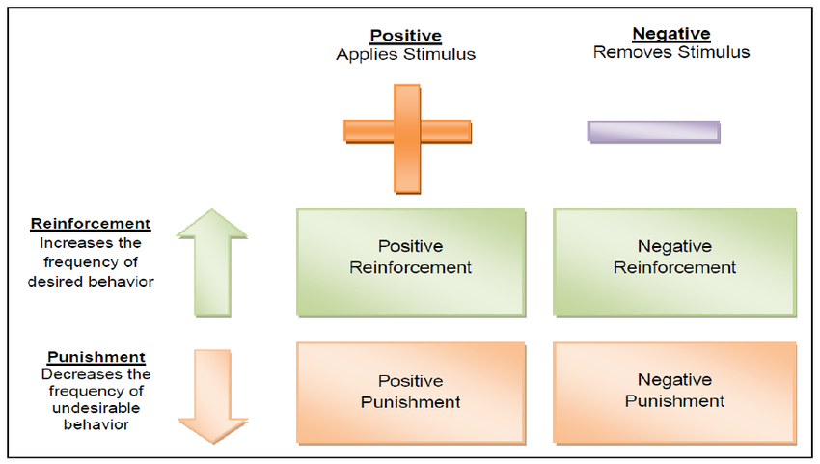
Figure 3: Reinforcement Theory
(Source: )
For influencing individual behaviour and shaping their values and attitudes in alignment with organisational needs, I have found the reinforcement theory to be highly useful for my role as a store manager of Asda. I have simultaneously used the reinforcement-punishment matrix, as depicted in figure 3, while managing my employees. I have used the positive reinforcements whenever I identified particular behaviour of my subordinates which were beneficial for Asda as well as their own career. Reward system is used for positive reinforcement. However, it does not always incorporate monetary or material reward (Locke and Henne, 2016). For instance, whenever I found an employee to be coming to store earlier for getting ahead of an important task, I would praise them so that they repeat this in similar situations. Monetary rewards are also effective tools for positive reinforcements. Employees at my store are rewarded a particular sales bonus for exceeding their weekly sales target. In Asda, the management has various techniques to encourage the employees. But the company demands the leadership skills from the manager and leaders to maintain the aggressiveness of the employees. I had to develop my leadership and motivational skills in Asda to encourage the employees for the better output in the team. Like the positive reinforcement, negative reinforcement also incorporates a reward system. The difference is that the employees are rewarded by removing something unpleasant from their job responsibilities for repeating the desired behaviour (Wood et al., 2014). For instance, I found a subordinate of mine at Asda to be continuously meeting his deadline. To counter this, I asked him to come up with daily reports of progress towards the deadline. Faced with this, he managed to meet his next deadline perfectly. Once I have assessed his capability of delivering within deadline, I stopped requesting for the daily progress reports. With this, the aforementioned employee became more motivated and negative reinforcement was in effect here.
Positive punishment can be referred to as the imposing of negative consequences in order for stopping or reducing unwanted behaviours at workplace (Brooks, 2009). Although positive punishments can lead to poor relationship between manager and employees, sometimes they are the best motivating tools. For instance, after noticing few of my employees coming late at the shop regularly, I warned them about their job safety if they repeated such behaviour and it was no surprise that they were always in time after that. Another example of positive punishments could be suspending an employee whom I found to be stealing during his duty. This sent a message for other employees at the shop that such behaviour and attitude wouldn’t be tolerated.

3. Impact of beliefs, attitudes and values on own workplace behaviour
How an individual behave in a certain environment is large under the influence of their individual belief, values and attitude system. The value system of an individual is based on the beliefs s/he holds whereby the individual perception of and attitude towards something is influenced by their values (Locke and Henne, 2016). The behavioural school of management put emphasis on how the individual beliefs, values and attitudes could exert influences on workplace behaviour. While the classical school of management were too task-oriented and took personnel as a production factors, they didn’t take the role of individual beliefs, values, and attitudes in shaping workplace behaviour into consideration (Greenberg and Baron, 2013). The discussions below illustrate the role that beliefs, attitudes, and values can play in influencing individual behaviour in a workplace setting from the viewpoint of behavioural theories of management. Likewise, other people, I do have my own values, ethics, and beliefs towards my life developed by my culture and my learning. In the workplace of Asda, my position, workplace behaviors, and roles are affected by my own values and ethics. This part would discuss how my own value influences my role as a Store manager in Asda.

3.1 Herzberg’s Two Factor Theory
What is the key thing that individuals seek from a job? Is it high salary or opportunities for growth and advancement or good relationships in friendly environment or something else? Asking the same questions, Fredrick Herzberg proposed the two factor theory in the 1960s which states that individual motivation and workplace behaviour is driven by the attitude of the individual (Mullins, 2017). Although it was previously argued that presence or absence of certain factors could determine the level of employee motivation, two factor theory, however, proposed that the factors leading to job satisfaction and dissatisfaction are altogether different. The key argument of this theory is that job satisfaction may vary significantly from person to person (Wood et al., 2014). Even when two individuals are presented with the same situation and job roles and benefits, they might be differently satisfied or dissatisfied indicating towards the significance of individual attitude in determining the level of job satisfaction. Herzberg categorized the satisfying and dissatisfying factors into two groups viz. motivation and hygiene factors which is why this theory is also regarded as the motivator-hygiene theory (Locke and Henne, 2016). The presence of hygiene factors ensures that employees are not dissatisfied but cannot ensure employee motivation. In order for motivating employees, the motivator factors must also be included in the scenario. These factors, according to two factor theory, are by-product of individual beliefs and values.
In the workplace of Asda, the flexible culture and the healthy environment helped me to be comfortable and more flexible for the responsibilities. While working under the pressure, I have to get the motivation from the various sources that Asda manages to deliver for the better workplace behaviors of the individuals. While playing my role as a store manager in Asda, I have found this theory to be highly relevant in motivating employees and shaping their workplace behavior by influencing their individual beliefs, values and attitudes. I have found that employees, despite having potentials and capacity, to be underperforming because of their job dissatisfaction (Wood et al., 2014). Hence, I emphasized on the hygiene factors in order for removing job dissatisfaction from such employees.
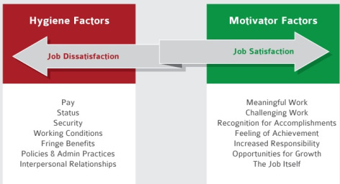
Figure 4: Herzberg's Tow Factor Theory
(Source: Brooks, 2009)
The first thing I attempted on this the organizational bureaucracy and poor employee policies. For instance, there were discrepancies among the salaries and benefits for different roles which were much spread in comparison with the differentiated roles individuals had to play. Moreover, I made it sure that my subordinates are paid timely. This is crucial because I, as a store manager in Asda, also get dissatisfied when there is delay in salary payment as it leads to major problems in daily life. Among other hygiene factors, I found job security and working condition to be more instrumental in keeping employees from being dissatisfied.
While removing job satisfaction is a must for ensuring smooth operations by employees, superior workplace performance can hardly be attained without ensuring optimum motivation of the employees (Jones, 2008). With regards to that, Herzberg introduced the motivator factors the absence of which might not lead to employee dissatisfaction but there wouldn’t be job satisfaction as well (Locke and Henne, 2016). Some of the motivator factors shaping individual workplace behaviour by influencing their individual beliefs, values and attitudes include but not limited to meaningful and challenging work, recognition and accomplishments, increased responsibility, opportunity for growth and the job itself (Mullins, 2017). For providing employees with challenging and meaningful work, I interchanged the job roles of my subordinates at regular intervals so that they do not get bored with typical routine work. Moreover, knowledge and skill of different job roles help them understand their individual significant role in the overall organizational goal achievement (Greenberg and Baron, 2013). For ensuring individual growth, I have made sure that they have sufficient training and development opportunities. Finally, I personally recognize and appreciate the contribution of individual employee so that they are always satisfied with their job at Asda.

3.2 Hawthorne Study
Elton Mayo and Fritz Roethlisberger carried out the Hawthorn Study in the 1930s where they studied the correlation between individual workplace behaviour and the social context of the workplace (Wood et al., 2014). In their study, they found that different employees having the same working environment and social context of the workplace can have different level of productivity which indicates towards the significance of individual beliefs, values and attitude in shaping employee productivity.
In their study, Elton Mayo and Fritz Roethlisberger experimented with a group of workers who were performing moderately in their usual working environment. The group of workers was later transferred to a special room with different environment where they were asked to perform their same job roles. Despite treated in the same manner and having the same benefits and rewards, the performance of the employee group improved significantly. Although some of the performance improvement can be attributed to changing social context of the workplace, the most significant role here was played by the changing beliefs, values and attitudes of the employees (Locke and Henne, 2016). As they believed that they more capabilities for which they were grouped separately, their values and attitude towards their job also improved which motivated them to give their best for superior workplace performance.
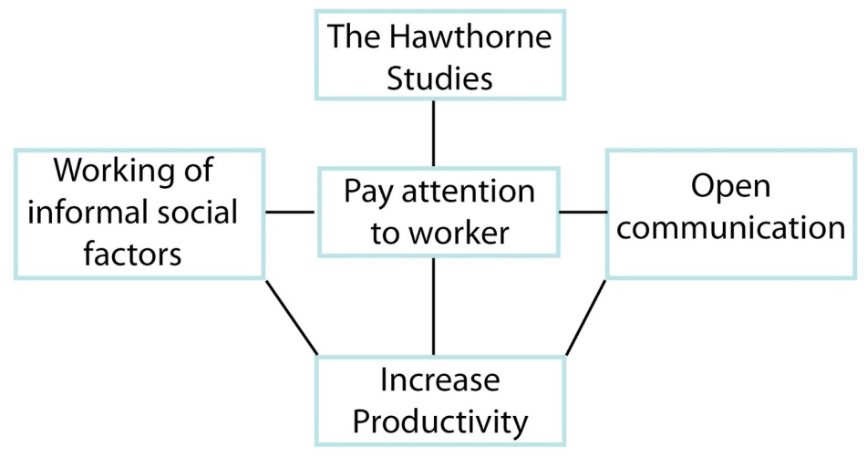
Figure 5: Hawthorne Studies' Effect on Productivity
(Source: Wood et al., 2014)
I have also found the Hawthorne studies to be useful for influencing the workplace behaviour of my employees at Asda. Paying attention to workers individually is the most crucial in this regard. I, through open communication with the employees and making them believe of their individual significance, motivated them towards improved workplace performance. My individual beliefs, values and attitudes have also impacted my changing behaviour at Asda which can be justified by Hawthorne studies. When Asda management equipped me with the responsibility of managing a store within a very short period of my engagement with the retailer, it led to improved self-assessment and I started to believe that I had the capacity to run a store optimally. If I were given the same role without proper communication, it could be disastrous as my values and beliefs wouldn’t be transformed as significantly as in the aforementioned case.

3.3 Contingency Theory
The contingency theory, developed by Edward Fiedler, proposes that no particular leadership style or strategy is the best for managing a workforce; rather the effectiveness of diverse strategies and leadership style is dependent on internal and external situation (Mullins, 2017). According to this theory, a leader needs to change their style of leadership based on the assessment of changing internal and external environment of the organisation. The emphasis of the theory, however, isn’t on the adaptive strategies of the leaders rather on assessing the style of leadership of the leader and then assessing the situation. The style of leadership can be assessed through Least Preferred Coworker Scale (LPC) method. In this method, leaders are scored based on their task orientation and personal skills. Leaders with high LPC are referred to as people-oriented leaders whereby those with low LPC are referred to as task-oriented leaders (Jones, 2008).
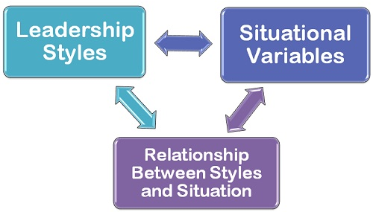
Figure 6: Contingency Model of Leadership
(Source: Greenberg and Baron, 2013)
After assessing my own LPC, I have found myself to be more of a people-oriented leader. However, identification of own leadership style is not sufficient according to Fiedler’s model. ‘Situational favourableness’ indicating towards the best situation for the leader is also crucial for effective leadership (Mullins, 2017). As changing the leadership style was more strenuous than changing the situational favourableness, I, in order for making my leadership style effective in Asda, emphasise on the factors constituting a situation. Leader-member relation is the most significant among the three factors (Greenberg and Baron, 2013). Hence, I always try to act in a friendly and cooperative manner with the employees at my store thus aligning it with my people-oriented leadership style. While keeping a close relationship with the subordinates, I have also found a moderate level of positional power to be necessary for influencing employees’ workplace behavior at Asda.

4. Recommendation
The difference of the workplace ethics, values, and the principles can affect the values, ethics, and beliefs of the employees. At the same time, the employee can face the conflicts over the workplace behaviors in a different situation. For managing the workplace behavior and the values, some recommendations are as follows:
- Asda needs to develop the environment where the employees of the company are aware enough of the differences in the values and the beliefs of the organization to maintain the consequences. The awareness in the workplace will help individual including me to accept and integrate with the differences while managing own workplace behaviors.
- The conflicts and competition can increase the negative impacts in the organization but the employees should not accept the negative values to provide a negative attitude to the workplace. The employees of Asda should be able to develop employability skills while developing workplace behaviors.
- The management of the company needs to be supportive towards the different beliefs, values and the attitudes of the employees to create a healthy environment and the workplace situations in Asda.

5. Conclusion
In alignment with the development of a critical approach to workplace, relevant management theories of individual beliefs, values and attitudes have been discussed and applied in the paper. The theories proposed by the classical school of management including but not limited to Maslow’s hierarchy of needs, McGregor’s theory X and theory Y, reinforcement theory state that individual beliefs, values and attitudes are interrelated and they can be influenced by adoption of different strategies by the managers. The changing beliefs, values and attitudes, according to the behavioral school of management, exert significant influences on the workplace behavior of individuals. I have found both the classical and behavioral theories to be more than useful in managing the employees at Asda. This report has discussed the value and the principles that the company carries where the employees and employers need to manage the workplace behaviors and values of the company. The conflicts can grow while working on the different values in the workplace. This report also has discussed how the management theories in the workplace of Asda affect the values and ethics of the individual like me in the position of the company.

6. References
Asda.co.uk. (2018). About Asda. [online] Available at: https://asda.co.uk [Accessed 9
Dec. 2018].
Brooks, I. (2009). Organisational behaviour: individuals, groups and organisation. Pearson
Education.
Greenberg, J. and Baron, A. (2013). Behavior in organizations: Understanding and managing the human side of work. Pearson College Division.
Jones, R. (2008). Nursing leadership and management. New Delhi: Jaypee.
Locke. A. and Henne, D. (2016). Work motivation theories. International review of industrial and organizational psychology, 1, pp.1-35.
Mullins, J. (2017). Management and organisational behaviour. Pearson education.
Robbins, P., Judge, T. and Breward, K. (2013). Essentials of organizational behavior (Vol. 7).
Upper Saddle River, NJ: Prentice Hall.
Schermerhorn, J. (2015). Management.
Vaidya, K. (2012). Inter-organizational information systems and business management. Hershey, Pa: IGI Global.
Wood, M., Chapman, A., Fromholtz, M., Wallace, P. and Zeffane, R. (2014). Organisational
behaviour: A global perspective

