

Strategic Management

STRATEGIC ANALYSIS OF APPLE INC



Student name: Antonella Gaeta
Student Number: 2217962
Lecturer: Gladius David Kulothungan
Word count: 6795
Submission Date: 8 Sep 2023

Table of Contents
Introduction 3
Apple Inc. Background 4
Apple Inc.'s Mission and objectives 4
Macro Environmental Analysis…………………………………………………………………... 5
PESTLE analysis 5
Micro-Environment Analysis 9
Industry Life Cycle 9
Porter’s Five Force Analysis 12
Internal Analysis 13
Apple Inc. 's Strategic capabilities and resources 13
Value chain Analysis 14
Primary Activities 15
Secondary Activities 16
VRIO Analysis 17
SWOT Analysis 20
Sustain competitive advantage strategies 20
Growth Strategies 21
CSR and Green strategy 23
Conclusion 25
Recommendation 25
References 26

Introduction
Strategic analysis is the specific procedure that involves in researching of the overall business environment of a company within that organization operates. The “strategic analysis” is crucial to formulate the overall “strategic planning” for smooth working and decision-making of the particular organization (Barney, 2019). The business strategy of Apple can be classified as vertical integration in a way that the organization has modernized expertise in hardware, services and software at the same time. The vertical integration of Apple is one the significant factors that set it apart from the competition (Tien, 2019). The abilities for competitive advantage of Apple are innovation capability, powerful brand image, and unique design capability. This organization’s success is mainly lies in a strategic vision that comprehended simple desktop computing to include wearable and mobile devices. Both design and performance are main drivers of the Apple brand and its current success. It also involves an evaluation of market trends, regulatory factors, and other external factors that may impact the organization's success (Dubey, 2016). Furthermore, this report will discuss the strategic analysis of Apple Inc. The typical customer profile of Apple is middle to high in their economic status.
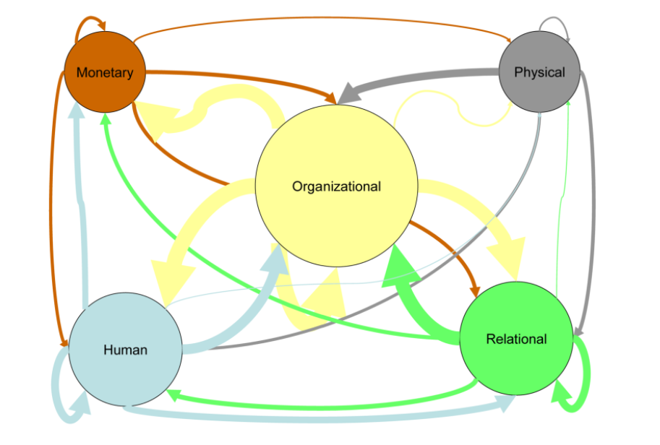
Figure 1: International Business Strategy and Entrepreneurship: An Information Technology Perspective
Source: (Ordóñez de Pablos, 2014)
In the above figure of the international business strategy and entrepreneurship comprises human, relational, physical and monetary contexts (Ordóñez de Pablos, 2014). On the other hand, the opportunities that have been recognized by the organization are based on strategic management. Threats are the external forces that the organization has to face the business purpose.

Background
Apple Inc. was known as “Apple Computer Inc.” and is an American consumer and computer electronics company. The former Apple Company was established on 1st April 1976 by Steve Wozniak and Steve Jobs. Apple uses their brand idea “making technology so simple that everyone can be part of the future”.
Apple gained popularity in the 1980s with the release of the Apple II and Macintosh computers. The Macintosh, in particular, introduced the use of graphical user interfaces and mouse-driven controls, which revolutionized personal computing. In the 2000s, Apple diversified its product line and released the iPod, which became the market leader in portable music players. This was followed by the iPhone in 2007, which transformed the smartphone industry and became Apple's flagship product (Stacey, 2011).
Additionally, Apple has introduced other successful products, including the iPad and the Apple Watch. The company has a strong brand identity and is consistently ranked among the most valuable brands in the world. As of 2021, Apple is one of the world's largest technology companies, with annual revenues exceeding $300 billion. This company is famous for creating i Pad, phones, and Macintosh computers. Globally, Apple is a large brand with a market cap of more than $2 trillion (Whittington, 2020). Apple has a specific strategic positioning; it is now utilizing to rack up numbers which indicates the product differentiation strategy. This organization distinguishes itself from other companies by placing a laser concentration on user experience, design-functionality, and an ecosystem along with vertical integration.

Mission and objectives
The mission of Apple Inc is to take proper “user experience” to all consumers through “innovative software”, hardware, and services and make a contribution worldwide by making tools that advance humankind. The mission of the company has been notified as user-friendly and it has contributed to its success.
Apple Inc. is an established company that has the best experience for the consumers through this initiative, the mission has been made by the organization (Stacey, 2011). The company has the feedback of feedback from best-used as the I Pad, i Phones, and others. Apple-designed products have been made to be user-friendly.
Innovative products
The company pushed the standard designed products in making the products and that is addressing the unique needs of the customers. The company has made the standard designed products for the market and the hardware and software situations cater to the different and various segments of the market(Budiono et al. 2021). The company has increased the presence of healthcare with innovative products such as Apple Watch that detect heart irregularities(Dubey, 2016). Moreover, the Apple healthcare record features that allow one to check medical data through mobile devices.
Service Delivery Quality
The company is obsessed with the consumers' comfort zone and it oversees the development and designs for product sales, repairs, and development.
- To obtain stellar services and products within the time frames
- To become a leading business in the mobile market worldwide

Macro-Environment Analysis

PESTLE analysis
PESTLE stands for Political, Economic, Sociocultural, Technological, Legal, and Environmental factors, which are analysed to gain insight into the macro-environmental factors that may impact the organization's performance. The analysis gives a bird's view of the organization and guides it (Ordóñez de Pablos, 2014).The necessity of every factor can be different for different types of industries such as the imperative of any strategy of a company that wants to develop and conduct the PESTLE analysis (Dubey, 2016).
Here is a brief description of each of the PESTLE factors:
Political:
This factor considers the impact of political factors such as government policies, regulations, and political stability on an organization.
The political factors include the country in which the business operates that is including the relationship between the foreign and home countries (Ordóñez de Pablos, 2014). Apple products make political stability in most countries and present several opportunities.
- Apple products depend on manufacturing at low cost in China and political causes the negative impacts on the business of these products (Stacey, 2011).
- The government of the USA has increased the tax on Chinese imports and the Apple products taxes have also increased and the supply products of Apple has decreased in China.
Economic:
This factor includes economic factors such as inflation, exchange rates, economic growth, and unemployment rates that may impact an organisation’s performance. The company Apple Inc. analysts the business strategies that help businesses function in economic changes (Oham, 2022).
- Apple Inc, makes rapid development and growth in developing countries that affect the businesses positively.
- The economic growth and GDP levels in Asian countries make the fastest growth in the Asian markets.
Socio cultural:
This factor looks at social and cultural factors such as demographic changes, lifestyle trends, cultural norms, and consumer behaviour. The factor of society defines the mindset of a particular country including the culture, beliefs, and traditions that affect business sales (Oham, 2022).
- In several countries Apple products are a status symbol that helps the business to generate revenue by introducing the products more.
- Apple Inc. increasing social media and mobile popularity worldwide makes an opportunity for the brand.
- By the help of strategic management in their organization, Apple has included Inclusion and Diversity in their workplace. Over the years, they have increased 89% female workers, 71% black employees, and 104% increase in the number of LatinX employees from the US (Apple.com. 2023). According to Apple, they believe that leadership is important for the present generation to deliver a powerful progress.
- Apple is committed in increasing the number of managers from different backgrounds because they want to make their team stronger and more innovative.
- More than half of the board of directors working an Apple belongs to the Asian, and LTBTQ+ community. Women hold half of the board and committee leadership positions in the organization.
Technological:
This factor considers the impact of technological advancements on an organization, such as automation, digitalisation, and innovation. Apple Inc. always integrated state-of-the-art technology (Grant, 2021). Including cloud computing, technical integration, and the growing market are the technological factors. The safest in security and terms and updated technology are the advantages of the products (Whittington, 2020).
- The competitors of Apple's advanced applications, programs quicker and systems develop the advanced system.
- The payment options of Apple’s Pay are much more secure and it is not an easy payment option that is a challenge.
Legal:
Every country is having different laws and regulations and operating a business in several counties deals with laws and rules as per the country. The brand Apple has the proper idea and knowledge about the legal factors and it keeps the transporting of the products successful (Stacey, 2011)..
- The brand tries to involve in the automobile industry or another highly regulated sector and the entrance can shift the business to another level.
- The products of Apple Inc. are dependent on the parts of the covered products under the intellectual laws of property.
Environmental:
This factor considers environmental factors such as climate change, natural disasters, and sustainability that may impact an organisation’s operations. Including sustainability, labor rights, product energy efficiency, and carbon emissions. Over the years the company has started to enhance its business sustainability (Morden, 2016.).
- Apple's supply chain is affected by rising global warming.
- Changing the climate has an impact on the Apple supply transoceanic and changes manufacturing and regulation costs for business purposes.
PESTLE | Factors | Impact
Political | - USA is 2nd largest country in the democracy  - USA has a multi-party system  - President of USA is their head who elected for a 4-year term | Positive
Economic | - USA is the economically largest country in the world  - GDP of USA is projected to increase in 2023 is 3.1% (Cbo.gov, 2023b).  - USA has such a large manufacturing sector | Positive
Social | - As the population, USA is 3rd largest country  - Total population is around 336 million as of 2023 (Cbo.gov, 2023). | Positive
Technological | - USA is the global leader in technologically  - In 2023, total number of internet users in the USA will be around 311 million (Petrosyan, 2023). | Positive
Legal | - Every state of USA has its own legal system  - “Civil rights Act 1991” has prohibited employment discrimination | Positive
Environmental | - USA has a diverse climate, geography, and wildlife  - The USA sustained more than 220 climate and weather disasters in the last 40 years. | Negative
Table 1: PESTLE Analysis
(Source: Self-Developed)
PESTLE analysis is very important for any kind of organization to find out the proper marketplace in a country. In every part of this analysis, the USA is very strong to make a proper business particularly; the USA is very rich economically (Ordóñez de Pablos, 2014).

Micro-Environment Analysis

Industry Life Cycle
Figure 2: Principles of strategic management
Source: (Morden, 2016.)
From the above figure it can be depicted that principles of strategic management involves strategic analysis -planning, strategy implementation, strategy choice, and strategy formulation along with strategic decision-making. The life cycle of industry indicates the business or industry evolution depending on the stages of decline and growth (Fuertes et al. 2020). The five different stages of the life cycle of industry are the decline phases, development, maturity, growth and introduction operates in the technology industry, which can be classified as being in the mature stage of its life cycle (Ordóñez de Pablos, 2014).
Apple believes in racial equality and justice and has therefore invested in the economical impact to change the lives by changing the system. According to them, black Americans have been incarcerated into different state prisons nearly five times more as compared to the white Americans (Apple.com. 2023). This is the reason Apple continues in supporting and donating to the organizations that treats and serves everyone equally. They are also donating the domestic groups for generating a meaningful reform to the United States.
Here is a brief description of each stage of the industry life cycle and how it relates to Apple:
Introduction:
During the introduction stage, a new product or technology is introduced to the market. Apple was in this stage in the 1980s when it introduced the Macintosh personal computer. A goal of the owner may spread the data about the brand to the targeted customers, as they might fund the advertisements in order to widen the reach of their brand to the maximum number of people (Morden, 2016.). As per example, a brand of skin care might start its life cycle of industry though launching a moisturize and a cleanser. The company might have plans to introduce the same products to different types of skin as it becomes more famous.
Growth:
During the growth stage, demand for the product increases, and new competitors enter the market. Apple was in this stage in the 2000s when it introduced the iPod and iPhone, which quickly gained popularity and helped the company grow its market share.The second stage of the life cycle of the industry is the stage of growth there the newly developed business attains recognition as a proper brand (Dubey, 2016).
Maturity:
During the maturity stage, the market becomes saturated, and growth slows down. The industry experiences increased competition and pricing pressure. Apple is currently in this stage, as the smartphone and personal computer markets are mature and saturated. The stage of maturity is that the company within the market attains more strength by defeating its competitors (Barney, 2019).
Decline:
During the decline stage, demand for the product decreases, and sales decline. The industry experiences increased consolidation and exit by weak competitors. The company has also successfully diversified its product line, which has helped it to weather market changes and maintain its position as a leader in the technology industry (Oham, 2022).Every product Apple Inc. goes through a particular life cycle.
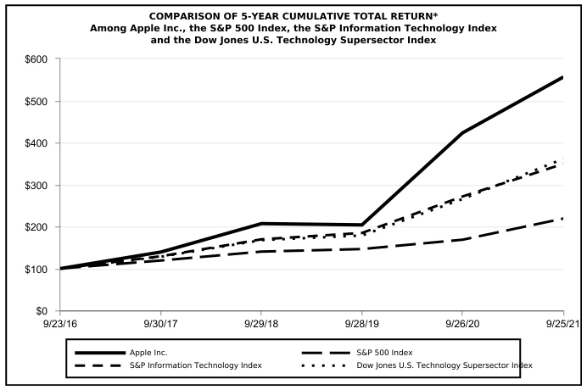
Figure 3: Comparison of 5-Year cumulative total return of Apple Inc

(Source: Sec.gov. 2021)
The following graph depicts a comparison of the total return of the shareholder calculated on a dividend-reinvested basis. According to the S&P 500 index, the graph has assumed $100 in the common stock of a company and the market has closed on September 25, 2021. $100 has been invested on September 23, 2016 that includes reinvestment of dividends. Data points on the fiscal year provided a common stock for the indexes.
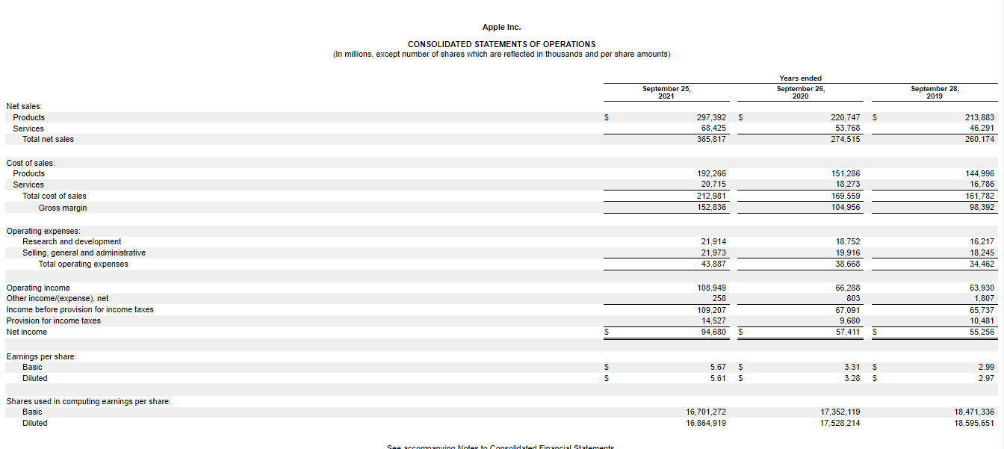

Figure 4: Consolidated Statements of Operations
(Source: Sec.gov. 2021)
The consolidated financial statements often include the accounts of Apple Inc, and their entire subsidiaries. The consolidated financial statements reflect the different adjustments in the presentation of their profit according to the presentation of current period.

Porter’s Five Force Analysis
Bargaining Power of Buyers
Some specific points in this part are analyzed further in the force such as collective bargaining and individual bargaining. Apple has a strong brand image and a loyal customer base, which gives it some leverage in negotiations with buyers (Stacey, 2011). However, buyers have access to many alternative products and can switch to competitors if Apple does not meet their needs or if pricing becomes too high.
Bargaining Power of Suppliers
This is relatively a poor force for “Apple's products” in the marketplace. However, the supplier's bargaining position is weakened through a large potential number of suppliers. Apple has a strong bargaining position with its suppliers due to its size and scale (Whittington, 2020).
The Threat of New Entrants
Any new entrants in the marketplace of the personal Smart phone or computers have been needed for having a huge capital amount for spending in R&D to improve and produce a “product portfolio”. The technology industry has a high barrier to entry due to the need for significant capital investment, economies of scale, and intellectual property protection (Stacey, 2011). Therefore, the threat of new entrants in the industry is low.
The threat of Buyers
The overall market force for Apple is very low due to specific fact that most “potential products” have some limited abilities as compared to the product of Apple. Apple faces strong competition from rivals such as Samsung, Huawei, Google, and Microsoft (Whittington, 2020). However, Apple's focus on design, innovation, and customer experience has helped it maintain a strong competitive position in the industry.
Industry Competition
The competition level among every major company related to similar industries that battle with Apple is too high. However, Apple has direct competition with “Google, Samsung, Amazon, and Hewlett-Packard”. All these companies are extending such significant capital in marketing and “research and development” as Apple. The technology industry is characterized by constant innovation, and many substitutes are available for Apple's products.

Internal Analysis

Strategic capabilities and resources
The core competency of Apple is “innovation” and they have a long history of improving “innovative and unique” “technology products”. This is as well including “iPod, Mac computer, i Pad, i Phone, Apple Watch, and Apple TV”. These functions are to sense and threats and shape opportunity, to reconfigure the resource base and to seize the opportunities (Ordóñez de Pablos, 2014). On the other hand, Apple Inc. has several strategic capabilities and resources that have contributed to its success in the technology industry. Here are some examples:
Brand Image:
Apple has a strong brand image that is associated with quality, innovation, and design excellence. This brand image has helped to create a loyal customer base and differentiate Apple's products from those of its competitors.
Vertical Integration:
Apple has a vertically integrated supply chain that enables it to control the quality and availability of its components, reduce costs, and improve its time-to-market for new products.
Research and Development:
Apple invests heavily in research and development to innovate and develop new products and technologies. This has led to the creation of new markets and product categories, such as the iPod, iPhone, and Apple Watch (Ordóñez de Pablos, 2014).
Design and Innovation:
Apple is known for its focus on design and innovation, which has helped to create products that are not only functional but also aesthetically pleasing. This focus on design has enabled Apple to differentiate its products from those of its competitors and create a unique customer experience.
Intellectual Property:
Apple has a strong portfolio of patents and trademarks that protect its products and technologies from imitation and copying by competitors.
Financial Resources:
Apple has significant financial resources, including cash reserves, that enable it to invest in research and development, marketing, and acquisitions. Besides that, Apple's strategic capabilities and resources have enabled it to differentiate its products from those of its competitors, create a unique customer experience, and maintain a strong competitive position in the technology industry (Oham, 2022).

Value chain Analysis
The value chain of Apple has been divided into two distinct parts, one is main and the other is supportive activities. The value chain analysis is a process that identifies each activity to determine the value and the cost of the product (Morden, 2016.).
Research and Development (R&D):
Apple invests heavily in R&D to innovate and develop new products and technologies. This includes hardware and software development, as well as design and user experience. In different sector the companies are conducting the R&D semiconductors, pharmaceuticals, has generally spend the most (Stacey, 2011).
Procurement:
Apple has a vertically integrated supply chain, which means that it controls the procurement of components and materials for its products. This enables it to ensure quality and availability while also reducing costs.
Manufacturing:
Apple's products are manufactured by contract manufacturers, primarily in China. The products have been made with the best manufacturing process and have been delivered with best quality (Whittington, 2020). The brand is making the products to maintain the quality and the process of making is more confidential.
Marketing and Sales:
Apple markets its products through a combination of advertising, public relations, and word-of-mouth. Its products are sold through its retail stores, online store, and third-party retailers. Apple has versatile process to deliver the products to the consumers (Stacey, 2011). Consumers are having several ways and opportunities to grab the demanding products by doing pre booking and several ways.
Service and Support:
Apple provides service and support for its products through its retail stores and online support channels. The employees and the organization are co-operating to each other and also the management and the technologies are also participating in the service and the support of the company.
Logistics and Distribution:
Apple has a global logistics and distribution network to ensure that its products are delivered to customers on time and in good condition. It has been maintained by the management team of the logistic department of the company (Oham, 2022).
After-sales service:
Apple has an active after-sales service department. Apple stores offer customers Genius Bar and other technical support, training, and repairs. This allows Apple to create products that are differentiated from those of its competitors, meet the needs of its customers, and maintain a strong competitive position in the technology industry (Morden, 2016.).

Primary Activities
Apple Inc. is one of the most valuable technology companies in the world, and its success can be attributed in part to its effective management of primary activities in its value chain.The primary activities of the company is recognized as the manufacturing and producing, marketing the products in the market (Ordóñez de Pablos, 2014).
Inbound Logistics:
Apple's inbound logistics include the procurement of raw materials, components, and sub-assemblies for its products. Apple has a vertically integrated supply chain that enables it to control the quality and availability of its components while reducing costs (Podolny and Hansen, 2020). In an organization the part of inbound logistic is playing a crucial role in the marketing process no matter it is in the national or international transport logistic (Morden, 2016.).
Operations:
Apple's operations include the manufacturing and assembly of its products. Apple also invests heavily in research and development to innovate and develop new products and technologies (Morden, 2016.).
Outbound Logistics:
Apple's outbound logistics include the distribution and delivery of its products. Apple has a global logistics and distribution network to ensure that its products are delivered to customers on time and in good condition. This includes warehousing, transportation, and customs clearance Marketing and Sales:
Apple's marketing and sales efforts are focused on creating a unique customer experience and building a loyal customer base. Apple markets its products through a combination of advertising, public relations, and word-of-mouth.
Service:
Apple's service efforts include the provision of after-sales support, such as technical support, training, and repair services.
Apple has a huge distribution network, which includes indirect and direct channels (Ordóñez de Pablos, 2014). However, Apple has extensive channels to distribute its all products to its clients and it particularly ranges from the retail shop to the internet and in its own branded shops. Apple has such a huge “supply chain” and this has various alternatives for getting “raw materials”. This integrated approach has helped Apple to differentiate its products from those of its competitors, create a unique customer experience, and maintain a strong competitive position in the technology industry (Ordóñez de Pablos, 2014).
Apple's design philosophy is to create products that are intuitive to use and that provide a superior user experience. This focus on design has helped Apple to create a loyal customer base and differentiate its products from those of its competitors (Apple, 2022).
Another primary activity that sets Apple apart is its retail stores. Apple stores are designed to provide a unique shopping experience, with sleek and modern design, knowledgeable staff, and a range of services, such as technical support and training (Ordóñez de Pablos, 2014).
Finally, Apple's service efforts are an important part of its primary activities. This focus on customer service helps to create a positive customer experience and build loyalty (Dubey, 2016).The goods of Apple are being manufactured in different and multiple countries.

Secondary Activities
Apple has invested a lot of money in R & R&D and it is recognized for some of its technical innovations and distinctive and high-quality product design. Apple should invest heavily on R & R&D to preserve its competitive advantage. This organization spent over $10 billion on R&D in 2016 and around $11.6 billion in 2017. However, Apple raised R&D investment by over $5 billion since 2014.
Procurement:
Apple's procurement activities involve identifying and selecting suppliers, negotiating contracts, and managing supplier relationships. Apple has a global supply chain that spans across multiple countries and involves many different suppliers. The company works closely with its suppliers to ensure that they meet its quality and ethical standards, and it invests heavily in supplier responsibility programs (Dubey, 2016).
Technology Development:
Apple invests heavily in technology development to innovate and improve its products and services. The company has a large research and development team that is responsible for creating new products and technologies.
Human Resource Management:
Apple's human resource management activities involve recruiting and retaining talented employees, developing their skills, and creating a positive work environment. Apple has a reputation for being a great place to work, and it offers a range of benefits and perks to its employees. The company also invests in employee training and development programs (Stacey, 2011).
Infrastructure:
Apple's infrastructure activities involve the development and maintenance of its physical and digital infrastructure. This includes its manufacturing facilities, data centers, and retail stores.
Procurement:
The company works closely with its suppliers to ensure that they meet its quality and ethical standards, and it invests heavily in supplier responsibility programs (Stacey, 2011). In addition, Apple's secondary activities support and enable its primary activities by providing the necessary resources, infrastructure, and capabilities.

VRIO Analysis
This analysis is an internal tool of analyzing the situation of an organization that categorization the resources that is based on the hold curtains in the framework. VIRO stands for Value, Rarity, Imitability, and Organization. Here is an analysis of Apple Inc. using the VIRO framework:
Value: Apple's brand is one of its most valuable resources, as it is widely recognized and respected around the world (Ma et al. 2020). Apple's innovative products, such as the iPhone, iPad, and MacBook, are also highly valued by consumers, and the company's ecosystem of software and services, such as the App Store and Apple Music, add significant value to its products (Morden, 2016.).
Rarity: Many of Apple's resources and capabilities are rare and difficult for competitors to replicate. Apple's supply chain is also highly integrated and sophisticated, which gives it a competitive advantage in terms of cost and speed (Barney, 2019).
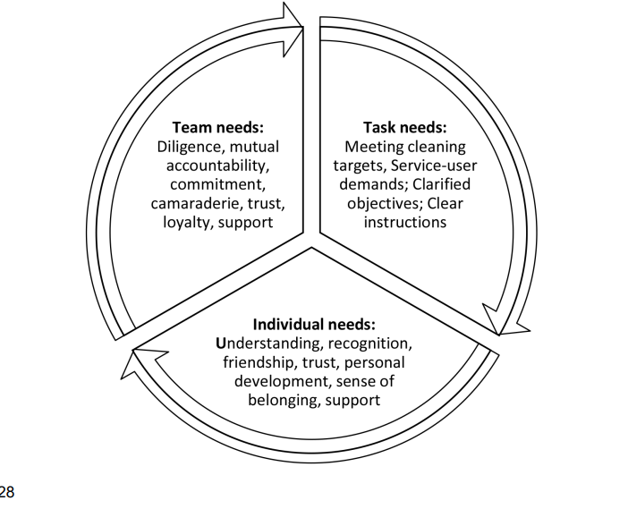
Figure 4: Action Centred Leadership
Source: (Oham, 2022)
Imitability: Competitors can attempt to replicate Apple's products and design, but they may struggle to achieve the same level of quality and user experience. From the above figure it can be understood that to fulfil the individual needs understanding, recognition, friendship, personal development, trust, sense of belonging, and support all are crucial factors. Diligence, mutual accountability, loyalty, support, trust, camaraderie, and commitment are significant to fulfil the team’s accountability. In order to achieve the aim of any projects meetings targets, service-user demands, clear instructions, and clarified objectives are crucial elements. Apple's culture of secrecy and product obsession also helps it to maintain a competitive advantage by keeping competitors guessing and constantly innovating (Barney, 2019).
The company's brand, innovative products, ecosystem of software and services, design and engineering capabilities, and supply chain are all valuable, rare, and difficult to imitate (Ordóñez de Pablos, 2014).
Capability and Resource | Valuable | Rare | Inimitable | Organizational Support | Result
Business Process Automation | YES | NO | YES | NO | Competitive advantage as temporary
Product mix diversity | YES | YES | NO | YES | Competitive advantage as Sustainable
Innovation and Research | YES | NO | YES | YES | “Competitive advantage” as Sustainable
Global Recognition | YES | NO | YES | NO | Competitive Parity
Supply Chain | YES | YES | YES | NO | “Competitive advantage” as temporary
Table 2: VRIO Table
(Source: Self-Developed)
This analysis has been evaluated on “value, rarity, immutability, and the organization of a business. The overall internal analysis has been as well determined by every core competency and also the competitive advantage of Apple that is based on the VRIO variables.

SWOT Analysis
The SWOT analysis has been explained the organization’s strength, weakness, opportunities and the threats that is about the condition of the organization. The analysis has been recognized as the entire condition of an organization (Ordóñez de Pablos, 2014).
Strengths | Weaknesses
- Strong loyal customers and brand recognition  - High product quality and services | - The expensive service and product  - A discrepancy of innovation in current times.
Opportunities | Threats
- Incorporation of some new “product lines” to emerging market  - Enhanced focus in most content streaming products | - Battle against the “counterfeit products”  - Enhance the competition in different industries
Table 3: SWOT Analysis of Apple
(Source: Self-Developed)
Some cheaper hardware is now trending to mean decreased product quality and most customers might end up having a negative experience while using the device (Morden, 2016.).

Sustain competitive advantage strategies
Apple reiterated the target of its “carbon neutrality” by 2030 and they plan for being 100% “carbon neutral” towards its overall “manufacturing supply chain” as well every “product life cycle”.
Sustainability reports about Apple Inc
The pattern has been called the resource-based competitive advantage. These skills and resources can be the advantages of the sustainable competitive. Consumers are focusing on the brand and the quality of the products that depends on the organization. It attracts the consumers have to maintain the policies to involve in the business products (Stacey, 2011).
Continuous Innovation:
Apple has built its reputation on its ability to innovate and develop new products that are unique and offer a superior user experience. The company invests heavily in research and development to create new products and technologies, and it is constantly looking for ways to improve its existing products (Morden, 2016.).
Vertical Integration:
Apple's vertically integrated business model, which involves owning and controlling all aspects of its supply chain, has been a key source of competitive advantage.
Marketing and Branding:
Apple's marketing and branding efforts are also a key source of competitive advantage. The company's brand is widely recognized and respected around the world, and its marketing campaigns are highly effective at creating hype and demand for its products.
Customer Focus:
Apple has a strong focus on customer experience, which is reflected in the design and functionality of its products. The company places a premium on creating products that are easy to use, intuitive, and aesthetically pleasing. Apple's commitment to customer experience has helped it to build a loyal customer base and maintain a competitive advantage.
Strategic Partnerships:
Apple has developed strategic partnerships with a range of companies to enhance its products and services. For example, its partnership with Intel has helped it to develop faster and more powerful processors for its Mac computers, while its partnership with Nike has enabled it to integrate fitness tracking features into its Apple Watch.
Diversification:
Apple has diversified its product portfolio over the years to reduce its dependence on any one product line.The service transition that implicitly that includes the health service that is inadequate to make up expected i Phone sales (Stacey, 2011). The iPhone 14 pro has been designed to reduce its overall impact in their environment that with the 100% recycled “rare earth elements” using including used in the MagSafe. This is also with 100% of recycled tungsten in their tactic engine.

Growth Strategies
An organization can pursue several types of business growth strategies and some strategies are in work tandem. The strategy of the growing business needs to be authentic and reasonable as making strategies is enlarging the business ground.
Growth Strategy Revenue
Pursuing business revenue growth can monitor cash flow and sales forecasting reports, diminish consumer acquisition costs, and the strategic partnership with other businesses that improve the bottom line.
- The strategies of using low-cost marketing and lower consumer acquisition cost.
- The training sales program to boost the close rates
- Collaborating with other companies that promote the products and services.
The Strategy of Consumer Growth
The plan of boosting new consumers over the time period and business pursuing a strategy of consumer large investments that leads to greater acquisitions (Apple, 2022).
- Increment in marketing spend and advertising.
- Addition of new services and product lines
- Adoption of the strategy of freemium pricing
Growth Strategy of Marketing
A strategy of market growth is different from the market as it is an organizational plan to increase the total market and the existing market share.
- Appeal launching new products the buyers in the new market
- Regions that open new locations in other regions
Growth Strategy of Product
It is an organizational plan that has increase product usage and expands the product lines and this growth strategy type requires the significant in the organization product growth (Oham, 2022).
- Exciting products that benefit to add new features
- The pricing strategy of the product need to be authentic
- Providers and manufactures with the new partnering
The 401(k) plan of Apple is deferred the salary arrangement that under 401(k) section of “internal revenue code”. In this particular plan, participate of all US employees might defer the specific part of their pretax earnings, up to “internal revenue service annual contribution limit” of nearly $19500 of 2021 FY.
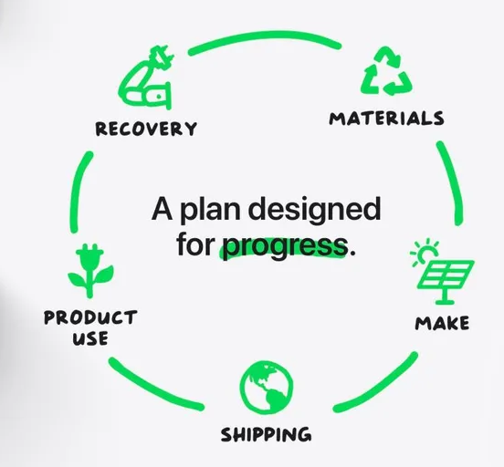
Figure 5: Apple sustainable environment plan

(Source: 9to5mac.com. 2023)
Apple has shared their access for the progress of their organization and has promised to become carbon neutral by the year 2030. On the earth day of April, 2022, Apple has shared their 2023 environment progress that helps in diving towards carbon neutrality. There are more than 40,000 metric tons of the electronic scrap that have been directed and 20% of the materials have been shipped from the recycled sources. 80% shipping emission reduction has been introduced into the newer transportation plan and 70% in the reduction of average product energy usage since the year 2008.

CSR and Green strategy
CSR Strategy
The CSR strategy of Apple Inc. has been addressing the interests of stakeholder groups in various industries and markets. The ethical issues of CSR strategies with Apple Inc are very poor working, child labor, and a poor environment (Azim and Nahar, 2020). The major four categories of CSR strategy in the Apple brand are ethical rights, environmental responsibility, economic responsibility, and philanthropic responsibility.
Green Strategy
The strategy of Green management is a business strategy that particularly includes the awareness about some perfecting business practices and policies, environmental issues, and initiatives some innovative programs that would create significance.
Renewable Energy:
Apple Inc. is powered by 100 percent of renewable energy from the multiple sources that is including on site solar installation and also the four megawatts of the bio gas fuel cells (Apple, 2022). The company is constructing with the two new data centers in Denmark that is running on the 100 percent energy of renewable from the first day (Oham, 2022). In Singapore, the company Apple Inc. has made around 800 rooftops of the renewable energy.
Energy Efficiency:
The environmental process of Apple 2021 covers the 2020 year of fiscal. The brand has been successfully covered the and reduced the emission of nine percent decrease (Apple, 2022). The Apple materials recovery is having the significance in Texas by producing the natural materials in the recycled i phone.
Sustainable Materials:
Apple has worked to develop sustainable materials for its products, such as recycled aluminium and plastic, and it has set a goal to use only recycled and renewable materials in its products. The company has also developed a robot called "Daisy" to disassemble iPhones and recover valuable materials for reuse (Ordóñez de Pablos, 2014). The company Apple reports the two thirds of the aluminum and three quarters of the rare earths and over 95 percent of the tungsten of the products that has been sourced from all 100% recycled materials (Apple, 2022).
Recycling:
Apple has developed a closed-loop supply chain for certain materials, such as aluminium, which allows it to recycle and reuse materials from its products. The products and the purses of the products has been used in the process of making products (Stacey, 2011). In every type of business this process has been recognized as the popular process that helps the business process more productive.
Green Packaging:
Apple takes an initiative for the packaging of the products by launching green packaging in the product packages. The idea of green packaging has been recognized as a natural way to make the packaging and it will be beneficial for the reducing product materials (Rashid, 2022). The way of making the packages is the way of reducing the waste products and makes them use in the making of the product packaging (Stacey, 2011).
Supplier Responsibility:
Apple has implemented strict environmental and labour standards for its suppliers, and it works with them to improve their sustainability practices. The company has also developed a Clean Energy Supplier program, which helps its suppliers to transition to renewable energy (Yanet al. 2021). The company is having the education and advancement opportunities to the employees. Apple suppliers code to conduct the commitment with the human rights and the sound business practices, environmental protections (Whittington, 2020). In every year the company Czech the quality of the supply chain management and upgrade the status of the management.

Conclusion
From the above discussion, this can be concluded that “strategic analysis” is crucial to formulate the overall “strategic planning” for smooth working as well decision-making of the particular organization. Apple has a huge distribution network, which includes indirect and direct channels. Its ecosystem of Apple is the main and solid competitive advantage that gives unprecedented strength in its market.

Recommendation
It is recommended from an overall study that Apple should continue the rapid and aggressive innovation to develop the products of this organization. It is also recommended to apply vast competencies to its manufactured hardware and software that would be compatible to increase product performance. The brand has proposed the new strategies to make the business in anotherlevel that hopes the significantly carbon reduce and taking out the power from I Phone packages (Ordóñez de Pablos, 2014).

References

References
Apple, (2022). Apple's Sustainability report. s.l.:s.n.https://www.apple.com/environment/pdf/Apple_Environmental_Progress_Report_2022.pdf[Accessed:25th September, 2023]
Barney, J. a. H. W., (2019). Strategic management and competitive advantage: Concepts and cases.. s.l.: Pearson.[Online]. Aviable at: https://cberuk.com/cdn/conference_proceedings/2022-09-16-09-25-05-AM.pdf[Accessed:25th September, 2023]
Dubey, R. e., (2016). Strategic management of sustainable manufacturing operations.. s.l.:IGI Global..[Online]. Aviable at: https://cberuk.com/cdn/conference_proceedings/2022-09-16-09-25-05-AM.pdf[Accessed:25th September, 2023]
Morden, T., (2016). Principles of strategic management. .. s.l.:Routledge.[Online]. Aviable at: https://books.google.com/books?hl=en&lr=&id=y7gFDAAAQBAJ&oi=fnd&pg=PT10&dq=+Principles+of+strategic+management.&ots=pjE2URwef3&sig=B8LkPYbgm4hqux6ygHIj72e5OD4[Accessed:25th September, 2023]
Oham, C. e., (2022). Cases on Survival and Sustainability Strategies of Social Entrepreneurs.. s.l.:IGI Global..[Online]. Aviable at: https://books.google.com/books?hl=en&lr=&id=wG9bEAAAQBAJ&oi=fnd&pg=PR1&dq=Oham,+C.+e.,+2022.+Cases+on+Survival+and+Sustainability+Strategies+of+Social+Entrepreneurs..+s.l.:IGI+Global.&ots=bREk6R8twT&sig=WnAAUGI--lvAb7-R0vke-vwlMi0[Accessed:25th September, 2023]
Ordóñez de Pablos, P. e., (2014). International Business Strategy and Entrepreneurship: An Information Technology Perspective: An Information Technology Perspective.. s.l.:IGI Global..[Online]. Aviable at: https://books.google.com/books?hl=en&lr=&id=SuiWBQAAQBAJ&oi=fnd&pg=PR1&dq=Ord%C3%B3%C3%B1ez+de+Pablos,+P.+e.,+2014.+International+Business+Strategy+and+Entrepreneurship:+An+Information+Technology+Perspective:+An+Information+Technology+Perspective..+s.l.:IGI+Global&ots=EyiFd5-R-T&sig=y1lmtLYuAsQ3a1CuwmhizjvZeJc[Accessed:25th September, 2023]
Report, A. S., (2022). Environmental Progress report. s.l.:s.n.https://www.apple.com/environment/pdf/Apple_Environmental_Progress_Report_2023.pdf[Accessed:25th September, 2023]

Stacey, R., (2011). Strategic management and organisational dynamics: The challenge of complexity to ways of thinking about organisations.. s.l.:Pearson education...[Online]. Aviable at: https://www.advisory21.com.mt/wp-content/uploads/2023/04/Strategic-Management-and-Organisational-Dynamics-Ralph-D.-Stacey-PDFDrive-.pdf [Accessed:25th September, 2023]
Whittington, R. A. D. R. P. J. G. S. K. a. K. P.,( 2020). Exploring strategy, text and cases.. s.l.:Pearson Education...[Online]. Aviable at: https://pureportal.coventry.ac.uk/en/publications/exploring-strategy-text-and-cases[Accessed:25th September, 2023]
Tien, N.H., (2019). International distribution policy comparative analysis between samsung and apple. International journal of research in marketing management and sales, 2020(1), p.2..[Online]. Aviable at: https://www.researchgate.net/profile/Nguyen-Tien-32/publication/338719419_International_distribution_policy_comparative_analysis_between_samsung_and_apple/links/63b014d1c3c99660ebbad865/International-distribution-policy-comparative-analysis-between-samsung-and-apple.pdf[Accessed:25th September, 2023]
Budiono, S., Purba, J.T. and Adirinekso, G.P., (2021). Strategic Business Analysis by Using Determinants of Buying Decision on Products: Lessons from an International Company in Indonesia. In ieomsociety. org. In Proc Int Conf Ind Eng Oper Manag (pp. 1232-1242)..[Online]. Aviable at: http://www.ieomsociety.org/brazil2020/papers/555.pdf [Accessed:25th September, 2023]
Grant, R.M., (2021). Contemporary strategy analysis. John Wiley & Sons, pp. 5..[Online]. Aviable at: https://books.google.com/books?hl=en&lr=&id=TadJEAAAQBAJ&oi=fnd&pg=PR5&dq=Grant,+R.M.,+2021.+Contemporary+strategy+analysis.+John+Wiley+%26+Sons,+pp.+5.&ots=oR-4VNjoSb&sig=hQ-Y9QLYEqNSih3nCfoeAmxGLqg [Accessed:25th September, 2023]
Fuertes, G., Alfaro, M., Vargas, M., Gutierrez, S., Ternero, R. and Sabattin, J.,( 2020). Conceptual framework for the strategic management: a literature review—descriptive. Journal of Engineering, 2020, pp.1-21..[Online]. Aviable at: https://www.hindawi.com/journals/JE/2020/6253013/ [Accessed:25th September, 2023]
Podolny, J.M. and Hansen, M.T., (2020). How Apple is organized for innovation. Harvard Business Review, 98(6), pp.86-95.[Online]. Aviable at: https://empowerment.ee/wp-content/uploads/2021/03/How-Apple-Is-Organized-for-Innovation.pdf[Accessed:25th September, 2023]
Ma, G., Wu, H., Qiao, Y. and Wang, D., (2020). A Resource-Based View on Sustaining Competitive Advantage: A Case Discussion. International Journal of Innovative Research and Development, 9(10).[Online]. Aviable at:https://salford-repository.worktribe.com/output/1605437/a-resource-based-view-on-sustaining-competitive-advantage-a-case-discussion [Accessed:25th September, 2023]
Azim, M.I. and Nahar, S., (2020). How Green Is The Apple? Understanding Apple’s CSR Disclosure Practices. Azim, MI; Nahar, S, How Green Is The Apple? Understanding Apple’s CSR Disclosure Practices, Accountancy Business and the Public Interest, 2020, 19, pp. 309-329.[Online]. Aviable at: https://research-repository.griffith.edu.au/bitstream/handle/10072/404732/Nahar427168-Published.pdf?sequence=2 [Accessed:25th September, 2023]
Rashid, M.M., (2022). Corporate social responsibility (CSR): Evaluating/auditing corporate social responsibility (CSR) practices. Journal of Economic and Social Thought, 8(4), pp.141-156.[Online]. Aviable at: http://kspjournals.org/index.php/JEST/article/view/2261 [Accessed:25th September, 2023]
Yan, Y., Yao, F. and Sun, J., (2021). Manufacturer’s cooperation strategy of closed-loop supply chain considering corporate social responsibility. RAIRO-Operations Research, 55(6), pp.3639-3659.[Online]. Aviable at: https://www.rairo-ro.org/articles/ro/abs/2021/07/ro210238/ro210238.html [Accessed:25th September, 2023

