

Programme: BSc Health and Social Care
Module Name: Changemakers: Creativity and Value Creation
Module Code: BMHP5014
Component 1 – Online Portfolio
Student Name: Farah Deeba
Student Number: 2325143
Teacher’s Name: Tomy Adattu Chako
Submission Date: 06th July 2026

Table of Contents
Task 1 – Concept Map 3
Task 2 - Self-Reflection of Group Activity 4
Task 3 - Case Study of a UK innovation 5
Task 4 - Research Task 6
Task 5 - Podcast 7
Task 6 - NHS Leadership Framework Analysis 7
Task 7 - Self-Reflection Journal Entry 8
Reference List 10

Task 1 – Concept Map
The concept map (see figure 1) illustrates the interdependent relationship between the concepts of creativity, value creation, and improvement in health and social are (H&SC). Creativity is concerned with the generation of ideas that are unique and useful. It is a result of critical and divergent thinking which is then followed by convergent thinking so that a single most valuable outcome may yield as a consequence of evaluating various possible solutions. The H&SC field relies on creativity as a point of commencement for producing innovation that aims to resolve the issues identified by the staff and service users, thereby, identifying new methods for delivering care services.
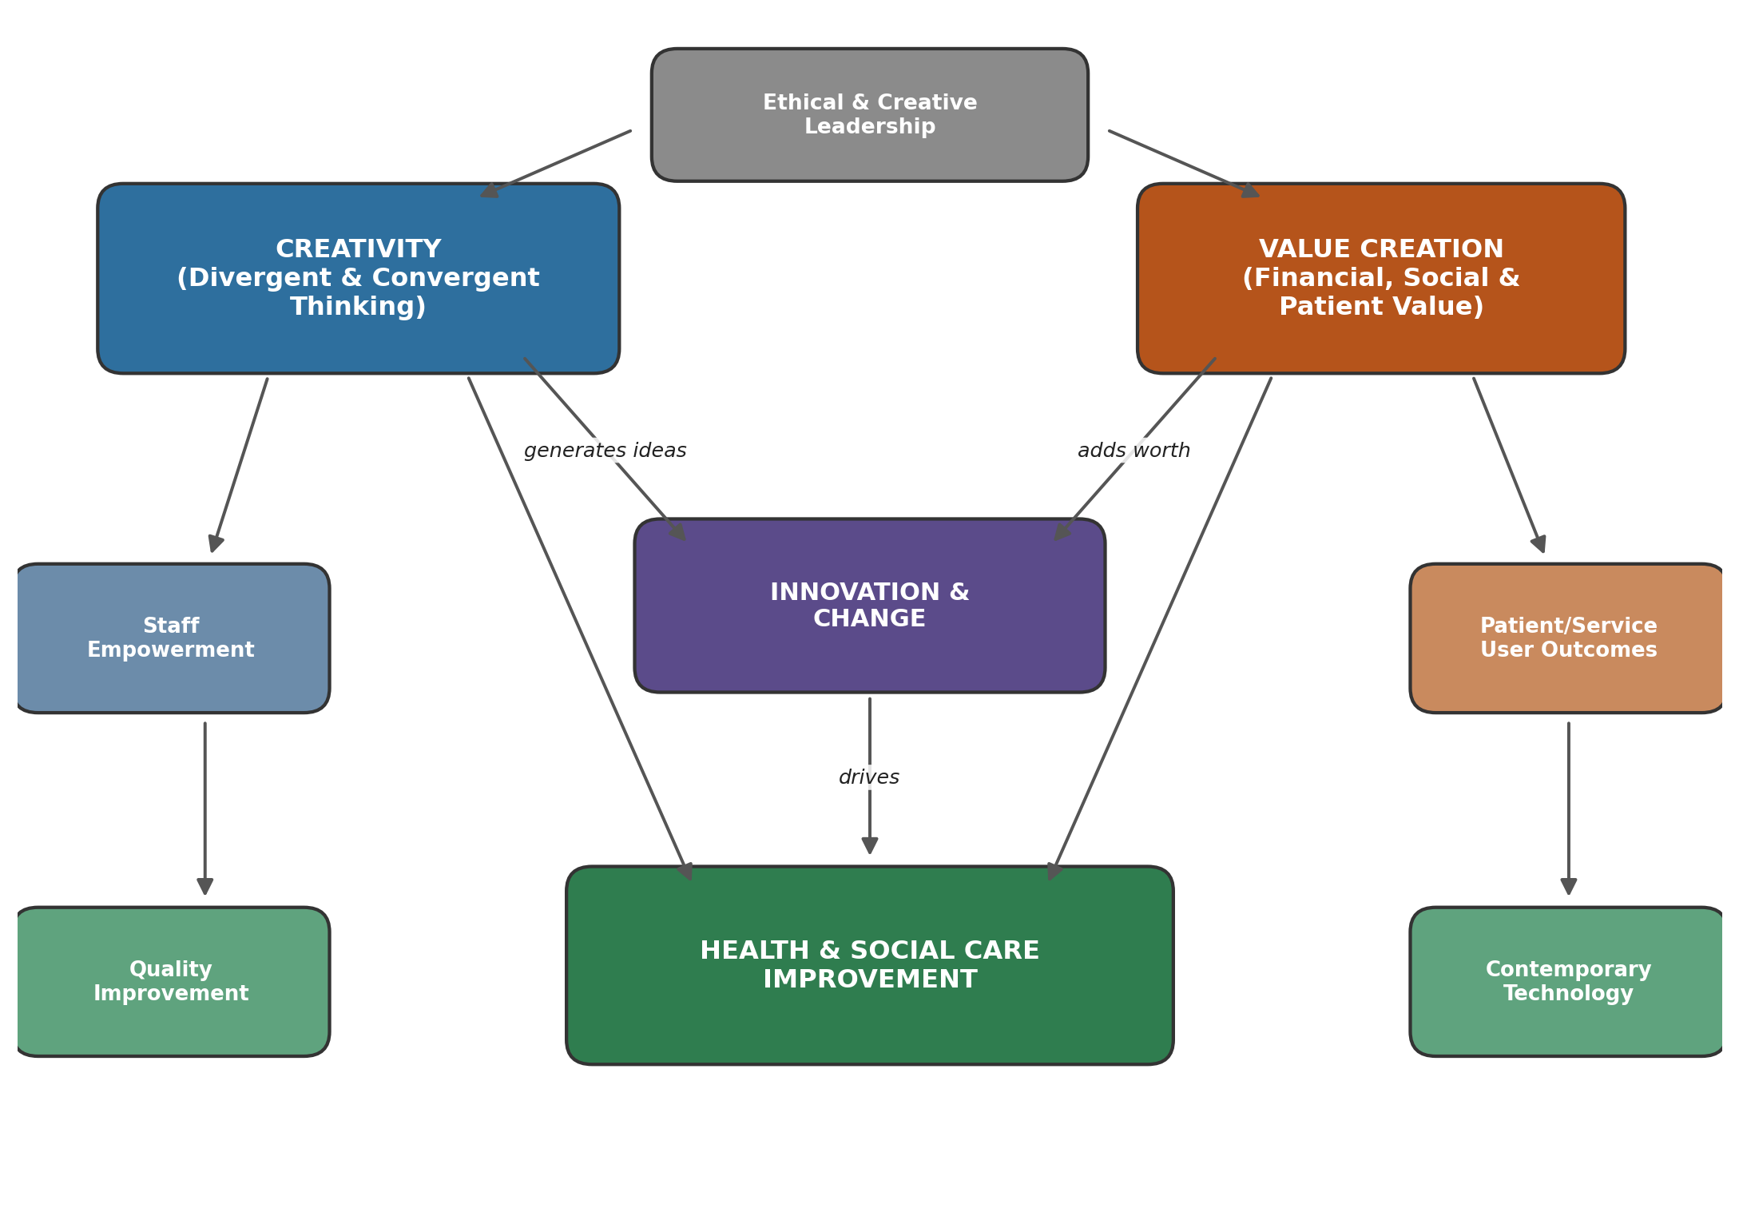

Figure 1: Concept map showing the relationship between creativity, value creation and health and social care improvement.
Moreover, value creation is recognised as a process through which the very creative and innovative ideas are implemented to yield benefits that are practical and benefit within the financial, social, and experiential dimensions associated with patients, staff, and organisations. Roth et al. (2024) argue that value is mostly not created by any single individual, instead, multiple stakeholders associated with the health and social care ecosystems collaborate to create a shared solution. The very stakeholders may include clinicians, managers, service users, and organisations such that their activities involving mixing, compromising, and legitimizing of actions result in creation of innovation through combined contribution.
The creativity and value creation functions are intentionally directed towards yielding H&SC improvement concerning enhanced patient outcomes, more efficient service provision, and improved experiences of the staff and service-users. All of the above discussed elements are facilitated through an ethical and creative leadership due to the significance of the role of the leaders in shaping culture, utilisation of resources, and provision of permission thereby allowing the subordinates to safely pursue unique and innovative ideas. Moreover, improved care is also an outcome of some supporting concepts such as workers’ empowerment, modern technology, quality improvement, and feedback from patient outcomes that make it practically possible to implement ideas to create value.

Task 2 - Self-Reflection of Group Activity
The module included the paperclip activity related to divergent/convergent thinking which was completed during class hours. This section utilizes the Gibb’s Reflective Cycle (1988) to reflect on it.
Description: We were divided in small groups and provided with two minutes to think divergently and list the maximum possible alternative uses for a paper clip within the provided timeframe. After that, we were required to convergently think by selecting and justifying the best idea among them.
Feelings I was initially anxious on a slight note concerning the pressure due to time constraints. I was also worried that my ideas were very obvious and not unique. However, I was able to feel more confident as the exercise progressed since suggestions from other group members helped me unlock ideas.
Evaluation: The divergent thinking part was more efficient compared to the convergent thinking one since the former did not require me to form an immediate judgment of ideas while the latter involved the challenge of narrowing down to opt for one best solution which required higher degrees of critical thinking.
Analysis: This mirrors real health and social care practice, where teams must first generate a wide range of possible solutions to a problem before critically evaluating feasibility, cost and safety. The activity demonstrated that creativity is not a single skill but two distinct cognitive processes that must be deliberately sequenced.
Conclusion: The activity taught me that proceeding too quickly towards convergent thinking limits the range of ideas that can be generated while spending too long contemplating on the divergent part can create fatigue concerning decision making.
Action Plan: In future, I will more effectively separate idea formation from decision-making. Further, I will use a ranking technique to decide more effectively during convergent stage.

Task 3 - Case Study of a UK innovation
The considered case study examines the Quality Improvement (QI) Programme by East London NHS Foundation Trust (ELFT) which is a famously recognised example of yielding value through creativity within the UK mental health and community care sector.
ELFT is among England’s largest mental and community health providers which serves around 1.7 million people in the areas of East London, Bedfordshire and Luton (Institute for Healthcare Improvement, 2024). The Trust came into a partnership contract with Institute for Healthcare Improvement (IHI) in 2013. The aim was to develop a culture of sustained improvement (Institute for Healthcare Improvement, 2024). The provided QI methodology training to majority of the stakeholders including staff, service users, and carers. It enabled the care provision teams to recognise and comprehend problems, develop creative and practical solutions for local issues.
The above discussed decentralized approach allowing a ‘hundred flowers to blossom’ (Shah et al., 2018) enabled ELFT to execute multiple improvement projects simultaneously. Later, as the organisation had built confidence and expertise, the very projects stabilized to take shape of smaller number of routine strategic requirements. The above stated event included a mechanism of a collaborative learning system that was utilized to enhance the social access to mental health services (Shah et al., 2018). It enabled the frontline staff to recognise and implement swift changes as required instead of depending upon complete restructure of top-down framework. Therefore, the very creative bottom-up approach significantly reduced time of waiting while improving consistency concerning the services’ access.
This programme created value within the social and financial dimensions. Concerning the former dimension, the morale and responsibility among the staff was improved and the service users experienced more responsive care pathways (Institute for Healthcare Improvement, 2024). With respect to the latter dimension, the framework for clear evaluation enabled the ELFT to present recognizable return on investment (Shah et al., 2018). It secured support from the authorities thereby allowing the trust to practice creativity and experimentation despite the financial constraints associated with the NHS environment.
Several themes learned in the module are reflected from this case. Creativity is not considered as an option, instead, it was applied through ensuring psychological safety and sincerely dedicated coaching. Moreover, value was created with the stakeholders instead of merely for them. Effective leadership focused upon building to capabilities over sustained period instead of opting for quick fix. Therefore, the example is suitable for explaining the significance of integrating creativity within routine practices which is made possible through effective leadership thereby yielding quality and efficiency improvements within health and social care services.

Task 4 - Research Task
The Issue: Inequalities concerning healthcare services access for people related to low-income demographics within the UK.
The UK citizens encounter a demographic divide concerning the access to healthcare services within the UK which negatively impacts the people living below the poverty lines. The situation exists despite the NHS care costing free at the point of use. A qualitative study was conducted by Bidmead et al. (2024) in North East England and North Cumbria involving 24 low-income parents and 8 voluntary-sector staff. The researchers identified three major barriers to healthcare access which included hidden costs, problems with securing appointments, and negative relationships with service providers. The first barrier included costs associated with transport, hospital food, parking, and income loss experienced while attending appointments and missing work. Similarly, the families that do not have reliable internet access or free calling minutes encounter a disadvantage due to reliance on digital booking systems. The very demographic segment also reported experiencing negative judgements by the staff which discourages them from seeking early help.
The concept of ‘candidacy’ further explains the very situation which includes an argument that the term access is beyond mere availability of services. It includes joint negotiations between service users and providers through several stages (Dixon-Woods et al., 2006). These stages include individual recognition for their own eligibility for receiving help, going through complicated referral networks, and being recognised as suitable for care by healthcare providers. The concept of candidacy is compromised due to lack of finances, time, and social confidence which considerably impacts the low-income groups as observed in the more recent study of Bidmead et al. (2024).
The above resources reveal that unequal access to health and social care services is a consequence of a combination of financial, cultural, and relational barriers where the former is more visibly obvious than the latter two. These barriers exist within the services and systematic frameworks that must be addressed through ethical systematic redesigning thereby restructuring the attitudes of staff instead of mere financial adjustments.

Task 5 – Podcavv
(double click for audio)

Task 6 - NHS Leadership Framework Analysis
Summary of the NHS Leadership Framework
The leadership model promoted by NHS Leadership Framework encourages a single and shared perspective on leadership for all the staff members associated with the field of health and care services. The principle observes leadership as a behavioural responsibility of all the staff members within the hierarchy according to the requirements of their specific role instead of limiting it to the management roles only (NHS Leadership Academy, 2011). The structure includes seven specific areas of leadership. The expression of individual Personal Qualities includes self-awareness, self-management, sustained learning, and maintaining integrity. Moreover, Working with Others considers relationships development as significant and encourages stakeholder contribution in development of resourceful networks.
Similarly, Managing Services includes plan development, resources management, and accountability display. Improving Services prioritizes patient safety and encourages innovation for service enhancement. Setting Direction requires the contextual comprehension for change and informed decision making. Creating the Vision is concerned with the development and communication of an influential and convincing future vision. Delivering the Strategy yields practical action out of the vision thereby aligning resources, mitigating risk, and ensuring sustainable outcomes. In combination, the very leadership areas enable the staff at every hierarchical level to develop their own capabilities (NHS Leadership Academy, 2011).
Applying one domain to encourage creativity: Creating the Vision
Creativity can significantly be encouraged through the aspect of Creating the Vision. According to Fullan (2016), a genuinely committed leadership positively impacts the subordinates to yield enhanced outcomes for an organisation. Similarly, a convincing and effectively communicated vision induces a collaborative sense of purpose among the staff member thereby encouraging healthy levels of creative risk-taking.
A leader influencing a creative vision may develop a vision that is simultaneously ambitious and practically acquirable thereby minimising waiting times and increasing the quality of care. Such leadership practices then motivates the frontline staff to develop and implement their own creative ideas for achieving the organisational purpose instead of strictly dictating them. Thus, a leader can create psychological safety for the staff through representing organisational values and communicating with clarity the need for change. Such a sense of security enables the staff to more creatively engage with their duties and thereby yield organisational improvements

Task 7 - Self-Reflection Journal Entry
Journal Entry – Module Reflection
Prior to commencement with this module, I considered creativity mainly as a part of arts instead of viewing its connection to the health and social care provision. I considered the latter field to be more of a practical and evidence-oriented domain and limited to it. The weekly topics introduced me to divergent and convergent thinking, value creation, ethical and creative leadership, modern technology, and creation of vision which considerably influenced my perspective. Now, I comprehend the significance of creativity within the H&SC sector as a structured process which includes development of a range of unique ideas, testing their potential, and assessing their impact on stakeholders and resources.
The case studies and activities made me understand that leadership does not always require individual invention of solution measures. contrarily, an effective leadership creates an environment for the subordinates that encourages them to bring up unique ideas. Such environment is created through trust, safety, and clear communication. My learning shall serve as the basis for all my future actions associated with academics and professional practice within the considered field.

Reference List
Bidmead, E., Hayes, L., Mazzoli-Smith, L., Wildman, J., Rankin, J., Leggott, E., Todd, L. and Bramhall, L. (2024) 'Poverty proofing healthcare: A qualitative study of barriers to accessing healthcare for low-income families with children in northern England', PLOS ONE, 19(4), e0292983. Available at: https://doi.org/10.1371/journal.pone.0292983 (Accessed: 1 July 2026).
Dixon-Woods, M., Cavers, D., Agarwal, S., Annandale, E., Arthur, A., Harvey, J., Hsu, R., Katbamna, S., Olsen, R., Smith, L., Riley, R. and Sutton, A.J. (2006) 'Conducting a critical interpretive synthesis of the literature on access to healthcare by vulnerable groups', BMC Medical Research Methodology, 6(35). Available at: https://doi.org/10.1186/1471-2288-6-35 (Accessed: 1 July 2026).
Fullan, M. (2016) Indelible Leadership: Always Leave Them Learning. Thousand Oaks: Corwin Press.
Gibbs, G. (1988) Learning by Doing: A Guide to Teaching and Learning Methods. Oxford: Further Education Unit, Oxford Polytechnic.
Institute for Healthcare Improvement (2024) Fostering an Improvement Culture: Learning from East London NHS Foundation Trust's Improvement Journey Over 10 Years. Boston: Institute for Healthcare Improvement. Available at: https://www.ihi.org/library/publications/fostering-improvement-culture-learning-east-london-nhs-foundation-trusts (Accessed: 1 July 2026).
NHS Leadership Academy (2011) Leadership Framework: A Summary. Coventry: NHS Institute for Innovation and Improvement.
Roth, M., Vakkuri, J. and Johanson, J-E. (2024) 'Value creation mechanisms in a social and health care innovation ecosystem – an institutional perspective', Journal of Management and Governance, 28(4), pp.1017–1048. Available at: https://doi.org/10.1007/s10997-024-09696-x (Accessed: 1 July 2026).
Shah, A., Chitewe, A., Binley, E., Alom, F. and Innes, J. (2018) 'Improving access to services through a collaborative learning system at East London NHS Foundation Trust', BMJ Open Quality, 7(3), e000337. Available at: https://doi.org/10.1136/bmjoq-2018-000337 (Accessed: 1 July 2026).

