AUDIT CASE STUDY ON ACCOR HOTEL GROUP

Student name : Cristina Cornea
Student ID : 2117591
Module : Management and Organisational Behaviour
Lecturer : Jaliya De Silva

AUDIT REPORT STUDY ON ACCOR HOTEL GROUP

Introduction
The Accor Hotel Group is a global hospitality enterprise with over 5200 establishments 10000 food and beverage hotels in over 110 countries (ACCOR, 2023). The corporation runs several hotel brands, including economy, mid-scale, and luxury properties. Accor is growing in Asia and the Americas but still maintains a significant position in Europe. This case study aims to audit, examine, and assess the Accor Hotel Group's corporate and individual unit levels based on their organisational structure, culture, and objectives. This case study will also discuss and evaluate recent change initiatives, their impact and how well they were managed, the organisation's strategic direction, and current business performance. The analysis will be grounded in pertinent theories to comprehend the significant factors influencing the organisation thoroughly. Furthermore, ideas for improvement will be offered along with comparisons with competitors in the industry.
Organisation Structure, Culture, and Goals
Organisation Structure
The two segments of Accor Hotels are Premium, Midscale & Economy, and Luxury & Lifestyle. A Group Management Board and a Global Shared Platform that provides knowledge and services to both divisions, including Digital, Technology, and Procurement, serve both divisions, According to ACCOR (2023). The organisational structure of the Accor Hotel Group is in line with Mintzberg's configurations, exhibiting a hybrid model that combines aspects of professional bureaucracy at the individual unit level and Simple Structure at the corporate level based on the website report. Accor Group can effectively negotiate the complicated landscape of the global hospitality business with its hybrid approach that supports unit-level flexibility and specialisation and capitalises on centralised decision-making (Jerab and Mabrouk, 2023). However, careful management is necessary to balance the uniformity requirement and different units' independence.
The span of control technique employed by Accor Hotel Group seems to follow a tiered approach, acknowledging the requirement for varying degrees of control at different organisational levels. The success of this strategy is based on striking a careful balance between localised flexibility and centralised control. To handle coordination difficulties and preserve consistency while allowing adaptability at different levels, the organisation must engage in training and development, standardise essential procedures, and improve communication channels and regular assessment.
Accor employs a hierarchical model with centralised corporate decision-making regarding organisational structure. Marriott International, on the other hand, uses a matrix structure that combines divisional and functional structure components. The hierarchical structure establishes a clear chain of command, making it easier to communicate and implement strategies consistently throughout the company's wide range of brands (MARRIOTT INTERNATIONAL, INC, 2023). However, there could be difficulties with flexibility and agility due to the centralised decision-making process. However, through multiple reporting ties, Marriott International's matrix structure enables a more flexible decision-making process. Workers can respond to market fluctuations more quickly since they report to functional and project managers (Barbier and Fayolle, 2021).
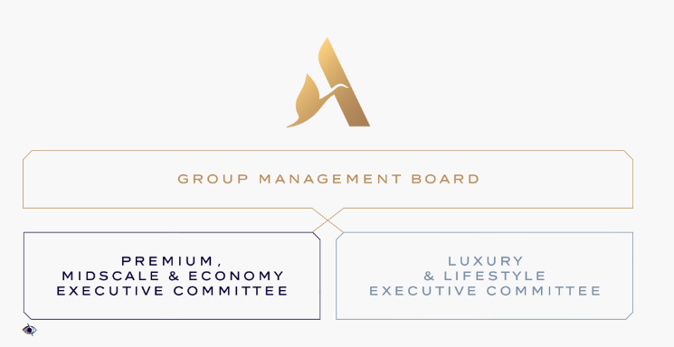
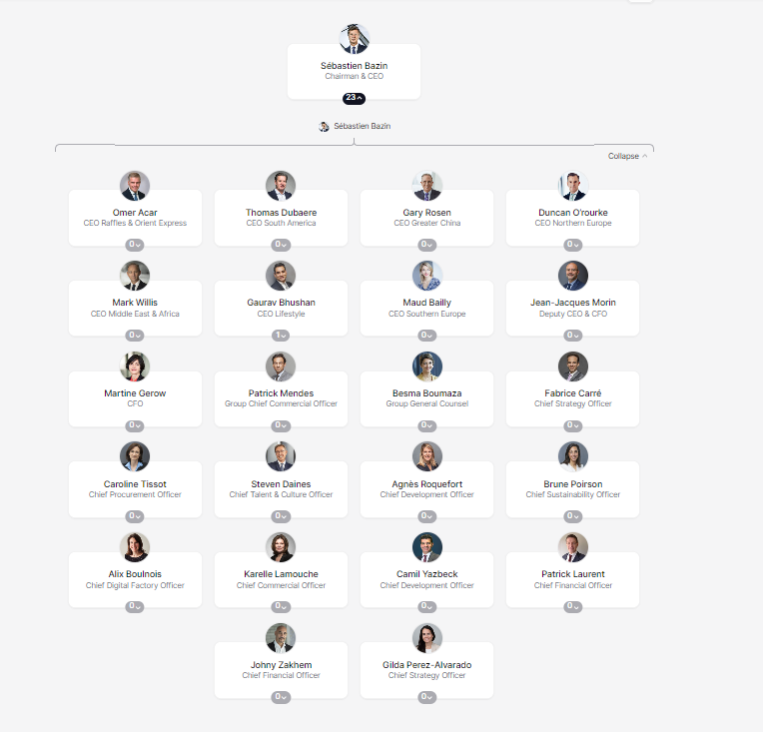
Organisational structure of the Executive management at Accor Group (ACCOR, 2023)
Organisational Culture
The core principles of Accor's corporate culture are innovation, hospitality, and respect. Accor promotes creativity and innovation among its staff members by creating a good and productive work environment, which has assisted in attracting and keeping top personnel (Camelia, Ioana-Valentina-Alexandra. and Larisa-Andreea, 2019). According to Hofstede's theory, Accor's emphasis on hospitality is consistent with a strong emphasis on individualism and collectivism, which promotes individual freedom and community cohesion, as Seidu et al. (2022) suggest. Schein's model further highlights the common values and beliefs that Accor's culture is built upon, influencing employee behaviour and organisational identity through the "Feel Welcome" campaign and the varied brand portfolio.
Examining underlying presumptions reveals inbuilt trust in workers and a foundational culture that encourages creativity and flexibility. The implicit confidence that underpins the autonomy granted to business units reflects a conviction in the capacity of employees to uphold the fundamental principles of hospitality. The emphasis on innovation as a fundamental principle conveys a proactive approach toward changing market trends and an openness to adaptation (Sugiri and Mahyuni, 2019). However, ongoing alignment and reinforcement of these components is necessary. The organisational culture will be strengthened by encouraging staff engagement, the constant communication of customer-centric principles, and consistency in messaging and behaviour.
The organisational culture of the Accor Hotel Group also exhibits conformity to multiple cultural orientations, such as hierarchy, market, adhocracy, and clan cultures. A sense of community is reflected in the "Feel Welcome" campaign and staff training initiatives, which promote cooperation and common ideals outlined by Raza et al. (2021). Concurrently, the fundamental principle of innovation is consistent with adhocracy culture, strongly emphasising flexibility and originality. While Accor's emphasis on expanding its market share and maintaining a wide range of brands aligns with market culture, the corporate level's centralised decision-making system reflects aspects of hierarchy culture and offers stability. These cultural orientations must be balanced for Accor to function well and gain advantages in creativity, competitiveness, stability, and pleasant workplace relationships (Duarte et al., 2020).
Rivals like Marriott and Hilton may differ in emphasis, yet they have comparable cultural aspects (Graziano, 2021). Accor Group, therefore, needs to innovate in customer engagement, regularly benchmark, customise employee programmes, and seamlessly incorporate these cultural factors if it wants to stay ahead of the competition, as highlighted in a discussion by Aboramadan and Karatepe (2021)on organisational support, and effects on employee performance. With this strategic convergence of cultures, Accor is positioned to lead the competitive and dynamic hotel industry.
Organisational Goals
The Accor Hotel Group has clear and precise business goals that emphasise global brand expansion and improving the customer experience, according to ACCOR (2023). These aims are expressed in yearly reports and strategic plans. Financial audit reveals that even though some goals have set deadlines, goal evaluation can benefit from being more clearly time bound. Brand-specific plans, which prioritise financial, customer, and operational objectives, align with the corporate strategy at the level of individual units. Additionally, the business is dedicated to social responsibility and sustainability (Rubel et al., 2023).
Theories like Porter's Competitive Advantage and SMART Goals provide a framework for assessing Accor's objectives. According to Weintraub, Cassell, and DePatie (2021), SMART goals ensure clarity and concentration by emphasising objectives' specific, measurable, achievable, relevant, and time-bound aspects. In line with Accor's business aims Porter's Competitive Advantage emphasises the significance of distinctiveness and cost leadership. Accor's objectives align with the four standpoints of the Balanced Scorecard. Financial objectives stress long-term financial performance, customer-focused objectives stress satisfying customer experiences, and internal process objectives stress effectiveness and quality (Guix and Font, 2020). Learning and growth objectives support staff advancement and are consistent with the organisation's long-term goals.
Accor demonstrates objective achievement with good profitability and revenue growth trends regarding finances. Metrics measuring consumer fulfilment meet industry norms, indicating a reasonable level of objective achievement. Although operational efficiency has increased, more investigation into quality management indicators may be necessary. Strong employee training initiatives demonstrate a constructive emphasis on development and learning. As mentioned, Accor Hotel Group is centred on expansion and client satisfaction. The main objectives of Marriott International's organisation are financial performance, customer satisfaction, and operational excellence. Marriott is dedicated to extending its hotel portfolio and broadening its global reach while simultaneously focusing on delivering solid financial performance. The three main objectives of Hilton World wide’s organisation are operational effectiveness, brand distinction, and worldwide expansion, according to the website Hilton Worldwide (2023). Hilton is dedicated to giving its customers a distinctive experience and differentiating its brands. Enhancing operational effectiveness and boosting profitability are other top priorities for the business. Accor should set more precise deadlines for corporate and individual unit goals to improve goal achievement. Sustained success in the demanding hospitality sector will be facilitated by tighter quality management oversight, ongoing improvement of customer satisfaction indicators, and bolstering staff development initiatives.
Recent change initiatives, their impact, and how well these were managed
A comprehensive digital transformation, sustainability measures, and the cohesive "Feel Welcome" campaign implemented at corporate and individual unit levels are the company's recent change initiatives. The "Feel Welcome" campaign exemplifies Lewin's three-step model of unfreezing through industry shift recognition, changing through digital transformation and sustainability programmes, and refreezing with the integration of changes. Kotter's strategies are also evident in Accor's change initiatives with a clear understanding of urgency, a leading coalition, a shared change vision, empowered staff members, and quick wins from effective technology rollouts and brand launches (SUFI, 2019). These results align with the organization's objectives of improving visitor experience and responding to market developments.
The latest reform initiatives of the Accor Hotel Group have resulted in diverse repercussions for various stakeholders. Workers have benefited from improved professional development possibilities and training programmes but have also encountered resistance and possible job instability during cultural shifts (Camelia, Ioana-Valentina-Alexandra, and Larisa-Andreea, 2019). Consumers have seen benefits, such as enhanced brand experiences, sustainable business practises, and better digital services. Positive effects on customer satisfaction and brand reputation have been seen by shareholders, which may lead to future gains in shareholder value, as Akpa, Asikhia, and Nneji (2021) elaborate. On the other hand, issues like upfront costs and brief delays during tech rollouts could immediately impact stakeholders.
An evaluation of change management demonstrates well-thought-out planning, successful communication tactics, robust staff involvement, and proactive resistance management. Accor's comparison to rivals Marriott and Hilton demonstrates its strong brand unification and industry trend adaptation. Accor's initiatives are similar to Marriott's acquisition of Starwood Hotels and Hilton's emphasis on sustainability and digital innovation (Fachada, 2023). In contrast, Accor has shown a comprehensive approach to change by demonstrating agility in implementing sustainability and technology projects at both corporate and unit levels. The organisation needs to skilfully traverse these hurdles to maintain success and beneficial effects on stakeholders in the competitive and dynamic hotel industry. Accor will need to continuously analyse and adapt to optimise the advantages of its change initiatives and improve its strategies.

The organisation's strategic direction and current business performance
A SWOT analysis is utilised to evaluate the internal and external capabilities of Accor Hotel Group. The Accor Hotel Group's strengths include a loyal customer record, a strong distribution channel, a commitment to innovation, sustainability initiatives, and a strong international brand portfolio (ACCOR, 2023). Weaknesses include necessary renovations for some branches, reliance on mature markets, and delaying digital transformation. The business is in an excellent position to benefit from expanding to different markets, implementing updated technologies, high demand for sustainability initiatives in the hospitality industry, and growing markets of hospitality services. However, Accor faces threats OF economic downturns, high competition, geopolitical instability, and increasing short-term rental platforms.
The four main elements that comprise the Accor Hotel Group's distinct strategic orientation include Digital transformation, improved customer experience, sustainability leadership, and worldwide brand expansion. According to Bharwani and Mathews (2021), recent expansions into untapped markets or well-timed purchases, for example, show a dedication to expansion. Financial metrics like profitability, return on investment, and revenue growth are utilised to assess key operational variables reflecting Accor's operational efficiency, including market share, occupancy rates, average daily rate (ADR), and revenue per available room (RevPAR). The report suggests that Accor Hotel Group should think about strengthening its competitive position by emphasising tactics unique to the market, increasing operational effectiveness, and monitoring client satisfaction (Damnjanović, Lončarić, and Dlačić, 2020). This may include specific initiatives such as targeted marketing campaigns, business alliances, and technological investments for operational efficiency. In terms of other brands, such as Marriott and Hilton worldwide, the table below provides a comparison.
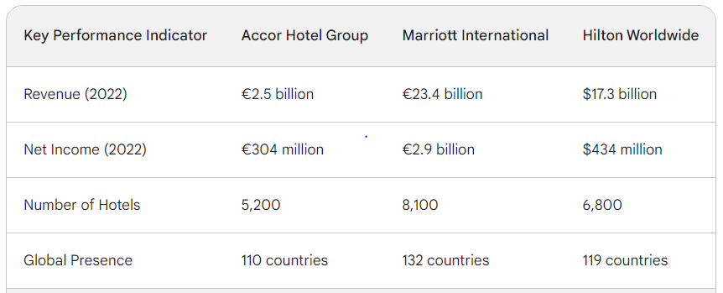
Conclusion
Accor Hotels is a well-known and affluent brand in the hospitality industry. The goals, organisational structure, and culture of Accor Hotel Group are closely linked, forming the company's identity in the demanding hospitality industry. This study, supported by pertinent theories and models, provides insightful guidance for strategic enhancements, and lays the foundation for ongoing benchmarking against rivals in the market. The recent change efforts of the Accor Hotel Group demonstrate a strategic and all-encompassing strategy in line with Lewin's and Kotter's models. The accomplishments of these efforts are demonstrated by their favourable effects on stakeholders, practical change management techniques, and competitive positioning. Robust planning, communication, and staff participation are essential to mitigate challenges. Accor's strengths are evident compared to its competitors, especially regarding brand unification and industry trend adaptability. The strategic orientation of Accor Hotel Group is in line with market trends and is reinforced by the company's strong financial results and high customer satisfaction rates. In the competitive, ongoing innovation, adaption, and an emphasis on distinctiveness is essential for long-term success.

References
Aboramadan, M. and Karatepe, O.M. (2021) Green human resource management, perceived green organizational support and their effects on hotel employees' behavioural outcomes. International Journal of Contemporary Hospitality Management, 33(10), pp.3199-3222. https://www.emerald.com/insight/content/doi/10.1108/IJCHM-12-2020-1440/full/html
ACCOR (2023) World Leading Hospitality Group. https://group.accor.com/en.
Akpa, V.O., Asikhia, O.U. and Nneji, N.E., 2021. Organizational culture and organizational performance: A review of literature. International Journal of Advances in Engineering and Management, 3(1), pp.361-372. https://ijaem.net/issue_dcp/Organizational%20Culture%20and%20Organizational%20Performance%20%20A%20Review%20of%20Literature.pdf
Barbier, L., and Fayolle, A. (2021) Organizational design for innovation in the hospitality industry: Insights from a study of the Accor group. Journal of Hospitality and Tourism Management, 61, 198-210. https://journals.sagepub.com/doi/10.1177/1096348007302352
Bharwani, S. and Mathews, D. (2021) Techno-business strategies for enhancing guest experience in luxury hotels: a managerial perspective. Worldwide Hospitality and Tourism Themes, 13(2), pp.168-185. https://www.emerald.com/insight/content/doi/10.1108/WHATT-09-2020-0121/full/html
Camelia, G., Ioana-Valentina-Alexandra, M. and Larisa-Andreea, N. (2019) Organizational culture: A case study of the impact of ethical organizational culture on the efficiency of Accor Hotels. Romanian Economic and Business Review, 14(2), pp.86-96. http://www.rebe.rau.ro/REBE-SU19.pdf#page=86
Damnjanović, V., Lončarić, D. and Dlačić, J. (2020) Digital marketing strategy of Accor Hotels: shaping the future of hospitality. Tourism and Hospitality Management, 26(1), pp.233-244. https://www.cabdirect.org/cabdirect/abstract/20203255714
Duarte, J.E.L., de la Garza Carranza, M.T., Martínez, JDJC, de Anda, F.J.P., Zatarain, J.C.N. and Farías, J.P.G. (2020) Organizational culture in the hospitality industry a bibliometric analysis and systematic literature review. Independent Journal of Management & Production, 11(4), pp.1140-1162. https://dialnet.unirioja.es/servlet/articulo?codigo=7528720
Fachada, B.C. ( 2023) Business adaptive strategies in crisis: the case of Hilton Hotels Worldwide (Doctoral dissertation). https://repositorio.ucp.pt/handle/10400.14/41371
Graziano, H. (2021) Responsibility and Sustainability in International Hotel Chains. In Tourism in the Mediterranean Sea: An Italian Perspective (pp. 143-166). Emerald Publishing Limited. https://www.emerald.com/insight/content/doi/10.1108/978-1-80043-900-920211012/full/html
Guix, M. and Font, X. ( 2020) The Materiality Balanced Scorecard: A framework for stakeholder-led integration of sustainable hospitality management and reporting. International Journal of Hospitality Management, 91, p.102634. https://www.sciencedirect.com/science/article/pii/S0278431920301869
Hilton Worldwide (2023) Hilton Brands | Global hospitality Company. https://www.hilton.com/en/corporate/.
Jerab, D.A. and Mabrouk, T., 2023. Strategies for Effective Organizational Restructuring: A Comprehensive Guide. Available at SSRN 4584665. https://papers.ssrn.com/sol3/papers.cfm?abstract_id=4584665
MARRIOTT INTERNATIONAL, INC (2023) Explore our Brand https://www.marriott.com/marriott/aboutmarriott.mi.
Raza, A., Farrukh, M., Iqbal, M.K., Farhan, M. and Wu, Y. (2021) Corporate social responsibility and employees' voluntary pro‐environmental behaviour: The role of organizational pride and employee engagement. Corporate Social Responsibility and Environmental Management, 28(3), pp.1104-1116. https://onlinelibrary.wiley.com/doi/abs/10.1002/csr.2109
Rubel, M.R.B., Kee, D.M.H., Yusliza, M.Y. and Rimi, NN (2023) Socially responsible HRM and hotel employees' environmental performance: the mediating roles of green knowledge sharing and environmental commitment. International Journal of Contemporary Hospitality Management, 35(7), pp.2645-2664. https://www.researchgate.net/profile/Mohammad-Rubel/publication/370067026_Socially_responsible_HRM_and_hotel_employees'_environmental_performance_the_mediating_roles_of_green_knowledge_sharing_and_environmental_commitment/links/64400f651b8d044c6335bfa0/Socially-responsible-HRM-and-hotel-employees-environmental-performance-the-mediating-roles-of-green-knowledge-sharing-and-environmental-commitment.pdf
Seidu, S., Opoku Mensah, A., Issau, K. and Amoah-Mensah, A. (2022) Does organisational culture determine performance differentials in the hospitality industry? Evidence from the hotel industry. Journal of Hospitality and Tourism Insights, 5(3), pp.535-552. https://www.emerald.com/insight/content/doi/10.1108/JHTI-11-2020-0208/full/html
Steyn, R.,(2020). Leadership styles and organizational structure. International Journal of Human Resource Studies, 10(3), pp.98-116. https://www.academia.edu/download/72606819/13503.pdf
SUFI, T.(2019) Principles of hotel star ratings. Notion Press. https://books.google.com/books?hl=en&lr=&id=QaSoDwAAQBAJ&oi=fnd&pg=PT7&dq=%22Feel+Welcome%22+campaign+in+Accor+Hotel+chain&ots=5divLEp8rD&sig=HlUIAx_zPOZNm6zWlxjyj2gbQyU
Sugiri, K.G.L. and Mahyuni, L.P.(2019) Sustainable tourism practices as a strategy to enhance corporate brand. International Journal of Business, Economics and Law, 20(5), pp.7-17. https://www.academia.edu/download/99391555/IJBEL20_206.pdf
Weintraub, J., Cassell, D. and DePatie, T.P. (2021) Nudging flow through 'SMART ‘goal setting to decrease stress, increase engagement, and increase performance at work. Journal of Occupational and Organizational Psychology, 94(2), pp.230-258. https://bpspsychub.onlinelibrary.wiley.com/doi/abs/10.1111/joop.12347

