Production Diary

This is the process of what I have achieved from the 1st of October to 6th of December, I will be explaining what I have done over this time and also what I can improve on, I will also include a Gantt chart of how I predicted what I would be doing over this period and how it actually went.

1st October – 8th October
We discussed what our overall game Idea would be and game to the conclusion it would have three levels and that I would be working on the neo Tokyo level which included a Godzilla like monster within the race. We also discussed the mechanics of the game to see what would make the game fit in with our style of maps.
I completed my first piece of concept art to bring the overall project together and bring the idea to life as it was Godzilla with a hidden mecha Godzilla layer to see which of the two versions my class mates preferred, it also included a rough version of how the game could possibly look with the big suspended bridges and sky scrapers surrounding it. I also included a sketch of what our potential mid speed car could look like. I also included the asset list to complete in their priority order, I hope to complete all the assets marked with an M next to them.
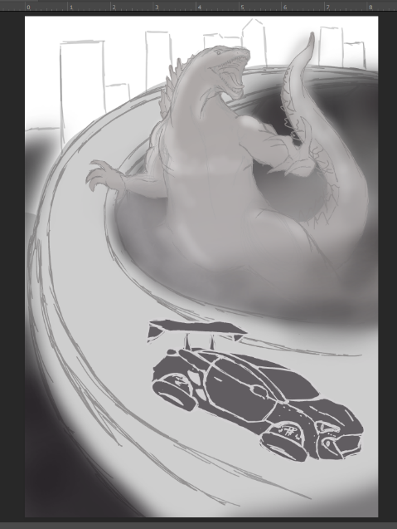
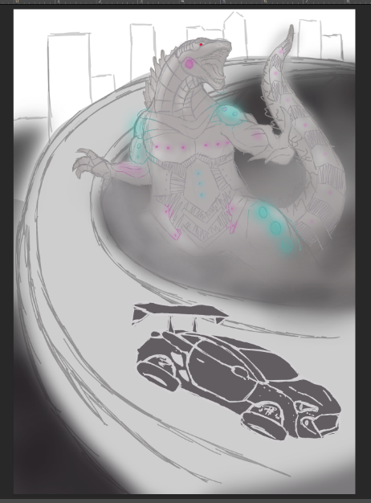

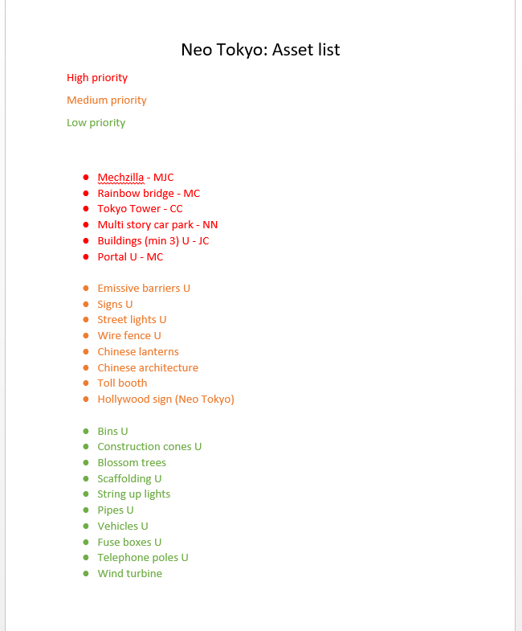

9th October – 15th October
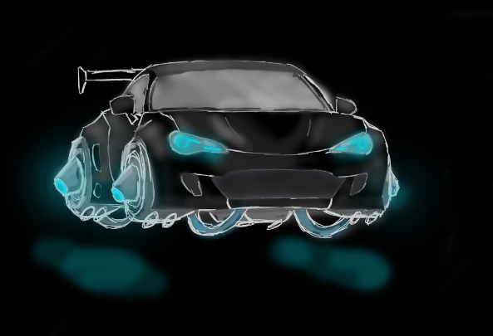
I finalised one of my ideas for the mid speed car and tested some potential hover systems we could use instead of wheels, I also included bright neon lights to fit in with the futuristic neo Tokyo level. We also discussed more about level layout and decided from my concepts that we are having a mecha Godzilla with neon lights over it to make it feel more mechanical and fit in with the 80s futuristic style of Tokyo. I also made a Gantt chart showing my predictions as to when and what I am going to be doing, this will be updated as I am progressing through my work adding other assets and rearranging times as to when they will be completed. I also used a reference of a Toyota GT86 as a reference image because I feel like this vehicle would really fit the style we are going for, for the fast vehicle.
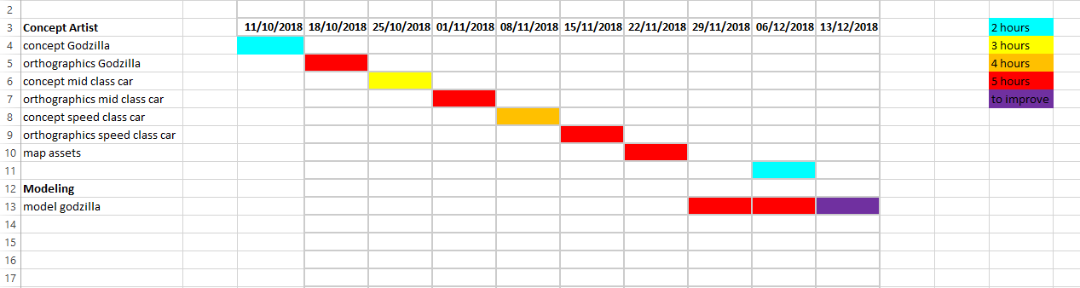

16th October – 22nd October
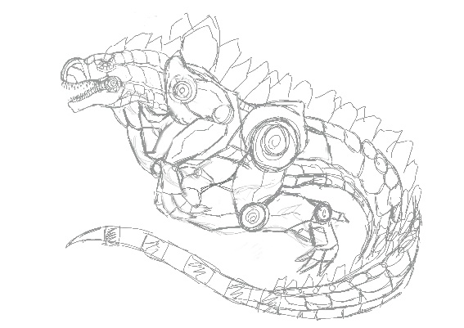
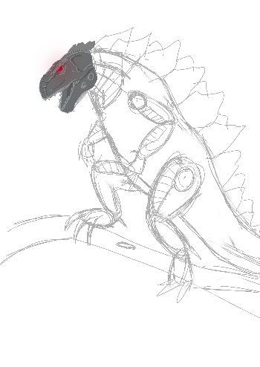
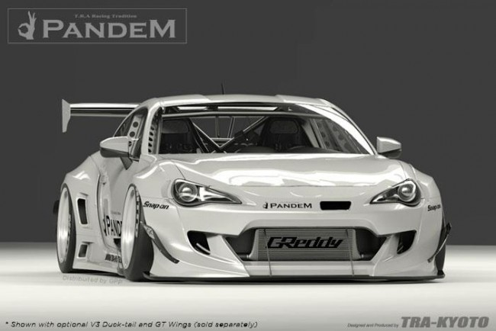
I first tried to complete two other sketches of mechazilla but I was not happy with the way that they turned out, the first one I did was way too complicated and you could not see what was going on, and couldn’t tell what limb was what, the second sketch I did I just wasn’t happy with the positioning of mechazilla so I started colouring the head just to see how well the red contrasted the grey, I then completed the final concept of Mecha Godzilla with no colour to see how people liked it and this draft then needed to be tweaked for the final version that needed to have a colour layout, I went on to take certain features away from the design and correct little things. I then added colour on the 21st and had our outcome of the design that everyone agreed on. The things that needed to be changed is the ribs coming out from the front, also we decided the feet should be flat instead of pivoted because it would be easier to animate. I used two main reference images to help me achieve the concept of mechazilla, I used the organic creature to help me get a rough pose for the concept I also used Grimlock from transformers to help me get a more mechanical feel for the design and help get the panelling right. I used neon lights to go down the belly of the creature to make the creature fit in with its environment and not just look like a metallic dinosaur, I wanted the design to look like it was meant to be in the city, the colours I chose for the light on the design are, a cyan and a bright pink/purple. I chose these colours because these are the colours that we have used throughout the overall map, I also chose those colours because it contrasts with the black very nicely. I may need to remove the spikes from the back of mechazilla, because it’s very close to Godzilla, so I will change it to make sure it’s not too similar. I also completed some traditional sketches to figure out the positions and the way mechazilla will move when it comes to animation, they are quick sketches to get some ideas down however I believe it will show how I get to my final design.

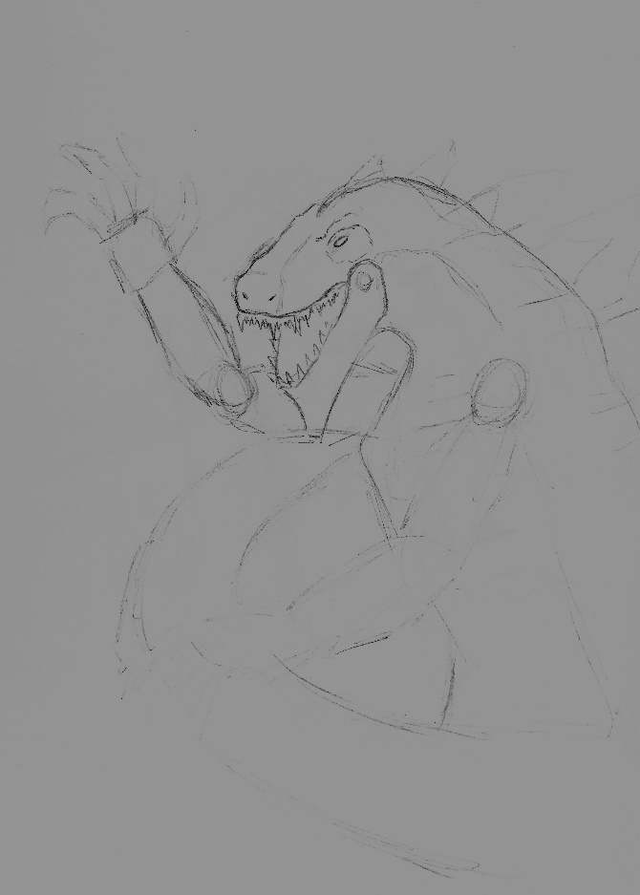
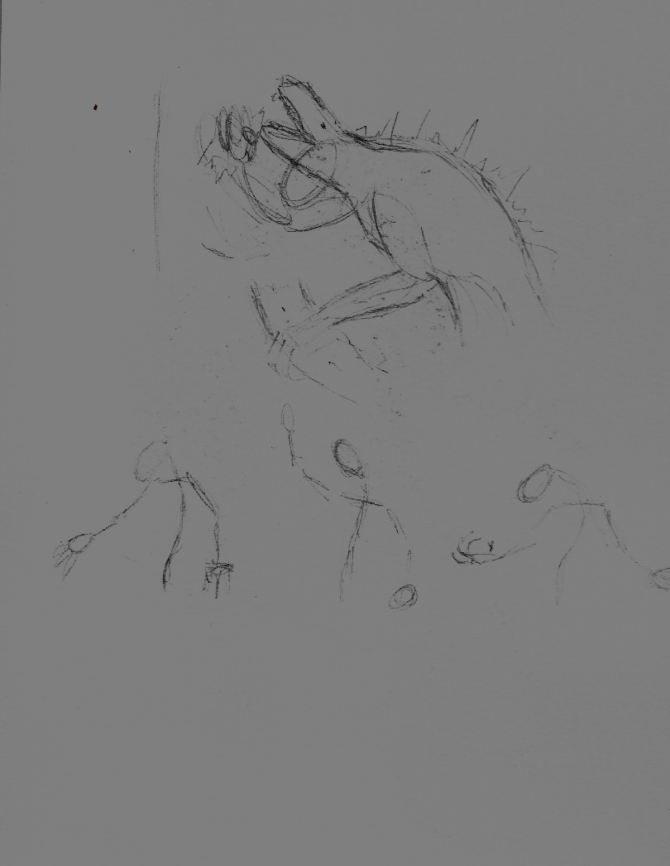
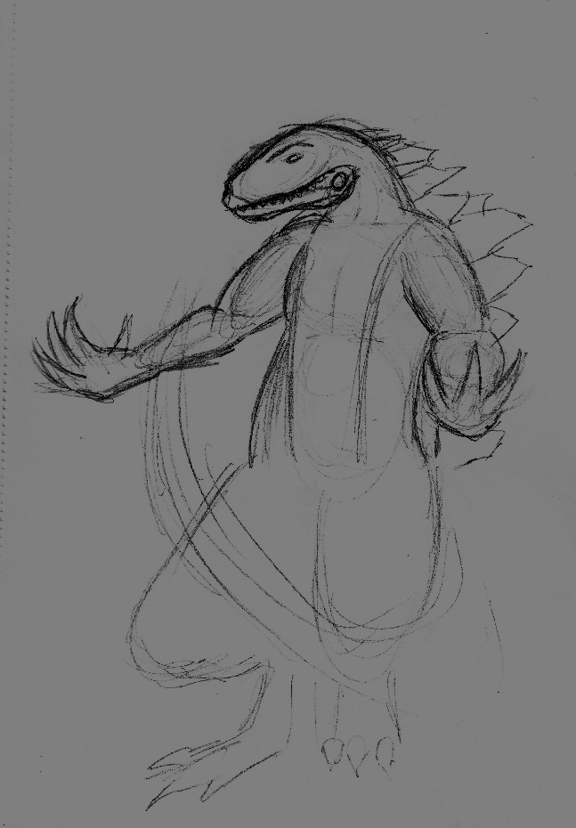
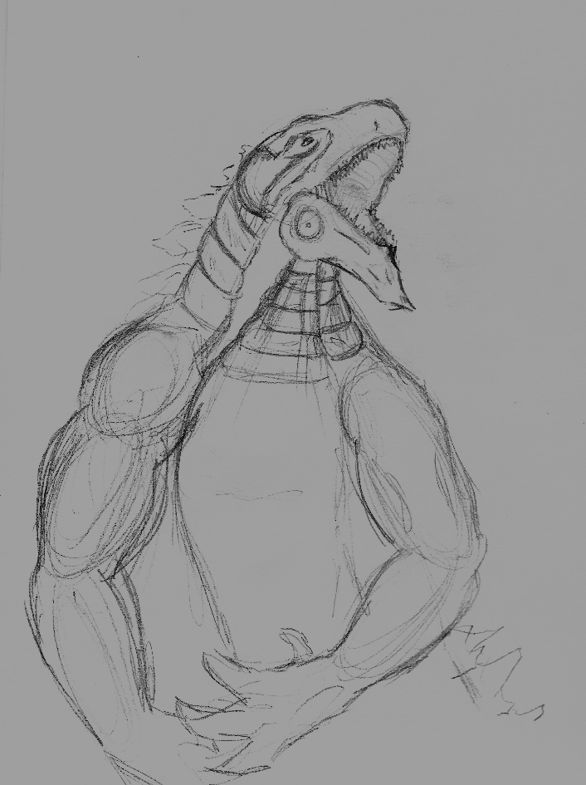

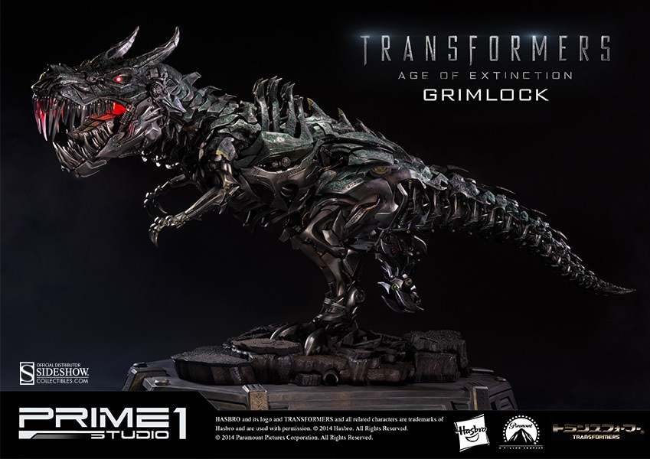
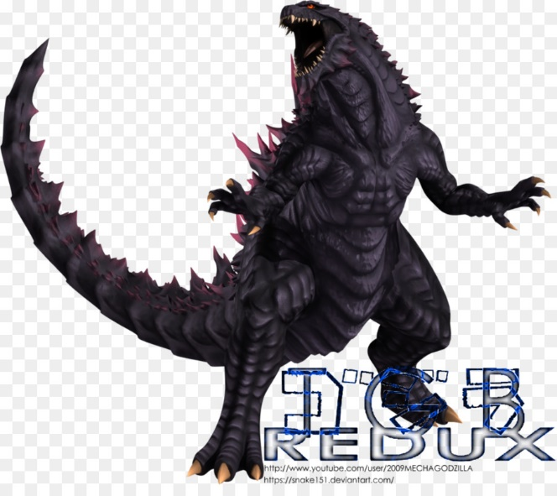
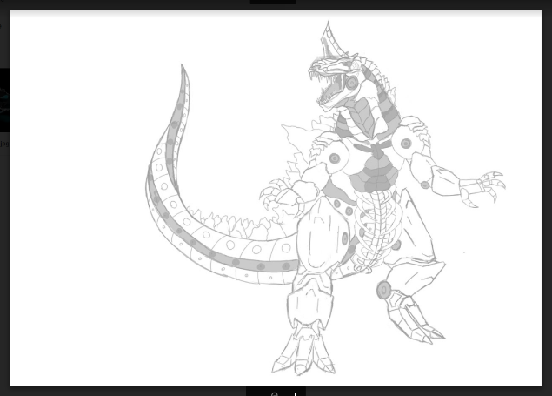
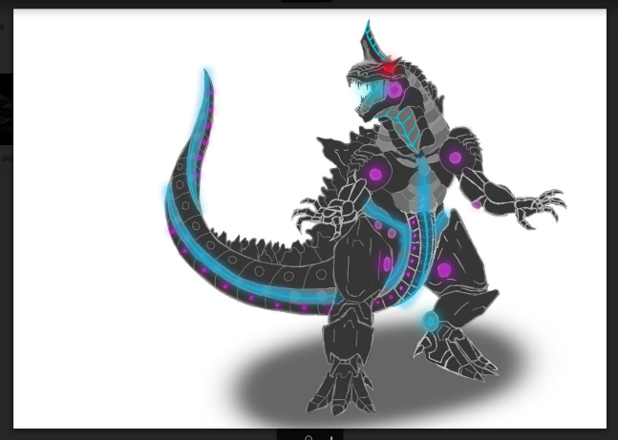

23rd October – 29th October
On this week I completed the orthographic for Godzilla to be passed on to the next person to block the model out, this took me about 4 hours to do which made this a high priority task and has had a influence on the other tasks that need to be completed such as the final design for the mid class vehicle. I struggled on the head and the arms whilst completing the orthographic for the monster because it was hard to line everything up to the front view whist drawing out the side view however I am very happy with how it came out and believe it is accurate enough to get a block out completed from it. I may need to change the spikes later on in the project, as I am the one who is editing the block out in zbrush I will redo the orthographic without the spikes, however this may be done next semester.

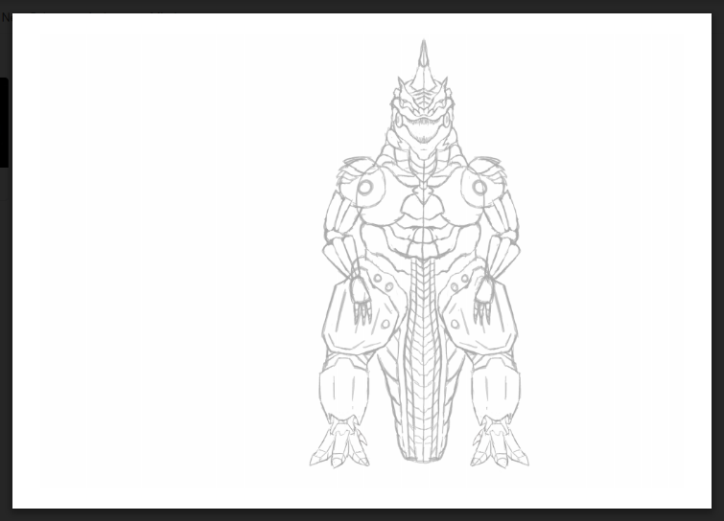

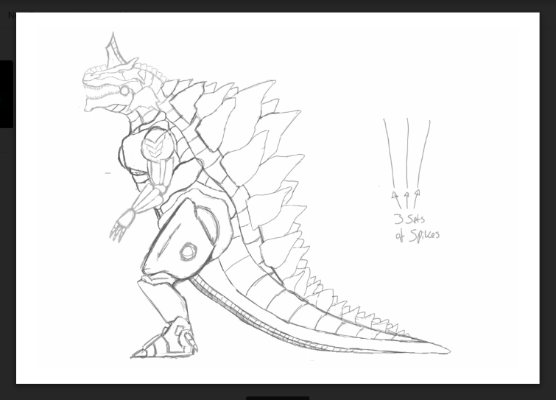

30th October – 5th November

I completed the orthographic for the fast car this was very hard because I could not get the perspective right for the front view and struggled getting the perspective right with he spoiler, to do the orthographic it took around 2 hours however I still have the rear orthographic to complete, I will most likely go back and edit these to get a more accurate model as I am not too happy with how the angle of the front came out. To achieve the most accurate drawing of the orthographic I used the ruler tool in photoshop to line everything up then separated the layers to allow me to make the rulers disappear when I want too. I also drew up some quick sketches for future vehicles or skins for the game, these are just rough ideas however they may come in handy in the next semester when if we need more vehicles
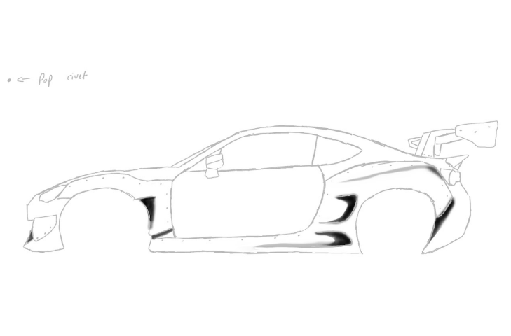
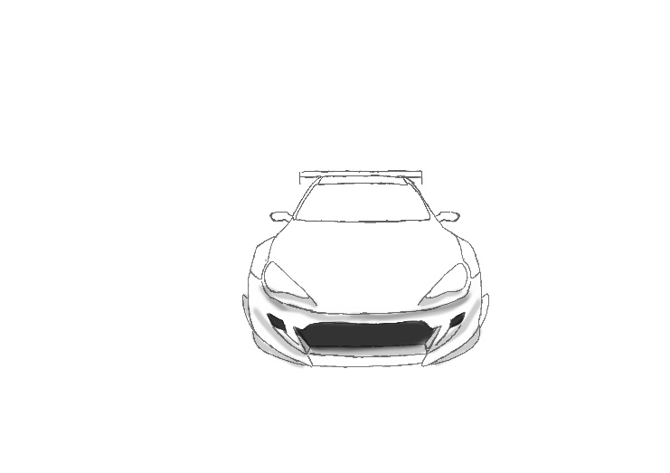

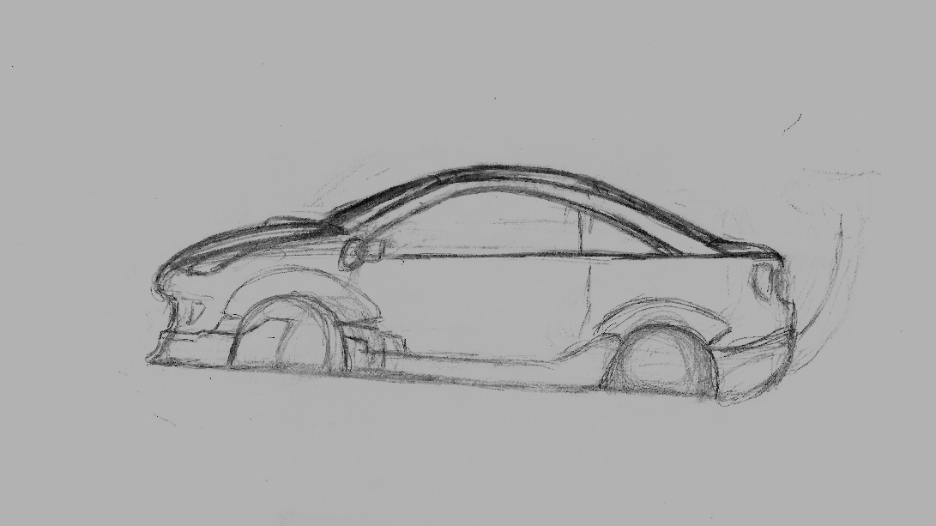

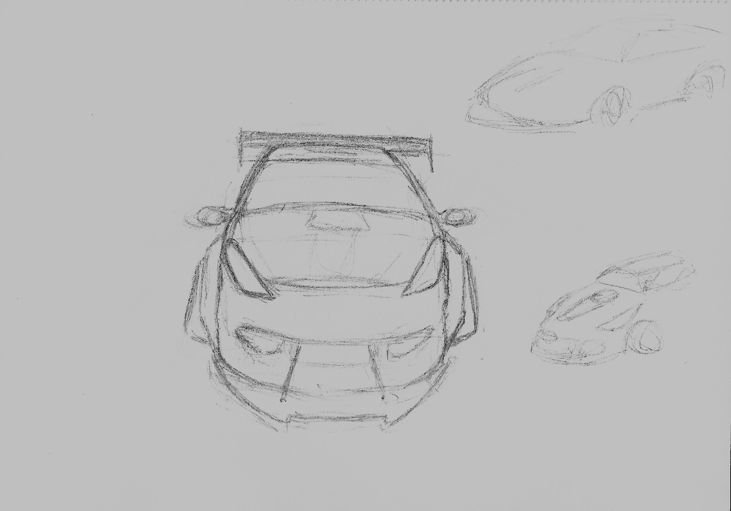

6th November – 12th November
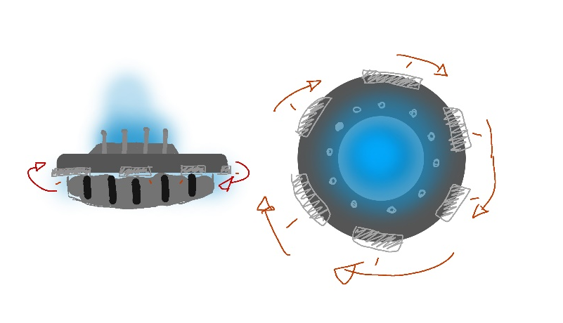
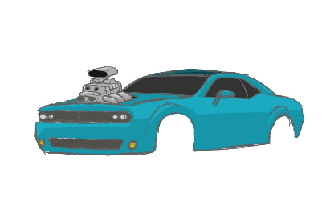
This week I completed the first concept for the middle-class car, however I still must work on the concept for the hover system for both cars, we as a group are undecided whether or not we want two separate hover systems our just one universal one, this could be something to concept if I have time. The mid class car is based off a dodge demon, with a exposed engine, this is shown from the reference images I have provided. I concepted the hover system briefly, however I believe that we will only have one hover system for this semester and next semester we will delve deeper into making each car unique to their own level.

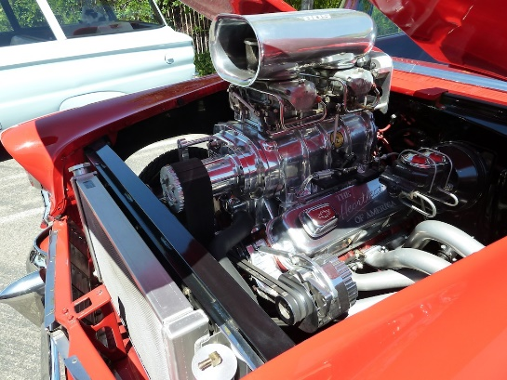
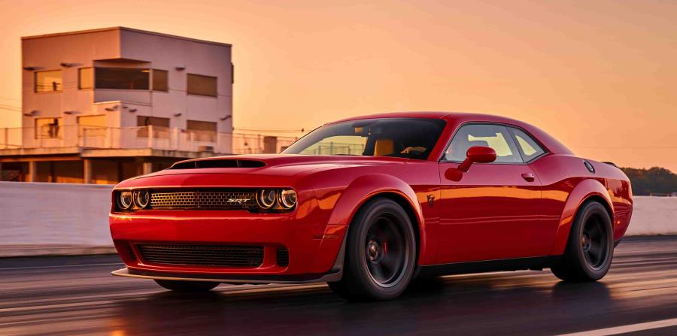

13th November - 19th November
This week I completed the orthographic for the mid car, we decided that the concept I did last week was good enough to start orthographic straight away without any other concepts, hover when doing the orthographic I had to re design certain things such as the rear lights because I didn’t design them in the concept stage, this is something to improve as it make the orthographic easier and quicker to complete which will save time. This is the first updated version of the Gantt chart, due to a time constraint I have not had time to update my Gantt chart, and this is shown in my Gantt chart due to most items listed being revised and taking longer than anticipated. I also finished the rear orthographic for the fast car this was difficult to do as I had to find all the lines for the wide body kit. I used the same technique as I used to do the orthographic on the mid class car, by using the photoshop rulers to get the most accurate proportions for my vehicle.
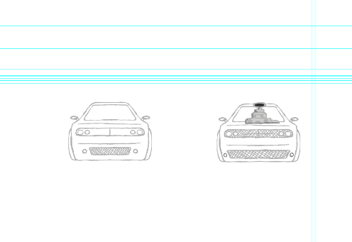
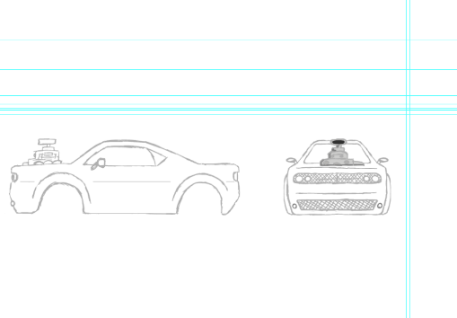

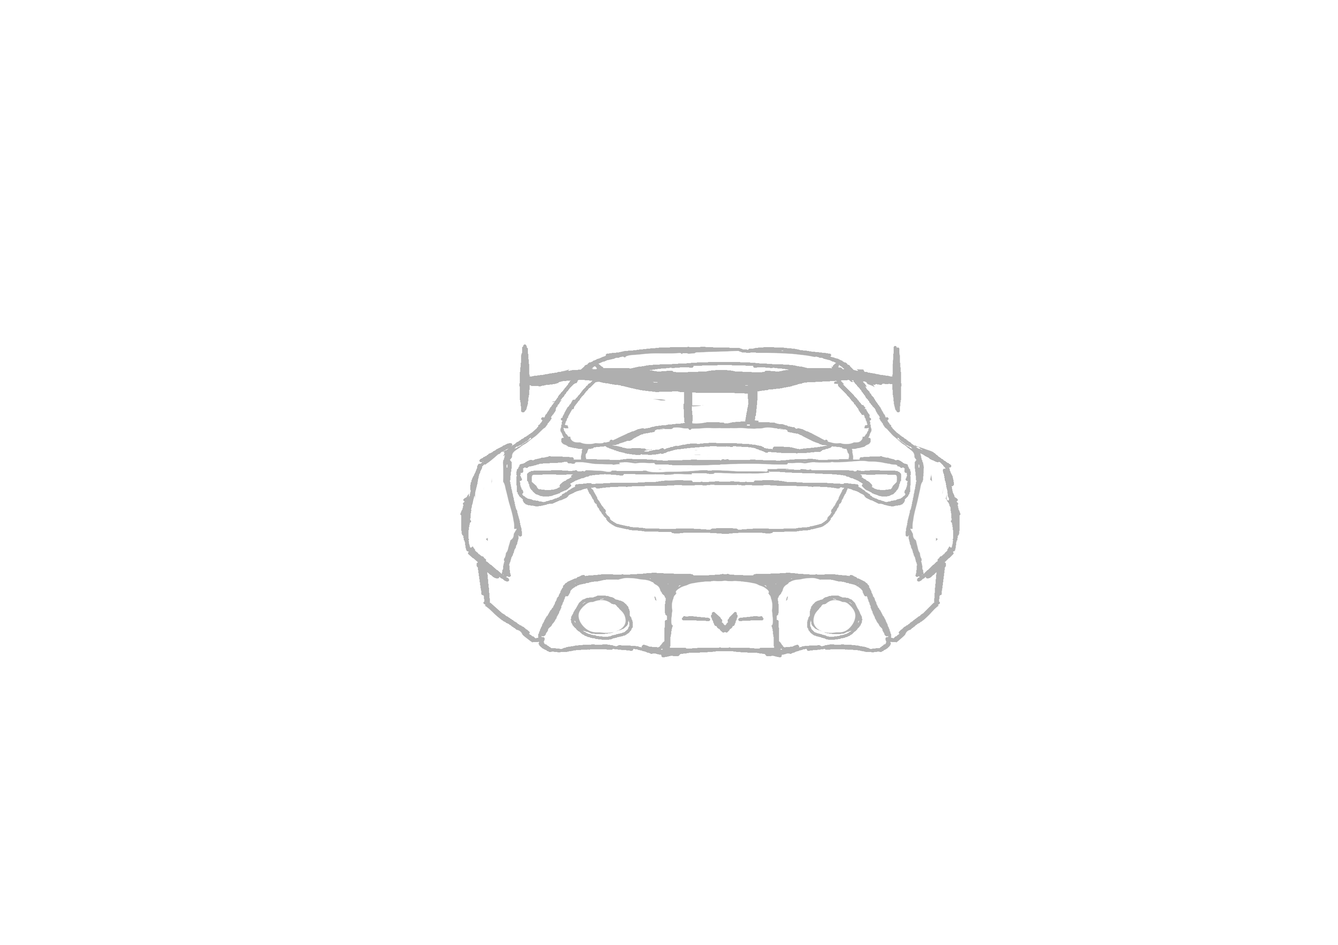

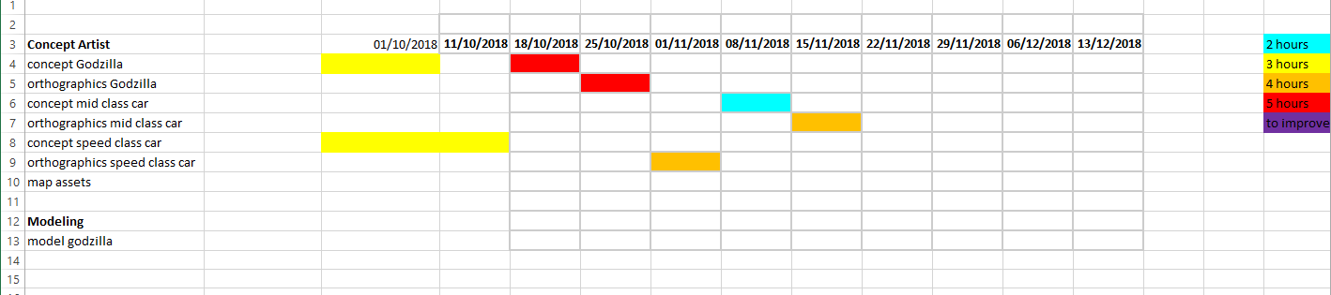

20th November – 26th November
Here I have imported the block out and started modelling the head of the main asset within the Neo Tokyo level, I especially found the bottom jaw hard to model because I could not get it to look right, I also tried to model the hands and the tail of the model however the divides in the model are proving to be a problem because they are not filling in the way I would like too, however this is block out may have to be put in the game next semester, whilst sculpting the head I used YouTube videos to refresh my memory of how to use brush and to get more of an idea where to start whilst modelling (Tutorials, 2018). I also re did the front orthographic for the fast car because I was not happy with the angle of how it turned out. I still couldn’t get the angle right with 2. Because it was hard to match everything up to the side orthographic, however I revisited this on the 25th and managed to get it looking the way I wanted (1.) when modelling attempting to model the hands of mechazilla the hands were too small the build upon, as they were shrinking when using the smooth tool on the fingers. Also, when attempting to smooth the tail, because they were separated the mesh was not going to blend together and become one object. I also updated my Gantt chart I am actually ahead of schedule as I have started modelling mechazilla a week before I originally planned as my predication Gantt chart shows. I also drew up a few mock sketches of buildings and a scene of mechazilla destroying some buildings to set a overall tone for the game, the buildings I tried to make to look unique with a spiral effect to them, as a main point of focus for the player to stand out from the ordinary buildings.
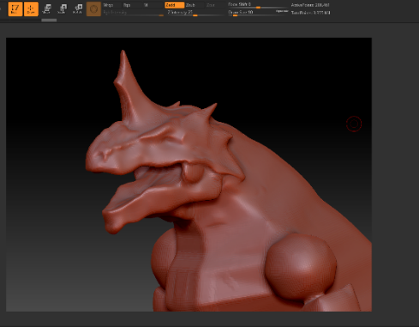
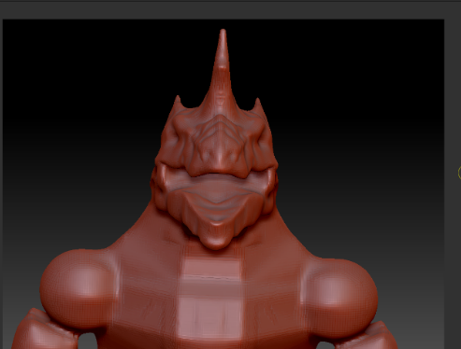
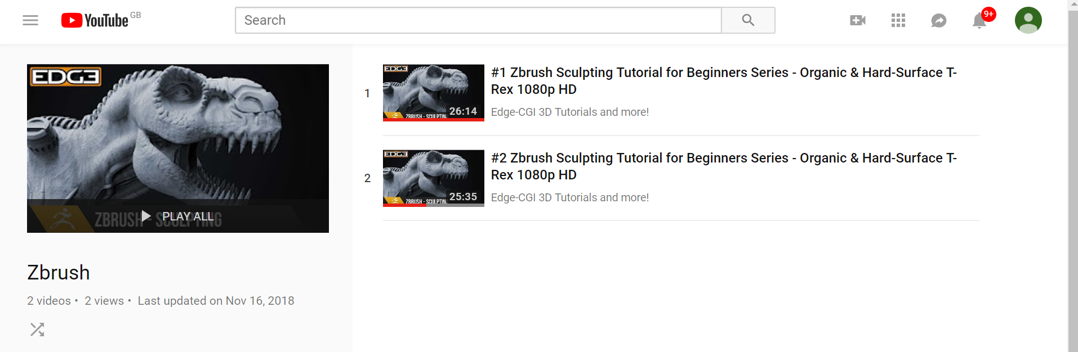
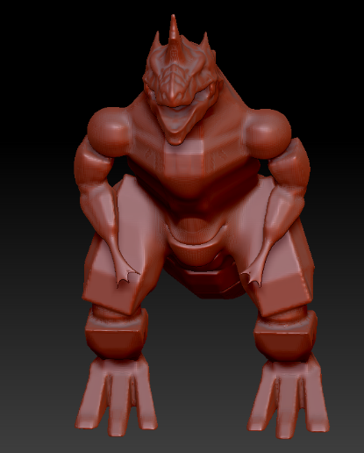
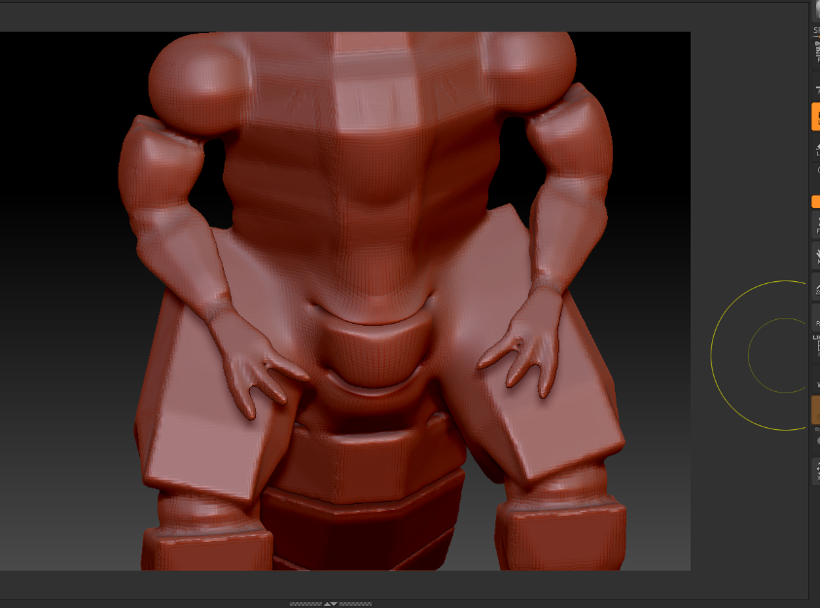
Webbed fingers, when smoothing and disintegrates, making it hard to build upon to get the most detail possible.

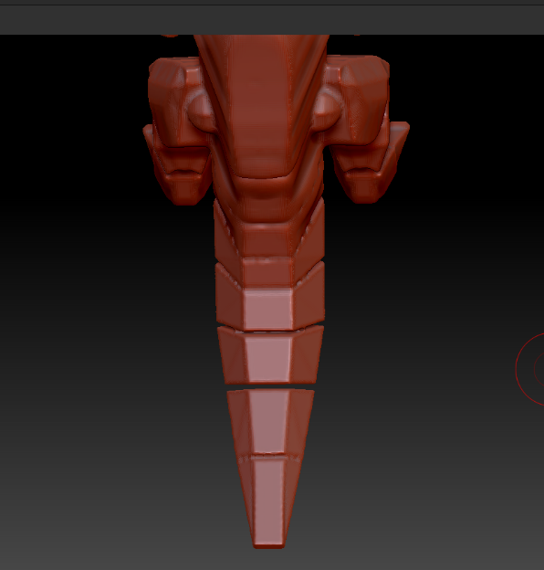

Separate in the tail, not able to mould them together

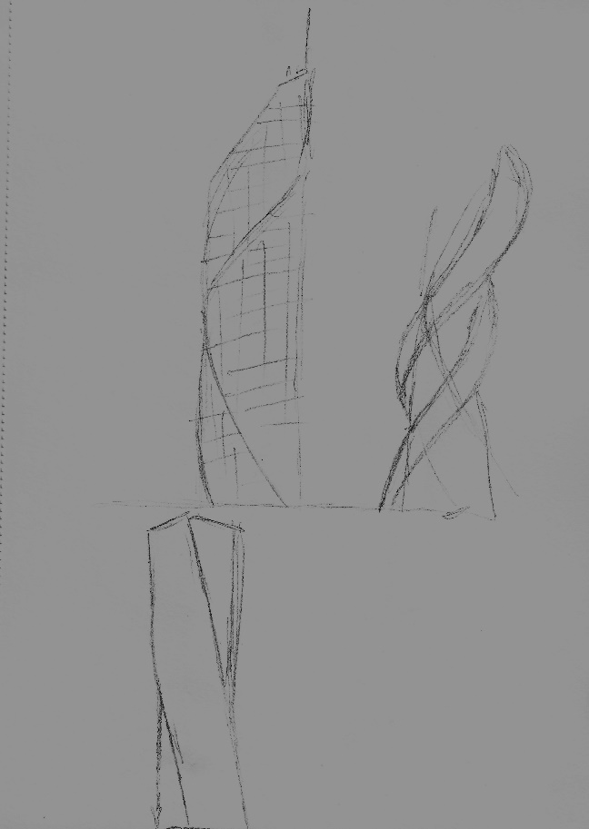
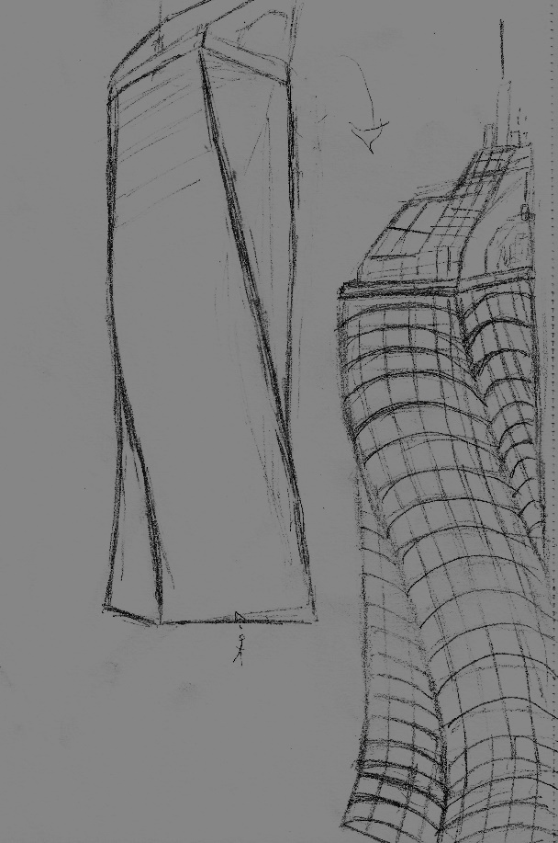
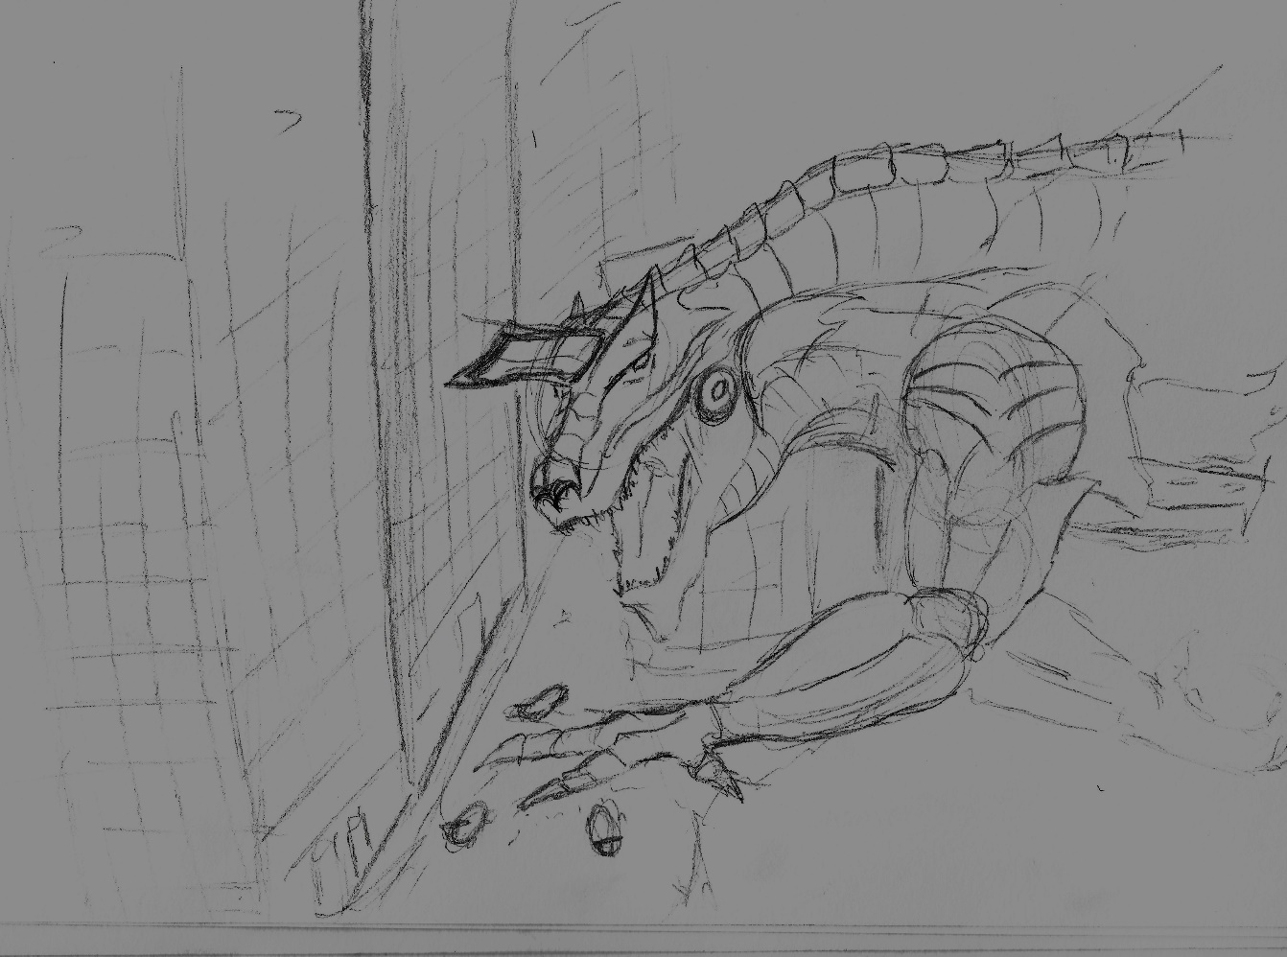

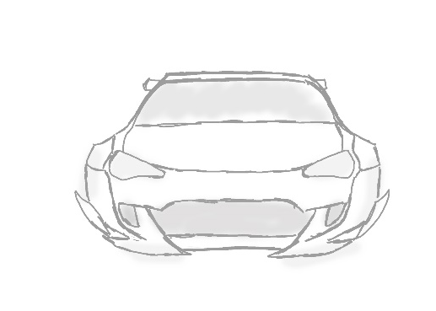
1.

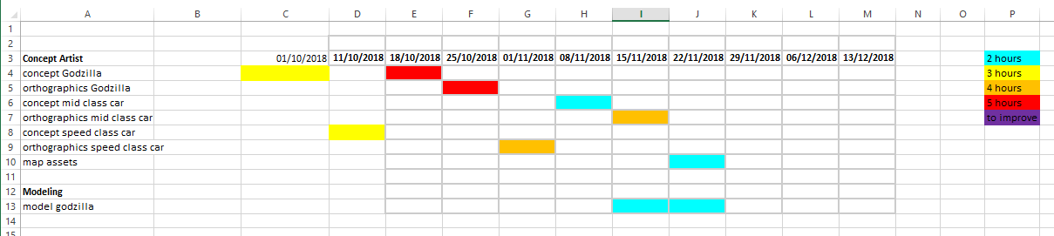
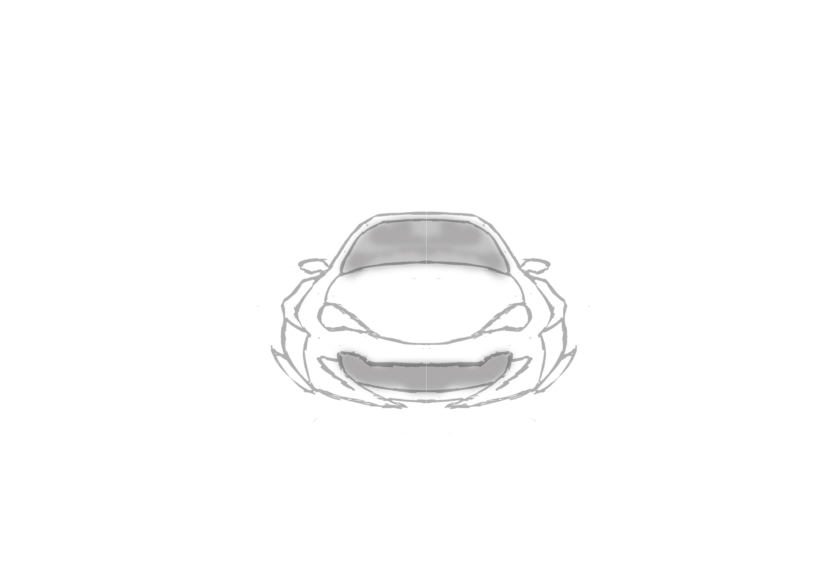 2.
27th November – 3rd December
I completed a top view of the fast vehicle for the modeller because he was finding it difficult to get the shape of the over fenders for the fast car, this was simple to do as it just required me to overlap the previous orthographic of the fast vehicle and marking out the major components such as where the wheel wells start and finish and where the wind screen starts and ends. The modeller for the mid class car also requested a top view due to finding it difficult to get the overall shape of the vehicle, this is shown on both orthographic how detailed the shapes of the cars are. I also updated my Gantt chart with 2 new major assets to design (the bridge, and Portal) I have started the design of the bridge as shown below I will do a more detailed version with dimensions for the modeller to get an accurate model from the drawings, I chose the colours of neon blue and purple because I feel it will fit the theme of the map best as these are the main two colours in the map I am focusing on.
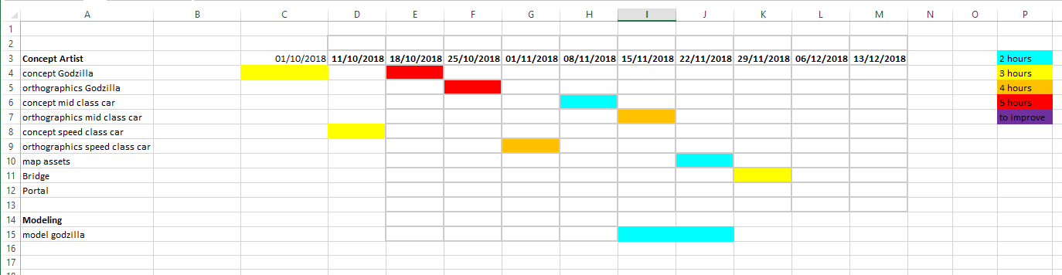
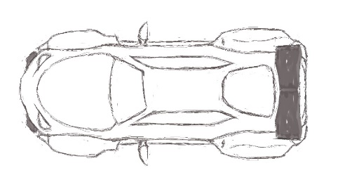

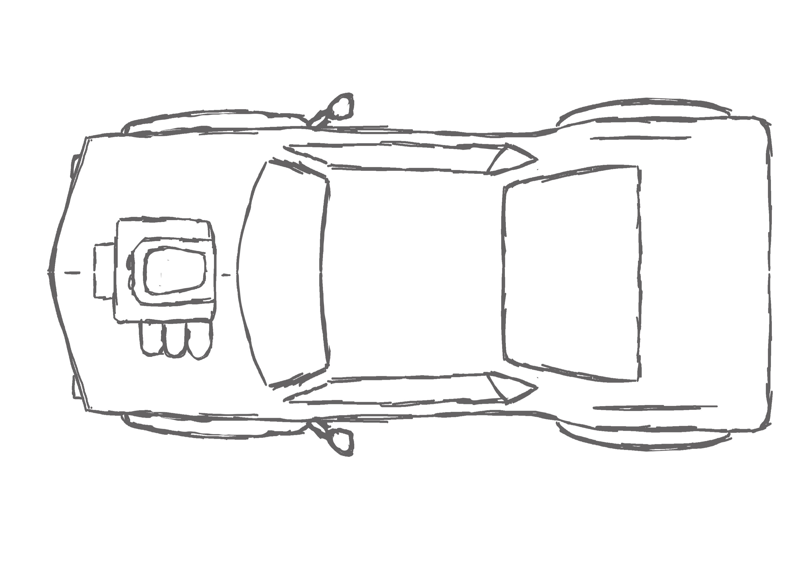
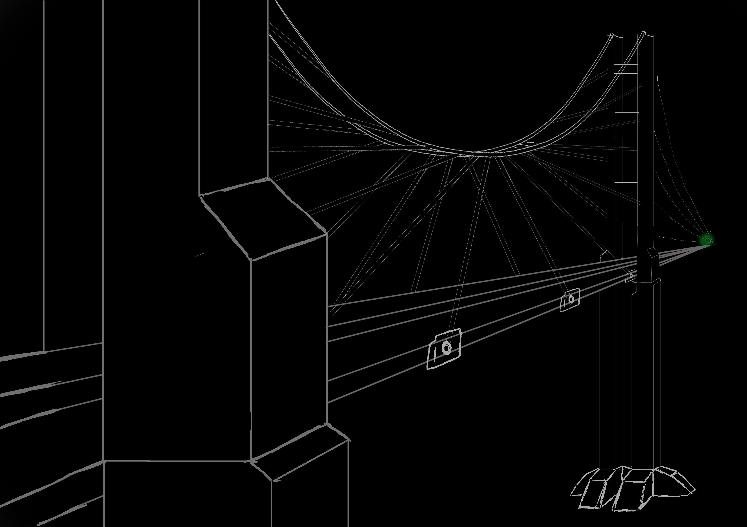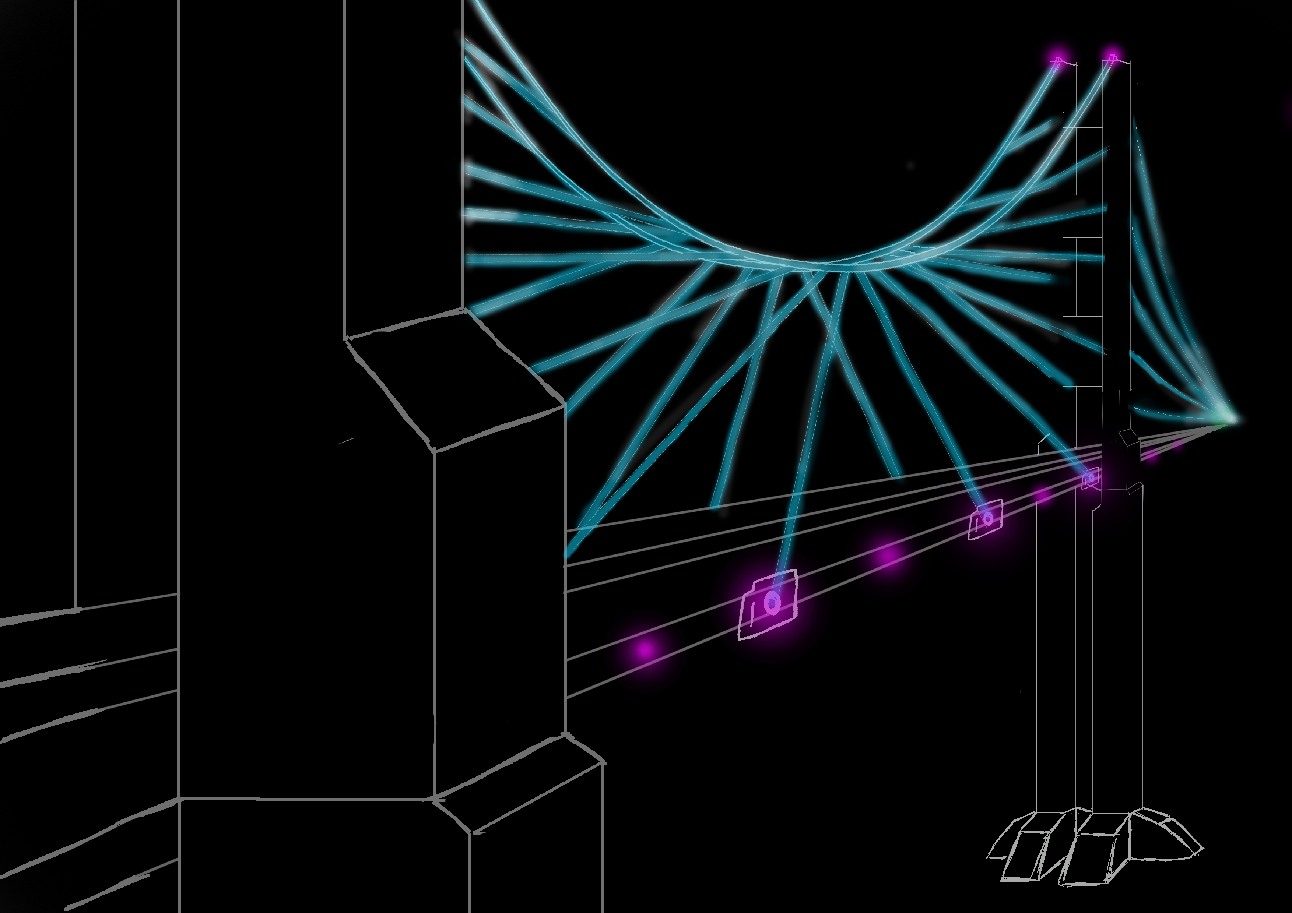

4th December – 6th December
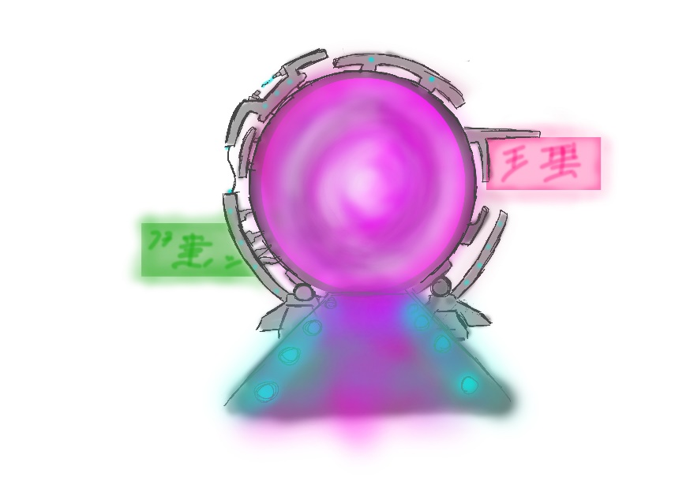
Coming to the end of the semester I did a concept of the Portal for Neo Tokyo, I included neon signs on the outside to get it a more mechanical city feel, because I wanted to get a different feel for it compared to the industrial portal that the other artist completed, I did two portal designs one with the ramp leading in to it, and one without so it would be easier for the modeller to get a overall feel of how to model the stands of the portal, next semester I will draw orthographic for the portal to get a more accurate measurement for the signs and the ramp etc. I also updated my Gantt chart showing when I completed the portal, this is the last update I will make to the Gantt chart.
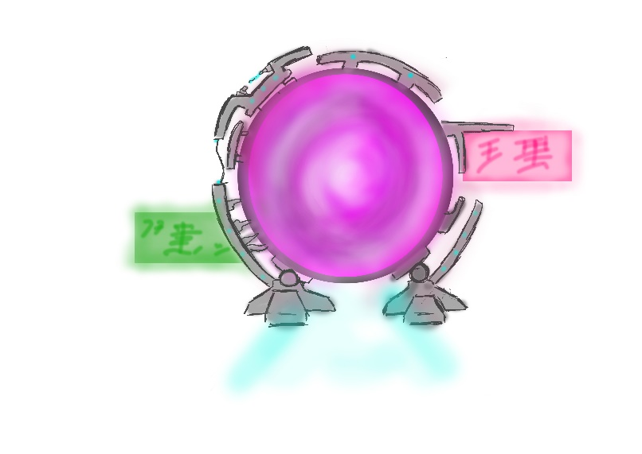
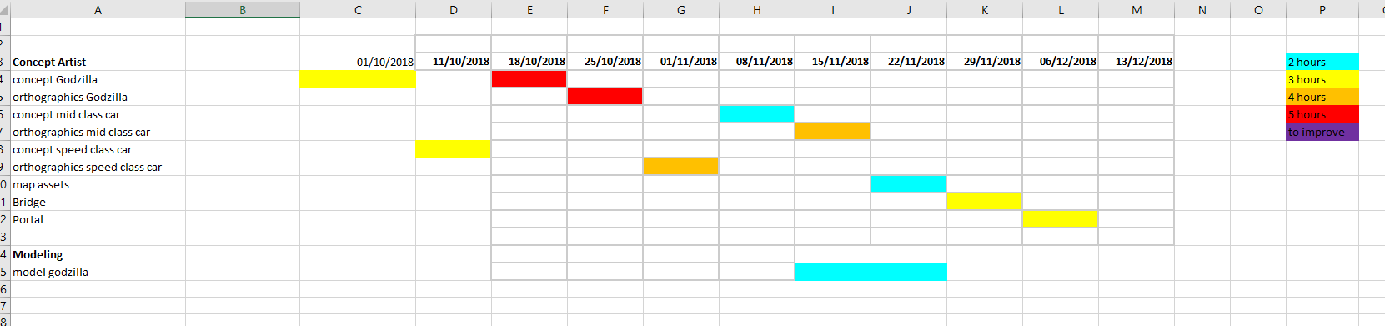

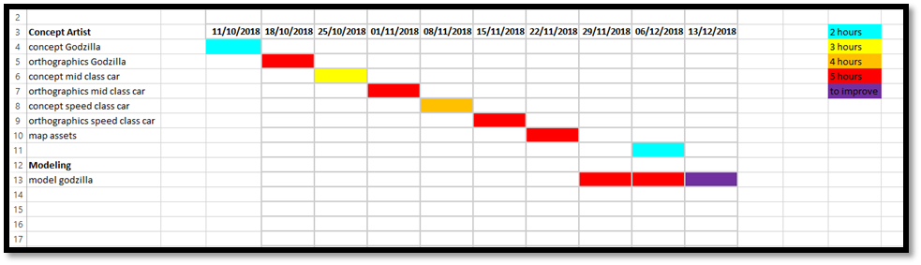
(Predication Gantt chart)

In conclusion I completed all my set tasks on the task list at the beginning of the production diary, I have also found new skills that I need to improve on such as orthographic and modelling in zbrush to get the most out of the program. I also need to improve my time management skills, because if you look at my Gantt chart prediction showing how and when I was going to complete all of my tasks. I am not happy with the way that mechazilla’s hands and tail is at the moment however that is something I can improve on for next semester.

References
#1 zbrush sculpting tutorial – Edge CGI 3D Tutorials for beginners https://www.youtube.com/watch?v=8Ididulfg9w

#2 zbrush sculpting tutorial – Edge CGI 3D Tutorials for beginners
https://www.youtube.com/watch?v=-g1L9jQtl0A

