Video link for presentation - https://www.youtube.com/watch?v=zoHV9rWHSJw&list=PLjV5htEtDATKzlYwqyZp4T6c7nRvxQ-Ic
Explanation of my chosen intervention.
Within this file, the reader will find research related to transitions with autistic children in the Foundation Phase (FP) aspect. This topic intrigued me because the writer wanted to know how teachers successfully put interventions into place for children on the autistic spectrum disorder (ASD) as ASD children do not like change (Mesibov et al., 2005). The writer has learned that ASD children like routines and order (The National Autistic Society, 2017), so how do ASD children cope every day in school when twenty-five percent of a school day (Hume, 2008) is made up of transitions from activity to activity (Mesibov et al, 2005). The writer wanted to find out what creative strategies are in place and offered to teachers for support of inclusion (UNCRC, 1992) for ASD children. Transitions are a hard period for any child, especially for a child with ASD. Unsuccessful transitions can make negative impacts on children’s well-being (Turnbull, 2006) therefore, it is important to strive for children to have successful transitions to build resilience in their lives (Trodd, 2013). As the writer has chosen FP area of learning this year, in her last teaching year of practise, the writer decided she wanted to look at transitions from home to nursery with ASD children. This is where the intervention was created.
In the past teaching practise, the writer has met children with ASD in mainstream classes from FP to Key Stage Two (KS2). The writer has always had an area of interest to research into ASD as she does not think she has enough prior knowledge to teach and help children cope with their ASD in a mainstream classroom. It is important to understand that children with special education needs (SEN) should be included in mainstream settings as, “it makes social sense for all children to learn together” (Grigg, 2015 & CSIE, 2002). Through doing research and visiting nurseries and learning centres (LC) that cater for SEN children (WAG, 2004), the writer has developed an excellent understanding through these experiences around her local area as well as researching into charities offering online support for anybody and everybody to learn about ASD and how to support these children. National Autistic Society is a charity who offer great advice to assist teachers and parents to develop their ASD children’s learning which helps them to progress for their futures. There are many research articles from this charity in the intervention file as the writer found them interesting to read as well as informative which supported her to progress the intervention of inclusion for ASD children.
To develop the intervention, the writer has been researching how every child develops successfully to be successful in their future life’s as this is what the new curriculum from Donaldson (2015) wants practioners to achieve. The writer discovered that children need positive relationships with schools and parents where there is a welcoming and positive environment (Maslow, 1943) for children to achieve in life (Bronfenbrenner, 1990). Therefore, it is important for schools to participate with the document of, “Well-being of Future Generations (Wales) Act,” (WAG, 2015) as this will develop teachers understanding of children’s rights (UNCRC, 1992) and will develop how to embed well-being across schools to provide children with a supported and caring environment for successful futures. Community needs to be actively involved in schools also, as children need to understand society to be able to flourish in the world, so activities that undertake the local area, attending church and many other visits will help children develop this understanding. This would mean that schools across Wales will need to provide children with beneficial and co-operative strategies that are fair and includes all children. These children are the future society therefore, in order to make society safe (Maslow, 1943) and create a friendly, respectful ethos, we need to teach our children how to change the perspective in Wales.
All children including SEN children are taught through play (Erikson, 1998) in FP. Playing for children teaches them how to communicate with others which develops skills from the FP curriculum in literacy and numeracy as well as building confidence, respect and resilience (Cousins, 2007). Playing can take place in formal and informal aspects for children to develop social skills such as willingness to work with others (Erikson, 1993), cultural and historical contexts (Vygotsky, 1978). The aspect of play will help teachers visualise the psychology of children through the children being egocentric (Vygotsky, 1962). Teachers that set provision in activities will help children grow in their zone of proximal development (Vygotsky, 1978) which is where children develop through different stages of life. Through researching this theory, the writer has come to conclusion that children develop at different stages at different times through social interaction and other aspects (Erickson, 1993).
This includes that while the writer had to research about different strategies to teach ASD children, the writer also had to provide diverse learning strategies to develop each child differently at their own pace through different cognitive and conceptual thinking strategies. Through research, the writer discovered that ASD children take a longer time to develop their skills, therefore they need more time to think about different subjects to process the information they have been given (The National Autistic Society, 2017). Hence why the different strategies the writer chose, including the sensory room activities, lego therapy and play dough activities (Maslow, 1954), provided time for ASD children to process and progress in their learning. The different strategies suited different learning styles according to children’s needs (Dunn, 2012). They need to mature naturally in order to develop motor skills and other aspects (Vygotsky, 1960). The sensory room (Grigg, 2015) research is evident in the file as the writer wanted to create a new environment and space for ASD children to be educated in by allowing them to mature their skills and be creative and confident (Maslow, 1954) while discovering the world around them (Faulkner et al., 1998).
The learning centre in Maesmarchog Primary in which the writer has visited, has incorporated children with severe ASD. Primary school teachers within these settings have put strategies into place to help them develop skills and knowledge from the curriculum to a certain extend through an individual education plan (IEP) (Ricciardi, 2004) which is shown to parents to provide teachers with permission from parents to go ahead with interventions as well as providing parents with communication, (Lamb, 2009) involvement in their child’s learning (WAG, 2004) and to make sure the targets for development are tailored properly to suit the families (Robinson, 2008) and carers wishes (Anderson, 2018). The ASD children that the writer witnessed in mainstream schools were not as severe as the ASD children in the learning centres, but some of the same strategies are used in mainstream settings such as, “DO DISCO.” This strategy is to develop children’s fine motor skills which can be used in mainstream nurseries to help children develop at the own development pace as well as including ASD children. The writer has witnessed excellent practise, such as in Maesmarchog Primary School, which has helped her to develop an understanding of how strategies are used especially by teaching assistants and how they handle challenging situations with some children (Grigg, 2015). They went above and beyond to support and care (Pedro-Carroll, 2005) for those children which is what Donaldson (2015) wants teachers and other supporting staff to practise. Wales’ teachers need to see challenges such as behaviour, as ASD children show many different behaviours such as anxiety and stress which then they “lash out,” as potential to overcome barriers of learning for children with ASD (DfEE, 1999).
Within Maesmarchog Primary school, the writer had witnessed well-being influences throughout the school including a well-being (WAG, 2015) week where the children embarked on different activities through that week to motivate (Erikson, 1993) children to understand their health and rights which developed the schools outstanding well-being atmosphere and environment (Bronfenbrenner, 1990). The writer witnessed well-being Wednesday which children undertook an exercise class in the school hall. The writer witnessed nursery/reception children undertaking this activity in the morning and then witnessed ASD children in the FP learning centre class in the afternoon. It was a fitness activity that included trampolines, hula hoops, bowling, throwing skills, bat and ball skills (hand and eye co-ordination) and many other activities. This provided a range of skills for nursery children and ASD children who developed physical skills such as fine motor skills as well as communication and social skills. This provided the writer with evidence that the school was taking a cross-curricular (Barnes, 2011) approach in learning to develop every child’s individual needs and skills. The hall had the same equipment for the mainstream children and the learning centre children to show that ASD children were no separation issues involved and they were being included in the well-being week. The school has an excellent attitude to helping all children grow.
Overall, the writer appreciated researching and learning about strategies to help and support ASD children to provide them with quality teaching for them to have quality learning (Dunn, 2012). The writer also enjoyed experiences in the learning centre of Maesmarchog Primary school as this allowed the writer to witness how teaching is practised towards produce confident and competent learners in the LC. The school’s moto is, “REACH FOR THE STARS” and the writer believes the children are provided to do this, for them to progress and achieve their best skills at their own pace of development (Vygotsky, 1978). The writer now feels she has the confidence to teach and embed strategies that will provide ASD children with the finest support in a mainstream setting. The writer wants every child, including SEN children, in her future classes to aim for their best, where they can use their knowledgeable skills and progress these skills for their futures to be prosperous, healthy and most of all happy people (WAG, 2015) whatever their background or condition.

Evaluation of assignment
Overall, I believe this assignment was beneficial for my future teaching practise as I now understand and have better knowledge on how to teach and include all children with additional learning needs within my classes. I believe the research I have collected within my file will be useful for my upcoming practise within my last teaching year in university also.
My strengths within this assignment was that I was committed to find quality and in-depth research to be able to understand how autism affects children and their learning as I want to be an outstanding teacher within the qualified teacher standards (QTS). In order to achieve outstanding, I must achieve the standard within the aspect of S1 which is, “professional values and practice” (WAG, 2009). The standard I would achieve would be S1.1 which is,
“They understand the diverse learning needs of learners and endeavour to provide the best possible education for them to maximise their potential, whatever their individual aspirations, personal circumstances or cultural, linguistic, religious and ethnic backgrounds”
And, “They demonstrate the professionalism to ensure that relationships with learners are built on mutual trust and respect and to recognise that this will help maximise their learning potential.”
I believe this would be a strength that I have understood that this assignment is helping me to develop the QTS standards to a high standard as well as developing my knowledge about the importance of research and reading various books to develop my evidence within my file and video presentation. I think that my video includes vital information and research for the viewers to understand my intervention of inclusion. I can also reflect upon this assignment that I have developed my time management skills as I believe I had undertaken early research which provided quality work within my file. Also, the completed file and video presentation has developed my confidence and self-esteem as I have gained a better understanding of the topic of transitions as well as inclusion for all children through my own research and experiences that I put into place.
I think my areas of weakness would be to add more interaction within my video such as examples of autistic children playing with lego and play-doh which I saw volunteering within Maesmarchog Primary. I should have made videos or taken pictures to prove that I saw these activities being practised within the classroom as well as adding them to my video presentation to make the presentation more enjoyable for viewers.
In conclusion, I can provide evidence that my file and video all links within the intervention of inclusion with theories also. I thoroughly enjoyed learning about autistic children and relished my experience within the learning centre to see autistic children in action developing and progressing their skills in Maesmarchog Primary. For future practise, I realise that I need to include all my strengths as well as addressing my weaknesses to become an outstanding teacher by delivering great lessons to all children for them to achieve their best outcomes at their own pace of development.
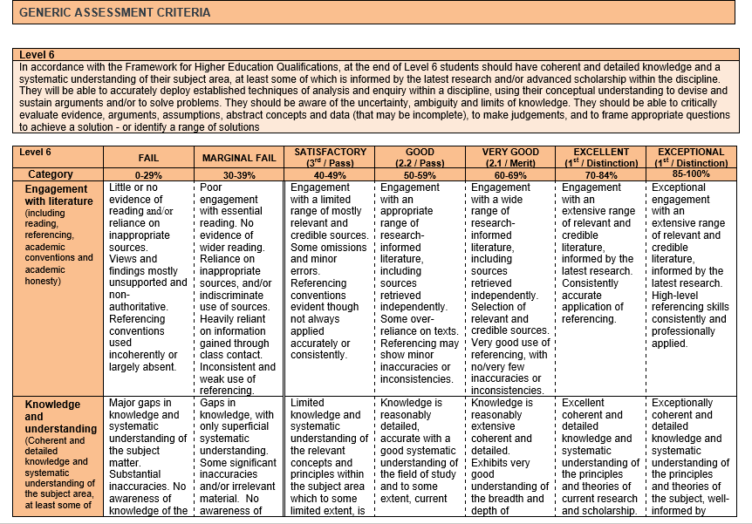

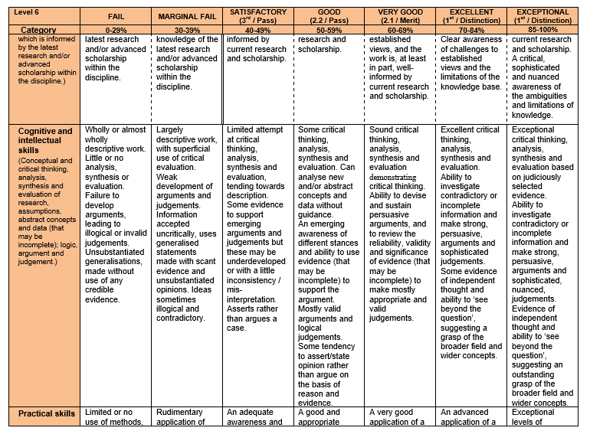

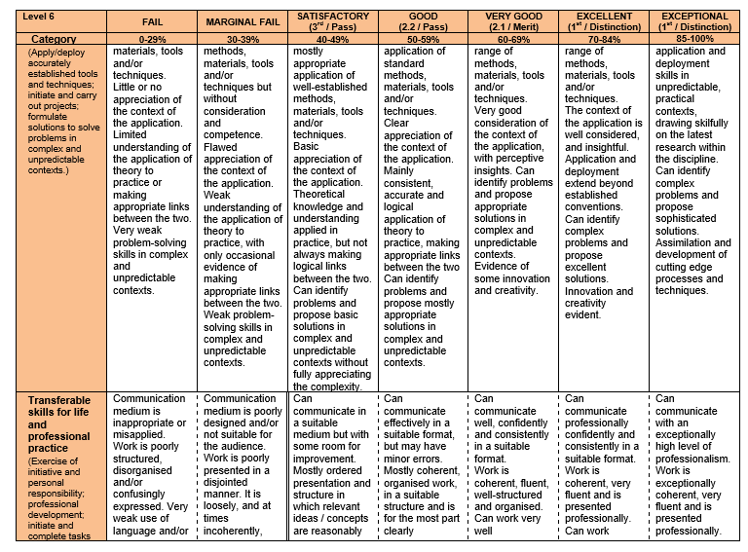

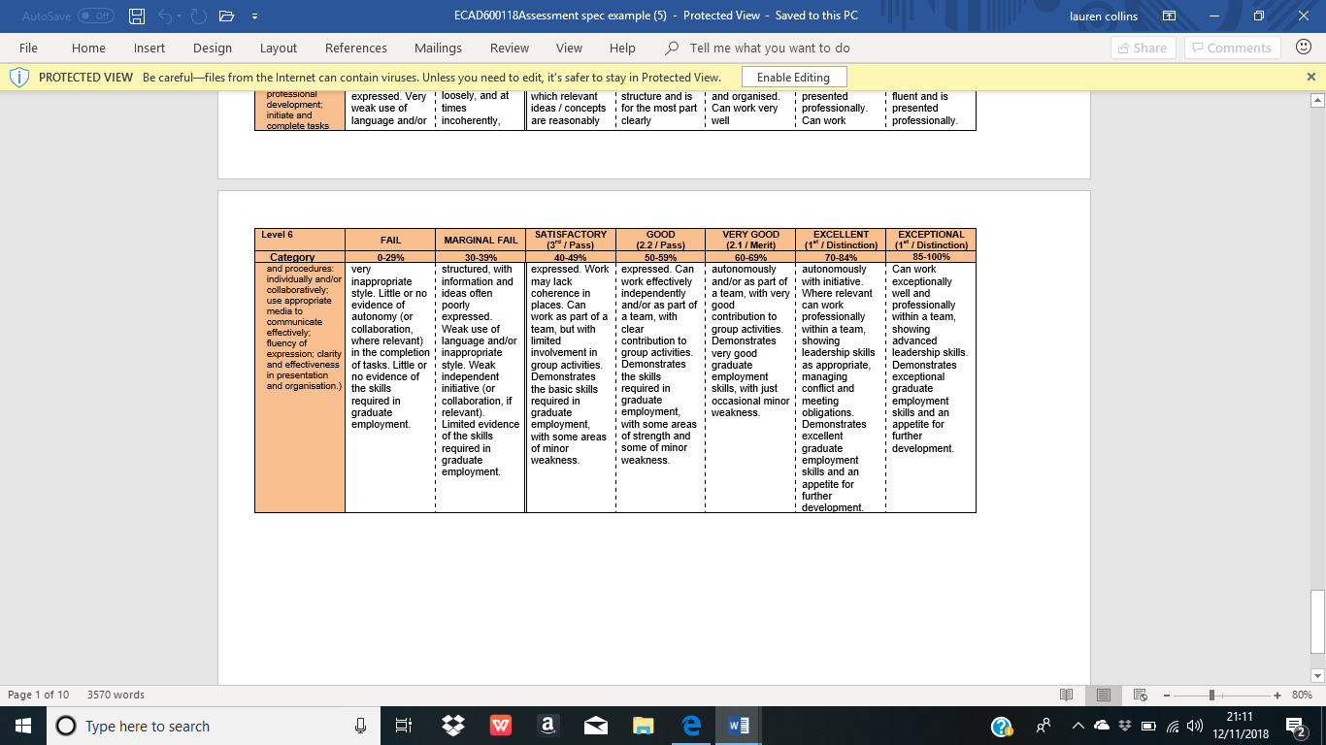

Reference list
Adel. (2016) Living with an Autistic Child; Play Dough, Fine Motor Skills Development. WordPress. [ONLINE] Available on: https://livingwithanautisticchild.com/tag/play-dough/ [Accessed on: 22.10.2018].
Anderson, D. (2018) Senior Director, ADHD and Behavior Disorders Center, Director of Programs, Child Mind Institute. Child Mind Institute. [ONLINE] Available on: https://childmind.org/bio/david-anderson-phd/ [Accessed on: 15.10.2018].
Aneurin Bevan University Health Board. (2017) Autism Sound Walk. Aneurin Bevan University Health Board. [ONLINE] Available on: http://www.wales.nhs.uk/sitesplus/866/page/91136 [Accessed on: 12.10.2018].
AP Cymru. (2012) About AP Cymru, Autism Puzzles. [ONLINE] Avaiable on: https://apcymru.org.uk/aboutus [Accessed on: 21.10.2018].
ASD in Wales. (2018) Learning with Autism, ASD info Wales; Early Years; Programme Overview. [ONLINE] Available on: https://asdinfowales.co.uk/home.php?page_id=9061 [Accessed on 15.10.2018].
Barnes, J. (2011) Cross-Curricular Learning 3-14, London: Paul Chapman.
Bronfenbrenner, U. (1990) Discovering What Families Do. In Rebuilding the Nest: A New Commitment to the American Family. Family Service America. [ONLINE] Available on: http://www.floridahealth.gov/AlternateSites/CMS-Kids/providers/early_steps/training/documents/bronfenbrenners_ecological.pdf [Accessed on: 17.10.2018].
Cherry, K. (2018) Verywell Mind, Erik Erikson's Stages of Psychosocial Development. [ONLINE] Available on: https://www.verywellmind.com/erik-eriksons-stages-of-psychosocial-development-2795740?print [Accessed on: 25.10.2018].
Cousins, L. (2007) Making Transitions Easier, Primary Headship. [SITED in Trodd, 2013].
CSIE. (2002) Ten Reasons for Inclusion, London: CSIE.
DfEE. (1999) The National Curriculum: Handbook for Primary Teachers in England, London: DfEE.
Donaldson, G. (2015) Successful Futures, Independent Review of Curriculum and Assessment Arrangements in Wales. [ONLINE} Available on: http://gov.wales/docs/dcells/publications/150225-successful-futures-en.pdf [Accessed on: 17.10.2018].
Dunn, D. (2012) How to be an Outstanding Primary School Teacher, London: Bloomsbury.
Erikson, E.H. (1993) Childhood Studies and Society (2nd ed.) New York: Norton.
Erikson, E.H., & Erikson, J.M. (1998) The Life Cycle Completed. New York: Norton.
Estyn. (2015) A Report on Maesmarchog Primary School. Estyn, Her Majesty’s Inspectorate for Education and Training in Wales. Cardiff: Estyn. [ONLINE] Available on: https://www.estyn.gov.wales/provider/6712155 [Accessed on: 08.10.2018].
Estyn. (2016) A Report on Gnoll Primary School. Estyn, Her Majesty’s Inspectorate for Education and Training in Wales. Cardiff: Estyn. [ONLINE] Available on: https://www.estyn.gov.wales/provider/gnoll-primary-school [Accessed on: 08.10.2018].
Estyn. (2018) Creative and Stimulating Activities Through Pupil Immersion Days. Cardiff: Estyn. [ONLINE] Available on: https://www.estyn.gov.wales/effective-practice/creative-and-stimulating-activities-through-pupil-immersion-days [Accessed on: 09.10.2018].
Estyn. (2018) Effective Transition from Primary to Secondary School. Cardiff: Estyn. [ONLINE] Available on: https://www.estyn.gov.wales/effective-practice/effective-transition-primary-secondary-school [Accessed on: 09.10.2018].
Experia. (2015) Multisensory for Everyone, The Benefits of a Sensory Room. [ONLINE] Available on: https://www.experia-innovations.co.uk/blog/the-benefits-of-a-sensory-room/ [Accessed on: 25.10.2018].
Faulkner, D., Littleton, K., & Woodhead, M. (1998) Learning Relationships in the Classroom. London, New York; Routledge.
Green Modular. (2017) How Sensory Rooms in Schools Can Help Students, School and Nursery Classrooms. [ONLINE] Available on: https://www.green-modular.com/blog/sensory-rooms-schools/ [Accessed on 27.10.2018].
Grigg, R. (2015) Becoming an Outstanding Primary School Teacher, New York: Routledge.
Hume, K. (2008) Transition Time: Helping Individuals on the Autism Spectrum Move Successfully from One Activity to Another. [ONLINE] Available on: https://www.iidc.indiana.edu/pages/Transition-Time-Helping-Individuals-on-the-Autism-Spectrum-Move-Successfully-from-One-Activity-to-Another [Accessed on: 24.10.2018].
Integrated Treatment Services. (2018) Talkabout, BigSpring; Integrated Treatment Services. [ONLINE] Available on: http://integratedtreatmentservices.co.uk/our-approaches/speech-therapy-approaches/talkabout/ [Accessed on: 27.10.2018].
Lamb, B. (2009) Inquiry into Parental Confidence in the Special Educational Needs System. London. [ONLINE] Available on: http://webarchive.nationalarchives.gov.uk/20130320215632/https://www.education.gov.uk/publications/standard/publicationDetail/Page1/DCSF-01143-2009 [Accessed on: 28.10.2018].
LeGoff, D., Sherman, M. (2018) ASD Aid; International LEGO Therapy Advocacy for Autistic Kids. Department of Psychiatry, University of Cambridge. [ONLINE] Available on: http://asdaid.org/lego-and-asd/lego-therapy [Accessed on: 23.10.2018].
Martinelli, K. (2018) Why Do Kids Have Trouble with Transitions? Child Mind Institute. [ONLINE} Available on: https://childmind.org/article/why-do-kids-have-trouble-with-transitions/ [Accessed on: 16.10.2018].
Maslow, A. H. (1943) A Theory of Human Motivation. Psychological Review. [ONLINE] Available on: http://highgatecounselling.org.uk/members/certificate/CT2%20Paper%201.pdf [Accessed on: 24.10.2018].
Maslow, A. H. (1954) Motivation and Personality. New York: Harper and Row.
Matthiae, J., Gaynor, G. (2008) Transition and Beyond: Moving Forward Together. National Teacher Research Panel for the Teacher Research Conference, Kings Norton, Birmingham. [ONLINE] Available on: http://www.curee.co.uk/files/publication/1230896326/Transition_and_beyond_moving_forward_together.pdf [Accessed on: 05.10.18].
McLeod, S. A. (2007) Maslow's Hierarchy of Needs. [ONLINE] Available on: http://highgatecounselling.org.uk/members/certificate/CT2%20Paper%201.pdf [Accessed on: 24.10.2018].
Mesibov, G., Shea, V., & Schloper, E. (2005) The TEACCH Approach to Autism Spectrum Disorders. New York, NY: Plenum Publishers.
Oakley, B. (2017) Snagglebox; 18 Tips to Make Transitions Easier. [ONLINE] Available on: http://snagglebox.com/article/autism-transitions-tips/ [Accessed on: 17.10.2018].
OFSTED. (2014) A Smooth Transition: The Village Nursery. Early Years, North West, OFSTED. [ONLINE] Available on: https://assets.publishing.service.gov.uk/government/uploads/system/uploads/attachment_data/file/620752/The_20Village_20Nursery_20-_20good_20practice_20example.pdf [Accessed on: 11.10.2018].
Paquette, D., Ryan, J. (2001) Bronfenbrenner’s Ecological Systems Theory. [ONLINE] Available on: http://www.floridahealth.gov/AlternateSites/CMS-Kids/providers/early_steps/training/documents/bronfenbrenners_ecological.pdf [Accessed on: 17.10.2018].
Pedro-Carroll, J. (2005) Fostering Children’s Resilience in the Aftermath of Divorce, Family Court Review, 43, 52-64.
Quinones-Fontanez, L. (2015) Atypical Familia; How Playing with LEGO Helped My Son with Autism. [ONLINE] Available on: http://atypicalfamilia.com/how-playing-with-lego-has-helped-my-son-with-autism/ [Available on: 20.10.2018].
Ricciardi, C.R. (2004) President’s Message: Appreciative Inquiry: Promoting Individual and Organisational Change, Journal of Paediatric Health Care. [SITED in Trodd, 2013].
Robinson, M. (2008) Child Development from Birth to Eight: A Journey Through the Early Years. Maidenhead: Open University Press.
The National Autistic Society. (2015) Why is Occupational Therapy Important for Autistic Children? London. [ONLINE] Available on: https://network.autism.org.uk/good-practice/case-studies/why-occupational-therapy-important-children-autism [Accessed on: 12.10.2018].
The National Autistic Society. (2017) In the Classroom; Autistic Pupils. London. [ONLINE] Available on: https://www.autism.org.uk/professionals/teachers/classroom.aspx [Accessed on: 12.10.2018].
The National Autistic Society. (2016) Starting or Changing School, Preparing for Change. London. [ONLINE] Available on: https://www.autism.org.uk/about/transition/starting-or-switching.aspx [Accessed on: 12.10.2018].
Tissier, A. (2011) SEN, Special Educational Needs, Outdoor learning for children with SEN. SEN Magazine, National Trust. [ONLINE] Available on: https://senmagazine.co.uk/articles/articles/senarticles/outdoor-learning-for-children-with-sen [Accessed on: 22.10.2018].
Trodd, L. (2013) Transitions in the Early Years, Working with Children and Families, London: SAGE Publications.
Turnbull, A, (2006) Children’s Transitions: A Literature Review. Cambridgeshire Children’s Fund. [SITED in Trodd, 2013).
UNCRC. (1992) UNICEF: A Summary of the UN Convention on the Rights of the Child. United Kingdom Committee for UNICEF, Stratford, London. [ONLINE] Available on: https://www.unicef.org.uk/what-we-do/un-convention-child-rights/ [Accessed on: 06.10.12].
Vygotsky, L.S. (1962) Thought and Language, Cambridge, Mass., MIT Press.
Vygotsky, L.S. (1978) Mind in Society; The Development of Higher Psychological Processes, Cambridge, Mass., Harvard University Press.
Welsh Assembly Government. (2004) Children and Young People: Rights to Action. Cardiff, Welsh Assembly Government. [ONLINE] Available on: http://www.assembly.wales/Committee%20Documents/HSS(2)-02-04%20Paper%201%20%20Children%20and%20Young%20People%20Rights%20to%20Action-04022004-14558/n0000000000000000000000000016990-English.pdf [Accessed on: 16.10.2018].
Welsh Assembly Government. (2004) Special Educational Needs Code of Practise for Wales. Cardiff, Welsh Assembly Government. [ONLINE] Available on: http://learning.gov.wales/docs/learningwales/publications/131016-sen-code-of-practice-for-wales-en.pdf [Accessed on: 17.10.2018].
Welsh Assembly Government. (2009) The Qualified Teacher Status Standards Wales 2009 (2009 No.25). Cardiff, Welsh Assembly Government. [ONLINE] Available on: https://gov.wales/legislation/subordinate/nonsi/educationwales/2009/3220099/?lang=en [Accessed on: 10.11.2018].
Welsh Assembly Government. (2015) Well-being of Future Generations Wales Act. Cardiff, National Assembly for Wales, Welsh Government. [ONLINE] Available on: https://gov.wales/topics/people-and-communities/people/future-generations-act/?lang=en [Accessed on: 18.10.2018].
Welsh Government. (2017) Education in Wales: Our National Mission, Action Plan 2017-21. Cardiff, The Education Directorate, Welsh Government. [ONLINE] Available on: https://beta.gov.wales/education-our-national-mission [Accessed on: 18.10.2018].
Williams, A. (2018) ASD in Wales; Growing with Autism; Autism: A Guide for Parents and Carers Following Diagnosis, ASD in Wales. [ONLINE] Available on: https://asdinfowales.co.uk/growing-with-autism [Accessed on: 15.10.2018].

Appendices
Appendix 1 – video presentation youtube link and script.
Slide 1:
Bore da a Croeso. My name is Miss. Lauren Collins and I am the SENCO of the school and the Nursery/ Reception teacher. I love my job and this school, and therefore I have chosen to talk to you about the importance of my new intervention and how it will raise standards for the whole school as teachers can adapt my intervention to suit the needs of upper FP and KS2. The reason I have chosen this intervention of inclusion is because when I was reading our latest Estyn report, I noticed it does not mention inclusion for ASD children in our mainstream setting. Our learning centre is providing the more severe cases of ASD children with great opportunities, so I wondered why we are not doing this in our mainstream school. Therefore, I will be discussing our latest Estyn report in order to show you which elements we will be raising standards in. This will prepare us to show Estyn our improvement on the recommendations. My intervention will be achieving targets on our School Development Plan which I will show you later. The intervention is vital because I noticed that my nursery/reception class does not have enough resources to provide my ASD children with opportunities to develop basic skills such as sensory as well as developing their overall performance in literacy, maths and DCF.
Slide 2:
Our recent inspection was in 2015, therefore we could be due an inspection soon as they take place every 3-6 years as you are aware. Therefore, is it important to embed the intervention of inclusion now, so that the children will be provided with opportunities to explore the world creatively and achieve better learning experiences, this is what Kirsty Williams states in the National Mission. The new curriculum by Donaldson wants us to be creative with our teaching and to make our children more creative. Therefore, this intervention will be purposeful as it will provide more creative resources in school.
Slide 3:
In our report, I discovered that the intervention of inclusion for all children fits appropriately into the three areas we need to improve. (READ THE IMPROVEMENTS ON SLIDE). Looking at these three improvement areas, it is clear to see that our assessment information is not allowing children to reach their next step in their learning. This would mean we need to add more opportunities for them to develop their next step independently through new resources to help them. Consequently, I want to add new areas of provision in my classroom and build an outdoor space for all children to learn in, this will improve their learning requirements. The second area of improvement is to work effectively with a wide range of partners to improve outcomes, by working closely with parents of our ASD children to show our caring and friendly school ethos. Also, we need to work with the wider community for this target to be improved, I will speak about this later in my presentation. The last target is to use our funding more appropriately and use it for the children’s needs to improve their learning, especially children with disadvantaged backgrounds and ASD children. We need to make sure the children are at the heart of the learning taking place. By including the outdoor learning space this will develop their learning as already mentioned.
Slide 4, 5, 6, 7:
Here are our 3 targets on our SDP and looking at our Estyn report our outcome for Well-being was good. Therefore, I do not see target 1 as an area to improve, but I do see at as an area to continuously to keep achieving and working on which my intervention does. High levels of well-being will lead to progress in children’s attainment and achievement. Inclusion is an aspect of well-being. Every child has the right to be included in school. This is acting on children using their rights stated from the UN convention. The children will have the rights from the article highlighted which I have provided for you to show you what those articles are. Well-being shines through these articles. To make sure autistic children are being supported, I want to train myself and 2 other members of staff to be trained in massage therapy course which myself and 2 other staff members can create circuits and massage setups in the school hall before school begins. This will provide autistic children with support to calm them from any stress or anxiety. This is relating to well-being because the children are at the heart of this practise and this practise ensures pupil progress. Our second target on SDP, is where I created my intervention from. I believe that my nursery class does not provide the best support for children with ASD. I have researched into how to build autistic children’s resilience and self-esteem through many resources such as lego and play-doh. Last but certainly not least, the intervention of inclusion will be working on the target 3 for developing partnerships with parents and carers to make sure they are on board with what is happening in school. I suggest we create a group every Wednesday for parents with ASD children to attend for them to talk about any problems they may have relating to ASD issues. Children need a good environment in order to learn, therefore if we include parents, we will form great partnerships which will make us a great school to be in. we will then get higher ratings on our Estyn parent questions as well.
Slide 8:
Children of any age will be scared to start school if they have never been in a school-based environment before. As a nursery teacher, I understand that the thought of leaving parents and feeling lost in school is a big concern when children start school. I do home visits in the summer to new children starting in September, to build relationships and break down social barriers. Also, when I visit them, I give them a map of the nursery class and pictures of myself and TA’s. Parents are involved in this transition as they can explain to their child that school isn’t a place to fear. This means when children start school they will not be worried of the unexpected. Also, they visit the school with parents then transition to independent visits, 3 times before school starts so they have a feel of the class which helps to settle them in. Transitions are hard for any child to undertake but especially for ASD children. So, when I visit ASD children’s homes, I give them the other items as I just mentioned but also a sound map which is on an IPAD. The IPAD is given to provide ASD children to develop DCF skills. The sound map provided will sustain ASD children with an insight to the class. ASD children do not like loud and chaotic noises which a nursery class can sometimes be. Therefore, if they understand and listen to the noises with parents beforehand, the children will become more comfortable with the noises that take place which will relieve confusion, anxiety and stress. I am now going to discuss some of my ideas which I want to include in my classroom to support inclusion of ASD children.
Slide 9:
Through researching different activities to develop ASD children’s skills, I came across lego therapy. Lego helps as a therapy tool for ASD children while working collaboratory with the other children. This is how inclusion is linked. LEGO could be placed in my construction provisional area as a tool to calm ASD children down if they feel they are stressed or feel a “melt down” coming on. The reason I researched further into lego was because one of my ASD children loves lego as it provides him with guides on how to step by step create different products. ASD children prefer to use step by step guides as it provides them with clear instructions instead of chaos tasks that leads them to confusion. This is an example of a transition that may be difficult for ASD children. Though the children from nursery cannot read yet, the visual guides help them to build the product through pictures. This would mean ASD children are developing skills such as reading as they are learning how to read a book properly from left to right. They also build the skill of turn-taking and social skills. LEGO therapy is a course where staff members can be trained which costs £700. Training is vital to understand how lego provides children with rich learning experiences which is vital for their futures.
Slide 10:
Another activity to be introduced into the classroom is play doh disco. This is a song that develops children's fine motor skills and can be played every morning to start the day in a fun way. This targets ASD children without them realising as they need to develop basic skills such as grasping as they struggle with these skills. This shows evidence for inclusion in the classroom. There will also be a provision area where play-doh is always on display, so any child can use this resource to develop basic skills further. ASD children would really benefit from this exercise as they are engaging in the whole class too.
Slide 11:
As I have already mentioned, I would like to build an outdoor sensory room called, “cwtch corner” to enable ASD children as well as the other children in my class to develop their sensory skills. The outdoor area will provide ASD children with a safe place to go when they need space. ASD children suffer with stress and anxiety. This area would reduce stress and anxiety within the mainstream setting. In this room there would be, beans bags and cushions with different light sources such as a lava lamps. This area will be in the shape of a tepee because tepees are more fun than regular spaces like sheds and will develop children’s creative thinking. Within this area, I would like all the children to bring in one item from home, such as a favourite toy, to keep in the tepee so when any child feels upset with transitions, they know that they can go to the sensory, “cwtch corner” to have space. This allows me to have more one to one time with children to build good relationships with them.
Slide 12:
As previously mentioned, circuits and massage classes before school would not only benefit my ASD children in my class but can involve all ASD children in a whole-school approach to “warm them up” for the day ahead. This has been proven to work through occupational therapist research. This a whole school approach to benefit mainstream setting ASD children. This would mean this class will take place at 8.30am to 9am for the ASD children to be ready for the day ahead.
Slide 13 and 14:
I have explained previously that we need to include parents more within school life. To make sure this is achieved, I want to set up a club that our parents of the school can attend to talk to us about any problems. It will take place on Wednesdays after school where parents can communicate with other parents with ASD children and adults with ASD from the wider community. I will be there also and can provide information if needed as well as asking them questions about any issues they may have regarding to ASD. We need to communicate with our parents in order to understand our children. Parents are windows to see into our children, if we understand parents and make partnerships, they will trust us with teaching their children. Here is a handout out that all parents will be given at the start of the year to explain the arrangements. This will help transitions for children too as parents will feel confident and happy therefore their children will be confident and happy.
Slide 15:
Thank you for taking the time to listen to me today, I hope you can see the benefits and support my intervention will provide better learning experiences for children. If you have any questions, please feel free to ask. Thank you again.
Appendix 2 – presentation PowerPoint slides.
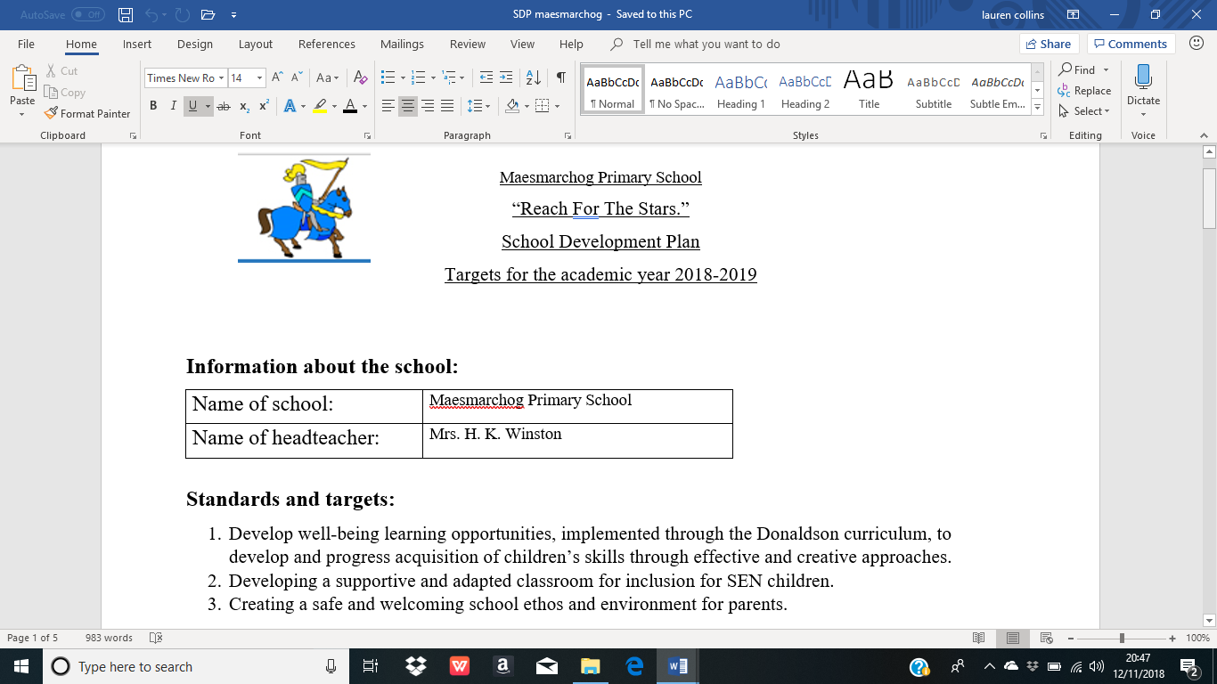
Appendix 3 – School Development Plan:

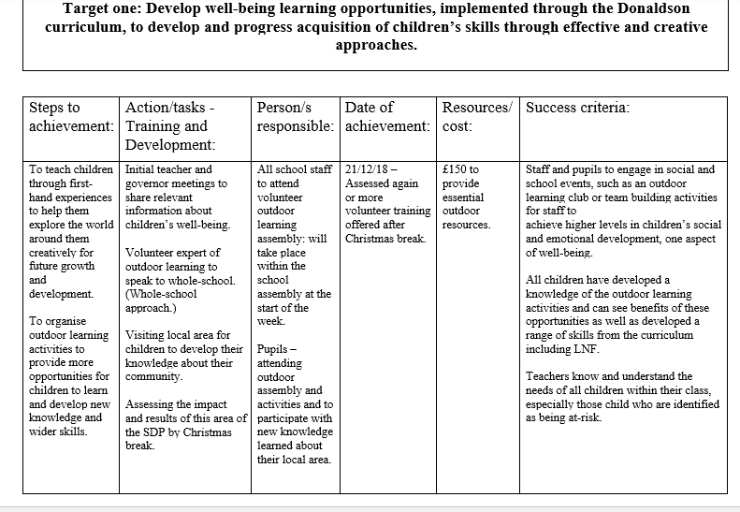

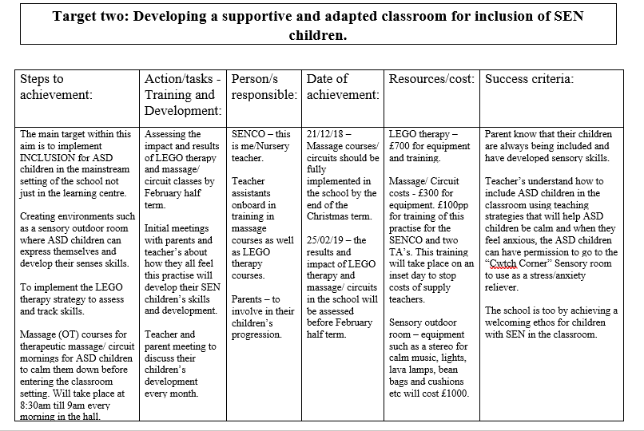

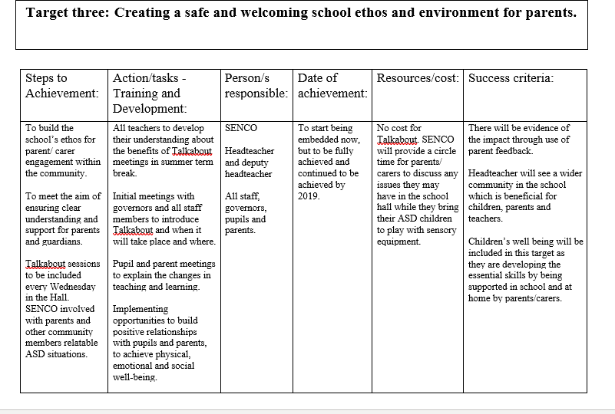

Appendix 4 – Talkabout letter for parents.

Appendix 4: Talkabout letter handout for parents:

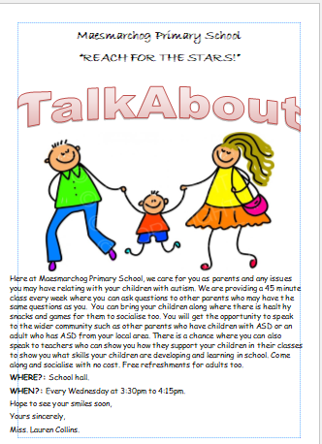

Appendix 5 – Background of school.

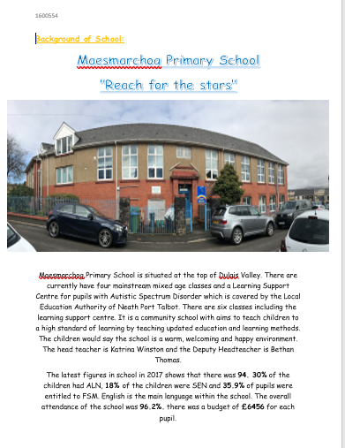

(in file):
Appendix 6 – Estyn report of Maesmarchog School.
Appendix 7 – Case studies.
Appendix 8 – policies and legislation documents.
Appendix 9 – autism research documents.
Appendix 10 – theory documents and books.

