05/03/2021
Corina Elena Cernat (2019920)
Word Count 2419
Professional Career Development BMSW4005_CARD
Contents
Executive Summary 3
Terms of reference 4
Procedure 5
Introduction 6
Main findings 7
What did I learn? 7
What challenges did I face? What learning and development strategies can I employ to overcome them in future? 7
How can I apply this learning to my personal professional career development “journey”? 8
What follow up work and research did I undertake? 8
SMART 9
SWOT 10
Learning styles 11
Employability skills 12
PDP 14
Conclusion 16
References 17
Appendices 19
Honey Mumford Questionnaire 19
Myers Briggs Questionnaire 28
Vark Questionnaire 31

Executive Summary
For this report I reflected on the employability skills I would need to achieve my smart goal and how I can apply my learning styles to reach my objectives.
I have started by listing what I have learned from each attended lecture so far, the challenges I came across and my strategies in overcoming them.
Into the Main Findings I have identified a SMART goal that is relevant to my professional and personal development.
I followed up with a personal SWOT analysis and I then tried to convert some of my weaknesses and threats into opportunities.
After a brief definition of employability skills, I have touched upon the ones I am looking to improve and why they are important for my growth. I followed up with a Personal Development Plan and named three learning objectives and how I can achieve them by applying my learning styles.

Terms of reference
The current report has been requested by Melanie Squire to demonstrate the importance of self-awareness and our understanding of the employability skills and the knowledge required to progress in our professional career.
The report has been compiled by Corina Cernat with the submission date of 05.03.2021.

Procedure
For this report I have consulted the online library and accessed books, journals and other websites recommended by the lecturer.
I have also completed three of learning styles questionnaires and submitted my results in the main findings.

Introduction
Professional development is important for our career success as it allows us to gain knowledge and skills required for workplace.
Employability is rapidly changing and whit it, the skills required for success. As individuals we put ourselves under pressure to be more competitive and thriving in our career path.
For most of the students, employability is a strong reason for enrolling in academic learning (Wharton, Goodwin and Cameron, 2014) as it is a way to continue our personal growth and gain new skills deemed necessary for our career progression too.
Employability can be defined in several ways, and it includes both a set of achievements that can make individuals more likely to gain a job and be successful in their chosen field (Yorke, 2004) and the ability to gain critical thinking and self-reflection (Harvey, 2003).
Self-awareness and critical reflection are very important tools for our personal development. They bring numerous benefits on different aspects of our life (Cottrell, 2015), work and studying, improve our relationship with others, time management and organisational skills, opportunities we can pursue.
Self-awareness serves as a continuous motivation for our priorities and allows us to understand our values, how we interact with others and how we can measure our achievements (Covey, 2004).
Through this report I am looking to reflect on my learning journey, present the employability skills I am looking to further improve for my professional development and how I can achieve my SMART goal.

Main findings

What did I learn?

During the first lesson I have learned about the importance of self-assessment for improving my personal and professional development.
We were also presented with the SWOT analysis and we learned how to set up a SMART goal.
The SWOT analysis is one of the most used business tools to help planning the organizational strategies (Ghazinoory et al, 2011), but due to its versatility, has also been applied to career development (Addams and Allfred, 2013)
We have also been presented with some of the most used personality profiling and learning styles questionnaires and asked to complete them and share our results.
The following week I learned about employability skills, how we can obtain them and overcome the potential barriers in our development.
A first attempt to define the employability skills belongs to Becker (1964) who tried to separate general skills that were necessary in any workplace from the specific skills, that can be required by one employer.
The general skills have been given different names across the time and have been identified with employability skills by Harvey (2001) and Brigstock (2009) and are defined as the ability to find a job and keep it.
After identifying the employability skills, I have then set up three learning objectives in my Personal Development Plan that will help me achieve my SMART goal and improve the skills that are further required for my professional growth.
The Personal Development Plan (PDP) is one of the most important tools for self-growth and helps us to improve our performance and learning to plan effectively for our goal achievement on three different levels: academic, professional, and personal. (Cottrell, 2015)

What challenges did I face? What learning and development strategies can I employ to overcome them in future?

Initially I found challenging having to accommodate the lectures with my existing schedule. Although I am a part time worker now, majority of my time is spent looking after my son who is only two. I realised how important it is to plan effectively so I can find childcare for him and allocate the time and other resources to my lectures and self-learning.
When we attended the first lecture, I found a bit difficult to compose my SWOT analysis, especially thinking about my weaknesses and threats I face. After exploring the employability skills and learning about the importance of time management, I realized it is one of the skills I urgently need improved.
In order to overcome this challenge, I have created a time management sheet where I am incorporating all my daily activities and I am prioritizing what is needed.

How can I apply this learning to my personal professional career development “journey”?

Self-assessment will help me in knowing my strengths and weaknesses, how to overcome them and increase my work performance. I also find that knowing my personality type and my learning styles will make be more efficient, plan wisely and continue my learning journey over the next years.

What follow up work and research did I undertake?

During the first lectures we have been presented with the Johari Window (Luft and Ingram, 1961) a tool intended to encourage behaviour communication and self-awareness. It is built from four regions, each of which represents information about the individual and whether that information is known or unknown to the person or the others (open area, blind spot, hidden area, and unknown).
It presents numerous advantages for individuals as it improves interpersonal relationships, communication, team development and group dynamics (Suresh, 2016).
It has drawn my attention and I tried to apply it to myself to help me with my personal development.

Known to self Unknown to self

Known to others

Unknown to others

Another research method I undertook was to use Gibbs reflective theory (1988) on creating a reflection about returning to education.
This reflective theory is the most used one and consists of six components: description, feelings, evaluation, analysis, conclusion, and action plan.
The last part of the six components, the Action Plan, has helped me in setting some of my learning objectives for my current PDP.

SMART
My goal is to complete level 4 and level 5 of Skills for the Workplace course by the end of 2023.
This goal is SMART as it meets all five requirements:
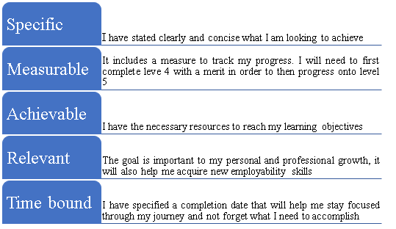

SWOT
For the purpose of this report, I have tried to identify my strengths, weaknesses, opportunities and threats as accurate as I could, although I found it a bit challenging as is not something I think of everyday.
Thorough my learning journey I am looking to take advantage of all the resources made available to improve some of my weaknesses, like verbal communication and poor time management skills. These are important skills for my personal and professional development and will help me achieve my SMART goal.
One of the threats I identified is a high competition on the work market, but with the help of this course I will be gaining new employability skills that will offer me advantages when it comes to my career progression.

STRENGHTS  - Digital skills  - Attention to detail  - Quick learner  - Empathetic  - Good at working under pressure  - Resilient  - Team worker  - Experience in customer service | WEAKNESSES  - Poor verbal communicator  - Shy  - Overanalytical  - Low self confidence  - Avoiding conflict  - Poor time management skills
OPPORTUNITIES  - Continue learning.  - Gaining new skills that will help me progress in my workplace.  - Better pay. | THREATS  - Big pause from academic learning  - High competition on the work market  - Covid-19 effects on the workplace

Learning styles
Throughout my self-awareness journey I have also completed some of the most important learning questionnaires that revealed my learning styles.
The Learning Style Questionnaire developed by Honey and Mumford (1986) was intended to identify learning style preferences of management trainee and it measures four different styles: activist, reflectors, theorists, and pragmatists.
Upon completion I came across as a reflector and pragmatist. I was not surprised by the results as I like to observe from different perspectives and always think thoroughly before concluding. As a reflector I am always very cautious about everything that surrounds me and I tend to overanalyse things, which sometimes can be in my detriment, like having to take a decision under pressure. Although I am aware of the implications this has when it comes to decision making, I am trying to improve by being more self-conscious about it. My current workplace is very fast paced, and my role requires me to often take a decision quickly and this is when I remember that I can not afford to waste precious time and act fast.
The second result from the questionnaire indicates I am a pragmatism and again I was content about the accuracy of it. I identify myself with majority of the characteristics, I always preferred practice to theory, whether it is work or school related, and sometimes I am impatient when it comes to actions I need to complete.
I find this characteristic links very well with another learning questionnaire completed, Vark, developed by Neil Fleming (1992). According to the results, I am mostly kinaesthetic learner, which means I learn by using all my senses, I need to try the things myself to memorise them. I can always remember experiences more than words or if I am given practical examples. One of the less positive things about this style is that I find I lose my focus if I just have to watch something that explains pure theory and I can’t learn about it unless I find a way of practicing it.
The last questionnaire helped me identify my personality profile and again I was impressed by its accurate outcomes. It is the one created by Myers Briggs (1985) and one of the most known personality tests.
There are 16 learning styles formed by a mix between four measurements and a tendency for a certain procedure (Tzeng et al, 1989). These personality types are listed in the table below.
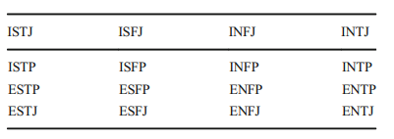
Tabel 1. MBTI personality types (adapted from Kamal and Radhakrishnan, 2019)
The type I identify with is INFP, also known as Dreamer, and is characterised by introversion, intuition, feelings, and perception. The personality type revealed helps me realise that I have come to know myself a lot better over the years, I knew I am an introvert, I have and will continue to rely on my intuition in many situations. Feelings have always been important to me and I find myself taking decisions based on them. As a perceiving person, I find that I can adapt quickly to changing situations, although is not something I enjoy, but helps me be resilient. One less positive thing about it is that I can also start more projects at the same time and find it difficult to complete them.

Employability skills
For my personal development I identified several employability skills that I would like to improve:
• Presentation skills
• Time management
• Verbal communication
These skills are important as they will help me be more productive, efficient, feel more confident. I find they are essential in achieving my SMART goal but will also help me in my career development.
I am looking to develop them by doing more learning, research, prioritise important things, learn to delegate, practice more for a presentation.
I expect to encounter some barriers over the time, like finding the necessary time to allocate to my learning and research as I am also working and looking after my family, I need to find a work life balance.
Another barrier might be losing my motivation or focus, not having enough self-confidence. In order to overcome these barriers, I have drawn a Personal Development Plan to monitor my steps and help me achieve my goals.

PDP
To achieve my SMART goal, I have identified three main objectives that require further development and I have detailed them in the plan below.
As a kinaesthetic learner I need to be actively engaged with what I am learning, and I will need to perform practical activities., like the ones detailed in the plan. I have the tendency to start working on several tasks at the same time and not finishing them or leaving it to the last minute and with the help of this PDP I am hoping to improve my skills and become more productive.

Development objectives | Specific actions | Barriers and how will they be removed | Support required | How will I know when I achieve my objectives
1. Improve Self learning | Apply my learning styles  Read every week from the bibliography suggested.  Work on my assignments each week  Ask for feedback and book 1-1 lessons | Finding the time- write a list of priorities and stick to it  Leave work for the last minute- Focus on one part of the assignment at a time | Computer  Library  Online resources  Family | My assignments will be ready on time
2. Improve verbal communication | I am looking to practice my public speaking every week by doing mock presentation in front of my family, speak in every team meeting at work and during lectures | I am feeling nervous every time I speak in front of someone I do not know, but I will practice my presentation skills more often in front of my family and friends | Friends  Family  Work and school colleagues | I will be able to speak publicly with confidence.
3. Improve time management | I will need to keep a journal, prioritize, and plan ahead, stick to the plan and set goals with realistic deadlines | Will not be able to find a balance between work-school-family time- keep a time management schedule and prioritize | Diary  Online calendar  Books  To do list  Family | I will become more efficient and have more time to spend with the loved ones

Conclusion

Employability skills are rapidly changing but they remain at the heart of professional development.
Self-awareness and critical thinking should be used constantly not only during our learning journey, but also in different moments of our lives as it brings numerous advantages and is essential for our delelopment.
After becoming aware of the importance self-awareness has for our growth, I am grateful I managed to identify my strengths and weaknesses, as well as the employability skills I need to improve.
I am looking forward to continuing with my research and gain more knowledge from the lectures and the resources made available. After identifying my personality type and learning styles, I am hoping to improve my self-learning methods and reduce procrastination.
I am feeling confident about the Personal Development Plan and that it will help me to remain motivated throughout my learning journey and most importantly help me achieve my SMART goal.

References
- Addams, L., Allfred, A. T. (2013). The first step in proactively managing students’ careers: teaching self-SWOT analysis. Academy of Educational Leadership Journal; Arden Vol. 17, Iss. 4, (2013): 43-51., available at https://search.proquest.com/openview/1531d28cc13854421b6136e094cb9f92/1?pq-origsite=gscholar&cbl=38741, accessed on 02.03.2021
- Becker, G. (1964). Human capital. Chicago and London: The University of Chicago Press.
- Bridgstock, R. (2009). The graduate attributes we’ve overlooked: enhancing graduate employability through career management skills. Higher Education Research & Development, 28(1), 31–44.
- Cottrell, S. (2015), Skills for Success. Personal Development and Employability, Palgrave Macmillan
- Covey, S.R. (2004), The 8th Habit: From Effectiveness to Greatness, Free Press, New York
- Fleming, N. D., Mills, C. (1992), Not Another Inventory, Rather a Catalyst for Reflection, To Improve the Academy, Vol.11, p 137
- Ghazinoory, S., Abdi, M., Azadegan-Mehr, M. (2011). SWOT methodology: a state-of-the-art review for the past, a framework for the future. J. Bus. Econ. Manag. 12, 24–48, available at https://www.tandfonline.com/doi/abs/10.3846/16111699.2011.555358, accessed on 02.03.2021
- Gibbs, G. (1988) Learning by Doing: A guide to teaching and learning methods. Further Education Unit. Oxford Polytechnic: Oxford
- Harvey, L. (2001). Defining and measuring employability. Quality in Higher Education, 7(2), 97–109.
- Harvey, L. (2003). Transitions from Higher Education to Work: A Briefing Paper Prepared by Harvey, L (Centre for Research and Evaluation, Sheffield Hallam University), with Advice from ESECT and LTSN Generic Centre Colleagues, available at http://bit.ly/oeCgqW, accessed on 03.03.2021
- Honey P, Mumford, A. (1986) The manual of learning styles. Peter Honey, Maidenhead.
- Myers, I.B., (1985) Manual: A guide to the development and use of the Myers-Briggs type indicator., Palo Alto: Consulting Psychologists Press.
- Kamal, A., Radhakrishnan, S. (2019). Individual learning preferences based on personality traits in an E-learning scenario. Education and Information Technologies, 24(1), pp. 407.
- Luft, J. (1961) The Johari Window: A graphic model of awareness in interpersonal relations. Human Relations Training News, 5 (1), 6–7
- Suresh, S. (2016) Communication and Education Technology, India: Elsevier Health Sciences.
- Tzeng, O. C., Ware, R., Chen, J. M. (1989). Measurement and utility of continuous unipolar ratings for the Myers-Briggs type Indicator. Journal of Personality Assessment, 53(4), 727–738
- Wharton, C. Y., Goodwin L. J., Cameron A. J. (2014). Living up to Our Students’ Expectations: Using Student Voices to Influence the Way Academics Think about Their Undergraduates Learning and Their Own Teaching. International Journal of Higher Education 3(4). Available at https://doi-org.ezproxy.uwtsd.ac.uk/10.5430/ijhe.v3n4p72, accessed on 02.03.2021
- Yorke, M. (2004). Employability in Higher Education: What It is – What It is Not, Learning and Employability Series No 1. York: Higher Education Academy

Appendices

Honey Mumford Questionnaire
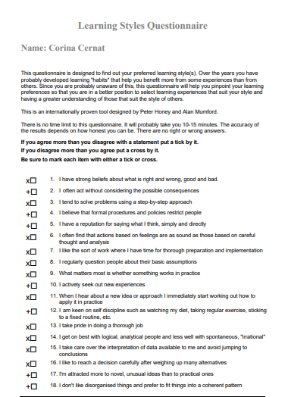
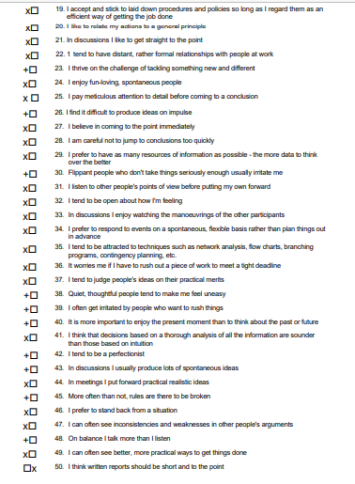

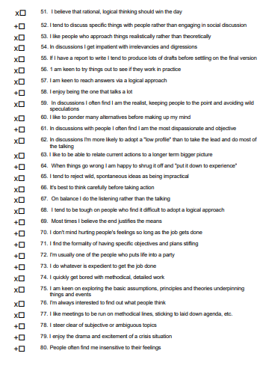
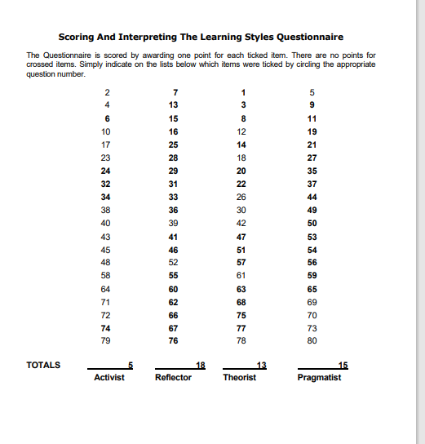
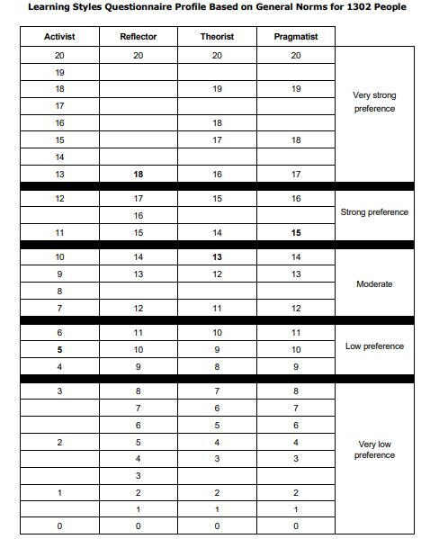
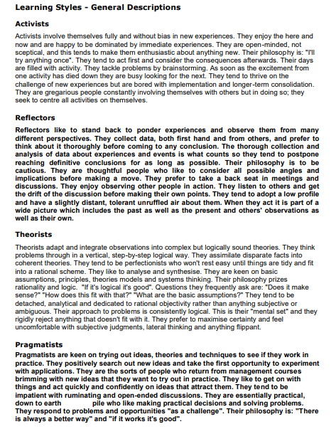
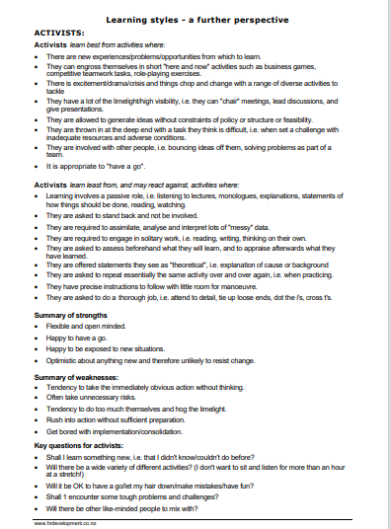
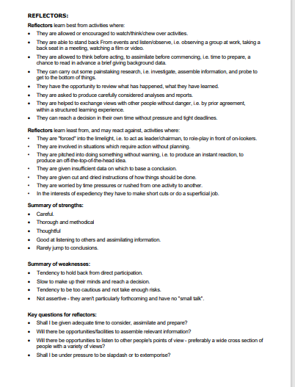
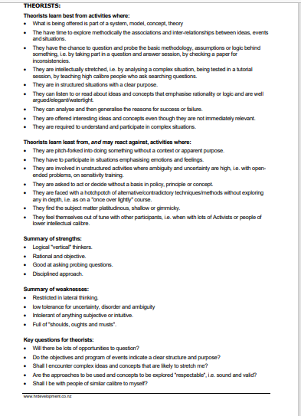
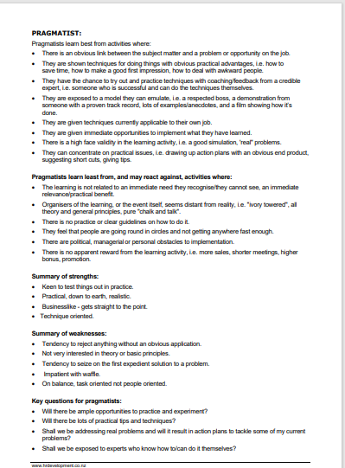

Myers Briggs Questionnaire
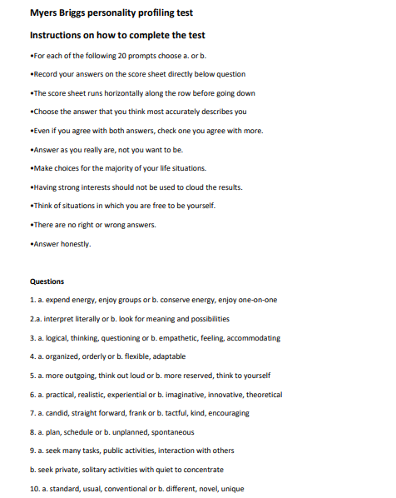
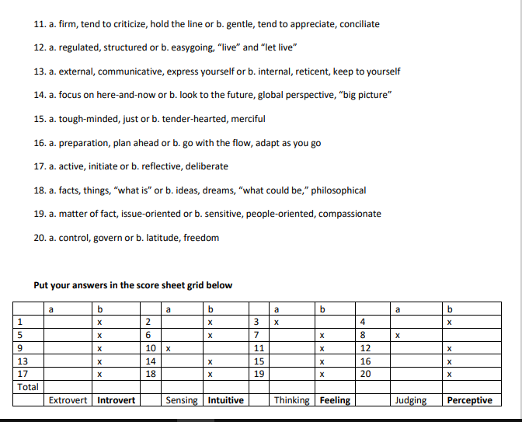

Vark Questionnaire



