
Opening of a new Business MANAGING Enterprise
Carly North

[Date]
Student Number:1904917
University of Wales Trinity St David
Name of the Business
The name of my business idea I’ve come up with is a café/diner which I have named “The plate in hand”.
The mission statement
What is a mission statement?
A mission statement for a business is a brief description of a company's fundamental purpose. Ward. S (2019)
The mission statement for the business idea I have is: We imagine a world where there’s no such thing as a bad plate of food and all our customers are happy.
The main aim for the business
- Will be for the business to go somewhere in the future expanding by having a business growth.
- To have sustainable profit to keep the business running.
- To provide high quality food and services withing the business.
The name of the business idea “The plate in hand” was chosen because it describes well what sort of business your involved with (food).
The objectives of the business
- Will be to focus on atmosphere and ambience as there is more to running a successful café business than just serving great food as having a good atmosphere and ambiance is almost important as the business goals as it helps attract customers and leave them an impression on their overall experience.
Product/Services
Withing my business idea my aim will be offering a service that will provide food to all customers also to the homeless and venerable people to make sure they are looked after to help and support the homeless and venerable individuals by doing this the service will run after each day and there will be a time slot that these individuals will be able to come have a warm and a bite to eat.
The business will be promoted using advertisement withing social media using the web I’ll have my own café/diner page also the web google search as recommendations on trip advisor, flyers will be handed out to local shops and doors of area that the café be situated as its eye-catching advertising. Also, the local village bus can public transport the café advertisement on the side of the buses.
Introduction
My Business idea I’ve come up with is setting up a business where I’ll be running my own café/diner which I have named “The plate in hand”. The business will be set up by myself who has been left money from a member of family who passed away and wanted to see me do well out of it in the future so I had the idea of setting up my own business. I will be employing four members of staff, each member of staff will have their own roles such as wiping over tables once collected unfinished dishes, taking orders and payments, washing up and serving customers with a smile and using presentable manners. overall making sure the café is spotless. The reason for choosing this business idea is to provide a service for others serving quality foods at affordable prices. The type of business I have picked is a sole trader business.

Definition of a sole trader A sole trader is the only owner of a business, meaning that they are responsible for the entire operation and are considered self-employed. Being a sole trader involves shouldering the responsibility for any business losses, all bills and business accounts (meaning that accurate records of sales and spending must be kept diligently. Harrison P, (2019)
Physical Resources
The location of the business I will be opening will be based in Llanelli in the area of Felinfoel which is a village that has no cafes. The area is near many houses so it will be a disadvantage to not situate a café in the area. The business is going to be a bricks venture. The business will require the following:
Cooking equipment, like ovens and stoves, grills, steamers, fryers, and immersion cookers.
Kitchen equipment to support the cooking process, fridges and freezers, dishwashers, heat lamps, condensation hoods, espresso and coffee machines.
Workspaces like counters, storage spaces, food coolers, prep tables, and cold food tables.
Cooking utensils, like knives, spatulas, cutting boards, gloves, containers, ladles, and brushes.
Dishes and serving materials, like plates, silverware, glasses, tablecloths and placemats, and napkins.
Furniture, like chairs and tables.
Plumbing, toilet and sink areas.
Here’s some of the pricing examples:
Espresso machine- £1000-£6000
Combination refrigerators/freezers - £4000
Ice machine- £1800
Dishwasher- £4000
Sink areas-£ 300–600
Food service equipment (microwave, toasters, blenders, etc.)- £3000–5000
Coffee accessories (espresso tampers, frothing pitchers, measuring cups and spoons, scales, etc.)-£300–400
Crockery- £400
Disposable coffee shop supplies (paper hot cups and lids, custom coffee sleeves, napkins, etc.)- £300
Tables chairs and other equipment- phone, furniture-£3000
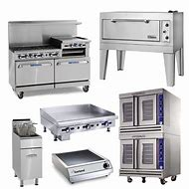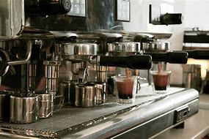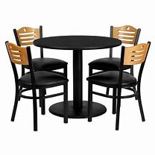
Financial Resources
The business finance venture will be obtained from a family member who left money for myself to start up a business of my own.
What is a cashflow withing the business?
Cash inflow is the importance of your business and comes from sources like payments from customers, an investor, or interest on savings or investments to do with your business. Cash is also important because it later becomes the payment for things that make your business run such as the expenses like stock or equipment, employees, rent and other expenses. Having positive cash flow means a business is running smoothly. High positive cash flow is even better and will allow any business to make new investments such as being able to hire employees, open another location for further growth for the business to progress. Cash outflows are any money paid out of the business. The profit alone is not always enough to sustain a business. Chapman. s, (2020), Any Business must also have enough cash on hand to pay any bills. A better gauge of a business’s financial health is its cash flow, the money flowing in and out of the business from sales, expenses and investments. Identifying my business’s cash flow can help me predict my business future success.
Why are cashflow statements important?
Cash Flow Statement importance is that cashflow statements can measure the cash inflows or cash outflows during the given period of time of a business. Wall street mojo, (2020)
Having cash flow statements when running my business will advise me on how much money I am spending withing my business and what I need to be aware of not for my business to be out of pocket and be a failure.

Human Resources
The following skills I have towards my chosen business venture are patience, trust, having clean hygiene, also being able to work as a team these skills are essential to maintain a business, these skills will set towards running a successful business.
I will be employing four members of staff, each member of staff will have their own roles such as wiping over tables once collected unfinished dishes, taking orders and payments, washing up and serving customers with a smile and using presentable manners. overall making sure the café is spotless. our cafe can be open 8–24 hours per day and myself as the sole trader can set the number of shifts accordingly. As the location is very handy situated in an area with no other café, I could have 12 tables or more, then I will need at least three people per shift. Additionally, then I could hire two or three more people to rotate shifts among my staff and give them days off if it gets busier.
The qualifications, skills and experience myself as the owner and my staff will need to have basically will be:
Skills- Patience, communication, multitasking, trust, cleanliness, teamwork.
Qualifications- Certificate in hospitality, Food safety and hygiene. (at least a Level 2 Hygiene Certificate in Catering)
If you sell food or make food to be sold in any sort of food environment, you need to have certificates, A level 2 certificate is essential for food handler compliance with the current Food Safety Act, this is a valuable component of a Continuing Professional Development which stands for (CPD) plan. (2020)
The level 2 certificate isn’t a one-off every three years the café will have an Environmental Health officer who comes to the café to do an inspection to evaluate the cafes Food Hygiene skills, so it is only essential that I will make sure myself and my staff will be on top of our knowledge and basic skills and maintain up to date certificate. Getting a Food Hygiene Certificate can take as little as 2 hours, this makes all the difference when Environmental Health come knocking. If I don’t make sure the café is run properly with all the right criteria, up to date certificates and the cleanliness of the café, the effects will be the business will be basically shut down. Hygiene is very important which is essential to make sure when running a business that the food is going to be safe to eat and serve to my customers. There are four c’s of hygiene these are cleaning, cooking, chilling, contamination. The 4Cs can be used to prevent the most common food safety problems. Food Agency, (2018)
Also, the other important part of setting up a business is to have Insurances to be able to run a successful business.
What is café insurance?
Café insurance can cover claims for damages and legal costs made against you if a customer is hurt or their property is damaged at your café.
Legal Insurances for the set-up of my business.
Part of my procedure to do with the start-up of my business venture would be to take the route of getting insurance policies to cover me and the café business. One way to get several types of coverage in one policy is with a business owners policy (BOP). This typically includes general liability insurance, property insurance, business interruption insurance and other coverage types to customize the cafe insurance. This covers the cafe against property damage and injury lawsuits.
Employability Insurance.
As I’ll be employing members of staff, then I will be legally required to have employers’ liability insurance, this will protect my cafe business against any claims if an employee is ever injured or becomes ill as a result of working within my business.
The insurance I will need will depend on what type of business I have. Employers’ liability cover is a legal requirement for most businesses with staff, public liability insurance is important if you’re in contact with members of the public. Simply. B, (2020)
Public liability insurance.
Public liability insurance I would need as my business comes into contact with members of the public e.g. my customers, as they will be entering my premises. It can protect my business against compensation claims for injury or damage made by my customers, suppliers, or other third parties.
Business Building and Contents Insurance.
Building and contents insurance is a priority as this insurance protects your business premises, equipment and tools, if any of the above are damaged, destroyed, lost or stolen the cover of the insurance policy will pay the cost of replacement or repairs. This also will cover any stock that needs replacing if it has been stolen or broke in anyway.

Marketing activities
To let people know my business is opening I will be advertising using advertisement withing social media using the web I’ll have my own café/diner page also the web google search as recommendations on trip advisor, posters will be used to advertise around the area also flyers will be handed out to local shops and placed in doors of the area that the café be situated as its eye-catching advertising. Also, the local village bus can public transport the café advertisement on the side of the buses. I will be doing money off vouchers to the first 10 people that visit the café/diner plus 10% off for all key workers and the Nh’s as a good deed for all that they do for us just as a good will gesture.

Swot Analysis
A swot analysis is a strategic tool that helps a business owner identify his/her strengths and weaknesses, as well as any opportunities and threats that may exist in a specific business situation. Gregory A, (2019)
Strengths
- Excellent location
- Close to houses
- Great value of food provided
- Extended opening hours to feed the homeless and vulnerable people
- Private parking even a garden with playground equipment for the children.
- Friendly staff and polite
- Excellent customer service
Strengths of my business are the venture is situated in an excellent location with no other café business in place. Having extended hours to feed the less fortunate and homeless so I’m helping out those in need that goes along way therefore the café will be known to help others. Excellent customer experience is also expected which also states in the job description that you will need good customer experience meaning whoever I employ will need to be happy and cheerful that meets all customer’s needs without all these strengths the café/diner won’t be a much of a success.
Weaknesses
- Single location that limited profit of business
- Competitors can offer similar service with lower pricing.
- Financial risks
Weaknesses of the business will be there could be other competitors that see the café being a success try to overcome my business by offering cheaper pricing and service.
Opportunities
- Business can invest more to expand
- Opportunity to develop partnership with local catering services to provide food in local events
- Room to grow to bigger business
There’s always room to grow my business if my business is successful by taking the opportunity by making enough profits by doing this, I will have the opportunity to maybe grow my business by moving to a bigger place and going maybe into a restaurant or pub food business venture. Another opportunity would be to work together with the local catering services to cater for local events.
Threats
- Food trends changing rapidly
- Staff off sick
- High competition
- Financial issues
A threat of a café/diner is basically the high competition of other cafes once they see your business is picking up by doing well, they’ll try to over-come your venture by making more profit than you. Staff phoning in with sickness can’t be helped but when you’re that one person down it can have affect sometimes as your one staff less.

The 4p’s in Marketing
The four Ps are the four essential factors involved in marketing goods or a service to the public. Twin. A, (2020)
These are the four Ps of my business:
Product-The goods or service that I provide
Price -what the customers pay e.g. the value
Place-the location the café is situated in, accessibility, parking.
Promotion- The advertisement it took for me to advertise the business
A questionnaire was undertaken and the results show that the age range on visiting cafes I found were the majority of people were aged between 30-39 and 50 and above. I can use the questionnaire feedback to attract different age groups as each individual has different interests Mialki, S (2020). The most popular gender who like to visit cafes are the woman from the results recorded. The amount of people who filled out the questionnaire who like to go to a café and have their value for money results showed that it was equal with how important and quite important it was for them. The Highest amount of people said that when visiting a café, it is very important to them that they are served and when visiting a café that they get served by friendly staff. The mass majority of people who filled out the questionnaire said that it’s not that important if they go to a café that there is somewhere for children to play. It’s very important when vising a café that the cleanliness of the café is crucial as hygiene is very important, results showing how many people when filling out the questionnaire suggest when they go to a café, expecting they have visited a clean maintained café. The highest amount of people shown on one of the Questionnaire graphs like to eat when visiting any café homemade foods. The majority of people on the graph like to go to a café at around lunch time. The importance to an amount of people who visit cafés was the service they were receiving. The questionnaire undertaken was showing these results. The highest amount of people who filled out the questionnaire like to go to café’s and have a menu that provides special meal deals this will attract many customers which is good advertisement. The results of how many people who filled out the questionnaire showed that the majority of the people only visit cafes monthly this was shown on a graph. The highest amount showed that people like to visit both mixed and modern style of cafes. The results recorded in a graph shown that the amount of people who visit cafes and like to roughly spend between £15-£20. They like to budget themselves. I can use the useful information within the feedback from the set questions in the questionnaire I compiled to conduct further research to think about when the business is in the process of setting up and while my business is open, I need to aim for the strengths to a successful business to overcome the weaknesses to be able to open up more opportunities to overcome any threats.
The graphs showing these results are in appendices.

Appendices
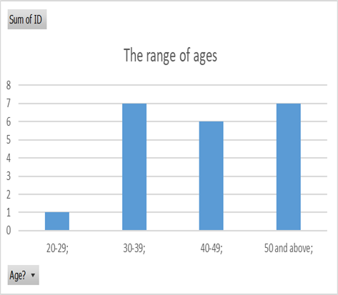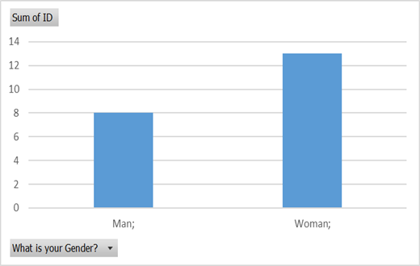
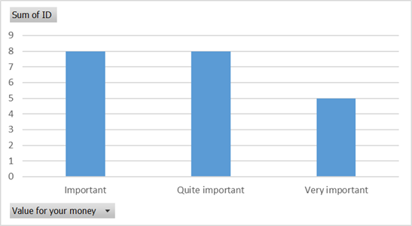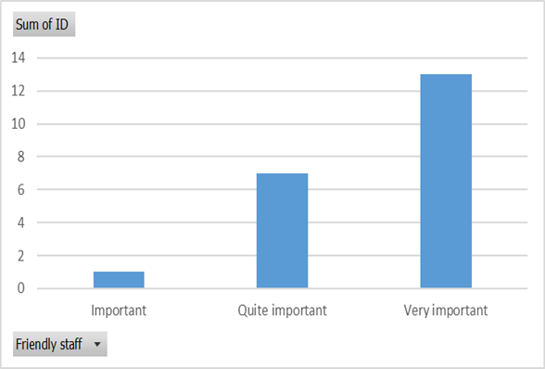
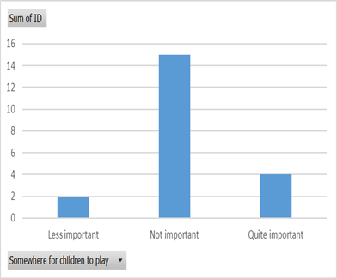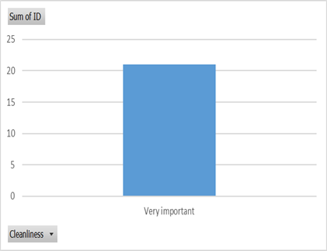

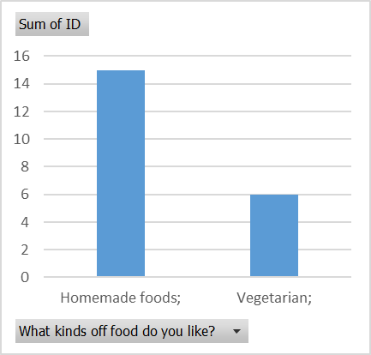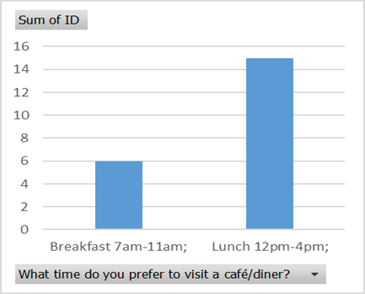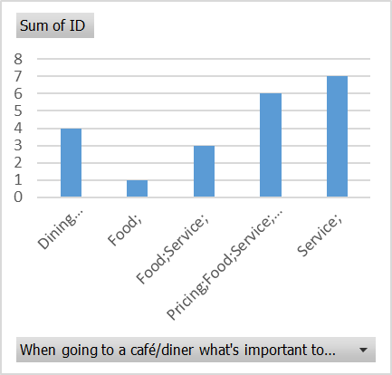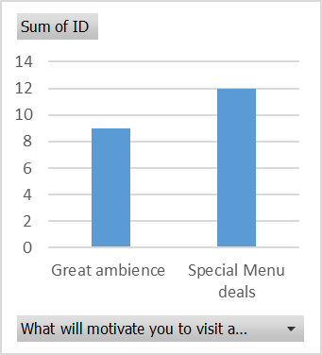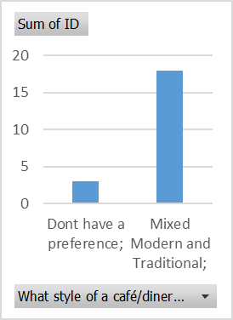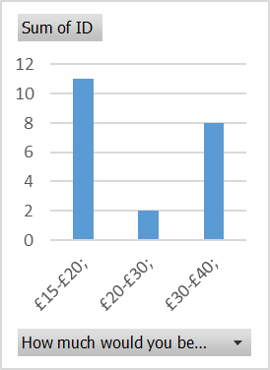

Reference List
Ward. S, (2019) A mission statement for a business is a brief description of a company's fundamental purpose. Available at https://www.thebalancesmb.com/mission-statement-2947996 [accessed on 18/6/20 at 12.30]
Harrison P, (2019) “A sole trader is the only owner of a business, meaning that they are responsible for the entire operation and are considered self-employed”. Available at https://startups.co.uk/what-is-a-sole-trader [accessed on 7/6/2020 at 9.00]
Chapman. S, (2020) The profit alone is not always enough to sustain a business. Available at https://smallbusiness.chron.com/business-cash-flow-43162.hmtl [accessed on18/6/20 at 10.05]
Wall street mojo, (2020) Cash Flow Statement importance is that cashflow statements can measure the cash inflows or cash outflows during the given period of time of a business. Available at https://www.wallstreetmojo.com/cash-flow-statement-importance/ [accessed on 18/6/20 at 12.00]
(2020), A level 2 certificate is essential for food handler compliance with the current Food Safety Act, and is a valuable component of a Continuing Professional Development (CPD) plan. Available at https://www.bing.com/search?q=level+2+hygiene+certificate&form=EDGEAR&qs=AS&cvid=a24684322ac7453ebf6bb4d22b062a60&cc=GB&setlang=en-US&DAF1=1&plvar=0&PC=LCTS [accessed on 15/6/20 at 12.00]
Food standards agency, (2018). There are four c’s of hygiene these are cleaning, cooking, chilling and contamination. The 4Cs can be used to prevent the most common food safety problems. available at https://www.food.gov.uk/business-guidance/starting-a-food-business [accessed on 15/6/20 at 12.15]
Simply. B, (2020). Employers’ liability cover is a legal requirement for most businesses with staff, public liability insurance is important if you’re in contact with members of the public. Available at https://www.simplybusiness.co.uk/insurance/faq/what-type-of-business-insurance-do-i-need/ [accessed on 14/6/20 at 7.00]
Gregory A, (2019) “A swot analysis is a strategic tool that helps a business owner identify his/her strengths and weaknesses, as well as any opportunities and threats that may exist in a specific business situation”. Available at https://www.thebalancesmb.com/swot-analysis-for-small-business-2951706 [accessed on 7/06/2020 at 8.00]
Twin A, (2020) “The four Ps are the four essential factors involved in marketing goods or a service to the public”. Available at www.investopedia.com/terms/f/four-ps.asp [accessed on 8/6/20 at 11.00]
Mialki, S (2020) Each individual has different interests. Available at https://instapage.com/blog/demographic-segmentation [accessed on 16/6/20 at 4.00]

