Modul Code: BMSW4005
Module Name:
Professional Career Development

Assignment task:
Report containing a personal reflection on the role play and career development planning, demonstrating an understanding of the skills and knowledge that contribute toward working effectively, their readiness for employment, an understanding of personal strengths and areas for further development, as well as establishing their employment goals and develop a personal action plan/development plan.

Student ID: 2008172

Word count: 2036
UWTSD, 2021

Table of Contents

Introduction 3
Role Play Models of communication 4
Gibbs reflective cycle 5
Personal Development Plan 6
SWOT Analysis 6
SMART Objectives 7
The Johari window 8
Conclusion 9
References 10

Introduction

My name is Billy Kamanda, and I am a university student. I have a modest collection of professional and personal talents, which allows me to remain focused and dedicated in achieving each and every objective I set for myself throughout my life. Prior to this degree, I studied business, administration, and law, which prompted me to choose this particular institution to begin my adventure. I've also had a variety of job experiences. My job experience began in United Kingdom in 2015; however, my true employment adventure began when I enrolled at the University of Wales Trinity Saint David to obtain a degree of higher education: workplace skills. Since beginning this course, I've been able to improve not just my professional knowledge and awareness, but also my talents and experiences.
The role play (Bateman, 2014), which was split into two sections and required me and my partner to perform the roles of interviewer and interviewee, will be the primary subject of discussion and analysis in this report. This role play lasted 20 minutes for each group and took place between weeks 9 and 10. My partner in the role play had to interview me for a position as I am applying for the Network rail company , working as a railway engineer, on signalling, and then I had to interview my partner for the position of a coach in the a football team
In addition, a self-reflection evaluation of the role play will be conducted, as well as a personal growth plan based on a SWOT analysis. The JOHARI WINDOW structure and SMART goals will also be studied and explained. In addition, various references from in-class activities and other important and trustworthy sources will be given in this report, and all of them will be noted at the conclusion of this piece.

Role Play Models of communication

I played as both an interviewer and an interviewee for several jobs in the role play, but I'll focus on the scenario in which I was the interviewee, and my partner in the role play conducted the interview for Network rail company, working as a railway engineer, on signalling (Toffler, 2019).The first question was for me to explain why I believe I am qualified for the job of the desired job; I responded by saying that I am a confident, trustworthy, and careful individual. I work well under stress, and I am also a diligent worker and a great team player (Kurtines, Azmitia and Gewirtz, 2018).
Second, my partner in the role play requested if I could speak about what motivated me to apply for this position and willing to work, my previous experience and my motivation, which I stated were mostly acquired and developed via my prior job experiences. This includes clear communication as well as persuasive speaking abilities. I needed to explain why I am willing to apply for this position and how can I benefit the company as well (Smith, 2017).
The next question was, "What the railway industry is mostly operating in the night ,if they offered me a job will I be flexible to work even under pressure I have said that I was flexible to work at any rotation and I am fast learning with the ability to prioritise workloads and work effectively under pressure but , oblivious to the fact that you are working and must be focused as this job is really responsible.
My companion provided a case scenario as the next inquiry. In this instance, he said that the job is having a very busy day, and that there is a problem to be solved immediately and we needed to find the best possible solution to get out of a possibility for further troubles.
Finally, he inquired to know about where I find myself in 5 years time, I replied that my plans were linked to my future job and education. I said that after gaining more experience in the business, I would like to grow in my career after completing my courses my university degree.
Reflection is the process of recognising what you are thinking in your own words (Chamberlain, 2019). Making "meaning" is making sense of an occurrence, which we do by interpreting it. Making "meaning" becomes "learning" when we utilise this interpretation to drive our decision-making or action (Chamberlain, 2019).

Gibbs reflective cycle

Using the Gibbs reflective cycle, I will analyse my thoughts on the role play in the following sections (Williams, Woolliams and Spiro, 2012). This reflection model “provides a framework for evaluating events, and given its cyclic character, lends itself especially well to repeated encounters, enabling you to learn and prepare from things that went well or poorly.” (Bassot, 2016) There are six stages to this:
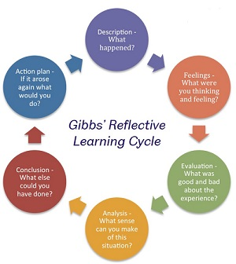
Description
I performed the interview for the position of interviewed as I am applying for the Network rail company, working as a railway engineer, on signalling. I felt confident in all of my questions throughout the brief interview, and even during the Q&A, I must say that I maintained a calm demeanour, which I can say the same for my partner in the role play. The interview was completed in the time allotted by the professor.
Feelings
I don't think there were many problems throughout the interview in which I was the interviewer. My performance had left me very pleased. This, I think, is due to the fact that asking questions is easier than answering them. I remember the hard sensation I got when I was the one responding; despite the fact that we had practised many times, I was still anxious and jittery, while I felt peace and tranquillity in my partner's voice.
Evaluation
There were a lot of good elements in this role play that I noticed. Despite my terrible nervousness, the role play went through without a hitch. I also found my partner's serenity to be extremely reassuring and encouraging. On the other hand, I disliked the interruptions produced by various electronic gadgets.
Analysis
This scenario made me realise that there was a lot more that might have been done to enhance the role-playing experience. However, I think that both my colleague and I were very confident, and we carefully followed the time limit set by the lecturer, allowing us to complete our play ahead of schedule.
Conclusion
I'd want to finish by saying that it's clear that both me and my role play partner still have space for growth in many areas.
Plan of Action
After going through this role play review, I think we have a better understanding of where our shortcomings are, and we will be able to address them if the scenario arises again. We shall methodically work our way to the top of each organisation through improving.

Personal Development Plan

SWOT Analysis

My SWOT analysis will be based on the following position for a railway engineer, on signalling (Seth, 2015):
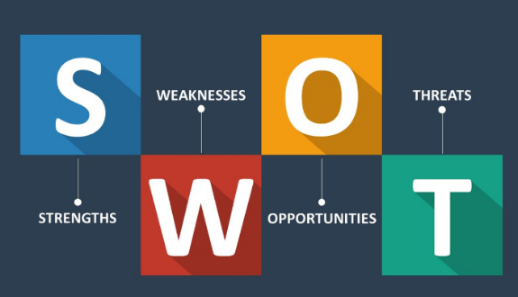
Strengths
As previously said, I think I possess a small collection of abilities that I regard to be my strengths. In whatever I do, I believe myself to be trustworthy, confident, attentive, and thorough. I think I have strong communication abilities, which I can use to convince any customer to like our goods. I operate well under stress and have distinct problem-solving abilities and time management skills.
Weaknesses
There aren't many flaws in my character. When I'm under stress sometimes I might lose my patients and I want everything to be ready instantly.
Opportunities
Other skill sets development would improve my ability to work more effectively and establish more connections in the fashion business. In addition, completing my education will allow me to pursue greater job possibilities.
Threats
We face the danger of losing or obtaining a job as a result of the Pandemic, and even if a job is obtained, the workload may rise owing to a lack of personnel. Furthermore, after I finish my degree and am ready to start my own company, I am well aware of the fierce competition I will be up against.

SMART Objectives

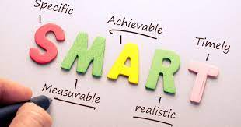

The SMART approach is widely regarded as the gold standard for creating effective, measurable goals and objectives in management.” (Templar, 2021) Following a thorough examination and assessment of my talents and skills, I will provide a framework of Smart goals that will benefit my future career.
Specific
My long-term aim is to start my new career in the rail industry as the beginner level and also complete my education, so that would give me the opportunity to grow in my career furthermore.
Measurable
Yes, my objective is quantifiable.
Achievable
It is possible to achieve. My plan of action is very comprehensive. Financially, my family and I have been putting money aside for the start-up of the company, and I will also seek a bank loan. In addition to working my way up the rail transport business, I've been attending a number of seminars to assist me improve my abilities and knowledge of the industry. In addition, I will be able to create more lucrative contacts as a result of this.
Relevant
“The Pareto principle says that in many situations, 80 percent of the consequences originate from 20% of the causes.”
Timely
My objective will be completed and accomplished within a three-year time period.

The Johari window

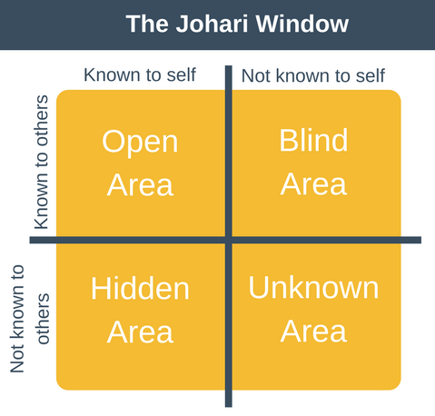

The Johari Window paradigm is a method for increasing self-awareness and allowing others to comprehend one's emotions and information (Diana Duncan Holmes and Edmondson, 2020).
Open
I think that the abilities of being determined in whatever I do, dependability, and hard effort are the qualities that I and everyone else knows about me. Most people are aware that I am tenacious and conscientious. Also, everyone is aware of that quiet yet extroverted individual.
Blind
What I don't realise about myself, but others do, is that I am a selfless person who is always willing to assist those in need, even if it means spending my own money. Some claim I'm a keen observer who pays close attention to details.
Hidden
I am passionate, prideful, and emotional, and I do not accept excessive sarcasm, among other things I know about myself that others do not.
Unknown
What I don't know about myself, and what others don't know about me, is that I forgive too fast and trust too readily.

Conclusion

In this paper, I came to the conclusion that knowing oneself is critical. To accomplish all of my objectives, I must improve my talents and character. In addition, I believe that the role play that we did in class and that we discussed here has helped me realise my strengths and shortcomings, as well as my full potential.

References

- Bassot, B. (2016). Reflective journal. London: Palgrave Macmillan.
- Bateman, C. (2014). What are we playing with? Role-taking, role-play, and story-play with Tolkien’s legendarium. International Journal of Play, 3(2), pp.107–118.
- Chamberlain, D. (2019). Reflection. London: Macmillan.
- Diana Duncan Holmes and Edmondson, A. (2020). The Johari window. Cincinnati, Ohio: Diana Duncan Holmes.
- Kurtines, W.M., Azmitia, M. and Gewirtz, J.L. (2018). The Role of values in psychology and human development. New York, N.Y.: Wiley.
- Seth, C. (2015). SWOT analysis. S.L.: 50Minutes.com.
- Smith (2017). Learning by virtual work and role play. Development and Learning in Organizations: An International Journal, 27(1), pp.22–24.
- Templar, R. (2021). Fast thinking : appraisal : avoid confrontation, agree smart objectives, motivate your staff. Edinburgh Gate, Harlow England: Pearson Education.
- Toffler, A. (2019). Learning for tomorrow; the role of the future in education,. New York, Random House.
- Williams, K., Woolliams, M. and Spiro, J. (2012). Reflective writing. Houndmills, Basingstoke, Hampshire ; New York: Palgrave Macmillan.

