Joseph Blanchard
Course: Creative Computer Games Design
Lecturers: Jessica LaCombe, Richard William Morgan.
Word Count: 5066
Game Design & Critical Analysis
M6X02045

Contents
Proposal 2
The 12 principles of Animation 3
Squash and Stretch 3
Timing 5
Exaggeration 5
Arcs 5
Quantitative and Qualitative Data 7
Methodologies 8
Methodology 1 - Interviews 8
Structured Interview 9
Semi-Structured Interview 9
Narrative Interview 10
Interview 1 11
Methodology 2 - Questionnaire Writing 13
Leading Questions 13
Questionnaire Fatigue 14
Clear Purpose with Concise Questions 14
Open versus Closed Ended Questions 15
Questionnaire 1 17
Questionnaire 2 19
Questionnaire 3 21
Conclusion 23
Bibliography 24
Books 24
Journals 24
Online Resources 24
Videos 24
Video Games 25

Animation in the Context of Play Testing

Proposal
I will be conducting research within this paper to explore different methodologies of play testing within the context of Animation. The main methodology explored is Questionnaire Writing and Testing, while One to One and Group Interviews were only considered.
Using the principles of Animation set out within The Illusion of Life: Disney Animation (Thomas and Johnston, 1995) I will explore if these same principles apply to animation within a video game. Throughout this essay I focused on the principles of Squash and Stretch, Timing, Exaggeration and Arcs.
This research will coincide with a game I am creating within a team, my main role is to animate the playable character and therefore, the research conducted here will be used to improve not only my knowledge on play testing but for practical application as well.

The 12 principles of Animation
During this paper I will be using testing methods to consider the 12 principles of animation within a video game setting. I will mainly be looking at Squash and Stretch, Timing, Exaggeration and Arcs as these considerations are possible for development within the video game.

Squash and Stretch
According to Thomas and Johnston in The Illusion of Life: Disney Animation (1995):
“The standard animation test for all beginning artists was to draw a bouncing ball… The assignment was merely to represent the ball by a simple circle, and then, on successive drawings, have it drop, hit the ground, and bounce back up in the air, ready to repeat the whole process.”
Using this to start my process this suggests that the simplest way to show squash and stretch would be through a ball, therefore I can apply this within the testing methods that will be explored.
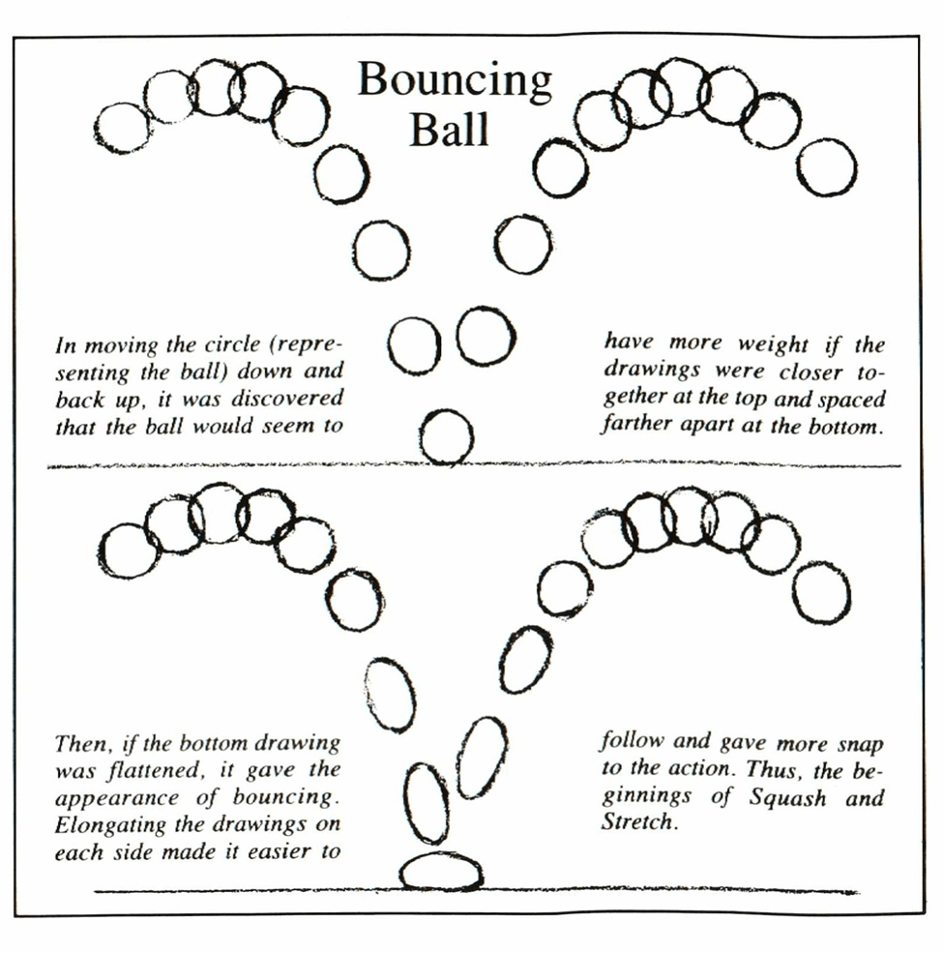
Figure 1:
Bouncing Ball The Illusion of Life: Disney Animation (Thomas and Johnston, 1995)
In the diagram above you can see that a basic animation has already been decided taking into account spacing, however under that you can see the difference between stretching the ball at its fastest point and squashing it down on impact; allowing it to feel faster and heavier while also having elasticity. I decided to use this principle to explore because the playable character is small and rounded similar to the ball, therefore, this sort of action could in theory translate well.
Although not many games are known to have used squash and stretch within the animation process some include Overwatch (2016) Celeste (2018) and Super Meat Boy (2010). This shows that although not common, some video game animators have used knowledge from traditional animation to recreate some of the principles within a video game context.
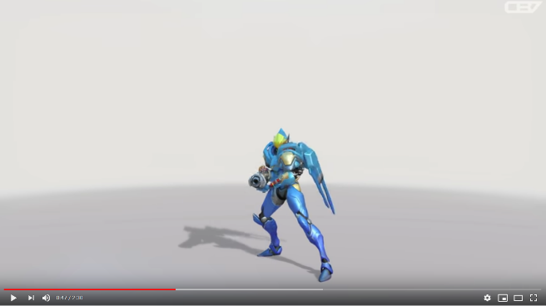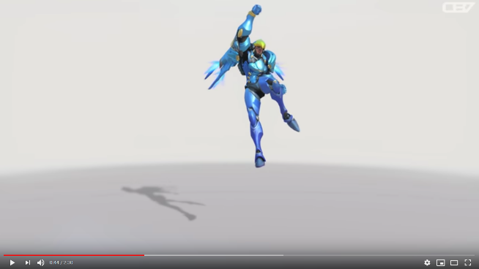
Figure 2: Figure 3:
Funny Animations in Slow Motion (CryBox7, 2018) Funny Animations in Slow Motion (CryBox7, 2018)
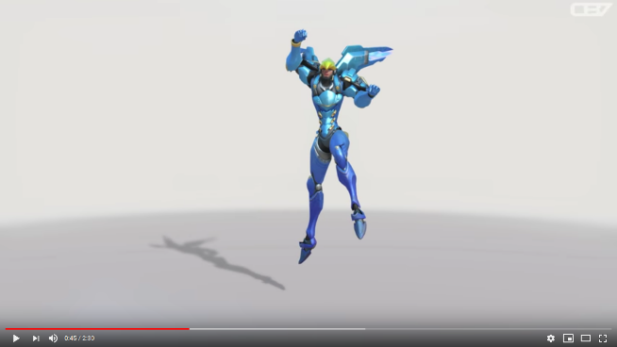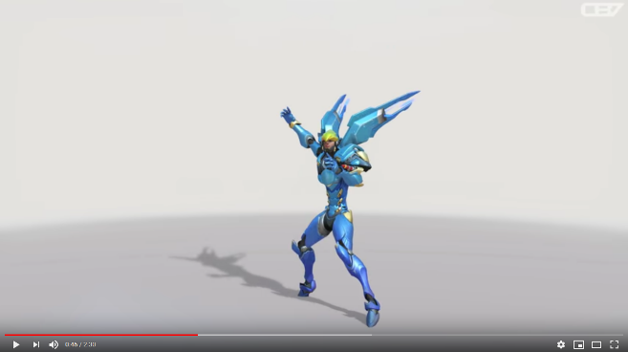
Figure 4: Figure 5:
Funny Animations in Slow Motion (CryBox7, 2018) Funny Animations in Slow Motion (CryBox7, 2018)
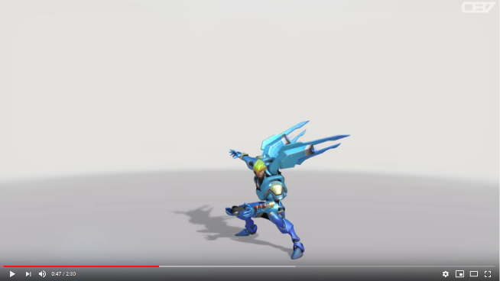
Figure 6:
Funny Animations in Slow Motion (CryBox7, 2018)

Timing
Timing explained by Thomas and Johnston:
“The number of drawings used in any movement determines the amount of time that action will take on the screen.” (Thomas and Johnston, 1995)
When comparing this to digital 3D animation, drawings can refer to Key Frames or Keys which suggests less Keys should be used for fast actions and more Keys are to be used for slower actions.

Exaggeration
Exaggeration is used to push animations to their extremes, this means that it can be used with other principles to enhance the effect. For example, squash and stretch uses “The exaggeration of a shape or other object’s volume to indicate movement.” (School of Motion, 2019) while the essence of the principle uses exaggeration already, when combined with the principle of exaggeration it suggests that the extremes of each state should be pushed further so that there is more movement and impact.

Arcs
An Arc in terms of the principles of animation refers to the path in which a movement takes:
“very few living organisms are capable of moves that have a mechanical in and out or up and down precision.” (Thomas and Johnston, 1995)
meaning that every movement will have some curve or arc that it follows out of demand from its own body or nature.

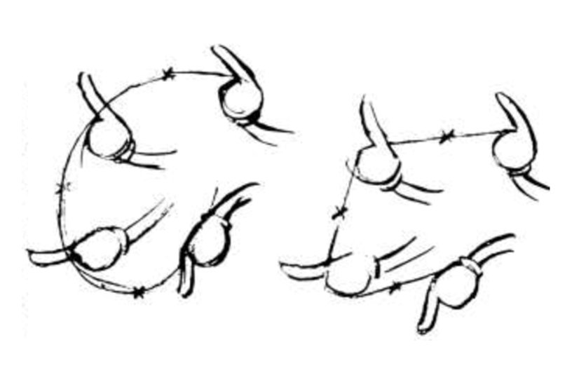
Figure 7:
Action of a hand gesture The Illusion of Life: Disney Animation (Thomas and Johnston, 1995)
This image demonstrates the nature of this arc in relation to a moving hand,
“The action of a hand gesture with a pointing finger follows a circular path. The animation charts the position of his hand drawings along this arc. He makes his key drawings, indicating where inbetweens should be placed to keep the line of action on this arc. Inbetweens done without following this arc change the action radically.” (Thomas and Johnston, 1995)
meaning that if any of the frames are changed, the animation takes on a whole different action and meaning entirely, so the arc created should be followed precisely.

Quantitative and Qualitative Data
There are different kinds of data, which vary depending on the needs of the investigation being implemented. If the data required is for statistical purposes, such as discovering a majority/minority or other number-based results relating to the quantity, then that data would be known as quantitate data. If the information gathered needs to determine the quality of something, finer details such as preferences or opinions would be referred to as qualitative data, which uses language rather than number results:
“Quantitative data is information about quantities, and therefore numbers, and qualitative data is descriptive, and regards phenomenon which can be observed but not measured, such as language.” (McLoed, 2019)
This means that to be able to gather the data required for the research I intend to conduct, a decision needs to be made on whether quantitative or qualitative data is required and if both, how much of each is needed.
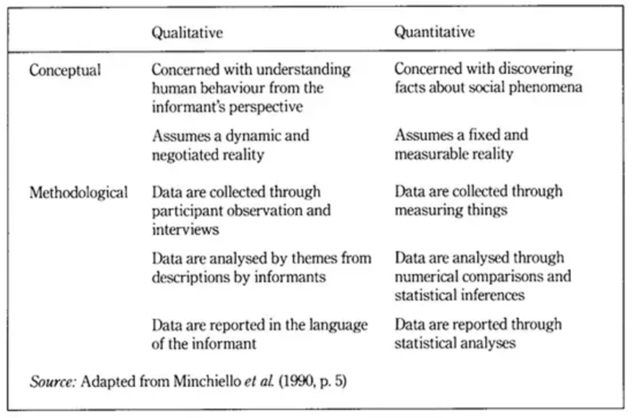
Figure 8:
Quantitative verses Qualitative Research (McLoed, 2019)
Due to the research I am conducting, qualitative data is the main requirement of my findings as it is opinion based. However, based on the way in which a question is asked, I can find out preference through a closed-ended question (please refer to the Open versus Closed Ended Questions section within Methodology 2 – Questionnaires in this report for a full explanation) the data can be collected through quantitative means.

Methodologies
While looking into different testing methods, I came across two main ways to gather data; questionnaires and interviews. Questionnaires would better allow for quantitative data, being able to publish the questionnaire online so that many people could answer, whereas one to one interviews would allow for qualitive data to be gathered meaning fuller responses with more information. In this section I will look at both approaches and consider each equally while deciding on the most suitable method when conducting my research.

Methodology 1 - Interviews
There are different types of interviews that can be conducted within testing sessions, depending on the nature of the research being sought and the audience being interviewed. Three different types of interviews are explained in more detail within an academic journal entitled Three types of Interviews: Qualitative research (2018) listed as:
“…(1) Structured; (2) semi‑structured; and (3) narrative interview. The primary difference between them is the amount of control the interviewer has over the encounter and the aim of the interview.” (Stuckey, 2018)
This suggests that the style of the interview has an impact on the resulting data gathered from the interviewee and therefore might influence the results of this method.
With different approaches within this methodology there are different requirements from each, I will explore each section to conclude on whether to use one of these approaches to this methodology or to research another more relevant methodology.

Structured Interview
A structured interview refers to the methodology of a set amount of questions asked to the interviewee, with no deviation due to the interviewee’s responses. This approach is very rigid, meaning that even with an interesting enquiry to follow, deviation from the questions already set out is not allowed.
Although this approach is rigid, it is faster to complete compared to a semi-structured or narrative interview as there are only a set amount of questions to be asked and answered. Alongside that, the data collected can be placed into clear concise categories for analysis.
Due to this approach being too rigid to be able to follow interesting enquiry lines that may come up during an interview, I have decided against using this strategy within this methodology.

Semi-Structured Interview
This method is suggested to be the “most commonly used type of interview in qualitative research” (Stuckey, 2018) Due to the flexibility of the interview process, while formulating specific but open-ended questions to allow the interview to become led by the interviewee:
“The researcher sets the outline for the topics covered, but the interviewee’s responses determine the way in which the interview is directed” (Stuckey, 2018)
This method would require a degree of forward planning, so adequate time should be allowed ahead of the interview as well as time to conduct the interview in a relaxed and timely manner:
“…often preceded by observation, informal and unstructured interviewing in order to allow researchers to develop a keen understanding of the topic of interest necessary for developing relevant and meaningful semi-structured questions.” (Stuckey, 2018)
This methodology would allow for the flexibility of interviewee lead responses, while keeping the data on track with prompts that lead the topic towards the research at hand. The main issue with using this methodology would be the time required to carry out the test, and due to the type of data required, this is not the best methodology for the collection of data required to the investigation.

Narrative Interview
“Narratives are stories that are based on the unfolding of events or actions from the perspective of a participants’ life experience.” (Stuckey, 2018)
The way in which this methodology would be applied to the investigation would be through the use of prompts that would allow interviewees the chance to explain in their own terms what their own life experience and perspective can contribute to the investigation, using less relevant data to produce a new perspective on the research at hand. Due to this being very open, and unstructured this type of interview can cause many issues with the data collected as much of it could be irrelevant to the study, while also taking time out of a secondary test due to the time needed to explore the data collected.

Interview 1
Below you can find the method in which the interview should be carried out, this is the first iteration, and therefore will need to be improved upon with future iterations.
- In a quiet room, the interviewee would be asked to view 3 animations alongside each other.
- These animations would be of a ball bouncing, the first would just move up and down in a simple motion, the second would have timing added to the frames making it feel like that of a real bouncing ball, finally the third would have timing along with squash and stretch applied.
- Once they have seen the animations, the interviewee would be asked a series of questions, however depending on their response the interview may take a different path, allowing it to be interviewee lead.
- The interview will be recorded via a Dictaphone, or phone used the same way.
- After the interview has been completed the interviewee would be thanked
Due to Thomas and Johnston suggesting in The Illusion of Life: Disney Animation (1995) that all principles should be followed to create a better animation, “As each of these processes acquired a name, it was analyzed [sic] and perfected and talked about, and when new artists joined the staff they were taught these practices as if they were the rules of the trade. To everyone’s surprise, they became the fundamental principles of animation…” (Thomas and Johnston, 1995)” the outcome of this test would suggest that animation three should be the most aesthetically pleasing.
Here are the suggested prompts for the interview.
- Which animation do you find most ecstatically pleasing?
- Why? (follow line of questioning, complete this for each prompt).
- Which animation do you feel is complete?
- Is there anything you would like to say about animation 1?
- Is there something you wish to say about animation 2?
- Would you like to say something specific about animation 3?
- Does any of the animations appeal to you in a different sense to aesthetics?
After considering the time required and my ability to analyse the data that would be collected, I have decided against using this methodology, however, this entire methodology should be considered within the development of any video game as it can collect enlightening data.

Methodology 2 - Questionnaire Writing
Within the following section I will talk about the different types of issues that can arise with writing a questionnaire, alongside research and examples.

Leading Questions
Leading questions are questions that can create biased data as it pushes the participant in a direction of how they should respond. These types of question can cause untrue, skewed data, as well as limiting constructive feedback that would otherwise exist. In their article titled Leading Questions and Memory: Pragmatic Constraints (1980) Dodd and Bradshaw state that: ‘Presuppositions in leading questions are generally held to directly affect language comprehension and memory’. Some characteristics of leading questions are conjecture within the question, intentionally framed questions, and questions that rely on the responder’s personal input. Although these are some of the characteristics, these characteristics alone do not always equate to a leading question as context effects them heavily. Below are some examples in the context of my own questionnaire:
- Which animation did you like the best?
This question suggests that they liked all the animations when this might not be true.
- Animation 1 took longer to create, which animation do you prefer?
This question includes unnecessary information to sway the responder to answer with Animation 1.
- Most people preferred Animation 1, Choose your preferred animation.
This is a question loaded with conjecture, this would likely cause a bias response as it draws attention to a specific element.
- Which animation do you prefer?
The above question would take away the leading parts out of the questions above, allowing for an unbiased response that would allow for feedback.

Questionnaire Fatigue
Questionnaire fatigue is another issue that can arise in questionnaires especially those which are lengthy. Questionnaire fatigue refers to the disinterest in the questions after a certain point at which the responder answers as quickly as possible, with minimal input meaning that results are vague and could be inaccurate. The best way to avoid this is to have a clear concise questionnaire that gets to the point as quickly as possible as to not waste anyone’s time. Although asking the same question differently can extrapolate a different response from the participant, it can lead to them feeling like they are just repeating themselves causing annoyance at questionnaire therefore it would be best to avoid this where possible.
“If you ask your respondents to answer surveys that are too long or that contain irrelevant questions, you run the risk of them becoming tired and uninterested in the task at hand. This will result in a decline in the quality of the data they provide and the possibility of negative brand perceptions.” (Schlesinger, 2017)

Clear Purpose with Concise Questions
Many issues arise in questionnaire writing when there is not a clear purpose, and not knowing what you want out of the data. This can make a questionnaire feel random to the participant, while also giving data that is useless to the creator. Before creating a questionnaire, a clear purpose should be considered so that after the questions are created, they can be checked against the purpose.
Another thing to consider when creating the questionnaire is the way in which the questions are asked, they should be clear without any unnecessary information that can complicate them. Confusing the responder can create responses that can be unusable so should be avoided, one way to make sure a question is not confusing is to have it ask about one single point. The questionnaire can be asking about a wider topic however each question should ask about one individual thing at a time.

Open versus Closed Ended Questions
Open ended questions are those that require the participant to respond in their own words, usually needing anywhere from a sentence to a paragraph. Considering what the question is asking, the space given to the responder to write in should give an indicator to the participant on how much they would need to write.
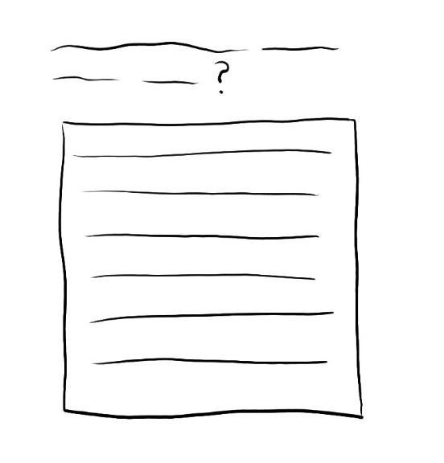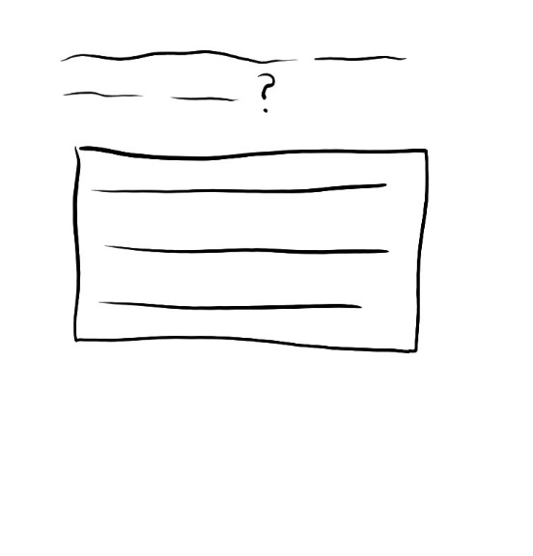
Figure 9: Figure 10:
A sketch of the space given on a questionnaire. A sketch of the space given on a questionnaire.
Figure 9 shows that it requires a lot of written words to fill the space given, this can be intimidating to a participant due to a number of reasons, some include: anxiety around spelling, punctuation and grammar, not understanding the meaning behind the question, the participants response being very direct and therefore the space is too big. This can give many participants the feeling of needing to fill the space given, where they may have been given too much for the question asked.
Figure 10 shows a smaller space that is more manageable to fill with a response, this takes away the stress of writing a large amount of words to answer a simple question. To combat taking away the participants allowance to fully express their selves, space should be given at the end so that if the space given was not enough, they have somewhere to continue their dialogue.
This sort of question can give qualitive data, having many different responses that can vary expansively from person to person. Although qualitive data is useful depending on the context, it is not always plausible to use, sorting through this sort of data can be extremely time consuming and can also give responses that answer in a way that is unusable or unsuitable to the creator.
Closed ended questions on the other hand is used for quantitative data, this sort of question requires the participant to respond with a yes or no answer. If this is what the creator requires then using a closed ended question is the best way to go when creating the questionnaire. The issues with this sort of question can mean that the creator will not know the reasoning behind the responses they receive, because of that they may not know where to take their research further in the future. As closed-ended questions have yes or no responses, it can limit the understanding of the choices made by participants when analysing the data. This can restrict the further development of questionnaires as, no understanding for the choices made would limit how you can progress to push that line of questioning in the future iterations.

Questionnaire 1
Below is the first iteration of the application of research into questionnaire writing applied to the investigation at hand. I chose to use questionnaires as I intend to collect quantitative data. The decision to use this methodology was due to the research into the type of data I required, alongside the availability to use and execute a questionnaire to a test group.
This is the method I will be using during this questionnaire:
- Testers will be asked to watch 3 separate animations
- Then they will be asked to answer a questionnaire on Google Forms
- This will be done in a carousel with other tests
- The other tests will be to do with the same project however they will be testing other parts
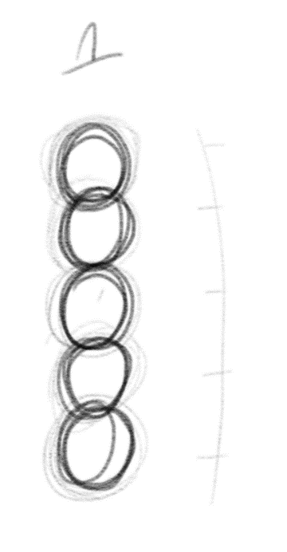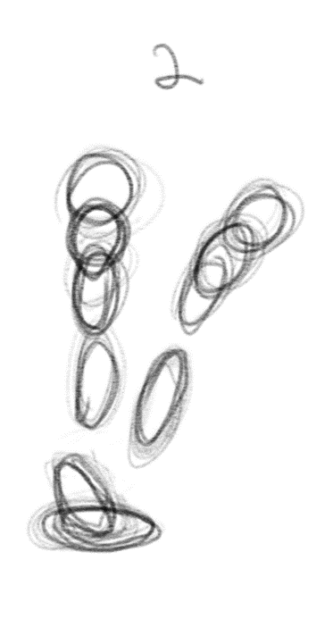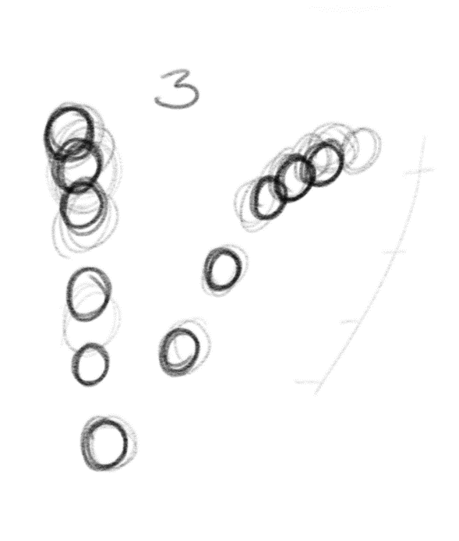
Figure 11: Figure 12: Figure 13:
A sketch of a ball moving. A Sketch of a ball moving with A sketch of a ball moving with timing.
timing, squash and stretch.
This questionnaire was to be used alongside three animations of a ball bouncing, the first animation would just be a simple ball moving up and down with no timing, arc or squash and stretch considered (Figure 11). The second animation would use timing, arc and squash and stretch principles within the animation and the third would use just timing (Figure 12). The third animation would consist of the moving ball with timing considered (Figure 13).
This was to test the timing alongside the squash and stretch of the animations, as within the book Illusion of Life (Thomas & Johnston, 1995) it suggests that for good animations, they need to follow all the ‘12 principles of animation’
The following questions were proposed as a first draft for a questionnaire:
- Which Animation do you like the best?
- Why?
- With these animations do you feel one is more complete?
- Of these animations which do you feel would work best in a video game setting?
- Comparing Animation 1 to 3 which do you feel you prefer?
After looking through this questionnaire, I found that it didn’t really ask what I intended for a first test. The questions although different essentially asked the same thing, therefore making someone feel as if they were repeating themselves five times; because of my research into questionnaire writing, I understand that this could cause fatigue for the responders making it seem like a chore. If a responder becomes annoyed or fatigued within the questionnaire this would lead to less feedback and inaccurate responses. Therefore, before I used this questionnaire, I changed the issues I stated above.

Questionnaire 2
This questionnaire was to be used alongside the same animations within Questionnaire 1. With this questionnaire I tried to improve the issues I had come across in the first one, what I was asking the participants, essentially was which did they like best, however the wording in the first questionnaire could skew the results a
s asking which they thought was the best, meant that there was a best to begin with which might not be the case. Changing the wording to which do they prefer allows them to choose an animation based on their own reasoning.
- Which of the Animations do you prefer?
- Why do you prefer that Animation?
Adding the secondary question why to the questionnaire allows them to explain the participants own reasoning behind their choice, meaning I would be able to follow different lines of enquiry moving forward. This sort of data is qualitive data, the reasoning I had behind the choice to include this was understanding and comprehension of the individual answering and finding out if there was a common thought amongst the participants.
The number of lines I allowed the participant to write in was two, this was because it was a simple question and would not need a lot of space to explain. The reason I used such a small space was to avoid confusing and demoralising the participants into thinking that they would need to write a full page on why they chose one animation over the others. Intimidating the participants would lead to more issues with data so I feel like this was the correct approach for this specific question. Next time I will add a space at the end so that if a participant requires more space to write, they have somewhere to put their dialogue.
There was a problem with one of the animations and due to not being able to fix the problem before conducting testing this seems to have influenced the data causing it to be inaccurate. I continued with testing although there was an issue due to time, the testers were brought in on a specific day where other tests would be conducted in a carousel so that the participants would not feel bored while waiting for the next set of play testing. Although it was a small sample size of only 4 people, the data suggests that Animation 3 was the preferred option.
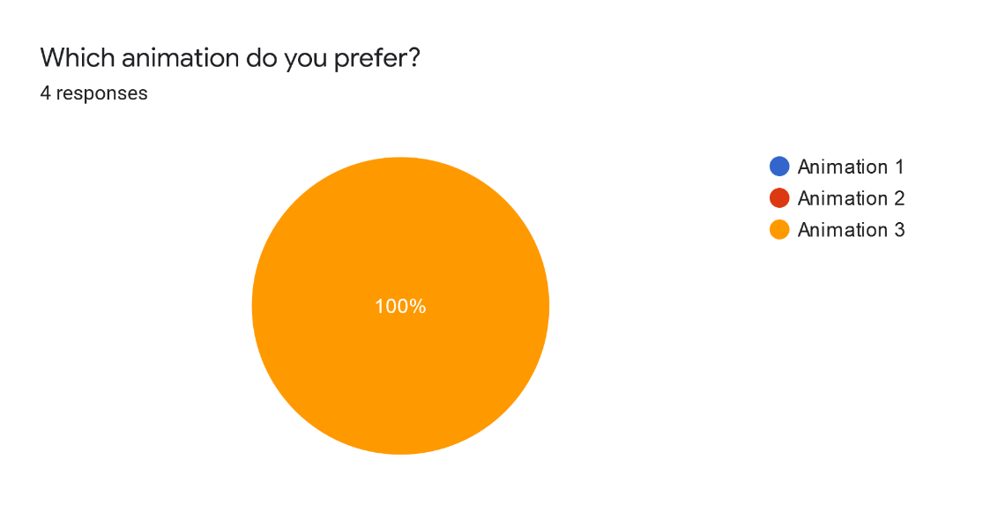
Figure 14:
Data Collected and Displayed as a Pie Chart.
One of the main issues with this study is the sample size, it is way too small to be able to draw any conclusion from the data. Knowing that, next time I will make sure to increase my test group, one way in which I can achieve this is by attaching the animations directly into the questionnaire so that it can be distributed online.
Another issue with my test group is that I never considered the target audience of the overall game, meaning different audiences could have different needs and wants. The target audience of the game is 18+ however there is not a concrete age range with interest-based knowledge. To be able to have a clear, and concise test, the target audience needs to be considered and decided. Moving forward we as a group must make a conscious decision on the target audience before continuing with the test as using anyone other than our target audience may give us a false view on what the actual target audience wants and/or needs.
One way in which we can branch out to our specific target audience would be through social media, through social media I could target specific areas where the age range and interest-based target audience has a high presence. From there I can ask the to fill in the online questionnaire, however, I am unsure if the amount of people that would participate would increase all that much. Another way to engage these people would be to add an incentive to completing the questionnaire, one incentive would be having their name added to the end credits as Quality Assurance Tester (QA tester).

Questionnaire 3
Improving on the previous tests, this would take the same approach as before, however, this questionnaire contains the animations of the playable character. Using the same set up as the previous questionnaire, while the animations take on the same use only the model has changed.
The first animation would be of the playable character moving up and down without any additional processes.
The second animation would be of the playable character moving up and down, with timing considered. Having more frames on the slowest part of the animation and less frames on the fastest part of the animation.
Finally, the third animation will use timing alongside squash and stretch techniques, meaning the character will flatten out on impact, changing volume to show movement, and stretch out during the fastest part of the animation to show speed.
Each of these animations will be embedded within the questionnaire to be able to distribute it online to the intended target audience.
- Which animation do you prefer?
- Why?
- Is there anything you would like to add?
During making this questionnaire, I had intended to add the animations of the playable character, however, some issues with rigging the character. Rigging refers to the process of creating the digital bones and structures to control the skeleton for animation, in terms of this specific rig, I had to add a way in which it allowed the playable character to maintain its volume when squashing and stretching. Due to these issues, I was unable to complete the animations in time to conduct this questionnaire.
Next time to improve on this I would need to consider time management, contingency plans and organisation. If my time management was better, I would’ve been able to conduct a different test using another method of creating the animation as I would have been able to have more time to solve the issues that arose. Having better organisation would’ve helped me by being able to adapt to the situation quicker and being able to find a work around for the questionnaire produced. Finally having a contingency plan, knowing that I may not finish the rig ready for the animation, I would’ve had a plan to follow in the case of this and due to not being organised I failed to create a contingency plan.
To improve upon my time management, next time I will look at the bigger picture, considering everything that needs to be completed to progress with each part of research. I will use project planning tools such as Gannt charts that shows everything within the production pipeline so as to not forget a crucial step that may be required, such as the issue with the rig for the playable character. Another way would be through a software-based project organiser such as ftrack, which creates a Gantt chat based on the tasks you set within the site.
Improving my organisation by using the plan for time management to allocate the time needed for each part of the pipeline, making sure to give enough time for issues that may occur. Doing this would mean a better start to a project, and a more focused research plan.
While being organised is better, having a contingency plan ahead of issues would solve some that would arise as issues are always discovered.

Conclusion
To conclude, many issues arose while conducting first-hand research meaning that the data, I collected was irrelevant or unusable, however, due to this I was able to find out my weaknesses on the subject and continue forward learning more ways to improve upon the last iteration.
My main downfall within this research was time management, next time I will need to be able to manage the time needed to create and conduct each test session proposed. To do this I will need to understand my own limitations by setting out clearly what needs to be done alongside a deadline. To compliment this, I will need to create contingency plans so that if I come across the same issues here, I have a plan on how to tackle this issue going forward. Although creating contingency plans for the issues already addressed in this document is wise, other contingencies should be created in the unfortunate event other issues arise so each part of the project should be considered individually within a pipeline.
One thing that went well during this research was learning about questionnaire writing, I feel that I have gained a lot of knowledge on how to create a good questionnaire, as Oppenheim states “Questionnaires do not emerge fully-fledged; they have to be created or adapted, fashioned and developed to maturity after many abortive test flights” (Oppenhiem, 1966) meaning it can always be improved upon.

Bibliography

Books
Adams, Ernest. (2014). Fundamentals of Game Design, Third Edition. United States of America: New Riders.
Oppenheim, A.N. (1966). Questionnaire Design, Interviewing and Attitude Measurement: New Edition. London: Continuum.
Thomas, Frank and Johnston, Ollie. (1995). The Illusion of Life: Disney Animation. New York: Walt Disney Productions.
Williams, Richard. (2001). The Animator’s Survival Kit. United States: Faber and Faber Inc.

Journals
Dodd and Bradshaw,
Leading Questions and Memory: Pragmatic Constraints
Journal of Verbal Learning and Verbal Behaviour 19, 695 - 704 (1980) University of Utah.

Online Resources
McLoed, Saul. (2019). What is the difference between qualitative and quantitative research? [online] Available at: https://www.simplypsychology.org/qualitative-quantitative.html [Accessed: December 2019].

Videos
School of Motion. (2019). Exaggerate Animation with Squash and Stretch. [online video] https://youtu.be/cx3Jpz4tYj4 [Accessed: December 2019].
CryBox7. (2018). Funny Animations in Slow Motion [Overwatch]. [online video] https://youtu.be/Lk4coGVVfVU [Accessed: November 2019].

Video Games
Blizzard Entertainment (2016) Overwatch [video game]. Windows, PlayStation 4, Xbox One. Irvine, California: Blizzard Entertainment
Matt Makes Games (2018) Celeste [video game] Windows, PlayStation 4, Xbox, Nintendo Switch. Matt Makes Games
Team Meat (2010) Super Meat Boy [video game] Windows, Xbox 360, Xbox One, PlayStation 4, PlayStation Vita, Wii U, Nintendo Switch. Team Meat.

