Research In Practice ADAD5004
Student Number: 2103414
Student Name: Hunter Hare
Course Title: BA (hons) Graphic Design
Tutors Name: Donna Williams
Keywords: Health, Ethics, Fitness
Word Count: 2673
Bibliography Word Count: 400

Introduction
The aim of this particular essay is to decide on a question for my dissertation; therefore the structure of this essay will differ to a lot of essays as I will begin by discussing my research and findings, then by the end, I will have hopefully decided on at least one question that I would like to research further for my dissertation in my third year. Throughout this essay I will discuss the research I have found about my chosen keywords; Before beginning this essay, I had picked out three keywords that I felt passionate about, these keywords are health, ethics and fitness. For each keyword I found both a thinker and piece of work to help analyse them and further my research. For my first keyword, health, I chose the World Health Organization as my main thinker, my piece of work for health is an advertisement campaign from McDonald’s called “You Can’t Run from Us Forever”. For my second keyword, ethics, I chose the thinker Lucienne Roberts, and the work “Olay Definity with Twiggy” released by Olay. Finally my last keyword fitness, although it is similar to health, I have decided to research it separately from health as much as I can. For this keyword I have chosen the thinker Joe Wicks and the work is an advertisement from PureGyms “Everybody welcome at the UK’s favourite gym”. I will begin by discussing my three keywords independently and in depth. I will then finish the essay by summarising my findings and generating some questions from this essay and my interests.

Health
Health is a huge subject to cover so to begin my research I found some definitions of health, according to WHO, health is not only the absence of illness but about being physically, mentally and socially well (WHO, 2023,) according to the Cambridge Dictionary, it’s about the body and mind being free from illness and social well-being (Cambridge Dictionary, 2023) these definitions suggest that health is more than just physical health, but also the mental and social well-being of a person.

Key thinker
My thinker is WHO (World Health Organization), WHO is an organisation founded in 1948, they aim to connect people and nations from across the world to help keep everyone safe as well as promoting both health and quality of life. Their mission is not only to promote healthy living but also to expand universal health coverage and use science-based programmes to teach health (WHO, 2023.) I chose WHO as my thinker for the health as they are backed up by science and are a reliable source of information.

Why health.
I chose health as it’s one of the most vital factors in our lives, it plays an enormous part in both quality and quantity of everyone’s lives therefore I feel deeply passionate about this subject. I, like many people, have unfortunately been affected by both mental and physical illness but I have learnt how to change and adapt things, to make the quality of my life better. My mental illness that I was diagnosed with in 2016 was anxiety, which is one of the most common mental illnesses that people experience, with over 8 million people in the UK suffering from it (mentalhealth.org, 2023.) Personally, I had to make changes to my lifestyle in order to improve my mental health. Some of the changes I made were altering my diet to be more nutritious and healthier, as well as going to a gym at least four days a week. I began to notice that the more I focused on my lifestyle and physical health, my mental health started to improve, (obviously this is different for everyone.) I became passionate about health from doing this which is why I have chosen to research it further.

My key work
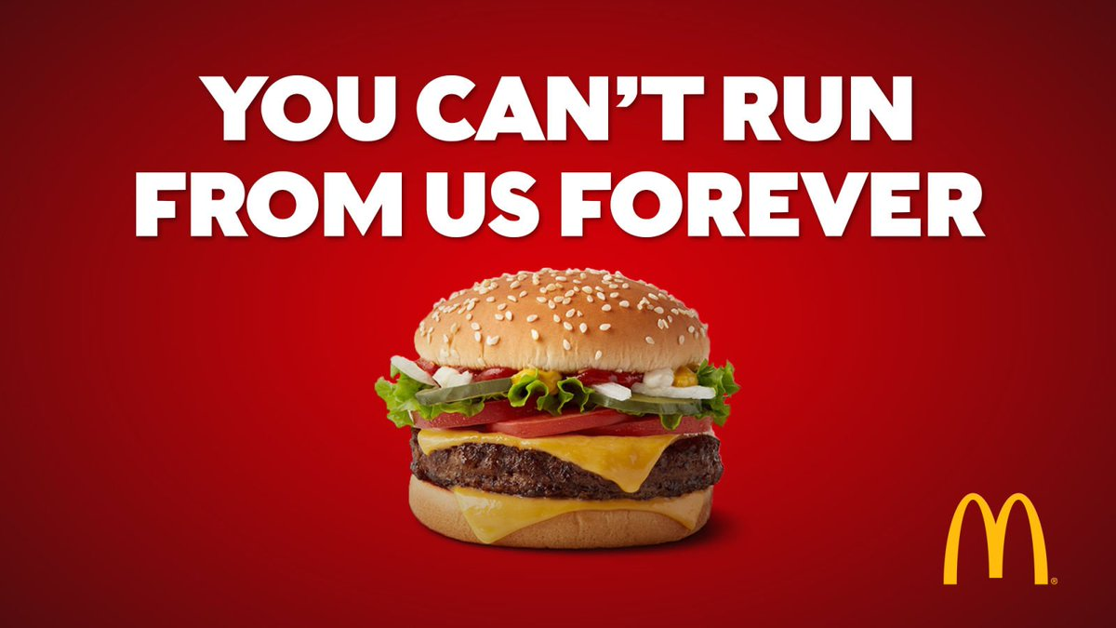
Figure 1: ‘You Can’t Run from Us Forever’ Advertisement – McDonalds, 2019

I chose this McDonald’s advertisement (figure 1) as my key work because McDonalds like many fast-food chains promote unhealthy food. According to The Onion this campaign, released in Chicago, was McDonalds attempt to “win back” the customers who are deciding to become healthier (Unknown, The Onion, 2019). Recently, health has become quite trendy; according to a 2021 survey by Gov.uk they found that over 80% of the 5,000 adults surveyed wanted to become healthier and have started to change their lifestyles. With health becoming more accessible, it is likely that these companies selling poor nutritional and unhealthy foods will see some decrease in their sales. But why are these fast-food companies so bad?

Fast-food and obesity
It’s estimated that globally, 2.8 million people die each year due to being obese or overweight (WHO, 2021.) In 2021 the Health Survey was released, it found that “25.9% of adults in England are obese and a further 37.9% are overweight but not obese” (Health Survey, 2021) this means that over 60% of England (in 2021) were considered an unhealthy weight. A study found that fast-food can be associated with having a higher body fat percentage, as well as it being more difficult to maintain or lose weight especially in children, increasing their risk of obesity (Dr Ananya Mandal MD, News Medical, 2023.) This article offers some proof that there is a connection between the increasing amount of obesity and the growing fast-food industry. This is an area of health that I’m rather passionate about due to my history of mental illness, these statistics of deaths related to obesity shocked me and makes me wonder if I could take this further for my dissertation.

Coeliac disease
This essay has allowed me to research a possible health condition of my own, Coeliac disease. It’s a disease that not many people are familiar with but many suffer from. Roughly 1 out of 100 people in the UK suffer from this disease but nearly 60% go undiagnosed meaning that there are close to half a million people who have this disease but haven’t been diagnosed yet (Coeliac UK, 2023.) So what is it? It’s an autoimmune disease, where the immune system will react to gluten and attack itself; this unfortunately causes damage to the villi (small intestine lining) therefore the body struggles to absorb nutrients and vitamins from foods, leading to other illnesses like Crohn’s disease (Coeliac UK, 2023.) I wanted to research this disease as I have been tested and told by doctors that it’s very likely that I suffer from this, however it’s very difficult to diagnose. As seen on the Channel 4 programme ‘Know your S**t: Inside Our Guts’ (episode 5) after having blood test the next stage of diagnosis is an endoscopy, where a small camera goes down the throat and into the small intestines where biopsies will be taken and sent to a lab for testing, however there are many things that can affect the results of this procedure leading to invalid results which makes the disease hard to diagnose, this unfortunately happened to me. At this moment in time there is no cure for the disease only a treatment involving a gluten free diet (‘Know your S**t: Inside Our Guts’, episode 5, 2023.) I wanted to research this disease as it is personal to me and gives me something to potentially take forward for my dissertation.

Ethics
To begin my research for ethics, also known as moral philosophy, I decided to find some definitions, according to the Cambridge Dictionary ethics is defined as “a system of accepted beliefs that control behaviour, especially such a system based on morals” (Cambridge Dictionary, 2023.) Another definition, states it’s about making good or bad actions and being morally right or wrong (Peter Singer, Britannica, 2023.) In the book, Ethics for dummies, it describes ethics as being actions that are morally good or bad (Panza, & Potthast, A, 2010, Ethics for dummies.) In summary, ethics is about morals of a society or group and whether we make good or bad decisions, for example murder is ethically wrong in most societies.

Why ethics.
I’m not massively passionate about ethics but I believe it’s important as both a human being and a designer. We hold a responsibility in our society to make certain decisions such as to not kill, steal or commit crimes to name a few. Ethics is of course deeper than the choice to not kill but that is the most common example of ethics people know. I chose to research ethics as I and many people have become aware of some (potentially) unethical things making their way into our society and I believe that we should learn and practice etchics within our lives.

Lucienne Roberts
My thinker Lucienne Roberts is a graphic designer who is very aware of ethics in life and in design. Who is Lucienne Roberts? Well, Roberts in her own words is a graphic designer, the founder of LucienneRoberts+ (a graphic design studio), and a co-founder of GraphicDesign& (Lucienne Roberts, LinkedIn, 2023.) Roberts has also released many books relating to graphic design. In 2006, Roberts published Good: An Introduction to Ethics in Graphic Design; In this particular book, Roberts explains how design is impacted by ethics and that designers have a responsibly to be ethical in the choices we make. Roberts explains that design is neutral and only becomes ethical or unethical because of the intention or purpose of said design. (Lucienne Roberts, 2006, Good: An Introduction to Ethics in Graphic Design)

My key work
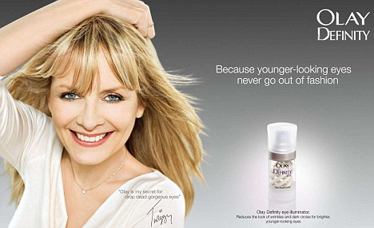
Figure 2: Olay Definity with Twiggy – ‘Olay rapped over Twiggy's lying eyes: Advert banned for retouching 60-year-old model.’ 2009, Daily Mail.

My key work is a 2009 advert released by the company Olay, this advert features Twiggy, a late 1960’s top model (IMDb, 2023.) This advertisement caused controversy due to suspected photoshopping and airbrushing as at the time of this advert Twiggy was 60 years old. (Sean Poulter, Daily Mail, 2009) According to the Daily Mail article experts were certain that the advert was edited, especially when compared to other photos of the model, this caused many complaints as the product being advertised is anti-aging eye cream. This type of advertising has been labelled false advertising or misleading advertisement. In 2008, the UK government released the ‘Consumer Protection from Unfair Trading Regulations’ Law which prevents companies from leaving out vital information or using deceptive and misleading messages (Gov.uk, 2008.) This advert is a good example of how some companies ignore ethics in order to make sales, as this is an advertisement and a form of visual communication it relates to graphic design and the belief that designers should be ethical when designing, however, as Olay is a paying client it is often hard for designers to make ethical choices. In the book Design Issues: How Graphic Design Informs Society, it explains that as a designer we are being paid to create what clients want, therefore it’s difficult to stay ethical as a designer (Holland, 2001, Design Issues: How Graphic Design Informs Society.)

Fitness
To begin my fitness research I found some definitions, Cambridge dictionary states that fitness is about being physically fit, healthy and strong (Cambridge Dictionary, 2023.) The World Health Organisation which states that fitness is any bodily movement that requires energy expenditure to perform (WHO, 2023.) So what are the recommendations when it comes to fitness? The NHS is a great source that supplies information on how much exercise we should do and what types of fitness we should incorporate into our lives. For the average adult they recommend at least 150 minutes per week of moderate intensity or 75 minutes per week of intense activity (NHS, Physical activity guidelines for adults aged 19 to 64, 2021;) they suggest that even a 10-minute brisk walk every day can reduce risks of certain diseases as well as, increasing your stamina and helping burn extra calories (NHS, Walking for health, 2022.) However, what we eat and drink is just as important as what exercise we do, a large amount of people are unaware of the recommendations, as we know from my first keyword that roughly 60% of England are overweight (Health Survey, 2021.) The NHS suggest that for the average woman she needs to consume 2,000 calories every day and for men they need 2,500 calories (NHS, What should my daily intake of calories be? 2019,) but what is meant by calories? They are the measurement of how much energy is contained within food or drinks as well as the amount of energy you burn through physical activity or just being alive (NHS, What should my daily intake of calories be? 2019.) To maintain weight it’s vital that you balance calories in (consumed) and calories out (burnt through activity) and to lose weight it’s important to either decrease the amount consumed or increase your exercise also known as a calorie deficit (NHS, What should my daily intake of calories be? 2019.) To conclude, fitness is vital in our lives, and should be paired with a healthy diet.

Joe Wicks
Also called the Body Coach, Wicks is a successful personal trainer who has released multiple nutrition books and free fitness videos on YouTube and is now working on a fitness app. Wicks has the goal to help millions on their fitness journey and improve their health and lives (The Body Coach, 2023.) I chose Joe Wicks as my thinker due to the success of his work, in a recent interview with the Mirror, Wicks states that he believes fitness can be a lifesaver and it helps with your mental state, Wicks also believes that fitness should be accessible to everyone for free (Louise Lazell, The Mirror, 2023) which I agree with. Wicks most commonly promotes HIIT (high intensity interval training) which he does from home, making sure it is accessible for his viewers and clients to achieve (The Body Coach, 2023.)

Gyms
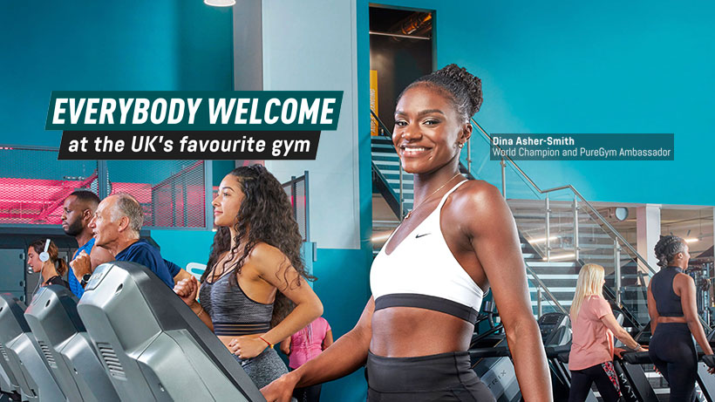
Figure 3: “Everybody welcome at the UK’s favourite gym” PureGym advertisement with Dina Asher-Smith (2019)
My key work is a 2019 advertisement from a UK gym, PureGyms. PureGyms (claiming to be the UK’s favourite gym) believes in making affordable and accessible gyms around the UK as well as being judgement free. Gyms are a good place for a workout and to achieve your fitness goals as they supply a large variety of equipment, such as weights, cardio machines etc. Gyms have become more popular recently and according to research found by PureGyms roughly 14% of the UK hold gym memberships (which is nearly 10 million people) as well as 19% of the people surveyed state that they are planning on joining a gym in the next year. (PureGyms, The UK Fitness Report – 2022/23 Gym Statistics, 2022.) As a regular gym-goer, these statistics are shockingly low, however if people are following Joe Wicks and other professional trainers online then they don’t need gym memberships as they exercise effectively from home. The app that will soon be released by Joe Wicks will also enable more people to exercise and eat better at home (The Body Coach, 2023.)

Fitness for designers
From my own experience as a designer, I find that I often spend long hours sitting down and staring at a laptop, so I believe that exercising regularly throughout the week and taking breaks to go for walks is very beneficial for both mental and physical health. I chose to research fitness because one of my ideas for my practical project in 3rd year is a guide to help designers become fitter and healthier as it’s a job that involves being inactive for long periods of time.

Conclusion
After researching my keywords and being happy with my findings I have a couple of ideas for my dissertation question:
- Has design and advertisement impacted our health?
- How can we be healthier as designers?
- Does design influence our lifestyle?
My questions all have similar themes, as this is the area I feel most passionate about and can imagine myself researching further; they can all be linked to my keywords. I plan to research more over summer to help with my dissertation and practical project for 3rd year.

Bibliography:
Books:
Holland. (2001). Design issues: how graphic design informs society. Allworth. Y Fforwm UWTSD. Accessed 13th March.
Panza, & Potthast, A. (2010). Ethics for dummies. Wiley. Y Fforwm UWTSD. Accessed 13th March.

Roberts. (2006). Good : an introduction to ethics in graphic design. AVA Academia. Y Fforwm UWTSD. Accessed 13th March.

Websites/Articles:
“Body Coach Joe Wicks says exercise 'changes everything' and is 'essential'” Louise Lazell, The Mirror, 2023
https://www.mirror.co.uk/3am/celebrity-news/body-coach-joe-wicks-says-29074976 Accessed 12th April.

Coeliac UK, ‘Coeliac disease FAQs’ 2023
https://www.coeliac.org.uk/information-and-support/coeliac-disease/coeliac-disease-faqs/ Accessed 24th March.

‘Ethics’ Cambridge Dictionary, 2023
https://dictionary.cambridge.org/dictionary/english/ethic Accessed 24th March.

‘Ethics’, Peter Singer, Britannica, 2023
https://www.britannica.com/topic/ethics-philosophy Accessed 24th March.

‘Fitness’ Cambridge Dictionary, 2023
https://dictionary.cambridge.org/dictionary/english/fitness Accessed 12th April.

‘Health’ Cambridge Dictionary, 2023 https://dictionary.cambridge.org/dictionary/english/health Accessed 16th March.

‘Health matters: public health issues’, Public Health England, Gov.uk, February 2014.
https://www.gov.uk/government/collections/health-matters-public-health-issues Accessed 18th March.

Lucienne Roberts, LinkedIn, 2023
https://www.linkedin.com/in/lucienne-roberts-10982833/?originalSubdomain=uk Accessed 27th March.

Marketing and advertising: the law, (Consumer Protection from Unfair Trading Regulations, 2008,) Gov.uk, 2023
https://www.gov.uk/marketing-advertising-law/regulations-that-affect-advertising#:~:text=Advertising%20to%20consumers&text=including%20false%20or%20deceptive%20messages,using%20aggressive%20sales%20techniques Accessed 10th April.

‘Obesity’, World Health Organisation, June 2021
https://www.who.int/news-room/facts-in-pictures/detail/6-facts-on-obesity . Accessed 17th March.

‘Obesity and Fast Food’ Dr. Ananya Mandal, MD, News Medical, 2023.
https://www.news-medical.net/health/Obesity-and-Fast-Food.aspx#:~:text=Fast%20food%20is%20associated%20with,raising%20their%20risk%20of%20obesity. Accessed 18th March.

‘Physical activity guidelines for adults aged 19 to 64’, NHS, 2021
https://www.nhs.uk/live-well/exercise/exercise-guidelines/physical-activity-guidelines-for-adults-aged-19-to-64/ Accessed 13th April.

PureGym, ‘about us’, 2023
https://www.puregym.com/about-us/ Accessed 13th April.

PureGym, ‘The UK Fitness Report – 2022/23 Gym Statistics’, 2022
https://www.puregym.com/blog/uk-fitness-report-gym-statistics/

‘Seven in 10 adults are motivated to get healthier in 2021 due to COVID-19’, Public Health England, Gov.uk, January 2021.
https://www.gov.uk/government/news/seven-in-10-adults-are-motivated-to-get-healthier-in-2021-due-to-covid-19 Accessed 17th March.

The Body Coach, ‘mission’, 2023
https://www.thebodycoach.com/mission/ Accessed 12th April.

‘The Health Survey for England 2021’, House of Commons Library, Carl Baker, January 2023.
https://commonslibrary.parliament.uk/research-briefings/sn03336/#:~:text=Adult%20obesity%20in%20England&text=The%20survey%2C%20published%20in%20December,to%20be%20overweight%20or%20obese. Accessed 17th March.

‘Twiggy’ Biography, IMDb, 2023
https://www.imdb.com/name/nm0493341/bio?ref_=nm_ov_bio_sm Accessed 2nd April.

‘Walking for health’, NHS, 2022
https://www.nhs.uk/live-well/exercise/running-and-aerobic-exercises/walking-for-health/ Accessed 13th April.

‘What is Anxiety?’ MentalHealth.org, 2023
https://mentalhealth-uk.org/help-and-information/conditions/anxiety-disorders/what-is-anxiety/ Accessed 16th March.

‘What should my daily intake of calories be?’ NHS, 2019
https://www.nhs.uk/common-health-questions/food-and-diet/what-should-my-daily-intake-of-calories-be/#:~:text=An%20ideal%20daily%20intake%20of,women%20and%202%2C500%20for%20men. Accessed 13th April.

World Health Organisation ‘About’ 2023
https://www.who.int/about Accessed 15th March.

World Health Organisation ‘Constitution’ 2023 https://www.who.int/about/governance/constitution Accessed 15th March.

Figures:
Figure 1: McDonald’s Appealing to Health-Conscious Consumers with New ‘You Can’t Run from Us Forever’ Ad Campaign – The Onion, September 17, 2019.
https://www.theonion.com/mcdonald-s-appealing-to-health-conscious-consumers-with-1838181744 Accessed 4th March.

Figure 2: Olay Definity with Twiggy - Olay rapped over Twiggy's lying eyes: Advert banned for retouching 60-year-old model. 17 December 2009, Sean Poulter, Daily Mail.
https://www.dailymail.co.uk/femail/article-1236236/Olay-rapped-Twiggys-lying-eyes-Advert-banned-retouching-60-year-old-model.html Accessed 4th March.

Figure 3: “Everybody welcome at the UK’s favourite gym” PureGym advertisement with Dina Asher-Smith, 2019.
https://www.facebook.com/puregym/photos/a.357607994278875/2941489402557375/?paipv=0&eav=AfZ0NT9e3lldKoFbFcXe2fW_hBx8QbpiYbZSLVn06AcEwTZClFZ0l-Tlw_LvpPMMYgs&_rdr Accessed 5th March.

