Dominic Parker (2008455)
Specialised Performance Practice - Process Workbook (ADPA5014)
Professional performance practice has been a very physical and creative module in which we have, over the weeks, been physically explorative and creative devising a movement performance called Unit(e). This workbook is here to document the creative process of this module reflecting on everything I’ve learnt and done during this module.
First Steps
At the start of this module we began by asking questions about what culture means to us. During rehearsal we started to brainstorm our answers to different questions about culture which is what we wanted to base our performance on. I found that answering these questions and listening to the answers and ideas of my colleagues gave me thoughts and ideas on culture that I wouldn’t have thought about otherwise.
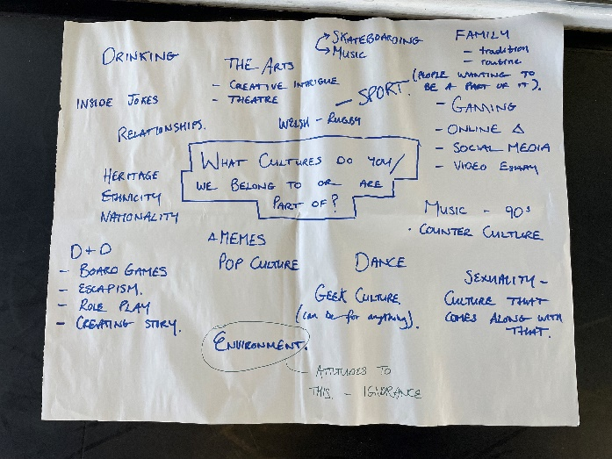
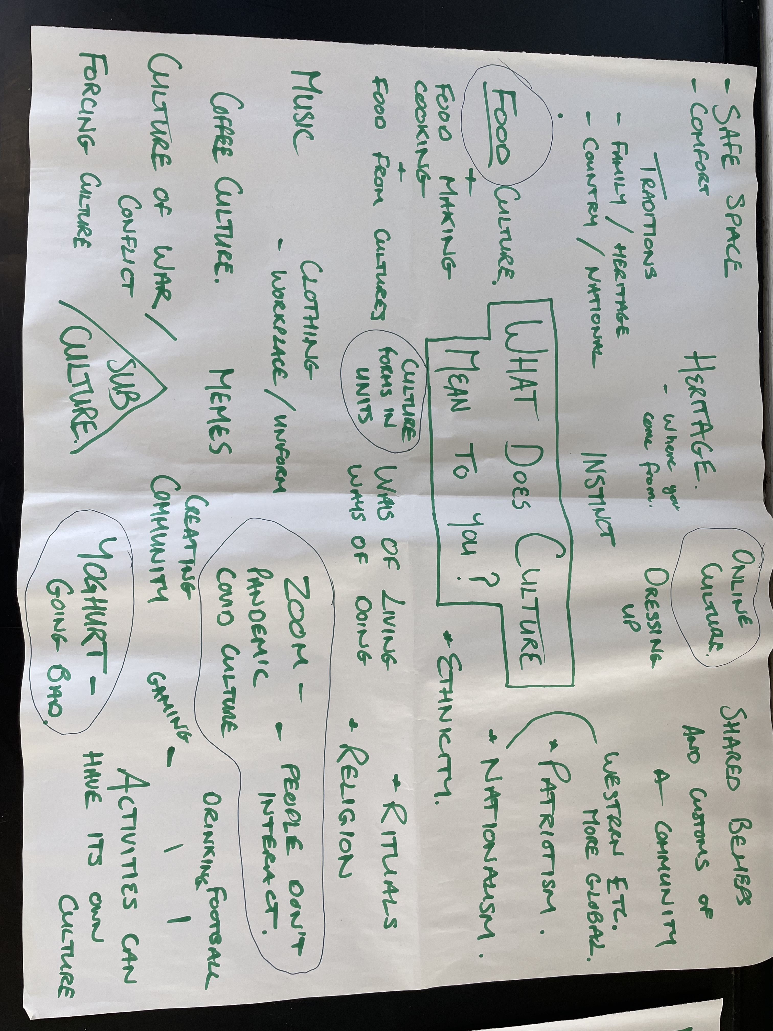

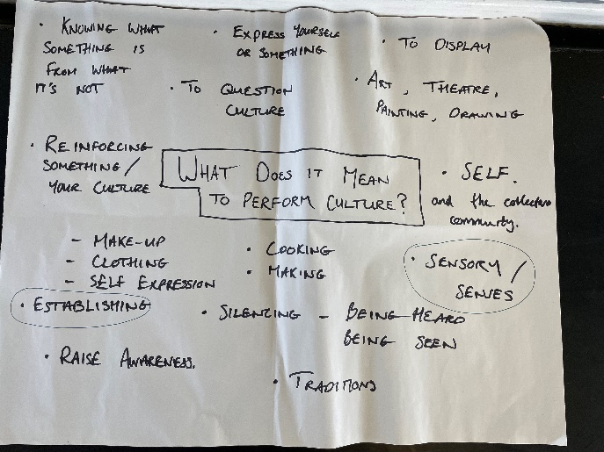
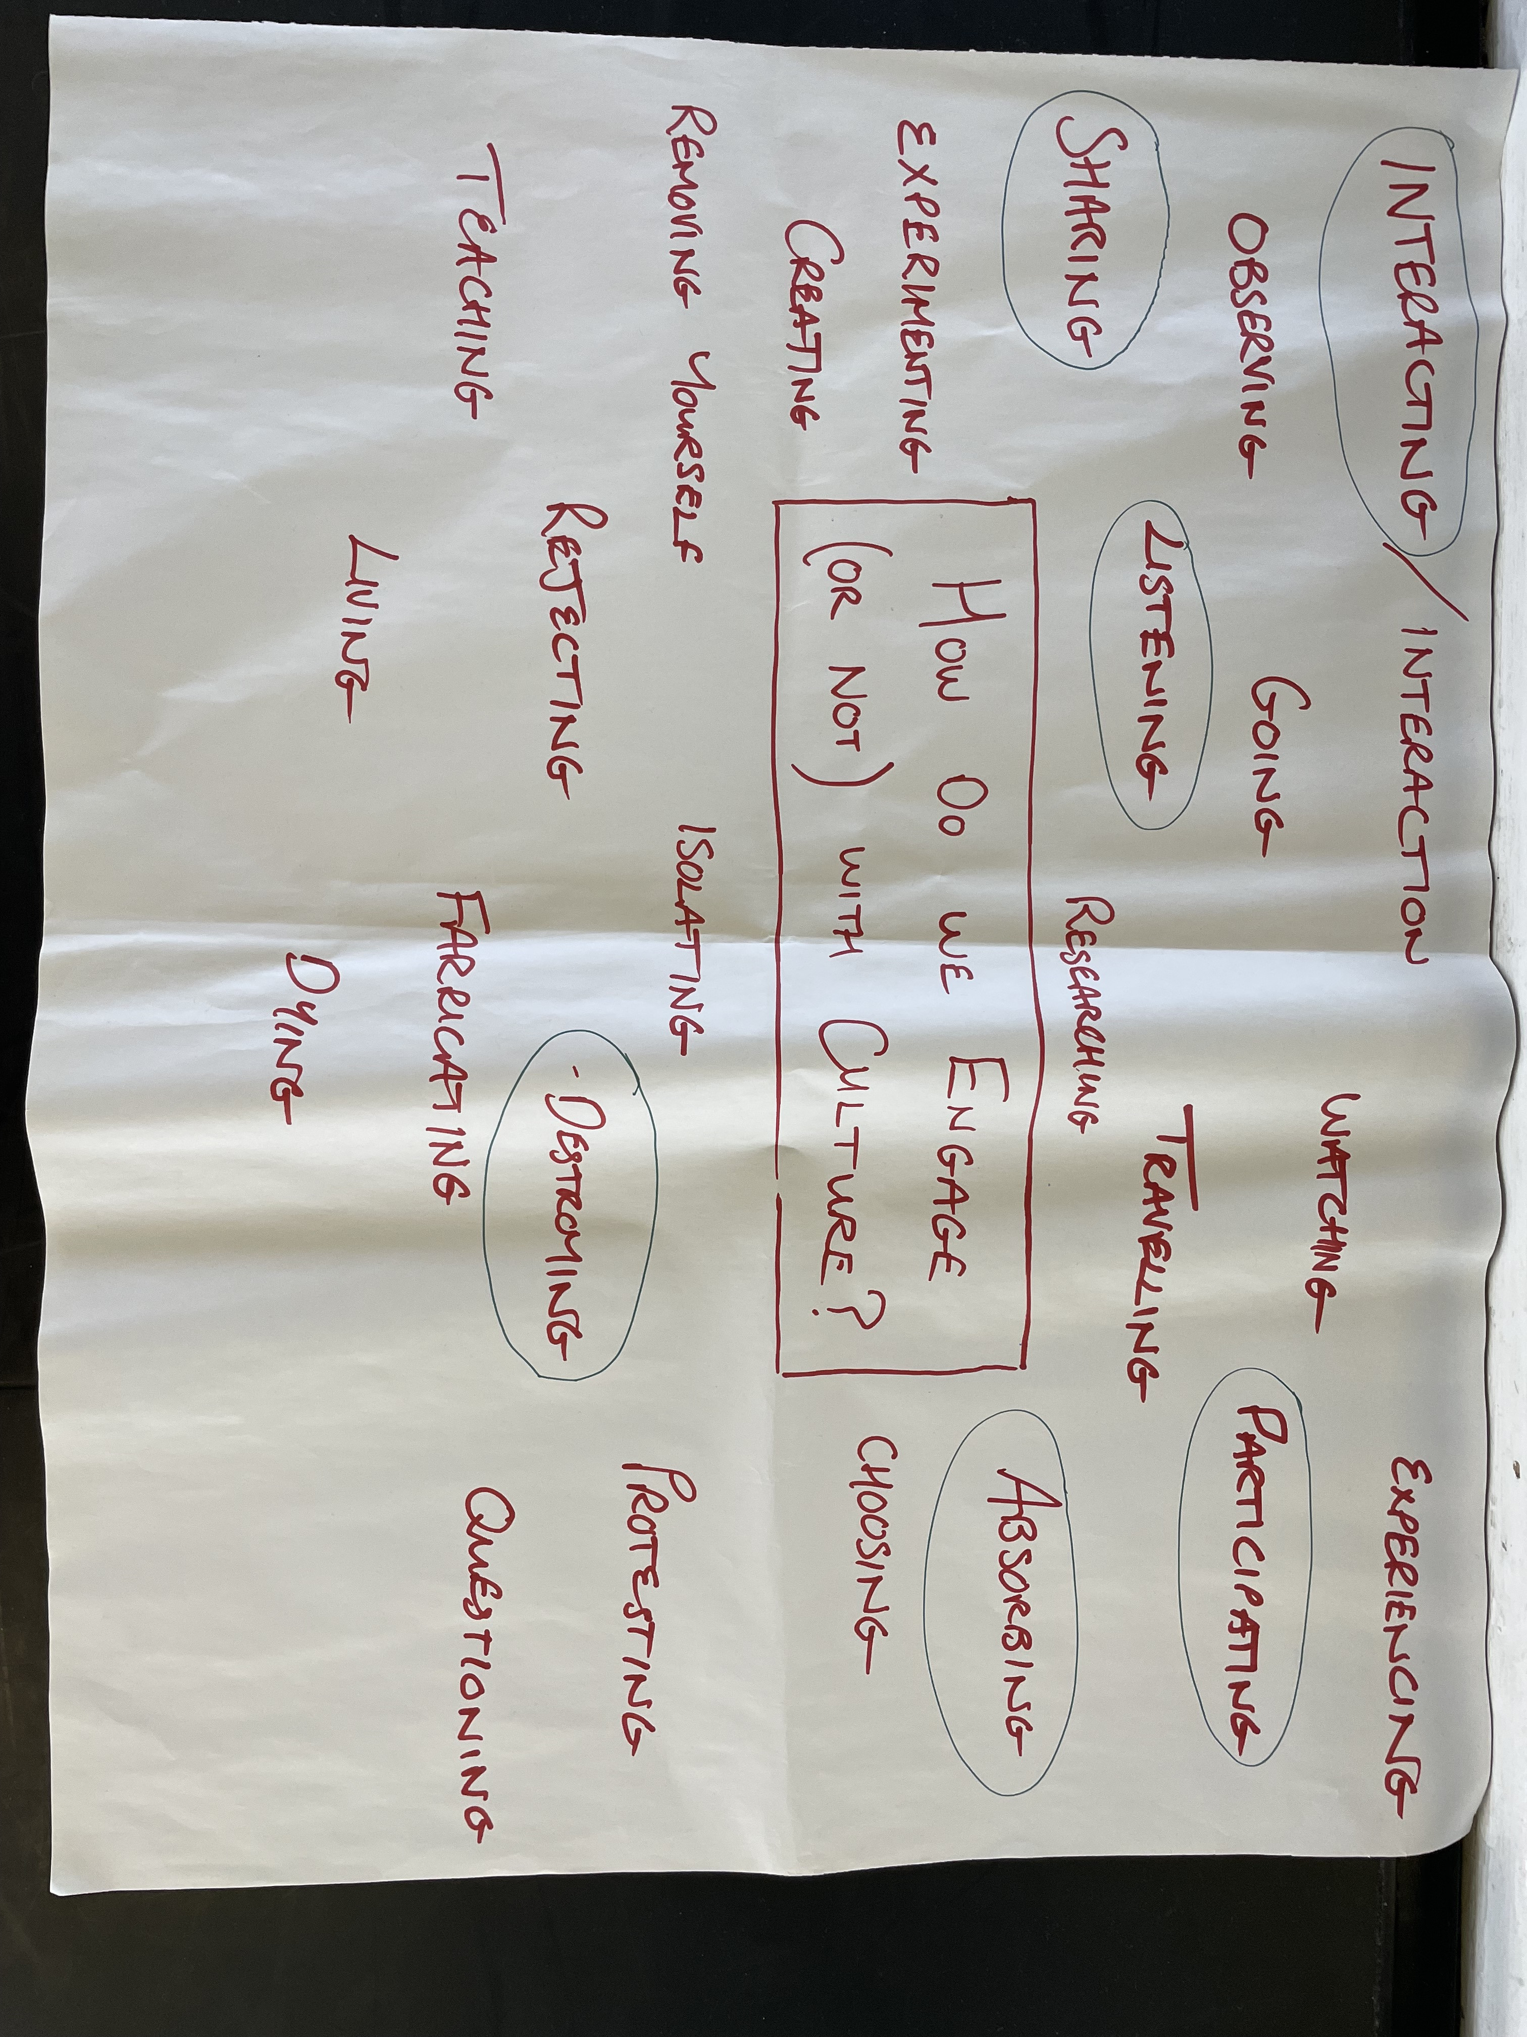

After brain storming these ideas we then wrote down words we wanted to focus on while creating our performance. I found these sheets particularly useful as it gave me ideas to the type of physical actions/ movements we would incorporate into our performance. For example the word sharing has many movements. Sharing a hug, a high five, sharing a secret. All the words linked in some sort of way that represents the coming together and building of human relation/connection, (which eventually became more of the focus than culture), which creates a culture.
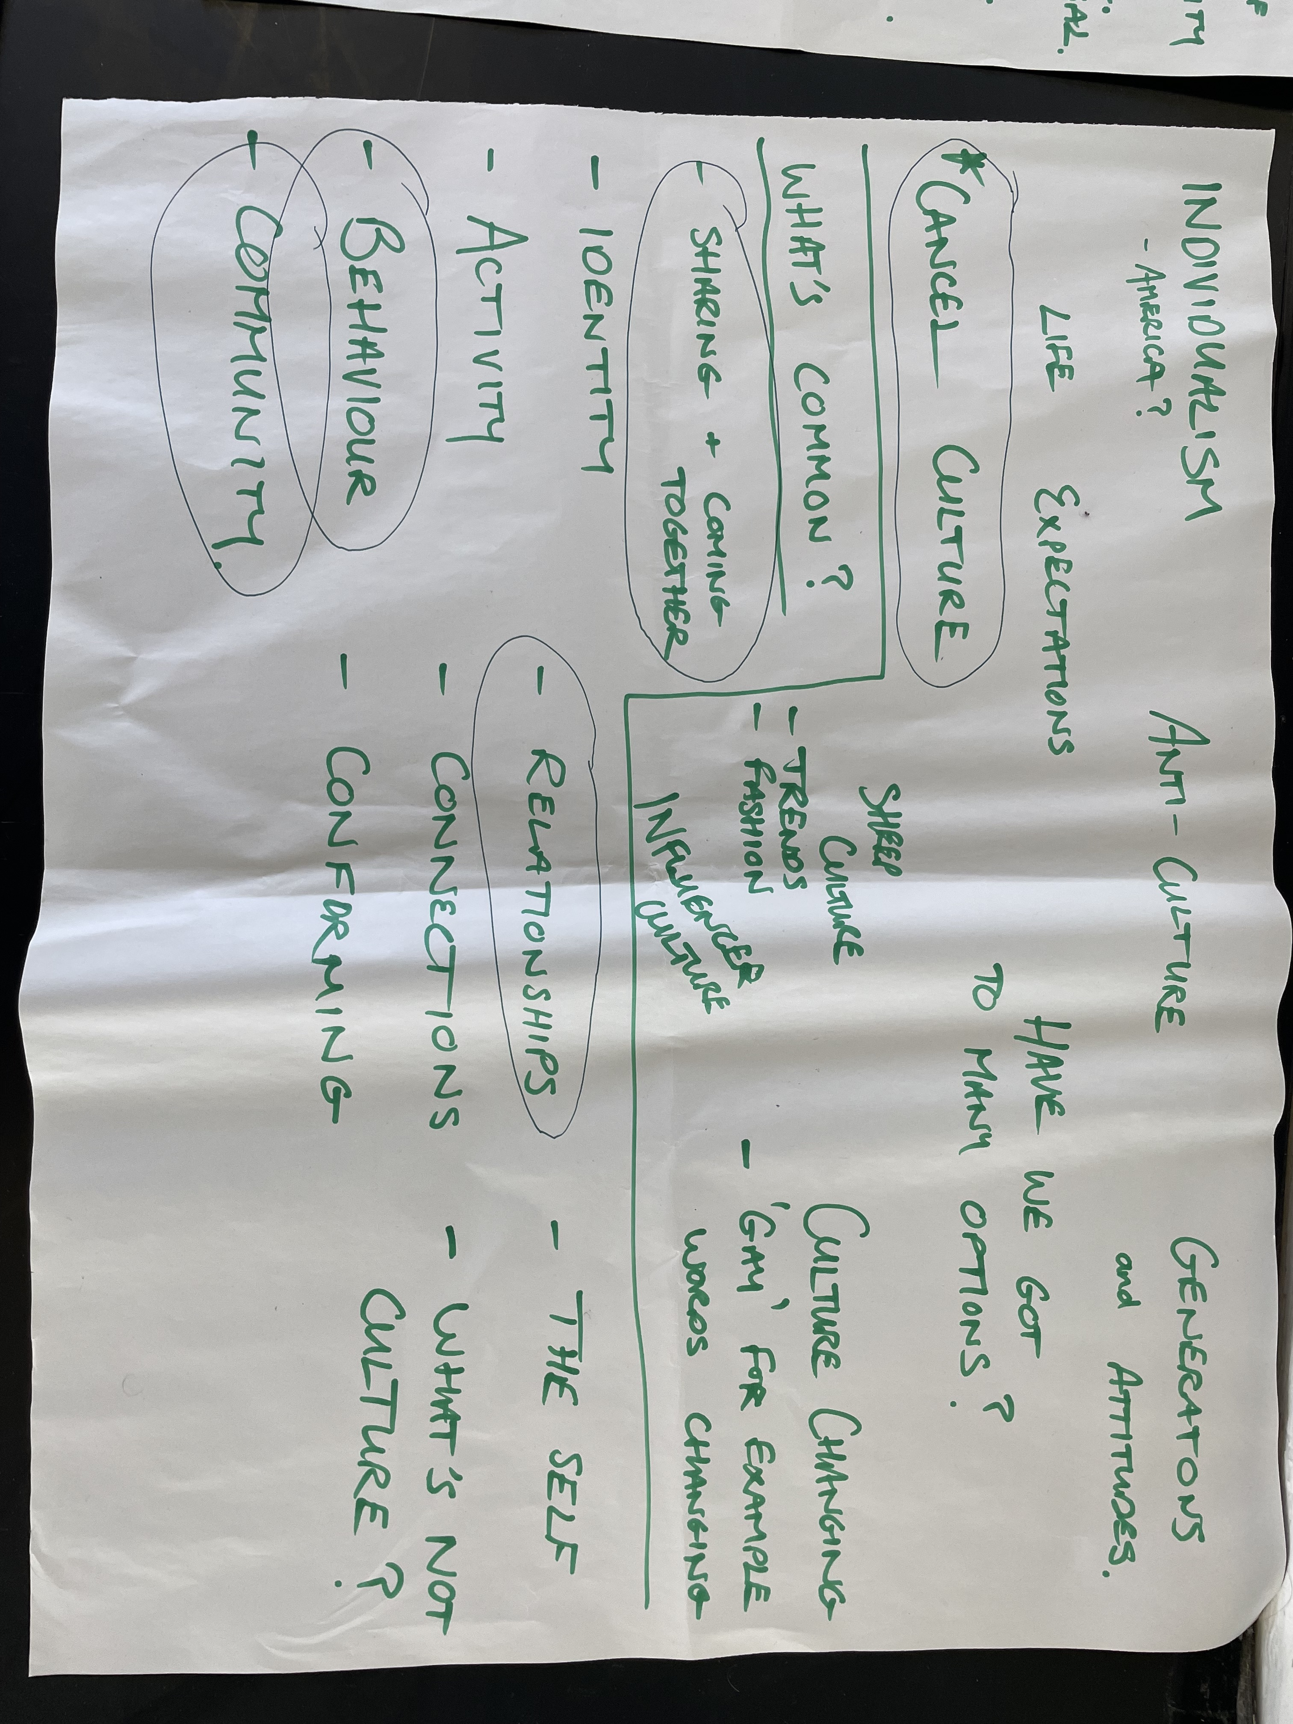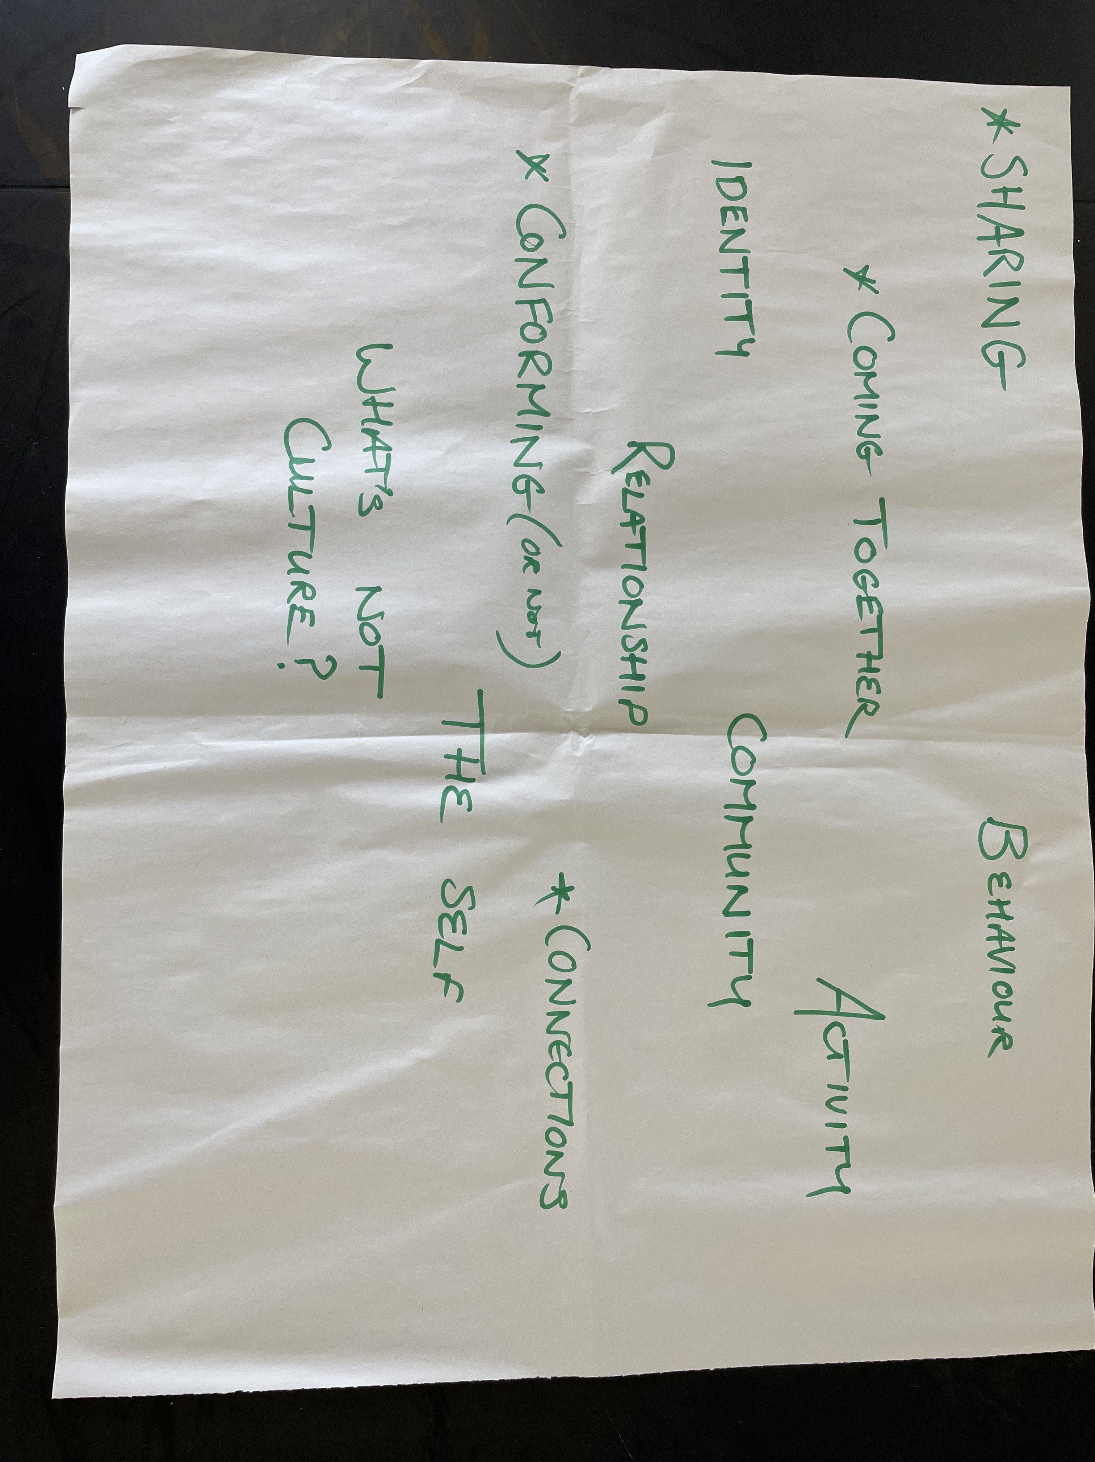
We looked at ways to create movement on stage and one practitioner we studied was Anne Bogart. We looked at her viewpoints. “Viewpoints is a philosophy translated into a technique for (1) training performers; (2) building ensemble; and (3) creating movement for the stage.”(Bogart)
Throughout our rehearsal process we learnt about the 9 viewpoints:
- Special relationship
- Kinaesthetic response
- Shape
- Gesture
- Repetition
- Architecture
- Tempo
- Duration
- Topography
These viewpoints influenced my movement throughout the module greatly. An example would be my kinaesthetic response, and tempo, to the audience interaction part of my performance. We played around with different ways to react to touch and the speed at which we would respond to said touch. Overall I believe most of our movements in Unit(e) relate to the viewpoints in some way and they’re theory I will use in the future to analyse and create movement.
Development
In the rehearsal space we looked at ways to physically represent culture becoming extreme/bad with time. An exercise we did to explore this concept physically was laughing for 10 minutes straight. I found this challenging because I became physically tired trying to maintain laughter for so long with my facial muscles aching and struggling with breath. In the performance there is a section where we have to laugh really over the top. The more we did this the less tiring it became.
We did a smiling exercise where we smiled on a scale of 1-10 with the smile becoming more exaggerated as the numbers went up. We then went from 11-20 and forced the body to be physically tense. 1-10 was just the face, and 11-20 we used our bodies. I found that using the body to create tension through movement, and targeted shaking of body parts can feed into the emotions, heightening the level of expression you are able to present. Doing this exercise made me aware of how much greater my personal limit of what I thought my biggest smile would be. I learnt that the body and physicality can feed into emotions and the face bringing things further. I will use this knowledge in the future when trying to portray a certain emotion or character in performance. The smiling exercise became part of our performance and exercised my awareness as performers because I have to use my peripheral to be in touch with the other performers to ensure we go up the scale at a similar time. Exercising an awareness to others around me is something I’ve actively had to do during these 6 weeks and is something I will take forward into future collaborations of theatre with other performers.
The 28 routine is a set movement piece with 28 movements in which we had to do a movement for each count with a total of 28 counts. We also learnt it reversed going back down from movement 28 to 1. I found this challenging to learn the first day we did it because there was a lot to remember in such a short amount of time. I found, when I practiced 28 independently, that using my own metronome at a slow tempo was helpful to ingrain certain sections of the choreography in my head in addition to be able to recognize parts I was getting wrong, why they were wrong, and then being able to correct them. I used this learning technique to practice these movements from the day we learnt 28 to performance week gradually speeding up the tempo as I become more confident in the movements. As I increased the tempo of the metronome the better my time keeping skills became the tighter the movements looked. I will learn future choreography’s, especially difficult ones, with a slow metronome at first because it will help with my performance timekeeping skills ensuring that I hit each movement in time, as well as helping me to learn movements in the most efficient way I know to this day. This technique can be applied to many other things like rapping/singing, or learning an instrument which are all useful to develop and add to my catalogue of skillsets as a performer.
During these 6 weeks I’ve exercised my creative skills. Examples of this were coming up with movements that represent myself, and then expressing those with a high amount of energy. We do this in the circles section of our performance where before 28 we dance to the chorus. I found it challenging to let go and commit to the movements. When advised to pretend as if the audience were there I performed as if they were there. Doing this is something that enabled me to let go and become more comfortable doing the movements. I also found that doing this gave me an insight to how far I can go with regards to a performance commitment and energy, helping me to push myself further and becoming more confident with being able to reach that level of commitment and energy for performance. Rehearsing as if the audience is in the room is something I’ll take forward into future rehearsals to improve and better my performances as an actor.
Taking notes of the feedback I received after each practice run of Unit(e) was valuable experience. Developing and practicing this gave me insight and experience to what doing a show over and over again would be like as a director always gives notes and makes changes to the performance. Having the challenge of applying each note to the new run-through of the show challenged me as a performer to apply the feedback I’ve received and also gave me something new to work on. Reflecting on each run, seeing what can be improved also gave myself and others the opportunity to improve with each run, and this reflective mind-set is a way of thinking that I will bring forward to all my future creative projects/performances to achieve a standard that I am both proud and happy with.
Along with creative, collaboration and teamwork skills have been developed throughout this process. In working in pairs or groups for certain sections, like creating duo greeting, or the insect lifting I found that I had to listen to what others were saying. Collaborating with others is something I’ve done over the whole time I have been at university. It always is a creative process, and it was amazing to exercise these creative juices over this project because I believe creativity is like a muscle. I also found that my teamwork and communication skills improved by working in groups and constantly bouncing off of my peers in set tasks. Continuing to create in a healthy working relationship with my peers is something I will strive for in future performance, trying to avoid working with dictatorial people and non-collaborative types.
Assessment Reflection
I’m happy with the energy myself and my peers had during the performance. I feel as though I gave it my all and thanks to the rehearsal process was confident in what I was doing and when. It enjoyed working with Mei and the rest of my class during this process and am extremely proud of everyone. I will definitely take forward the experience and what I have learnt into my future to better myself as a performer.

Bibliography
-Anne Bogart. (2004). Viewpoints and composition what are they?. In: Unknown The Viewpoints Book: A Practical Guide to Viewpoints and Composition. 2nd ed. London: Nick Hern Books. p7-12. Anne Bogart. (2004). Viewpoints and composition what are they?. In: Unknown The Viewpoints Book: A Practical Guide to Viewpoints and Composition. 2nd ed. London: Nick Hern Books. p7-12.

