

MSc Software Engineering
Agile Software Engineering Principles
University of Wales Trinity St David
Lecturer: Jaymie Phillips

By Lewis Wells.
1503245.

Table of Contents
Abstract 3
Introduction 3
Agile software development 3
Advantages of Agile 4
➢ Great customer satisfaction 4
➢ Predictable Costs and Schedule 4
➢ Stakeholder connection 5
➢ Accommodates change 5
Disadvantages of Agile 5
➢ Less documentation 5
➢ Scope creep 5
➢ Cost 5
SCRUM 5
Product backlog 6
Sprint Planning 6
Sprint 6
Sprint review 7
MVP 7
British Telecom Case Study 7
Waterfall approach 7
Agile approach 9
Conclusion 10
Bibliography 11

Figure 1 - Agile SDLC [5]. 4
Figure 2 - Scrum process [10]. 6
Figure 3 - Delivery cycle. 9
Figure 4 - Product quality transition. 10
Figure 5 - Deployment from Traditional to Agile. 10

Abstract

The following document will outline the fundamental principles in agile software development, it will also discuss some of the most popular agile methodologies and how they deviate from the traditional software development method.
The conclusion will evaluate the findings and provide feedback from the authors perspective on how agile affects the software development process.
The document will also evaluate the advantages and disadvantages of using Agile by using a case study from British Telecom for reference.

Introduction

Agile was introduced in the late 1990’s when the awareness of a small group of methodologies began to achieve growing attention due to them using a collaboration of longstanding concepts and innovative new ideas [1].
Agile software development is an approach taken when creating software which identifies the requirements and solutions by utilising a collaborative effort and ensures customer interaction is at the centre of the focus [1].
The agile manifesto adheres to a particular collection of core values which are:
- Individuals and interactions over processes and tools [2].
- Working software over comprehensive documentation [2].
- Customer collaboration over contract negotiation [2].
- Responding to change over following a plan [2].
These values are what clearly define the difference between an Agile approach and Traditional approach.

Agile software development

Any company or organisation which incorporates the agile approach will invariably make use of at least one agile methodology, the methodology will provide a proven way of undertaking the process of delivering software in an agile manner [3].
The agile approach deviates from the traditional way of developing and delivering software by why providing a more flexible approach. The traditional method (waterfall) is a very structured and rigid methodology which has an enormous amount of planning and paperwork, it also assigns the testing phase at the end of the development as opposed to an agile way of incorporating it throughout to produce a more robust system architecture [4].
The agile approach uses a cycle of iterations or sprints normally between 2 – 8 weeks to develop the against the user stories which have been pre-determined and agreed with the product owner and/or stakeholders. During this period the tasks which have been assigned are expected to be delivered, this may not indicate the end of the development of the software/product; It could denote the first of many sprint or iterations with each one having its own set of user stories. This cycle can be visualised in figure 1.
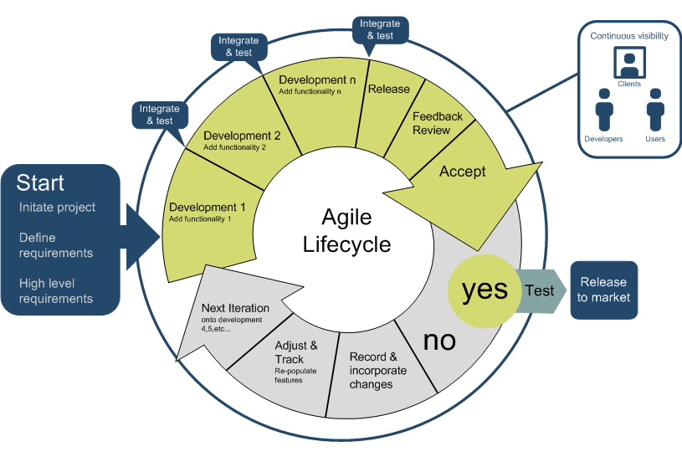
Figure 1 - Agile SDLC [5].
It is commonly believed that an agile approach is only beneficial to small projects and teams due to the nature of the approach; however, if an organisation has concerns about the reliability of this approach with a large project, they can choose to adhere to the SAFE framework (Scaled Agile Framework) [6].
The traditional approach has many benefits which make it useful for projects of all sizes; it is the disadvantages of the approach which is enticing more organisations to incorporate the agile way of working [6].

Advantages of Agile

There are numerous reasons for software to be delivered using an agile approach but the style does have drawbacks to, below describes some of the main advantages and disadvantages of adopting this style of working.
- Great customer satisfaction - because of the scale of involvement they have with the project, every sprint delivers a working feature of the software so they can provide feedback and check whether it meets their expectations [6].
- Predictable Costs and Schedule – According to ‘Segue Technologies’, “Because each Sprint is a fixed duration, the cost is predictable and limited to the amount of work that can be performed by the team in the fixed-schedule time box. Combined with the estimates provided to the client prior to each Sprint, the client can more readily understand the approximate cost of each feature, which improves decision making about the priority of features and the need for additional iterations” [7].
- Stakeholder connection – the stakeholders are highly involved with the production of the software to improve the visibility on the requirements the client actually needs, the collaboration between them and the project delivery team ensures that the software being developed meets the expectations and provides assurance for the client [8].
- Accommodates change – The ability for the projects requirements to change and it to have minimal effect on the software outcomes is one of the key features why companies decide to embrace this style, changing requirements is common and they can be implemented in the next sprint or iteration of the development giving the client increased reliability that the software meets their expectations. The new user stories will effectively take precedence in the next sprint with the less prioritised or redundant stories being driven back in the backlog [8].

Disadvantages of Agile

Some of the disadvantages of adopting this approach are:
- Less documentation – Although this is commonly listed as a benefit of Agile it can be detrimental in large or high risk projects, some projects require huge risk assessments and analysis before production can begin. This can also effect new members of a development or test team who don’t have the ability to understand what is expected because they documentation does not delineate it [6].
- Scope creep – Due to the possibility of changing requirements and clients constantly asking for extra features to be included, this can proceed to jeopardise the current workload and create an extensive backlog of items. In addition to this, work which may have already been completed on specific user stories or tasks and the client may change their mind if this is what they want which will result in time wasted on redundant features [6].
- Cost – Clients may not have a defined cost of the project because the costs run through the cycle of iterations and is no solely based on the whole project (waterfall); In contrast to this, it could be beneficial because the client could have a better indication when their software is delivered to their standard rather than paying additional costs for unnecessary requirements [9].

SCRUM
This agile approach focuses on effective team collaboration when considering intricate products and incorporates adaptive techniques to contend with any unexpected problems in the form of iterations and sprints [4].
A scrum team consists of a development team, a scrum master (agile manager) and a product owner. It is common for organisations to use elements of a methodology or framework and incorporate it with another to adapt to a better way of working, this could include things such as adding team members (business analysts) or integrating techniques which are not commonly used with the primary framework/methodology [4].
The illustration below by Ken Schwaber and Jeff Sutherland in their book “software in 30 days” and depicts the scrum process in action.

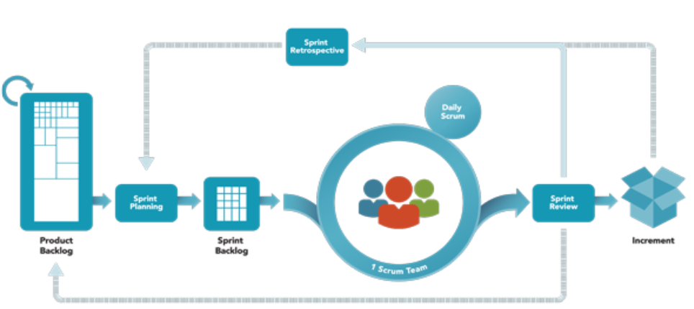
Figure 2 - Scrum process [10].

Product backlog
The product backlog is essentially an array of tasks which need to be completed in the project, this is often where the user stories are found but the backlog can contain tasks of a technical description. The product backlog would not be found if using a traditional approach, the traditional approach will involve using a requirement specification document which will outlines the tasks in an incredibly detailed way [11].
The product backlog is organised by the scrum team to include a priority for each element and a difficulty rating which is discussed and agreed before proceeding to undertake the user stories. This ensures that the highest priority user stories are attempted first and an understanding is gained of the complexity of the tasks/user stories. The user stories discussed in the backlog are deconstructed and then assigned to the development team accordingly in a sprint plan [12].

Sprint Planning
A sprint plan consists of the scrum team meeting with scrum master and product owner to discuss the product backlog and provide assistance in identifying the tasks which are required to complete the user stories. A sprint backlog is constructed from the result of this meeting and the development team/test team can then develop against these tasks and requirements [13].

Sprint
A sprint consists of a sprint goal which the team must agree on before the sprint begins, the sprint goal is what the team aim to achieve within the sprint period which is usually between two and four weeks [13].
Each day the scrum master holds a daily stand-up meeting with the rest of the scrum team and they create a plan of action for the next 24 hours regarding the sprint. This is a key principle in agile, this augments the team collaboration and execution by examining the work previously done in the last daily stand-up and forecasting the expectations and plans for the future [13].

Sprint review
A sprint review is held at the end of a sprint to access what has been achieved during this phase, it is also a chance for the product owner to declare what items have been completed and what have not. Information gathered in this meeting can be used in the next sprint plan to further engage the collaborative effort by the scrum team, it can also identify the next tasks which should commence on the next sprint [4].

MVP

The minimal viable product is terminology often used in agile to describe the delivery of a product with minimal features which can be delivered to customers [14]. There is a common misconception regarding what the MVP is actually intended to represent. Eric Ries is the Author of ‘The Lean Start-up’ and suggests that “the minimum viable product is that version of a new product which allows a team to collect the maximum amount of validated learning about customers with the least effort” [15]. While the statement may seem inferior it can be understood that depending on the working environment or organisation which delivers software to clients, can have different interpretations to what signifies a MVP.

British Telecom Case Study

British telecom until 2004 adopted a traditional approach in the delivery of the I.T programmes produced, in 2004 a new CIO systematically revolutionised the redundant approach being utilised at the telecommunication giants [16].
This evaluation will discuss an article produced by Ian Evans from British telecom, the article discusses the transition from a traditional development approach to an Agile development approach. It delineates the issues which corresponded to the traditional way of working and provides an insight into how the Agile approach has revolutionised the I.T department [16].

Waterfall approach

British telecom successfully managed to deliver solutions to the vast amount of projects they undertook; however, they were highly criticised for delivering the solutions outside the desired time-frame [16].
The organisation employs a large number of I.T professionals including:
- Project and delivery managers.
- Architecture and Design specialists.
- Software engineers.
- Software Testers.
- Operational support team.
The I.T teams are responsible for overseeing the projects and the development and delivery of it, during the waterfall era the team encountered problems such as:
Poor requirements captured
Stakeholders where concerned about including their known requirements for the upcoming release of the products. When the requirements originally were required the stakeholders desired them; however, due to the duration of time it took to implement these they were no longer required. The requirement stated often bared no correlation to the solution of the problem raised, it was acknowledged that there were a multitude of meaningless requirements which had no relevance to the solution of the actual problem [16].
Divided design
The precipitous volume of requirements invariably led to confusion understanding the meaning and relevance to the software, this led to valuable team members being allocated to other software projects and this had a detrimental effect on the previous one.
Due to the nature of the requirements there was a degree of uncertainty understanding what the stakeholders regarded as a completed design or task, stakeholders often expressed their concern over the expectation of the design and what they received; this led to stakeholders refusing to sign off designs as they interpreted them as not finished or incorrect [16].
Development
As previously mentioned there was huge confusion and disappointment regarding the design stage which inevitably proceeded to cause difficulties in the implementation/development phase. The prolonged design phase and ambiguous design led to the development teams creating solutions against unpredictable designs, this was to try and save precious time and to ensure the projects had more time to meet their target date [16].
Testing
The projects diverted to the test teams often were released to them weeks or months after the test teams expected them, this compromised the possibility of integrating the code completely bug-free. The lack of regression testing and proficiency to sufficiently perform required testing methods to fragmentary code caused the development teams to make essential modifications to the code which had a detrimental effect on the other project they were working on. The integration of the code takes months instead of weeks and important resources are being consumed when needed elsewhere. It was apparent at this time that projects would not be completed anywhere near the agreed delivery date which created an unconceivable frustration for the business.
After months and months of anticipation the software can be finally released, unfortunately the demand for the software holds no relationship to what was previously required. The scope of projects was frequently being undershot and the arbitrary requirements forced the projects to take up considerable resources and time. Furthermore, the amount of redundant software never utilised by the organisation due to the time frame they were released in demonstrated mass waste of money and human resources [16].

Agile approach
In 2004 a revolutionary approach was taken by the organisation which saw the company adopt an Agile ethos regarding the software development process, this approach would provide solutions to the previous pre-existing problems the company faced using a traditional (waterfall) approach.
Some solutions to pre-existing problems were identified:
- It was identified that necessity to have large amounts of documentation and requirements was not essential (waterfall), the introduction of user stories and prioritising what was integral to overcoming the problem would be a core principle in challenging the software projects (figure 3). Breaking the problems down into small iterations or sprints helped improve the quality of the software produced [16]. The transitions from Waterfall to Agile regarding this issue are demonstrated below:
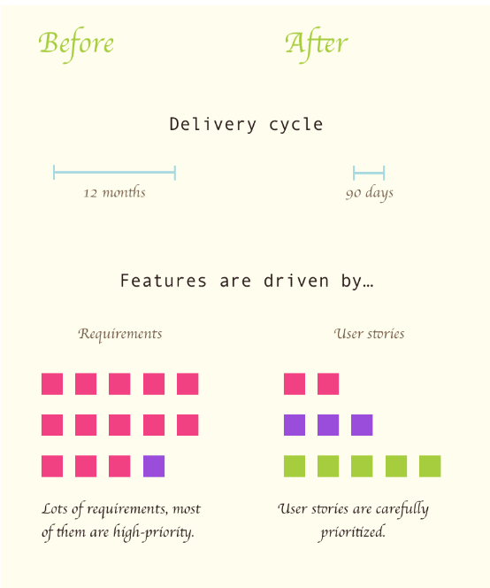
Figure 3 - Delivery cycle.
- Including the customer at all times ensures that the product is being designed and developed to the expectation they maintain [12].
- The problem is broken down into a more controllable segments (sprints in scrum), this allows for clear and concise responses from the customer and assurance is obtained about the direction of the projects [12].
- The development and testing approach will consist of “test first” and integration testing to provide a solution to issues faced in the waterfall approach. This will allow the development team and test team to begin their work immediately after getting the requirements and aids in the process of sub dividing convoluted problems (Figure 4).
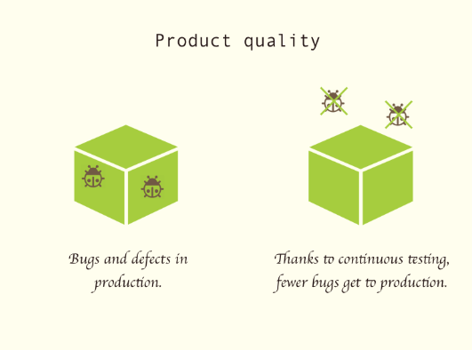
Figure 4 - Product quality transition.
- The more efficient working environment provided by using an Agile ethos ensured that the deployment of software can be effortlessly achieved, utilising the continuous delivery approach assured the customers/stakeholders that the product would meet the expectations and delivery date (Figure 5).
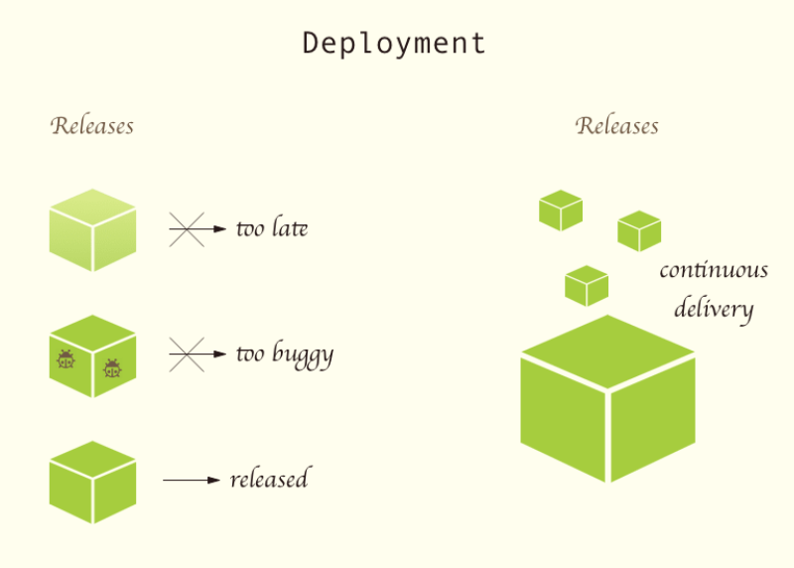
Figure 5 - Deployment from Traditional to Agile.

Conclusion

It can be concluded that adopting an agile or traditional approach to software development is purely dependent on the project. For large projects with high risk involved the traditional approach may seem more beneficial than the agile way.
Based on the research undertaken it can comprehensively suggest that for small to medium sized projects an agile approach would enhance the delivery of the projects and provide greater client satisfaction.
BT Case
The transition from a completely “waterfall” based organisation to an organisation which practices the Agile ethos took considerable time and effort. The transition has renovated the I.T department and this has resulted in a major improvement regarding the delivery of value for business, the company now adopts the Agile way has no intention of returning to the traditional approach. The transition has not come without problems, using a test driven approach was incredibly hard to implement as the mainstream systems are constructed around legacy code and external sourced components. The previous systems are scheduled to be updated and transform for the legacy state, this will be completed when funding is granted [16].

Bibliography

[1] | D.-B. C. TsunChow, “A survey study of critical success factors in agile software projects,” Agile Product Line Engineering, vol. 81, no. 6, pp. 961 - 971, 2008.
[2] | Agile Manifesto, “Manifesto for Agile Software Development,” Agile Manifesto, 2001. [Online]. Available: https://agilemanifesto.org/. [Accessed 03 January 2019].
[3] | J. S. H. T. Darrell K. Rigby, “Embracing Agile,” Havard business review, pp. 1 - 16, 2016.
[4] | M. Cohn, Succeeding with Agile: Software Development Using Scrum, Pearson Education, 2010.
[5] | Software Design Consultants, “Agile,” Software Design Consultants, 23 November 2011. [Online]. Available: http://sdc.net.au/services/application-development.aspx. [Accessed 03 January 2019].
[6] | D. S. D. G. Sheetal Sharma, “Agile Processes and Methodologies: A Conceptual Study,” International Journal on Computer Science and Engineering (IJCSE), vol. 4, no. 5, pp. 892 - 898, 2012.
[7] | Segue Technologies, “8 Benefits of Agile Software Development,” Segue Technologies, 25 August 2015. [Online]. Available: https://www.seguetech.com/8-benefits-of-agile-software-development/. [Accessed 03 January 2019].
[8] | W. K. L. W. Y. T. S. F. T. Yu Beng Leau, “Software Development Life Cycle AGILE vs Traditional Approaches,” 2012 International Conference on Information and Network Technology (ICINT 2012), vol. 37, pp. 162 - 167, 2012.
[9] | M. M. B. G.-M. Marian Stoica, “Software Development: Agile vs. Traditional,” Informatica Economică, vol. 17, no. 4, pp. 64 - 76, 2013.
[10] | J. S. Ken Schwaber, Software in 30 days, John Wiley & Sons, 2012.
[11] | K. Schwaber, Agile Project Management with Scrum., Microsoft Press, 2004.
[12] | S. S. S. S. M. M. D. S. S. Irum Inayat, “A systematic literature review on agile requirements engineering practices and challenges,” Computers in Human Behavior, vol. 51, no. B, pp. 915 - 929, 2015.
[13] | D. K. P. Andrew T. Pham, Business-Driven IT-Wide Agile (Scrum) and Kanban (Lean) Implementation, New York: CRC Press, 2012.
[14] | P. Veyrat, “Can Scrum and Minimum Viable Product methodologies work together?,” HEFLO, 15 December 2017. [Online]. Available: https://www.heflo.com/blog/agile/minimum-viable-product-scrum/. [Accessed 03 January 2019].
[15] | E. Ries, The Lean Sartup, Penguin uk, 2011.
[16] | I. Evans, “Agile Delivery at British Telecom,” Methods and tools, 14 July 2006. [Online]. Available: http://www.methodsandtools.com/archive/archive.php?id=43. [Accessed 03 January 2019].

