Abstract
This document constitutes a 31-page portfolio which includes one 1500-word critical reflection and several subsequent examples of supporting evidence. Both the reflection and supporting evidence convey my engagement with and promotion of the Welsh language throughout my PGCE year.
1500 Word Critical Reflection
Throughout my PGCE, I have taken several steps in order to promote the learners’ development of the Welsh language in accordance with the aims of the Donaldson curriculum. For instance, upon joining Swansea University of Wales Trinity Saint David (UWTSD) I undertook its entry level Welsh course, partook in a Welsh micro-teach and have consistently attempted to incorporate incidental Welsh within my professional teaching experiences. Whilst studying at UWTSD, I opted to develop my Welsh speaking skills at entry level for various reasons. For example, primarily, I endeavoured to familiarise myself with basic Welsh speaking and listening skills in order to increase my knowledge of incidental Welsh. In turn, I hoped that these skills would enhance my Welsh translation, interpretation, and overall communication competency. Consequently, and more importantly, I had hoped that these components would strengthen my ability to deliver secondary school English lessons that incorporated and exposed my pupils to the Welsh language. The purpose of this was to support the pupils in developing their use of the Welsh language in correspondence with Donaldson’s intentions.
Indeed, I believe that the university’s sequence of Welsh sessions supported the development of my basic Welsh competency skills. For instance, the sessions covered a range of Welsh topics which have aided my basic Welsh translation, comprehension and communication skills. For instance, within the sessions I have been introduced to basic but essential Welsh language components that have supported my recently developed Welsh entry skillset. Such include, the Welsh alphabet, vowel and consonant sounds and the placement of Welsh accents. The sessions have also familiarised me with helpful Welsh conversation starters and questions such has hello (Shwmae), good morning (Bore da) and good afternoon (Prynhawn da) type greetings. They have also taught me how to express emotions in Welsh in terms of how I might be feeling (e.g. Rywn bendegedig). In turn, I have learned how to inquire about how others are feeling (e.g. Sut wyt ti?) and express Welsh praise

adjectives such as “fantasteg”. I have also been introduced to the format of the Welsh date regarding Welsh translations for weekdays and months. Moreover, I have become familiar with Welsh basic grammar formations. Resultantly, I am now able to recognise a modest variation of masculine and feminine Welsh words as well several key Welsh route verbs.
As well as having the opportunity to explore basic Welsh literacy, the sessions have introduced me to basic Welsh numeracy recognition skills. This has supported my ability to state both singular numbers and number combinations as well as the time in Welsh. Resultantly, both the literacy and numeracy related skills that I have had the opportunity to explore within the Welsh sessions, have enabled me to incorporate incidental Welsh within my pedagogy thus far. For example, during the English lessons that I delivered whilst on placement, I drew from and implemented the Welsh language knowledge that I had gained at university. For instance, upon the learners’ arrival to my lessons I greeted them in Welsh. I also stated the Welsh date and at times requested that the class inform me of the Welsh date in order to support them in recalling Welsh months and week days. I also responded to the class with Welsh command words such as “dwylo I fyny” and “dim siarad”. Moreover, I actively utilised Welsh feedback in terms praise.
To further enhance my ability to incorporate Welsh within my future practice, whilst at university I partook in a Welsh micro-teaching exercise. My micro-teach consisted of a ten-minute English Literature lesson on the topic of ‘Inference Skills’. Within this lesson, I incorporated several elements of the Welsh entry level competency framework. In order to support the learners in achieving entry level listening skills I aimed to develop the learners’ ability to understand and respond to simple every-day sentences. Thus, I opened the lesson with the basic sentence “Prynhawn da pawb, sut wyt ti?” This consequently gave the learner’s an opportunity to practice their listening and speaking skills simultaneously. For example, the learners were initially required to access the meaning of the greeting phrase by utilising their listening skills. Consequently, to practice their speaking skills they needed to verbally respond with the appropriate word choices. This also prompted the learners to access Welsh vocabulary such as “Rwy’n dda iawn, a chi?”
Within my micro-teach, I also gave the learners several other opportunities to access simple sentences and Welsh vocabulary. For example, to introduce the class to the topic of the lesson ‘Inference’ and promote learner

engagement with the Welsh language, I opened with the question “Beth yw casgliad?” For the purpose of the learner’s clarity, I then stated its translation, “What is an inference?” The purpose of questioning my learners through both Welsh and English translation was to enhance their understanding of simple Welsh sentences in accordance with the Welsh entry framework’s listening component. Upon my English translation question “Beth yw casgliad? ” (What is an inference?) the class began to respond with suitable answers such as “When we make an inference, we are working something out based on the clues that we are given.” Therefore, this granted me an opportunity to further engage with Welsh vocabulary through directing praise words to the learners such as “da iawn pawb.” The core phase of the lesson further enabled me to expose the learners to several other forms of Welsh vocabulary. For instance, within my lesson on the classroom PowerPoint I presented the learners with the following character description of J.K. Rowling’s Albus Dumbledore:
“Professor Dumbledore was tall, and thin with silver hair and a beard…His blue eyes were light, bright and sparkling behind half-moon spectacles and his nose was very long and crooked, as though it had been broken at least twice."
Beneath this description I placed the following word bank, including English and Welsh adjective and sentence starter translations:
WORD BANK:
Direidus (Mischevious) Ddidoral (Interesting)
Ymladdwr (A fighter) Infancc (Young)
Hen (Old) Diflas (Boring)

Mae Dumbledoreyn_______achos______________.
Dumbledore is_______because_____________ .
In order to enhance the classess’ Welsh word recognition ability via their listening skills, I pronounced each of the words displayed above along with the Welsh sentence starter. After stating each Welsh word, I requested that the class “repeat each word afer me”. In turn, I hoped that this would support their speaking skills in terms of pronounciation. Hence, this would assist the learners

during the inference task that I had pepeared. This task required the learners to infer which of the Welsh words displayed above most appropriately described Dumbledore’s personality, based on the character desctiption provided. Thus, during the task phase I requested that the pupils state their answers in a full Welsh sentence, using the sentence starter provided as displayed above. Through exposing the learners to both written and spoken versions of the above Welsh adjectives and sentence starter, I aimed to introduce the class to Welsh words with which they might not yet be familiar. In turn, through this activity I endevaoured to increase their knowledge of Welsh vocabulary in order to develop their Welsh langauge skills.
On reflection, I would consider my Welsh entry micro- teach a successful introduction to various Welsh entry level skills for beginner learners. For example my inclusion of a Welsh translation wordbank enabled me to support the learers in engaging with Welsh entry level reading, listening and speaking skills, for the learners were automatically required to utilise each componant during in the set task. Moreover, through the support of pronunciation practice, vocabulary translation and sentence starter provision, the learners were able to engage well with the lesson content. This was confirmed when I noted that each learner was able to partake in each activity whilst correctly pronouncing the words that I had earlier introduced them to in the “repeat after me” activity. Thus, I believe that this lesson particularly supported the learners’ Welsh speaking skills, both in terms of simple sentence structure and pronunciation. Moreover, I believe that through the use of Welsh greetings and command words as afore discussed, my lesson was further successful in exposing the class to Welsh entry level vocabulary. Nevertheless, despite enabling learners to develop their reading, speaking and listening skills, within my micro-teach learners were not required to engage with Welsh entry writing skills such as correctly writing simple sentences. Consequently, during in future lessons I will create an activity that enables students to construct basic Welsh sentences in a written as well as spoken format. In turn, this will enable me to support prospective learners’ Welsh written skill development. Consequently, I will take this action point forward and implement such activities within future lessons.
In conclusion, this reflection has enabled me to consider several areas in which I have engaged with and promoted the Welsh language throughout my PGCE year. Such include my engagement in the Welsh sessions provided by the UWTSD as well as my attempts to promote Welsh during my own professional teaching experiences. However, it has also alerted me to the notion that I must

adapt my current lesson plans to incorporate activities that promote learners’ Welsh writing skills alongside their reading, speaking and listening skills. Moreover, since my lessons predominately promote Welsh entry level literacy, I must endeavour to incorporate elements from the next phase of the Welsh entry framework (Foundation Level). In turn, this may support both my own Welsh language development as well as my future pupils’.
Supporting Evidence
Example 1 (Welsh Micro-teach lesson plan and PowerPoint):

Lesson Plan Phase 1

Lesson Plan – Step 1 Cynllun Gwers – Cam 1

Student-teacher | Lucy Sullivan | Class: | Micro Teach Group
AoLE or Subject | English Literature | Date: | 09/03/2020
Lesson Focus: | Developing Welsh vocabulary within an English lesson whilst focusing on the use of inference skills.
Meaningful links to Curriculum | Cross-curricular responsibilities.
Meaningful links to:  Cross Curricular Responsibilities | The lesson will utilise Welsh synonyms alongside their equivalent English synonyms in order to expose the learners to the subject discipline of Welsh.
Personal Targets (Linked to QTS)

To utilise an increased amount of Welsh vocabulary alongside my current implementation of incidental Welsh.

Learning Objectives (focus on Learning- use accessible vocabulary):
The pupils will learn to:

- To create character descriptions with the use of inference skills and Welsh adjectives.

- To read, identify and pronounce several Welsh adjectives.

- T construct a full sentence in Welsh with the incorporation of Welsh adjectives.

Success Criteria (clearly linked to each Learning Objective and related to the process and/or product of learning) | Assessment of Pupils’ Learning  Evidence  (What have the learners to say/write/do/produce – to demonstrate learning)
- To identify the correct Welsh adjective that can be utilised appropriately to describe a given character. | - To select the most appropriate adjectives from a given set of adjectives  - To describe a given character using that adjective in a full Welsh sentence with the support of the scaffold provided

Time | Activities/Methodology/Key Concepts  (Teacher’s Role – including key teaching points, differentiation strategies and key questions) | Pupil Tasks  (Pupils’ role –including differentiation, engagement in formative assessment and homework) | Resources  (Including Health and Safety requirement)
Opening phase (with links to prior learning) | Firstly, the learners will be greeted with the Welsh phrase for good afternoon- prynhawn da, so that they are exposed to incidental Welsh vocabulary upon a rival.  Secondly, several learners will be asked “How are you? In Welsh- “Sut wyt ti yn Gymraeg?” in order to further encourage their practice of and familiarity with incidental Welsh vocabulary.  Thirdly, the learners will be asked to note down the Welsh date and the Welsh word for lesson objective (Nod) before being asked to note down the full lesson objective alongside the Nod: To create character descriptions with the use of inference skills and Welsh adjectives. | The learners are expected to respond with the Welsh greeting prynhawn da.  The learners are expected to respond to the question Welsh. For example, through a sentence such as “Dwi yn gwych” (I am great).  The learners must note down the Welsh date and lesson objective. | Power Point.
Teaching & Core Learning | Once the opening phase is complete, the learners will view a power point slide which reads:  Beth yw casgliad?  What is an inference?  I shall then read each sentence aloud to the students, in order to re-emphasise the main focus of the lesson (utilising inference skills. The Welsh translation for “What is an inference?”- “Beth yw casgliad” shall be read in order to further expose the learners to Welsh vocabulary and translation. Next, in Welsh the learners will then be asked to raise their hand “codwch eich llaw”.  After the learners have contributed their answers, I shall provide of what an inference is. This summary shall also be displayed on the class power point:  When we make an inference, we are working something out based on the clues we are given.  Next, I shall read a short character description of Professor Dumbledore from the Harry Potter fictional book series.  Then, the classes attention will be drawn to a series of English adjectives alongside their Welsh translations. The class will then be asked to utilise their inference skills in order to select which adjectives they believe best describe Albus Dumbledore. The class will be asked to raise their hands and give a full description of Dumbledore using the Welsh adjective they have selected and the Welsh scaffolding sentence on the power point:  Mae Dumbledore yn_______achos___________________________.  Dumbledore is_______ because______________________________. | The learners will be expected to raise their hands in response to “codwch eich llaw” if they know the answer to the question “What is an inference/ Beth yw casgliad?”  In response to “codwch eich llaw” the learners are expected to raise their hand in order to offer an appropriate description of Albus Dumbledore using the Welsh adjectives and scaffold provided.
Plenary | Without the support of the power point translations, the learners will be asked what the equivalent English words are for the Welsh adjectives stated by the teacher. | The learners are expected to state the English translation of the Welsh adjectives they have been introduced to during the lesson. | Power Point.

Lesson Plan – Phase 1
Evaluation of the Learning Experience
(include references to QTS)

Evaluation of Pupil Learning

Evidence of Learning (including attitude to learning over time)) | The learners engaged with the content of the lesson. They understood what was meant by the term inference and were able to contribute answers with appropriate Welsh vocabulary.
Next Steps for Progress | The pupils must explore an alternative character in order for them to practice using alternative Welsh adjectives within their character descriptions.

Reflective Analysis of Teaching and Strategies For Development – including justification/rationale for pedagogical choices

Evidence of my Effective Practice | Each learner was able to partake in each Welsh vocabulary based lesson activity.
Areas for my Development  Personal Targets for Progress | I must provide learners with an increased range of Welsh response sentence scaffolds and structures in order to further develop their Welsh competency.  I must familiarise myself with a greater range of Welsh sentence structures.

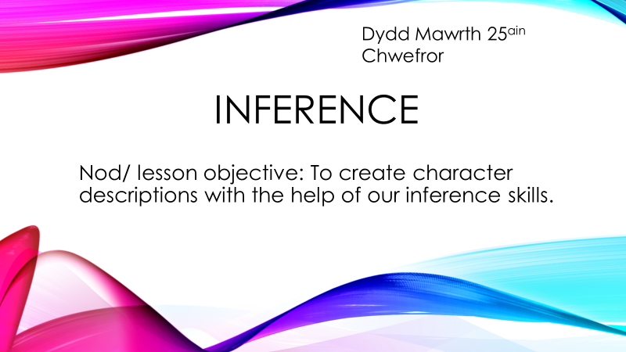
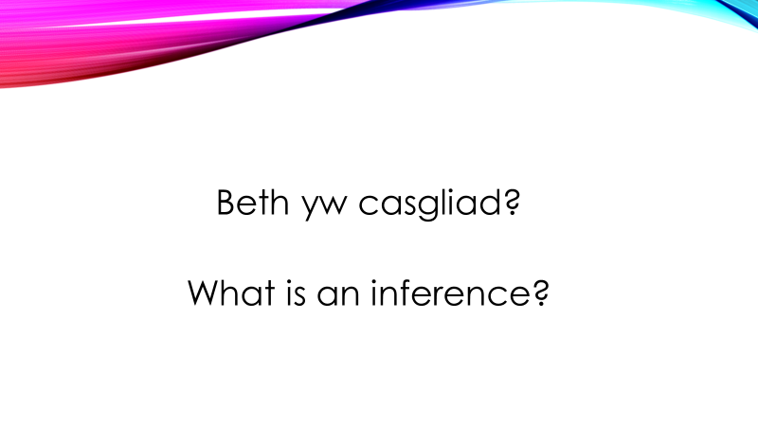

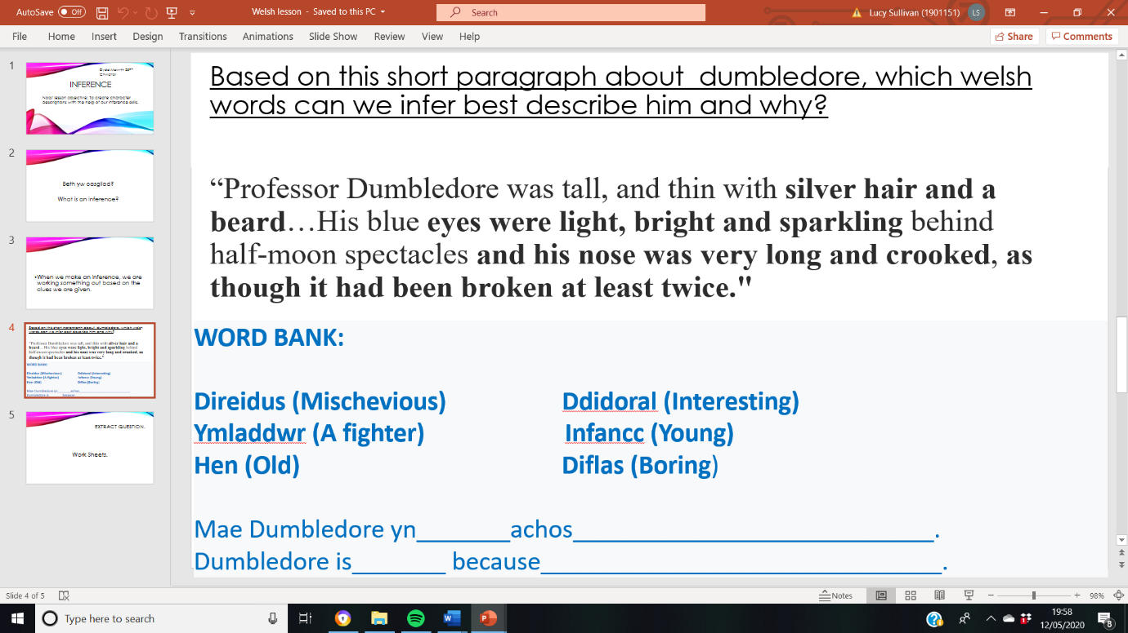
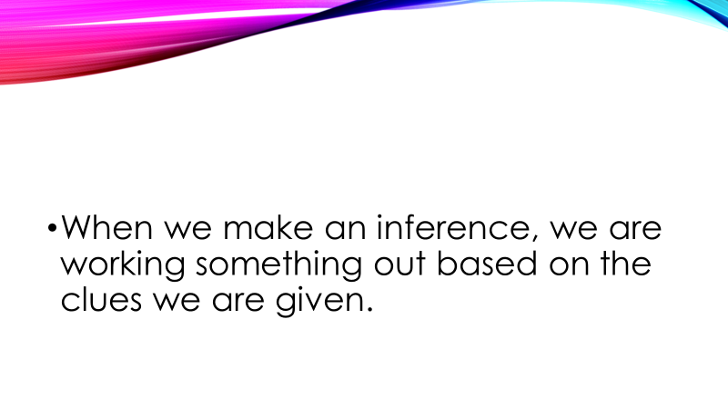
Example 2 (professional teaching experience lesson plans)

Lesson Plan – Step 1 Cynllun Gwers – Cam 1

Student-teacher | Lucy Sullivan | Class: | 8I2
AoLE or Subject | English | Date: | 06/02/20
Lesson Focus: | Right to Life
Meaningful links to Curriculum | Problem solving creative and critical thinking.
Meaningful links to:  Cross Curricular Responsibilities | Literacy.  Incidental Welsh.
Personal Targets (Linked to QTS and identified in weekly review)

To maintain my improved activity timing.

Learning Objectives (focus on Learning- use accessible vocabulary):
The pupils will learn to:

To evaluate and discuss whether or not everyone deserves the right to life.

Success Criteria (clearly linked to each Learning Objective and related to the process and/or product of learning) | Assessment of Pupils’ Learning  Evidence  (What have the learners to say/write/do/produce – to demonstrate learning)
The pupils must utilise their creative and critical thinking skills.  The pupils must understand what is meant by the word ‘ethical’.  The pupils must be able to comprehend the information within the given article.  The pupils must be able to explain their answers in full sentences. | The pupils must verbalise their understanding by participating in the question and answer based task discussion.  The pupils must complete the comprehension task in full sentences.

Time | Activities/Methodology/Key Concepts  (Teacher’s Role – including key teaching points, differentiation strategies and key questions) | Pupil Tasks  (Pupils’ role –including differentiation, engagement in formative assessment and homework) | Resources  (Including Health and Safety requirement)
Opening phase (with links to prior learning) | The pupils will note down the Welsh date, title and Welsh word for ‘Nod’ followed by the lesson on objective. In order to further promote the Welsh language, I shall utilise incidental Welsh such as the afternoon greeting “Prynhawn da” and “Sut wyt ti” as well as praise words including “Da iawn” and “Bendigedeg”. I will also incorporate Welsh command words such as “Dwylo i fyny”.  They will then complete a starter, in which they must copy down the correction description of the term ‘right to life.’  The pupils will then be given further clarification on what is meant by the term ‘right to life’ and informed that this will be the topic of focus during current lesson. | The pupils will complete the starter and which they must note down the correct definition. This will then discuss their answers in the class discussion. | Power Point.
Teaching & Core Learning | A class vote will take place in which the pupils will raise their hands depending on whether they think that all humans deserve the right to life.  After this, the pupils will then be introduced to the concept of the death penalty. After this, they will be asked to read through the human rights displayed on the board and note down which of the human rights most persuade them that the death penalty is immoral (they will also receive clarification on the terms moral and immoral.)  The pupils will then discuss their answers in the class discussion.  The pupils will then be asked to complete a persuasive techniques grid, using scaffolds in order to create their own persuasive sentences surrounding the idea that prison is either a positive or negative idea. | The pupils will each take part in the class vote.  The pupils with partake in the independent writing activity in silence and then share their answers in the class discussion. | Power Point.  Human Rights.org
Plenary | The pupils will discuss their answers in the class discussion for the purpose of AfL and further clarification opportunities. | The pupil must verbalise their answers in the plenary. | Power Point.

Lesson Plan – Phase 1
Evaluation of the Learning Experience
(include references to QTS)

Evaluation of Pupil Learning

Evidence of Learning (including attitude to learning over time) | The pupils participated well throughout the lesson and were able to offer answers to the questions asked.
Next Steps for Progress | The pupils must prepare for their group discussion.

Reflective Analysis of Teaching and Strategies For Development – including justification/rationale for pedagogical choices

Evidence of my Effective Practice | The pupils appeared interested in the topic as indicated through their performance in terms of questioning and written tasks.
Areas for my Development  Personal Targets for Progress | Timing wise during this lesson I achieved my timing target.  I must maintain the above target in order to further progress with it.

Lesson Plan – Step 1 Cynllun Gwers – Cam 1

Student-teacher | Lucy Sullivan | Class: | 8FZ
AoLE or Subject | English | Date: | 12/11/19
Lesson Focus: | Textual analysis.
Meaningful links to Curriculum | Ambitious Capable Learners.
Meaningful links to:  Cross Curricular Responsibilities | To an extent, this lesson can be linked to the subject of Physical Geography as it explores how humans respond to situations that are associated with natural disasters.  Entry Level Welsh.
Personal Targets (Linked to QTS and identified in weekly review).

The personal targets which I have been set by my mentor involve two areas. These include focusing on responsiveness to task completion. For example, if the majority of students have finished the task it can be judged whether or not the lesson can be moved to its next phase. My second target is to circulate the room during written task work to check for general understanding.

Learning Objectives (focus on Learning- use accessible vocabulary):
The pupils will learn to:
To understand the use of the protagonists’ (Neville’s) coping mechanisms in I Am Legend.
To develop their analysis skills.

Success Criteria (clearly linked to each Learning Objective and related to the process and/or product of learning) | Assessment of Pupils’ Learning  Evidence  (What have the learners to say/write/do/produce – to demonstrate learning)
To understand the use of the protagonists’ (Neville’s) coping mechanisms in I Am Legend.  To develop your analysis skills. | The learners must complete the tasks assigned to them and share their answers in the class discussions after each task so that their level of understanding is made evident.

Time | Activities/Methodology/Key Concepts  (Teacher’s Role – including key teaching points, differentiation strategies and key questions) | Pupil Tasks  (Pupils’ role –including differentiation, engagement in formative assessment and homework) | Resources  (Including Health and Safety requirement)
Opening phase (with links to prior learning) | The opening phase consists of an introduction to the lesson in which the date, topic title and learning objectives are displayed and read out for the student to copy into their books. In order to further promote the Welsh language, I shall utilise incidental Welsh such as the afternoon greeting “Prynhawn da” and “Sut wyt ti” as well as praise words including “Da iawn” and “Bendigedeg”. I will also incorporate Welsh command words such as “Dwylo i fyny”.  Then, the students will be presented with a starter that is related to the main topic of the lesson so that they make quick associations between the starter and the main topic, coping mechanisms- this starter is titled ‘If you were stranded on a desert island and could only take three items what would you take and why?’ Once the students have completed the starter and discussed their answers they are informed that the starter relates to coping mechanisms, the main focus of the days lesson. This is followed by an explanation of what a coping mechanism is as well as why and how they are used. | The pupils’ role includes the completion of their three set tasks, each of which are followed by a class discussion in which pupils are expected and encouraged to participate in by sharing their answers. | Resources include the use of two worksheets, one printed sheet of narrative, one booklet and the Power Point displayed on the interactive whiteboard.
Teaching & Core Learning | Once the topic has been introduced in the opening phase as well as an explanation of why the starter is significant to the lessons’ topic, the next phase of the lesson will occur. During this phase, students will receive and be read an extract in which the protagonist is stranded on a desert island but manages his time on the island by utilising different coping mechanisms. A discussion will then take place in which the class are asked to state the coping mechanisms that they recognise are used by the character within the extract. This helps to supports their locate and retrieval skills. After this, the students are told to utilise the answers that they gave in the class discussion to create a statement, evident, analysis paragraph. However, before this the students are given an explanation of how to write an SEA paragraph which is modelled for them on the Power Point. | The pupils are expected to recall, locate and retrieve the types of coping mechanisms used by the protagonist in the text. After this, they will share them in a class discussion. One this has ended, the students will be told to use their answers from the discussion to help them generate an SEA paragraph. | Resources include an extract (created by myself) called ‘Charlie’s Island.’ The students will also need to utilise their workbooks provided by the school to write their SEA paragraphs.
Plenary | For each of the tasks that the students complete, a class discussion will take place. This enables a check for understanding throughout each phase of the lesson. Furthermore, the final task involves the students created an SEA paragraph of the coping mechanisms used in I Am Legend. This will enable me to check whether the students are able to transfer the skills that they have been taught in the previous SEA task. | The pupils will share their written answers after each task reaches its time limit. | The plenary task utilises an I Am Legend extract form the aforementioned booklet resource and the students workbooks.

Lesson Plan – Phase 1
Evaluation of the Learning Experience
(include references to QTS)

Evaluation of Pupil Learning

Evidence of Learning (including attitude to learning over time)) | The class were able to complete and understand each task, which was clarified in each class discussion phase and the plenary.
Next Steps for Progress | The next steps include a more in-depth analysis of how coping mechanisms are used in the text I Am Legend now that the students have been provided with an introduction to coping mechanisms.

Reflective Analysis of Teaching and Strategies For Development – including justification/rationale for pedagogical choices

Evidence of my Effective Practice | Evidence of affective practice includes the students’ ability to complete the tasks set and participate with the expected answers during the class discussions.
Areas for my Development  Personal Targets for Progress | The students could be provided with a more in depth or varied explanation of how to create an SEA paragraph.  To stay at the front of the class during the class discussions rather than walk around the room in order to ensure that behaviour is visible and reduce the potential to students to chat to one another in another area of the room and fall off task.

Lesson Plan – Step 1 Cynllun Gwers – Cam 1

Student-teacher | Lucy Sullivan | Class: | 8I2
AoLE or Subject | English | Date: | 10/01/2020
Lesson Focus: | Persuasive Techniques
Meaningful links to Curriculum | Problem-Solving, Creative and Critical Thinking  Assessment For Learning
Meaningful links to:  Cross Curricular Responsibilities | Literacy and Numeracy: The class will be tasked with reading an article in which they will need to understand how bother literacy and numeracy are involved in persuasive techniques.  Welsh Language Entry Level .
Personal Targets (Linked to QTS and identifed in weekly review)

Utilising settler tasks DURING the lesson, as well as at the beginning should the class become distracted.

Learning Objectives (focus on Learning- use accessible vocabulary):
The pupils will learn to:

To understand the purpose of persuasive techniques.

Success Criteria (clearly linked to each Learning Objective and related to the process and/or product of learning) | Assessment of Pupils’ Learning  Evidence  (What have the learners to say/write/do/produce – to demonstrate learning)
To understand the purpose of persuasive techniques.  To recognise which persuasive techniques are used be writers and speakers. | The pupils must be able to display an understanding of what persuasive techniques are used to do; this should be reflected by their responses to questions that I ask about the purpose of each technique used in the relevant article/ video.

Time | Activities/Methodology/Key Concepts  (Teacher’s Role – including key teaching points, differentiation strategies and key questions) | Pupil Tasks  (Pupils’ role –including differentiation, engagement in formative assessment and homework) | Resources  (Including Health and Safety requirement)
Opening phase (with links to prior learning) | After copying down the words for the Welsh date, classwork and lesson objectives the class will begin with the following starter (5 minutes). In order to further promote the Welsh language, I shall utilise incidental Welsh such as the afternoon greeting “Prynhawn da” and “Sut wyt ti” as well as praise words including “Da iawn” and “Bendigedeg”. I will also incorporate Welsh command words such as “Dwylo i fyny”.  Starter:  In your books, list the crimes in order of which is most to the least dangerous in your opinion. 1 being the most dangerous and 5 being the least.  Shoplifting  Graffitiing  Knife Crime  Lying  Bullying  The purpose of which is to engage the class and introduce them to a key word within the lessons case study ‘knife crime.’ The class will be informed that this keyword is highly important to today’s topic. | The class will need to complete the starter and offer their answers within the class discussion to engage their thinking about the severity of knife crime. | Power Point.
Teaching & Core Learning | Next, the students will be played a 4 minute video clip and tasked with the following:  In your books, list three things that THE speaker discusses in video which persuade you knife crime is an extremely serious crime.  The purpose of this task is to encourage students to engage with and recognise persuasive techniques subconsciously, before being taught of exact types of techniques such as ‘emotive language’ and ‘rhetorical questioning.’ This will be followed by a class discussion in which the pupils will be asked to share their answers.  After this stage, the pupils will be formally introduced to the definition and purpose of persuasive techniques:  Persuasive techniques are used by writers or speakers to persuade their reader or listener to agree with their point of view.  There are various different persuasive techniques. However today we will focus on four only:  Rhetorical questions  Emotive language  Statistics  Tripling  ^ In order to settle them after the discussion and set them on task, the class will be asked to copy the above list into their books.  Then, there will be a teacher led explanation of what each term means along with examples.  Next, the students will be shown an article on knife crime which they will take turns to read aloud. They will also be told to underlie any examples of the four techniques discussed earlier.  The class will then be asked  ‘What types of things do the persuasive techniques say in the article to persuade us that knife crime is a serious issue?’  After a discussion of their answers, the students will be asked to write a paragraph involving persuading the reader that knife crime is a serious issue:  ‘Using the examples of rhetorical questions, emotive language, statistics and tripling from the article that just we read, write a paragraph persuading your reader that knife crime is a serious crime.’  The students will also be provided with possible sentences starters such as ‘Knife crime is a highly serious offence. For example…’  I will circulate as the students complete this for the purpose of assessment for learning. | The students will need to respond to the clip and make notes as to what the speaker says which persuades them that knife crime is a serious issue.  The pupils will need to note the four persuasive techniques displayed on the board in their books.  The pupils will need to participate in reading the article aloud and underlining any examples of the aforementioned persuasive techniques found.  The pupils will then discuss the persuasive techniques that they detected in the article.  The students will then spend seven minutes writing a short paragraph in response to the afore stated statement. | Power Point.  BBC News Article, Cardiff Knife Crime, Ali Abdul.
Plenary | After the students have been given 7 minuets to writer a short paragraph, they will be asked to read their answers aloud, so that I may check for general understanding and address any misconceptions. | The pupils will be asked to read their paragraphs to the class | Power Point.

Lesson Plan – Phase 1
Evaluation of the Learning Experience
(include references to QTS)

Evaluation of Pupil Learning

Evidence of Learning (including attitude to learning over time)) | The pupils engaged well with each task and were able to respond to questions asked.
Next Steps for Progress | The pupils will need a further revision lesson of the persuasive techniques discussed in order to solidify their understanding and memory of the key techniques.

Reflective Analysis of Teaching and Strategies For Development – including justification/rationale for pedagogical choices

Evidence of my Effective Practice | The students participated well and were engaged throughout the lesson.
Areas for my Development  Personal Targets for Progress | Peer assessment; it might be useful that I provide students with a success criterion and allow them to mark their own paragraphs during a later lesson.  Assessment for learning in terms of utilising peer assessment.

Example 3 (Welsh sessions and tasks that I engaged with at the UWTSD)



