
Student name: NADIA OLLSON KASIRYE

Student ID number:2415798

Module:

Module code: Lchs4

Lecturer: Jolly Nwankwo

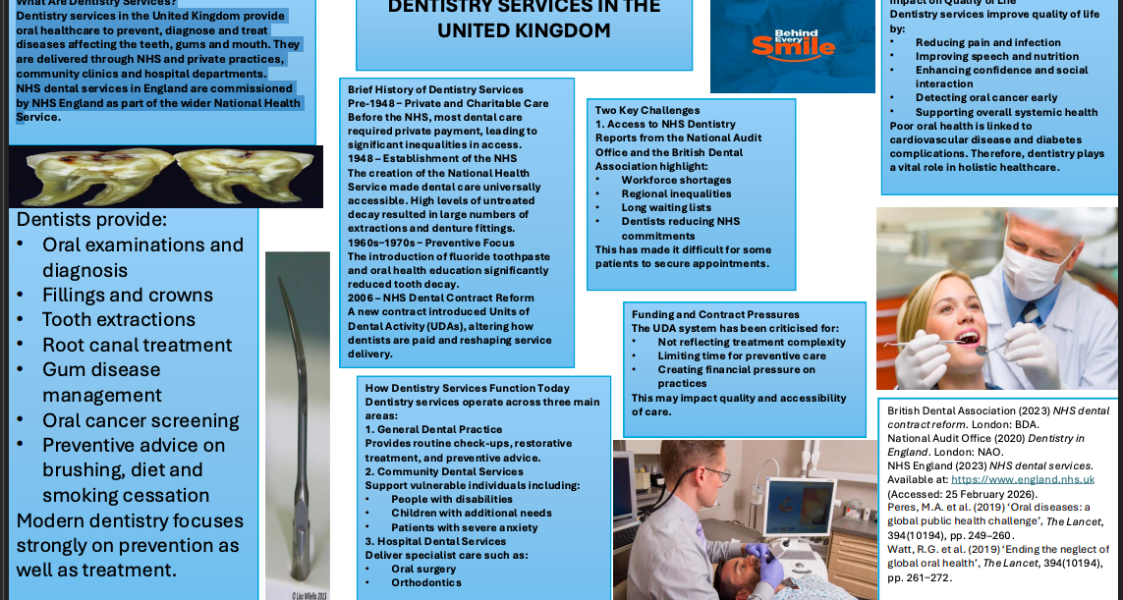

Dentistry Services in the United Kingdom: Historical Development and Contemporary Significance
services in the United Kingdom have evolved from predominantly private provision to a publicly funded healthcare service embedded within the National Health Service. Their development reflects broader public health reform, increasing professionalisation, and growing awareness of t Dentistry he link between oral health and overall wellbeing.

Prior to 1948, dental care was largely accessed through private payment or charitable provision. As a result, oral health inequalities were widespread. The establishment of the NHS marked a turning point by ensuring universal access to dental services. However, post-war Britain experienced extremely high levels of untreated dental disease. Consequently, early NHS dentistry was heavily focused on extractions and dentures rather than prevention.

During the 1960s and 1970s, the introduction of fluoride toothpaste and oral health education campaigns significantly reduced dental caries. This period marked a shift from reactive treatment to preventive care, aligning with wider public health strategies.

A major reform occurred in 2006 when NHS England introduced a new dental contract based on Units of Dental Activity (UDAs). While designed to improve efficiency and budget control, the contract has been widely debated. The British Dental Association argues that the system does not sufficiently reward preventive care and may incentivise quantity over quality.

Today, dentistry services operate across general practice, community services and hospital-based specialist care. Modern dentists provide restorative treatment, preventive advice, oral cancer screening and lifestyle interventions such as smoking cessation guidance. Community dental services play a critical role in supporting vulnerable groups, thereby reducing inequalities.

Critically evaluating the current system reveals both strengths and challenges. A significant strength is the preventive orientation of contemporary dentistry. Early detection and routine check-ups reduce long-term complications and emergency admissions. Additionally, integration within NHS structures supports coordinated patient care.
However, access to NHS dental services remains problematic.

The National Audit Office has reported regional disparities in service provision and workforce shortages. Many practitioners have reduced NHS commitments due to dissatisfaction with contractual arrangements. This undermines equity, one of the founding principles of the NHS.

Despite these pressures, dentistry services significantly enhance quality of life. Oral health influences nutrition, speech, employability, and self-esteem. Untreated dental conditions can result in severe pain, infection, and psychological distress. Furthermore, research demonstrates links between oral health and systemic conditions such as cardiovascular disease and diabetes. By preventing and managing oral disease, dentistry services contribute to both physical and psychological wellbeing.

In conclusion, dentistry services in the UK have transitioned from unequal and treatment-focused provision to a prevention-oriented public healthcare service. Although contractual and workforce challenges persist, dentistry remains essential in reducing health inequalities and promoting long-term wellbeing across the population.

British Dental Association (2023) NHS dental contract reform. London: BDA.
National Audit Office (2020) Dentistry in England. London: NAO.
NHS England (2023) NHS dental services. Available at: https://www.england.nhs.uk (Accessed: 25 February 2026).
Peres, M.A. et al. (2019) ‘Oral diseases: a global public health challenge’, The Lancet, 394(10194), pp. 249–260.
Watt, R.G. et al. (2019) ‘Ending the neglect of global oral health’, The Lancet, 394(10194), pp. 261–272

