

Global Competitiveness of South Korea’s Semiconductor Industry and a Critical Evaluation of Intel’s Strategic Operations

Programme Name: Master of Business Administration
Module Name: International Business Concepts
Module code : LCMB7034

Lecturer’s Name: Jean Wang
Student Name: Md Sohidul Islam
Student ID: 2504070
Group: 03, Term 2
Word Count: 5314
Submission Date: 27th April 2026

AI use acknowledgement
Note: One acknowledgement is needed for each used AI tool.

I acknowledge the use of Grammarly (https://www.grammarly.com/) on 09 April to check my grammar mistakes. I used the prompt:
1. Please check the following text for readability, grammar and syntax

I confirm that I have not presented any AI-generated text as my own work. I confirm I have copies of my drafts, notes, and other resources I used before and after the use of AI tools, which I may be asked to provide in evidence.

Table of Contents
Introduction 4
Industry and Country Overview 4
Overview of the Semiconductor Industry in South Korea 4
Major Firms in the Semiconductor Industry 5
Competitive Landscape and Challenges 5
Porter’s Diamond Model of National Advantage 6
Factor Conditions 7
Demand Conditions 7
Related and Supporting Industries 8
Firm Strategy, Structure, and Rivalry 8
Role of Government 8
Role of Chance 9
Evaluation of Intel’s Operations in South Korea 9
Political and Economic Environment 9
Political Stability and Impact on Intel’s Operations 9
Economic Conditions and Infrastructure 10
Legal and Cultural Environment 11
Legal Framework and Intellectual Property Protection 11
Cultural Factors and Business Practices 11
Hofstede Cultural Analysis 12
Strategic Implications for Intel 13
Market Entry Strategy 13
Competitive Positioning 13
Utilising South Korea’s Value Chain 14
Recommendations for Intel 14
Conclusion 15
Reflective Account 17
Concrete Experience 17
Reflective Observation 18
Abstract Conceptualisation 18
Active Experimentation 19
Conclusion 20
Reference 21

Introduction
This report analyses the global competition of the semiconductor industry and Intel’s operations in South Korea. South Korea is a huge contributor to the global market of semiconductor products, with firms like Samsung and SK Hynix dominating the market to the greatest extent. Intel is one of the major Multinational Corporations (MNCs) operating in this competitive environment, attempting to maintain its market share and adjust itself to the prevalent local elements (Shaw and Luiz, 2018). The purpose of this report is to make a critical assessment of factors that made Intel successful in South Korea. The evaluation of South Korea's competitive advantages in the semiconductor industry will be done using Michael Porter's Diamond Model of National Advantage. While Porter's model does give us valuable insights, their national factors perspective may not take into account the fast-paced changing technologies and competition between firms (Park, 2023). As well, theories of Foreign Direct Investment (FDI) will be used to examine Intel's strategy for entering South Korea, with caution, since these models tend to assume that the flow of capital is solely based on economic considerations while ignoring the complexity of the political, cultural, and other issues that Intel will need to overcome to enter South Korea.

Industry and Country Overview

Overview of the Semiconductor Industry in South Korea
South Korea is a world leader in the semiconductor business, one of the biggest manufacturers of semiconductors in the world. In 2022, South Korea had around 20% of semiconductor exports in the world, an amount of more than $100 billion USD. This is possible only because of its lead in memory chips like DRAM and NAND Flash (Wang et al., 2023). Samsung Electronics and SK Hynix, the two biggest semiconductor companies domestically, are leading this success, with Samsung having over 40% market share of the world's DRAM supply and SK Hynix having about 25%. The semiconductor industry is an important part of the South Korean economy, and its contribution to GDP is well above 10%, and its contribution to total exports remains at nearly 20 per cent. The industry is not important to the national economy simply, but also to the technological innovation of the industries that use it (for example, electronics, automotive and information technology) (Schlegelmilch and Szőcs, 2020). South Korea's semiconductor companies are indispensable in supply chains worldwide, regardless of how far the applications go: From smartphones to artificial intelligence (AI) to cloud computing, their products are used. Moreover, semiconductors are responsible for providing a large part of the nation's employment, with hundreds of thousands of people working in the sector directly and indirectly.

Major Firms in the Semiconductor Industry
Business groups and MNCs in South Korea coordinate to focus on different elements within the semiconductor value chain, rather than the same product. Korean firms, such as Samsung Electronics and SK Hynix (Schlegelmilch and Szőcs, 2020). It dominates memory semiconductors, leveraging economies of scale, new wafer fabrication, and interlocking with the Korean electronics industry. Samsung Electronics and SK Hynix dominate memory chips, where Korea holds about 60.5% of the global memory market, including 70.5% of DRAM and 52.6% of NAND (Samsung, 2025). Samsung remains the integrated firm with DRAM, NAND and foundry, while SK Hynix is transitioning into a DRAM, NAND and high bandwidth memory (HBM) AR data-centre firm. This provides Koreans with economies of scale, technological advantage and exportability. By comparison, the MNCs (foreign multi-nationals) - Intel, Micron, Nvidia, Qualcomm and AMD are more specialised (Griffin and Pustay, 2020). Intel is the leader in micro-processors, data centre chips and super-computing, not Korea. Micron focuses on memory but does not have local connections like Samsung and SK Hynix. NVIDIA, Qualcomm and AMD target design-intensive, mobile, AI and processor markets but leverage Asian manufacturing. Semiconductor revenues increased to $655.9 billion in 2024, by 21%, suggesting that the market is growing (Wong et al., 2024). But effective functioning in South Korea calls for segmentation: local companies are good in manufacturing and memory, while international MNCs excel in design, processors, AI chips and partnerships.

Competitive Landscape and Challenges
The semiconductor market in South Korea is very competitive, with domestic companies such as Samsung and SK Hynix competing with multinational companies such as Intel and Micron, and another South Korean company, TSMC (Taiwan Semiconductor Manufacturing Company). Samsung and SK Hynix are dominating the memory chip sector, but Intel is still a strong contender when it comes to sectors such as microprocessor and high-performance computing (Franco, 2021). The competition between these firms is particularly high in light of the technological advancements that require more advanced and powerful semiconductors, such as AI, 5G, and autonomous vehicles. These developments are challenging firms to constantly innovate around areas related to products such as 5 G-ready chips and AI accelerators. One of the big challenges for the firms of South Korea is technological obsolescence. As the semiconductor industry sees an accelerated pace of technological transformations, it is a must for Samsung and SK Hynix to keep the lead in memory chips (Gao, Ren and Shih, 2023). However, both these companies are subject to pressure from emerging markets as well as barriers in the form of technology, such as the rise of quantum computing and the use of different kinds of materials to make semiconductors. The induced pandemic of covid 19 is disrupting the supply chain, and geopolitical tensions are also playing a role in creating further complications in the market. Government regulations also present challenges, as South Korea's semiconductor industry has to abide by trade regulations around the globe and local regulations (Lamsal, Devkota and Bhusal, 2023). Trade challenges between the U.S and China have created a greater level of uncertainty in the security of the supply chain. For example, export restrictions by Japan in 2019 of semiconductor materials had direct impacts on the chip production capabilities of Samsung and SK Hynix (Lamsal, Devkota and Bhusal, 2023). Despite these challenges, the semiconductor industry in South Korea continues to thrive, courtesy, in large part, of the strong support of the government and continuous investments of its top companies.

Porter’s Diamond Model of National Advantage
Michael Porter's Diamond Model is a model that explains the reasons some countries and some industries can be globally competitive. The model has four important factors: factor conditions, demand conditions, related and supporting industries and firm strategy, structure and rivalry (Tsiligiris, 2018). By applying this model to the situation of the South Korean semiconductor industry, we can grasp the key driving forces of the success of the semiconductor industry (Frieske and Stieler, 2022). However, the model has its limitations, as well, since it may not necessarily take into consideration rapid changes in technology and disruptions in the market.
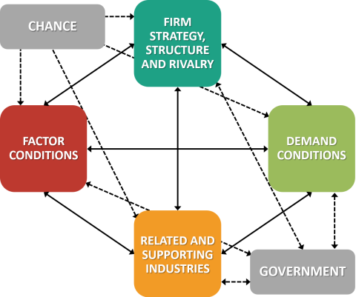
Figure 1: Porter’s Diamond Model of National Advantage, Source: (Tsiligiris, 2018)

Factor Conditions
Factor productivity in South Korea's semiconductor industry is enhanced by high-quality human resources, technology and fabrication. It has produced engineers and scientists via tech education and industry-academic collaborations. Samsung and SK Hynix benefit from this because they need engineering and process know-how and research in their semiconductors (Tsiligiris, 2018). Korea provides cutting-edge facilities, test houses and logistics services for high-value memory devices. But factor conditions can't be left to chance. Memory chip manufacturing is capital-intensive, and plants need upgrading into super-high-tech factories (Grimes and Du, 2022). It has insufficient skill sets in chip design, semiconductors for artificial intelligence and packaging. So, South Korea is harvesting the fruit of skills and infrastructure, but also being proactive with skills to compete with Taiwan, China and the US.

Demand Conditions
Demand conditions for semiconductors in South Korea are strong. It has sophisticated customers and leading electronics, automobile, telecommunication and digital industries. Samsung mobile phones and consumer electronics, cloud services, 5G, electric vehicles and artificial intelligence are confronting customers for better semiconductors (Lee et al., 2021). This encourages companies to bring faster operation, smaller and power-efficient chip and memory products such as DDR5, NAND flash and high-bandwidth memory to market. South Korean exports bring domestic production to the worldwide demand from data centres, smartphones, autonomous vehicles and artificial intelligence. But the demand is uncertain (Teixeira, 2020). The PC and smartphone demand is cyclical, but AI and autonomous-vehicle demand is rapidly changing. Related and supporting industries help Porter explain the effect of demanding customers, but not technological change.

Related and Supporting Industries
South Korea's dominance in semiconductors is thanks to related and supporting industries. It has extensive electronics firms, equipment manufacturing firms, chemical firms, displays manufacturers, batteries manufacturers, telecommunications firms and transport firms (Teixeira, 2020). This results in efficiency as companies have access to a range of specialised inputs, intermediate users and technical support in the same cluster. Samsung federation between Electronics, Displays and Semiconductor provides intra-corporate demand and information sharing. SK Hynix connects to suppliers, research institutes and consumers (Bouguerra et al., 2023). The value of this system is complemented by demand for electric vehicles, 5G, AI servers and devices. However, South Korea relies on imported materials, machinery and technologies for design, which can be subject to shocks and export controls.

Firm Strategy, Structure, and Rivalry
Firm strategy, structure and rivalry are key to South Korea's success. R&D investment, scale, vertical integration and rapid market introduction of new memory chip technology is used by Samsung and SK Hynix. Samsung's coordination provides cost and coordination benefits, through design, manufacturing and use (Aithal, 2017). SK Hynix has profited from dynamic random-access memory, NAND and high-bandwidth memory with growing AI datacentres. Rivalry from local companies, which spurs innovation and competition from Intel, Micron and TSMC, which drives the need for higher productivity and differentiation, challenges the companies. Intense rivalry leads to over-investment, price and memory cycles (Aithal, 2017). Because of the capital intensity of its manufacturing process, rivalry needs to be tempered by planning and moderation.

Role of Government
The government has been crucial for Korea's semiconductor success. Firms have benefited from government incentives in manufacturing through industrial policy, taxation, R&D, infrastructure and export promotion. This is because manufacturing semiconductors is a long-term, risky and collective activity. Semiconductor cluster, talent and supply-chain localisation policies help Samsung and SK Hynix (Luo, 2009). The government is also defensive against geopolitical risks - such as the US-China rivalry and export restrictions. But the government's role is not always desirable. Subsidy undermines market efficiency, and bad policy might distort allocation. South Korea is forced to play a game of trinity diplomacy with the United States, China and Japan dominating global markets and supply chains, so South Korea needs them for its competitiveness.

Role of Chance
Chance has impacted South Korea's competitiveness. COVID-19, the memory chip shortage, Japanese export controls and AI affected supply and demand. Opportunities and risks emerged. The chip shortage prompted Korean memory manufacturers to become more strategic, and the development of AI has demanded faster off-chip memory (SK Hynix, Samsung). The crisis also made businesses vulnerable to offshore resources, equipment & geopolitics (Bouguerra et al., 2023). The role of chance, therefore, suggests a flaw in the Porter theory: benefits of national advantage are not created just by strategy, but also by chance. The key to success in South Korea lies in the ability of businesses and the government to make decisions quickly.

Evaluation of Intel’s Operations in South Korea
Intel, a major multinational technology company, has had its share of opportunities and challenges in South Korea's very competitive semiconductor market. Despite being internationally no. on microprocessor production, the fact is that Intel has to deal with South Korea's unique political, economic, legal and cultural environment in order to maintain its competitive edge (Daniels and Sullivan, 2011). This section analyses the factors affecting the operation of Intel in the Republic of Korea, such as political stability, economic environment, legal frameworks, cultural factors and the strategic implications to the company.

Political and Economic Environment

Political Stability and Impact on Intel’s Operations
South Korea's political scenario is relatively stable, and it has a democratic system that has brought about economic growth and technological development. The government's pre-emptive policy towards technological innovation and foreign direct investment (FDI) have added to the appeal of South Korea as a place where international companies such as Intel are attracted to (Daniels and Sullivan, 2011). The government's support for research and development, a supportive tax environment for high-tech firms and infrastructure-building have enhanced the opportunity for semiconductor firms. Political risks remain, mainly in terms of low-level geopolitical risks of North Korea and trade relations with some other countries, such as Japan. Such factors can create uncertainties that could affect Intel's business, such as in its supply chain or market access.
Furthermore, the Korean trade agreements with major markets (i.e., the USA, China and the European Union) have ensured that Intel has a good environment in which to carry out its activities. The Korea-U.S. Free Trade Agreement (KORUS FTA), for example, allows easier trading between the two markets, and Intel might benefit from tax reductions and diminishing hindrances of trade (Mohammad, Elomri and Kerbache, 2022). However, while relations have been fruitful under such agreements, the fact that South Korea is dependent on the exports of semiconductors makes the country vulnerable to global trade disruptions, particularly when geopolitical relations often go sour.

Economic Conditions and Infrastructure
South Korea's strong economic situation is further in favour of Intel's choice to invest in South Korea. The economic growth of the country, as well as its stable currency and very well-developed technological infrastructure, make it an ideal environment for Intel's semiconductor operations. With the investment of strong governmental R&D and innovation, South Korea is a centre of semiconductor output that provides a well-established base of operation for Intel (Grimes and Du, 2022). As well, South Korea's infrastructure, particularly related to the efficiency of the logistics and the supply chain, provides Intel with the ability to efficiently control production and distribution. The efficient port systems of the country and transportation networks ensure the smooth motion of goods, which is critical to a world player such as Intel.
However, the high cost of doing business in South Korea (especially in the semiconductor sector) is a challenge. Due to having to depend on imported raw materials and the cost of advanced equipment utilised in the manufacturing process, the operational costs are on the rise. Despite these challenges, Intel has turned the technological and logistical advantages to its benefit and has turned South Korea into an interesting market to invest in.

Legal and Cultural Environment

Legal Framework and Intellectual Property Protection
Korea always ensures IP protection through its legal system. Intel is one of its key drivers. The country complies with international IP standards, and the legal framework has played a pivotal role in the protection of patents and trademarks, which is critical for semiconductor innovation (Mohammad, Elomri and Kerbache, 2022). South Korea's strict IP enforcement has made it safe for Intel to invest in R&D and spread proprietary technologies with no worry of IP infringement.
However, Intel may face some difficulties in connection with the laws of labour and regulation policies in South Korea. South Korea has stringent labour laws, such as legislation concerning employee benefits, working hours and union rights. These regulations can have an impact on the operations of Intel, as a result of the increase in labour costs and Human Resource Management (Asmat, Norhayati and Abdul Latif, 2022). For example, if Intel were to increase their workforce in South Korea, it would have to follow these regulations in order to remain within the labour laws of the local area. Additionally, despite the advanced regulatory government bodies that South Korea has, the pace at which any change should occur in terms of regulation can itself be a cause of uncertainty for any international companies that wish to invest in South Korea, including Intel, especially concerning environmental regulations or regulations concerning exports.

Cultural Factors and Business Practices
Also, the unique culture and business practices in South Korea have an influence on the ways in which Intel does business. The culture of work in South Korea is very hierarchical, with lots of emphasis on respecting authority and seniority (Yoon et al., 2020). This dynamic can be capitalised to impact the management practices of integrating employees who are local and cross-cultural teams with Intel. Intel has to adapt its leadership style to local practices, balancing the global corporate culture with the local culture of respect and authority. Failure to do so can lead to problems in communication and employee dissatisfaction.
Consumer behaviour in South Korea is tech-savvy and highly competitive, meaning a fast-paced market for semiconductors. Intel needs to innovate constantly to keep up with the demand for high-performance chips for smartphones, computers and emerging technology such as AI and 5G. While the consumer behaviour of South Korea offers strong opportunities for Intel, it also makes the competition more competitive (Wong et al., 2024). Domestic players such as Samsung and SK Hynix are leading the way in the memory market, and the processor space is only being competed by Intel. As a result, Intel's position is extremely challenging in that it is trying to get established against the strong local consumer loyalty of established local players.

Hofstede Cultural Analysis
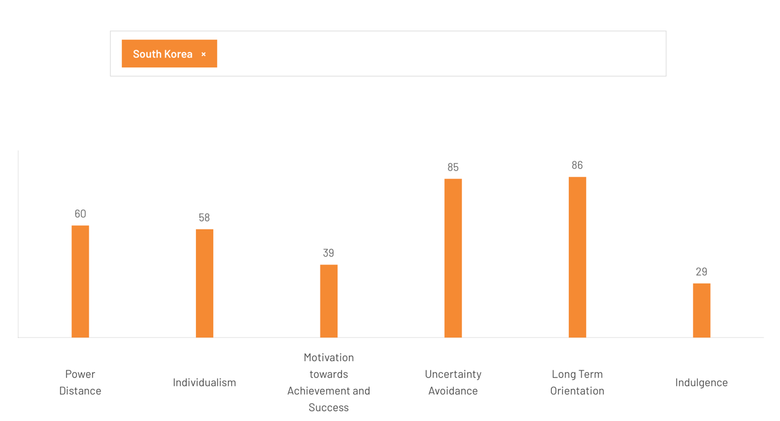
Figure 2: Hofstede Cultural Analysis
Source: (Hofstede Insights, 2020)
Hofstede’s cultural dimensions provide some evidence of how the South Korean business culture impacts Intel. A moderate power distance (60) means hierarchical organisational structures, so Intel needs to adapt to respect for hierarchy and seniority (Hofstede Insights, 2020). The relatively high individualism (58) means aspects of both individual and collective cultures, so that Intel can focus on collective goals as well as rewarding individuals. A relatively high level of uncertainty avoidance (85) in South Korea suggests stability, having rules and procedures, and a dislike of risk, so Intel must ensure it has these (Hofstede Insights, 2020). The relatively high long-term orientation (86) is good for Intel's long-term strategy in semiconductors, with a focus on long-term R&D. The relatively low masculinity (39) indicates a less competitive, more nurturing society, with an emphasis on quality of life (Hofstede Insights, 2020). Finally, lower indulgence (29) is associated with a restrained attitude and influences work ethical values and loyalty. Overall, cultural fit is important for Intel to operate smoothly in South Korea.

Strategic Implications for Intel

Market Entry Strategy
Intel has entered the South Korean market, focusing on the mechanical proficiency of the processor and semiconductors for personal computers and data centres. Given South Korea's leadership in memory chips, Intel's foray into the market was a strategy of using its strengths in microprocessors (Shattuck, 2021). And not necessarily competing directly with the dominant local companies, such as Samsung and SK Hynix, in memory technology. This strategic decision allowed Intel to create a space in the South Korean semiconductor market against head-to-head competition with the local rivals under the category of discrete.
Intel's market entry was also enhanced by its investment in local partnerships and its collaboration with firms in South Korea in related areas like consumer electronics and telecommunication (Peterson and Thomas, 2017). Through those partnerships, Intel got access to key local knowledge and technologies to help tune its product offerings and grow its presence in the region. However, Intel's rather minor share in memory chips means that the company has to constantly compete against Samsung and SK Hynix in some segments, which require Intel to differentiate itself through innovation and smart pricing.

Competitive Positioning
Intel's place in South Korea is decided by its competition with South Korean giants such as Samsung and SK Hynix, as well as companies from other places, such as Micron (Lee et al., 2021). While Intel had a leading position in microprocessor technology on the PC and data centres, Samsung and SK Hynix have a leading position in DRAM and NAND flash markets. In this very competitive environment, Intel has a formidable task ahead of it: whereas Intel enjoys a good position in the high-performance computing chip market, it is usually marginalised in the memory chip business, which is one of the key segments of the semiconductor industry.
Intel's approach has been to focus on product innovation and product differentiation, which is vital in a market of changing competitive environments at a very fast pace. The South Korean semiconductor market will show growth in the niche of AI and 5G technologies (Daniels and Sullivan, 2011). Intel is setting out to assert itself as a processor leader in the new fields in demand. The company's investments in AI accelerators, as well as the 5G technologies, help the company stay relevant in a market that demands more and more sophisticated chips.
However, Intel has some difficulties in getting a foothold in the South Korean semiconductor market, where Samsung and SK Hynix are still dominant. Despite the superiority of its processor technology, Intel is finding it difficult to compete with the production scale and economies of scale of these domestic players in memory chips (Teixeira, 2020). This discrepancy leads to a loss of market share of Intel in the semiconductor industry in South Korea compared to its counterparts.

Utilising South Korea’s Value Chain
Intel benefits from South Korea's well-developed semiconductor value chain. The country's leading rank in the manufacturing of Memory Chips provides Intel with an established manufacturing ecosystem for semiconductor innovation (Bouguerra et al., 2023). Intel uses the high-tech infrastructure and research capabilities of South Korea for the development of cutting-edge processor technology and for integrating them into a global value chain. The presence of high-level research and development facilities and the availability of skilled manpower make it an attractive destination for Intel’s semiconductor operations.
Intel also makes good use of the powerful semiconductor supply chain in South Korea, which has local suppliers of critical materials such as silicon and rare earth metals, critical for semiconductor manufacturing (Aithal, 2017). However, the overreliance on imports for the provision of raw materials implies that South Korea faces challenges from time to time, particularly when there are interruptions to the global supply chains, such as one that was faced during the COVID-19 pandemic. To mitigate these risks, Intel will need to keep diversifying the source of its supply chain and participate in strategic partnerships with local firms in order to ensure the resiliency of the supply chain.

Recommendations for Intel
To enhance its operations in South Korea, Intel should consider the following recommendations:
Focus on Niche Markets: Intel should continue to differentiate itself by focusing on high-performance processors for emerging technologies like AI, 5G and cloud computing, which are areas where local players like Samsung and SK Hynix are not as strong (Yeung, 2022). This strategy gives Intel an opportunity to not directly compete in the memory chip market, but to be able to reap the benefits of the growth of the electronics semiconductor industry in South Korea as a whole.
Strengthen Local Partnerships: The global nature of the South Korean market means that intelligence must expand its local partnerships with South Korean firms. It can strengthen its position in the South Korean market by gaining access to new markets and technologies (Peters, 2023). It approaches through its partnership with other crucial stakeholders in the South Korean tech sector.
Adapt to Cultural and Legal Norms: Intel will need to further familiarise itself with the unique work culture in South Korea. The country has a formal and hierarchical environment in the business culture (Yeung, 2022). Intel knows how to manage this workplace effectively, which will simply help Intel better manage its local staff and work with its partners.
The operations of Intel in South Korea are informed by a complex interplay of political, economic, legal, and cultural factors. While the company faces a lot of competition in the market from local companies, strategic adaptation and innovation in the field of emerging technologies will be central in determining a competitive edge in the region.

Conclusion
South Korea's semiconductor industry, dominated by Samsung and SK Hynix, occupies the leading position in the world market, particularly for memory chips. Intel, although a leader in processors, is faced with great competition in South Korea, where memory technology has some very strong players. Despite that, Intel is still on a competitive level to focus on high-performance computing and microprocessors to complement local demand for semiconductors for AI and 5G technology (Luo, 2009). Porter's Diamond Model showed the competitive advantages possessed by South Korea in reference to factor conditions, technological infrastructure and support of the government. However, it may disrupt the market as it does not really cover emerging technologies such as quantum computing (Lamsal, Devkota and Bhusal, 2023). FDI theory explained the decision of the Intel company to directly invest in South Korea in order to protect intellectual property, but did not consider the geopolitical risks that could affect the decision to invest. To boost its position, on the other hand, Intel should focus on niche markets like AI, 5G and high-performance computing where its local rivals don't have such a strong presence. Strengthening local partnerships and especially the developing tech ecosystem of South Korea will help Intel to deal with the competitive pressure (Grimes and Du, 2022). Furthermore, adapting to the hierarchy in the work culture of South Korea and complying with the labour regulations will make operations more efficient. By practising strategy diversification and ideally aligning the local market needs, Intel can achieve success in the long-run in a dynamic market like the semiconductor market in South Korea.

Reflective Account
To reflect on the research, analysis and preparation process used in the assessment of Intel's operations in South Korea's semiconductor industry, I used Kolb's reflective cycle, which consists of 4 stages: Concrete Experience, Reflective Observation, Abstract Conceptualisation, and Active Experimentation (Kleinheksel et al., 2023). This cycle justified evaluating the phases of the assignment and being able to critically reflect on the challenges I encountered, theories which I implemented, as well as how my comprehension of international business was influenced.
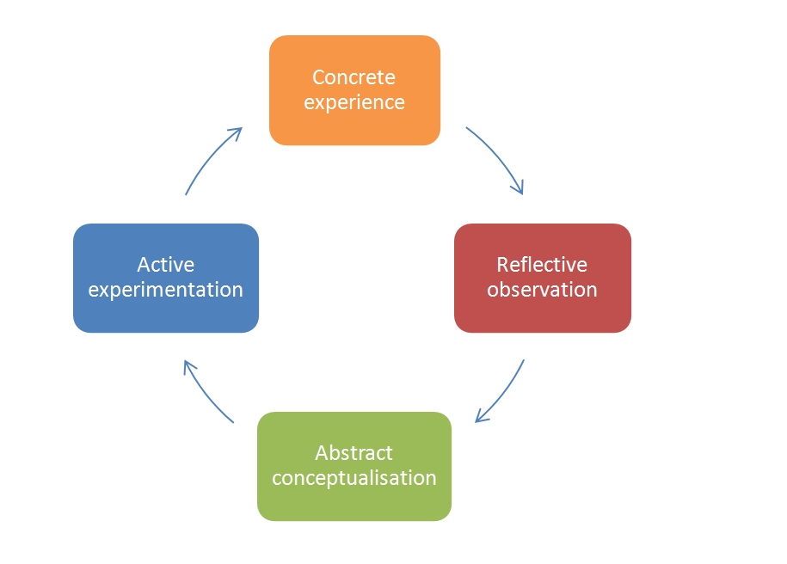
Figure 3: Kolb's Reflective Cycle, Source: (Kleinheksel et al., 2023)

Concrete Experience
The research process began with the data collection about the South Korean semiconductor industry and Intel's market position. At first, I was trying to learn the macroeconomic background of the South Korean semiconductor market and the role of Intel. The more I researched the subject, the more I began to appreciate how fast the industry is changing, particularly in industries like memory chips and processors (Kleinheksel et al., 2023). This phase got me thinking about the complexities of the global semiconductor supply chains and, most specifically, how two countries might interfere in the marketplace (North Korea and Japan both).
However, I was amazed by the scale of the South Korean semiconductor industry and the position of the Korean firms like Samsung and SK Hynix in the world of memory technology. I had formerly underestimated the competitive intensity of the market, most particularly the ways Intel had to make itself different in its operations from the overwhelming dominance of local firms in memory chips.

Reflective Observation
If I reflect on my experience, I came across a few challenges. One of the biggest hurdles was the difficulty in getting some information related to Intel's operations in South Korea. While Intel's operations in different parts of the globe have been pretty well documented, its game plan in South Korea was less so (Meijer et al., 2022). This small size makes it difficult to analyze Intel's intellectual property (IP) or market share and position in the semiconductor market of the country.
I also realised that the application of Porter's Diamond Model and FDI theories gave valuable insights, but they had limitations. Porter's Diamond Model helped me to understand South Korea's competitive advantages, such as skilled labour and infrastructure (Meijer et al., 2022). But did not really talk about the speed of technological change or the role of new technology, such as AI and quantum, in reshaping the semiconductor market. The model was also prone to focus on only the macroeconomic factors and did not take into account the speed of technological disruptions in the industry (Morris, 2020). Similarly, FDI theories, most notably the internalisation theory, were useful when attempting to explain why Intel took the decision to directly invest in South Korea to protect its intellectual property. However, these theories didn't really address these complex geopolitical challenges, and the dynamic and fast-changing nature of the semiconductor market.

Abstract Conceptualisation
During this phase I was synthesizing what I have gathered in terms of information and I started to critically think about the various factors that impacted the operations of Intel. I conceptualised that Porter's Diamond Model contributed to understanding the macro-level factors that affect South Korea's semiconductor industry. But it didn't fully comprehend the rapid pace of change in technology and the complex geopolitical issues affecting Intel's strategy (Watson et al., 2019). The model's focus on factor conditions, demand and related industries was useful, but was too static in explaining a dynamic, technology-driven market.
Similarly, though FDI theories contributed to simulating the case of Intel's decision to invest in South Korea, I realised that theories were oversimplifying the case. Geopolitical instability, trade disputes and technological obsolescence were major factors that these models didn't take into full account (Morris, 2020). Reflecting on this, it assisted me in appreciating the need to adapt traditional business models in order to reflect the problems experienced by Intel in South Korea's semiconductor market. I also came to understand that the strategy Intel put into action was more about differentiation in microprocessors, leveraging a unique niche for itself out of direct competition from local firms in memory chips, to avoid a saturated market for memory chips and to be innovative in other domains.

Active Experimentation
In this phase, I used my reflections to finish my analysis and writing. I adapted my use of Diamond's Model of Porter's work by considering an understanding of changes in technology that occurred within the Semiconductor industry, specifically the rise of AI and Quantum Computing (Meijer et al., 2022). I decided to expand my topic to include the macro-level elements, but also include the role of technological disruption on the competitiveness of the South Korean semiconductor industry.
I also sharpened my analysis of the theory of FDI, incorporating the effect of geopolitical risk and technological change on the decision of Intel to make an investment in South Korea. I talked about Intel's plan to corner high-performance computing and microprocessors and not go toe-to-toe with local players such as Samsung and SK Hynix in the memory chip market. This allowed me to differentiate the strategy of Intel and gave me a better idea of the competitive positioning of Intel (Kleinheksel et al., 2023). With these insights, I was able to support my conclusions and recommendations for Intel. I recommended that Intel continue to focus on emerging technologies such as AI/ 5G technologies and develop local partnerships as well as change Intel's corporate culture to fit South Korea's hierarchical business environment. I also focused on the need for supply chain diversification, in order to reduce the risks by disruptions in the world.

Conclusion
Using Kolb's reflective cycle helped me to critically evaluate in the process of researching, analysing, and preparing the report. The cycle allowed me to go beyond the typical use of theoretical models, however, to realise the limitations of models, and the need for tailoring the models to use in dynamic industries such as semiconductors (Yoon et al., 2020). Reflecting on challenges in securing data, Porter's Diamond Model, and FDI theories, if integrated, helped me to improve my approach and ensure my analysis was relevant and conscious of the complexities of the real world. Through this process, I learned more about the South Korean semiconductor industry and Intel's strategic positioning and the complexities involved in doing business internationally. This is an experience that has given me the skills to be able to critically evaluate business strategies, as well as the ability to change theories to quickly changing environments. This will be valuable as I continue on my academic and professional endeavours.

Reference
Aithal, P.S. (2017) A Critical Study on Various Frameworks Used to Analyse International Business and Its Environment, papers.ssrn.com. Rochester, NY. Available at: https://ssrn.com/abstract=3073051.
Asmat, N.A.T., Norhayati, Z. and Abdul Latif, S.A. (2022) Multidisciplinary perspectives on cross-border trade and business. Hershey, PA: Business Science Reference.
Bouguerra, A., Hughes, M., Cakir, M.S. and Tatoglu, E. (2023) ‘Linking Entrepreneurial Orientation to Environmental Collaboration: A Stakeholder Theory and Evidence from Multinational Companies in an Emerging Market’, British Journal of Management, 34(1). Available at: https://doi.org/10.1111/1467-8551.12590.
Daniels, R. and Sullivan, D. (2011) International business. Harlow: Pearson.
Franco, S. (2021) ‘The influence of the external and internal environments of multinational enterprises on the sustainability commitment of their subsidiaries: A cluster analysis’, Journal of Cleaner Production, 297, p. 126654. Available at: https://doi.org/10.1016/j.jclepro.2021.126654.
Frieske, B. and Stieler, S. (2022) ‘The “Semiconductor Crisis” as a Result of the COVID-19 Pandemic and Impacts on the Automotive Industry and Its Supply Chains’, World Electric Vehicle Journal, 13(10), p. 189. Available at: https://doi.org/10.3390/wevj13100189.
Gao, H., Ren, M. and Shih, T.-Y. (2023) ‘Co-evolutions in global decoupling: Learning from the global semiconductor industry’, International Business Review, 32(6), p. 102118. Available at: https://doi.org/10.1016/j.ibusrev.2023.102118.
Griffin, R.W. and Pustay, M.W. (2020) International business: A managerial perspective. 9th edn. Harlow: Pearson.
Grimes, S. and Du, D. (2022) ‘China’s emerging role in the global semiconductor value chain’, Telecommunications Policy, 46(2), p. 101959. Available at: https://doi.org/10.1016/j.telpol.2020.101959.
Hofstede Insights (2020) Country comparison tool, Theculturefactor.com. Available at: https://www.theculturefactor.com/country-comparison-tool?countries=south+korea (Accessed: 28 March 2026).
Kleinheksel, A.J. et al. (2023) ‘Putting reflection back into practice: Kolb’s theory of experiential learning as a theoretical framework for just-in-time faculty development’, SN Social Sciences, 3(3). Available at: https://doi.org/10.1007/s43545-023-00649-z.
Lamsal, R.R., Devkota, A.K. and Bhusal, M.S. (2023) ‘Navigating Global Challenges: The Crucial Role of Semiconductors in Advancing Globalization’, Journal of The Institution of Engineers (India): Series B, 104(6). Available at: https://doi.org/10.1007/s40031-023-00938-4.
Lee, J. et al. (2021) ‘SWOT-AHP analysis of the Korean satellite and space industry: Strategy recommendations for development’, Technological Forecasting and Social Change, 164, p. 120515. Available at: https://doi.org/10.1016/j.techfore.2020.120515.
Luo, Y. (2009) ‘Political risk and country risk in international business: Concepts and measures’, in Rugman, A.M. (ed.) The Oxford handbook of international business. Oxford: Oxford University Press.
Meijer, M.W. et al. (2022) ‘Implementing Kolb´s Experiential Learning Cycle by Linking Real Experience, Case-Based Discussion and Simulation’, Journal of Medical Education and Curricular Development, 9, pp. 1–5. Available at: https://journals.sagepub.com/doi/full/10.1177/23821205221091511.
Mohammad, W., Elomri, A. and Kerbache, L. (2022) ‘The Global Semiconductor Chip Shortage: Causes, Implications, and Potential Remedies’, IFAC-PapersOnLine, 55(10), pp. 476–483. Available at: https://doi.org/10.1016/j.ifacol.2022.09.439.
Morris, T.H. (2020) ‘Experiential Learning - a Systematic Review and Revision of Kolb’s Model’, Interactive Learning Environments, 28(8), pp. 1064–1077. Available at: https://doi.org/10.1080/10494820.2019.1570279.
Park, S. (2023) ‘Semiconductors at the Intersection of Geoeconomics, Technonationalism, and Global Value Chains’, Social Sciences, 12(8), p. 466. Available at: https://doi.org/10.3390/socsci12080466.
Peters, M.A. (2023) ‘Semiconductors, geopolitics and technological rivalry: the US CHIPS & Science Act, 2022’, Educational Philosophy and Theory, 55(14), pp. 1–5. Available at: https://doi.org/10.1080/00131857.2022.2124914.
Peterson, M.F. and Thomas, D.C. (2017) Cross-cultural management: Essential concepts. 4th edn. Thousand Oaks: SAGE.
Samsung (2025) SAMSUNG SECURITIES REPORT 2024 - SUSTAINABILITY: Building a Resilient World, www.samsungsecurities.com. Available at: https://www.samsungsecurities.com/eng/invest/annual_report.do?tabCode=1 (Accessed: 10 April 2026).
Schlegelmilch, B.B. and Szőcs, I. (2020) Rethinking business responsibility in a global context: Challenges to corporate social responsibility, sustainability and ethics. Cham: Springer.
Shattuck, T.J. (2021) ‘Stuck in the Middle: Taiwan’s Semiconductor Industry, the U.S.-China Tech Fight, and Cross-Strait Stability’, Orbis, 65(1), pp. 101–117. Available at: https://doi.org/10.1016/j.orbis.2020.11.005.
Shaw, B. and Luiz, J.M. (2018) ‘The Impact of Distance (External) and Organizational Factors (Internal) on the Knowledge Chain of Multinational Corporations: South Africa as a Host Country’, Thunderbird International Business Review, 60(3), pp. 295–311. Available at: https://doi.org/10.1002/tie.21892.
Teixeira, N.M. (2020) Management control systems and tools for internationalization success. Hershey, PA: IGI Global.
Tsiligiris, V. (2018) ‘An adapted Porter Diamond Model for the evaluation of transnational education host countries’, International Journal of Educational Management, 32(2), pp. 210–226. Available at: https://doi.org/10.1108/ijem-03-2017-0076.
Wang, Q. et al. (2023) ‘Environmental data and facts in the semiconductor manufacturing industry: An unexpected high water and energy consumption situation’, Water Cycle, 4, pp. 47–54. Available at: https://doi.org/10.1016/j.watcyc.2023.01.004.
Watson, M.K. et al. (2019) ‘Using Kolb’s Learning Cycle to Improve Student Sustainability Knowledge’, Sustainability, 11(17), p. 4602. Available at: https://doi.org/10.3390/su11174602.
Wong, C.-Y. et al. (2024) ‘Geopolitics and the Changing Landscape of Global Value Chains and Competition in the Global Semiconductor industry: Rivalry and catch-up in Chip Manufacturing in East Asia’, Technological Forecasting and Social Change, 209, p. 123749. Available at: https://doi.org/10.1016/j.techfore.2024.123749.
Yeung, H.W. (2022) ‘Explaining Geographic Shifts of Chip Making toward East Asia and Market Dynamics in Semiconductor Global Production Networks’, Economic Geography, 98(3), pp. 1–27. Available at: https://doi.org/10.1080/00130095.2021.2019010.
Yoon, C. et al. (2020) ‘Chemical Use and Associated Health Concerns in the Semiconductor Manufacturing Industry’, Safety and Health at Work, 11(4), pp. 500–508. Available at: https://doi.org/10.1016/j.shaw.2020.04.005.

