Coursework component 2: 500 word close visual analysis

Choose ONE of the below pieces of visual art. Identify the myth represented, explain the form and composition of the depiction, and analyse its effectiveness.
(No footnotes or bibliography are required for this assignment. Please include a word-count at the end of your work. Your assignment must be submitted via the Moodle link by 23.59 on Tuesday 7th March)

OPTION ONE:
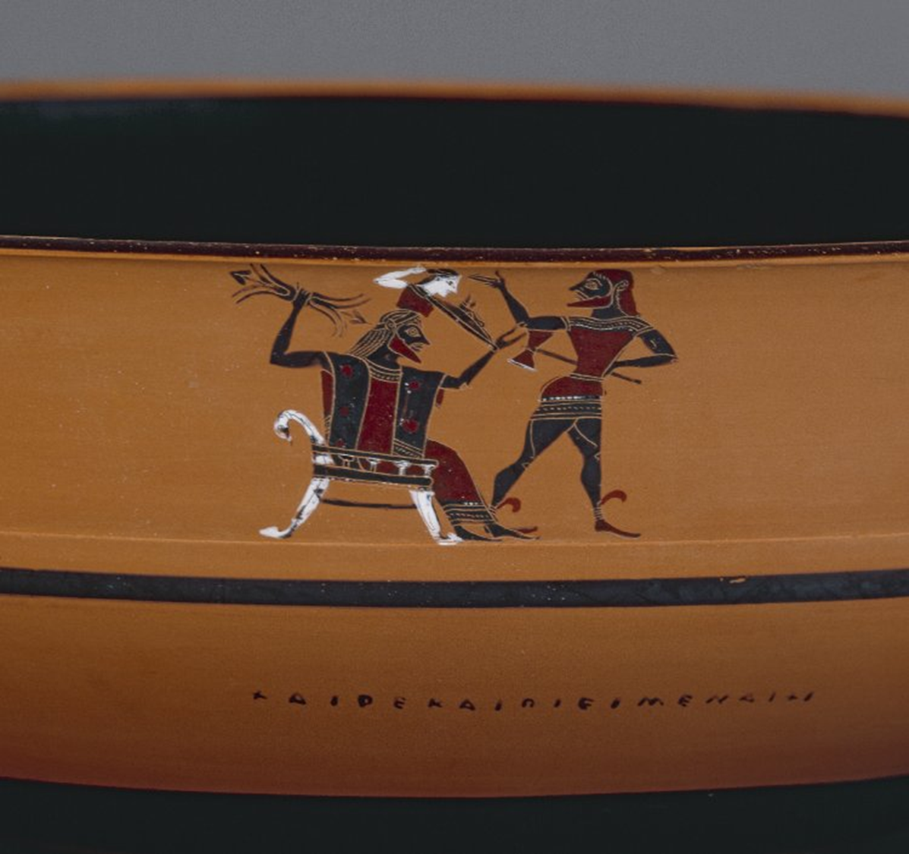
Edge of a black-figure kylix, c. 500 BCE

OPTION TWO:
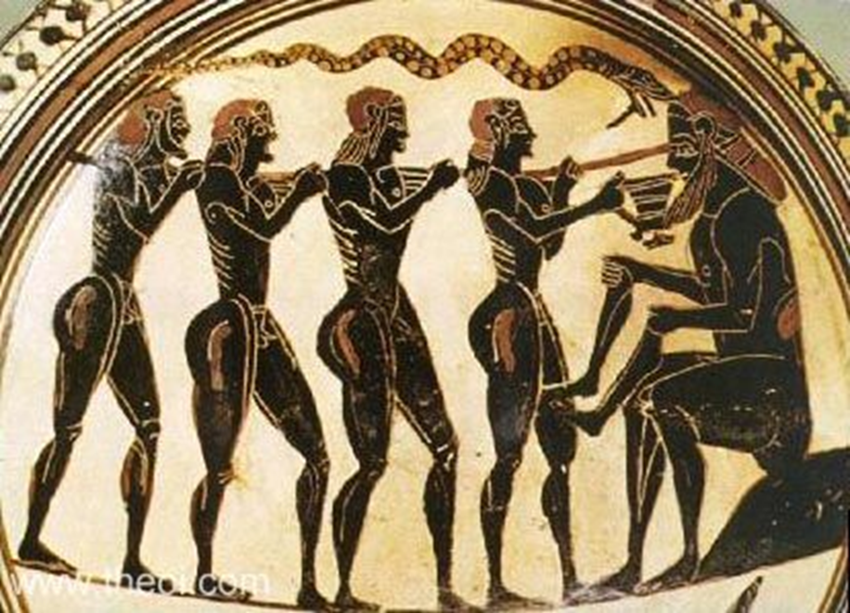
Laconian black-figure cup, c.560 BC

OPTION THREE:
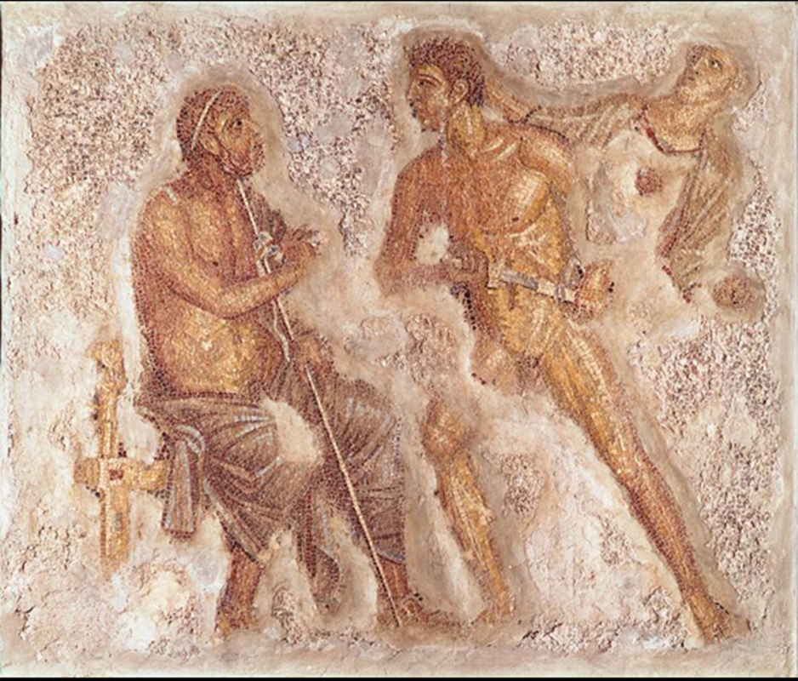
Mosaic from Pompeii, 1st century AD.

