University of Wales Trinity Saint David School of Engineering



2D Transient Heat Equation Solved with the Explicit Finite Difference Method
Computational Methods AMCA6012

Sean Mee
2218461
30/01/2026
Table of Contents
1 Abstract iv
2 Introduction 1
2.1 Aims 1
2.2 Objectives 1
3 Literature Review (Chapters Two & Three) 2
3.1 Governing Equation 2
3.2 Finite Difference Method (FDM) 2
4 Model Methodology (Chapters Four & Five) 4
4.1 Initial State & Analytical Validation 4
4.2 Core Loop 4
4.3 Dependent Functions 5
5 Model Results & Analysis (Chapters Six & Severn) 8
5.1 Validation & System Outputs 8
5.2 Sensitivity & Error Analysis 9
6 Limitations & Improvements (Chapters Eight & Nine) 12
7 Conclusions 13
8 References 14
9 Appendix 16
9.1 MATLAB Code 16
9.2 Sensitivity Analysis Methodology 20

Equation 1 General Differential Heat Equation 2
Equation 2 (a, b, c) First order Forward, Backward and Central Difference Equations 2
Equation 3 First order Forward Difference Equation, including Truncation error Expression 3
Equation 4 Explicit Finite Difference Equation 3
Equation 5 Steady-State Analytical Solution to Thermal Diffusion 4

Figure 1 EFDM Flow Diagram of MATLAB solution 5
Figure 2 Flow Diagram of the Analytical Solution MATLAB Function 6
Figure 3 Flow Diagram of Fourier Number MATLAB Calculation 6
Figure 4 Flow Diagram of Forward Difference Calculation implemented in MATLAB 6
Figure 5 EFDM Plate Matrix Update MATLAB Flow Diagram 6
Figure 6 MATLAB Plate Matrix Generation Process Flow Diagram 7
Figure 7 (a, b) FDM & Analytical Solution Heatmaps at 50ºC, 5m x 5m Plate 8
Figure 8 Absolute Error Heatmap for Figures 7a & 7b 8
Figure 9 (a, b, c & d) Mesh Graphs of Maximum Absolute Error for Approximately 300 Trials, at a range of settings 9
Figure 10 (a, b, c & d) Mesh Graphs of RMSE for Approximately 300 Trials, at a range of settings 10
Figure 11 Mesh Graph of Maximum Absolute Error at TE = 0.05ºC and from ∆t = 0.1s 11
Figure 12 Absolute Error Heat-Map of ∆t = max, h = 0.5m at TE = 0.05 11
Figure 13 Flow Diagram of Sensitivity Analysis Error Data Collection 21

Abstract
This report details the development and validation of a MATLAB-based simulation designed to solve the 2D transient heat equation for an aluminium plate using the Explicit Finite Difference Method (EFDM). By applying Taylor series expansions, continuous partial differential equations were converted into discrete linear expressions for computational analysis.
The simulation iterates through a core loop until the plate reaches a predefined thermal equilibrium threshold. Accuracy was verified by comparing the numerical results against a steady-state analytical solution, assuming an accuracy level of for the analytical model. The model’s validity is strictly dependent on the Fourier number being < 0.25; above this value the derivation of the heat equation, via the Taylor Series, returns impossible values due to limitations in approximating the partial differential equation. Truncation errors and round-off errors, as the key sources of discrepancy, were explored through running the simulation through many iterations for extremely high and low values of the Fourier number.
While the thermal maps generally matched analytical expectations, the highest absolute errors were concentrated at the centre of the plate, as accuracy decreases further from known boundaries.
Limitations and Future Work The study identifies limitations in using a static 0.05°C threshold for equilibrium, which can result in false positives at low temperatures. To improve future iterations, the implementation of alternative methods of approximating partial differential equations could achieve unconditional stability and higher accuracy.

Introduction

Aims
This report focuses on the numerical simulation of two-dimensional (2D) heat conduction within an aluminium medium. The aim is to create a computational prediction method for thermal energy distribution over time within MATLAB. To achieve this, an EFDM method will be applied to solve a partial differential equation which assesses the final temperature state in a material.

Objectives
- Mathematical Modelling: Defining the governing 2D heat equation under ideal assumptions, including uniform density, conductivity, and specific heat.
- Numerical Implementation: Developing a MATLAB-based script utilizing the Explicit Finite Difference Method (EFDM) to calculate the thermal state of elements or 'nodes'.
- Validation: Verifying the accuracy of the numerical results by performing a direct comparison against an analytical solution.
- Sensitivity Analysis: Evaluating how variations in grid spacing, time steps, and equilibrium tolerances influence the model's performance and robustness.

Literature Review (Chapters Two & Three)

Governing Equation
The heat equation provides a precise mathematical description of how thermal energy flows through a medium. It's a partial differential equation that relates the spatial and temporal changes in temperature. For a two-dimensional geometry with no internal heat source term, the equation is mathematically defined as shown in Equation 1 (Vázquez, 2006).
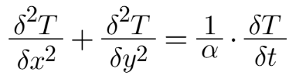
Equation 1 General Differential Heat Equation

Where (x) & (y) are the coordinates of the point being considered, (α) is the thermal diffusivity, (T) is the temperature at a moment in (t) time. The thermal diffusivity (α) is determined by the specific physical properties of the material involved, related by the formula α=ρ⋅ck:
• k: The thermal conductivity (W⋅m⁻¹⋅K⁻¹).
• ρ (Rho): The density of the material (kg⋅m⁻³).
• c: The specific heat capacity (J⋅kg⁻¹⋅K⁻¹).

The equation is purely algebraic, meaning it models a continuous function; computers cannot directly process this method, and therefore, numerical methods such as the Finite Difference Method are used to translate these continuous functions into discrete steps a computer can calculate.

Finite Difference Method (FDM)
The Finite Difference Method (FDM) bridges the gap between a 'continuous' analytical expression and a linear expression which can more easily be computed. This is achieved by computing discrete values and approximating derivatives via the Taylor series expansions (Kafle et.al., 2020). The Taylor series allows the prediction of a function's value at a nearby point (x0​+h) based on the value and derivatives at the current point (x0​) (Wole et.al., 2021). Rearranging the Taylor expansion provides the first-order derivatives in Equation 2 (a, b, c).
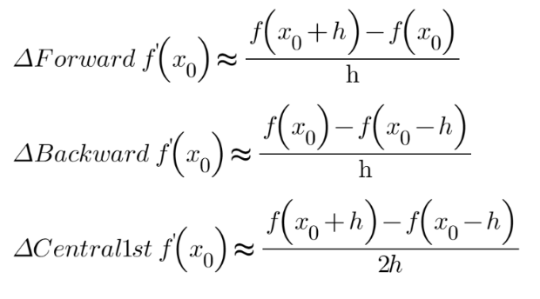
Equation 2 (a, b, c) First order Forward, Backward and Central Difference Equations
Equation(s) 2 shows the three first-order derivations of the Tayler series. All of these equations are linear relationships; halving (h) halves the truncation error of a calculation. By combining forward and backward expansions, the second-order central difference approximation for the second derivative is significantly more accurate as it's inversely proportional to h². While being more accurate, the second-order central difference equation is significantly harder to compute.
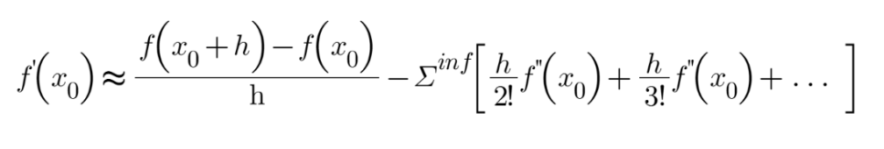
Equation 3 First order Forward Difference Equation, including Truncation error Expression

Every numerical calculation using these methods introduces truncation error, which occurs because Taylor series equations are accurate to Σ^{inf}; as such, the equations are 'truncated'. The central difference is significantly more accurate; halving h reduces the error by a factor of four (Croft and Lilley, 1977).
The forward difference is used to derive the Explicit Finite Difference Method (EFDM) because it can be expressed with one unknown to solve for a 'future' state (∂T/∂t/). It defines the temperature at the next time step (t+Δt) using only known values from the current time step (t). To solve the heat equation numerically, a 2D space is broken into discrete 'nodes' which can be individually computed. Each node is computed in a 'step' to advance the solution towards the future state. The temperature at a node is defined as a point (T^{t}, at point in time t). The grid spacing is uniform, such that h=Δx=Δy. Time is also segmented into discrete steps of size (Δt), or the 'time step', which is how far the model moves forward in each iteration.
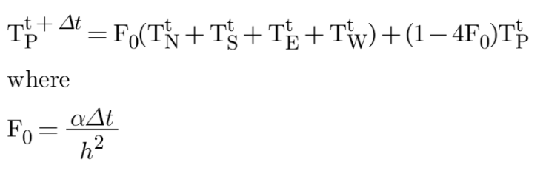
Equation 4 Explicit Finite Difference Equation

The temperature at location (P) at a future time (+Δt) is expressed as a product of its adjacent nodes (North N, South S, etc.), 'Fourier number' and the current temperature at the node (Equation 4). The Fourier number (F_{r}​) is a dimensionless value that governs how far in space or time the expression is looking. At values where F_{r}<0 or ​F_{r}>0.25, the equation isn't valid, as when F₀>0.25, tiny rounding errors are amplified exponentially, causing the simulation to produce impossible results where temperatures exceed the initial heat source (Croft and Lilley, 1977).

Model Methodology (Chapters Four & Five)

Initial State & Analytical Validation
In the simulation of heat propagation across a 2D metal plate, several initial conditions are assumed. At the start of the simulation (t=0), the entire internal domain of the aluminium plate is set to a uniform initial temperature, 0°C, except the top boundary. Any deviation of the grid after t=0 is the result of thermal diffusion. The simulation employs boundary conditions at the top of the plate set by the user. Fixed temperatures around the border at 0°C do not change over time. The behaviour of the plate is the result of the interaction of these boundaries over time.
The choice of these specific boundary conditions is justified by the requirement for the FDM employed to be validated by a corresponding analytical technique. Because exact analytical solutions are only available for a limited set of configurations, the simulation must adhere to the parameters used in the steady-state analytical solution described for Equation 5 (Özışık, 2013; Press, Teulosky, Vetterling, & Flannery, 2007).
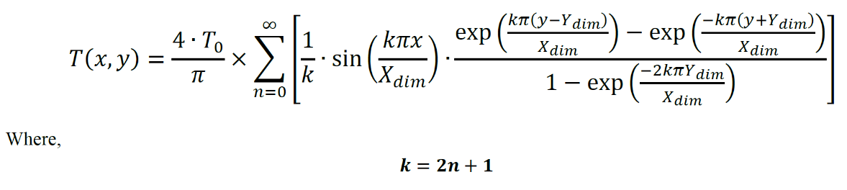
Equation 5 Steady-State Analytical Solution to Thermal Diffusion

By comparing the numerical temperature distribution at thermal equilibrium with this analytical method's thermal equilibrium, the accuracy of the Explicit Finite Difference Method (EFDM) implemented for any set of inputs can be verified. If the numerical simulation is implemented correctly, the resulting thermal map should be nearly identical to the analytical result. Deviation from the analytical method will primarily be a result of the combination of round-off errors caused by the physical limitations of the computer's floating-point storage precision and the truncation errors derived from the Taylor series. This method is also not exactly accurate, as it also holds a term which is satisfied by Σ^{inf}. As such, the analytical solution is assumed to be accurate at Σ⁵⁰⁰⁰.

Core Loop
The program operates through a central loop, as outlined in Figure 1, to guarantee a controlled exit or re-input OF data without adding branches for a series of scenarios. This loop guides the user through the program and calls any relevant code based on user input.
At the start of the main loop, the program introduction is displayed, and the functions for creating the plate matrix (Gen_Matrix) and calculating the Fourier number (Fourier) are called. Each of these has user inputs within it to complete these processes. These processes are shown in Figures 2 and 3. The analytical solution is calculated, creating an analytical results matrix (AS_Plate), saving the use of a variable to store the initial conditions.
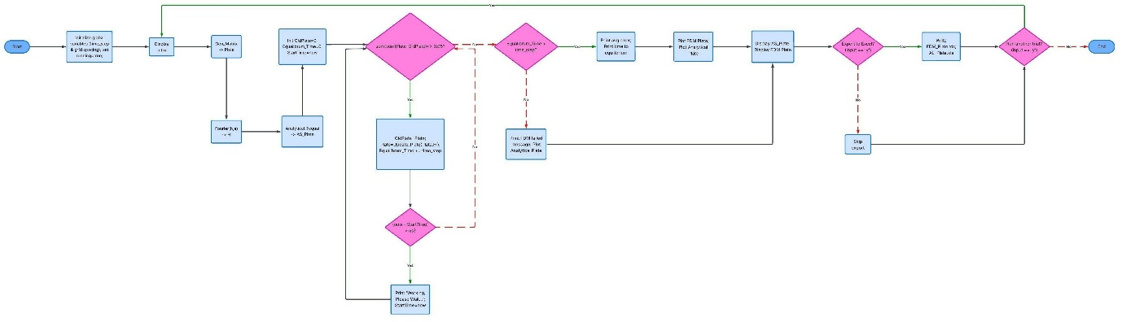
Figure 1 EFDM Flow Diagram of MATLAB solution

After these functions execute, A loop saves the original plate, updates the plate based on the Fourier number and increments the equilibrium time. These actions repeat if the system doesn't meet the equilibrium criteria. Additionally, the program displays a message asking the user to wait every 5 seconds, which communicates to the user that the program hasn't frozen. This helps indicate the programming is running, and increases the time a user is willing to wait (Gronier & Baudet, 2019).
Once the sum temperature of the current plate differs by < 0.050 °C from the previous cycle’s plate, the program concludes equilibrium has been reached. This threshold was determined through trial and error to balance program runtime, error rate, and the risk of false equilibrium when the plate has a very low applied temperature or time step. This decision was informed by Figures 9 & 10.
Finally, the program generates outputs for the user, including printed matrices and colour maps. If the aforementioned error is detected (only one EFDM cycle has run), this is highlighted to the user, and any EFDM results are invalidated. The user also has the option to export the matrices to Excel before being prompted to end or repeat the program.

Dependent Functions
Figure 2 takes the inputs of grid spacing and a plate matrix in the initial state. The length and height (X & Y) dimensions are calculated for the input plate (a plate only consists of dimensionless nodes). The origin position is then set as Y at the maximum position to align with MATLAB’s origin, taken from the top-left of a matrix. Then two loops run, the outer descending through each Y value, and the inner ascending through each X value. For each X & Y value, the steady-state solution is applied until both loop conditions are fulfilled, at which point the new matrix is returned.
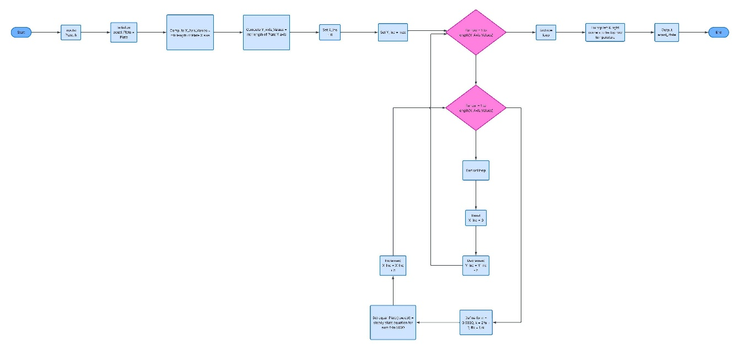
Figure 2 Flow Diagram of the Analytical Solution MATLAB Function

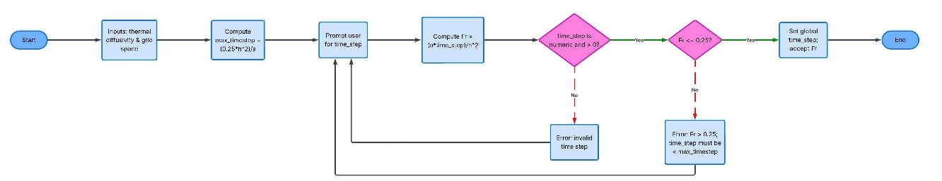
Figure 3 Flow Diagram of Fourier Number MATLAB Calculation

Inputs of thermal diffusivity and grid spacing are required by the Fourier function (Figure 3). The program prompts the user to enter a time step and uses it to create a Fourier value. The function inputs are validated against the requirement that the Fourier number be <= 0.25. If it isn't, the user is provided the maximum value and asked to repeat the input. Once an acceptable value is found, the valid time-step overrides the global time-step, and the Fourier value is returned. The forward difference calculation, shown in Figure 4, is a linear calculation as it's only a product of its inputs.

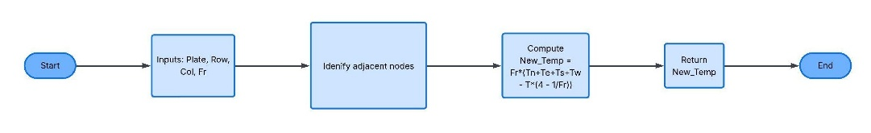
Figure 4 Flow Diagram of Forward Difference Calculation implemented in MATLAB

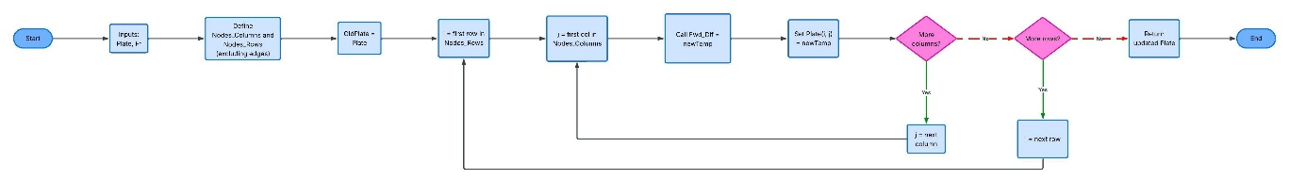
Figure 5 EFDM Plate Matrix Update MATLAB Flow Diagram

Figure 5 shows how a plate of known size and composition is updated to the next 'forward difference' state using a Fourier value. Similar to Figure 2, it processes each node in turn using two loops for the X and Y axes (in this case, columns and rows). The plate's state is saved at the start of the function so that as the plate is updated, the new values don't pollute the calculations. Each node runs through the forward difference equation, Figure 4, inputting 'i' and 'j' (current columns and rows) until the entire plate has been processed.

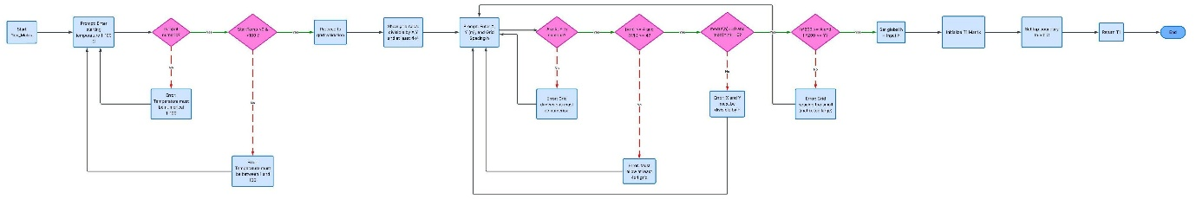
Figure 6 MATLAB Plate Matrix Generation Process Flow Diagram

To generate a new matrix, a starting temperature, grid spacing and plate size are used. The function Gen_Matrix, shown in Figure 6, focuses on validating these inputs before returning a completed matrix and writing the grid spacing to a global variable 'h'. The plate dimensions are dependent upon each other, so they are tested together. Additionally, a grid over 60,000 nodes or under 4 nodes (244x244) is rejected to prevent extremely long and error-prone calculations or failure of the method.

Model Results & Analysis (Chapters Six & Severn)

Validation & System Outputs
The following Figures (7 & 8) show an example of an EFDM and analytical results. This example has a moderate RMSE of ~4°C and a maximum absolute error of 8.56°C. All the error testing plates used to verify this model were 5m x 5m, heated at 50°C. This RMSE rate is calculated only based on the nodes, not the edges of the FDM model. This is because the boundaries aren't computed as part of the model, so they cannot display any discrepancy. As such, only those nodes being calculated and which can have an error value are being considered.

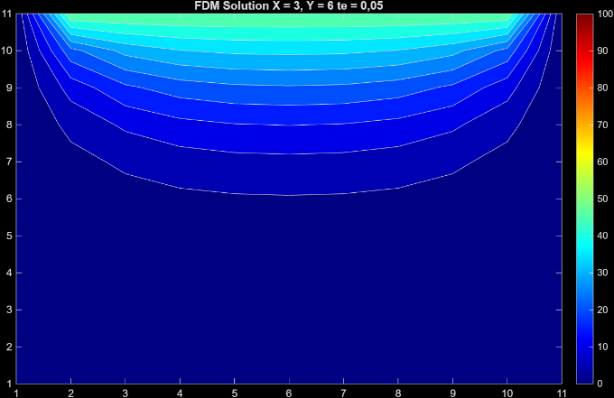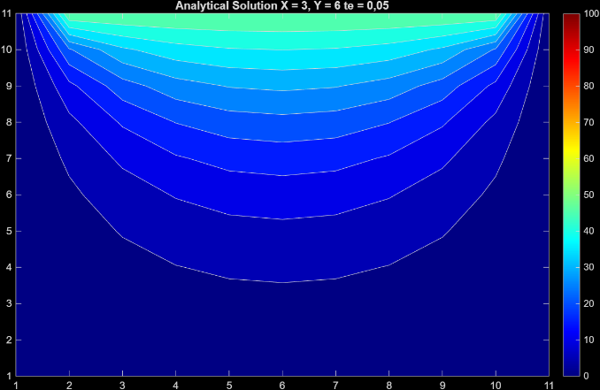
Figure 7 (a, b) FDM & Analytical Solution Heatmaps at 50ºC, 5m x 5m Plate

Comparing Figures 7a and 7b, we can see that the obvious physical difference between the FDM and analytical solution is that the temperature doesn't spread as far through the plate as would be expected, instead getting compressed into the top. However, the error isn’t concentrated towards the top as this behaviour might imply. As in Figure 8, the errors are actually concentrated towards the centre of the plate; this is presumably due to the model becoming less accurate as it's asked to predict the temperature further from its 'known' boundaries.

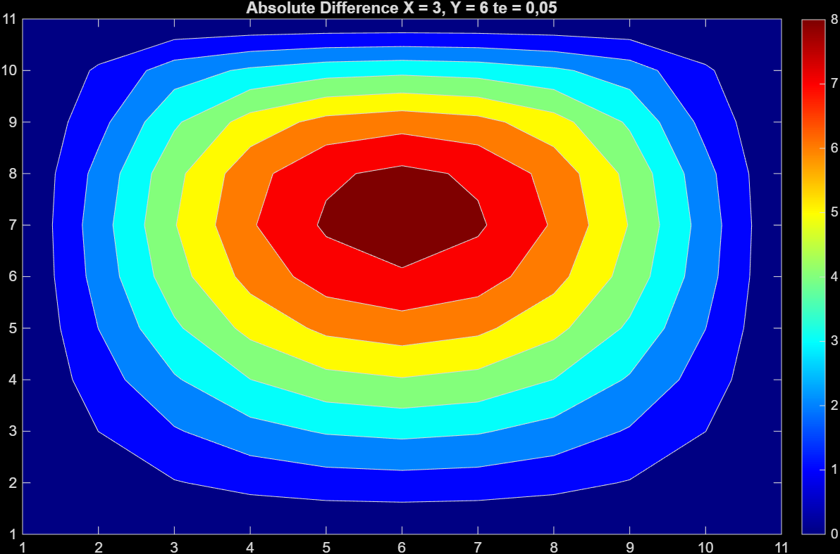
Figure 8 Absolute Error Heatmap for Figures 7a & 7b

Sensitivity & Error Analysis
There are three key parameters which affect the accuracy of the FDM technique applied in this solution. Grid spacing (h), the time-step (∆t) and the target equilibrium condition. The two main sources of error in this method are truncation errors (E_{T}) (Iannelli & Denaro, 2003) and round-off errors (E_{R}) (Karamavruç, Clark & Çelik, 1995). The target of equilibrium influences the balance between these two types of error; in a theoretical solution where the condition for thermal equilibrium was 0, the round-off error for any given combination of grid-spacing and time step would fulfil E_{R} = max. In order to map the behaviour of these three parameters, several hundred combinations of a 5m x 5m plate were run to map out Figures 9, 10 & 11. For each combination of h and ∆t, the root mean square error (RMSE) or the maximum absolute error was plotted on a 3D mesh graph.

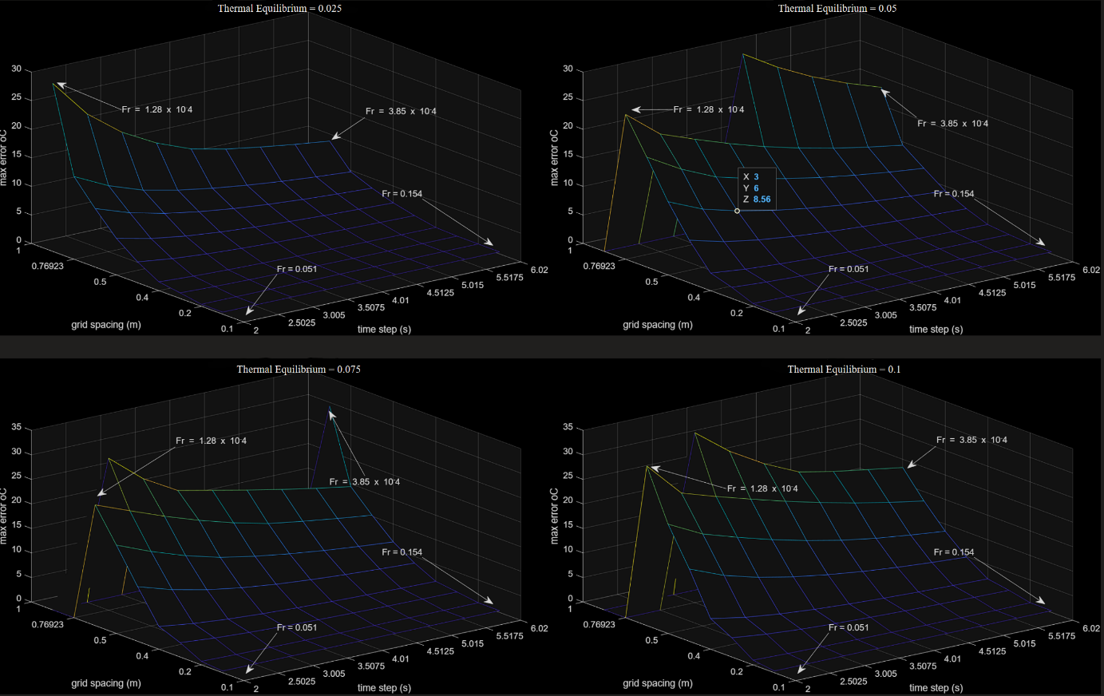
Figure 9 (a, b, c & d) Mesh Graphs of Maximum Absolute Error for Approximately 300 Trials, at a range of settings

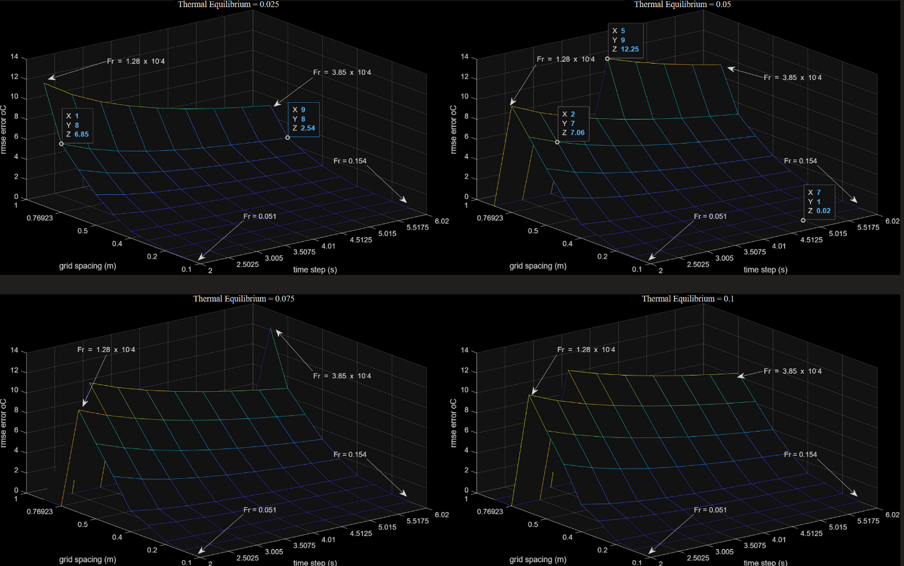
Figure 10 (a, b, c & d) Mesh Graphs of RMSE for Approximately 300 Trials, at a range of settings

The truncation error is driven by the Taylor series derivative that the FDM method used here is based upon (Equation 4) and is influenced by the time step and the grid spacing; the relationship between these is such that the truncation error is proportional to the term ∆t h² in any FDM technique (Iannelli & Denaro, 2003). The amplitude of the error is seen not to be affected by the equilibrium condition, but instead changes the inflexion point, at which the model stops being reliable. The grid spacing is the main driving factor in this type of error. We can see this in Figures 9 & 10, where the error in all the graphs is increasing exponentially with the grid spacing, at an extreme rate. The round-off errors increase with a finer grid, but due to the exponential relationship of the truncation errors means truncation error is the dominant behaviour when changing the grid spacing.
When the grid is extremely fine, the dominant error type flips and the round-off error takes over (Debrabant & Lang, 2015), which prevents the total RMSE or maximum error from reaching zero. At h = 0.1 & ∆t = 2, the RMSE is 0.21°C, which will predominantly consist of round-off errors.
It’s generally considered that in forward difference approaches, no minimum time step exists as far as accuracy is concerned (Yang & Gu, 2005). Yet we can see that the total error increases with smaller time steps, despite truncation errors theoretically decreasing with smaller time steps (Rößler et.al., 2017). This implies that E_{R} is primarily influenced by ∆t. Additionally, we can see that at higher values of ∆t, the total error doesn't increase, as shown in Figure 12. The error calculated across the plate at ∆t = 927s, h = 0.5. The maximum error in the solution is 0.35°C; this demonstrates that the time step is the key driver of round-off errors and has very little influence on truncation error.
In Figure 11, a larger range of time steps starting from 0.1s was used with the same other parameters as Figure 9(b). The spikes in Figure 11 show the points where total error is at its maximum; beyond these peaks, the change in the system is lower than the Thermal Equilibrium target. Because of this, no solution can be found for these values at the value for Thermal Equilibrium. The gradient in the X and Y (time step and grid spacing, respectively) tends towards 0 at the boundary of ∆t = max and h = min. From this, we can conclude that the area between this boundary and the inflexion point where the total error makes the model unreliable is the zone in which the FDM solution is viable. This zone is shown in dark blue/purple.

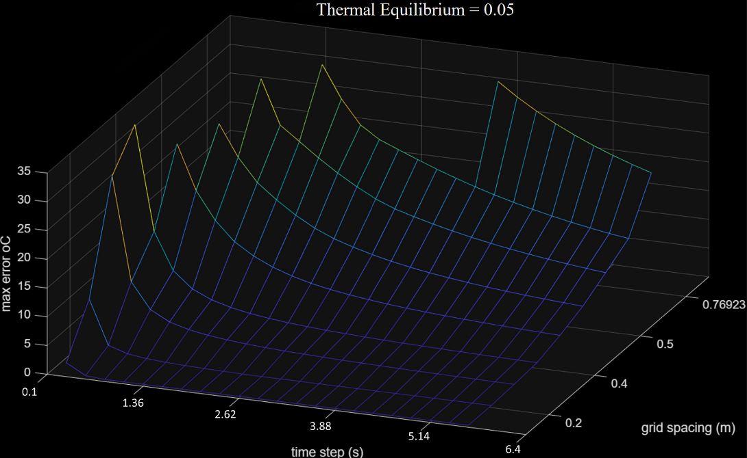
Figure 11 Mesh Graph of Maximum Absolute Error at TE = 0.05ºC and from ∆t = 0.1s

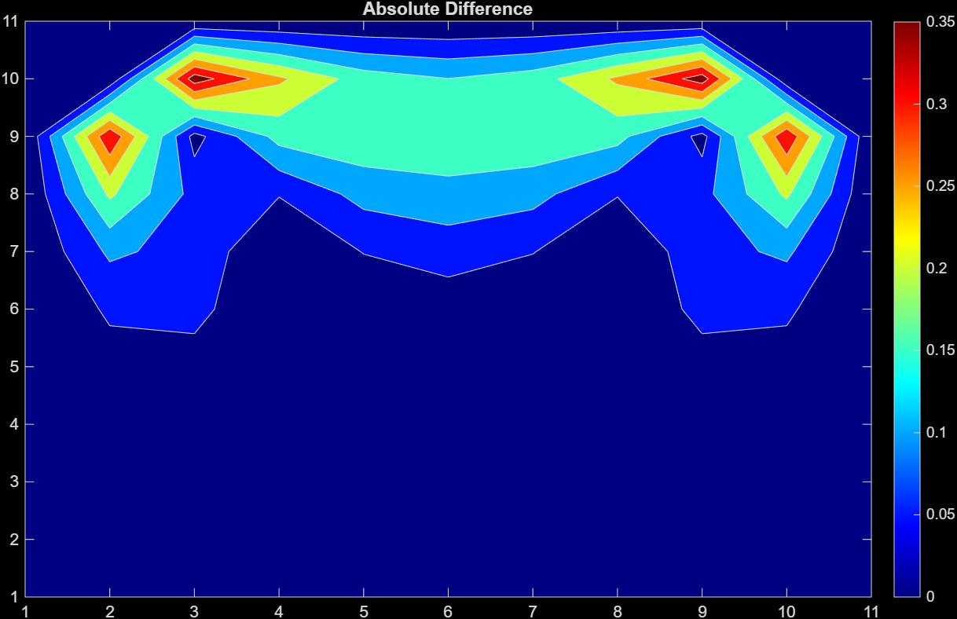
Figure 12 Absolute Error Heat-Map of ∆t = max, h = 0.5m at TE = 0.05

Limitations & Improvements (Chapters Eight & Nine)
The performance of the numerical model is constrained by both the theoretical foundations of the Finite Difference Method and the approximation of differential calculus into a linear method. Additionally, limitations of using a finite element methodology as a computational method lead to errors when simulating any continuous system.
The sensitivity analysis demonstrates that truncation error is the dominant factor in simulations with a coarse grid. Increasing the grid space causes the total error to rise exponentially. Modelling systems with an extremely fine grid incurs a computation penalty, in which each subsequent increase in accuracy requires exponentially more computing time. Additionally, the model cannot achieve complete accuracy, as the total error plateaus due to a persistent presence of round-off errors. These round-off errors can only be mitigated up to a point, due to fundamental limitations imposed by this derivation of the Taylor series and the Fourier coefficient. Using this method to find system states far into the future isn't possible. The time step is constrained in size by being proportional to the Fourier number as per Equation 4.
To overcome stability constraints (Fr < 0.25) and thus improve accuracy, the model could apply a different method to solve differential equations computationally. The Crank-Nicolson scheme, which is a widely employed implicit finite difference technique for numerically solving partial differential equations. This method has unconditional stability, which allows it to produce reliable solutions across various time steps (Liu & Hao, 2022) (Eso et.al., 2024). Unlike the current forward difference approach, this method and alternatives like it offer higher-order accuracy through time, potentially by applying larger time steps.
Throughout the stability analysis, a significant practical limitation is that the method for determining thermal equilibrium is apparent. The code compares successive temperature maps against a tolerance threshold (e.g., 0.05°C). While computationally efficient, the sensitivity analysis reveals that this can lead to false positives in equilibrium. This occurs when the change between iterations is smaller than this arbitrary tolerance, common with very low temperatures or small-time steps.
To prevent false positives, future iterations of this method should implement a convergence criterion using a measurement system which isn't a static value. A simple method could be based on the differential expression of the temperature, dT/dt. Measuring the differential examines the rate of change, and as such is resistant to false positives from low time step modelling.

Conclusions
This study implemented the Explicit Finite Difference Method (EFDM) and validated it against an analytical steady-state solution. This analysis confirmed the limits of model accuracy and highlighted errors concentrated toward the plate’s centre, along with the boundaries of accuracy regarding inputs. Grid spacing is the primary driver of truncation error, while the time step dictates round-off error. The static 0.05°C equilibrium threshold can cause ‘false positives’, particularly at low temperatures. To enhance robustness, future iterations could adopt the Crank-Nicolson scheme for unconditional stability. Additionally, replacing static thresholds with a convergence criterion would improve reliability. These refinements would evolve the model into a more robust tool for complex thermal diffusion problems.

References
Croft, T.N. and Lilley, D.G. (1977) Heat transfer calculation using finite difference equations. New York: John Wiley & Sons.
Debrabant, K. and Lang, J. (2015) ‘On asymptotic global error estimation and control of finite difference solutions for semilinear parabolic equations’, Computer Methods in Applied Mechanics and Engineering, 288, pp. 110-126. DOI: 10.1016/j.cma.2014.11.032.
Eso, R. et al. (2024) ‘The Two-Dimensional Conduction Heat Transfer Equation on a Square Plate: Explicit vs. Crank-Nicolson Method in MS Excel Spreadsheet’, Journal of Physics: Conference Series, 2734(1), 012050. DOI: 10.1088/1742-6596/2734/1/012050.
Gronier, G. and Baudet, A. (2019) ‘Does Progress Bars’ Behavior Influence the User Experience in Human-Computer Interaction?’, Psychology and Cognitive Sciences - Open Journal, pp. 6-13.
Iannelli, P. and Denaro, F. M. (2003) ‘Analysis of the local truncation error in the pressure‐free projection method for incompressible flows: a new accurate expression of the intermediate boundary conditions’, International Journal for Numerical Methods in Fluids, 42(4), pp. 399-437. DOI: 10.1002/fld.520.
Kafle, J., Bagale, L. P. and K.C, D. J. (2020) ‘Numerical Solution of Parabolic Partial Differential Equation by Using Finite Difference Method’, Journal of Nepal Physical Society, 6(2), pp. 57-65. Available at: https://doi.org/10.3126/jnphyssoc.v6i2.34858
Karamavruç, A. I., Clark, N. and Çelik, İ. (1995) ‘Numerical Uncertainty in Heat Conduction Calculations for a Tube Immersed in a Fluidized Bed’, Proceedings of the Institution of Mechanical Engineers, Part C: Journal of Mechanical Engineering Science, 209(5), pp. 323-336. DOI: 10.1243/pime_proc_1995_209_161_02.
Liu, J. and Hao, Y. (2022) ‘Crank–Nicolson method for solving uncertain heat equation’, Soft Computing, 26(3), pp. 937-945. DOI: 10.1007/s00500-021-06565-9.
Özışık, M. N. (2013) Boundary Value Problem of Heat Conduction. Mineola, NY: Dover Publications.
Press, W. H. et al. (2007) Numerical Recipes: The Art of Scientific Computing. 3rd rev. edn. Cambridge: Cambridge University Press.

Rößler, T. et al. (2017) ‘Regional and seasonal truncation errors of trajectory calculations using ECMWF high-resolution operational analyses and forecasts’, Geoscientific Model Development. Available at: https://doi.org/10.5194/gmd-2016-314
Vázquez, J. L. (2006) The Porous Medium Equation. Oxford: Oxford University Press. DOI: 10.1093/acprof:oso/9780198569039.001.0001.
Wole, A., Lobo, M. and Ginting, K. B. (2021) ‘The application of finite difference method on 2-D heat conductivity problem’, Journal of Physics: Conference Series, 2017(1), 012009. Available at: https://doi.org/10.1088/1742-6596/2017/1/012009
Yang, C. and Gu, Y. (2005) ‘Minimum time‐step criteria for the Galerkin finite element methods applied to one‐dimensional parabolic partial differential equations’, Numerical Methods for Partial Differential Equations, 22(2), pp. 259-273. DOI: 10.1002/num.20097.

Appendix

MATLAB Code
clear all %- removes all commands in current matlab code
close % - closes all figures
k = 143;
p = 2.8*10^3;
c = 795;
a = k / (p * c); % Calculate the thermal diffusivity

%% functions called during main_loop

function T1 = Gen_Matrix()
% this will take values from the user to make the matrix T @ t=0 (T1)
global h;

% First loop checks for temperature input validity
Validity = false;
while Validity == false
% takes string input, then checks if its only numbers in double
% data form
StartTemp = str2double(input('Please input the starting temperature between 1 & 100 degrees C:','s'));

if isnan(StartTemp) % check if input is numbers or letters
fprintf('Temperature must be a numerical value between 1 & 100.\n No symbols allowed\n')
elseif StartTemp < 1 || StartTemp > 100 % Checks input is between 1 & 50
fprintf('Temperature must be between 1 & 100.\n')
else
Validity = true; % sets the input validity to true to end input loop
end
end % ends while loop

% Second loop validates the Plate size & shape. These inputs must be
% tested together in order to cross-compare against each other
Validity = false;
while Validity == false
fprintf(['Grid spacing must be divisible by X & Y dimensions\n' ...
'Grid spacing must allow for atleast a 4 by 4 grid\n\n'])

% takes string input, then checks if its only numbers in double
% data form
X = str2double(input('Please input X dimension of Plate in mtr:','s')); % take value for X
Y = str2double(input('Please input Y dimension of Plate in mtr:','s')); % take value for Y
h = str2double(input('Please input the Grid Spacing:','s'));
% take value for grid space in mtr (h)

if isnan(X) || isnan(Y) || isnan(h) % check if input is numbers or letters
fprintf(['Invalid input. Please ensure grid dimensions are only ' ...
'input as numerical values.\n']);
elseif (X/h) < 4 || (Y/h) < 4 % checks if there are atlease two notes in both X and Y
fprintf(['Invalid input. Please ensure grid dimensions allow ' ...
'atleast 2 nodes and divisible both width and depth.\n'])
elseif mod(X,h) ~= 0 || mod(Y,h) ~= 0
fprintf(['Invalid input. Please ensure grid dimensions are ' ...
'both divisible by the Grid Spacing.\n'])
elseif (X/h)*(Y/h) > 60000 % this checks the size of the matrix as
% a maximum of ~ 60,000 nodes (244x244). This is effectively a
% partial limit on the computational time which the program can run
fprintf(['The grid-spacing is too small. Please specify a smaller ' ...
'Plate or larger spacing under 60,000 nodes\n'])
else
Validity = true; % sets the input validity to true to end input loop
end
end % ends while loop

T1 = zeros(int8(Y/h+1), int8(X/h+1)); % Initialize the matrix T1 with zeros
% interger 8-bit is used to qualify the result of X/h & Y/h as
% intergers. This is because when dividing very small values e.g
% 10^-5/10^-7 matlab returns float data-type, which 'zeros' won't accept
% ONLY APPLICABLE FOR UN-REALISTICLY SMALL PLATES, BUT SHOULDN'T BE
% EXCLUDED AS THIS IS UP TO USER DISCRETION

T1(1,2:end-1) = StartTemp;

end % end of function

% - - - - - - - - - - - - - - - - - - - - - -

function Fr = Fourier(h,a)
global time_step
% This function uses previous step variable to assign and validate
% Fourier number
% a = thermal diffusivity, h = grid spacing

max_timestep = (0.25*h^2)/a;
Validity = false;
while Validity == false
fprintf("time step must be < %gs\n", max_timestep)
time_step = str2double(input('Please Input a Time Step:','s'));
Fr = (a*time_step)/h^2; % generate possible Fr value

if isnan(time_step) || time_step <= 0
fprintf('Invalid input. Please ensure the time step is a positive numerical value.\n');
elseif Fr > 0.25
fprintf(['Invalid input. Fr = %g, and must be <= 0.25 \n' ...
'Please ensure the time step is < %gs.\n'],Fr,max_timestep);
else
Validity = true; % sets the input validity to true to end input loop
end
end
end

% - - - - - - - - - - - - - - - - - - - - - -

function New_Temp = Fwd_Dif(Plate,Row,Col,Fr)
% This function has been defined to compute the forward difference
% equation for a 'Plate' 2D matrix for a single given location, and a
% given Fouier Term

Tn = Plate(Row-1,Col); % defines term 'Temperature North'
Te = Plate(Row,Col+1); % defines term 'Temperature East'
Ts = Plate(Row+1,Col); % defines term 'Temperature South'
Tw = Plate(Row,Col-1); % defines term 'Temperature West'
T = Plate(Row,Col); % defines term 'Temperature Current Location'

New_Temp = Fr*(Tn+Te+Ts+Tw-T*(4-(1/Fr)));% Creates the node's new temperature
end

% - - - - - - - - - - - - - - - - - - - - - -

function Plate = Update_Plate(Plate,Fr)
% This function is responsable for running a single itteration of heat
% transfer for a given value of Fouier's term. This function calls a
% forward difference equation function for each node

Nodes_Columns = 2:(length(Plate(2,:))-1); % Defines Col nodes (all except 1st and last)
Nodes_Rows = 2:(length(Plate(:,2))-1); % Defines Row nodes (all except 1st and last)
OldPlate = Plate; % Saves Current plate as 'OldPlate' so that the updating values aren't used in calculations

for nodeRow = Nodes_Rows % for each row of nodes
for nodeCol = Nodes_Columns % for each coloumb of nodes
newTemp = Fwd_Dif(OldPlate,nodeRow,nodeCol,Fr); % Calls forward difference equation to
% find new temperature for the current node
Plate(nodeRow,nodeCol) = newTemp; % Re-allocates this temperature to the node
%loop moves onto the next node in the row (moving through 2nd,
% 3rd etc coloumb
end
%loop moves onto the next node in the row (moving through 2nd,
% 3rd etc coloumb
end
end

function equal_Plate = analytical_Tequal(Plate,h)
% this function runs a thermal steady state analytical solution for a 2D
% given plate, and a given mtr distance between each node (h).
% equal_Plate = input plate at equalibrium
% this function processes steady state analytical solution for entire
% input plate
equal_Plate = Plate;
X_Axis_Values = 0:h:(length(Plate(1,:))-1)*h; % Defines X axis values in mtr
Y_Axis_Values = 0:h:(length(Plate(:,1))-1)*h; % Defines Y axis values in mtr
X_Inc = 0;
Y_Inc = (length(Plate(:,1))-1)*h; % this must run from top (Ymax) as that is
% where matlab takes the origin; equal_Plate(1,1)

for row = 1:length(Y_Axis_Values) % for each Y axis increment
for col = 1:length(X_Axis_Values) % for each X axis increment
n = 0:5000; % sum to infinity is aproximated as sum to 5,000
k = 2.*n+1;
Rk = 1 ./ k; % this is the reciprocal of k

% Equation is broken up into each term to make code for
% readable.
term_1 = (4.*Plate(1,2))./pi(); % Plate(1,2) is referencing start temp
term_2 = sin((k.*pi().*X_Inc)./X_Axis_Values(end));
term_3 = exp((k.*pi().*(Y_Inc-Y_Axis_Values(end)))./X_Axis_Values(end));
term_4 = exp((-k.*pi().*(Y_Inc+Y_Axis_Values(end)))./X_Axis_Values(end));
term_5 = exp((-2.*k.*pi().*Y_Axis_Values(end))./X_Axis_Values(end));

equal_Plate(row,col) = term_1 .* sum(Rk.*term_2.*((term_3-term_4)./(1-term_5)));
% computes result for the current cell

%loop moves onto the next X Value in the row untill all X
%values are exhausted
X_Inc = X_Inc + h; % moves Xmtr on one place
end
X_Inc = 0; % resets Xmtr location at end of row
Y_Inc = Y_Inc - h; % moves Ymtr location down one
%loop moves onto the next Y Value in the row untill all Y
%values are exhausted
end
% fixes anomany where top left and top right corners are 0 for the
% analytical solution, but gets generated as 50 using previous code.
% This sets these corners as correct value so that colour maps match.
end

%% Core Loop % - - - - - - - - - - - - - - - - - - - - - -

global h time_step; % makes grid spacing & time_step global variable, Grid spacing comes from GenMatrix

running = true;
while running == true
clc % - clear command window
fprintf(['This program calculates the final condition of a plate heated at one end, starting ' ...
'at zero degrees C across the plate.\nThe starting temperature can be specified. The ' ...
'material of the plate is assumed to be aluminium with:\n' ...
'Conductivity = 143 W/m.C\n' ...
'Density = 2800 kg/m^3\n' ...
'Specific heat = 795 J/kg.C\nThe number of nodes is limited to 60,000 nodes\n'])

Plate = Gen_Matrix; % Calls Gen_Matrix to collect user input and create plate matrix
Fr = Fourier(h,a); % Calls Fourier to gain user input and generate a fourier number
clc % - clear command window
fprintf('Input all validated. Fourier Number = %g\n\n',Fr);
pause(2)

AS_Plate = abs(analytical_Tequal(Plate,h)); % Plate generated by the analytical Solution
% abs corrects for error where last row displays as -0.00 ??!?!
OldPlate = 0; % Variable 'OldPlate' Must be defined before the loop starts
% (Value cannot be reassigned before it exists)
Equalibrum_Time = 0; % sets the total time to equalibrum to zero
StartTime = datetime('now'); % Saves the time and date the programme begins calculation

while sum(sum(Plate-OldPlate)) > 0.05 % 0.025 Represents the condition for equalibrium
% The plate will contine to be updated untill the the sum difference
% of [the current condition - the last condition] is < 0.025degC. This is
% a much quicker
OldPlate = Plate; % Updates the state of the old plate to check equalibrium condition
Plate = Update_Plate(Plate,Fr); % Updates the plate one time step
if (datetime('now') - StartTime) > seconds(5)
% This condtion checks the Start time against the current time. If
% this is more than 5 seconds a message will be shown to assure the
% user the programme is still running.
fprintf('Working, Please Wait...\n')
StartTime = datetime('now'); % Resets the saved time
end
Equalibrum_Time = Equalibrum_Time + time_step;
end

if Equalibrum_Time > time_step % checks if only one iteration has been
% performed. at extremely low time_step & temp values the condition
% for equalibrium will be reached imediately
E_time_min = floor(Equalibrum_Time/60); % number of minutes taken to reach equ
E_time_sec = Equalibrum_Time-(E_time_min*60); % number of seconds taken to reach equ

% The following calcualates rmse error, mean error and maximum
% error node along with a matrix of the absolute errors
rmse_Plate = sum(sum(Plate(2:end-1,2:end-1)))/numel(Plate(2:end-1,2:end-1));
rmse_ASPlate = sum(sum(AS_Plate(2:end-1,2:end-1)))/numel(AS_Plate(2:end-1,2:end-1));
avergermse = rmse(rmse_Plate,rmse_ASPlate);
average_dif = abs(sum(sum(AS_Plate(2:end-1,2:end-1)-Plate(2:end-1,2:end-1))))/numel(Plate(2:end-1,2:end-1));
Plate_Difference = abs(AS_Plate-Plate);

fprintf(['Result Reached, average (rmse) error between Analytical and FDM Solution nodes = ' ...
' %goC\n'], round(avergermse,2))
fprintf(['Result Reached, average (mean) error between Analytical and FDM Solution nodes = ' ...
' %goC\n'], round(average_dif,2))
fprintf(['Result Reached, Maximum Absolute error between Analytical and FDM Solution nodes = ' ...
' %goC\n'], round(max(max(Plate_Difference)),2))

% takes the sum temperature difference between the plates and / by
% number of cells in the Plate matrix, rounding to 2 dp
fprintf('Time to reach equalibrium = %gmin and %gsec\n\n',E_time_min,E_time_sec)
%Displays the time to reach equalibrium

close all % Close existing figures
figure;
contourf(flipud(Plate)) % Generate a colour map
% flipud used as matrix naturally plots with heated edge at the bottom
colorbar % Add colour-bar key
clim([0 100]); % sets the colour scale between 0oC and 100oC
colormap("jet"); % sets the colours from red to blue (theme "jet")
title("FDM Solution")
hold on
figure;
contourf(flipud(Plate_Difference)) % Generate a colour map
% flipud used as matrix naturally plots with heated edge at the bottom
colorbar % Add colour-bar key
colormap("jet"); % sets the colours from red to blue (theme "jet")
title("Absolute Difference")
hold on

elseif Equalibrum_Time <= time_step
fprintf("FDM failed, as the time step or temperature was too low " + ...
"to permit FDM solution to iterate,\nand is indistinguishable from " + ...
"equalibrium to an itteritive model.\nPlease attempt again with " + ...
"larger time step or temperature.\n\nOnly Analytical Solution will be " + ...
"displayed.\n")
end

figure;
contourf(flipud(AS_Plate)) % Generate a colour map
% flipud used as matrix naturally plots with heated edge at the bottom
colorbar % Add colour-bar key
clim([0 100]); % sets the colour scale between 0oC and 100oC
colormap("jet"); % sets the colours from red to blue (theme "jet")
title("Analytical Solution")

Write_EXCEL = input(['Press enter to see Plate matrix/matrices,' ...
' enter y to export to excel >>> '],'s');
disp("Analytical Plate")
disp(AS_Plate)
if Equalibrum_Time > time_step
disp("FDM Plate")
disp(Plate)
end
if Write_EXCEL == "y" % checks user input for export call
writematrix(round(Plate,2),'FDM_Plate.xls')
writematrix(round(AS_Plate,2),'AL_Plate.xls')
end
Write_EXCEL = ""; % resets for second loop

Loop_End = input('If you would like to run another trial enter y >>> ','s');
% delays the outputting of the matrix, and allows the user to run the
% programme again if required
if Loop_End ~= "y"
running = false;
end
Loop_End = ""; % resets for second loop
end

Sensitivity Analysis Methodology
In order to conduct the sensitivity analysis, a ‘mesh’ graph was created based on many pairs of EFDM and analytical simulations. The error was calculated for each pair and plotted based on the inputs of h and ∆t. This was repeated for equilibrium conditions. Mapping the results over several equilibrium conditions was important to fully understand the behaviour of the system, but it’s impossible to visually represent the results of these three parameters along with the resulting error in one graph (four measurements would require a four-dimensional graph).
Running these simulations required heavy modification to the code presented above, and this code wasn’t developed into a presentable condition. Figure 13 shows a flow diagram of the core loop for this modified program. This program iterates through a given range of values and stores the computed error into a matrix. There is one matrix of results per thermal equilibrium value. Computing this took approximately 2 hours due to some of the extremely small time step values required to trigger measurable round-off errors.

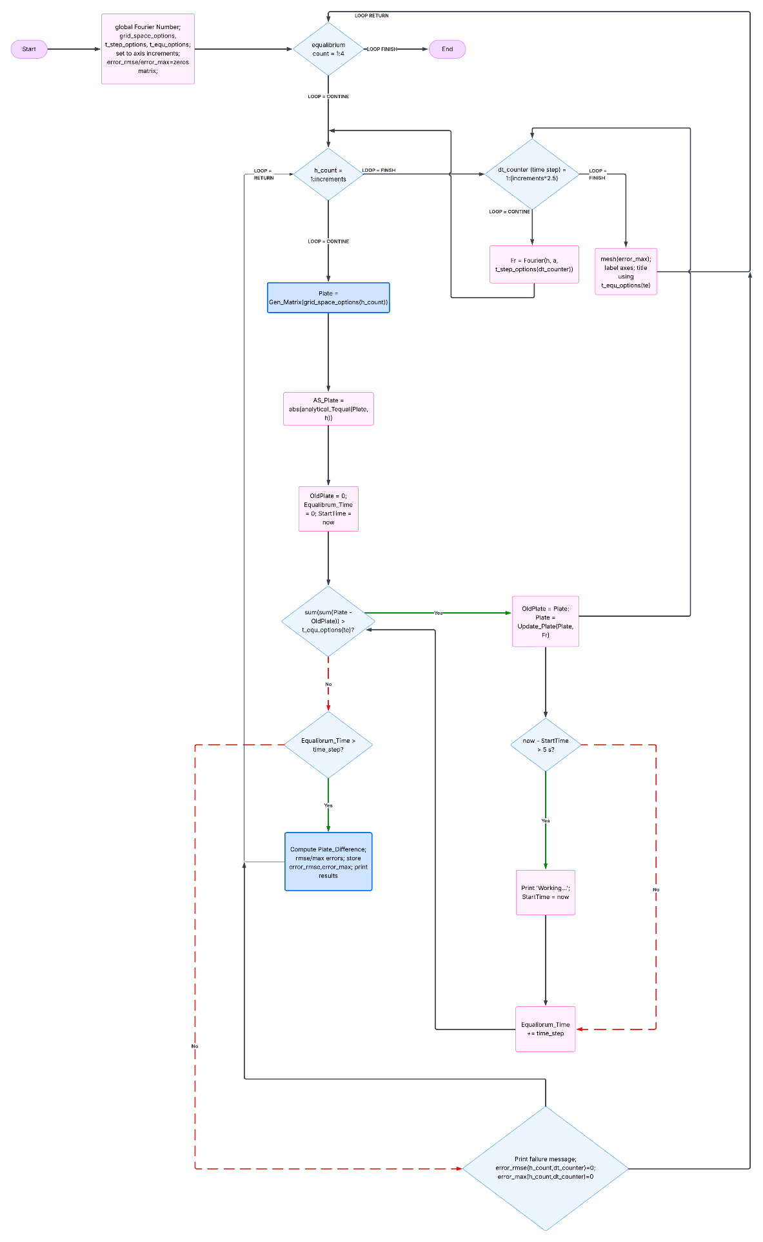
Figure 13 Flow Diagram of Sensitivity Analysis Error Data Collection

