Effective Team Working and Communication.

Executive Summary:
Workplace productivity and relationships depend on communication. Communication with co-workers, supervisors, and customers is a skill that sets people apart. Schramm's communication paradigm has an encoder, a decoder, an interpreter, and a message. Similar job duties, backgrounds, and experiences help people understand one another. Lack of responsiveness, interest distraction, and cultural differences all impede effective communication. and Weaver models are among the most important communication models. Critics contend that this technique was designed to overcome technological issues rather than human interaction. The SMCR model stands for Source-Message-Channel-Receiver. Communication skills are important in all professions and at all levels of management. Workers now must be able to successfully communicate by mobile phone, email, and social media. Business connections need effective verbal and nonverbal communication. Effective discussion requires attentive listening. A lack of listening skills may lead to miscommunication. A lot of well-known companies provide hearing instruction. Listening skills improve client satisfaction, productivity, and knowledge sharing. A person must emotionally connect with the other person to empathize. Communication is difficult in tight relationships. Abdul may create a Schramm communication model to solve the lack of communication. After effective communication, he may assign duties to each team member.

Table of Contents
Introduction 4
Communication model 4
Shannon and Weaver (1948) 4
Schramm (1954) 5
Berlo (1960) 6
Communication Skills 7
Verbal Communication 7
Non-verbal Communication 7
Listening 8
Active Listening 8
Empathetic Listening 8
Case Study 8
Conclusion 9
References 10

Introduction
The term "communication" refers to the procedure of conveying and receiving messages by verbal or nonverbal means, including speaking or verbal communication; writing and visual images; and signs, gestures, and behaviour (Muyeen, 2017). Communication is the key to attaining productivity and building solid working relationships. Effective communication with co-workers, bosses, and customers is a talent that sets individuals apart from their competition. Effective communication is important in resolving disputes and avoiding future ones. Developing effective communication skills helps one understand what others want and how to provide it. One can naturally enhance their workplace by making others feel heard and understood. Also, efficient communication boosts productivity. In contrast, lack of response, interest distraction, cultural differences, and other factors prevent good communication from taking place, and as a consequence, poor communication occurs, which has the potential to have a bigger impact. The inability to communicate effectively may cause time pressure, lower morale, and ultimately decreased production, a lack of creativity, and poor customer service (Hartley, 2015). Using real-life examples from the corporate world, we'll show how communication difficulties affect an entire company and how to overcome them.

Communication model
This essay will cover the three most important models of communication that have emerged throughout time.

Shannon and Weaver (1948)
Communication models such as the Shannon and Weaver models are among the most significant in the field of communication. "Mathematical Theory of Communication," "Mother of All Models," and other terms are used to describe it. It is known as the "communication transmission model (Costa, Aparício and Braga, 2012)." Noise, disruptions, and transmission mistakes are all topics that have been presented via the use of this modelling tool. Shannon and Weaver's model of communication includes a wide range of ideas, such as the information source, the transmission channel (as well as the information destination), the encoded message, and decoding. As a result, it is more technical than other linear models. According to critics, the hardware portion of this approach, this was built for technical difficulties rather than to promote communication between human beings lies at the heart of its flaw. The fact that it did not take into consideration the concept of feedback is another point of contention. Providing feedback is often viewed as essential to the completion of communication activities (Petersons and Khalimzoda, 2016). Following the case study's example, Abdul phoned each member of the team to explain their duties and responsibilities, seeming to be confident that everything was going well so far in the process. A number of contacts from community organizations have lately expressed dissatisfaction with the project's community liaison leaders, and he got a number of responses to this effect. When team members contact Abdul directly, they are unable to communicate due to noise or distraction. More than group or mass communication, it is more of an interpersonal communication paradigm than any of the two. It also overlooked feedback.

Figure: Shannon and Weaver model of communication (Communication Theory, 2022)

Schramm (1954)
Wilbur Schramm, a well-known communication expert, was unable to tell the difference between technology and non-technical language in his research. There is a strong connection between the Shannon and Weaver models. A common orientation between transmitter and recipient was integrated into his model (Elleström, 2018). As the name suggests, the transmitter and receiver are in constant communication with one another. When two people have similar backgrounds, communication is more effective and helpful. When it comes to communication, this paradigm focuses on both people's cumulative experience rather than a single person's perspective. There is no interaction, feedback, or exchange of experiences here. Based on the experiences of the people, the source could be encrypted and the destination could be decrypted. When people have similar job responsibilities, educational backgrounds, and life experiences, they are more able to relate to one another (Goodwin, Jeng and He, 2014). Conversely, when people vary in terms of numerous characteristics, they will have difficulty communicating, and communication procedures will not be conducted effectively. This approach also reinforces the links between sources and destinations. When both senders and receivers are in similar circumstances, they must pick up the message, receive it, and understand it within frames of reference that include noise and feedback. A second-grade student, for example, cannot be taught past participles by an art professor. The Schramm communication paradigm includes an encoder, a decoder, an interpreter, and a message.
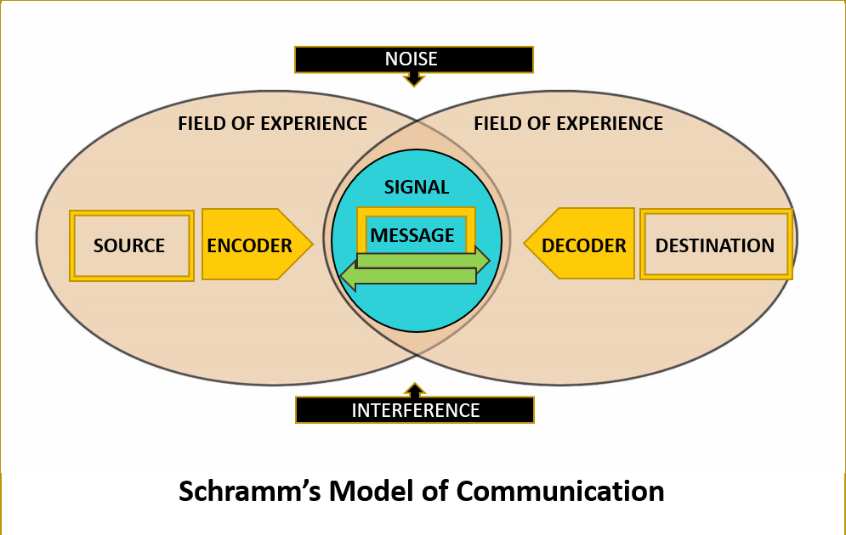
Figure: Schramm’s Model of Communication (Qsstudy.com, 2022)

Berlo (1960)
The SMCR communication model is an acronym for the Source-Message-Channel-Receiver model of communication, which was developed by David Berlo in 1960 and is still in use today (Kurtzo et al., 2019). Berlo created this idea based on the Shannon-Weaver communication paradigm (1949). His presentation focused on some of the factors that make communication more successful. SMRC are also components of the fundamental communication process's nine key communication elements (Muyanga and Phiri, 2021). David Barlo's SMCR model of communication can be applied to watching the news on television. Source, message, transmission path, and receiver are all facets of Barlo's model. The newscaster is first and foremost the person who gathers and conveys the news to the general audience. The message is transmitted through television news. Finally, the audience is made up of both those who receive the message and those who watch television. In this case, the audience has no involvement. It is also a one-way communication mechanism with no feedback.

Communication Skills
Communication skills are vital in every profession since they are applicable to all levels of management as well as co-workers and employees. Workers in today's digital world must be able to communicate effectively by mobile phone, email, and social media, in addition to in-person contact.

Verbal Communication
The phrase "verbal communication" refers to a type of oral communication in which the message is transmitted via the use of spoken words. The sender expresses his or her feelings, thoughts, ideas, and perspectives verbally and via speeches, discussions, presentations, and conversations. Verbal communication must be clear, relevant, and delicate in the formation of sentences and tones in order to be successful. It must also be short and insightful. To keep business relationships strong, effective verbal communication is needed. An increase in communication boosts productivity, decreases errors, and simplifies processes (Coffelt, Grauman and Smith, 2019). To be effective, a message must be complete in all respects, not just concise. Do not forget clarity and thoroughness for the sake of brevity. It's crucial to grasp the difference between over-and under-talking. As a result, it is often recommended to keep things as basic as possible. Make a concerted effort to help them become more effective communicators. Improved delivery may be achieved by the use of examples, a non-threatening body position, and an appropriate tone.

Non-verbal Communication
Nonverbal communication includes nonverbal messages such as body language, facial expressions, and tone of voice, eye contact, and posture. When it comes to business, nonverbal communication is critical since it creates new avenues of contact with co-workers, competitors, customers, and potential ones in the future. Basic indicators like body language and voice tone might be used to exhibit dependability and consistency. Additionally, other characteristics, such as the speaker's pacing and volume, may convey information to the listener (Buerger, 2019). It's possible that the speaker's fragrance and physical contact with the audience might influence how the audience perceives what the speaker is saying. Even if one doesn't say a word, they're still communicating nonverbally. A pause in face-to-face communication might cause misunderstandings.

Listening
Being able to listen well is being able to hear and understand what others are saying. To have a successful conversation, you must be able to listen intently. A lack of listening skills might lead to misinterpretation of a message. This causes communication to break down, which may lead to frustration or irritability for the message's recipient.

Active Listening
Active listening is a style of listening that keeps one engaged with their conversation partner in a good way. It is the practice of paying attentive attention to what another person is saying, studying and reflecting on what was said, and abstaining from expressing judgment or advice in response to the dialogue. The ability to listen well is a key component of being a productive group member, as well as being able to effectively express one's thoughts and ideas. To prepare their employees for today's challenging audio logical environment, a large number of well-known corporations provide specialized hearing training to their employees. It should come as no surprise that good listening skills boost customer satisfaction, productivity, and the flow of information. All of these things contribute to an increase in an individual's degree of imagination and creativity. According to research, listening skills are beneficial for both supervisors and workers in the workplace.

Empathetic Listening
Empathic listening is the practice of observing and reacting to others' thoughts and viewpoints. To empathize, one must emotionally connect with the other person and find commonalities in their experiences. More than merely being there in the same room as the speaker, presence entails paying attention to what the speaker has to say. It's difficult to express one's emotions in intimate relationships. The speaker may need some time to identify the appropriate words and feel more comfortable delivering them. People may be more receptive to you if you demonstrate empathy for them. In the workplace, teams often collaborate to solve problems. Listening empathically means merely hearing what the other person has to say, not adopting their opinions.

Case Study
Based on the scenario, Abdul laments the lack of communication. Thus, efficient and effective communication is advised for this project to improve team performance. Abdul may develop a Schramm communication model that correctly addresses the problem of lack of communication. A community event initiative involving local stakeholders, commercial firms, and non-profit groups is the subject of the case study presented in the preceding section. The event manager, technical support, research and marketing team, and extended team are all required positions in order for this project to be effectively implemented. Abdul may simply delegate tasks to each team member after establishing efficient communication. He can easily describe their task using the communication paradigm. The team will know what the objectives are and how each process will be executed for the event project's success. Because the responsibilities and roles have been clearly defined, the effect is likely to be favourable. The project can be executed successfully and the processes can be performed easily with the support of a large staff. As seen above, the current epidemic of COVID-19 caused the issue. A lack of regard for one another caused production delays and missed deadlines due to the physical constraints of collaboration. The team's communication is vital to the project's success. In the given instance, the team failed to communicate effectively since they seemed disinterested when asked for assistance. In the face of this obstacle, the workforce fell short.

Conclusion
The ability to communicate effectively is essential to the success of any business. It aids in the resolution of both new possibilities and old difficulties. Increasing productivity in the workplace is made possible by employees' capacity to communicate their thoughts and ideas clearly and concisely. If you want to effectively communicate with another person through transmission and reception, you must be able to speak and listen in addition to sending and receiving messages. Taking into account how to communicate respectfully and also be true to one's promises is very important.

References
Buerger, S., 2019. Communication Skills. A Guide to the Scientific Career, pp.97-101.
Coffelt, T., Grauman, D. and Smith, F., 2019. Employers’ Perspectives on Workplace Communication Skills: The Meaning of Communication Skills. Business and Professional Communication Quarterly, 82(4), pp.418-439.
Costa, C., Aparício, M. and Braga, A., 2012. Design of communication. Proceedings of the Workshop on Information Systems and Design of Communication - ISDOC '12,.
Elleström, L., 2018. A medium-centered model of communication. Semiotica, 2018(224), pp.269-293.
Goodwin, S., Jeng, W. and He, D., 2014. Changing communication on researchgate through interface updates. Proceedings of the American Society for Information Science and Technology, 51(1), pp.1-4.
Hartley, P., 2015. Business Communication. Taylor and Francis, p.65.
Kurtzo, F., Edgar, L., Edgar, D., Graham, D. and Russell, M., 2019. Exploring Communication Tendencies of Program Facilitators. Journal of Applied Communications, 103(1).
Muyanga, C. and Phiri, J., 2021. Assessment of Effective Communication in International Schools in Developing Countries Based on the Berlo’s SMCR Model. Open Journal of Business and Management, 09(01), pp.448-459.
Muyeen, S., 2017. Communication. Stevenage, Herfordshire, UNKNOWN: The Institution of Engineering and Technology, p.34.
Petersons, A. and Khalimzoda, I., 2016. COMMUNICATION MODELS AND COMMON BASIS FOR MULTICULTURAL COMMUNICATION IN LATVIA. SOCIETY. INTEGRATION. EDUCATION. Proceedings of the International Scientific Conference, 4, p.423.

