Introducing the Modern Workplace (LCBB4003)

Student Name : Angela Nastasiu
ID:1907399

Contents
Introduction 3
Team and Group behaviors of Kellogg’s 4
Team Behaviours 4
Team Behaviours Models 4
Tuckman’s Teamwork Model 4
Team Behaviours at Kellogg’s 5
Conclusion 7
References 8

Introduction
In this report, the team and group behaviours model and process of Kellogg’s will be analysed and discussed. Kellogg’s, the American food business company which established in 1906 and headquartered in Michigan (Kellogg’s, 2020). They have four brands (Pringles, Eggo, Gardenburger, and Sunshine Biscuits) and so many products like toaster pastries, crackers, cereals, frozen and vegetarian food etc. Kellogg’s uphold the Team Behaviour theory of Tuckman at their firm. Stages of the Tuckman model facilitated them to signify themselves as such a giant business concern and still now, they monitor this model to be more systematized as well as to progress their business.

Team and Group behaviors of Kellogg’s
A team is a gathering of individuals who harmonize their specific efforts and share a mutual goal along with several stimulating objectives. It may be revealed that the members of the team are equally dedicated to accomplish their objectives as well as goals. They also accomplish with a solid bond and durable inspiration which is formed from their cooperative liability (Kumar, 2009).

Team Behaviours
Deprived of goal and determination, a team cannot be built. Everyone in a team must be functional to do their work accurately and they should make sure that the environment of doing work is comfortable for each (Wiedow and Konradt, 2010). This is important to do all the works logically. Each member should understand his value in the group to do his work properly. Contributing together is the main key to fulfill the works and to prosper in the determination.
A good strategic plan can help to develop a teamwork. To approve the strategy, commitment and understanding should be taken as a priority. A fixed goal and cooperation with each other and so many good wills can make sure the success of a teamwork undoubtedly. A leader must use the idea to set outlooks for individuals as well as for the entire team. Cooperative performance by focusing on the task will increase the relationship inside a team.

Team Behaviours Models
Among many models, Tuckman’s model is widely discussed in the matter of team building and it is also very significant. It identifies the point that groups do not get started fully-structured and functional. The theory was first introduced in 1965. Tuckman proposes that a team raises through definite phases to create the group as an exclusive and task-oriented (Tuckman, 2010). Tuckman created the oft-quoted terms: “forming”, “storming”, “norming” and “performing”. Tuckman’s concepts undoubtedly specify that the "performing" stage is required for a relatively long time (PAPIC, 2014).

Tuckman’s Teamwork Model
Forming: This is the very early stage where the members are new to each other. They are thinking about the groups and the plans, too. A bonding between the members of the group started to form from this step. Because of this bonding, the members easily can find their comfort zone as well as the working position at the team.
Storming: Individuals begin to understand themselves as a part of a squad and they contest with each other. This is a step to rearrange the team. Ideas and cooperative intellectual minds of the team members help them to find the barriers and then they try to find the solution. By doing this, a regenerated system is built inside the team which is more durable than the previous policy. Storming is important to upgrade mental chemistry among the members because it helps one another to express their suggestion to the team as well as to the team leader.
Norming: It is the step of being together to confirm the success of the team. Decided ideas and policies of the "Storming" phase is applied here with different tactics (PAPIC, 2014). As a result, the rate of developing the process of the group increases. All the members of the team make sure their work is running properly and they also communicate their fellows to cover up the lacings. The establishment of the primary and secondary rules of the team is confirmed here.
Performing: This is the final stage and the practical stage as well. Practical accumulated performance is circulated by working together effectively. The members of the team are very well structured here to give good outputs from their combined practical works. The important thing is, the model of Tuckman is not about forming team structure but the gradual strengthening of the team (Tuckman, 2010). It identifies the internal problems, teaches moral values, and helps the members to make solutions by giving respect to others thinking.

Team Behaviours at Kellogg’s
Kellogg's balance their teamwork by following the stages of Tuckman's Model. They opened an office in London in 1924. After 1970, the company started following the "Forming" and "Storming" stages simultaneously. They collected a group of dedicated members and included them in the marketing team. They groomed up them and identified their marketing problems. Solutions were found against these problems but new problems also arrived in the meantime (Kellogg’s, 2020). So, they were always concerned to make themselves up to date to apply the solutions against the problems. "Norming" and "Performing" were the applying stages for them and these two steps helped them increase their business in the UK.
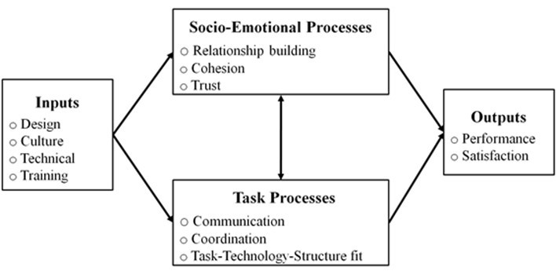
Figure 1: Process of performing team behaviour at Kellogg’s
Source: (Kumar, 2009)
At present, the company is following the aforesaid model's stages to increase their team performances and thereby the productivity of the business. But they make sure the inputs are up to date to build a good relationship with the consumers and satisfaction is the result. In 2019, 'Reputation Institution' of the UK recognized Kellogg’s as the most trusted drink and food company in the country. Kellogg’s is thinking about organic and healthy food nowadays because the people of the country is thinking so¬ (Wiedow and Konradt, 2010).

Conclusion
There is no doubt that, if Kellogg's team behaviors were improper, they couldn't increase their business in the UK as well as all over the world in such a short time. Their system of branding and marketing is always up to date by following all the four stages of Tuckman’s team behaviour model. So, to make sure the prosperity of the business, a well-arranged and effectively managed team is mandatory.

References
Kelloggs.co.uk. 2020. [online] Available at: <https://www.kelloggs.co.uk/en_GB/brands.html> [Accessed 1 May 2020].
Kumar, N., 2009. Organizational Behaviour. New Delhi: Himalaya Pub. House.
PAPIC, L., 2014. DEPLOYING CUSTOMER REQUIREMENTS VIA FOUR-STAGE TEAM APPROACH IN BUSINESS PLANNING. International Journal of Reliability, Quality and Safety Engineering, 14(03), pp.263-274.
Tuckman, A., 2010. DEFYING EXTINCTION? THE REVIVAL OF THE STRIKE IN UK EMPLOYMENT RELATIONS. WorkingUSA, 13(3), pp.325-342.
Wiedow, A. and Konradt, U., 2010. Two-Dimensional Structure of Team Process Improvement: Team Reflection and Team Adaptation. Small Group Research, 42(1), pp.32-54.

Appendix– POWER POINT PRESENTATION



