
\

Student name:
Student ID:

Module name:
Module code:
Lecturer name:

CHANGEMAKERS: BUILDING YOUR PERSONAL BRAND FOR SUSTAINABLE EMPLOYMENT

Table of Contents

Introduction 4
Reflection on Unit 1: Brand You 4
Screenshot 1: Moodle Forum Post 5
Screenshot 2: Activity Completion / Quiz Result 5
Reflection on Unit 2 5
Screenshot 1: Moodle Forum Post 6
Screenshot 2: Moodle Forum Post 6
Reflection on Unit 3 7
Screenshot 1: Moodle Forum Post 8
Screenshot 2: Moodle Forum Post 8
Reflection on Unit 4 8
Screenshot 1: Moodle Forum Post 9
Screenshot 2: Moodle Forum Post 9
Conclusion 9
References 10

Introduction
The Changemakers course, Building Your Personal Brand to Sustainable Employment has enabled me to grow professionally as an upcoming professional through addressing personal identity, employability skills and future career planning. In the four units, Brand You, It is a Small World, Opportunity Knocks and The Pursuit of Happiness, I have undertaken activities that enhanced my self-knowledge, enhanced my digital and professional identity and also enhanced my knowledge in global, social and organisational factors in career development. The module stimulated the reflective mind by performing tasks that include the analysis of its strengths, networking prospects, the labour-market trends, and analysis of wellbeing strategies. The exercises have assisted me to realise the role of personal branding and lifelong self-improvement in successful practice in health and social care facilities, whereby communication, professionalism and flexibility are pertinent. This portfolio is a compilation of my thoughts, evidence, and practice application that gives me the ability to understand how the module has influenced my future goals and employability.

Reflection on Unit 1: Brand You
Unit 1: Brand You presented the principles of personal ambition, Goal setting and motivation that made me begin to build a more detailed concept of my professional identity. The session started by discussing the meaning of ambition, which is the need to attain personal or professional growth. This definition made me consider how ambition influences my decision-making, especially in regard to my career future in health and social care as a student. I contemplated that ambition is not merely about status but doing something important. The content emphasized that ambition makes one strong and able to keep at it despite obstacles (Hirschi and Spurk, 2021), and this has been reflected in my academic life thus far. An important aspect of the week was that the role of authenticity in personal branding was acknowledged. The session had me reflect on how my values, strengths and experiences can be used to create a true brand rather than trying to come across as a perfect image. The stepwise method of setting goals aided me to have a more tangible vision of my future. Through visualising the future of my career path by assuming that I was in an entry-level position and then visualizing myself as a leader, I understood how I could motivate myself and be clear in career planning.
The sense of autonomy, mastery and purpose, which dominated the session, was especially efficient (Tyack and Wyeth, 2021). The theory as explained by Pink stated that individuals work better when they are given the autonomy, competency development opportunities, and purpose in their objectives. This made me realize why personal ownership is a necessary part of career planning as I learned the meaning of autonomy, which is the ability to have control over my decisions. The examples of health and social care (shared decision-making and self-management) linked autonomy directly to practice, demonstrating how the concept can be applied to the profession and service users. The reflection on mastery enabled me to contemplate the areas concerning skills that I should train, including empathy, communication and cultural awareness. Reflecting on purpose made me state the reasons as to why I would like to work in health and social care: to provide person-centred, caring support. On the whole, Unit 1 assisted in the realization of what motivates me and how ambition, motivation, and authentic goal-setting can be used to create a strong personal brand.

Screenshot 1: Moodle Forum Post
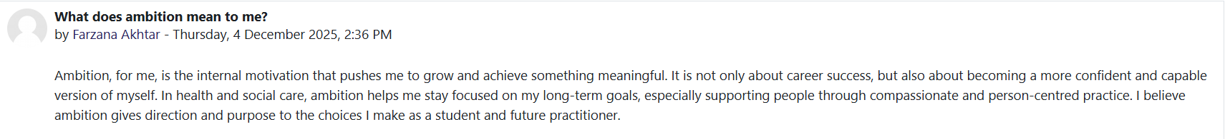

Screenshot 2: Activity Completion / Quiz Result
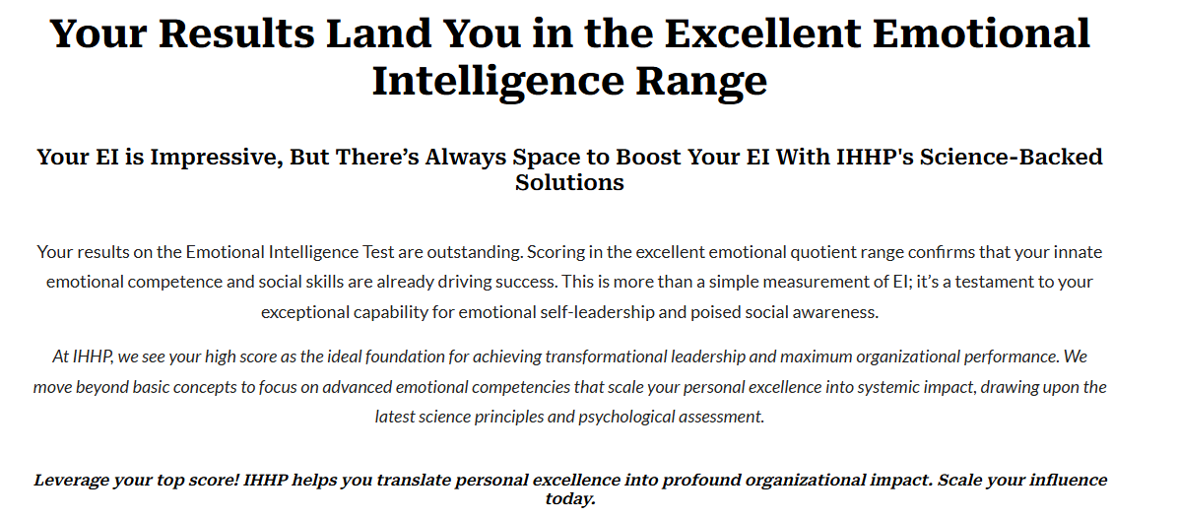

Reflection on Unit 2
Unit 2 has made me realize the importance of networking when it comes to establishing a solid personal brand and resiliency in the health and social care field. To start with, the session commenced by having networking determined as a process of interrelating with others in order to share information and develop professional or social connections. It prompted me to consider that networking is more than merely knowing people, and entails useful relationships, which can facilitate learning, career development, and learning in practice. The Week 3 information presented the significance of assessment in networking. I got to know the various forms of evaluation such as goal-based, process-based, and outcome-based evaluations and the way they aid organisations in determining whether their collaborative networks are working. The cases of Integrated Care Systems (ICSs) pointed to the fact that effective networking can positively affect the state of the health of the population by uniting the services offered by the NHS with the local authorities and local partners (Charles et al. 2021). This demonstrated that robust networks are critical in the health and social care where the collaboration and combined work have a direct influence on the quality of services.
The other important learning lesson was the focus on diversity in networking. The slides described the benefits of networks comprising people of varied backgrounds, professions and experiences in the creation of creativity and lessening of personal prejudice. This has also made me think about my comfort zone and realise the importance of developing relationships beyond myself and my close group. Various networks open eyes to new views and this is always essential in the provision of person-centred care (Ekman et al. 2021). Week 4 broadened this knowledge by allowing me to learn about a Network Society, in which digital communication determines how professionals interact, affect and cooperate. The workshops displayed the power of communication through the web and the importance of persuasion in developing trust, information exchange and decision making in the health and social care networks (Dilleen et al. 2023). This was especially applicable to me because nowadays the use of online platforms like LinkedIn and professional forums is being utilized as a necessity to create a personal brand. It was also the week of practical methods of connection-making, with an example of social work and social prescribing. These demonstrated that the support of service users, as well as the fact that networking is a career skill, is also the use of professionals to build social capital. Altogether, Unit 2 enhanced my knowledge in terms of the role of networking, digital communication, and various relationships in professional development and effective practice in health and social care.

Screenshot 1: Moodle Forum Post
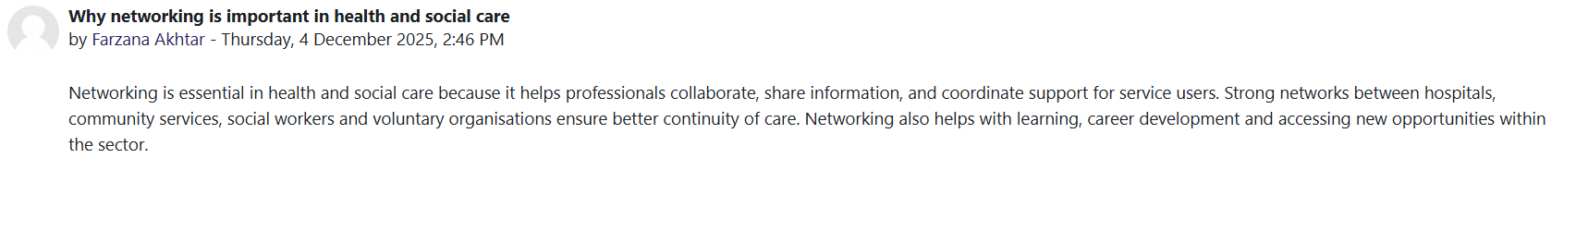

Screenshot 2: Moodle Forum Post
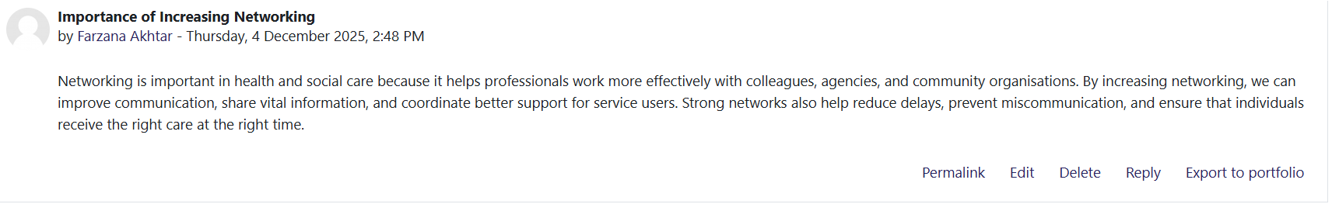

Reflection on Unit 3
Unit 3 allowed me to realize how the career opportunities in the field of health and social care can be determined not just by the qualifications but also by the mentality, vision, and online presence. The week started by discussing how a different perspective on things can result in professional development. The content has emphasized how a change of mindset is necessary in an industry that keeps on changing based on societal transformations, disparities, and limitations in health including the COVID-19 pandemic (Frenk et al. 2022). Being aware of this enabled me to think about the necessity of flexibility and receptivity in my relationships with various service users and complicated needs. One of the key concepts that were presented during this unit was the concept of making your own luck. In health and social care, one should not just be lucky but communicate, organise, maintain confidentiality, manage stress, and never cease learning (Stadler et al. 2023). This prompted me to realise that opportunities can be created as long as we prepare ourselves by networking, being aware of the need to develop my skills and actively doing so. This concept was supported by the introduction of the serendipity mindset. The development of serendipity as the power to discover valuable results despite the unexpectedness of its occurrence can be achieved both with the help of curiosity and involvement, and not with passively acquired luck (Busch, 2024). I thought that a proactive attitude, observation and willingness to new experience would allow me to develop in the future career.
Another topic that was covered by the unit was stretch goals that push the person out of the comfort zone and encourage innovation. The stretch goals made me think about the way to achieve high but not too high goals, like enrolling in specialized training or finding leadership positions in the future. The sixth week was about door opening and establishing a professional online presence. I also acquired useful techniques like revising my CV, networking via LinkedIn, and acquisition of skills via courses. The session has described the importance of having an online professional presence in the current digital world especially in health and social care where trust, communication, and accessibility matter a lot. The Five Cs of building an online presence made me understand how clarity, consistency and credibility would build my personal brand. Lastly, the experience of reading about the existence of blogging and other online communication technologies made me realize that digital spaces can be used to facilitate knowledge sharing, community establishments, and personal reflection. All in all, Unit 3 gave me more confidence in maneuvering opportunities with the help of mindset, preparation, and professional visibility.

Screenshot 1: Moodle Forum Post
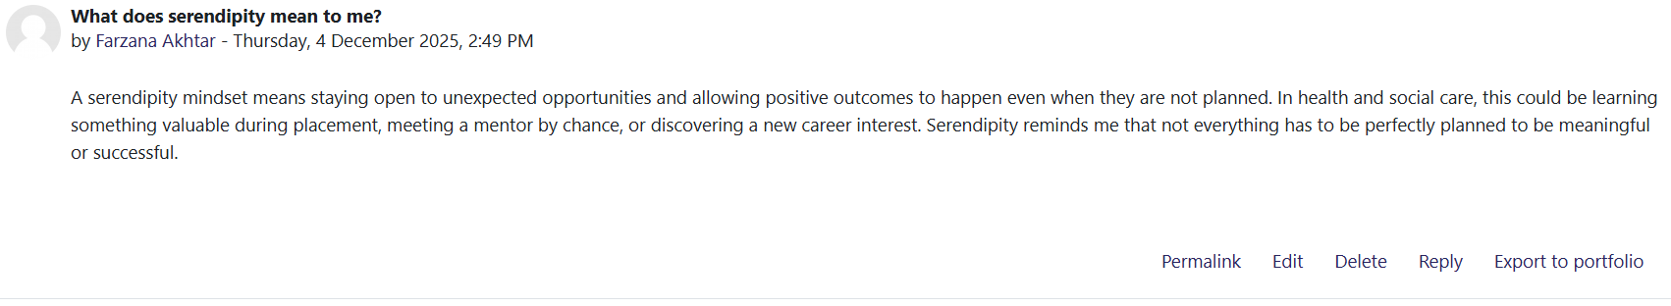

Screenshot 2: Moodle Forum Post
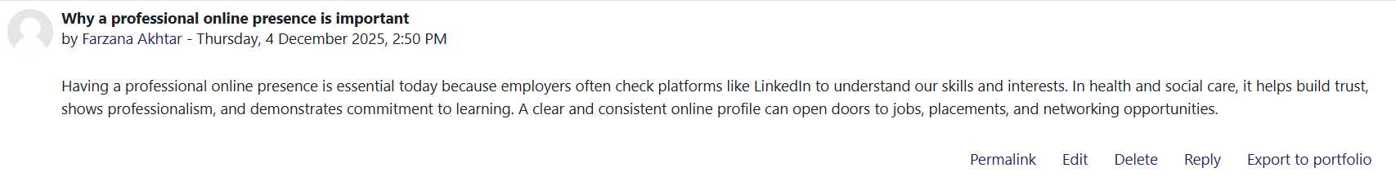

Reflection on Unit 4
Unit 4 made me think heavily about my future aspirations, my barriers and the type of professional I would like to be in health and social care. It started with the discussion of the reasons why people want to study as well as the reasons why many are health and social care. The presentations described that the profession is rewarding to work in with a chance to change the world positively, acquire transferable skills, and adapt to a continuously changing area influenced by technological and scientific changes. This made me re-establish my personal reasons for getting into the profession. One of the key areas that this unit covered was the limiting beliefs, the internal thoughts that inhibit potential, including self-doubt or fears of failing (Shahri et al. 2024). By the examples and activities, I also thought of how restrictive beliefs can put me on the wrong foot during placements or in the job application process. Acknowledging these assumptions and refuting them with the help of thought and reflection, evidence and positive thinking made me realise that mindset shift can affect both academic achievement and professional development. It was also during the session that the limitation of beliefs can affect decision-making, communication and behaviour in health and social care environments (Moore, Parsons and Jessup, 2019).
Grit was another important concept of Unit 4, which is long-term perseverance and passion in the face of challenges. The knowledge of grit made me look back at my personal persistence in the difficult modules and how I need to be resilient when dealing with vulnerable people who need regular assistance. This was closely related to the talk on how to cope with failure- not to feel overwhelmed by them, learning, and seeking support. I also understood that failure can be useful in professional maturity as long as it is taken positively. Week 8 continued the unit by discussing how technology is transforming the future of health and social care employment. The issues that were brought out in the slides included the absence of digital infrastructure and the risk of exclusion of individuals who would not be able to receive digital services . I thought of the necessity to constantly modernize digital skills and keep up with new tools to be able to keep a job. Antifragile thinking, which is a notion I should grow stronger in uncertainty, pushed me to recognize technological change as an opportunity, instead of a threat. Lastly, the material on mentors and social learning theory provided the focus on learning via empirical role models as the means of boosting confidence, skills, and career progression (Stålstrøm et al. 2023). This enabled me to learn the importance of directions in ensuring the realization of my future. In general, Unit 4 has enhanced my understanding of individual attitude, resilience and future preparedness in a fast-evolving industry.

Screenshot 1: Moodle Forum Post
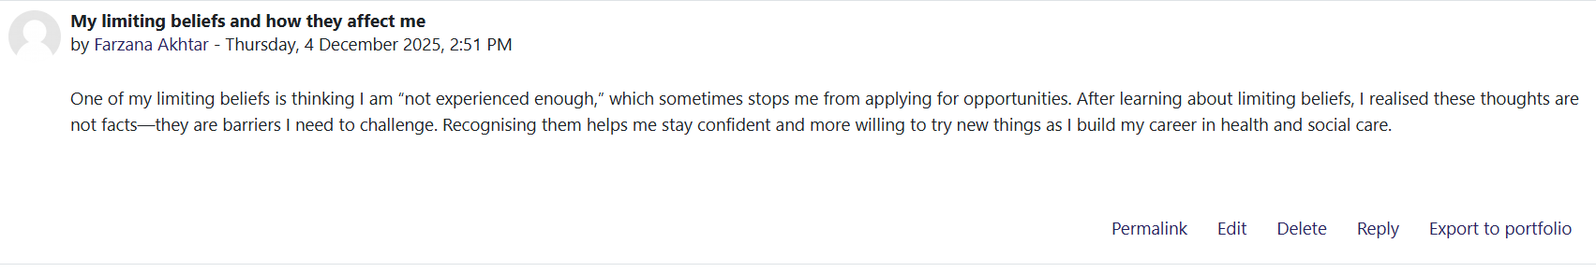

Screenshot 2: Moodle Forum Post
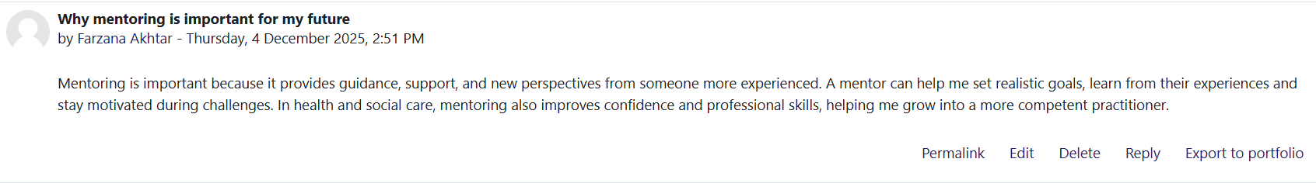

Conclusion
All in all, this portfolio has empowered my knowledge of personal branding, skills of employability and career growth in the health and social care sector. By using the four units, I got to find out the impacts of ambition, networking, opportunity awareness, and resilience in my development as an upcoming professional. My reflections about every unit enabled me to identify my strengths, confront the narrowing beliefs, and have a more accurate vision of my future career. I got to know that the concept of boundaryless careers, online communication, professional presence, and mentoring are all beneficial in establishing a robust and versatile personality in the highly dynamic industry. I also developed in the module as I was able to assess my emotional intelligence, broaden my networks, and create specific yet ambitious targets backed by a growth mindset. On the whole, the Changemakers module has given me the means to cope with the challenges, take opportunities and keep on developing as a confident, reflective and socially responsible health and social care practitioner.

References
Busch, C., 2024. Towards a theory of serendipity: A systematic review and conceptualization. Journal of Management Studies, 61(3), pp.1110-1151.
Charles, A., Naylor, C. and Murray, R., 2021. Integrated care systems in London.
Dilleen, G., Claffey, E., Foley, A. and Doolin, K., 2023. Investigating knowledge dissemination and social media use in the farming network to build trust in smart farming technology adoption. Journal of Business & Industrial Marketing, 38(8), pp.1754-1765.
Ekman, I., Ebrahimi, Z. and Olaya Contreras, P., 2021. Person-centred care: looking back, looking forward. European journal of cardiovascular nursing, 20(2), pp.93-95.
Frenk, J., Chen, L.C., Chandran, L., Groff, E.O., King, R., Meleis, A. and Fineberg, H.V., 2022. Challenges and opportunities for educating health professionals after the COVID-19 pandemic. The Lancet, 400(10362), pp.1539-1556.
Hirschi, A. and Spurk, D., 2021. Ambitious employees: Why and when ambition relates to performance and organizational commitment. Journal of Vocational Behavior, 127, p.103576.
Shahri, G.N.K., Mehr, A.M., Niri, V.S., Sheykhangafshe, F.B. and Farahani, H., 2024. Research Paper Effectiveness of Group Dialectical Behavior Therapy on Self-doubt, Thought Fusion and Depression in Women with Obsessive-compulsive Disorder.
Stadler, R., Walters, T. and Jepson, A.S., 2023. “Work it, work it non-stop”–Event industry employees' unconscious application of the Five Ways to Wellbeing. International Journal of Event and Festival Management, 14(1), pp.41-55.
Stålstrøm, J., Iskhakova, M. and Pedersen, Z.P., 2023. Role models and athlete expression at the youth Olympic games as impactful sport communication practices. International Journal of Sport Communication, 16(4), pp.435-449.
Tyack, A. and Wyeth, P., 2021. " The Small Decisions Are What Makes it Interesting" Autonomy, Control, and Restoration in Player Experience. Proceedings of the ACM on Human-Computer Interaction, 5(CHI PLAY), pp.1-26.

