Advanced Industry 4.0
Assignment 2 – Essay
MSc Industry 4.0 Advanced Manufacturing
Module Code: ACPA7000
Supervisor: Mahesh Kannath

A review of current manufacturing systems and processes and the impact that Industry 4.0 technologies may have on the economy, productivity, and society.

30th September 2022
Student: Christopher O’Connor
Email: christopher.oconnor@hanson.biz



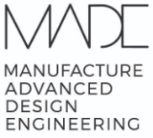

Contents
Introduction 3
What is Industry 4.0? 3
Manufacturing defined 4
Four current manufacturing system types 5
Custom Manufacturing Systems 5
Intermittent Manufacturing Systems 5
Continuous Manufacturing Systems 5
Flexible Manufacturing Systems 6
Primary Steel Manufacturing 6
Process Overview 6
Opportunities for Industry 4.0 Technology Implementation 8
Automation 8
IoT and Smart Technology 9
Artificial Intelligence 9
Detrimental Impact of Industry 4.0 Technology Adoption 10
Ethics 10
Cyber security 11
Conclusions 12
Table of Figures 13
Bibliography 14

Introduction

What is Industry 4.0?

Industry 4.0 is a term that is used to describe a new era in technological advancement that when applied to current and future industries and processes can offer full integration to organisational value and supply chains that can benefit in greater productivity, efficiency, and customisation whilst creating sustainable models in terms of environmental and socioeconomical impact (Oritz, 2020).
The term was originally coined in Germany in 2011 at the Hannover Fair, at the time referring to changes directly linked the integration of automation fields and information technology (Schwab, 2016). Its origins centred around the application technologies in manufacturing systems, however the explosion in technological advancements in areas such as robotics, artificial intelligence and connectivity has seen Industry 4.0 adoption transcend all types of businesses, organisations, and society in general across the globe.
The key technologies that are integral to the Industry 4.0 revolution can be summarised in four categories, which are:
- The Internet of Things (IoT)
- Additive Manufacturing
- Advanced Robotics
- Artificial Intelligence (AI)
The IoT can be described as a network of physical objects connected with digital systems over the internet using smart technologies such as sensors. Such objects can range from a component in a manufacturing process to a kettle in a home. It is estimated that by 2025, 20 billion physical devices will be connected via the IoT (Oracle, 2022). Typical benefits of IoT applications are real time information of a process, inventory, or product component. (Khan & Tariq, 2021) Give an excellent example of the potential application of IoT in the retail sector, where they describe how merchandise can be transformed into “smart merchandise” using sensors or RFID tags which, along with artificial intelligence and data analytics can give businesses real time data on inventory levels and customer preferences so that the customer experience can be tailored to the needs of the market more quickly than ever before.
Additive manufacturing (AM), which was previously referred to as rapid prototyping was originally used to produce part or whole models of a product or system using 3D scanners and 3D printing equipment for which the final models can then be based on (Gibson, et al., 2015). Advancements in technology in scanning, printing and material technologies meant that the rapid prototyping technologies could be scaled to produce final products rather than prototypes, and thus the term additive manufacturing was preferred. AM allows for the bypass of more traditional manufacturing process steps such as welding, forging, and machining for example and can produce a product that requires little to no further processing straight from the computational model.
Advanced Robotics are the combination of modern, powerful hardware and sophisticated programming that when combined with smart technologies such as sensors, can deliver a system that is fully interactive with the environment it works in and independent from human interaction (RGBSI, 2022). They offer greater accuracy, productivity and quality when implemented in current or new manufacturing processes by overtaking manual tasks typically populated by humans. Whilst this offers obvious benefits to business, as the prevalence of advanced robotics increases a great concern regarding the humanistic impact on society follows it. This is a seen a major challenge not just to advanced robotics, but to the integration of Industry 4.0 on society around the globe. The author will discuss in more detail further in this report, with specific examples, of how these challenges are presenting themselves and will look at opportunities to overcome them.
Artificial Intelligence may be the most impactful of the Industry 4.0 technologies that are emerging as it has the potential to transcend all manufacturing, business, and government enterprises whilst also playing a part in the everyday lives of the general public. On a basic level it can be described as a field that combines computer power with data analytics that together enables problem solving or decision making (IBM, 2020). It can be used to analyse datasets of Netflix subscribers which can then provide the user with suggestions of programmes they may like based on their previous watching history. This is a simple example, and there are many more that can be given to show greater or modest applications of the technology, from a simple chat bot to landing a rocket on a distant planet.
Despite the many benefits that AI promises to bring, there are many who are far more cautious of the implementation of AI in all corners of governance, mobility, medicine, warfare, and society as a whole. Elon Musk is particularly vocal of the dangers of AI and has been a stern advocate of the introduction of a regulating body to oversee the developments and application of AI technology (Kakaes, 2022). This concern is supported by (Liao, 2020)who raises fundamental questions on the ability of AI technology to think independent of, and more worryingly in contrast to the humans that it has been created to serve.
The overwhelming opinion appears to be that the positive impacts of Industry 4.0 technologies and their adoption, such as greater productivity, reduced emissions, and improved product customisation, for now at least outweigh the associated negative effects it may contribute to such as security and ethical concerns.

Manufacturing defined

Manufacturing can be defined as either an individual or company that takes a raw material and transforms it into a useable, finished goods product through the utilisation of various tools, equipment, and processes (CFI Teams, 2020). It can take many forms and is carried out on vastly varying scales.
For example, on one hand you may have a potter who takes a raw material, in this instance clay, and using various tools (a turn table, knife) and processes (shaping of the clay), can shape into an extravagant vase or bowl that has a subsequent use and purpose. Conversely, there are ceramic producers such as Wade Ceramics that operate on an industrial scale and turn out thousands of products per year with an estimated 180 employees accounted for and an annual turnover of £15 million (The Drinks Report, 2022). The product is the same, essentially, but the difference in scale is enabled through the use and application of more technically advanced tools, equipment and greater staff numbers that not only produce greater volumes at any one time, but also optimise the manufacturing processes used to maximise the productivity. Pottery, for example, is a product that dates back thousands of years to ancient Greek, Roman and Egyptian empires and even during those periods the manufacturing processes were being refined to optimise production and produce on mass volumes to meet the demands of the people of the time (Lake side pottery, 2021). It is not until the 18th century however, with the introduction of machinery during the 1st industrial revolution that such products could be produced on real scale.
Since then, in the subsequent 2nd and 3rd Industrial revolutions in the 19th and 20th centuries, respectively, the exponential progress in both machinery and technology has seen an explosion of manufacturing processes across all industries to a point where millions if not billions of products are manufactured daily all over the globe of various shapes, sizes and purpose to meet an insatiable demand of a global economy.

Four current manufacturing system types

Custom Manufacturing Systems
The Custom Manufacturing System is typical of your single potter making bespoke pottery one product at a time. The oldest of the manufacturing systems named here, it dates back thousands of years and is still just a prominent and desirable today. The reason being that usually, bespoke single product manufacture offers the customers a product that is usually of good quality and unique in comparison to any other product available, for it is made by hand and therefore may not benefit from the accuracy and perfection of another similar product that has been made by machines (Edwards, 2022).
The uniqueness of the product that is made, combined with the often-long duration that is needed to make it usually means that by product, this type of manufacturing is often the most expensive and time-consuming method of producing goods. With the ever-increasing demand that a global economy can bring, although this type of manufacturing will always have some place within the market it could never keep up with the demand to supplement the needs of its potential customers. Due to this fact, alternative methods of manufacturing arose out of necessity to produce at a lesser cost and with greater speed. Such examples will be described in the next few paragraphs.

Intermittent Manufacturing Systems
The Intermittent Manufacturing System type generally means that a manufacturing process is flexible enough to change the product that is produce depending on customer requirements, but not to the extend that a Flexible Manufacturing System has. Unlike the Continuous Manufacturing System, products are usually made in batches to specific order volumes rather than pumped out to stock in earnest of potential future orders (MBAKnol, 2022). An example of an intermittent system is a machine shop. Generally, a machine shop consists of a combination of highly skilled crafts people and basic to complex machinery, such as lathes or milling machines for example. These combine to make a wide range of components depending on the customer requirements and can quickly adapt to a change in the product design. Often this type of manufacturing is expensive due to the high capital needed to purchase the machinery and the wages that are demanded by highly skilled craftspeople.

Continuous Manufacturing Systems
It would be reasonable to suggest that when reading the term “Continuous Manufacturing Systems”, that the name Henry Ford and the Ford Motor company comes into mind first. For it was Ford in the 1920s that really made great strides in this type of system to satisfy the market demands of the then popular Model T. Ford went from a manufacturing model of cars being put together in batches, all the way to completion, to long continuous production lines where parts were added to a continuous line of cars until completion at the end of this production line. This method of production reduced the completion time of a vehicle from twelve hours on average to one hour and thirty-three minutes (History, 2009). This decrease in production time had a two-fold effect, as the more cars were able to make not only allowed them to meet the soaring demands for the car, but it also allowed them to sell it at a reasonable price by building them more efficiently.
In the proceeding one hundred years since Ford industrialised the continuous manufacturing system, with the introduction of better equipment and machinery, plus revolutionary advances in manufacturing philosophies driven by Toyota and its Lean principles (T & Faddoul, 2013) has led to an exponential growth in continuous manufacturing system adoption across all industries and products.
Problems often associated with this method of production however are high capital costs for the purchase of said machinery and associated labour. Traditionally this type of system is used to produce single products and therefore can be constrained from reacting quickly to shifting market trends and the ever-increasing demand on product customisation (Athena, 2022).

Flexible Manufacturing Systems
The most modern of the manufacturing types listed in this report, the Flexible Manufacturing System is based around a system that combines the use of machinery and human labour in tandem to produce goods en masse but can retain the flexibility to easily change produce specification to a change in customer preference or market demand. The system type has been talked about and desired since the 1970’s, but it is only through the technological advancement in the last twenty years that have meant that it is now a practical and viable system to implement (Karsak, 2002).
Although typically high in initial capital outlay, by using machines or robots that can produce a variety of products reduces the need for purchasing a variety of machines which, will require a high capital cost per machine but also adds an additional problem in the need for bigger premises to accommodate the machinery and production lines.
A business can base its strategy to include all, a mixture of, or a standalone manufacturing type as previously listed in this report. The decision of which is best is inevitability down to the size of the organisation, the products that it offers and the markets in which it operates in. One example of a business that implements all the systems aforementioned and which will be discussed in more detail in this report is the Steel Manufacturing industry. Specifically, the author will use the example of Tata Steel’s manufacturing plant in Port Talbot, Wales as a case study to discuss the current manufacturing systems in place and how they are using Industry 4.0 technologies to improve these processes and the effects they are/may have on productivity, society, and the environment.

Primary Steel Manufacturing

Process Overview
Tata Steels Steel manufacturing plant in Port Talbot, South Wales is one of two remaining primary steel making facilities in the United Kingdom. Annually, it produces 3 million tonnes of flat rolled steel every year, turning over more than £2 billion in the process (Tata Steel UK, 2020). The site is vast, spanning almost 5km in length and employing more than 3000 people directly. Holistically the site could be considered as a type of intermittent manufacturing system as it does have the ability to change the types of steel it produces, in terms of size, shape and chemical properties, but it does not have the flexibility that would be associated with a flexible manufacturing system. Interestingly, if you broke down the individual process components and the peripheral manufacturing system that support the operations as a whole, you would see all if not most of the manufacturing systems earlier described.
Primary steel manufacturing is where raw materials such as iron ore are processed along with other materials and additives in a Blast Furnace (BF) to make molten iron or in a Basic Oxygen Steel (BOS) vessel to make molten steel that is later cast and rolled to the final strip product. In contrast to Secondary steel making, which is typically done in an Electric Arc Furnace (EAF), where scrap steel is melted down with electricity, primary steel making offers greater quality of steel to customers which is of particular value to industries such as motor and aviation (Monroe Engineering, 2019).
An example of the primary and secondary steel making processes can be seen below:
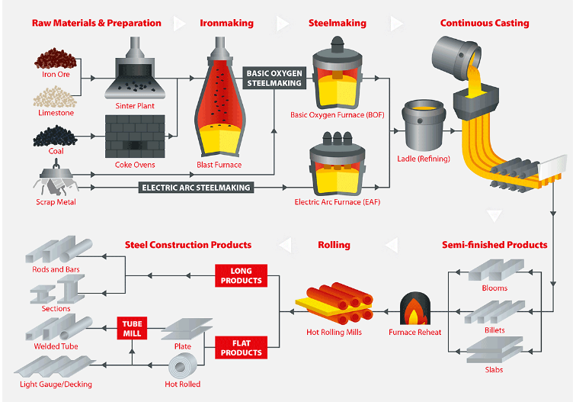
Figure 1 - Primary and Secondary Steel Making Process Overview (NSC, 2017)
The steel industry and particularly Port Talbot itself has seen a significant change in the industrial landscape in which it operates. Asian steel output, and in particular Chinese steel, has seen exponential growth over the last two decades which has seen it reach a point that China now outproduces the other thirty-nine steel manufacturing countries by a staggering 156 million metric tons per year (World Population Review, 2021). Typically, due to the advantage of historical knowledge of UK steel manufacturing had over its competitors up until recently it was able to somewhat maintain its market share based on the quality of steel that it was able to produce. However, the advancement of knowledge and technology obtained and deployed by its competitors has seen that quality gap decrease somewhat and reduce further the market share the company once held.
The detrimental impact of market dominance by its competitors on the companies’ profits has only been compounded further and perhaps more significantly by the challenges that manufacturing a highly energy intensive process presents. Electricity and fuel prices along have increased 500% and 30% respectively since January 2021 alone (Powercompare, 2022).
The impact of carbon intensive processes and the collective global carbon reduction targets that are now in place also add another problem to the ability of the business and industry as a whole to operate effectively whilst remaining profitable. The UK Governments target of net zero by 2030 (Gov.uk, 2021) is an enormous hurdle to overcome for a company that produces over six million tonnes of CO2 emissions per year, primarily through the burning of coal for process and fuel needs (Tata Steel Europe, 2022). As well as the obvious detrimental effect that such emission generation has on the local and global environment, when you add to this the negative publicity it often brings and the substantial carbon tax that must be paid, which runs into the millions of pounds each year, it easy to see that Tata Steel Port Talbot and the industry as a whole has a monumental challenge ahead to remain viable to continue operations.
It is through the implementation of Industry 4.0 technologies that the industry and site at Port Talbot may be able to make significant strides to becoming a more sustainable, reliable, and productive business. Below are some examples of how these technologies are being applied and what effect they can have on the business on a strategic level.

Opportunities for Industry 4.0 Technology Implementation

Automation
Through the combination of smart sensors, robotics and the IoT, Tata Port Talbot are making strides into the full automation of its coil dispatch process at the Hot Coil Finishing area.
Prior to the introduction of Industry 4.0 technologies, when a coil had finished coiling it would be labelled with a paint machine and transported via a series of conveyors and manually operated crane with grab to its stocking location. When the customer order arrived at the processing screen, a person would need to go out and identify the coil for it to be retrieved by the crane and loaded onto a truck or train for transport. The operator would then enter the coil I.D into the processing system to confirm dispatch. This manual process was not only labour intensive, but also introduced several safety issues due to the fact the coils were over 500 degrees Celsius and therefore could burn the operator during marking. On top of this, human error in both tagging, identifying and the feeding back the processed coil meant many human touch points that would often lead to errors. These errors would subsequently lead to one of two things, the need for the coil to be brought back and reprocessed or even worse, the wrong coil sent to a customer in error. Not only would this cause the obvious financial loss of re-work and time wasted, but it would also lead to loss of reputation within valuable customer streams.
The proposed solution for this is the introduction of a robot at the coil labelling location that will spray on the relevant I.D tag. The stocking area has a digital twin within the dispatch computer system that will then account for and designate a storage location for the coil. The current manually operated crane is to be replaced with an autonomous one that uses a combination of sensor and GPS technology to understand its position within the stocking area, but to also identify, pick up and locate the coil in the storage bay. Once the customer order is replaced, a loading plan is uploaded into the dispatch computer system automatically which in turn directs the crane to collect and load the coil. Once dispatched the dispatch computer system removes the coil I.D from the inventory log on its system.
There are several benefits that can be identified through the introduction of an automated dispatch inventory stocking and dispatch system. One such advantage that is discussed by (Yuan, et al., 2019) is the optimisation of storage space that can reduce crane travel times and optimise loading times. This will lead to reduced dispatch times and an improved service for customers and down stream operations. Other benefits that are synonymous with the implementation autonomous process that are discussed by (Forhm, et al., 2006) and are prevalent in this case are improved safety conditions for workforce, cost savings in the reduction of manning and reduced re-work and greater efficiency of the dispatch process.

IoT and Smart Technology
The IoT in combination with smart technologies, such as advanced camera technologies in this case are revolutionising the production of Sinter product that is considered a base material to produce molten iron. Sinter has an optimal size to be considered a prime feed for a blast furnace operation, and this at Port Talbot has been found to range between >5mm - <40mm in size. This allows it to effectively withstand the high temperatures and pressures within a blast furnace without breaking down too late or early in the process, which optimises the molten iron production (Satyendra, 2013). By introducing sinter into the blast furnace process at the correct size increases the efficiency of the furnace process and can optimise the gas quantities used in doing so.
The installation of a smart camera that can monitor, detect, and feedback oversized material that is viewed on a conveyor before it is sent to the blast furnace the specifically created algorithms can then be diverted back to the crushing system or dust bins for reprocessing.
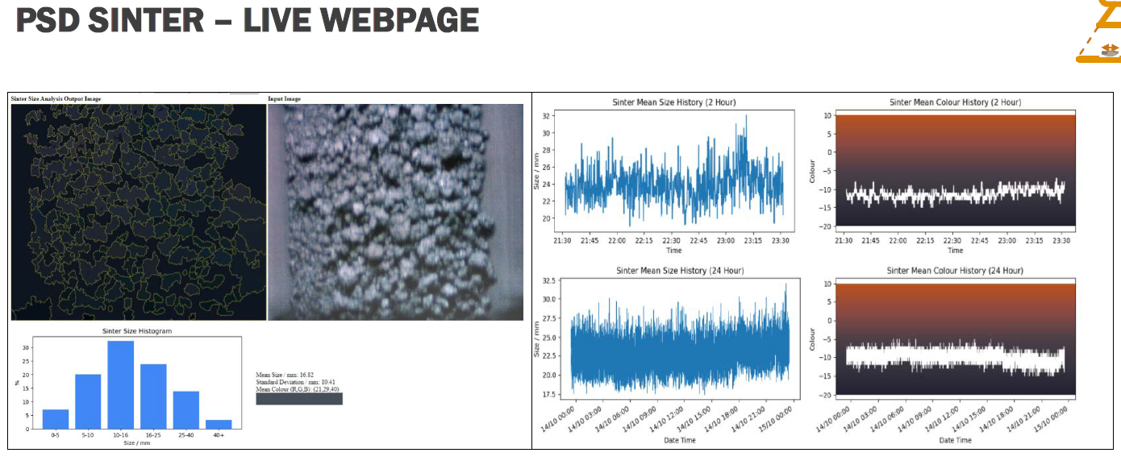
Figure 2 - Sinter Plant Online Sizing Equipment (PyrOptik, 2018)
The optimisation of sinter sizing and subsequent benefits of gas reduction at the blast furnace step may offer significant gains at a strategic level to the business as not only is it saving money in terms of its fuel usage, but it is offering a reduction in its carbon footprint whilst improving iron quality.

Artificial Intelligence
Another opportunity to integrate an Industry 4.0 technology into a current steel making process, and one that has not yet been considered yet by Tata but which the author feels would be prudent to at least investigate further, is the application of Artificial Intelligence technology to improve the Basic Oxygen Steel (BOS) making process by optimising the oxygen addition by time and volume.
At the BOS process step, molten iron, scrap metal and particular chemical additives are added to a vessel where they combine and reduce to molten product. Oxygen is then fed into the molten product via a lance which intensifies the process heat further to allow it to achieve the relevant optimal temperatures for the components to suitably mix and combine at a rate of 800 cubic meters per minute for 20 minutes. This equates to 16,000 cubic meters of oxygen per charge (Britannica, 2022).
An article by (Roldan, et al., 2022) describes how Artificial Intelligence supported by digital twin technologies and data analysis can collect, review, model and control oxygen volumes to the BOS process to optimise the process temperature of the system. The journal states that the BOS system that had implemented such technology had seen several benefits, which were:
- Reduced overheating of process (1 out of 15,000 heats exceeded the process temperature limit), therefore reducing wasted fuel
- Reduced cooling waiting times for tapping, which therefore increased productivity with more batches processed in a day
- Reduced oxygen use from over blowing, which results in a benefit in savings on oxygen costs
When looking at the challenges previously outlined in this paper that the steel industry is contending with, the above tick many significant boxes in how and where the industry can benefit such as, reduced fuel usage which saves both money and reduces the sites carbon footprint, plus greater productivity achieved at a lesser cost through increased cycle time facilitated by reduced cooling times.
By focusing on solutions to the high-level problems that present themselves during primary steel making, such improvements may offer significant strategic benefits to the companies short- and long-term positions. Not only can it potentially increase productivity and reduce costs now, by looking at ways to reduce fuel usage will only increase its competitiveness in what can be turbulent markets going forward.

Detrimental Impact of Industry 4.0 Technology Adoption

Ethics
The steel industry in the UK has had many turbulent periods over the last forty to fifty years, this uncertainty has already had a significant impact on the people who have and still work within it. For example, in 1970 there were estimated to be 320,000 people working within the steel manufacturing sector, today the number equates to about 5-10% of that (Atteridge, 2021). Whilst many argue that adoption of Industry 4.0 offers, there is a real threat to the job security of a vast amount of people who are currently fulfilling roles that would be subject to being replaced by technology applications. If this is to be the future, then what of the thousands of people alone in South Wales who rely on Tata Steel Port Talbot as a source of income. In area of the world already ravaged by the decline in heavy industry, there are not many alternative jobs that can offer a similar compensation package that Tata can.
Even if the jobs were not completely eradicated and the workforce were instead deployed elsewhere to roles which required less skill and engagement, this in itself can lead to significant problems within the workforce’s motivation and job satisfaction if you consider Maslow’s Hierarchy of Needs (MHN). MHN is a five-tiered model that outlines the basic human needs that are required to be fulfilled in order for a person to feel satisfied (McLeod, 2007). These tiers can be seen below:
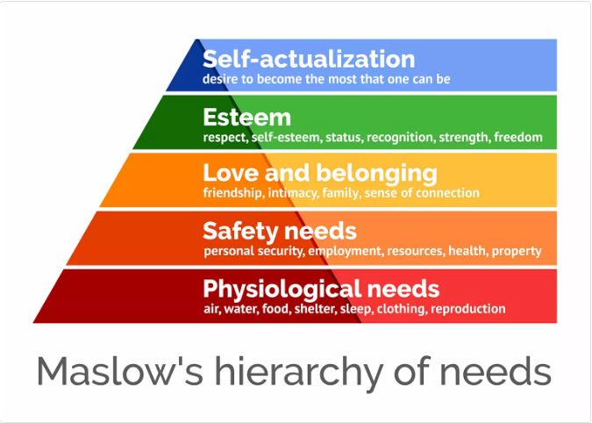
Figure 3 - Maslow's Hierarchy of Needs (McLeod, 2007)
If the plan to avoid job losses is to provide low skilled jobs as a replacement, how many of Maslow’s needs can be met for most people?
Alternatively, the introduction of new and advanced technologies is going to require adequately skilled people to operate and maintain them if necessary. Are businesses current employees adequality trained? If not, is it more beneficial to train them, which would no doubt be expensive (if they are capable of the new information to begin with), or do you supplement with costly, specialised contract labour?
The Welsh Government have identified this potential problem and are currently trialling one of the proposed remedies to it, basic income schemes. The scheme offers any person eighteen or over to sign up to the trial where they will receive £1600 per month for twenty-four months, with no requirement to work (Gov.Wales, 2022).
Whilst at face value this looks like a genuine option to a potential future unemployment problem, reverting to MHN’s, how will this satisfy those who seek purpose and value through their careers?
The Industry 4.0 ethical question is difficult, multi-layered one that society on a global scale must tackle before it is too late to do so.

Cyber security
One of the main founding principles of Industry 4.0 is the openness and connectivity of all persons, businesses, and organisation across the world. In doing this, new opportunities will be created, processes will become more efficient and reliable and anybody, anywhere will be able to have what they want and when they want it (within reason, of course).
Within this principle however there is a more sinister undertone that, if not protected from, can cause catastrophic harm to people, organisations and potentially the world itself.
The increased connectivity means that those wishing to infiltrate a business, individual or even government can now do so with far greater ease. Cyber security, or lack thereof has already caused significant problems for those who were not able to deal with them effectively. For example, in 2018 British Airways were subjected to a cyber attack that compromised its customers personal data. For this they were finding a considerable £20 million pounds (ICO, 2020). Whilst the experience must have been a damaging one for both company and customer, it is perhaps not as concerning as the Colonial Pipeline incident in the United States in 2021, where a ransomware attack saw key operating components of the pipeline overcoming, causing widespread panic amongst government and the wider public (Point Park University, 2021). This attack is more concerning as it had the potential to severely impact the country’s infrastructure, or even worse, lead to significant casualties if the control systems were tampered with.
Due to Tata Steel Port Talbots strategic importance to not only the UK’s manufacturing industry, but to its defence capacities also, there is a very real threat that in times of global and geo-political uncertainty, if the site opens its digital gates to harness the benefits that Industry 4.0 technologies have to offer, then it may be infiltrated by parties willing to cause harm to the business, or perhaps the country itself.

Conclusions

Whilst most people are accepting of the fact that Industry 4.0 technologies offer incredible opportunities for the advancement of businesses across all sectors, Tata Steel UK, much like society, must still proceed with caution when immersing themselves in this digital age due to the inherent risks and threats that Industry 4.0 as a philosophy contains.
Due to the challenges outlined in this report that Tata Steel Port Talbot are faced with, it is the authors belief that for the business to remain competitive it is essential that sooner rather than later is going to have to adopt Industry 4.0 into its current manufacturing systems and processes in order to reduce costs, improve efficiencies and reduce its carbon footprint via methods as previously mentioned. If it fails to do so, then it will be incredibly difficult to compete in a market that is flooded with products from companies and countries that have far less constraints in front of them in terms of carbon reduction objectives, fuel costs and socioeconomic factors.
The implementation of such technologies will not come without pain and a price, however. The ethical questions that will be raised from the potential of replacing skilled jobs with robots and automation may have an enormous detrimental impact on a community that is already suffering from the de-industrialisation of the Welsh economy on the whole. Whilst it is unlikely that Tata Steel will be able to overcome this problem on their own, the eagerness of the Welsh Government to take a forward step in trialling some possible solutions to this problem is at least a positive note to the people of the local communities.
Cyber security will also play a major part in Tata successfulness of Industry 4.0 implementation. Due to its strategic importance, and with geo-political tensions raised s they currently are with the Russia-Ukraine war, cyber threats on the business have never been at a more elevated level. Whilst it is the authors believe that of course some of this cyber defence strategy lies solely with Tata Steel Port Talbot, there is a serious question to be asked of governments on what controls and regulations they have in place that can ensure that businesses with the strategic importance of Tata Steel Port Talbot are suitably protected.

Table of Figures

Figure 1 - Primary and Secondary Steel Making Process Overview (NSC, 2017) 7
Figure 2 - Sinter Plant Online Sizing Equipment (PyrOptik, 2018) 9
Figure 3 - Maslow's Hierarchy of Needs (McLeod, 2007) 10

Bibliography
Athena, 2022. Continuous (Or Flow) Production Lines. [Online]
Available at: https://www.athena.zcu.cz/batcos/demo_en/c03m03en/c03m03u01s06en/text.htm
[Accessed September 2022].
Atteridge, A., 2021. Decline of the United Kingdom's Steel Industry, Stockholm: Stockholm Environmental Institute.
Britannica, 2022. Basic Oxygen Process. [Online]
Available at: https://www.britannica.com/technology/basic-oxygen-process
[Accessed 23rd September 2022].
CFI Teams, 2020. Manufacturer. [Online]
Available at: https://corporatefinanceinstitute.com/resources/knowledge/other/manufacturer/
[Accessed 27 September 2022].
Edwards, E., 2022. What is Custom Manufacturing. [Online]
Available at: https://www.thomasnet.com/articles/custom-manufacturing-fabricating/all-about-custom-manufacturing/
[Accessed 20th September 2022].
Forhm, J., Lindstrom, V., Winroth, M. & Stahre, J., 2006. THE INDUSTRY'S VIEW ON AUTOMATION IN MANUFACTURING. Elsevier, 39(4), pp. 453-458.
Gibson, I., Rosen, D. & Stucker, B., 2015. Additive Manufacturing Technologies : 3D Printing, Rapid Prototyping, and Direct Digital Manufacturing. New York: Springer.
Gov.uk, 2021. Environment Agency: reaching net zero by 2030. [Online]
Available at: https://www.gov.uk/government/publications/environment-agency-reaching-net-zero-by-2030
[Accessed 22nd September 2022].
Gov.Wales, 2022. Written Statement: Basic Income Pilot for Care Leavers in Wales. [Online]
Available at: https://gov.wales/written-statement-basic-income-pilot-care-leavers-wales#:~:text=The%20Programme%20for%20Government%202021,followed%20for%20over%2020%20years.
[Accessed 25th September 2022].
History, 2009. This day in history. [Online]
Available at: https://www.history.com/this-day-in-history/fords-assembly-line-starts-rolling
[Accessed September 2022].
IBM, 2020. Artificial Intelligence. [Online]
Available at: https://www.ibm.com/uk-en/cloud/learn/what-is-artificial-intelligence
[Accessed 12th September 2022].
ICO, 2020. ICO Fines British Airways £20m for data breach. [Online]
Available at: https://ico.org.uk/about-the-ico/news-and-events/news-and-blogs/2020/10/ico-fines-british-airways-20m-for-data-breach-affecting-more-than-400-000-customers/#:~:text=%20ICO%20fines%20British%20Airways%20%C2%A320m%20for%20data,attack%20on%2022%20June%202018
[Accessed 25th September 2022].
Kakaes, K., 2022. Politico. [Online]
Available at: https://www.politico.com/newsletters/digital-future-daily/2022/04/26/elon-musks-biggest-worry-00027915#:~:text=It%27s%20not%20Twitter.,existential%20risk%20for%20human%20civilization.%22
[Accessed 12th September 2022].
Karsak, E. E., 2002. Distance-based fuzzy MCDM approach for evaluating flexible manufacturing system alternatives. International Journal of Production Research, 40(13), pp. 3167-3181.
Khan, S. & Tariq, M. U., 2021. HARNESSING IOT ADVANTAGES IN THE DISRUPTIVE ERA: UAE RETAIL INDUSTRY. Academy of Entrepreneurship Journal, 27(2), pp. 1-13.
Lake side pottery, 2021. Clay and Pottery - Brief History. [Online]
Available at: https://www.lakesidepottery.com/HTML%20Text/brief%20history%20of%20clay_pottery.htm#:~:text=From%20a%20very%20early%20date,clay%20pots%20in%20for%20firing.
[Accessed September 2022].
Liao, S. M., 2020. Ethics of Artificial Intelligence. New York: Oxford University Press.
MBAKnol, 2022. Intermittent Manufacturing Systems. [Online]
Available at: https://www.mbaknol.com/operations-management/intermittent-manufacturing-systems/#:~:text=Examples%20of%20intermittent%20systems%20are,are%20laid%20out%20by%20process.
[Accessed 14th September 2022].
McLeod, S., 2007. Maslow's Hierarchy of Needs. [Online]
Available at: https://www.simplypsychology.org/maslow.html#:~:text=There%20are%20five%20levels%20in,esteem%2C%20and%20self%2Dactualization.
[Accessed 25th September 2022].
Monroe Engineering, 2019. Primary vs Secondary Steelmaking: What's the Difference?. [Online]
Available at: https://monroeengineering.com/blog/primary-vs-secondary-steelmaking-whats-the-difference/#:~:text=What%20Is%20Primary%20Steelmaking%3F,by%20Swiss%20engineer%20Robert%20Durrer.
[Accessed 20th September 2022].
NSC, 2017. An introduction into steelmaking. [Online]
Available at: https://www.newsteelconstruction.com/wp/an-introduction-to-steelmaking/
[Accessed 20th September 2022].
Oracle, 2022. What is IoT. [Online]
Available at: https://www.oracle.com/uk/internet-of-things/what-is-iot/
[Accessed 1st September 2022].
Oritz, D. J. H., 2020. Industry 4.0 - Current Status and Future Trends. London: IntechOpen.
Point Park University, 2021. 5 Famous Cyber Attacks. [Online]
Available at: https://online.pointpark.edu/information-technology/famous-cyberattacks/#:~:text=Some%20of%20the%20Most%20Famous%20Cyber%20Attacks%201,%282017%29%204%20Adobe%20Systems%20%282013%29%205%20Target%20%282013%29
[Accessed 25th September 2022].
Powercompare, 2022. Compare Business Electricity Prices. [Online]
Available at: https://powercompare.co.uk/business-electricity/
[Accessed 21st September 2022].
PyrOptik, 2018. Sinter Particle Size Distribution Camera. Wales.
RGBSI, 2022. The Impact of Advanced Robotics on Manufacturing. [Online]
Available at: https://blog.rgbsi.com/impact-of-advanced-robotics-on-manufacturing
[Accessed 7th September 2022].
Roldan, A. O. et al., 2022. Optimisation of Operator Support Systems through Artificial Intelligence for the Cast Steel Industry: A Case for Optimisation of the Oxygen Blowing Process Based on Machine Learning Algorithms. Journal of Manufacturing and Materials Processing, 6(2), p. 34.
Satyendra, 2013. The Sintering Process of Iron Ore Fines. [Online]
Available at: https://www.ispatguru.com/the-sintering-process-of-iron-ore-fines-2/
[Accessed 22nd September 2022].
Schwab, K., 2016. The Fourth Industrial Revolution. Geneva: World Economic Forum.
Tata Steel Europe, 2022. Sustainability Performance at Our Sites. [Online]
Available at: https://www.tatasteeleurope.com/construction/sustainability/performance-at-our-sites/port-talbot
[Accessed 22nd September 2022].
Tata Steel UK, 2020. Tata Steel in the UK. [Online]
Available at: https://www.tatasteeleurope.com/sites/default/files/Tata%20Steel%20UK%20Factsheet%202020%20%281%29.pdf
[Accessed 20th September 2022].
The Drinks Report, 2022. Wade Ceramics. [Online]
Available at: https://www.thedrinksreport.com/companies/42198-wade-ceramics-ltd.html#:~:text=With%20an%20annual%20turnover%20of,Ireland%20%E2%80%93%20for%20around%2040%20years.
[Accessed 25 September 2022].
T, T. S. & Faddoul, F. F., 2013. Lean Management—The Journey from Toyota to Healthcare. Rambam Miamonides Medical Journal, 4(2).
World Population Review, 2021. World Populatin Review - Steel Production by Country 2021. [Online]
Available at: https://worldpopulationreview.com/country-rankings/steel-production-by-country
[Accessed 20th September 2022].
Yuan, R., Graves, S. C. & Cezik, T., 2019. Velocity-Based Storage Assignment in Semi-Automated. Production and Operations Management, 28(2), pp. 1059-1478.

