

An exploratory look into community engagement and the evaluation of local problem-solving tool OSARA/SARA used by police forces.

School: UWTSD Swansea
Degree: Professional Policing Practice
Due Date: 15th July 2024
Student/Author (2117781) Lee David Richards

Acknowledgements
I would like to express my gratitude to Both, Samantha McAlister Wilson, and Jane Davies, for their invaluable support and guidance during the course of this dissertation.
I am also extremely grateful to Gwent Police, my family and partner for their unwavering support and encouragement. Their continual guidance and assistance, not only throughout my third year but also during my entire university experience, have been instrumental in keeping me motivated. I feel incredibly fortunate to have such a strong support system, both now and in the future.

Declaration
This work has not previously been accepted in substance for any degree and is not being concurrently submitted in candidature for any degree.
Signed: Lee David Richards
Date: 09/07/2024

STATEMENT 1
This dissertation is being submitted in partial fulfilment of the requirements for the degree of BA.
Signed: Lee David Richards
Date: 09/07/2024

STATEMENT 2
This dissertation is the result of my own independent work/investigation, except where otherwise stated.
Other sources are acknowledged by footnotes giving explicit references. A bibliography is appended.
Signed: Lee David Richards
Date: 09/07/2024

STATEMENT 3
I hereby give consent for my dissertation, if accepted, to be available for photocopying and for interlibrary loan, and for the title and summary to be made available to outside organisations.
Signed: Lee David Richards
Date: 09/07/2024

STATEMENT 4
I hereby give consent for my dissertation, if accepted, to be available on the university’s IT system to those who have consent to use the system.
Signed: Lee David Richards
Date: 09/07/2024

Abstract
Policing is almost impossible without the community's support and cooperation; this is why community engagement is important. The confidence cycle links community engagement to increased public trust in the police. It can increase the public's willingness to work with the police. When the neighbourhood’s major issues are addressed, public confidence rises, leading to increased trust in the community. The increased trust in the community leads to the community's willingness to provide important information to the police, which the police can use to develop intelligence. Using techniques such as OSARA/SARA, problem-oriented policing, the ten principles of crime prevention, and the problem analysis triangle to help tackle priority community issues. Tackling priority issues in communities fosters trust and support, resulting in a stronger relationship.

Table of Contents
1. Chapter One: Introduction 7
1.1 Introduction 7
1.2 Background and Rationale 7
1.3 Aim and Objectives 8
1.4 Research Structure 8
1.5 Conclusion 9
2. Chapter Two: Literature Review 10
2.1 Introduction 10
2.2 Understanding community support and engagement 10
2.3 Changes in policing and problem-solving methods. 11
2.3.1 Confidence Cycle 12
2.3.2 OSARA/SARA problem solving model 12
2.3.3 Problem Analysis Triangle 14
2.4 The effect that community engagement has on criminal activity 14
2.5 Conclusion of literature review 15
3. Chapter Three: Research Method 16
3.1 Introduction 16
3.1.1 Exploratory Research: Types & Characteristics 16
3.2 Developing a research method. 17
3.2.1 Saunders’ Research Onion: Explained Simply 17
3.2.2 Inductive vs Deductive Research: Two Approaches to Data Analysis 18
3.3 Limitations. 19
3.4 Ethical considerations 19
3.5 Conclusion 20
4. Chapter Four: Data analysis and results 20
4.1 Introduction 20
4.2 Data Analysis 20
4.3 Role within Gwent Police 21
4.3.1 Identity’s the role of the participant within Gwent police…………………………………………..21
4.4 Questionnaire Findings 22
4.5 Measuring the success of OSARA/SARA 22
4.5.1 After implementing a problem-solving tool such as OSARA/SARA led to increased intelligence reports from communities.. 23
4.6 Key issues with implementing OSARA/SARA 23
4.7 Questions with an inspector of a neighbourhood team in Gwent police. 24
5. Chapter Five: Findings, Conclusion and Recommendations 25
5.1 Introduction 25
5.2 Main Findings 26
5.3 Recommendations 26
5.4 Limitations 26
5.5 Further Research 27
5.6 The Achievements of Objectives 27
5.7 Self Reflection 28
5.8 Conclusion 29
6. Bibliography 29
7. Appendices 33
7.1 Appendix 1 – Research Onion by Saunders 33
7.2 Appendix 2 – Copy of Questionnaire 35
7.3 Appendix 3 – Figures from Literature review. 51
7.4 Appendix 4 – Figures from Mythology. 52
7.5 Appendix 5 – Figures from Data analysis and results. 54

Chapter One: Introduction

1.1 Introduction

The purpose of this project is to offer an exploratory look at community engagement and the efficacy of the widely used method OSARA/SARA currently employed by the Gwent police. This will entail reading journals and publications about past events that have strained ties within the community and considering what lessons can be drawn from them as well as how neighbourhood policing has changed over time to better engage the community.
This project will examine the value of community engagement, including past instances in which tensions within the community have negatively impacted police confidence. It will also investigate current problem-solving techniques and the results they can have, and it will conclude with a discussion of how effective community engagement can yield crucial information from the local community to aid in the reduction of organised crime and the boosting of public confidence.

Background and Rationale

Policing by consent is the model of policing throughout the United Kingdom therefore gain the trust and co-operation from the public is essential. Police and community residents must work together to prevent crime and run police agencies efficiently. Fundamentally, the judicial system relies on individuals to come forward with information, provide witness statements, and testify in court. However, it is critical to understand the reasons why people choose to cooperate with police forces, as some may be more eager to report crimes, identify suspects, and engage in legal proceedings than others (Jackson. et al 2012). Addressing criminal activity and enhancing public safety within the local community can help strengthen trust in police forces and promote greater participation from community members. Evaluating the impact of community engagement initiatives, particularly the problem-solving approach known as OSARA/SARA, can provide valuable insights into its effectiveness in fostering stronger relationships between police forces and the community.

Aim and Objectives

The aim of this dissertation is to have an exploratory look at community engagement and the efficacy of the widely used method OSARA/SARA currently employed by the Gwent police.

Objective 1; To understand the importance of community engagement and the consequences.

Objective 2; To investigate current methods available, how often they are used and their perceived effectiveness in community engagement and ultimately increasing community confidence.

Objective 3: Show the impact of improved community engagement and its effect on organised crime in local communities.

1.4 Research Structure

In order to achieve the goals of this research, the dissertation will be structured into five chapters.
Chapter one serves as the introduction to the project, providing background information on the chosen topic and outlining the rationale behind its selection. It also defines the aims and objectives in order to establish a clear structure for the project.
Chapter two provides a comprehensive review of literature on community engagement, emphasising the significance of historic events in showcasing their importance. The chapter also discusses theories on effective problem-solving strategies that can enhance public trust and foster community engagement.
Chapter three will outline the method and methodology utilised to identify appropriate primary research techniques for this study. The goal is to address research gaps and facilitate data analysis.
Chapter four an analysis will be conducted on the data obtained from the primary research. This analysis will lead to the identification of key findings which will serve as the basis for developing questions and talking points to be presented to a neighbourhood inspector.
Chapter five, the research will thoroughly examine the objectives and goals. Additionally, there will be an in-depth discussion highlighting the key findings, recommendations, and limitations of the study.

  - Conclusion

This chapter has successfully outlined the rationale for this project, outlining the aims and objectives that will be achieved. A structured framework has been put in place, creating a strong foundation for the project.

2. Chapter Two: Literature Review

2.1 Introduction

This chapter will explore the significance of community support and engagement by examining historical instances where the public has experienced feelings of disillusionment or alienation towards police forces in the United Kingdom. It will discuss initiatives and legislative changes aimed at rebuilding public trust and fostering a sense of unity to increase public support. The concept of public confidence will be analysed, along with the utilisation of established problem-solving tools and methods to address local issues effectively. A specific example of this approach will be presented, demonstrating how it can be utilised to identify and disrupt organised crime.
The review will conclude with recommendations for future research to gain a better understanding of the importance of community engagement and its associated benefits.
The goals will be met by using pertinent journals and publications about community policing and community engagement, information from reputable organisations like the National Police Chiefs' Council (NPCC) and the College of Policing, as well as an internet search engine called Google Scholar that will yield previously published scholarly material on relevant subjects.
When searching the internet for relevant information, I will use terms such as "community engagement", "events that have effected confidence in the police", "benefits of community engagement", "Police intelligence", and "Police problem solving".

2.2 Understanding community support and engagement.

Policing is almost impossible without the community's support and cooperation; this is why community engagement is important. According to The College of Policing (2013), community engagement is the process of allowing people and communities to participate in policing to the extent that they prefer. This includes providing information and assurance, as well as empowering communities to identify and implement local problem solutions while also influencing strategic priorities and decisions. The consequences of losing public support and engagement can result in major incidents and community tensions.
In 1981, minority communities in the United Kingdom felt victimised, alienated, and let down by police forces, resulting in the Brixton riots and the Lord Scarman report; it was widely accepted that police would serve their communities rather than the state. The main cause of the riots was a lack of engagement; some communities felt excluded. Briggs, D. (2012) describes Sheldon Thomas' experiences and the accumulation of police mistreatment, as well as a lack of social understanding. According to Lea, J. and Hallsworth, S. (2011), the black community felt they had been failed by the police and were perceived to be discriminated against because of their race. Community relations deteriorated again in 2011, following the shooting of Mark Duggan during a police operation. Because of underlying social issues and tensions between communities and the police, peaceful protests devolved into violent disorder. Newburn, T (2015) highlights and explains the similarities in the structural, political, and cultural context in which the 2011 riots occurred bears more than a passing resemblance to the 1980s riots. Both periods were characterised by an economic downturn, relatively high unemployment rates, a right-wing government enacting radical reforms, and rising levels of overall social inequality.
One of the solutions to bring transparency and make police forces accountable for their actions is the Police and Criminal Evidence Act of 1984, but section 1 of this act is a controversial among some members of the public. Cheadle, C (2022), provides a study also aimed to evaluate the effectiveness of stop and search practices by analysing any associated reductions in crime and disorder. The absence of significant riots or disorder following a considerable decrease in the application of these measures indicates that such powers are most effective when employed judiciously. In 2021 members of the public was asked directly about the use of stop and search, the confidence levels varied. It is noteworthy that 80% of the respondents believe that stop and search is a necessary practice (IOPC 2023). Maintaining confidence levels from the public with their police forces is crucial, as the communities they serve act as vital sources of information. When criminal activity goes unreported, it can remain undetected, allowing potential offenders to operate without consequence.

2.3 Changes in policing and problem-solving methods.

Community support officers were first introduced in 2002, and they spend much of their time patrolling their neighbourhood and interacting with members of the public every day. Community support officers are usually assigned to a neighbourhood policing team. According to G, Hughes, and Rowe, M (2007), it is frequently claimed that neighbourhood or community teams have the potential to support local 'at risk' communities, particularly in the reduction of anti-social behaviour. Locally dedicated visible patrol personnel who engage and work with local communities can give people a stake in their own security, nurturing ‘social cohesion', and aid in the regeneration of areas, thereby increasing public support and confidence. According to the Home Office Research Study 269 (2006), one aspect of reassurance is A neighbourhood policing package to boost public trust and reduce crime was deemed to require a highly targeted, problem-solving approach.
One of the most effective changes in policing to encourage engagement was the establishment of a neighbourhood branch, which included police community support officers. Innes, M. (2020, p. 217) supports this, stating that neighbourhood policing has been one of the most significant and visible innovations in UK policing in recent years.
The confidence cycle is a tool used in community policing that combines neighbourhood policing and problem-solving. The College of Policing (2013) provides detailed information on the confidence cycle.

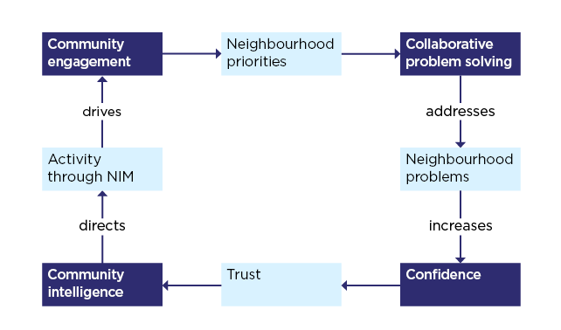
Figure 2.3.1 – Confidence Cycle (source College of Policing 2013)
The confidence cycle illustrated in Figure 2.3.1 operates in a clockwise manner. It begins with identifying community priorities, followed by collaboration with the community and partner agencies using problem-solving tools such as OSARA/SARA, which will be discussed in Figure 2.3.2. Addressing local or neighbourhood issues fosters trust and confidence in local police forces, encouraging community members to engage further and share valuable local information and intelligence. This information can be developed using the National Intelligence Model (NIM), contributing to a reduction in criminal activity and strengthening community engagement. The cyclical nature of this model allows for ongoing application, thereby fostering continuous community engagement.
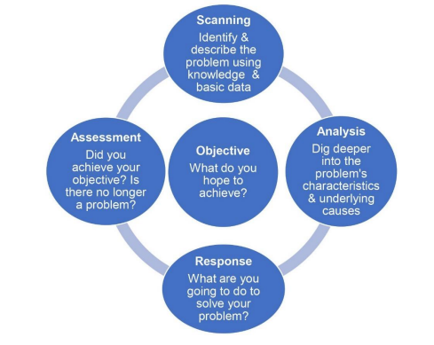
Figure 2.3.2 – OSARA/SARA problem solving model (source South Cambridgeshire district Council 2024)
The OSARA/SARA model is a recognised and effective framework for analysing the root causes of issues, identifying potential solutions, and evaluating the effectiveness of interventions (South Cambridgeshire district Council 2024). This problem-solving tool, as previously mentioned and illustrated in Figure 2.3.2, includes 'O' for Objective. It is essential to establish a realistic objective at this stage; setting an unrealistic objective would undermine the efforts before they even commence. A widely used approach for target setting is the SMART acronym. For further insights into SMART criteria and effective goal setting, you may refer to the video (Better Than Yesterday 2018). The next phase is the scanning stage, where you will collect comprehensive information related to the issue at hand. This involves engaging with partner agencies, the local community through focus groups, reviewing historical reports, and consulting local businesses and stakeholders. This process will yield a thorough understanding of the problem, enabling you to identify and articulate the full scope of the issue effectively. Using this information, you can proceed to the analysis phase of the model, during which root causes can be identified. The problem analysis triangle, illustrated in Figure 2.3.3, operates on the principle that addressing or providing oversight for one of the elements can effectively eliminate the issue. Upon completion of the analysis, it is important to introduce a response that incorporates the ten principles of crime prevention outlined on The Crime Prevention Website (2012). These principles provide detailed examples of how they can be effectively utilised to reduce or eliminate opportunities for individuals to engage in criminal activity. The final component of the model involves assessing the overall objective, evaluating its effectiveness, and determining whether further improvements can be achieved by reinstituting the cycle.
The National Police Chiefs' Council (2023) provides neighbourhood policing performance, which includes the importance of problem-solving methods. Problem solving is one of the most successful evidence-based policing strategies. It has been shown to reduce crime, anti-social behaviour, and demand in a variety of settings when fully implemented. Each stage of the problem-solving process, as outlined in the OSARA model, is critical to its success and can be linked to existing tasking and coordination procedures.

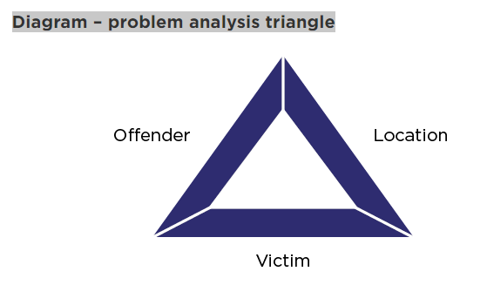
Figure 2.3.3 Problem Analysis Triangle (source College of Policing 2019)
Depicted above in figure 2.2.3 the problem analysis triangle from the College of Policing (2019) is sometimes used in conjunction with the OSARA/SARA model; it depicts a triangle with three sides: side one is the offender, side two is the location, and side three is the victim; this method suggests that safeguarding or removing one of the triangle's sides will aid in the resolution of the issue.

2.3 The effect that community engagement has on criminal activity.

Using tools such as OSARA (College of Policing 2020) to collaborate, discover, and resolve issues identified as neighbourhood priorities. When the neighbourhood’s major issues are addressed, public confidence rises, leading to increased trust in the community. The increased trust in the community leads to the community's willingness to provide important information to the police, which the police can use to develop intelligence. According to the College of Policing (2023), "police information refers to all information obtained, recorded, or processed for a policing purpose." Information gathered in the manner described above will be added to the police system using the three by five by two methods. This is simply how information is recorded on intelligence logs, graded, and disseminated. The College of Policing (2022) describes how the three by five by two system is used to convert information into intelligence.
The information obtained through community engagement and other methodologies can be utilised to mitigate crime and disrupt organised criminal networks. Organised crime groups can be defined as collectives of individuals who leverage their skills and previous experiences to engage in serious coordinated criminal activities, primarily for financial gain (CPS 2021). In practice, this approach would involve members of the public providing information about individuals known to be engaging in drug sales within the local community. Local police forces may not be aware of these activities, highlighting the importance of local communities acting as vigilant partners and informants for the police.
With the appropriate information transformed into intelligence markers within the police system, applications for search warrants can be submitted to the court. “A search warrant is a document issued by a magistrate or judge (“the issuing authority”) to a police officer or other investigator. A search warrant grants legal authority to enter premises and search for specified material” (Law Commission 2020). During warrant premises searches or stop searches conducted under the Misuse of Drugs Act 1971, Section 23, police officers may rely on intelligence provided by the local community to establish reasonable grounds for these actions. Items suspected to be associated with the alleged offenses may be seized. Any electronic devices that are confiscated will be forwarded to the high-tech crime unit for the extraction of relevant data pertaining to the allegations. The extracted data has the potential to identify individuals affiliated with organised crime groups, allowing police forces to formulate strategies for identifying key members and gathering crucial evidence to support prosecutions and disrupt or mitigate organized crime networks. This highlights the significance of information obtained through community engagement, and there are numerous other instances where community-sourced information has assisted police forces in bringing organised crime groups to justice.

2.4 Conclusion of literature review.

Based on the information gathered, it is clear that community support and engagement are easily lost, this could lead to major unrest and violent disorder. Several initiatives and reforms have been implemented to encourage community support, the most effective of which is the establishment of neighbourhood policing teams. Using techniques such as OSARA, problem-oriented policing, the ten principles of crime prevention, and the problem analysis triangle to help tackle priority community issues. Tackling priority issues in communities fosters trust and support, resulting in a stronger relationship. Better relationships have the potential to extract critical information on local criminal activity, which can be used to form intelligence that stops, identifies, or disrupts organised crime. To investigate this theory, I plan to distribute anonymous questionnaires to current and former members of the neighbourhood team, as well as hold a question-and-answer session with an experienced neighbourhood inspector. This will attempt to determine how the methods mentioned above work in practice, how beneficial these practices are in real-world situations, and the positive and negative experiences with interactions with members of the public. It will also consider what type of problems have been encountered and suggestions for possible improvements or approaches.

3. Chapter Three: Methodology

3.1 Introduction

After carefully reviewing the previous sections of this dissertation, it investigated currently used approaches to community engagement and how previous research has emphasised its importance, methods, and positive effects. To gain a more comprehensive understanding, this chapter will identify the most appropriate data collection method and foster collaboration by taking advantage of the most beneficial available resources.
Research refers to any information that has been gathered, discovered, generated, or created in order to validate the initial results of a study (University of Leeds 2024). There is two main ways of gathering data for research one is to gather the data personally and the other is to gather information obtain from previous studies.
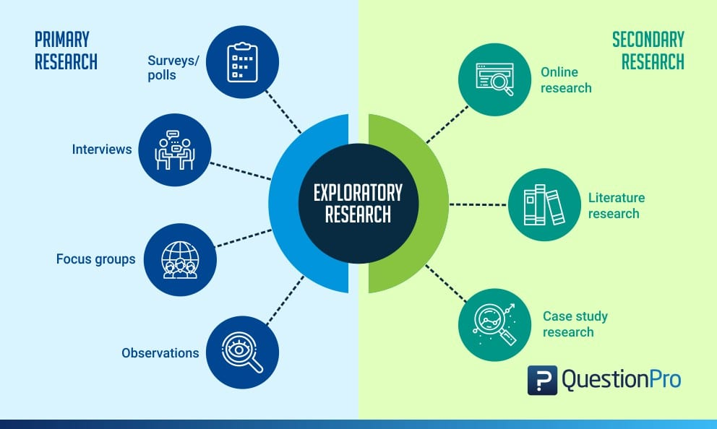Figure3.1.1 - Exploratory Research: Types & Characteristics (Source: QuestionPro 2024)

Figure 3.1.1 clearly depicts the two different methods of exploratory research: primary and secondary. The primary method, shown on the left, is data gathered personally by means of surveys, interviews, focus groups, and personal observations. Secondary is described on the right-hand side of the figure this shows data or information gathered from the internet, literature, and previous studies. Due to a lack of academic research into the direct impact of the confidence cycle and the OSARA model on community engagement.

3.2 Developing a research method.

When deciding which research approach to take, the research onion developed by Saunders et al in 2007 is the most practical and well-established method.
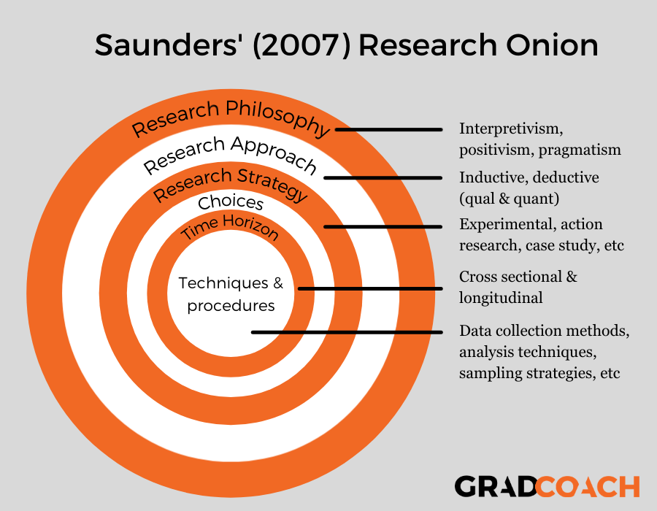
Figure 3.2.1 - Saunders’ Research Onion: Explained Simply (Source: Phair and Warren January 2021)

With the research onion, you work from the outside in, each step developing and shaping the research approach to answering the dissertation's question.
The outer layer examines the research philosophy, and when considering an exploratory look at community engagement and the efficacy of commonly used methods and techniques. Alharahsheh, Husam and Pius, (2020) explains that the Interpretivism emerged as a critique of positivism based on subjective perspectives. Interpretivism focuses on in-depth variables and factors related to a context. It distinguishes humans from physical phenomena by emphasising their ability to create deeper meanings. Social sciences research requires a distinct approach from natural science research. Interpretivism considers cultural, contextual, and temporal differences that shape social realities. The research method I consider best represents the subject is an interpretivism approach offers nuanced and diverse perspectives.
Working in to the second layer, this looks at the research approach as already described in the literature review, there is a distinct lack of research into the direct result in community engagement of methods such as OSARA.
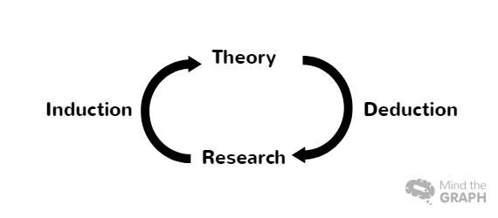
Figure 3.2.2 - Inductive vs Deductive Research: Two Approaches to Data Analysis (Source: Salomao, Anglica 2023)
Figure 3.2.2 shows how an inductive approach develops the theory, whereas a complete reversal deduction approach develops the theory. Given the theory surrounding this topic, an inductive approach would aid in the development of understanding, allowing the data to serve as a foundation for future research. Phair, David, and Warren, Kerryn (2021) explain how an inductive approach could be used to investigate a previously unknown topic. There is extremely little knowledge about this topic, so research would be required to learn more about it, resulting in the formation of theories.
The third layer of Saunders' (2007) research onion focuses on the research strategy, known as the practical or action stage. Because this is an exploratory investigation into community engagement, the best strategy is an action research approach. According to Phair, David, and Warren, Kerryn (2021), action research is concerned with learning by doing. Action research takes place in real-world settings rather than controlled environments, as in a science experiment. Researchers use action research to identify problems or weaknesses in real-world interactions.
The choices layer of the research onion aids in deciding which of three data collection methods to employ: mono, mixed, or multi-method. A single approach would lack the understanding required to conduct a more conclusive exploratory look; thus, with larger data sets, a mixed or multi-method approach would be preferable. Following this consideration, a survey will be administered first, followed by an interview with an experienced senior member of the neighbour team to discuss and validate the findings.
Layer five considers the time horizon; when this is taken into account, you must consider how long the study will be conducted over. Due to the time constraints of this study, a snapshot in time will be used to provide the best data set.
When arriving at the centre, all of the outer layers must be considered in order to implement the most appropriate research methods and conducting the practical steps. As a result, the research method developed from the research onion will be interpretivism with an induction approach, action research in a snapshot of time using surveys with members of Gwent police neighbourhood officers at all levels, and discussion and analysis of the results with an experienced senior leader member of a Gwent neighbourhood team.

3.3 Limitations

A survey will be conducted using a tool such as Survey Monkey, the data will be analysed, and the results will be used to develop a question set for an interview with a senior leader. The survey results will be displayed in a graphical format, allowing for visual interpretation of the data. The questions and responses will be transcribed and presented. Due to time constraints and the survey being conducted on perceived opinions of the administrators of the actions described, future studies from the perspective of the wider community could present differing views or results, so the data collected will have obvious limitations.

3.4 Ethical considerations

The research data that will be collected will consider ethical considerations; before conducting this research, I completed a comprehensive ethics form and received approval. The data will be collected using two primary research methods, and all participants will be informed and aware of how the data will be used during the data analysis process; this information is also highlighted in the pre-approved ethics form, which was submitted prior to the project's start. The survey will be administered online through the Survey Monkey online platform. Participation is completely voluntary, and the survey link will be shared on an internal police website for ease of access.
All survey results will be anonymous, and no personal information will be collected; all interviewee information will be kept confidential and anonymised, at any point participants will have the right to withdraw their contribution from the project.

3.5 Conclusion

This methodology chapter discussed both primary and secondary types of data collection before applying Saunders et al's 2007 research onion to develop the appropriate research method. Following that, the project's limitations and ethical considerations were discussed in detail. A comprehensive methodology has now been established to lay the groundwork for data collection and analysis, which will be presented in the project's subsequent section.

4. Chapter Four: Data analysis and results

4.1 Introduction

Chapter 3 describes the methods and methodology used in this research. The primary goal of this chapter is to investigate the importance of community engagement among current Gwent police officers, as well as the efficacy of the OSARA/SARA problem-solving approach in encouraging community engagement.
This chapter will present and analyse data from an online survey that received 48 responses from current Gwent police officers. This data will shed light on the use of OSARA and SARA in community engagement. The key research questions will be discussed, and the analysis will be used to develop questions to ask an experienced neighbourhood inspector.

4.2 Data analysis.

Data analysis is a process of examining, refining, converting, and modelling data in order to help understand, draw informed conclusions, and aid decision-making (Datacamp 2023). The data was gathered and analysed utilising the survey tool SurveyMonkey. Utilising SurveyMonkey for data collection proved advantageous for data analysis. SurveyMonkey allowed for immediate responses in real time and presented data in a clear, visually appealing format for easy interpretation. Given the volume of survey participants, SurveyMonkey is recommended as an effective analysis tool. The platform simplifies data interpretation, eliminating the need for extensive analysis of extremely high responses received.

4.3 Role within Gwent Police.

Participants were classified based on their position within the Gwent Police Department in order to analyse potential variations in the utilisation of OSARA/SARA across different roles.
Participants role within Gwent Police
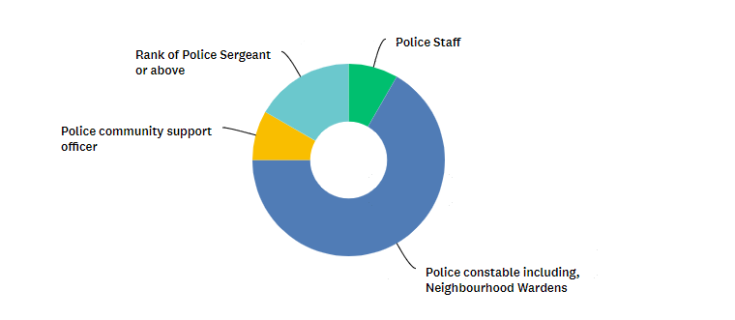

Figure 4.3.1 Identity’s the role of the participant within Gwent police.
Figure 4.3.1 clearly shows that the largest demographic of participants consisted of police constables / neighbourhood wardens, with 32 out of the 48 participants falling into this category. According to Gov.UK (2023), it is not surprising that the response rate was as anticipated, given that Gwent police force comprises a majority of police constables at 78%.
The primary focus of this project is to examine the impact on community engagement, particularly in relation to the role of a police community support officer. Only 4 out of the 48 participants identified themselves as such in this study. All participants have consented, in question 1 of the questionnaire, to allow their responses to be utilised in the dissertation.

4.4 Questionnaire Findings.

Familiarity and utilisation of OSARA/SARA problem solving tool.

When analysing the 48 responses, it is clear that the majority of participants are familiar with OSARA/SARA as a problem-solving tool. Only 12.5% of respondents indicated a lack of knowledge about it, while 87.5% stated that they had knowledge of the problem-solving tool. During the survey, the group was asked about their utilisation of OSARA/SARA in community engagement activities. After excluding 6 participants who were unfamiliar with OSARA/SARA, it was found that 52.4% of respondents reported actively implementing the tool in their community engagement initiatives. As stated in the literature review retrieved from the College of Policing (2020), the utilisation of problem-solving tools such as OSARA/SARA to address community issues has been shown to increase community confidence. This, in turn, enhances community engagement through the confidence cycle, as also discussed in the literature review.

4.5 Measuring the success of OSARA/SARA.

When surveying participants, it was found that over 50% identified community engagement as the primary measure of success for an OSARA/SARA in problem solving. This suggests that within Gwent Police, problem solving is seen as a key factor in enhancing community confidence and promoting improved community engagement.

OSARA/SARA leading to increased intelligence reports.

On further analyses the question was posed if the increased community engagement directly through positive result after implementing a problem-solving tool such as OSARA/SARA led to increased intelligence reports from communities. This question led to 12.5% of participants saying no they did not believe it led directly to increased number of intelligence reports.

After implementing a problem-solving tool such as OSARA/SARA led to increased intelligence reports from communities
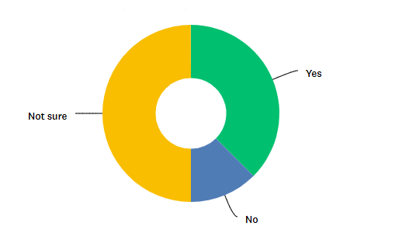

Figure 4.5.1 After implementing a problem-solving tool such as OSARA/SARA led to increased intelligence reports from communities.

Figure 4.5.1 indicates that a minority of survey participants reported not observing an increase in intelligence reports following the implementation of OSARA/SARA.

4.6 Key issues with implementing OSARA/SARA.

The survey was conducted to investigate the challenges faced by participants during the implementation of OSARA/SARA. Issues related to time constraints and the duration of the implementation process were raised by 16 out of the 40 participants, along with notable quotations.
“I struggle to find the time to complete OSARA/SARA tools during my duty”,
“Very long winded and 'clunky' Any forms, paperwork, computer work etc should be extremely simplified so that you can spend time dealing with the issue(s) and not spending countless hours filling out the Pop plan”.
and
“Can take a lot of time and effort to full think through and document and also getting other persons to buy into it”.
With 6 out of the 40 participants suggesting community engagement itself is a key obstacle in successfully implementing OSARA/SARA one comment capsulated this issue.
“Lack of cooperation from some members of the public, no engagement, criticism for wasting time and money, time consuming,”

4.7 Questions presented to neighbourhood inspector.
During the discussion, the inspector emphasised the significance of community engagement in law enforcement operations. The inspector emphasised the crucial role of community support in ensuring the conduct of policing activities with consent. The inspector pointed out that enhancing community engagement can enhance public perceptions of safety. By maintaining a visible and consistent presence in targeted areas, law enforcement can increase public confidence and provide reassurance, ultimately leading to a greater sense of safety within the community. The inspector concluded that engagement fosters trust, facilitates intelligence gathering, prevents crime and disorder, and promotes reassurance through open communication.
The inspector presented an online tool designed for measuring community engagement. This tool relies on input from the officers involved to capture information on the engagement activities and their outcomes.
The OSARA/SARA Model has been identified as a valuable tool for enhancing problem-solving capabilities. When fully implemented with the collaboration of all relevant teams and agencies, this model proves to be highly effective in addressing problems. Given its functionality, time efficiency, and the strong connections neighbourhood teams have with community partners, the OSARA/SARA tool is predominantly utilised within the context of neighbourhood policing.
The inspector proceeded to detail how OSARA/SARA is utilised regularly within the community, with active community participation in the scanning phase of the process. They further elaborated on the direct financial advantages, citing a specific instance of addressing anti-social behaviour within the area and outlining cost savings achieved through an ongoing OSARA/SARA initiative. The challenge of engagement and cooperation from certain individuals within the public and partner agencies may impede the effectiveness of an OSARA/SARA initiative, as noted by the inspector.

5. Chapter Five: Findings, Conclusion and Recommendations

5.1 Introduction

In the previous chapter, an examination and evaluation were conducted on the data collected from employees within the Gwent organisation. This analysis focused on the perceived efficacy of a problem-solving tool, such as OSARA/SARA, and its positive impact on community engagement. This chapter will analyse the study's results by integrating data from the survey and interview. This data will be used to investigate possibilities for improving the current processes. This chapter carefully assess the constraints of this study, identify potential areas for further research, and determine whether the objectives of the study have been met. Additionally, this chapter will include a discussion session focused on self-reflection.

5.2 Main Findings.

Throughout this dissertation, the significance of community engagement was thoroughly emphasised, enabling police forces nationwide to effectively garner consent from the public and efficiently police their respective communities. Positive actions by law enforcement officers contribute to building trust within the community, ultimately leading to increased engagement and cooperation, which in turn leads to improved intelligence gathering and more effective policing strategies, this is highlighted in the literature review (College of Policing 2013). A direct quote from an inspector in neighbourhood policing suggests that engagement allows for the development of trust, intelligence, the prevention of crime and disruption, and the provision of reassurance through two-way discussion.
One effective approach taken by law enforcement officers may involve utilising problem-solving tools like OSARA/SARA. This strategy is backed by a significant portion of Gwent police staff, who rely on community engagement as a key indicator of its effectiveness. In addition, the interviewed inspector indicated several benefits suggesting the successfully implemented the OSARA Model to address various issues, resulting in positive outcomes. Each OSARA approach is accompanied by a POP plan within our organization. Following the completion of the OSARA process, a Cost Benefit Analysis is conducted to evaluate the overall impact.
A limited number of surveyed employees expressed that they did not observe a significant uptake in intelligence reports. However, challenges with implementation have resulted in lower than anticipated utilisation of OSARA/SARA. One of the key challenges highlighted during the interview is encouraging the adoption of problem-solving tools such as OSARA/SARA. This includes effectively communicating with the local community to demonstrate our efforts and implementing actions to underscore engagement with their concerns.

5.3 Recommendations.

During the development of this study, it was evident that clear recommendations could be made regarding the importance of community engagement in daily policing practices. As such, it is imperative that we continue to utilise and enhance OSARA/SARA to effectively address community issues, in turn increasing confidence in the police. Bradford and Myhill (2014) highlight the importance of community engagement and tackling local issues to increase confidence in the police.
This study along with extensive academic literature dictates that the essential part that OSARA/SARA plays in community engagement and the community’s confidence in the police, therefore the use of this problem-solving tool should be utilised and as often as possible and communicated to the wider public to help encourage wider utilisation.
Based on the inspector's recommendation for cost savings, time constraints identified through collaboration between the survey and inspector, and the significance of community engagement supported by academic and research-based methods, it is proposed to form a dedicated team to address community issues and integrate within the policing framework using the key problem-solving tool OSARA/SARA. This team will utilise a cohesive approach with clear, measurable outcomes during a trial period.

One significant challenge identified in the survey was the time constraints and complexity associated with the OSARA/SARA process. One potential solution is to consider reengineering the process or breaking it down into components that can be managed by different departments within the organisation. Transparent communication about law enforcement efforts to address community concerns could also improve community engagement.

5.4 Limitations.

Incorporating limitations in this study enhances transparency and allows for a thorough review, enabling future research to identify areas that require further exploration. According to HelpfulProfessor.com (2014), including limitations in a study contributes to the overall integrity of the research.
This study was an exploratory look into community engagement and the evaluation of local problem-solving methods used by police forces, this study focused on from the organisation perspective and due to time restraints and the point of view of members of the public that have been involved or effected by OSARA/SARA was not obtained. In retrospect, exploring this particular avenue could have potentially contributed valuable data to the dissertation's objectives. However, due to time constraints during the data collection phase, this information was unfortunately not captured, impacting the overall data availability.

Given the researcher's experience in the police force and the survey pool consisting primarily of individuals from the same background, there is a potential for bias to influence the survey results. It is important to acknowledge this factor as it could potentially impact the accuracy and validity of the survey outcomes.

5.5 Further Research.

Due to constraints on the timeframe of this dissertation, the data collection process was limited to a subset participant from within the organisation, therefore not capturing a comprehensive range of perceptions. The study utilised a convenient sample due to time constraints, but employing a broader range of participants could enhance the generalizability of the results to a larger population. It is recommended for future research to consider sample opinions from general members of the population for a more balanced distribution of data. This study holds promise for further exploration in the future.

5.6 The Achievements of Objectives.

At the beginning of this study, three primary objectives were established. This section will examine these objectives and discuss the methods employed to accomplish them.

• To understand the importance of community engagement and the consequences.
The literature review offered a thorough examination of past events that have had a detrimental impact on community unity, leading to widespread riots in various regions. It highlighted the significance of fostering positive relationships between police forces and the community, as well as the concept of policing through mutual consent. During the inspector interview community engagement is described as the bedrock for upholding the principles of policing by consent.

• To investigate current methods available, how often they are used and their perceived effectiveness in community engagement and ultimately increasing community confidence.
During the literature review, it was observed that engaging in collaborative problem-solving to address community issues can improve community engagement and boost confidence levels. The majority of survey participants indicated that increased community engagement is a key indicator of the effectiveness of problem-solving tools such as OSARA/SARA. Additionally, during the inspector's interview, it was noted that OSARA/SARA is the primary problem-solving tool utilised by Gwent Police. The inspector stated that when the OSARA/SARA Model is fully applied with the support of all relevant teams and agencies, it proves to be a highly effective tool for problem solving.

• Show the impact of improved community engagement and its effect on organised crime in local communities.
During the literature review, it was noted that enhanced community engagement is expected to lead to an increase in intelligence reports from the general public. However, the survey results revealed that only a small percentage of respondents indicated that they did not observe a significant rise in intelligence reports following a successful OSARA/SARA operation. Additionally, when inspectors were asked about their observations, they reported frequently noticing an increase in intelligence reports.

5.7 Self-reflection.

As previously mentioned, the researcher of this study aimed to enhance their understanding of community engagement and the impact of problem-solving tools on public confidence. This interest stemmed from the researcher's personal commitment to their local community, which is served by the Gwent police force, and a desire to bridge the gap between the community and law enforcement. The researcher is optimistic that through increased understanding and positive public perception, recommendations can be implemented to enhance community engagement and ultimately reduce crime rates.
This dissertation presented the researcher with numerous challenges and learning opportunities, reinforcing the importance of self-directed learning, goal setting, and effective time management.

5.8 Conclusion.

This study examined the significance of community engagement and the implementation of problem-solving strategies such as OSARA/SARA in enhancing public trust and gathering information from the community to support crime prevention. The literature review underscored the potential risks of nationwide unrest without community support, emphasizing the importance of public backing. The confidence cycle from the College of Policing illustrates how problem-solving tools contribute to increased community participation, specifically highlighting the utility of OSARA/SARA. An example was provided to demonstrate how OSARA/SARA could be employed to address an Anti-Social Behaviour (ASB) issue. The survey and interview conducted reaffirmed the value of community engagement and the advantages of utilising OSARA/SARA. However, the findings also identified challenges related to time constraints and the complexity of implementing OSARA/SARA in a fast-paced environment such as response department and more suited in a neighbourhood background. Throughout this chapter, we have identified potential biases and discussed how the original objectives of the study have been addressed.

6. Bibliography.

Alharahsheh, Husam and Pius, (2020) A Review of key paradigms: positivism VS interpretivism Available at: https://gajrc.com/media/articles/GAJHSS_23_39-43_VMGJbOK.pdf (Accessed 10th March 2024).

Better Than Yesterday (2018) Setting SMART Goals - How To Properly Set a Goal (animated) Available at https://www.youtube.com/watch?v=PCRSVRD2EAk (Accessed 2nd August 2024).

Briggs. D (2012) The English Riots of 2011: A Summer of Discontent

Bradford, B. and Myhill, A. (2014) ‘Triggers of change to public confidence in the police and criminal justice system’ (Findings from the Crime Survey for England and Wales panel experiment 12th February 2014).

Charles E. Cheadle, (2022) A Critical Assessment of the Police and Criminal Evidence Act 1984 Available at: https://www.friedmanomics.co.uk/post/a-critical-assessment-of-the-police-and-criminal-evidence-act-1984 (Accessed 2nd August 2024)

College of Policing (2013), Engagement Available at: https://www.college.police.uk/app/engagement-and-communication/engagement (Accessed 1 February 2024).

College of Policing (2019), Understanding analysis Available at: https://www.college.police.uk/app/intelligence-management/analysis/analysis (Accessed 1 February 2024)

College of Policing (2020), Problem-oriented policing Available at: https://www.college.police.uk/research/crime-reduction-toolkit/problem-oriented-policing (Accessed 2 February 2024)

College of Policing, (2022). Intelligence report Available at: https://www.college.police.uk/app/intelligence-management/intelligence-report (Accessed 2 February 2024).

College of Policing, (2023). Information management Available at: https://www.college.police.uk/app/information-management#:~:text=Police%20information%20refers%20to%20all,processed%20for%20a%20policing%20purpose. (Accessed 2 February 2024).

CPS, (2021). Gang related offences - Decision making Available at: https://www.cps.gov.uk/legal-guidance/gang-related-offences-decision-making (Accessed 4th August 2024).

Datacamp (2023). What is Data Analysis? An Expert Guide With Examples available at: https://www.datacamp.com/blog/what-is-data-analysis-expert-guide (accessed 1 May 2024)

GOV.UK (2022) Confidence in the local police Available at: https://www.ethnicity-facts-figures.service.gov.uk/crime-justice-and-the-law/policing/confidence-in-the-local-police/latest#main-facts-and-figures (Accessed 15 November 2023).

Gov.UK (2023), Police workforce, England and Wales: 31 March 2023 available at: https://www.google.co.uk/url?sa=t&rct=j&q=&esrc=s&source=web&cd=&ved=2ahUKEwjqyLijkYWGAxWLcfEDHdQ5D9wQFnoECCsQAQ&url=https%3A%2F%2Fassets.publishing.service.gov.uk%2Fmedia%2F65fb16dc9316f5001164c458%2Fpolice-workforce-mar23-tables-280324-second-edition.ods&usg=AOvVaw3o_xL22-2y79CggHUQ9gcC&opi=89978449 (accessed 1 May 2024).

G, Hughes, and Rowe, M (2007), Neighbourhood policing and community safety available at: https://journals-sagepub-com.ezproxy.uwtsd.ac.uk/doi/epdf/10.1177/1748895807082059 accessed 1 February 2024).

HelpfulProfessor.com (2014) 21 Research Limitations Examples available at: https://helpfulprofessor.com/research-limitations-examples/ (accessed 08th June 2024).

Home Office Research Study 296 (2006), An evaluation of the impact of the National Reassurance Policing Programme available at: https://library.college.police.uk/docs/hors/hors296.pdf (Accessed 1 February 2024).

Innes, M. et al. (2020), Neighbourhood Policing: The Rise and Fall of a Policing Model.

IOPC, (2023), Public feel confident police respond fairly and proportionately to incidents, but questions remain around use of stop and search Available at: https://www.policeconduct.gov.uk/news/public-feel-confident-police-respond-fairly-and-proportionately-incidents-questions-remain (Accessed 2nd August 2024).

Jackson. et al (2012) Policing by consent: understanding the dynamics of police power and
legitimacy. Project Report. European Social Survey, London, UK Available at: https://eprints.bbk.ac.uk/id/eprint/5711/ (accessed 08 July 2024).

Law Commission, (2020). Search warrants reform to help law enforcement investigate crime Available at: https://lawcom.gov.uk/search-warrants-reform-to-help-law-enforcement-investigate-crime/ (Accessed 4th August 2024).

Lea, J. and Hallsworth, S. (2011), Understanding the riots, (Accessed 1 February 2024).

Michael, D. Reisig and Robert J. Kane (2020) Public Confidence in the Police: A Systematic Review of the Literature (Accessed 20 November 2023).

Misuse of Drugs Act 1971 Available at https://www.legislation.gov.uk/ukpga/1971/38/section/23/data.pdf (Accessed 4th August 2024).

Newburn. T (2015) The 2011 England Riots in Recent Historical Perspective, volume 15 (issue 1) available at: https://academic.oup.com/bjc/article/55/1/39/462374?login=true (accessed 1 February 2024).

Phair, David and Warren, Kerryn (2021) Saunders’ Research Onion: Explained Available at: https://gradcoach.com/saunders-research-onion/ (Accessed 10th March 2024)

Police and Criminal Evidence Act 1984, Available at: https://www.legislation.gov.uk/ukpga/1984/60/section/1 (accessed 1 February 2024).

QuestionPro (2024) Exploratory Research: Types & Characteristics Available at: https://www.questionpro.com/blog/exploratory-research/ (Accessed 6th March 2024).

Rak, J. (2023) When the construction of police legitimacy backfires? Emotion expression management in times of the erosion of the rule of law (Accessed 20 November 2023).
Salomao, Anglica (2023) Inductive vs Deductive Research: Two Approaches to Data Analysis Available at: https://mindthegraph.com/blog/inductive-vs-deductive-research/ (Accessed 10th March 2024).

Signori's et al. (2023) Relational continuity in community policing: Insights from a human-centred design perspective (Accessed 20 November 2023).

South Cambridgeshire district Council (2024) Problem solving Available at: https://www.scambs.gov.uk/community-safety-and-health/community-action/community-safety-toolkit/crime-prevention-in-your-community/problem-solving (accessed 08 July 2024).

The Crime Prevention Website (2012) Ten Principles of Crime Prevention Available at https://thecrimepreventionwebsite.com/police-guidance/720/ten-principles-of-crime-prevention/ (Accessed 2nd August 2024).

The National Police Chiefs' Council (2023) Neighbourhood Policing Outcome and Performance Guidelines (Accessed 4 February 2024).

University of Leeds (2024), Research data management explained Available at: https://library.leeds.ac.uk/info/14062/research-data-management/61/research-data-management-explained (Accessed 6th March 2024)

7. Appendices.

Appendix 7.1 Survey questions
Community Engagement and Intelligent Reporting Survey
- What is your current role in Gwent police?
Police Staff
Police constable including, Neighbourhood Wardens
Police community support officer
Rank of Police Sergeant or above
None of the above
- What is your knowledge of the problem-solving tool OSARA/SARA?
A great deal
A lot
A moderate amount
A little
None at all
- How often do you use OSARA/SARA in problem solving?
Always
Usually
Sometimes
Rarely
Never

- Do you use problem solving tools like OSARA/SARA in your community engagement efforts?
Yes
No
- How do you measure the success of your community engagement activities?
- Have you noticed any increase in community engagement after implementing problem solving tools like OSARA/SARA?
Yes
No
Not sure
- In your opinion, what are the key benefits of using problem solving tools like OSARA/SARA in community engagement?
- Would you say that using problem solving tools like OSARA/SARA has led to more intelligent reports?
Yes
No
Not sure
- What challenges have you encountered when using problem solving tools like OSARA/SARA for community engagement?

Appendix 7.2 Questions that was asked of the neighbourhood inspector.
Is community engagement important?
Yes/No
Explain why?
How do you measure community engagement?
What is your opinion on the use of the OSARA/SARA problem solving tool within the constraints of neighbourhood policing?
Would you consider OSARA/SARA would be used primarily by the police in a neighbourhood policing environment?
Yes/No
Explain why?
Explain the involvement required from the local community when implementing OSARA/SARA with a local problem?
How often is OSARA/SARA utilised within your department?
What is your opinion on a successful application of OSARA/SARA on community engagement.
Have you ever experienced key intelligence received during or after the application of OSARA/SARA.
Yes/No
What do you believe are the key issues with implementing OSARA/SARA?

Appendix 7.3 Figures from Literature review.

Figure 2.3.1

Figure 2.3.2

Figure 2.3.3
Appendix 7.4 Figures from Mythology.

Figure 3.1.1
Figure 3.2.1

Figure 3.2.2

Appendix 7.5 Figures from Data analysis and results.

Figure. 3.3.1

Figure 3.5.1.

