Module Code: ACMA5005
Lecturer: Andrew Thorn
Student Name: Ian Lewis
Student Number: (2015718)
Date: March 2023

Six Sigma
Green Belt
Mitie / Magnox Project Delivery

University of Wales Trinity Saint David
Six Sigma Green Belt Level 5

Executive Summary

When Mitie noticed a trend in project timeline slippage within their Magnox contract, concerns were raised by senior management. By not completing projects to agreed deadlines, Mitie were continuously failing to meet their contractually agreed KPI’s (Key Performance Indicators) and financial penalties were being incurred.
This was not acceptable and needed to be addressed by the Mitie project team working on the Magnox contract. To investigate these concerns, the Mitie project team applied Six Sigma methodologies to their project lifecycle processes to find the root cause of waste (time). The DMAIC methodology was applied to their processes with several Six Sigma tools used, including the 5 whys, process flow chart, cause and effect (fish bone) diagram, and FMEA (risk register).
After all data and risks were investigated, improvements/procedures were put in place to mitigate the waste (time), with the end goal being that projects were delivered on time, within budget and to the highest quality possible, while meeting the clients (Magnox) expectations and the contractually agreed KPI’s.
Controls have been put in place to monitor these new procedures/improvements, with a new gate process and sign off’s at every stage to prevent old habits creeping back into the lifecycle and deadlines missed.

Contents
Executive Summary 2
Introduction 4
Introduction to Mitie 4
What is Six Sigma 4
Six Sigma has five main principles: 5
Six Sigma Methodology 5
Define 7
Existing Process: 8
Measure 9
Process Flow Chart 9
Analyse 10
The 5 Why’s 10
Implementing the 5 Why’s methodology: 10
Pareto Chart 11
Cause and Effect (Fishbone) Diagram 12
FMEA/Risk Register 13
Improve 14
Updated FMEA/Risk Register 14
The ‘DRAFT’ Proposal 15
The Gate Process 15
Gate 0 15
Gate 1 16
Gate 2 16
Gate 3 16
Gate 4 16
Control 17
References 18
Appendix 19

Introduction
Key Stakeholders: Mitie Technical Services Limited, Magnox Nuclear Sites Limited.
Project Timeline: 19th September 2022 – 17th February 2023 (Six Months).
This report has applied Six Sigma tools and techniques to improve Mitie’s Project delivery across its client’s (Magnox) nuclear sites throughout the UK.
A trend was beginning to form within Mitie projects (across several Magnox nuclear sites in particular), where projects were not being delivered on time. This report has investigated why this was happening and applied Six Sigma methodology to implement new ways of working.
Note. Please note that some of the information provided within this report is official sensitive.

Introduction to Mitie
Founded in 1987, Mitie boast over 30 years’ experience and are the leading Facilities Management (FM) and Professional Services company in the whole of the UK. With over 78,000 employees who looking after over 2.5 million assets to over 4000 customers. Mitie have achieved recommendations of being within the ‘Top 50 employers’ and the ‘Top 100 apprenticeship employers’ in the UK. Mitie pride themselves on their 5 core values (Appendix 1), one of which is, ‘Our diversity makes us stronger’, Mitie has 155 different nationalities employed and pride themselves on having the right people in the right jobs.
Mitie deliver a wide range of services throughout the UK and Europe, including (but not limited to):
- Care and Custody
- Cleaning and Hygiene
- Energy and Carbon
- Engineering Maintenance
- Projects
- Health care
- Solar PV and Energy Storage
- Technical Services
- Security and fire
- Waste
(Mitie, 2023)

What is Six Sigma
Six Sigma defines various techniques and tools, designed to make business processes more efficient and effective, with the aim of achieving an extremely low defect rate. For a process to be considered efficient, its defect rate will be less than 3.4 defects per million units or events. The Six Sigma methodology was developed by Bill Smith of Motorola in 1986, with the aim of providing better products and services to customers. This methodology can be used in any industry to identify errors and help eliminate them, while improving efficiency, quality and enhancing profitability. (CFI, 2022)

Six Sigma has five main principles:

- Customer focus - The main objective is to maximize the benefits for customers and their demands.
- Assess the value chain and find the problem - Find out the problem and its root cause from gathering related data.
- Eliminate defects and outliers - Make appropriate modifications in the process and eliminate any processes that do not contribute to the customers value.
- Involve stakeholders - All stakeholders should collaborate to find solutions. Project failure risks need to be lowered to ensure optimal process performance.
- Flexible and responsive system – Employees and their working practices may need to be changed. If the environment is flexible and responsive, this can lead to a successful implementation and could provide the company/organisation with a competitive edge. (CFI, 2022)

Six Sigma Methodology
There are two main methodologies of Six Sigma, DMAIC and DMADV.
DMAIC
DMAIC is a data driven approach that can be effective in controlling change management. The five phases of DMAIC are:
- Define the problem and the goals of the project.
- Measure the different aspects of the existing process in detail.
- Analyse data to find the main flaw in a process.
- Improve the given process.
- Control the way the process is implemented in the future.(CFI, 2022)
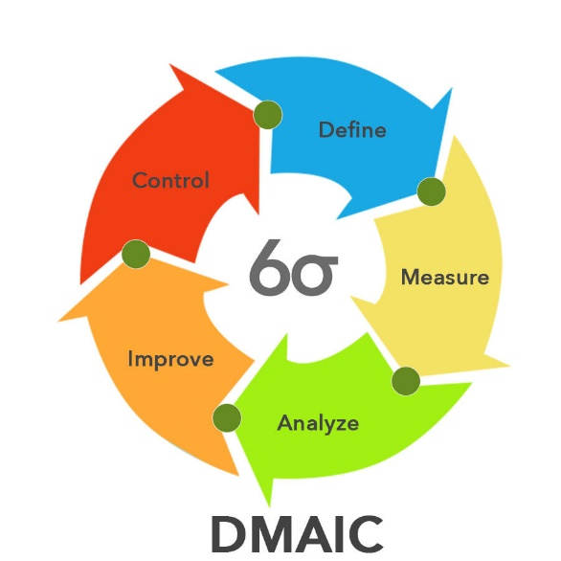
Figure 1 (Pyzdek, 2019)

DMADV
DMADV is a Six Sigma framework that focuses on development of a new service, product, or process.
The five phases of DMADV are:
- Define the problem and the goals of the project.
- Measure the different aspects of the existing process in detail.
- Analyse data to find the main flaw in a process.
- Design a detailed, high-level design for the selected alternative.
- Verify that the design is acceptable to all stakeholders, with expectations confirmed and all lessons learned documented. (Staff, 2012)

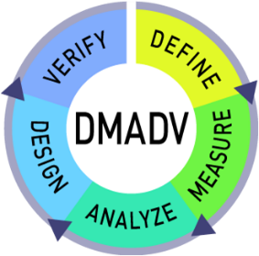
Figure 2 (Staff, 2012)

Lean Six Sigma generally concentrates on the DMAIC framework, which is mainly designed for developing existing processes. If redesigning a process is required in order to make an improvement, a different Six Sigma approach can be considered – DMADV. (Rodriguez, 2022)
This report has utilising the DMAIC framework to investigate and highlight the contributing factors that had been working against the Mitie project team when trying to deliver their projects within the agreed timeline. With these factors identified, DMAIC tools were be used to improve the process with project being delivered on time, on budget and to the heist possible quality being the end goal.

Define
Mitie Projects are contracted to Magnox to deliver projects across the entire Magnox estate. Recently, there has been a trend of timeline slippage, with projects not being delivered on time. On detecting this occurrence, 20 projects were monitored over a six-month period.
Over this period, 13 out of the 20 projects (there were 20 projects running over this period and all were monitored) monitored (65%) were delivered late (figures 3 and 4).

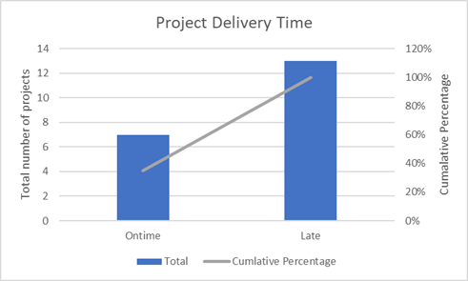
Figure 3 Figure 4

This trend was unacceptable and needed to be addressed. It would be unrealistic to assume that a change could be implemented, and all projects would be delivered on time every time, due to unforeseen circumstances that could delay a project and would be out of Mitie’s control, e.g., sickness/resource, weather conditions, etc. Albeit a change was required.
This shockingly poor statistic has instigated Mitie to investigate these concerningly low figures by applying Six Sigma methodology to their project delivery process and identify areas of weakness to be improved.
Without these improvements, Mitie are in breach of their contract with Magnox, as Mitie are consistently failing their KPI’s (Key Performance Indicators) and therefore incurring financial penalties.
Mitie have examined all areas of project delivery to identify what was within their capability to implement change. The working arrangements with Magnox was also looked at for possible improvements. Improved levels of engagement/communication with Magnox staff would assist when implementing a change.
Mitie were aiming to achieve projects that were delivered on time, without having a negative effect on project budget and quality, by applying six sigma methodologies. When Mitie’s improvements have been successful, the sites agreed KPI’s will be consistently met, and projects will be delivered to the client’s expectations.

Existing Process:
For many years, Magnox have used the same process to determine whether a work pack would be delivered in house (by their own engineering team) or via their contractor (Mitie). This very simple process map in figure 5, shows how their decision is made.

Figure 5 (Magnox, 2023)

- If a work-pack/project is deemed to be too complex for Magnox’s in house engineering team, then a budget approval would have to be obtained and a scope produced for the contractor (Mitie) to deliver via a Legal (NEC3) contract software platform - CEMAR.
- On acceptance of this scope, CEMAR would grant Mitie three weeks to go out to tender for the work (direct award <£25k, three quotes for £25k-£100K and five quotes for £100K+).
- When these quotes were obtained, Mitie would submit their recommended sub-contractor to Magnox via CEMAR and request a purchase order.
- The chosen sub-contractor would then submit RAMS (Risk Assessment and Method Statement) for Magnox approval, via Mitie to the Magnox construction office.
- Once the RAMS had been approved, a start date and programme of works was agreed.
- On the agreed start date, the contractor would attend site to be set to work by a Mitie sub-contractor supervisor and work in line with their agreed/approved RAMS.

Measure
Under this existing process, Mitie would have had three weeks to obtain their sub-contractor quotations. This was not long enough due to Magnox scope being consistently questioned by the sub-contractor.
The time taken (in days) for each stage of Mitie’s project lifecycle has been monitored over the past six months and inputted into a process flow chart (figure 6). As each project was different, the time that the contractor took completing the physical work could not be monitored accurately. The process building up to the physical work and the closing out of each project was the same and so the time (days) was recorded.
The total time Magnox spent getting their scope of works right was looked at, as well as the quotation period, the RAMS submission/review, the construction phase, and the closing out of each project. Figure 6 also displays where responsibility lies for each part of the process, this way, we have a better understanding to who and what is causing delays/waste (time) in the project lifecycle.

Process Flow Chart
Figure 6 (Thomas, 2023)

When following the process flow chart, we see that the average lifecycle (in days) of a Magnox/Mite project is 48 days, not including the physical work carried out for each project (some projects only lasted two weeks, while others lasted three months). To analyse this data to find out why these delays were occurring within Mitie’s project delivery time, the 5 Why’s methodology/tool was utilised.

Analyse

The 5 Why’s
The 5 Whys strategy is a simple, effective tool for uncovering the root of a problem. It can be used in troubleshooting, problem-solving, and quality-improvement. Firstly, ask why a problem is occurring, while making sure your answer is grounded in fact, and then ask the question again.
The 5 whys methodology can have single lane or multiple lanes, with multiple lanes having more than one reason/answer to a question, that then leads to additional single-track lanes. Sometimes there can be less than 5 why’s asked and, in some cases, there can be more than 5 why’s asked to get to the root cause. (MTCT, 2023)

Implementing the 5 Why’s methodology:

- Why are projects being delivered late?

- Because contractors are taking longer to complete takes.

- Why are contractors taking longer to complete tasks?

- Because the scope of work is changing on a daily basis.

- Why is the scope of work is changing on a daily basis?

- Because, as the work is progressing, Magnox are changing what they want to achieve.

- Why are Magnox changing what they want to achieve?

- Because, when the work was initially scoped, the work wasn’t investigated and designed correctly and therefore, a poor scope of works was issued to the sub-contractor via Mitie.

Pareto Chart
When looking at the process control chart, the scope of work phase was the longest process. So, a pareto chart (figure 7) was constructed to analyse this data.

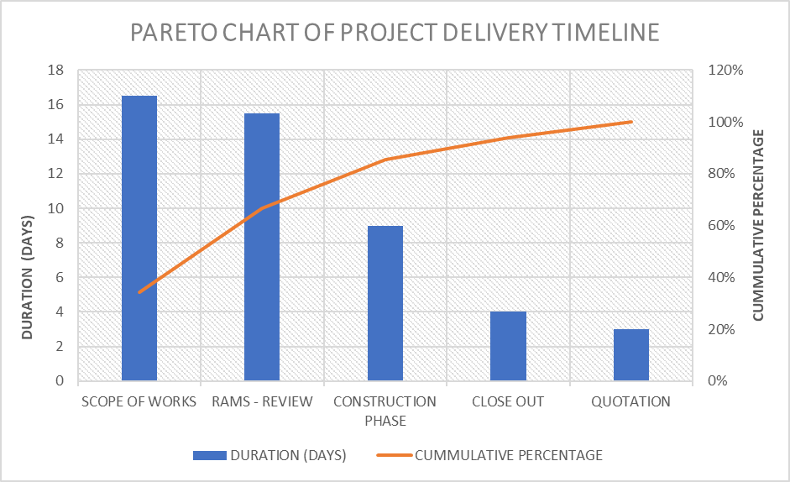
Figure 7

Figure 7 shows that the Scope of works, and the RAMS review phases took the longest time during the project lifecycle with 16.5 and 15.5 days respectively. These factors represent the steepest part of the cumulative percentage curve. Even though the reviewing of RAMS is completely out of Mitie’s control, since obtaining these results, Magnox have started their own investigation to reduce the wasted time of this time-consuming process.
The issuing of poor scope by Magnox was the root cause of the 5 why’s exercise, and adds additional weight to the pareto chart’s evidence of data. This emphasises the need for better communication.
To analyse this data further and try to pinpoint what issues are causing these delays to Mitie’s project timeline slippage, a Cause and Effect (fishbone) diagram was drawn up by the Mitie project team.

Cause and Effect (Fishbone) Diagram
The Cause and Effect (Fishbone) diagram was adopted by Dr W Edwards Deming as a helpful tool for improving quality. This tool/diagram can help to work through possible underlying factors of a specific problem and can assist those involved in creating a snapshot of a team’s knowledge of the problem and help gain a better understanding, while working towards possible improvements. (NHS, 2023)
Figure 8 is a Cause and Effect (fishbone) diagram that was constructed by the Mitie project team to determine what contributing factors were occurring and causing the projects to be delivered late.

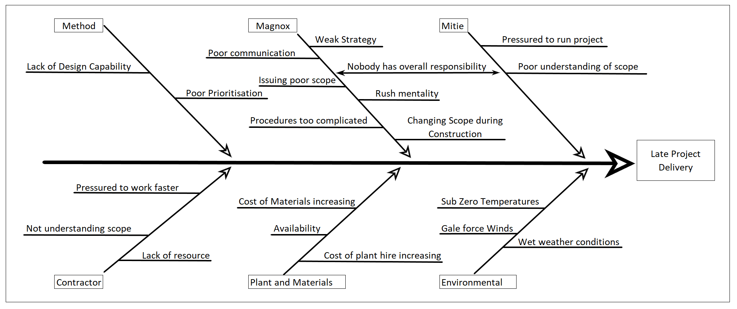
Figure 8

When looking at figure 8, there are many contributing factors causing a project to achieve timeline slippage. Although, there are a selected few that align with the previous analysis and jump out as key contributors:

- Environment,
- Poor Communication,
- Issuing of Poor Scope,
- Rush Mentality.

These four areas for concern were logged in a FMEA/Risk Register (figure 9) to determine their potential to interfere with the project timeline and rate their risk with a low, medium, or high rating.

FMEA/Risk Register

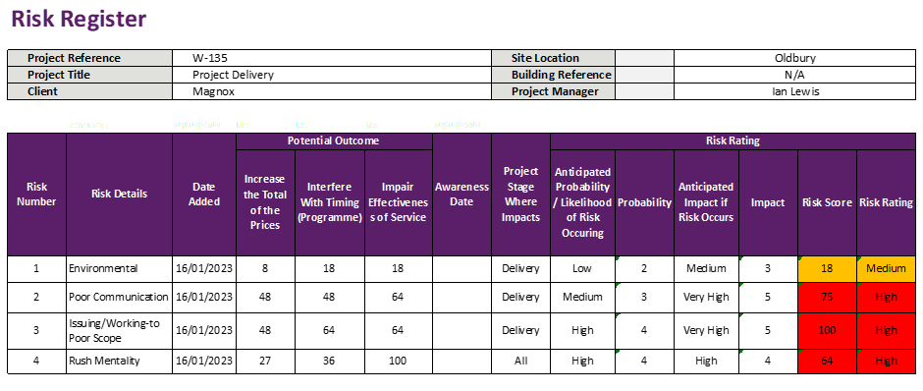
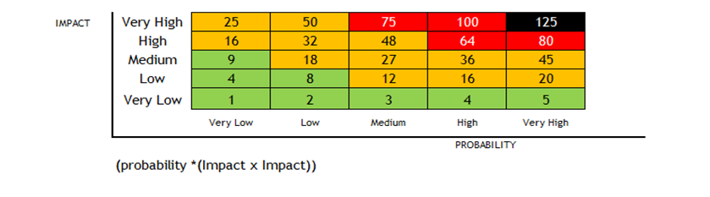
Figure 9 (Duff, 2022)

On completion of the FMEA/Risk Register it is quite clear that the issuing of poor scope is a huge contributing factor to the delay in the completion of project work. This is closely followed by poor communication and a rush mentality to start work. These three factors are closely linked and need to be reduced/eliminated. Even though the environmental impact is still a factor, most of these issues are out of Mitie’s hands and can be overcome with better planning/communication between Mitie and Magnox to prioritise work that could be affected by weather conditions.

Improve
When taking all main contributing factors into account, the Mitie project team came up with several improvements to mitigate the risks causing project timeline slippage. Each improvement was discussed with Magnox and re-submitted into the Risk Register (figure 10) to assess the new risk rating.

- Environment,
- Better Planning. Plan low priority Civils/external work for dryer warmer conditions.

- Poor Communication,
- Weekly planning meeting held between Mitie and Magnox to discuss progress of projects and iron out any possible hazards.

- Issuing of Poor Scope,
- Magnox to supply Mitie with a DRAFT copy of their scope before submitting to CEMAR. Any concerns from Mitie or a sub-contractor can be raised at the new weekly planning meeting.

- Rush Mentality.
- Mitie to implement a 4-gate project review process to ensure all documentation is present and the sub-contractor agrees the scope before commencement of work.

Updated FMEA/Risk Register

Figure 10 (Duff, 2022)

When applying these four solutions/actions to the project lifecycle, figure 10 shows that these risks are significantly reduced. All areas still have their risk present, but by controlling these solutions/actions, these risks can be monitored and controlled.

The ‘DRAFT’ Proposal
It has been proposed to Magnox that before submitting a scope of work to Mitie projects via CEMAR, Magnox first supply Mitie with a draft scope, for Mitie to review and provide feedback if necessary (as per Risk Register mitigation No.3). By utilising this draft format, Mitie can ensure that they are providing sub-contractors with a clear scope of work and therefore eradicating the need for queries, daily instructions, and an everchanging scope. A Scoping meeting can be held between Mitie and Magnox to discuss the scope of work and change/improve the document before issuing to a sub-contractor for quotation if necessary. This will give the sub-contractor a clear idea of what is expected from them and assist them when designing their programme of works and quotation. This draft can be discussed without Mitie being tied to the CEMAR three-week quotation deadline, therefore eradicating the failure of this particular KPI.

The Gate Process
Mitie have introduced a four-gate project review process to ensure that a project will not move forward until all relevant documentation is in place and all parties are clear and have agreed on the scope of work, therefore reducing the chances of a rush to start mentality.
The process follows the RIBA 0-7 steps, with three steps: Development, Work in Progress (WIP) and Close Out.
Figure 11 provides a visual aid of the process, followed by a brief description of each gate review.

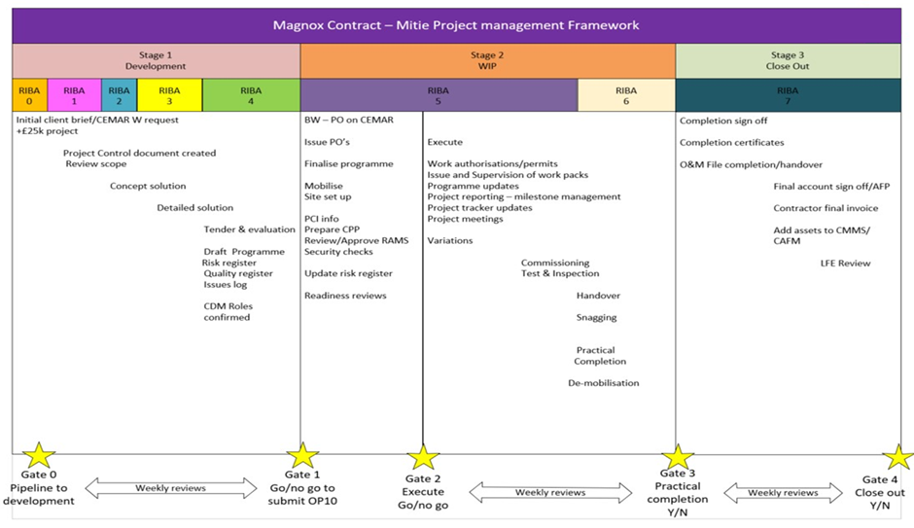
Figure 11 (Duff, 2022)

Gate 0
At Gate 0, Mitie will have been given a scope of work by Magnox. This scope will be reviewed by Mitie and a decision made by the senior project manager and head of projects on whether or not the scope is detailed enough to quote for. If the scope is poor, then it will be returned to Magnox and a meeting to discuss the scope will be scheduled.
If the scope is adequate, then Mitie will acknowledge this via CEMAR and move to contractor engagement.

Gate 1
On reaching gate 1, the Mitie senior project manager will have created a project control document, obtained the agreed number of quotations (for the value of the project), and created a risk register, along with the other items listed before gate 1 in figure 11.
If all documentation is in place and agreed by the Mitie senior project manager, head of projects, and the Mitie head of finance (for the Magnox contract), then the recommended sub-contractors quote can then be issued to Magnox via CEMAR (in the form of an OP10 document) for their approval.

Gate 2
At Gate 2, a Go/No-Go decision is made on whether or not the project is ready to start. If there is any doubt what so ever, then the project will be stopped until all documentation is in place and the client, contractor and sub-contractor is happy to proceed. It is at this point in the past where projects have been rushed to start to please senior Magnox management, but then go wrong and snowball out of control.
If all documentation is in place and the sub-contractor is clear on what is expected of them, with all costs and programme of works agreed between Mitie and Magnox, then the project can start.

Gate 3
Between gate 2 and 3 is where all the work is carried out on site by the sub-contractor. The Mitie senior project manager will pass the project over to the project engineer so that he/she can supervise the daily works. Throughout the whole project lifecycle, a daily diary (appendix 2) is kept, but it is at this stage that the diary is vitally important. The diary will keep track of any issues during the works and provide information on the construction phase of works after the project is completed if required.
If the project runs in to any issues and will incur additional costs, this will be communicated to the client via CEMAR and works stopped until approval has been agreed with the client.
On arriving at gate 3, all practical works would have been completed on site (including any snagging) and the finished project handed back over to the client.

Gate 4
Gate 4 is the end of the project and in place to ensure that all certificates and O&M’s are handed over to the client, with the final account signed off. Any assets will be uploaded to Maximo/CAFM (Computer Aided Facilities Management). A decision is made on whether or not to close out the project.

Control
On implementation of these actions, there needs to be an element of control to ensure that these actions are followed and that project timelines are on track without effecting budget and quality.
When Magnox issue a draft scoping document to Mitie, Mitie are to arrange a Gate 0 meeting at its earliest convenience, to discuss the scope of works and decide whether or not there is enough information within the scope for a contractor to provide a quotation. If the scope is adequate, then Magnox will submit the scope to Mitie via CEMAR.
Mitie Project Engineers to complete a Daily Site Diary (appendix 2).
Each gate review will need to be signed off by Mitie’s senior project manager and head of projects. In addition to this, Mitie’s head of finance (for the Magnox contract) will also be required to sign off the Gate 1 review before a sub-contractor’s quotation is submitted to CEMAR for Magnox approval.
At gate 2 review/sign off, a execute Go/No Go decision will be made by the Mitie senior project manager and the head of projects.
If there are any changes to the scope from then on, the project will be stopped, a delay report documented (appendix 3) and a variation of work/costs submitted to CEMAR for Magnox approval before the project can re-commence.
On completion of gate 4, Mitie will schedule a Lessons Learnt meeting with Magnox, with the meeting minuted and recorded in a Lessons Learnt report (appendix 4), before submitted to Magnox via CEMAR.
In addition, these improvements can be monitored over time using agreed Key Performance Indicators (KPI’s).

References
CFI. (2022). What is Six Sigma.
Duff, S. (2022). Six Sigma.
Magnox. (2023). Work Pack Alignment tool.
Mitie. (2023). Mitie. https://youtu.be/s7wnfjgrxr4
MTCT. (2023). 5 Whys.
NHS. (2023). Cause and Effect (Fishbone) Diagram.
Pyzdek, T. (2019). DMAIC Six Sigma.
Staff. (2012). What is DMADV.
Thomas, M. (2023). Process Flow Charts.

Appendix

- Mitie’s five core values:

- We are one Mitie.
- We are built on integrity and trust.
- We go the extra mile.
- Our diversity makes us stronger.
- Our customers’ business is our business.

Appendix 2
Daily Site Diary
Site
Site Manager (completed by) |  |  |  | Date
Site Attendance  (please list trade/ visitor) |  |  |  |  | Subcontractor? (Yes/ No) |  |  | Number on Site
Comms
Inductions |  |  |  | Daily briefing
Toolbox Talk |  |  |  | Flash (Safety/ Health/ Environment/ Quality)
Deliveries
Materials |  |  | Equipment
Weather Conditions
Detail any concerns that effect delivery to target date
Orders Place/ Requisitions Raised
General Comments

Appendix 3
Delay Report
To: Site/contract:

Attention of:

Contract no.

Ref: DR Issue no
Issue date:

1) Work area / location 2) Circumstances of delay/“relevant event”

3) Effect on programme progress 4) Action required by others to avoid or reduce effect of delay.
Programme activity ref:
Affected activity(s):
Nature of effect:

5) Effect on overall Mitie completion date. 6) Associated cost / potential cost effect.

7) Cessation date of delay and final effect. 8) Relevant contract delay clause no.’s.

We would be pleased to receive your early response to this notice in order that any delays can be minimised.

Signed: Date:

Distribution:

Contract file

Appendix 4

