“Developing an Application in the Context of the Rail Industry based on ‘JIT’ Procurement Principles”
  - Henry Cobbold: BSc Applied Computing
  - Lecturers: Dr. Kemi Ademoye, Michael Dacey

Word Count: 4241

Table of Contents:
Introduction 1
Background Literature 1
Industrial Context 3
Aims and Objectives 4
Research Methodology 5
Development Methodologies 5
Risks 8
Deliverables 9
Practical Resources 9
Human Resources 10
Timeline 11
References 14

Introduction
This section of the proposal will pose the scope of the proposed work. A title will be offered which can then be suitably determined by outlining key theoretical frameworks and project considerations developed during the process of a short critical literature review. The aims of the project throughout its undertaking will be considered to ensure both timely progression throughout its stages with accompanying objective offering suitable metrics with which to evaluate project outcomes.
The proposed project is entitled “Developing an Application in the Context of the Rail Industry based on ‘Just-in-Time’ Procurement Principles”.
The project will systematically explore the core concepts of ‘Just-in-Time’ and practically apply those identified in the development of a suitable e-procurement application for businesses in the scope of the UK rail industry. The anticipated use of industry-grade maintenance data will provide appropriate components to also discuss the key business and supply chain management aspects of this procurement model and how, through the use of this technique the partner company in question can improve its rail operations in their current industrial climate.

Background Literature
‘Just-in-Time’ (JIT) describes an operational architecture whereby the timing or integral processes are streamlined to such a degree that each action or event contained within is performed just at the point in the chain at which it is required [1], as simplified by Y. Monden and T. Ohno [2]
“The [A] subsequent process should withdraw the necessary products from the preceding process in the necessary quantities at the necessary point in time” [2].
Although commonly applied in the manufacturing context [3], the principles can be applied to various management processes, including that of electrical component replacement, within which JIT will be considered in this project.
Originating from the Japanese motor manufacturing environment at Toyota [3], JIT revolves around the core ‘Pull’ principle whereby the movement of products to the next stage of production, or shipment is down to the degree of urgency or demand applied by the customer [3]. This drastically contrasts to the ‘push’ model whereby the quantity, production and delivery to the customer is undertaken irrespective of current inventory levels [3],[4].
The ‘JIT’ framework, refreshed during the mid ‘90s when rebranded ‘Lean’ in a landmark paper by Womack, Jones and Roos [5], represents just one of several contemporary ‘failure replacement’ strategies designed to provide an alternative system aimed at alleviating the financially-detrimental effects of existing ‘push’ manufacturing [1],[6]. To show the popularity of these concepts the term JIT can now be considered an umbrella term for numerous smaller, niche models.
As outlined, the timing of component movement is integral to this manufacturing or logistics-oriented approach. The task of systemising traffic is down to the ‘Kanban’ concept [4], a key aspect of obtaining fresh materials at a given location when existing stock has been sufficiently depleted [7]. The ‘Kanban’ itself represents a token used to authorise the flow of materials from the previous stage of development to the current step, an authentication process which can be broken down into two main types, ‘withdrawal’ and ‘production-ordering’ [2]. A withdrawal Kanban defines the type and quantity of product required from the preceding stage with the production ordering Kanban purely outlining the details of the given material transaction [2], often for administration processes and cross-department operational transparency [1].
By inspecting the internal elements crucial to ‘JIT’ the benefits of the model can be most clearly seen [1]. Fig. 2.1. presents a hierarchical structure placing the factors crucial to JIT across three levels, once implemented the capability to fulfil JIT operation is realised [1].
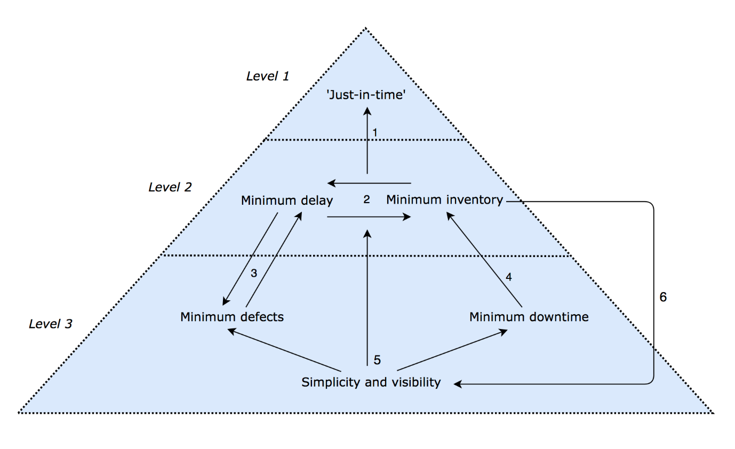Figure 2.1: A pyramid showing JIT pre-requisites [1].

A successful uptake of a dynamic JIT philosophy has deep-rooted implications throughout the internal business structure and external customer base. However, it was for this reason the techniques deployed by Toyota were admired. Companies were quick to see the benefits of the framework [6] due to the internal systems it requires, as seen in Fig. 3.1. As highlighted above the key aim of this model is to have access to materials at the exact point at which they are required, and although originating from the manufacturing sector this concept can be equally significant when applied to supply chains and procurement structures.
Businesses can use the core principles associated with JIT to structure relationships with manufacturing firms. Now the manufacturer and the client must align, and as such desired changes from one company must be reflected in the other. After all, a manufacturer pushing out products at full capacity directly conflicts with a business who’s default position is to request parts on an as-required basis. The manufacturer, using highly perfected internal principles, some of which have been outlined above, will need to provide the precise quantity exactly when specified. The result of this is a JIT-oriented supply chain.
However, as much as timespans are critical from the manufacturers perspective, if a business is aiming to deploy JIT procurement it is equally crucial for them to examine how a redesigned supply chain structure will influence the business. As of that in a JIT manufacturing process timing is critical for both parties. A business supply chain deploying JIT can be likened to that of a single internal process of a JIT manufacturing plant as it is closely monitoring when new materials are required, for much the same reasons as discussed above. However, as the flow of materials into a business will influence its internal processes the timings associated with supply chain management must be closely scrutinised. A firm must make allowances for the time between requiring the product and the point at which inaccessibility to the given product is costly – either financially or operationally. As previously highlighted the latter time marker, according to JIT principles, is the precise instance replacement materials are required.
A considerable proportion of the literature review which follows in the project itself explores the underlying principles of JIT and its application in the manufacturing industry, from where it originated. However, as discussed above and the central aspect for the proposed project is how its associated values can be applied to streamline the supply chain process. Further key aspects of the project, explored in the subsequent extended literature review, are various application design principles with a particular focus on the business and operational implications of JIT.

Industrial Context
The need for ‘Just-in-Time’ (JIT) procurement principles can be most clearly seen in the engineering environment where the need to timely procure hardware and mechanical components is crucial. For the purposes of this project the application in question will display and effectively manage the procurement of rail vehicle components, and as such, will be an appropriate application across the industry for numerous ‘Train Operating Companies’ (TOCs) [8], that are registered and trade under the ‘Rail Delivery Group’ (RDG) [9] name, formerly the ‘Association of Train Operating Companies’ (ATOC) [8]. The efficient use of rail assets is equally crucial for ‘Freight Operating Companies’ (FOCs) [8] and their pursuit of capacity to fulfil logistic contracts.
The opportunities to develop a system in conjunction with an industry partner are extensive due to the number of rail operators based in the UK, several of which are introduced below due to the current uncertainty regarding a confirmed industry partner. With the use of precise fleet maintenance data, the more accurate and worthwhile the application and the techniques used to develop it might be considered.
- DB Cargo UK (DBC): As the largest UK rail freight operator, and arm of global contract and bespoke logistics provider DB Schenker [10], a fleet comprising 263 locomotives [11] is handled from two primary maintenance facilities. A considerable proportion of the existing fleet were delivered from North America during the late-‘90s to mid-2000’s, phasing out older, less economically and environmentally friendly locomotives, though some have undergone refurbishment [12].
- Great Western Railway (GWR): High profile new Intercity rolling stock fleets have been delivered to this subsidiary of First Group [13] that operate Intercity, Inter-regional and local services across the South West, South Wales, Cotswold and Thames Valley [13]–[15] The new rolling stock will see the closure of several existing heavy maintenance facilities and the opening of new depots overseen under-contract with Hitachi Rail Europe [16]–[20].
- Rail Operations Group (ROG): A company providing widely varying services involving the transfer of rolling stock nationally, and short-term vehicle hire services to companies based in the UK, such as GWR. The concept of providing ATOC companies with a dedicated, specialist nationwide stock move oriented service was highly popular when offered to rail businesses [21],[22].
It is critical for businesses in this sector that their locomotives and associated vehicles are operating at their optimum in a stable schedule. The significance of the ‘Just-in-Time’ framework and associated asset management techniques are explored further in the following literature review.

Aims and Objectives
To develop an application based on JIT principles to streamline rail vehicle component procurement and increase the operational efficiency of its rail vehicles. However, to aid the project success evaluation, the clear definition of objectives is essential. To realise the aim the following objectives must be met:
- Gain a comprehensive understanding of the core values of the ‘Just-in-Time’ principle.

- Explore the existing systems operating in railway companies with a particular focus on a single business.

- Understand the key issues influencing the operational use of rail vehicles in a constantly fluctuating environment.

- To design and build an application for component e-procurement processes.

- To dissect the system following development to highlight areas for improvement and issues requiring further investigation.

Research Methodology

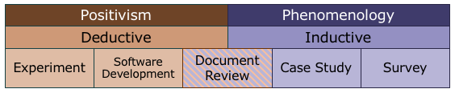
Fig. 5.1: The 'Research Wall'
To suitably position the project in the scope of academic research the use of the ‘research wall’, as shown in Fig. 4.1, is used. The proposed project must be clearly positioned in the above framework.
The design, development and evaluation of the application in this proposed project revolves around the ability to compare the practical results against theoretical concepts discussed throughout the literature review and organisational case study work. Due to the production of a practical result the project most closely aligns with a positivist philosophy, and although the factors influencing this development are not all statically based, they provide direct frameworks aiding the development of a directly identifiable set of results. This is process that can not so easily be calculated using subjective or phenomenological outcomes based around individual comprehension. Nevertheless, elements of the application success that can be categorised as phenomenologically based, such as user interface, must be touched upon in the applications suitability evaluation.
The core project approach too most closely aligns with the experimental manner. The literature review will concentrate on the core principles of JIT, producing a series of key techniques, frameworks and metrics a business application, process or structure can be measured against. An inductive based research with its focus on the development of conclusions following a practical development cannot be appropriately used to review the relative success of an application against pre-set metrics and guidelines with this approach more considering implications and not direct, comparative conclusions.
The project strategies must comprise three main elements. An extensive literature review concentrating on the principles, benefits, drawbacks of JIT will aim to generate key evaluation references, used in conjunction with further metrics and material extracted from both a sector and industry case study. The proceeding application development, itself a research process given the underpinning stakeholder and requirements analysis, aims to apply the findings in the development of a highly effective supply chain management tool.

Development Methodologies
It is vital internal application development processes are highly structured to ensure the activities undertaken at each process are of high quality, and a methodology is selected to provide the suitable framework [23]. To regulate the stages integral to application design and development the following methods can be highlighted, and conclusions drawn.
The deployment of ‘Feature Driven Development’ (FDD) today, one of a family of ‘Agile’ software development methodologies, is considerable. This cyclical approach revolves around the concepts of implementing arbitrary functionality in blocks, after which the new integrated features are appropriately demonstrated and tested before they are available to the customer.
Given the underlying theories of JIT the development of the application could be considered incremental with the development of application functionality introduced in accordance to the procurement requirements of JIT and the operational requirements of the business in question.

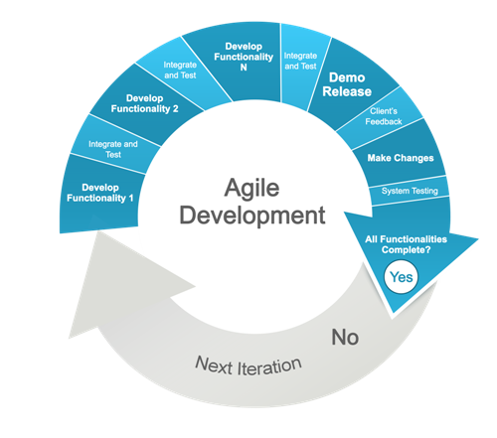
Figure 6.1: FDD methodology implements on a feature-basis

The use of FDD methodology provides several key attributes that align with the requirements of the application development process, namely; the ability to effectively provide progressive functionality to the client in a format that ensures high quality results within the appropriate timescale [23].
Despite being one of several similar methodologies, FDD biggest considerations is the process of application design and development, and how activities undertaken here can help provide a dynamic, responsive construction environment [24].

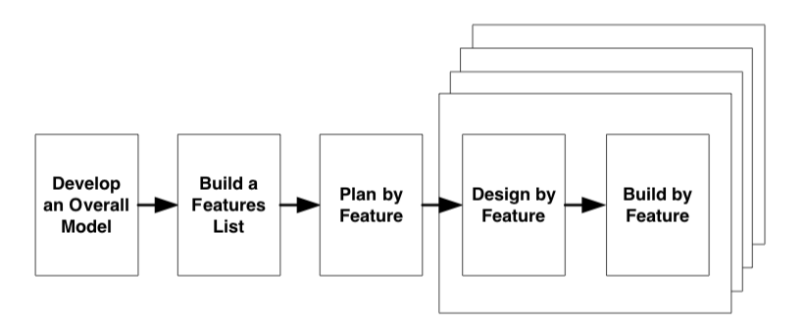
Figure 6.2: 5 key steps to deploy FDD [25]

Coming from a design and development perspective the model does not include a framework for requirements gathering. Instead, the initial process of breaking down the project involves the deconstruction of the project as a whole into its appropriate. The development of appropriate models for each domain, or element of the project however is required [25].
Based on the foregoing project documentation the development of the applications feature list, or client valued functions list, is now unambiguous. Each feature list can now be aligned with its suitable domain area that was previously identified with the aim of suitably consolidating domain of the project and the functionality it requires.
The process of ‘planning by feature’ aims to appropriately order development domains and their respective feature list(s), an activity enhanced further with the inclusion of suitable project milestones. Timely liaison with the client and significant stakeholders provides assurance during this step.
The processes identified can now be designed and developed in accordance to the domain area documentation [25]. The process of development will involve the development itself, the testing of its functionality in the context of the application, comparison against JIT concepts and business application research and appropriate integration with the application in its fore-most version. Development processes will include appropriate contingency timescales for each step leading to the domains final integration into the solution.
Whilst the benefits of FDD methodologies in this project is evident, the characteristics of corresponding methods should also be noted. However, several other development approaches contain concept relevant to the proposed project. ‘DevOps’ [26], designed to integrate both the development and operational aspects of application development offers elements worth considering. The key elements to this development architecture is its ability to balance the development team and the operations team, overcoming the sometimes-deep-rooted separation between the development team and those that must actually use the app in its native environment – a process that could provide functionality issues and operational inconsistencies.

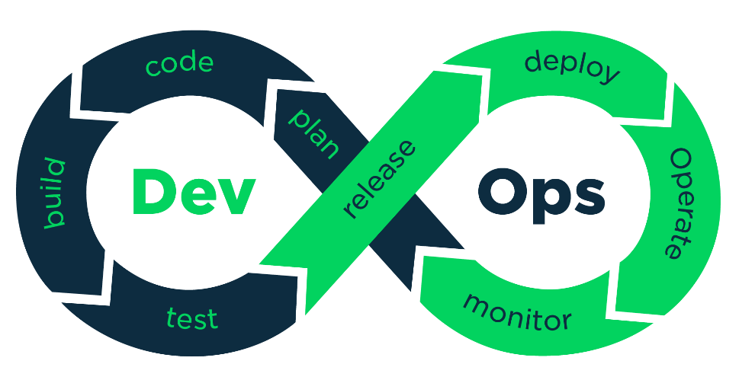

Figure 6.3: DevOps offers greater inter-departmental transparency

Risks
Risk is a large consideration of any IT project. The research and developmental nature of this project provides several key risks that will require suitable mitigation techniques and appropriate contingency plans.
- Obtaining the prototypical data for use in the application from a business in the rail operations sector
  - Ensuring organizational-specific data protection regulations are systematically managed
  - Ensuring data obtained is reliable, accurate and fit for its role in this project.
- Obtaining the appropriate organizational information to undertake a thorough case study.
- Ensuring organizational-specific data protection regulations are systematically managed
- Ensuring data obtained is reliable, accurate and fit for its role in this project.
- Access to suitable information for the production of suitable fictitious data should the award of industry data be prevented
- Access to suitable information for the completion of a comprehensive industry case study if company-specific data is unobtainable.
- Access to a suitable development environment(s) and/or tool(s) to develop the application.
- An inadequate understanding of the selected development environment(s) and/or tool(s) to construct the application.
- A poor selection of development environment(s) and/or tool(s)
- Access to computers to undertake the project both inside and outside the bounds of the university.
- Suitable access to university lecturers for suitable levels of support and/or guidance throughout the entirety of the project.
- A suitable timespan in which to undertake work towards, and successfully complete the fore-mentioned project objectives.
- The feedback regarding application development is not received, no direct survey data to present.

Deliverables
The project as a whole and the development of a procurement application for rail sector businesses in the UK requires, but not revolves around, the use of prototypical data from an industry partner. Whilst the research required to formulate fictitious data is undesirable, it is an appropriate contingency plan to keep in reserve should access to archetypal operational data be prohibited.
The industry data required will contain comprehensive maintenance data regarding one, but not necessarily limited to, physical rail vehicle operated by the partnership company in question – for which there are several, those introduced in the Industrial Context, the developer is currently involved in negotiations with. The data should provide a systematic record of the vehicles component list and the current maintenance state for each, documented in the common engineering metrics of miles or various single format date/time stamps [27],[28]. Some components may also take the format of sector specific metrics such as a single alphanumeric value regarding a level of vehicle examination – a scale ranging from A-F used to categorize the severity and timeliness of vehicle maintenance undertaken [28].
On collection of maintenance data, the process of identifying what information will be used in the prototype application can be made, though as stated above in Aims and Objectives the current state of the business environment will also influence the decisions made across the application development stages. The format of the records is currently unknown, but the state of which will influence what information will be used for the application and equally important, how this will be processed and displayed in accordance to JIT.
To reflect the aims and objectives identified above, project success will be the design and development of a procurement application. To be considered a success it must crucially be able demonstrate the application of JIT principles and appropriately handle supply chain management processes in the industry context. The ability to undertake procurement decisions relies upon the suitable access and processing of this component data with which to understand materials required for the more efficient deployment of rail vehicles.

Practical Resources
Successful progression through the project is partially reliant on suitable access to several key physical resources. These are highlighted below:
- Industry data – it’s currently unclear if rail vehicle maintenance data takes a physical format or whether this is handled digitally.
- A suitable application development environment(s) and/or tools(s) with which to develop the application. Two favorable systems will be subsequently tested further to ascertain the most effective platform
  - MIT AppInventor [29]: Currently an Android/Windows-only developer tool based around the screens and building blocks. This system provides data stream integration using ‘TinyDB’ and ‘TinyWebDB’ database components [30].
  - Microsoft PowerApps: This more business-centred tool allows the development of applications similarly to that of app-inventor, but with greater flexibility for data source integration.
- Access to Microsoft Project – a project planning tool used to ensure appropriate project progress through timekeeping.
- A data visualisation tool, such as Tableau, might be required to present visual data throughout the case study and literature review sections. Research aspects showing the current state of the rail sector, the use of rail vehicles by an industry partner or supply chain timespans could require the use of computer-based visualisation tools.
- University Computers to undertake project work
- ‘Home’, outside of the university, to undertake project work
- Access to rail industry journals and news sources to provide current statistics and present a comprehensive view of the sector.

Human Resources
A fundamental aspect of analysing the success of the application its success in meeting its business needs, those highlighted in the proceeding case study and literature processes. To understand the applications aptness the following human resources will be required:
- Timely access to lecturing staff within the university, and crucially the projects lead supervisor.
- An industry contact in a rail firm, they intend to be used as a key source for the case study and contact in supplying industry data, a large, if not ultimate factor in defining the projects viability.
- Maintenance staff in the business to view and/or use the application to formulate industry-level feedback on the systems suitability.

Timeline
The production of a project plan can provide a useful insight into both the scope of the project and its viability in the given timeframe. Fig. 11.1 below shows a breakdown of the main project objectives into tasks and subtasks. The use of Microsoft Project provides an easy method to develop a project timeframe and a tool to show task resources, human requirements and any pre-requisites. Of interest is ‘Feature-Driven Development’, structured with each features design, development, individual testing and implementation documented individually. As such the processes involved with each feature will work cyclically. The timeframe noted for this subtask is designed to cover the entire feature list constructed.

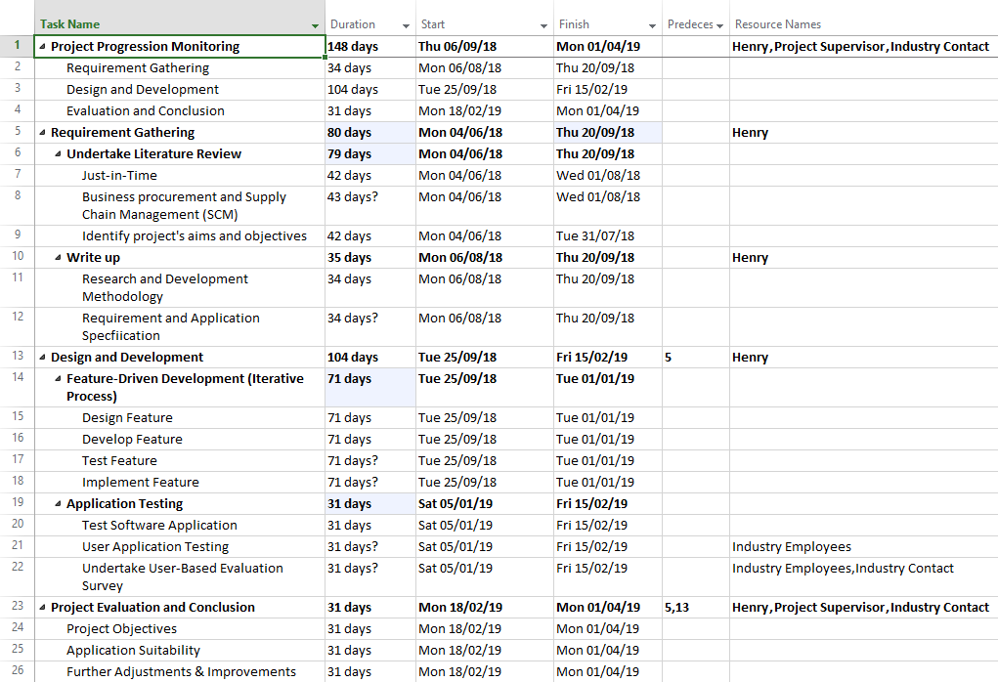

Figure 11.1: Microsoft Project view and some proposed timescales for each project tasks and subtasks

References
[1] A. Harrison and R. van Hoek, Logistics Management and Strategy: Competing through the supply chain, 3rd ed. Harlow, Essex: Pearson Education, 2008.
[2] Y. Monden and T. Ohno, Toyota Production System, 4th ed. Boca Raton, FL: CRC Press, 2011.
[3] A. J. Kootanaee, K. N. Babu, and H. F. Talari, “Just-In-Time Manufacturing System: From Introduction to Implement,” Int. J. Econ. Bus. Financ., vol. 1, no. 2, pp. 7–25, 2013.
[4] A. N. Bin Adnan, A. Bin Jaffar, N. B. Yusoff, and N. H. B. A. Halim, “Implementation of Just in Time Production through Kanban System,” Ind. Eng. Lett., vol. 3, no. 6, pp. 11–20, 2013.
[5] J. P. Womack, D. T. Jones, and D. Roos, The Machine That Changed the World: The Story of Lean Production. New York: Harper-Collins Publishing, 1990.
[6] W. J. Hopp and M. L. Spearman, “To Pull or Not to Pull: What Is the Question?,” Manuf. Serv. Oper. Manag., vol. 6, no. 2, pp. 133–148, 2004.
[7] Anonymous, “Just-in-time,” The Economist, 2009. [Online]. Available: https://www.economist.com/node/13976392. [Accessed: 30-Apr-2018].
[8] University of Birmingham and Network Rail, “List of Acronyms and Abbreviations for Railways (LAAR),” no. 24, 2011.
[9] Rail Delivery Group (RDG), “About Us | Rail Delivery Group,” About Us, 2017. [Online]. Available: https://www.raildeliverygroup.com/about-us.html. [Accessed: 30-Apr-2018].
[10] Deutsche Bahn AG, “The UK’s Largest Rail Freight Services Provider | Deutsche Bahn AG,” Our Company, 2018. [Online]. Available: https://uk.dbcargo.com/rail-uk-en/ourcompany/about-db-cargo-uk-2659128. [Accessed: 28-Apr-2018].
[11] Deutsche Bahn AG, “Company in numbers | Deutsche Bahn AG,” Company in numbers, 2018. [Online]. Available: https://uk.dbcargo.com/rail-uk-en/ourcompany/data-facts/company-in-numbers-1926702. [Accessed: 27-Apr-2018].
[12] C. Milner, “More Super 60s to emerge,” The Railway Magazine, Horncastle, Lincs., p. 94, Nov-2012.
[13] First Group plc., “First Rail – FirstGroup plc,” A great track record in rail, 2018. [Online]. Available: http://www.firstgroupplc.com/about-firstgroup/uk-rail.aspx. [Accessed: 30-Apr-2018].
[14] Great Western Railway (GWR), “New Intercity Express Trains | Fast Trains with Great Western Railway,” Modernising GWR, 2018. [Online]. Available: https://www.gwr.com/about-us/modernising-gwr/iet. [Accessed: 30-Apr-2018].
[15] A. Rogers et al., “Development of Class 800 / 801 High-speed Rolling Stock for UK Intercity Express Programme,” Hitachi Rev., vol. 63, no. 10, pp. 646–654, 2014.
[16] R. Clinnick, “Does Great Western Railway’s Class 800 IET Pass the Test?,” Rail, Dec-2017.
[17] R. Clinnick, “Hitachi unveils first UK-assembled IEP train,” Rail , 2016. [Online]. Available: https://www.railmagazine.com/news/network/hitachi-unveils-first-uk-assembled-iep-train?image=21636. [Accessed: 30-Apr-2018].
[18] C. Milner, “Brunel Inspiration as FGW re-brands as GWR,” The Railway Magazine, Horncastle, Lincs., p. 11, Oct-2015.
[19] N. Pigott, “Class 800 testing begins at Old Dalby,” The Railway Magazine, Horncastle, Lincs., p. 6, May-2015.
[20] C. Milner, “Class 387s in service - extra 1,400 peak-time seats,” The Railway Magazine, Horncastle, Lincs., p. 95, Oct-2016.
[21] C. Milner, “Carving out a Niche,” The Railway Magazine, Horncastle, Lincs., pp. 14–18, Sep-2016.
[22] C. Milner, “Class 442s stored in Cambridgeshire,” The Railway Magazine, Horncastle, Lincs., p. 84, Sep-2016.
[23] A. M. M. Hamed and H. Abushama, “Popular agile approaches in software development: Review and analysis,” in 2013 International Conference on Computer, Electrical and Electronics Engineering: “Research Makes a Difference”, ICCEEE 2013, 2013, pp. 160–166.
[24] P. Abrahamsson, O. Salo, J. Ronkainen, and J. Warsta, “Agile software development methods: Review and Analysis,” Espoo, Finl. Tech. Res. Cent. Finland, VTT Publ., p. 478, 2002.
[25] S. R. Palmer and M. Felsing, Practical Guide to Feature-Driven Development. Harlow, Essex: Pearson Education, 2002.
[26] J. Roche, “Adopting DevOps practices in quality assurance,” Commun. ACM, vol. 56, no. 11, pp. 38–43, 2013.
[27] Rail Standards Safety Board (RSSB), “Rail Vehicle Maintenance,” Rail Industry Standard, 2016. [Online]. Available: https://www.rssb.co.uk/rgs/standards/RIS-2004-RST Iss 1.pdf. [Accessed: 02-May-2018].
[28] D. Shirres, “Craigentinny does it all,” RailEngineer - Rail News, Rolling Stock and Components, 2016. [Online]. Available: https://www.railengineer.uk/2016/05/12/craigentinny-does-it-all/. [Accessed: 01-May-2018].
[29] MIT App Inventor, “About Us,” Anyone Can Build Apps That Impact the World, 2017. [Online]. Available: http://appinventor.mit.edu/explore/about-us.html. [Accessed: 03-May-2018].
[30] Massachusetts Institute of Technology, “Important Concepts in App Inventor,” MIT App Inventor, 2017. [Online]. Available: http://appinventor.mit.edu/explore/ai2/concepts.html#Database. [Accessed: 03-May-2018].

