
Skills for the Workplace
Module Assignment Submission
Student Name: | Nicola Dacosta
Student Number: | 2016821
Module No: | BMSK4005
Module Title: | Professional Career Development

Statement of Confirmation of Authenticity
By the act of making this submission, the student declares that this is the work of the student named above. The work has not, in whole or in part, been knowingly presented elsewhere for assessment, or where assessment has been built on a previous assessment, this has been identified. Where materials have been used from other sources it has been properly acknowledged. If this statement is untrue, the student acknowledges that an assessment offence has been committed.
Attention is drawn to the plagiarism and unfair practice policies of both the University and of ILM.

Table of Contents
Section 1 Professional Career Development 3
How to identify development needs 3
4
VARK Questionnaire 4
Honey and Mumford Questionnaire 7
Dantec Questionnaire 9
My Barriers of Learning 10
Colleague’s Barriers of Learning 10
Section 2 Personal Development Plans 12
SWOT Analysis 12
The Johari Window 16
My Personal Development Plan 16
Section 3 The Recruitment Process 20
Recruitment Process Reflection 20
20
Conclussion 22
References 24
Appendix 1 Job Application 25
Appendix 2 Cover Letter 31
Appendix 3 CV 32

Section 1 Professional Career Development

The world is a very competitive place, which is constantly changing. We are all responsible for our own personal development need to adapt to succeed.

Employers always look to hire the best candidates, so personal development is essential for getting a job. Constantly improving your skills, knowledge, and behaviours will allow an individual to develop in their chosen career.

In the following section we will be looking at how to identify development needs.

How to identify development needs

The first step to learning is self-development. We can achieve this by finding out what our strengths and weaknesses are through self-assessment.

We then reflect on our personal experiences. We need be honest with ourselves to identify weaknesses and improve on them. By having a clear perception of our personality, attitude, and behaviours we can find the best way to develop.

Self-awareness allows you to better understand yourself, other people and how they see you. It allows you the ability to make changes and to build on areas of strengths as well as identifying areas of improvement.

It is important to be self-aware and to recognise how you learn best and what will help you develop. Honey and Mumford (1986), Vark (Fleming 1987) and Dantec are three studies that have been implemented by employers so that they get the best our of their employees. The employees can also use it, so that they can discover their preferred learning style.

After completing all three questionnaire’s I was classed as a kinaesthetic multimodal and a reflector.

VARK Questionnaire

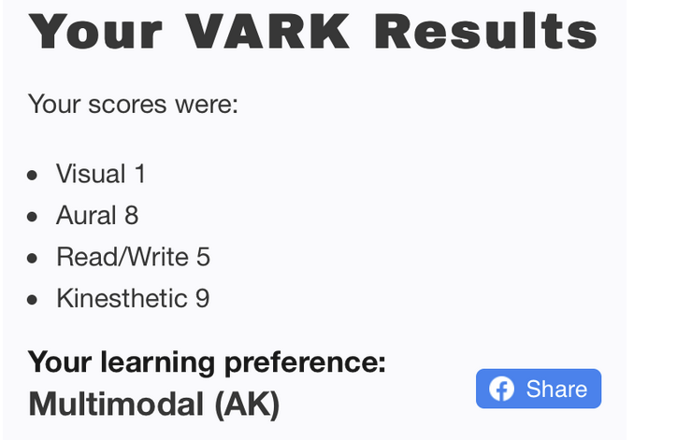

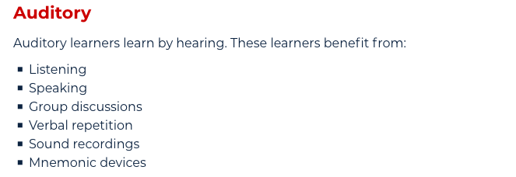

Auditory is described as an individual who enjoys talking and listening to others they like to try new things and may hum sing, whisper or talk out loudly they are also easily distracted and would have difficulty with written instruction.

I strongly agree that this accurately describes me. I am a talkative person with a bubbly, outgoing personality shown in my day-to-day life.
I am always ready to try new things but I do get easily distracted and find it hard to concentrate on topics that I am not interested in.

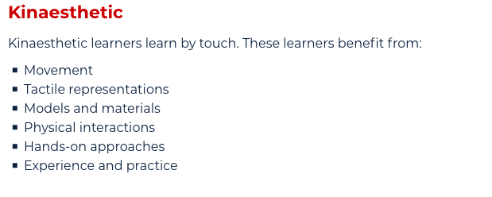
As you can see, I also scored a 9 on kinaesthetic. This would mean I enjoy physical activities I like to try new things I do not enjoy reading and I am often poor at spelling I like to use my hands whilst talking.

Much like the auditory result, I strongly agree. I thoroughly enjoy hands on activities and find I learn better when I am doing physical tasks. I have always been poor at reading and spelling and prefer to express my thoughts and feelings verbally and I like to communicate using my hands I feel as though I get my point across and get results this way. This method I’ve always felt comfortable in using.

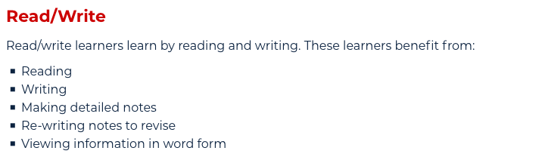

I scored a 5 on Read/Write which I do agree with as I don’t learn this way very often. I would only use this style of learning when receiving letters or emails. I realise I could take time out and try to read more and concentrate to improve my spelling and open up more personal development skills.

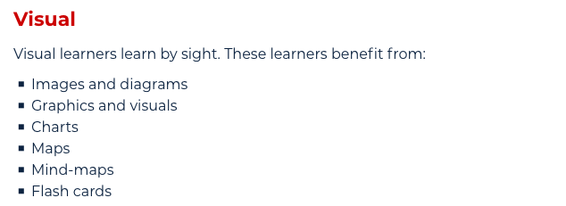

I scored a 1 on Visual again I would agree with this as I struggle with images, diagrams and visual aids. I find my memory is not very strong at holding information learned by sight.
Again, I feel I would benefit from observing rather than acting or talking, also learning how to memorise visually by practising in my own time.

In conclusion I feel that the VARK results accurately describe my personal leaning style.

My colleague also took the test and found out they were more of a visual learner. You can see that my colleague and I learn very differently. I struggle to use images and diagrams, whereas she can easily use visual aids to help her learn. This suggests that the VARK model does accurately depict how somebody learns. It allows you to develop your understanding of yourself and how you best learn.

Honey and Mumford Questionnaire

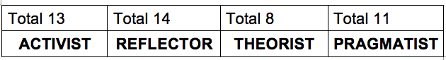

Reflector

- Think deeply about what they are learning
- They like things that are tried and tested
- Tend to be reserved

The second results are from Honey and Mumford (1986) on this questionnaire
I was classified as a reflector scoring 14 points in this category. A reflector is described as a person who thinks deeply about what they are learning; they like things to be tried and tested and tend to be a reserved.

I strongly disagree with this result, as I do not think deeply about what I am learning. I tend to jump straight in and try my best. I am very outspoken, and I do not need things to be tried and tested before I have a go at them. I am assertive and very hands on. I enjoy new experiences and adapt well to change. I am generally not a deep thinker.

Activist

- They like to deal with new problems
- Enjoy new experiences
- Like to be kept busy
- Love challenges

I feel my learning style best fits the activist category. Activists like to deal with new problems, enjoy new experiences and like lots of activities to keep them busy. When taking the Honey and Mumford test, I scored 13 for the activist category. This is very close to my Reflector score, implying that I do withhold many traits that an activist may have.

I show typical activist behaviours was at work. An example is, when the new track and trace scheme was implemented, I volunteered to go onto the phone lines before anyone had tested them and with very little training or knowledge on what I was expected to do. I wanted to do this as our companies’ house lines were closed and I wanted to keep busy and love a new challenge.

Another way in which I showed activist characteristics, rather than a reflector, is whilst training in my current job we were asked in an icebreaker to get up and give some true or false statements to be cross examined. The group was very nervous and reserved as it was our first week of work but I was very keen and volunteered to go first even though nothing had been tried or tested by any of my colleague’s prior to me.

I somewhat agree with the pragmatist result. I feel it is a bit high as I only really identify with being hands on. I am not a logical thinker and I find it challenging to apply what I learn to practical situations.

My lowest score was a theorist which I would agree with as I do not enjoy reading new material and I would not think about something before applying it. I generally jump straight into things and rarely take time out to take in new information.

Overall, I agree with the activist and pragmatist but not with the reflector or theorist part.

My colleague also took the Honey and Mumford (1982) test. They were a reflector. This means that she is a reserved person who likes to keep themselves to themselves. In social environments we were aware that we differed, however it is interesting to find that we also learn very differently. Whilst I prefer learning via new experiences, my colleague enjoys learning visually and when deep in thought.

Dantec Questionnaire

I also took the questionnaire on Dantec

I was classed as strong kinaesthetic. I agree with this result as I did in my vark results for the reasons fully explained there. In short, I really enjoy talking on the phone and I use my hands a lot when I speak. I am very expressive and love physical activity and feel this learning method describes me best. Having looked at all these learning styles I feel as a manager you need to be aware that everybody learns differently. I could not expect somebody who is a visual learner to learn via written resources. I should ensure that I adapt each area of learning to my employees so that they can all have equal opportunities at achieving their full potential.

My Barriers of Learning

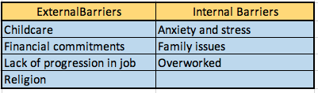

Colleague’s Barriers of Learning

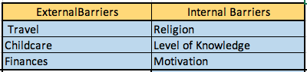

Barriers can restrict you from reaching your full potential. If you do not find ways to overcome your barriers you will be stuck at a point in life and not achieve your personal goals.

An external barrier that I have recognised is my religion. Me and my family have been attending church on Sundays for the past 2 years, which means that I cannot have plans on Sundays. This results in me being very tired, after working 3 days of the week. To overcome this, I could possibly go to church every other Sunday which would give me time to focus on myself and learn new skills.

Another internal barrier that could hinder my development is the constant pressure I am put under by my family. My mother is in a care home and it is a constant worry for me. I feel I could not move away from Cardiff, to possibly better myself, for instance, if I wanted to own a business.

Due to my mother being in a care home, I am the mother figure of my family. They come to me with their problems and issues and expect me to resolve them. To overcome this, I could speak about their problems with other members of my family and involve them so that they can then help my family members and reach a resolution for them, rather than myself.

Although internal barriers are key to note, it is also important to acknowledge your external barriers. I identified childcare as a barrier for myself. My children are the most important people to me. I feel, however, they do restrict me from reaching my full potential.

Childcare is too much money for me to pay for and therefore means that I must take time and look after my children. This means that I do not have time to focus on myself and grow as a person. My time is restricted. I would not be able to start a University degree without childcare, which is one thing I would really like to do. My colleague, however, does not have children and so her time is not limited. She has recognised her freedom as a strength. She is able to, learn new skills at home alongside working, which is an opportunity that I do not have due to having children. One way in which I can overcome this is by asking family members to help me or by waiting until my children are at an age where they are able to look after themselves before I look to grow and develop my skills.

Another barrier to my learning and growth, is that there is a lack of progression in my workplace. I am an ambitious person and find it hard working somewhere that does not allow me to grow or have goals. To conquer this, I could look for another job and try and find an occupation that will enable me to develop and thrive.

In terms of my colleague, travel was an external barrier since they cannot drive. This would limit their job opportunities as they would be restricted to where they could find work. They could overcome this by learning to drive or utilising public transport.

Another external barrier is finances. Being in a poor financial position stops my colleague from achieving their full potential. To overcome this, they could apply for support from the government or getting a loan from a bank or family members for financial support.

I also looked at internal barriers for my colleague, one thing that she struggles with is motivation. She finds it hard to get up and go and she finds it that it is big challenge that holds her back from achieving her full potential. To overcome this, she could try participating in regular exercise or make sure she has had adequate sleep (7-9 Hours).

My colleague has not done any further education after school this would mean she has a lack of knowledge, which is a barrier for her as she is limited to a certain type of job and cannot apply for specific roles which may need a degree. To improve on this, she could apply for further education or a university degree which would allow her to become more employable.

Section 2 Personal Development Plans

SWOT Analysis

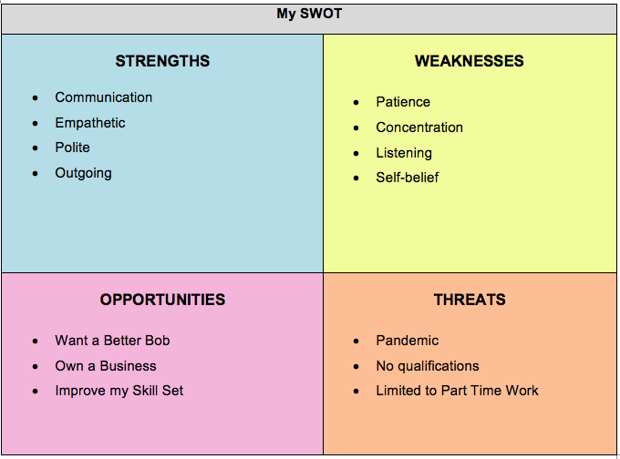

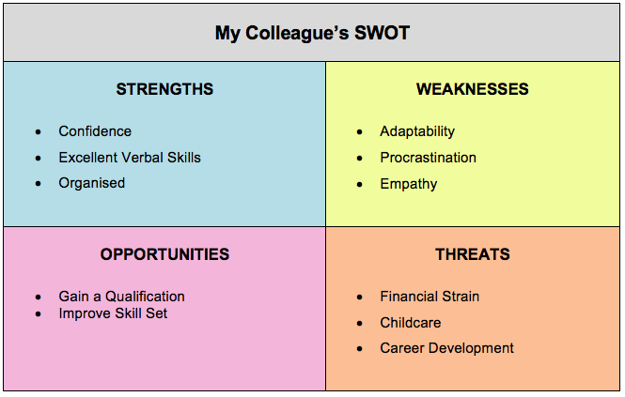

A different way to be self-aware is by using the SWOT analysis. SWOT allows you to acknowledge your strengths and weaknesses and how you can grow and develop yourself. It also highlights what opportunities you have in your life, as well as how these could be threatened. We will now look further into how to improve and develop new skills this way.

As you can see from the tables shown above, one of the strengths I have identified is how empathetic I am. I can sympathise and understand people’s circumstances. I work with many people and have to use this skill in my workplace. I need to be empathetic towards my customers who have different circumstances. For instance, financial, personal or bereavement issues. My colleague also completed their SWOT analysis and identified empathy as a weakness. This is because they do not have to use empathy every day in their job and it doesn’t come naturally to them, so it is not as vital for them to have acquired this skill.

Another strength I have identified is communication. I able to utilize my excellent communicative skills in my workplace and social life. I am able to change my demeanour depending on whom I am conversing with. For example, when in work I need to remain professional and friendly so that the customer is satisfied with my service. If they are elderly I need to remain patient and ensure that their queries are answered. My colleague also said that their communicative skills were exemplary. We both work on phones and need to have excellent communication skills to ensure that we can convey what we mean to the customer correctly.

In terms of my weaknesses, I acknowledged that I can become restless and bored when focusing on topics I am not interested in. This results in a lack of concentration. When in the workplace I need to make sure that I am constantly focused, whether I am interested or not. Sometimes I find this difficult and have to stop myself from zoning out as I need to be focused on each call to ensure that the customer receives the best service they can. To overcome this, I need to make sure that I try and take my time with each customer and be as interested as I can be.

Another weakness I recognized is my self-belief. I always get exceptional performance feedback in my 1-2-1 with my manager. However, I often think that I have performed poorly and ask for reassurance from my coach. I want them to confirm the information I am relaying to the customer is correct, even though it is always is. This has a detrimental effect on my confidence. To overcome this, I could take mindfulness classes that will give me techniques to use to instil self-belief within myself. My colleague identified one of her strengths as confidence. This is completely different to mine. She has a great outlook on life and can give herself positive feedback. She does not rely on others for help as much as I do. I feel this could be because she does not suffer with anxiety or stress and has little to deal with at home. She can focus on herself, rather than needing to provide for her family, as I have to.

When it comes to opportunities, I would like to improve my skill set and learning abilities in order to progress to a managerial position. I feel ready to commit now as my children are growing up and I have more time to concentre on my own personal goals and achievements. I would also be keen on opening my own business and learning about new ideas and different skills needed to become the best that I can be. My colleague has said that their work situation is a threat to them. They do not have room for progression in their job and this worries them as they are an ambitious person.

There are still apparent threats in my life that could stop me becoming successful and reaching my goals. This would include me having no qualifications to date which would have an impact on me applying for a new position, especially as a manager.

Also, I am currently only working part time because of childcare commitments so again this could hinder my need for further development and put an added strain on wanting to open my own business and becoming my own boss. Additionally, my colleague outlined childcare as a threat. We both feel that the lack of help with our child has a strain on our lives and could hinder our development.

To overcome my threats, I could apply for further education in order to gain qualifications that will allow me to achieve my goals in becoming a manger in the workplace. I could also ask for help either with after school clubs, child minders or family/friends to allow me to have more availability to be successful in the possibility of opening my own business.

The Johari Window

Another useful self-reflection tool is the Johari window. It is important to be honest with yourself and this involves gaining others opinion of you.

Of the four windows you can identify the Open and Hidden windows but you need to ask others to help with the blind spot window.

This will help you identify things you could improve on that may not be aware of.
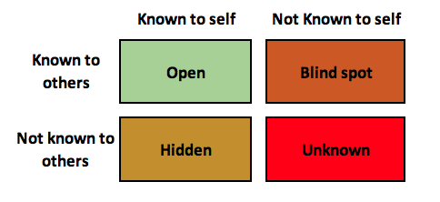

My Personal Development Plan

In my PDP I have outlined various behaviours that I feel I could improve on. These are listening, technological skills and self-belief; all of which affect my daily life and could hinder my progress as a University student.

Listening is a skill I have always found difficult to acquire. As discussed in previous points, I learn through communicating and find it hard to listen. To overcome this, I decided I needed to be more active in conversations and show a physical presence. To do this I suggested maintaining eye contact with whomever I am communicating with. As a result, I want to be able to take in information, for example in lectures, and not interrupt.

When I interrupt, I find I am unable to retain the information previously discussed as I am so focused on the point I have put forward. After review, I feel that I have most definitely achieved my goal. I am much more of an active listener and allow people to take time in explaining themselves.

Another skill I recognised as a weakness was my technological skills. Technology is up and coming today and it is integral that we understand the basics. I find technology extremely hard to work and am very put off by situations where I must use technological devices. To overcome this, I suggested booking appointments with the Student Support Team who will be able to give me more information on the applications used on my University course, as well as giving me a deeper insight into what the various applications do.

Additionally, I also suggested I attended online sessions, or watched online tutorials. In hindsight, this was a very good idea. I can visually see on my screen how I can access things and am guided through each process. This was extremely helpful for me. I feel without creating the PDP I would not have thought to use online tutorials and would not have obtained this basic information that I can now use in all aspects of my life. As a result, I can correctly complete the tasks set by my lecturer, as well as not feeling anxious or stressed before using electronic devices.

Overall, my PDP was very successful. It allowed me to overcome my weaknesses and improve on areas that were in desperate need of development.

My biggest achievement was being able to access Microsoft applications without supervision. The PDP has enabled me to set out tasks which are out of my comfort zone to reach an achievable goal. In the future I can use this plan to look back in times of need. When I may feel that my listening skills have declined, I can look at my PDP and revisit the tasks I set myself to ensure that I retain and maintain my listening skills.

My colleague also created a PDP. She recognised areas in which he could improve on. These were her adaptability, empathy, and procrastination. Like me, she suggested tasks that she can readily implement into his daily life that would allow her to develop these skills/behaviours. Her results were also very similar to mine. We both feel that the PDP was successful and allowed us to develop skills we had avoided improving.

My PDP table is shown below along with my colleagues table:

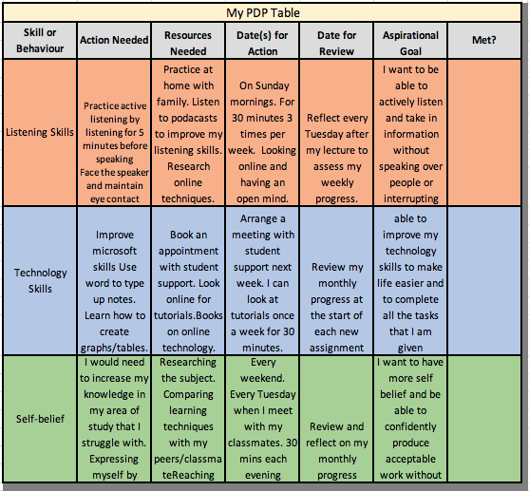

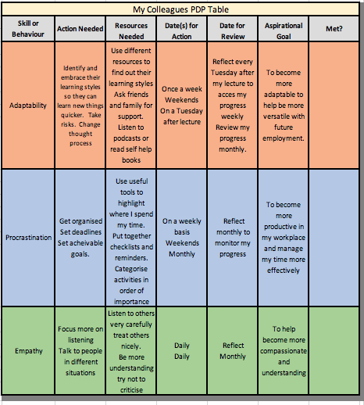

Section 3 The Recruitment Process

Recruitment Process Reflection

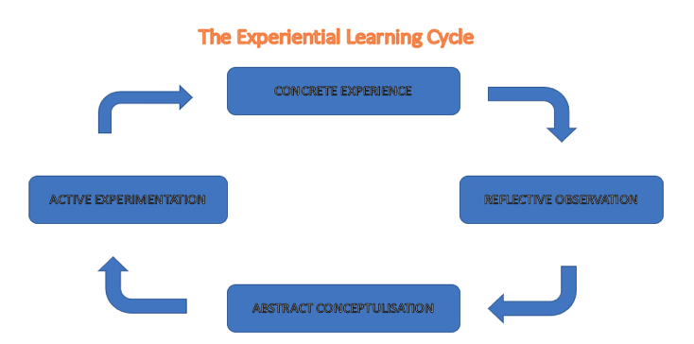

CONCRETE EXPERIENCE
One interview I had begun by applying online and filling out an application form. The next step, the company contacting me to arrange a telephone interview. I then had a telephone interview in which I had a role play scenario I had to pretend that I was speaking to a customer. I noted some information, personal details and bank details in a professional manner and making sure the information was relayed back and taken down correctly with no errors.
After successfully passing this stage I was invited for a face to face interview with the company where I had two interviewers. I was then asked a series of competency-based questions and had a written test to check my spelling and grammar. After this process I was told I would be contacted by phone to let me know if I had been successful or not.

REFLECTIVE OBSERVATION
On reflection I believe my interview went well. I felt relaxed during the initial stage when I had the telephone interview as I was at home at the time within familiar surroundings.
I felt prepared as I knew I was going to have a telephone interview and as my previous job was in a contact centre. My communication skills were of a high level. I was confident in my abilities to succeed in this interview. However, on the second stage of my interview, I felt very uneasy and nervous. I arrived at a very formal reception office and I had dressed accordingly. I felt extremely anxious whilst sat in the waiting room and was having heart palpitations. This was because I was out of my comfort zone.
When I was called in I was firstly asked to sit and listen in to one of the customer advisors within the company which made me relax more and she was very friendly and made me feel at ease. After around 15 minutes I was called into a room with two interviewers. I immediately felt comfortable in their presence as they were very friendly and welcoming. I actively joined in the discussion and did not feel at a loss for words when being asked questions. I felt I built a good rapport with the interviewers.
I found some of the competency questions difficult and in hindsight felt that I could have researched more about the company that I was interested in joining overall though I felt the interview went quite well.

ABSTRACT CONCEPTUALISATION
After going through this interview, I feel it went well. This is a good recruitment process. It was good to have the telephone interview first as it was in my home. It was good to have the option to sit in and listen to someone to view the job and see what it entailed before asking and being asked questions on the role.
ACTIVE EXPERIMENTATION
The only thing I would really change is researching the company more before the interview as I feel the extra knowledge would give me more confidence.
Moving forward I feel I could learn a lot from this interview. I was a bit thrown off with some of the competency questions and felt I didn’t read about the company as much as I should of. I could have also practised for some quick-fire questions in advance.
As a manager I feel I would do the telephone interview to make sure the individual is able to communicate effectively and also allow the potential employee to listen in to staff to gain more knowledge on my business.
I also would keep the interview process although I would change maybe just having one interviewer as it can be quite daunting with two for the employee. I would prefer my potential staff to feel relaxed and able to express themselves without the added pressure of two respondents.

Conclusion
In conclusion, it is clear how vital self awareness is in relation to professional career development. Knowing your preferred learning style, barriers and strengths and weaknesses can allow you to widen your skill set and improve professionally and personally.
The personal development plan is a good method of knowing how to develop and tasking yourself with activities that will allow you to improve areas you struggle with. Alluding to this, it is key to have a plan before applying for any jobs and researching your interviews before partaking in them. My interview experience has been good so far, so in the future I can use this experience to get the job I desire.
To conclude, you need to continue developing and improving to reach your full potential and achieve personal development.

References

Honey, P., and Mumford, A.(1982) ‘Manual of learning styles’ London: P Honey

Fleming, N. (1987) ‘Vark’ New Zealand

Dante’s, C., Diouri, M., Goodchild, L. (2006)’Dantec’ Southampton: University of Southampton.

Humphrey, A. (1960) ‘SWOT Analysis’ California: Stanford University

Morgan, P.(2017) ‘The Business Students Guide to Study and Employability’ London: SAGE

Kolb. D. A. And Fry, R. (1975) ‘Toward an applied theory of experiential learning’,in C. Cooper (ed.), Theories of Group Process, London: John Wiley

Joseph Luft and Harrington Ingham (1955).

Appendix 1 Job Application
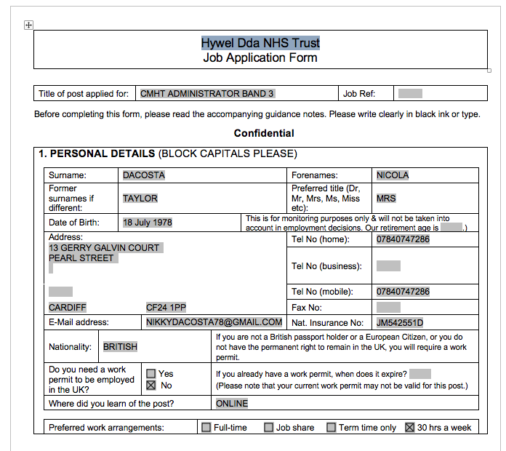
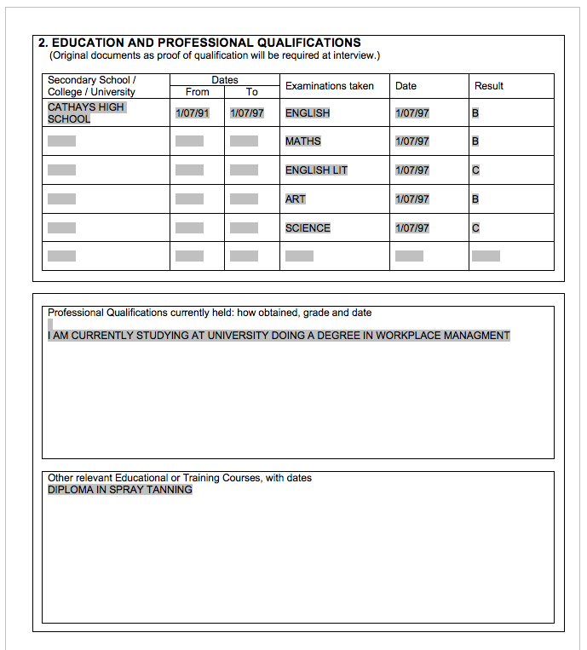

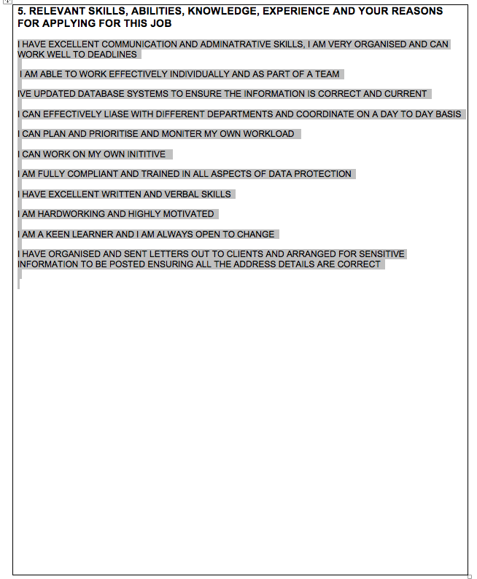
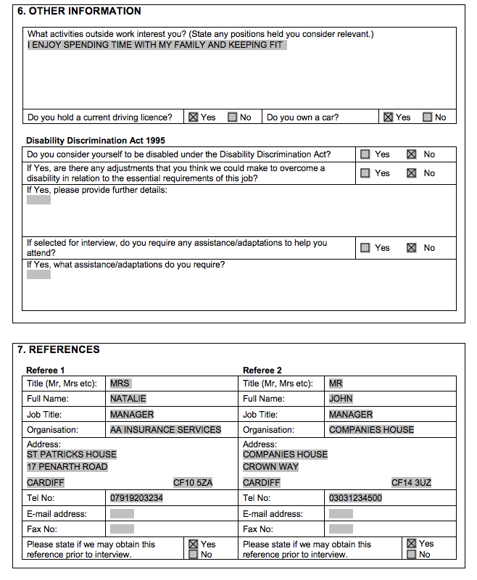

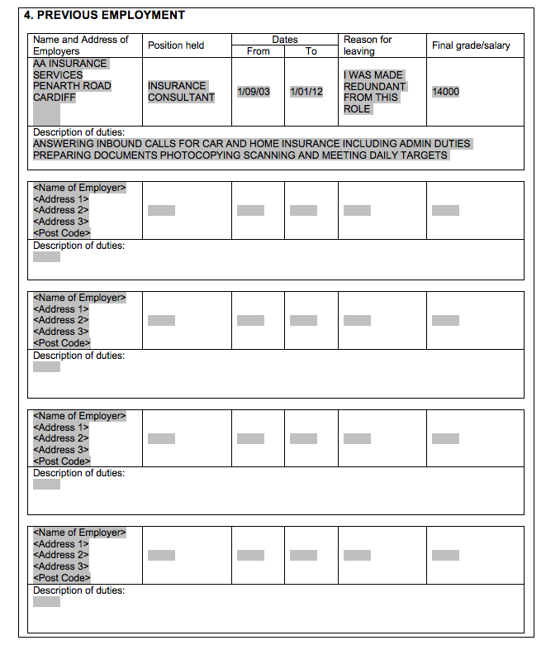
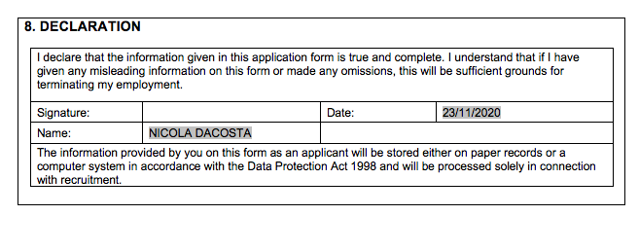

Appendix 2 Cover Letter

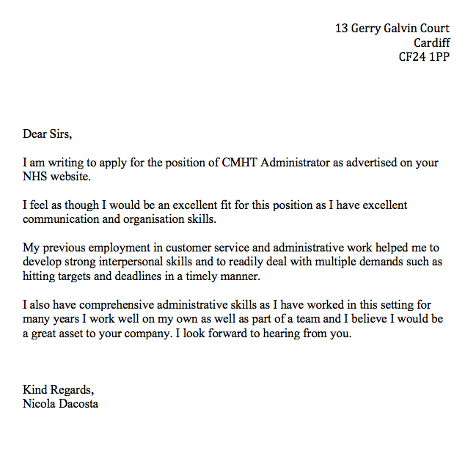

Appendix 3 CV



