

Assessment 2

Mental Disorders and Psychopathology BMHP6006
Lecture: Bianca Sanfilippo.
Student Name: Sevzhihan Hasanova.
Student Number: 2020999

Table of Contents

1-Introduction
2-General Anxiety Disorder
3-Schizophrenia
4-Autism
5-A list of references

1-Introduction
This article will provide a presentation of Chapter V of the International Statistical Classification of Diseases and Other Health Problems, 10th Revision (ICD-10), Version for 2010, Behavioural and mental disorders (F00-F99). It will also provide a critical analysis of the classification, diagnosis, treatment, and measurements of rehabilitation of three mental diseases based on the ICD-10 (WHO, 2010). These conditions were selected from a database that is kept up to date by the WHO. In accordance with the ICD-10, we shall discuss the following three types of mental illness:
-General Anxiety Disorder
-Schizophrenia
-Autism
2-General Anxiety Disorder (GAD) 873 words.
The National Health Service (2021) defines anxiety as "a persistent experience of tension, extreme panic, and worry that can have a substantial negative effect on the day-to-day life of an individual, negatively influencing both physical and mental health and welfare." Anxiety can have a detrimental influence on both an individual's mental and physical health and wellbeing. The effects of anxiety on a person's day-to-day life can be significant and debilitating, depending on the severity of the condition.
The diagnostic category for generalised anxiety disorder (GAD) is "F40-F48 Neurotic, stress-related, and somatoform disorders." GAD is under F41.1
2.1. What causes anxiety? The symptoms of anxiety disorders are similar to those of other types of mental illness. They are not the result of personal frailty, defects in character, or difficulties in childhood development. However, researchers aren't entirely certain on what factors lead to anxiety disorders. They have a hunch that a number of other elements are involved, including the following:
Chemical imbalance the chemical balance that determines your mood might be altered when you are subjected to severe or persistent stress. An anxiety disorder may develop because of prolonged exposure to high levels of stress over a period of time.
Environmental factors: Someone who has a higher genetic risk to begin with is more likely to develop an anxiety disorder if they experience a traumatic event that sets off their alarm bells.
Bereavement is the process of grieving after the death of a loved one, being abused, bullied, or harassed in any way, including experiencing racism, feeling lonely or alone as a result of these experiences. It is possible that you have struggled with anxiety because of the coronavirus pandemic because significant upheavals in your day-to-day life can be a particular source of anxiety triggers.
People suffering general anxiety disorder in the UK.

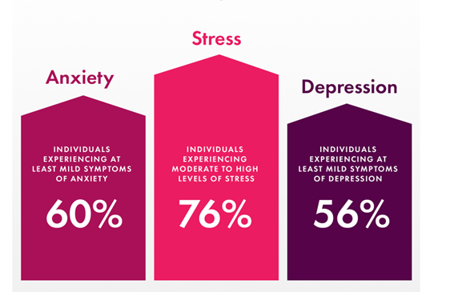
Source: anxiety in UK percentage 2020 - Bing images.
2.2. Signs and Symptoms
According to Chand and Marwaha (2022), common signs and symptoms of anxiety include the following: experiencing feelings of nervousness, restlessness, or tension; having an increased heart rate; breathing rapidly (hyperventilation); sweating; trembling; feeling weak or tired; having difficulty concentrating or thinking about anything other than the present worry; having difficulty sleeping; having difficulty controlling worry.
2.3. When anxiety can be diagnosed.
If you have had symptoms for at least six months and also undergo a physical examination, there is a high likelihood that you have generalised anxiety disorder (GAD).
You might also have the condition if you have trouble controlling your anxious sensations and find it challenging to do.
In order to assist with the diagnosis, the general practitioner (GP) may perform a physical examination or blood tests to rule out other disorders that may be causing the symptoms, such as anaemia (a shortage in iron or vitamin B12 and folate) or hyperthyroidism (an overactive thyroid gland). Both of these conditions are examples of potential causes of the symptoms.
Also, self-questionnaires can be completed by the patients. GAD7.
Information pertaining to the percentage of persons in the UK who suffer from anxiety.
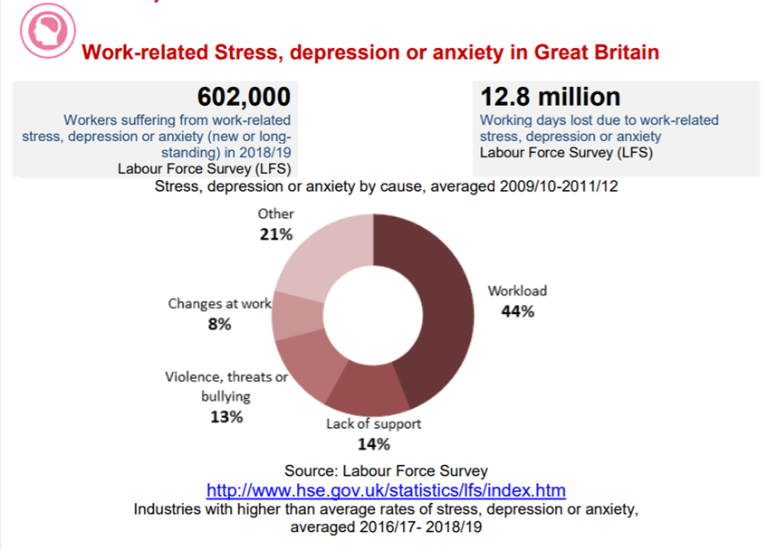

2.4. Current treatments: Talking therapies- psychological therapies, guided self-help, and Cognitive Behavioural Therapy (CBT), relaxation and lastly Medication- such as a type of antidepressant.
CBT offers a number of benefits, including the following: It places an emphasis on the individual's ability to bring about changes in themselves (their thoughts, feelings, and behaviour).
It has the potential to be as beneficial as medication in treating certain mental health problems, and it may be useful in situations where medication by itself has not been successful in treating the condition.
Some of the disadvantages of CBT to consider include it involves confronting your emotions and anxieties, which means you may go through initial phases in which you feel anxious or emotionally uncomfortable. CBT can be expensive, especially if you must pay for it out of your own pocket.
2.5. Evaluations of patient progress in rehabilitation. All these methods can be used to keep track of the patient's progress during the rehabilitation process and therapies, as well as to evaluate how well the treatments themselves are working.
To determine whether or not the therapies are successful, it is necessary to be familiar with the measurements of rehabilitation. This is due to the fact that if a treatment is not effective, it ought to be altered.... The 'Generalised Anxiety Disorder Questionnaire' (GAD-7) is one of the tools used in GAD rehabilitation as an assessment tool. This questionnaire is an instrument that can be used to determine the level of anxiety experienced over a period of two weeks.
2.6. Recommendations for improvement of anxiety (Complementary therapies)
Use of alternative or supplementary treatments. Several research, such as the one conducted by (Azami et al.2018) have proven that yoga is helpful in lowering levels of anxiety in female participants. This will have a beneficial effect because it will cut down on the consumption of medications and the negative impacts those substances cause.
Guidelines for the treatment of patients suffering from generalised anxiety disorder (NICE, 2020) describe that when working with people who have generalised anxiety disorder (GAD), it is essential to build a relationship and work in an open, engaging, and non-judgmental manner; explore the person's worries in order to jointly understand the impact of GAD; explore treatment options collaboratively with the person, indicating that decision making is a shared process; an anxiolytic medication; an exercise programme; an exposure therapy programme; an
Useful link where you can get help: National charity helping people with Anxiety - Anxiety UK Mind. Available at: https://www.mind.org.uk/information-support/types-of-mental-health-problems/anxiety-and-panic-attacks/about-anxiety/
3-Schizophrenia - (1200 words)
Classification (Schizophrenia within the ICD –10 is classified as schizotypal and delusional disorders (F20-F29).
Definition. Schizophrenia is a mental condition that is characterised by disruptions in thought processes, perceptions, emotional response, and social interactions. Although the course of schizophrenia varies from person to person, it is often a chronic condition that can be both severe and catastrophic when left untreated. (NIH,2020)
Also, Schizophrenia is a Brain Disorder That Can Affect Anyone. Schizophrenia is a disease that affects the brain and has its roots in the biological processes that are carried out by the cells in the brain. Since it was initially described by Dr. Emil Krapelin in 1887, it has been thoroughly researched for almost a century, but it is still a very complicated sickness that has not been fully comprehended, despite the fact that it has been examined in great depth. Although late onset disease can occur as late as the 70s, it typically strikes for the first time between the ages of late teens and early twenties. Men typically show symptoms slightly earlier than women do. It's extremely unusual to have schizophrenia before puberty. (Living With Schizophrenia, 2012).
Information and percentage of persons in the UK who suffer from Schizophrenia.
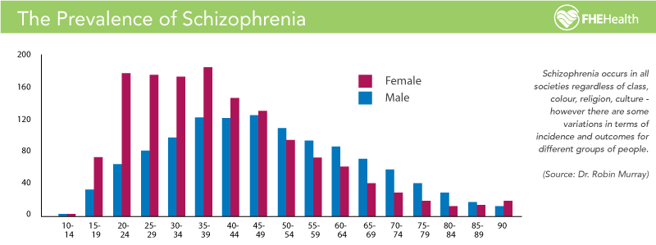
3. 1. Causes (Aetiology). There is a lack of understanding on the precise reasons behind schizophrenia. According to the findings of certain studies, an individual's susceptibility to developing the illness can be influenced by a number of different factors, including those that are genetic, environmental, psychological, and physical in nature. Some people may be genetically predisposed to developing schizophrenia, and a stressful or emotionally upsetting incident in their lives may be the impetus for a psychotic episode in these individuals. (NHS,2021).
3. 2. Schizophrenia presents itself with a variety of symptoms: Active-stage symptoms?
Schizophrenia's five main symptoms occur during the active period. These symptoms may occur together: Delusions, hallucinations, disorganised speech, strange motions, negative symptoms.
When someone is hallucinating, they are perceiving things with their senses of sight, hearing, smell, taste, and touch that do not exist in the real world. Hearing voices is by far the most prevalent form of hallucination. A delusion is a belief that is held with entire conviction even though it is based on an incorrect, odd, or unrealistic view. It is possible that it will influence the individual's behaviour. Delusions might start off very quickly, or they can build up over the course of several weeks or months. a disease of the ideas (confusion of the thoughts). People who are suffering psychosis frequently have problems following their own thoughts and the discussions they are having. Behavioural and mental shifts are being observed. It's possible that a person's behaviour will get more chaotic and erratic as time goes on.
Some people say that their thoughts are not their own, that someone else controls their thinking, or that someone else has planted thoughts in their mind. Others say that their thoughts are not their own because someone else has implanted them with such thoughts. Psychosis is a term that medical professionals frequently use when referring to schizophrenia.
It can be quite challenging to deal with one's first acute episode of psychosis, not only for the individual who is afflicted but also for their loved ones and close friends.
There is a possibility that the person's demeanour will drastically shift, and they may become agitated, worried, confused, furious, or distrustful of the people in their immediate environment.
They might not believe they require assistance, making it difficult to convince them to go to the doctor for treatment.

3.3. In order to make a correct diagnosis of schizophrenia, each of the following must be present:
A minimum of two of the primary five symptoms being shown. These symptoms, some of which have already been mentioned, include delusions, hallucinations, speaking that is disorganised or incoherent, movements that are disorganised or unusual, and unpleasant symptoms, as well as the length of time spent experiencing symptoms and their impact. At the very least, the principal symptoms that were being experienced should have lasted for a full month. In addition, the symptoms of the disease must persist for a minimum of six months, regardless of whether or not they meet all of the conditions for dysfunction in social or occupational settings. This suggests that the condition hinders either the patient's ability to work or their ability to maintain healthy relationships (whether those connections are platonic, romantic, professional, or any other type).
The diagnosis of schizophrenia requires ruling out other mental health illnesses and determining that the symptoms are not the result of substance misuse, medication, or a physiological disease. Some of the following factors can be considered while attempting to diagnose schizophrenia:
a-A health check-up. This may be done to help rule out other problems that could be causing the symptoms, as well as to check for any consequences that may be associated.
b. Examinations and preliminary checks. These may include tests that help rule out other illnesses that share similar symptoms, as well as tests to screen for alcohol and drugs. Imaging examinations, such as a magnetic resonance imaging (MRI) or computed tomography (CT) scan, may also be requested by the physician.
c-A psychological and mental health evaluation. Examining a patient's outward look and demeanour, as well as questioning them about their thoughts, moods, delusions, hallucinations, substance use, and the possibility of self-harm or suicide, are all components of a mental health evaluation performed by a physician or other mental health professional. In addition to this, a discussion about one's personal and family history will follow.
d-Diagnostic criteria for schizophrenia. The Diagnostic and Statistical Manual of Mental Disorders, Fifth Edition (DSM-5), which is published by the American Psychiatric Association, contains criteria that may be utilised by a medical practitioner or mental health professional.
3. 4. Management and treatment. The treatment for schizophrenia is typically comprised of multiple components, including medication, psychotherapy, and self-management strategies. Although talk therapy alone can often be effective in the treatment of most mental health issues, medication is typically required for the management of schizophrenia. It is essential to make a diagnosis and begin therapy as soon as possible because doing so raises the likelihood of successful treatment.
3. 5. Evaluation criteria for rehabilitation. When it comes to this condition, the only thing that can be measured is the quality of care and therapies that are provided in order to successfully control and manage the condition and avoid complications such as self-harm and suicide, the misuse of substances, neglect and self-neglect, a loss of dignity, and violations of human rights. Measurement of this quality is the only thing that can be done. Use the same markers that are used for identifying long-term mental issues in order to provide an accurate picture of an individual's quality of life.
"Quality Indicator for Rehabilitative Care" (abbreviated as QUIRC-SA). (For further reference, see appendix b). This instrument includes specific indicators that demonstrate that high-quality care and effective treatment are being provided to manage the condition (see appendix b for further information on these indicators). Because schizophrenia is a chronic disorder, it is vital that those who utilise mental health services receive assistance in order to maintain a satisfactory level of life. This can be quantified by the utilisation of indicators for rehabilitative care that are applicable to all long-term mental health problems.
3. 6. Recommendations for improvement of Schizophrenia: Cognitive behavioural therapy (CBT) is the most common form of talk therapy that is advised for the treatment of schizophrenia. This sort of therapy assists patients in recognising and altering any negative ideas or behaviours that are making life challenging for them. The goal of cognitive behavioural therapy (CBT) is to help patients cope with the symptoms of psychosis, such as hearing voices or having delusions.
Interventions of a psychosocial nature: As soon as the psychosis begins to improve, it is essential to continue taking medication while also participating in psychological and social (psychosocial) therapies. These may include the following:
1- Psychotherapy with a single patient. One possible advantage of participating in psychotherapy is that it can help normalise one's cognitive habits. People who have schizophrenia can learn how to better manage their illness by being more aware of the warning signs that suggest an oncoming relapse and acquiring skills to better manage stress.
2-Social skills training. This focuses on strengthening the ability to participate in daily activities as well as communication and social interaction skills.
3. Counselling for families. Families that are coping with schizophrenia can receive help and education as a result of this.
4-Vocational rehabilitation and assisted employment opportunities. This focuses on assisting those diagnosed with schizophrenia in preparing for, finding, and maintaining employment.
A large percentage of people who suffer from schizophrenia can control their symptoms with the help of suitable treatment.
4-Autism – (1137 words)
Classification (F80-F89 Disorders of psychological development, ICD, 2010)
F84: Pervasive developmental disorders-A set of illnesses that can be identified by the presence of qualitative anomalies in reciprocal social relationships and in patterns of communication, as well as by a constrained, stereotypical, and repetitive repertoire of interests and activities. These qualitative anomalies are a feature that is present in the functioning of the individual in any situation.
A set of illnesses that can be identified by the presence of qualitative anomalies in reciprocal social relationships and in patterns of communication, as well as by a constrained, stereotypical, and repetitive repertoire of interests and activities. These qualitative anomalies are a feature that is present in the functioning of the individual in all circumstances.
4. 1. Definition: Autism spectrum disorder (ASD) is a neurological and developmental illness that impacts how people learn and behave, as well as how they connect with others, communicate, and express themselves socially. Although an autism diagnosis can be made at any age, the condition is referred to as a "developmental disorder" since symptoms typically arise within the first two years of a person's life. (National Institute of Mental Health, 2022)
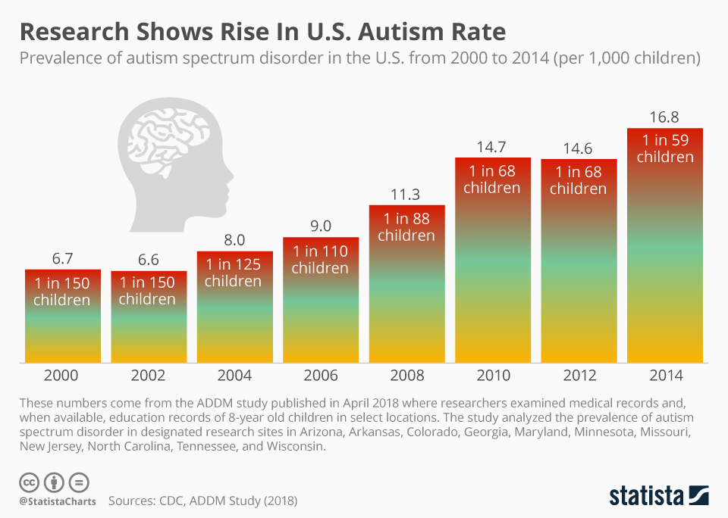

Source: https://www.statista.com/chart/17578/autism-rate-in-the-united-states/
4. 2. Causes (Aetiology): Research has shown that a person's genes and certain aspects of their environment can work together to influence a person's development in ways that can lead to autism spectrum disorder (ASD). On the other hand, researchers do not yet have a complete understanding of the factors that lead to autism spectrum disorder (ASD). Some examples of factors that have been related to an increased chance of developing autism spectrum disorder include the following: Being born with a very low birth weight, having a sibling who also has autism spectrum disorder (ASD), having older parents, having a certain genetic condition (such as Down syndrome or Fragile X syndrome, for example), and having older parents are all risk factors for developing autism spectrum disorder (National Institute of Mental Health, 2022).
4.3. Signs /symptoms: The following is a list that illustrates several examples of behaviours that are typical of individuals who have been diagnosed with ASD. People who have ASD may not exhibit all the following behaviours, but the vast majority of those with the disorder will demonstrate some of them.
Social interactions may include Lacking eye contact, appearing to ignore speakers, infrequently displaying, or communicating interest, enthusiasm, or enjoyment of objects or activities, Unresponsiveness to one's name or other spoken requests for attention.
Having trouble with conversational flow Talking too long about a favourite topic without realising others aren't interested or giving them a chance to answer. Discordant facial expressions, movements, and gestures, having a singsong or robotic voice. Not comprehending or predicting others' behaviours
Social issues shared imaginative play or friendship issues restrictive or repetitive behaviours include items, duplivincular be adjustments, uncommon behaviours like echolalia (repeating words or phrases). Being obsessed with figures, data, or facts overfocusing on moving things or portions of items disliking routine adjustments and having trouble transitioning sensitivity to light, sound, clothes, or temperature. ASD can cause sleep issues and irritability.
4. 4. Diagnosis: The procedure of diagnosis in young children frequently consists of two stages.
In the first stage, a general developmental screening is performed during well-child checks.
Paediatricians or early childhood health care providers should check all children. The Paediatrics advises screening all children for developmental delays at their 9-, 18-, 24-, and 30-month well-child visits, with autism screens at 18- and 24-month visits. A youngster with a higher risk of ASD or developmental issues may require further screening. Young children's screening should consider carers' concerns. The doctor may enquire about the child's behaviour and use ASD screening instruments and clinical observations to make a diagnosis, on the Centres for Disease Control and Prevention (CDC) information about screening instruments. The health care practitioner may refer a child for further examination if this screening reveals behavioural or functional problems.
Second-stage diagnostic testing, early and precise diagnosis of (ASD) in children is crucial for understanding how best to support each child. Early diagnosis can also aid parents in selecting the most appropriate educational and behavioural interventions for their child.
The following components are likely to be included in the diagnostic evaluation:
Exams in both the medical and neurological fields.
Examination of the child's mental capabilities.
An evaluation of the child's verbal capabilities.
The observation of the child's actions and reactions.
An in-depth discussion with the child's carers regarding the child's behaviour and how they view their child's progress as an individual.
An evaluation of the age-appropriate skills required to carry out daily tasks without assistance, such as eating, dressing, and using the restroom.
4. 5. Diagnostic measures include The Autism Diagnostic Interview- Revised (ADI-R) and the Autism Diagnostic Observation Schedule (ADOS).
Current treatments: Medications and other forms of treatment
When someone has been diagnosed with a disease that falls under the autism spectrum, treatment should begin as soon as possible. Early treatment for autism spectrum disorder (ASD) is vital because receiving the necessary attention and resources can help minimise the obstacles faced by individuals while also supporting them in building on their present abilities and acquiring new ones. Receiving early treatment for autism spectrum disorder (ASD) is essential. There is no one treatment that is universally acknowledged as being the best beneficial for autism spectrum disorder (ASD). This is due to the fact that people with ASD may suffer a diverse range of obstacles. The close collaboration with a health care practitioner that is required in order to determine which combination of treatment and services will be most beneficial to the patient is an essential component of the process.
Medication may be prescribed for the treatment of particular symptoms by a health care professional. A person who has autism spectrum disorder may experience fewer difficulties when taking medicine if they do: Irritability, Aggression, Behaviour that is repeated, Hyperactivity, Attention problems.
Interventions based on behavioural, psychological, and educational principles.
People who have autism spectrum disorder (ASD) might be sent to a health care practitioner who specialises in the delivery of interventions in the areas of behaviour, psychology, education, or skill-building. These programmes are typically very regimented and strenuous, and they may involve parents, siblings, and other members of the participant's immediate or extended family. People diagnosed with ASD might benefit from these programmes: Gain competence in social interaction, communication, and language use.
Reduce behaviours that get in the way of your day-to-day functioning.
Enhance one's abilities or make use of one's advantages.
Learn life skills for living independently.
4.6. Measurements of rehabilitation include the 'Childhood Autism Rating Scale (CARS)' and observation using the 'Autism Diagnostic Observation Schedule' (ADOS).
4. 7. Complementary therapies, such as yoga, are sometimes suggested as a means of treating autism, as a number of studies have shown that yoga helps alleviate behavioural issues that are characteristic of children who have the disorder. It is very effective It would appear that yoga could be an effective treatment for autism in children because it directly targets the symptoms that are associated with the disorder. It assists in the development of self-esteem and communication skills, as well as increases one's awareness of their own bodies, helps them become more adept at motor skills, and helps with the process of transitioning between activities.
Useful website for Autism -National Autistic Society- https://www.autism.org.uk/.
NHS autism resources and training- https://www.england.nhs.uk/learning-disabilities/about/useful-autism-resources-and-training/.
4. 8. Importance of person-centred approach, based on Human Rights Act non-discriminatory practice based on Equality Act 2010. What exactly does "person-cantered care” the Equality Act of 2010.
Carers are shielded from discrimination under the law if they are associated in any way with the person for whom they provide care. Workers who provide care are shielded from any kind of discrimination in the workplace. They could make a request for flexible working hours, which will allow them to better handle the demands of their care responsibilities.
5-Reference list
Autism Recognition, Referral, Diagnosis and Management of Adults on the Autism Spectrum National Clinical Guideline Number 142 National Collaborating Centre for Mental Health Commissioned by the National Institute for Health and Clinical Excellence.
Azami, Milad, et al. “The Effect of Yoga on Stress, Anxiety, and Depression in Women.” International Journal of Preventive Medicine, vol. 9, no. 1, 21 Feb. 2018, p. 21, www.ncbi.nlm.nih.gov/pmc/articles/PMC5843960/, https://doi.org/10.4103/ijpvm.ijpvm_242_16.
Chand, Suma P., and Raman Marwaha. “Anxiety.” PubMed, Stat Pearls Publishing, 8 May 2022, www.ncbi.nlm.nih.gov/books/NBK470361/. Accessed 21 Apr. 2023.
“Diagnosis - Generalised Anxiety Disorder in Adults.” Nhs.uk, 10 Feb. 2021, www.nhs.uk/mental-health/conditions/generalised-anxiety-disorder/diagnosis/?msclkid=5661d0a9a54011ec880a278cfce57bff. Accessed 21 Apr. 2023.
“Equality Act 2010 - Overview for Social Care.” Social Care Institute for Excellence (SCIE), www.scie.org.uk/key-social-care-legislation/equality-act#:~:text=The%20law%20protects%20carers%20from. Accessed 24 Apr. 2023.
Living With Schizophrenia. “Facts and Figures - Living with Schizophrenia.” Living with Schizophrenia, 2012, livingwithschizophreniauk.org/facts-and-figures/. Accessed 23 Apr. 2023.
National Institute of Mental Health. “Autism Spectrum Disorder.” National Institute of Mental Health (NIMH), Mar. 2022, www.nimh.nih.gov/health/topics/autism-spectrum-disorders-asd#:~:text=Autism%20Spectrum%20Disorder-. Accessed 24 Apr. 2023.
NHS (2021) Anxiety and panic attacks. Available at: Anxiety and panic attacks - NHS (www.nhs.uk) (Accessed: 01 May 2023).
NHS. “Causes - Schizophrenia.” Nhs.uk, 12 Feb. 2021, www.nhs.uk/mental-health/conditions/schizophrenia/causes/#:~:text=The%20exact%20causes%20of%20schizophrenia. Accessed 23 Apr. 2023.
NICE. “Recommendations | Generalised Anxiety Disorder and Panic Disorder in Adults: Management | Guidance | NICE.” Www.nice.org.uk, 2020, www.nice.org.uk/guidance/cg113/chapter/Recommendations#principles-of-care-for-people-with-generalised-anxiety-disorder-gad. Accessed 21 Apr. 2023.
“Schizophrenia.” National Institute of Mental Health (NIMH), www.nimh.nih.gov/health/statistics/schizophrenia#:~:text=Schizophrenia-. Accessed 21 Apr. 2023.
“UCL: QUIRC-SA.” Quirc.eu, 2023, quirc.eu/quirc-sa/. Accessed 24 Apr. 2023.
World Health Organisation, WHO (2010) ICD-10 VERSION. Available at: https://icd.who.int/browse10/2010/en#/F30-F39 (Accessed: 25 April 2023).

Appendix a: Generalised Anxiety Disorder Questionnaire GAD –7.
The tools are developed with the usage of medical professionals in mind. Because they are written by medical professionals in the UK and are based on research evidence, UK and European Guidelines.
As a screening instrument and a measure of the severity of generalised anxiety disorder (GAD), this patient questionnaire is straightforward to use and can be self-administered by the patient.

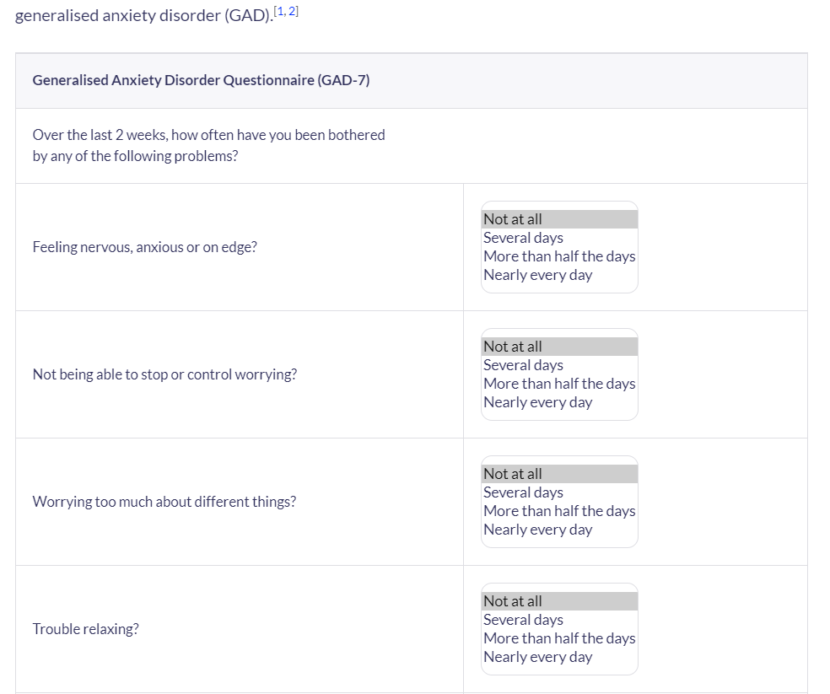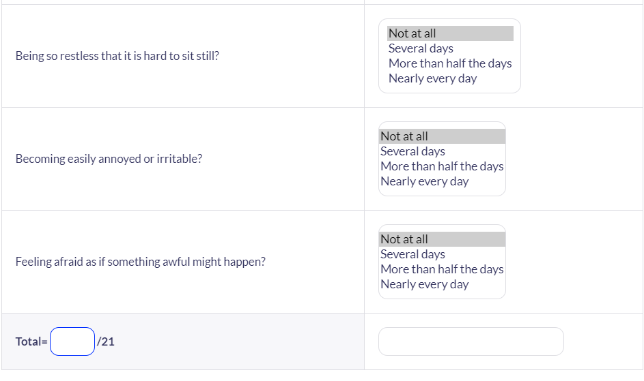

The GAD-7 score is calculated by assigning scores of 0, 1, 2, and 3, to the response categories of 'not at all', 'several days', 'more than half the days', and 'nearly every day', respectively, and adding together the scores for the seven questions.
Scores of 5, 10, and 15 are taken as the cut-off points for mild, moderate and severe anxiety, respectively. When used as a screening tool, further evaluation is recommended when the score is 10 or greater.
Using the threshold score of 10, the GAD-7 has a sensitivity of 89% and a specificity of 82% for GAD. It is moderately good at screening three other common anxiety disorders - panic disorder (sensitivity 74%, specificity 81%), social anxiety disorder (sensitivity 72%, specificity 80%) and post-traumatic stress disorder (sensitivity 66%, specificity 81%).
The result -Normal, Mild anxiety, Moderate anxiety, Severe anxiety.

Appendix b: Indicators for rehabilitative care:
‘Quality Indicator for Rehabilitative Care (QuIRC-SA)’
Quality Indicator for Rehabilitative Care, or QuIRC, is a tool that was at first established to evaluate the standard of care provided by inpatient and community-based mental health facilities for patients receiving treatment for prolonged periods of time. The QuIRC has strong psychometric properties; the service manager is the one who fills it out and gives scores on seven different aspects of care.
The indicators to be considered are the these:
Living Environment,
Therapeutic Environment,
Treatments and Interventions,
Self-Management and Autonomy,
Social Interface,
Human Rights,
Recovery Based Practice.

