Case study: The City Hotel
I acknowledge the use of Grammarly on 13/11/2024 to check my work for readability, grammar, and syntax.
I confirm that I have not presented any AI generated text as my own. I confirm I have copies of my drafts, notes, and other resources I used before, and after the use of AI tools which I may be asked to provide in evidence.
Module: Financial Management for the Hotel Industry
Module code: BMIH5007
Lecturer: Tristan Hawkins
Student: Eugen Gherasim (2242387)
Wordcount: 1859
Executive summary
The City Hotel, once a profitable and stable hospitality business, has encountered substantial financial setbacks attributed to external economic factors, rising operational costs, and industry-specific challenges. This report critically assesses the hotel’s financial position, revealing a severe decline in liquidity, solvency, and profitability over the past three years. The hotel’s revenue dropped sharply due to reduced customer demand, increased operational expenses, and workforce shortages, leaving it vulnerable in a highly competitive market.
Key financial metrics indicate that The City Hotel’s liquidity has weakened significantly, with its current ratio falling below 1.0 in 2023, limiting its ability to meet short-term obligations. Similarly, profitability metrics have deteriorated, showing a plunge in operating income due to elevated labour costs, supply chain disruptions, and geopolitical factors such as the Russia-Ukraine conflict. These conditions are compounded by climate-related factors, impacting travel patterns and increasing maintenance costs.
The report recommends a targeted turnaround strategy to address these pressing issues. Key initiatives include adopting a value-based pricing model tailored to fluctuating customer demand, enhancing employee retention to mitigate service disruptions, and leveraging digital marketing to strengthen brand visibility. Furthermore, embracing sustainability initiatives and proactive social media engagement are essential to restoring customer confidence and building competitive advantage. By implementing these strategies, The City Hotel aims to stabilise its operations, improve financial resilience, and position itself for long-term growth within the hospitality sector.

Table of Contents
Introduction 2
Discussions 3
1. Analysis of the current financial position of The City Hotel 3
Revenue 3
Expenses 4
Profitability 4
Liquidity 5
Solvency 6
2. Fundamental causes behind declined profit in The City Hotel 7
Geopolitics and world events 7
Global warming 8
Rising labour costs and hotel staff shortages 8
3. Application of turnaround strategies for business operations 9
Conclusion 10
References 11

Introduction
A more thorough grasp of a company’s success can be obtained by evaluating accounting roles inside firms by looking at both financial and non-financial criteria. Metrics such as customer satisfaction, internal processes, and innovation complement traditional financial indicators, fostering growth while maintaining stability. These non-financial metrics, particularly within corporate sustainability, are recognised as crucial components for comprehensive performance (Eccles, Ioannou, & Serafeim, 2014). In this report, the financial performance, including the applicability of some strategic initiatives over the business of The City Hotel, is mainly considered to provide a positive understanding, including the value processing approach on a developing basis.

Discussions

1. Analysis of the current financial position of The City Hotel
The recognition and evaluation processing of performance management for every business is relevant to identifying the primary area of growth, including operation compatibility, in a proper manner that mainly provides for general structural development and accountability initiatives. As per the essential identification, the formulations of ratio analyses are defined as one of the primary strategic tools for evaluating the financial structure or results of individual businesses more accurately, ultimately providing stability guidance for determining trending initiatives (Corporate Finance Institute, 2023a).
Several financial aspects related to this particular business have been provided in relation to the primary applications to identify the business's overall accountability growth position in terms of operational prospects.

Revenue
Revenue management is a strategic approach that leverages market segmentation and pricing analytics to maximise business income by aligning pricing with customer demand and market conditions (Bodea & Ferguson, 2014). The primary structure related to this particular business's present revenue initiative indicates a general growth initiative from the primary value of £5,248,290 in 2021 to £5,307,480 in 2022. In the current year, a significant decline of up to £2,325,440 has been noticed, representing a general uncertainty regarding the market initiative with the decreased position of marketing demand.

Expenses
The total main expenses have significantly decreased from 2021 to 2023. The total costs were approximately £4,584,120 in 2021, £4,632,750 in 2022, and £3,544,280 in 2023. This reduction indicates cost-cutting measures, which may reflect attempts to stabilise operations in response to declining revenue. Despite these cuts, the expenses in 2023 were not enough to maintain profitability, as the business reported an operating income loss of £1,218,850 in 2023. Employee costs are the largest expense category. These costs decreased from £1,724,760 in 2021 to £1,233,160 in 2023. This reduction could indicate staff layoffs, reduced wages, or operational adjustments due to declining occupancy rates. External expenses, another substantial cost, fell from £1,894,720 in 2021 to £1,071,030 in 2023. This may reflect reductions in outsourced services, supplier costs, or other third-party services. Depreciation and amortisation have increased significantly from £409,190 in 2021 to £661,590 in 2023, which might indicate recent investments in assets that are now depreciating, potentially contributing to cash flow challenges. Charges to Provisions have varied over the years, increasing to £55,550 in 2023 from £5,960 in 2021. This increase suggests a need to set aside funds for future expenses or anticipated liabilities, possibly due to higher risks in the current economic environment. The “Other operating income and expenses” line fluctuated, with a significant negative balance of £216,650 in 2023 compared to £34,780 positive in 2021. This shift could reflect unanticipated operational costs, restructuring costs, or extraordinary expenses impacting the hotel’s financial health.

Profitability
This particular analysis has been initiated to identify the overall accounting contemporary positioning growth in the form of earnings, which ultimately provides investors with a proper understanding of the business contemporary positioning growth initiative (Corporate Finance Institute, 2023b).
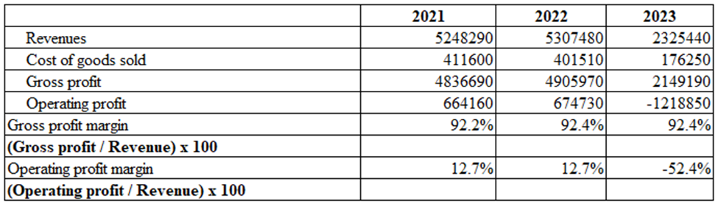
The gross profit margin remained stable over the three years, at approximately 92.2% in 2021, increasing slightly to 92.4% in 2022 and remaining at that level in 2023. This consistency indicates effective cost management concerning revenue, as the company was able to maintain its gross margin despite a substantial drop in revenue in 2023. However, the drop in gross profit from £4,905,970 in 2022 to £2,141,940 in 2023 reflects the impact of reduced sales volume, which may be attributed to external economic challenges or market conditions affecting demand. The operating profit margin was steady at 12.7% in both 2021 and 2022, suggesting stable operating efficiency during these years. In 2023, however, the operating profit margin plunged to -52.4% due to a substantial loss of £1,218,850. This decline signals significant financial strain, likely caused by high operating expenses relative to the reduced revenue. This may reflect challenges such as increased fixed costs, inefficiencies, or decreased demand impacting operational revenue.

Liquidity
Liquidity management is critical for ensuring businesses, particularly in the hospitality sector, can meet short-term obligations and maintain operational stability. Factors influencing hotel liquidity include cash flow management, working capital structure, and responsiveness to market fluctuations, which collectively contribute to a business's financial resilience (Gomes et al, 2021).
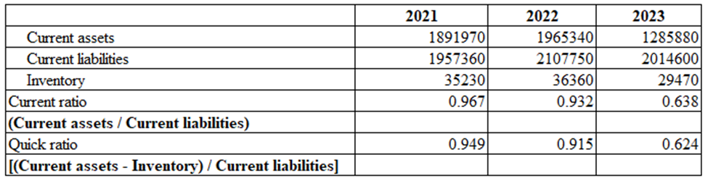
According to the liquidity analysis, the current ratio decreased from 0.967 in 2021 to 0.932 in 2022, suggesting a diminished capacity to fulfil short-term commitments. Additionally, operational challenges have resulted in a lower current ratio of 0.638, which signals limited capacity for supporting business growth. A downward trend is also seen in the quick ratio, which dropped from 0.915 in 2022 to 0.624 in 2023, driven primarily by increased current liabilities, adding uncertainty to the business's liquidity position.

Solvency
Solvency analysis in the tourism sector, as examined by Akbulaev, Guliyeva, and Aslanova (2020), can provide insight into leverage and financial distress risks, helping stakeholders evaluate the potential for bankruptcy within tourism enterprises. This engagement is used to assess the comprehensive value and stability of the business, providing an accurate basis for determining its value position. 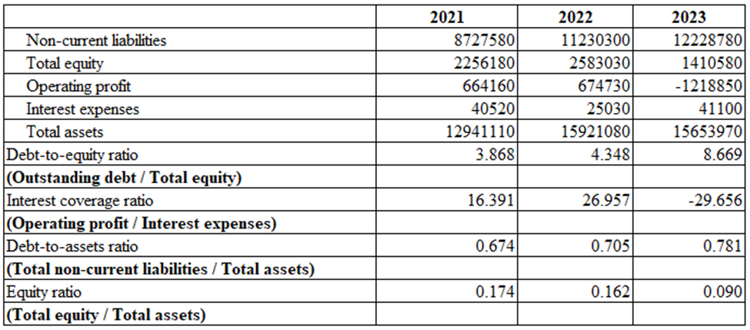
The current analysis indicates that the business's debt-to-equity ratio has risen from 4.348 in the previous year to 8.669 in 2023, reflecting a greater reliance on debt financing over equity. This trend suggests an expanded level of outsourced capital relative to equity. The interest coverage ratio has also declined, indicating reduced earnings available to cover borrowing costs, likely due to decreased profitability. Additionally, the equity ratio has dropped from a previous level of 0.162, signalling a declining proportion of equity within the business's capital structure.

2. Fundamental causes behind declined profit in The City Hotel
Macroeconomic and microeconomic factors significantly influence business operations and strategies, contributing to the growth and stability of business structures. In the UK hospitality sector, challenges such as market uncertainty have been identified, often leading to operational inefficiencies (House of Commons Library, 2021). The primary recognitions of some of those factors which also impose a negative impact on the declining profit of this city hotel include:
Geopolitics and world events
The applicability of geopolitical situation is relevant for every industry in the nation, and it ultimately provides stability in trade initiatives. In the present situation, the consequences of the Russia-Ukrainian war mainly negatively impact the supply chain engagement, which initiates a certain level of uncertainty in the hospitality business. Furthermore, the inflation rate in the United Kingdom has risen to 2.2%. Similarly, the interest rates have also grown to 5.25%, creating a degree of inadequacy concerning the trade initiative participation for individual hospitality enterprises in the UK (Rees and Anghel, 2024).
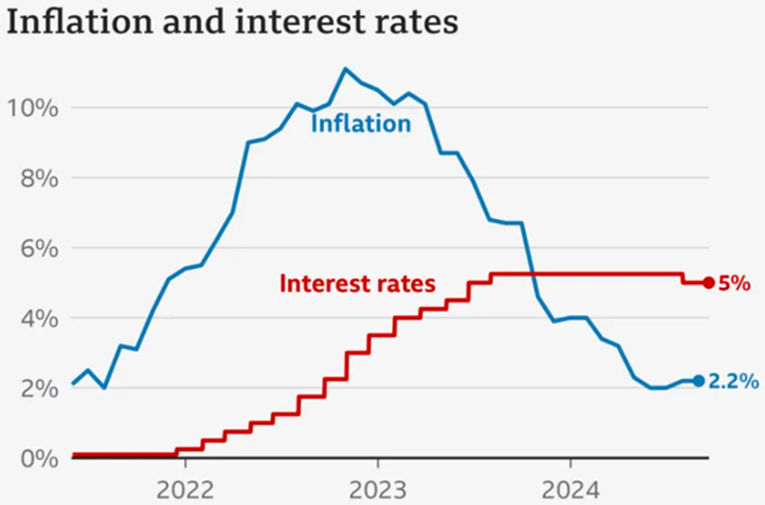
Figure 1. (BBC News, 2024)

Global warming
Global warming significantly influences tourism, as climate stability and favourable environmental conditions are essential for attracting visitors, which supports the hospitality sector. In the UK, data from the Met Office indicate an overall warming trend, with average annual temperatures increasing in line with global patterns since the pre-industrial period (Met Office, 2024). The provisional estimate of the UK's net greenhouse gas (GHG) emissions in 2023 was 384.2 million tonnes of carbon dioxide equivalent (MtCO₂e), which represents a 5.4% reduction compared to 2022 (Department for Energy Security and Net Zero, 2024). These environmental shifts will likely influence tourism trends, with potential implications for the UK hospitality industry. Although climate change is a significant factor, other variables, such as economic conditions, geopolitical issues, and public health concerns, also impact tourism patterns (Mota, Leite, & Ghasemi, 2024).
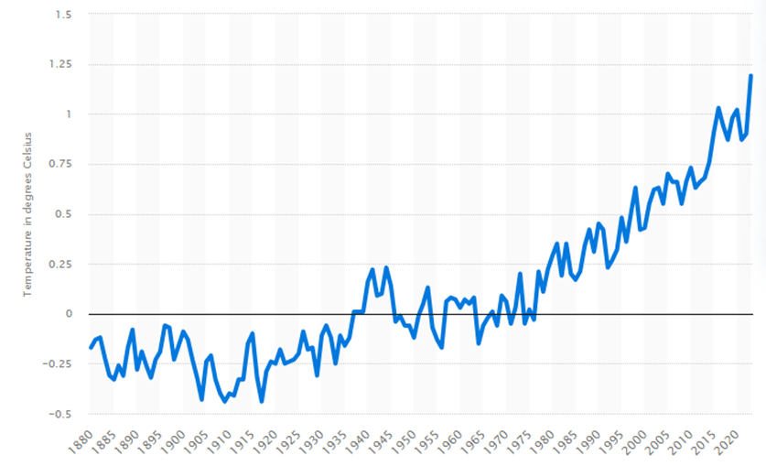
Figure 2. Annual land and water temperature anomalies (Statista, 2024).

Rising labour costs and hotel staff shortages
Rising labour costs and staff shortages might also impact The City Hotel’s profitability. Labour costs have increased, partly due to the UK’s minimum wage rise to £11 an hour as of 2024, directly affecting operational expenses (Office for National Statistics, 2024). Additionally, post-pandemic and Brexit-related workforce shortages in the hospitality sector have led to high vacancy rates, increased recruitment expenses, and, in some cases, reduced service quality and capacity. This staffing gap not only raises costs but also risks reducing customer satisfaction, further pressuring profits (UKHospitality, 2023).

3. Application of turnaround strategies for business operations
The primary initiative related to proper strategic formulations brings operating growth, including accountability support, and is also associated with business development. Concerning the present declining positions of profitability and revenue standard in The City Hotel, the applied initiative of focus on the value-based pricing strategy will be supportive and formulated for the business operation and engagement purpose, which will be able to provide a proper volume of stability through the discounting pricing position support (Lopez, 2020). Applying this type of engagement on a seasonal basis will provide appropriate customer retention support with Occupancy rate expansion.
Depending on the present market initiative, the primary importance of the engagement of employee retention structure, including skill enhancing support for the employees, will be sustainable for maintaining the service expansion benefits and internal operating stability attribute in the business more specific order (Michael and Fotiadis, 2022). The primary standard related to the applicability of cultural diversity engagement brings comprehensive guidance related to the benefits of employees' stability and accountability, which will be sustainable for business expansions in the future (Reidhead, 2020). The present standard is of primary importance to the online booking initiative, including AI engagement in relation to the operational engagement in this business, which will provide a proper volume of competitive advantage support for this company.
Embracing sustainability can boost a hotel's reputation, build market goodwill, and attract customers who prioritise environmentally friendly practices. As rising interest rates increase the cost of bank loans, relying on stable equity financing is a prudent choice for maintaining financial flexibility and supporting sustainable growth. Additionally, using social media for brand promotion enables hotels to reach a wider audience, attract more customers, and boost profitability by building stronger customer connections.

Conclusion
In conclusion, while The City Hotel has a strong foundation in terms of location and service offerings, recent market dynamics and operational challenges have compromised its financial health. The hotel’s decline in profitability and revenue, coupled with increasing costs, presents significant obstacles to achieving sustainable growth. However, by implementing strategic initiatives focused on pricing, employee retention, and brand engagement, The City Hotel has the potential to recover and strengthen its market position. The recommended turnaround strategy aims to stabilise operations, improve cash flow, and restore profitability. Prioritising sustainability and digital outreach will further enhance the hotel’s reputation and align it with the evolving preferences of modern consumers. With these focused efforts, The City Hotel can navigate current challenges and emerge as a more resilient and competitive entity in the hospitality industry.

References
Akbulaev, N., Guliyeva, N. and Aslanova, G. (2020). Economic analysis of tourism enterprise solvency and the possibility of bankruptcy: The case of the Thomas cook group. African Journal of Hospitality, Tourism and Leisure, 9(2), pp.1-12. Available at: https://www.ajhtl.com/uploads/7/1/6/3/7163688/article_26_vol_9_2__2020_azerbaijan.pdf (Accessed: 4 November 2024).
BBC News (2024). UK inflation falls for third consecutive month amid energy price drops. Available at: https://www.bbc.co.uk/news/business-12196322 (Accessed: 7 November 2024).
Bodea, T. and Ferguson, M. (2014). Segmentation, Revenue Management and Pricing Analytics. New York: Routledge. Available at: https://books.google.com/books/about/Segmentation_Revenue_Management_and_Pric.html?id=YvYjAwAAQBAJ (Accessed: 3 November 2024).
Corporate Finance Institute (2023a). Financial Ratios - Complete List and Guide to All Financial Ratios. Available at: https://corporatefinanceinstitute.com/resources/accounting/financial-ratios/ (Accessed: 29 October 2024).
Corporate Finance Institute (2023b). Analysis of Financial Statements. Available at: https://corporatefinanceinstitute.com/resources/accounting/analysis-of-financial-statements/ (Accessed: 3 November 2024).
Department for Energy Security and Net Zero (2024). UK Greenhouse Gas Emissions Provisional Figures 2023. Available at: https://assets.publishing.service.gov.uk/media/6604460f91a320001a82b0fd/uk-greenhouse-gas-emissions-provisional-figures-statistical-release-2023.pdf (Accessed: 11 November 2024).
Eccles, R.G., Ioannou, I. and Serafeim, G. (2014). ‘The Impact of Corporate Sustainability on Organizational Processes and Performance’, Management science, 60(11), pp. 2835–2857. Available at: https://doi.org/10.1287/mnsc.2014.1984. (Accessed: 29 October 2024).
Gomes, C., Malheiros, C., and Lucas, A. (2021). Impact Factors on Portuguese Hotels’ Liquidity. Journal of Risk and Financial Management, 14(4), p.144. Available at: https://doi.org/10.3390/jrfm14040144 (Accessed: 3 November 2024).
House of Commons Library. (2021). Hospitality industry and Covid-19. Available at: https://commonslibrary.parliament.uk/research-briefings/cbp-9111/ (Accessed: 10 November 2024).
Lopez, S. (2020). Value-based marketing strategy: pricing and costs for relationship marketing. Vernon Press. Available at: https://vernonpress.com/book/60 (Accessed: 11 November 2024).
Met Office. (2024). Temperature extremes and records most affected by UK’s changing climate. Available at: https://www.metoffice.gov.uk/about-us/news-and-media/media-centre/weather-and-climate-news/2024/temperature-extremes-and-records-most-affected-by-uks-changing-climate (Accessed: 11 November 2024).
Michael, N. and Fotiadis, A. (2022). Employee turnover: The hotel industry perspective. Journal of Tourism, Heritage & Services Marketing, 8(1), pp.38-47. Available at: https://papers.ssrn.com/sol3/papers.cfm?abstract_id=4121197 (Accessed: 12 November 2024).
Mota, L., Leite, E., & Ghasemi, V. (2024). Exploring the impact of climate change on lodging establishments: A systematic literature review. Quality & Quantity, pp. 1-26. Available at: https://link.springer.com/article/10.1007/s11135-024-01834-9 (Accessed: 11 November 2024).
Office for National Statistics (2024). Low and high pay in the UK: 2024. Available at: https://www.ons.gov.uk/employmentandlabourmarket/peopleinwork/earningsandworkinghours/bulletins/lowandhighpayuk/2024 (Accessed: 11 November 2024).
Rees, T. and Anghel, I. (2024). UK Inflation Steady at 2.2% Leaves Door Open for More Rate Cuts. Bloomberg.com. Available at: https://www.bloomberg.com/news/articles/2024-09-18/uk-inflation-steady-at-2-2-leaves-door-open-for-more-rate-cuts (Accessed: 7 November 2024).
Reidhead, C. (2020). Impact of organisational culture on employee satisfaction: A case of Hilton Hotel, United Kingdom. Journal of Economics and Business, 3(1). Available at: https://papers.ssrn.com/sol3/papers.cfm?abstract_id=3563546 (Accessed: 12 November 2024).
Statista (2024). Global land and ocean temperature anomalies from 1880 to 2023, based on temperature departure from the 20th century average. Available at: https://www.statista.com/statistics/224893/land-and-ocean-temperature-anomalies-based-on-temperature-departure/ (Accessed: 10 November 2024).
UKHospitality. (2023). Worker shortages. Available at: https://www.ukhospitality.org.uk/campaign/workforce/ (Accessed: 11 November 2024).

