Module: Ways of thinking
ADDA4022
Programme: BA Illustration
Lecturer: Chris Harrendence
Lilian Assa 2404675

This article examines the changes in art direction during the French Revolution. It analyzes the impact of new ideals on painting, from styles to the subject matter of artists' works. It discusses the evolution of art as a response to social and political changes.

"Art is the most glorious of all revolutions, and the French Revolution was its greatest expression."
— David d'Angers, French sculptor (1989)

During the French Revolution, artists were no longer confined to the traditional roles of simply depicting religious or aristocratic subjects. Instead, they embraced a newfound freedom to explore themes of liberty and equality. This shift in artistic focus was not only a means of expressing the revolutionary spirit of the times, but also a way to actively take part in the movement for social and political change, noted by Fiveable (2023).
One of the most notable ways in which art transformed during the French Revolution was through the creation of propaganda. Artists used their talents to create powerful images that reinforced revolutionary ideas and inspired the masses to act. From bold political cartoons to grandiose paintings depicting scenes of heroism and sacrifice, art became a vital tool for spreading revolutionary propaganda and galvanising support for the cause. My Modern Met, (2023).
Additionally, the French Revolution brought about a democratisation of art, as new forms of expression appeared that were accessible to a wider audience.Artspear (2023)discuss that the rise of public exhibitions and the proliferation of print media allowed for the dissemination of revolutionary art to a broader swath of society, challenging traditional notions of elitism in the art world.This democratisation of art not only empowered artists to reach a larger audience but also encouraged a more diverse range of voices and perspectives to be represented in artistic expression.

During the Old Regime in France, art was directly linked to the ruling monarchy and wealthy aristocracy. The Académie des Beaux-Arts played a significant role in shaping artistic standards, promoting classical and rococo styles that glorified luxurious lifestyles of courtly society. Artists such as François Boucher and Jean-Honoré Fragonard were renowned for their visually stunning works that depicted scenes of leisure and extravagance, providing an escape from the harsh realities of the time. (Boime ,1987, p.6)

Artistic expression took on a new meaning in the wake of the Revolution, it becomes a vehicle for ideological expression and societal transformation. Artists began to use their talents to challenge and question authority, and to provoke thought and action among the masses. Art became a means of resistance, a way to channel the frustrations and aspirations of the people into tangible, powerful statements that could not be ignored! (Vovelle, 1988, p.13)
This shift marked a rebirth of artistic creativity and innovation, as artists were inspired to explore new forms, styles, and mediums in order to better convey their messages. Art became more than just a pretty picture or a pleasing sculpture – it became a mirror reflecting the hopes.
One artist who embodied this shift towards a more serious and socially conscious approach to art was Jacques-Louis David. His neoclassical works, including the powerful painting "Death of Marat" heralded a new era in art that focused on themes of sacrifice, patriotism, and the greater good of the country. (Clark, 1992, p. 9)
Neoclassicism appeared as a revolutionary force in the art world, embodying a bold departure from traditional styles. With its emphasis on clean lines, structured compositions, and heroic themes, this movement harkened back to ancient ideals of order, liberty, and civic virtue. For Jacques-Louis David, the era of Revolution became a vast canvas on which to paint his vision (Crow, 1985, p. 3)
David's work became a weapon of revolutionary propaganda, immortalising the principles of freedom and equality in his art. Through his visionary creations, he showcased the power of visual media to ignite collective action and inspire change.

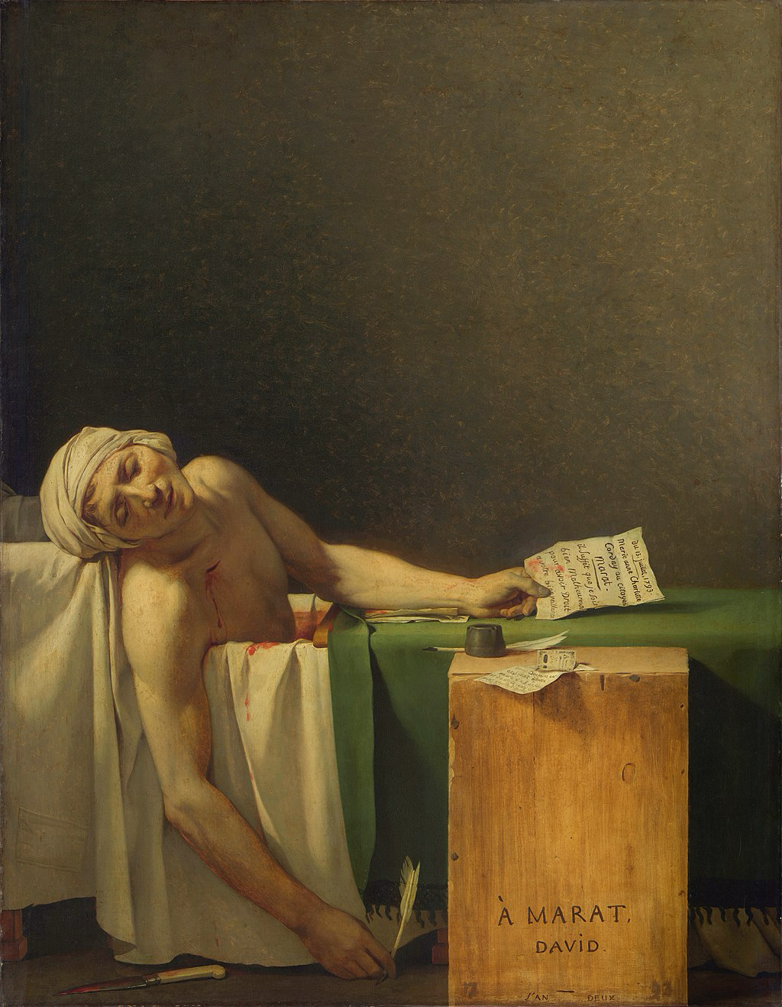
«The Death of Marat" Jacques-Louis David, 1793

David's painting depicts a young boy of thirteen who volunteered to join the army, a famous work by Jacques-Louis David showing the revolutionary Jean-Paul Marat in his bathtub after death. The painting portrays Marat as a martyr for freedom, embodying the revolutionary ideals and inspiring other artists to create works reflecting the events and spirit of the revolution. His masterpiece, transformed the fallen leader into a martyr, radiating an almost divine light of self-sacrifice for the greater good. Themes of heroism, death, political and social change, patriotism, and the emotions of the masses are prevalent in French art of this era. (Clark, 1992, p.21)

Propaganda and Symbolism in Revolutionary Art
During the French Revolution, art transformed into a powerful tool for mass communication. Various forms of visual art, including engravings, posters, and sculptures, were used to spread messages of liberty, equality, and fraternity to the wider public. A central symbol of this period was the allegorical figure of Liberty, often portrayed as a woman wearing a Phrygian cap and holding a revolutionary banner. This image not only became emblematic of the Revolution but also inspired later works, such as Eugène Delacroix’s Liberty Leading the People (1830).
Additionally, monuments, tombs, and bas-reliefs played a crucial role in reinforcing the revolutionary values, celebrating the heroes and remarkable events of the time for posterity. Sculpture became a medium for collective memory, intertwining art with the evolving narrative of a newly-formed France.

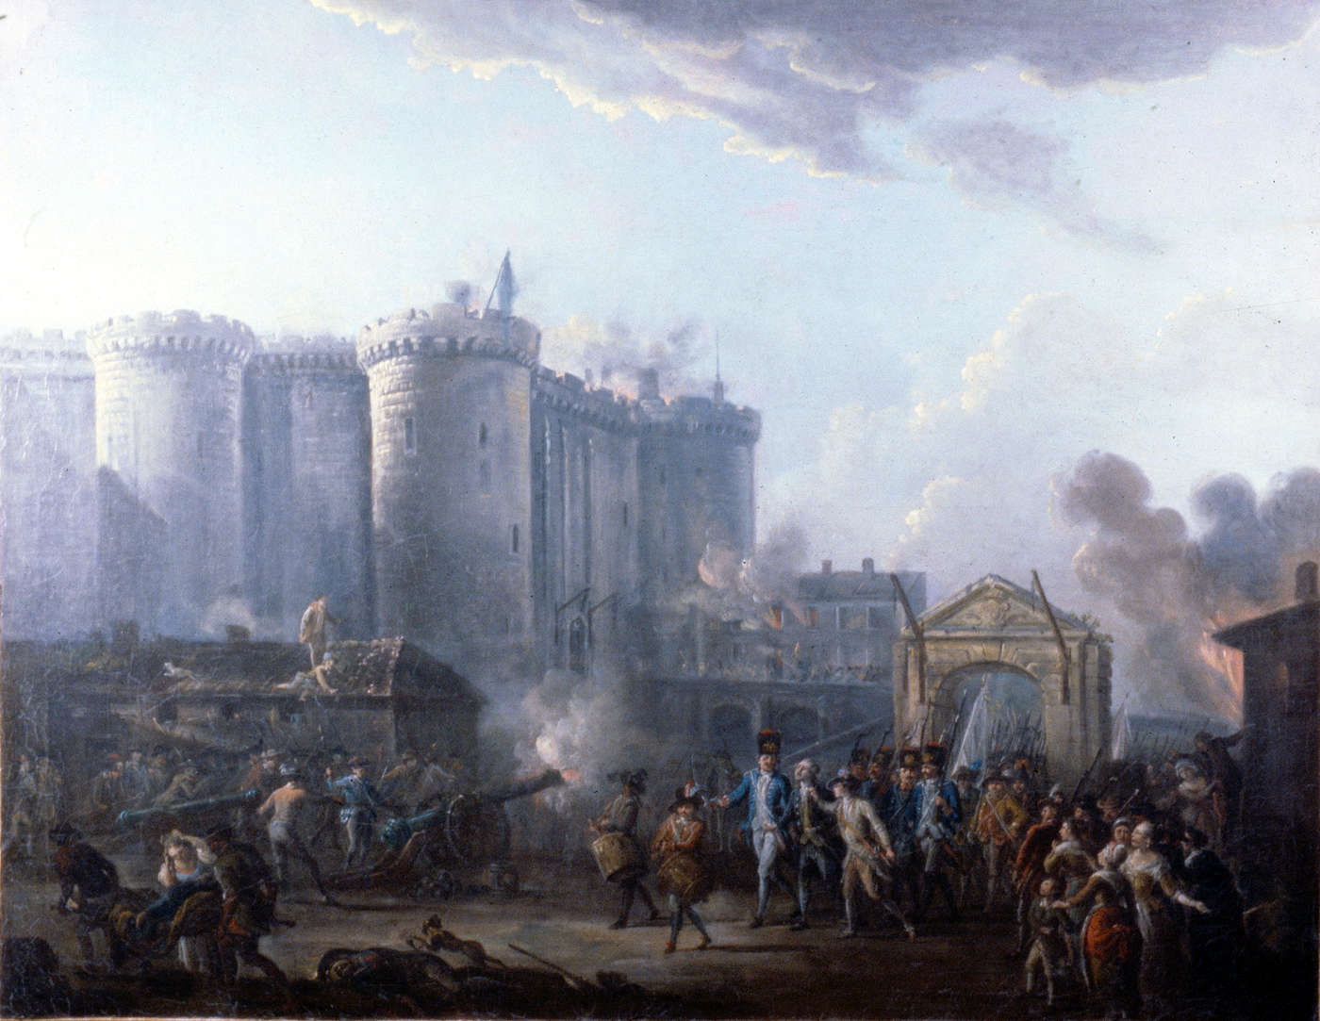
«The storming of the Bastille» July 14, 1789. Painting by Jean Pierre Houel. 1789

This painting depicts the storming of the Bastille, a symbol of the old order. This event is a turning point in the revolution and is celebrated as France's National Day.
During the French Revolution, art was strategically used as a means of mass communication, sending powerful messages of freedom, equality, and fraternity. Jean-Pierre Houelle’s «The Storm of the Bastille» (1789) is a good example of how such an event was presented to inspire revolutionary sentiment. The painting depicts a dramatic storming of the Bastille, which became a symbol of the tyranny of the monarchy and the people’s desire for freedom. In this work, the Bastille is not just a fortress, but a metaphor for the power of the old regime, and its destruction is seen as a triumph of the will of the people. This event, like other revolutionary artworks, reinforced the ideals of the revolution. Art became a tool for the collective memory through visual storytelling, ensuring that the symbols of the revolution remained in the public consciousness. The use of such powerful images reinforced the values ​​of the revolution and inspired future works of art, including metaphorical representations such as “liberty,” which became a symbol of the struggle for freedom. Sculpture, prints, and posters played a key role in spreading these ideals to the masses, further strengthening the connection between art and the revolution.

Echoes of Revolution in Modern Art , and how do we still see their impact in art today?

The artistic legacy of the French Revolution has endured. It profoundly shapes contemporary creative expression.
The echoes of the French Revolution are still felt in contemporary art. And its influence continues to shape the way artists express themselves today. Turbulent events and revolutionary changes left an indelible mark on the art world and still inspires artists to push boundaries and challenge conventions.
One of the most important legacies of the French Revolution in modern art is its emphasis on freedom and individual expression. The ideas of liberty, equality, and fraternity promoted during the Revolution encouraged artists to explore new forms of artistic expression and experiment with different media to express individual opinions and beliefs, that’s where artists look to break away from traditional norms and realise their unique visions.
Moreover, The French Revolution was a transformative period in art history, one that not only revolutionised artistic expression in France but also had a far-reaching impact on the global art world. The legacy of the French Revolution in art serves as a reminder of the enduring power of creativity to shape culture and society in times of upheaval and change.
In conclusion, the French Revolution was not only a political and social revolution, but also an artistic revolution that forever changed the course of art history. Its influence can be seen in the work of countless artists around the world, reminding us of the enduring power of art to inspire change, challenge norms, and shape the world around us.
French Revolution was a period of meaningful change in art history, influencing not only artistic expression in France but also the art world around the world.

Bibliography
- Chapon, J.-L., (1989). David d'Angers: Sculptor and Revolutionary. Yale University Press: New Haven.

- Fiveable 2023. Liberty Leading the People - Art Theory and Criticism. [online] Available at: https://library.fiveable.me/key-terms/art-theory-and-criticism/liberty-leading-the-people [Accessed 9 December 2024].

- My Modern Met, 2023. Liberty Leading the People, an Important French Revolution Painting. [online] Available at: https://mymodernmet.com/liberty-leading-the-people-eugene-delacroix/ [Accessed 1 December 2024].

- Artsper, 2023. Revolutionary Art and Public Impact. [online] Available at: https://blog.artsper.com [Accessed 2 December 2024].

- Boime, A., 1987. Art in the Age of the French Revolution. Chicago: University of Chicago Press.

- Vovelle, M. (ed.), 1988. Images of the French Revolution. Paris: Pergamon Press.

- Clark, T.J., 1992. The Death of Marat. New Haven: Yale University Press.

- Crow, T., 1985. Painters and Public Life in Eighteenth-Century Paris. New Haven: Yale University Press.

- Wikipedia, 2024. The Death of Marat. [online] Available at: https://en.wikipedia.org/wiki/The_Death_of_Marat[Accessed 6 December 2024].

- Clark, T.J., 1992. The Death of Marat. New Haven: Yale University Press.

- Delacroix, E., 1830. Liberty Leading the People. Available at: https://www.wikiart.org/en/eurgen-delacroix/liberty-leading-the-people-1830 [Accessed 8 December 2024].

- Houël, J.P. (1789) The Storming of the Bastille. Available at: https://useum.org/artwork/The-Storming-of-the-Bastille-Jean-Pierre-Houel-1789 [Accessed: 7 December]

Chapon, J.-L., (1989). David d'Angers: Sculptor and Revolutionary. Yale University Press: New Haven.
Fiveable 2023. Liberty Leading the People - Art Theory and Criticism. [online] Available at: https://library.fiveable.me/key-terms/art-theory-and-criticism/liberty-leading-the-people [Accessed 9 December 2024].
My Modern Met, 2023. Liberty Leading the People, an Important French Revolution Painting. [online] Available at: https://mymodernmet.com/liberty-leading-the-people-eugene-delacroix/ [Accessed 1 December 2024].
Artsper, 2023. Revolutionary Art and Public Impact. [online] Available at: https://blog.artsper.com [Accessed 2 December 2024].
Boime, A., 1987. Art in the Age of the French Revolution. Chicago: University of Chicago Press.
Vovelle, M. (ed.), 1988. Images of the French Revolution. Paris: Pergamon Press.
Clark, T.J., 1992. The Death of Marat. New Haven: Yale University Press.
Crow, T., 1985. Painters and Public Life in Eighteenth-Century Paris. New Haven: Yale University Press.
Wikipedia, 2024. The Death of Marat. [online] Available at: https://en.wikipedia.org/wiki/The_Death_of_Marat[Accessed 6 December 2024].
Clark, T.J., 1992. The Death of Marat. New Haven: Yale University Press.
Delacroix, E., 1830. Liberty Leading the People. Available at: https://www.wikiart.org/en/eurgen-delacroix/liberty-leading-the-people-1830 [Accessed 8 December 2024].
Houël, J.P. (1789) The Storming of the Bastille. Available at: https://useum.org/artwork/The-Storming-of-the-Bastille-Jean-Pierre-Houel-1789 [Accessed: 7 December]

