Exercises for Functions – 2

2. Calculate the area of the shaded part of the below.
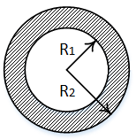
2a We have already written function calculatecircle() to help us to solve the area of the circle. Reuse this function in your new program (you can copy and paste it, or move it to its own file and use import if you like)

Sample output:

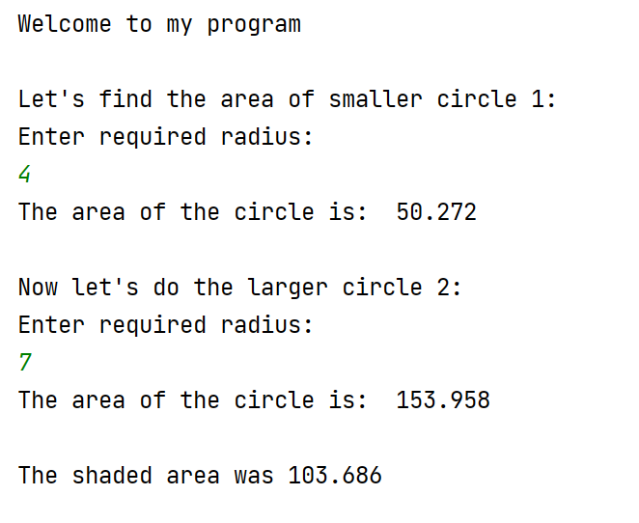

2b. If the outer radius is smaller than the inner radius, we'll end up with a negative area.

For example:

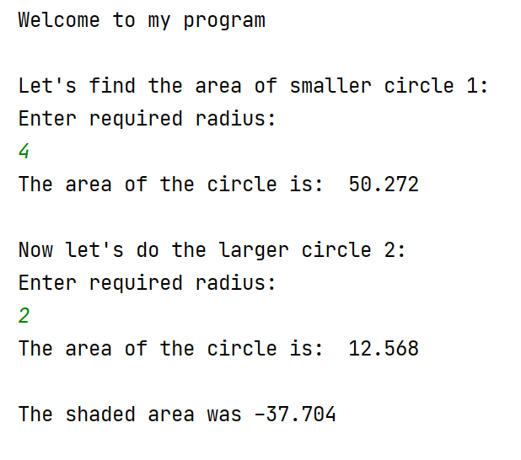

Warn the user about this if it occurs.

Sample output:



