
Student Name: | Debora Souza
Student Number: | 1706378
Module No: | BMSK5005
Module Title: | Professional Career Development
Submitted to:
Skills for the Workplace
Module Assignment Submission
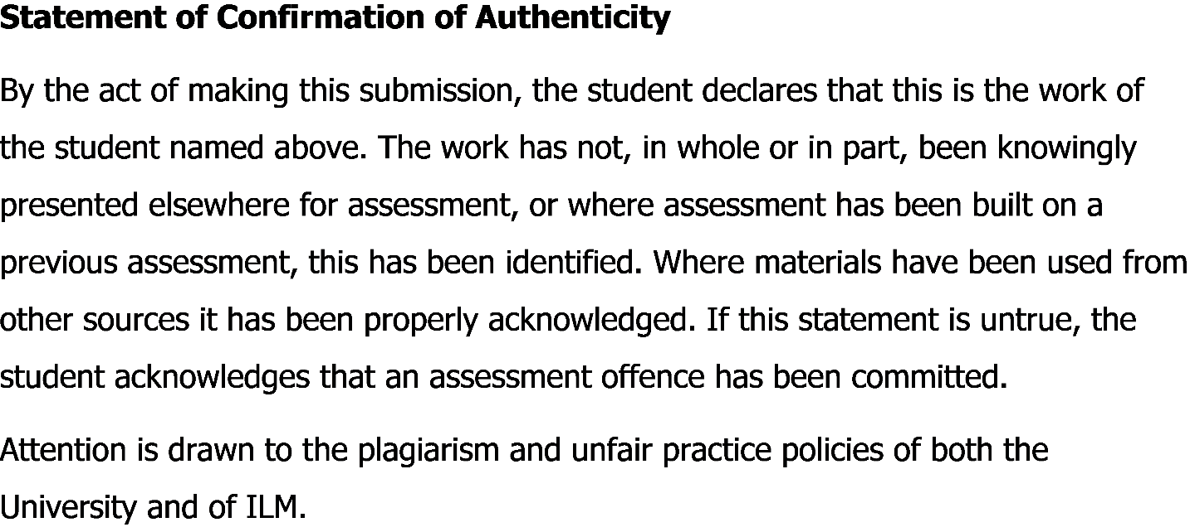

Table of Contents

Introduction 3
Lifeline Exercise 3
Self-Evaluation Review 5
Self-Motivation Quiz 6
Research and learning styles 8
SWOT Analysis of Myself 11
How I will improve my learning and my weaknesses using the opportunities available 13
Review of my understanding and expectations of the world of employment 14
A Review my own Potential in Suitable Job Roles 14
CV FOR SENIOR MANAGER 15
Evaluate the effectiveness of your personal contributions when working with others in your work place 17
Short term, medium term and long-term goals 18
Personal Development Plan (PDP) 18
Conclusion 20
References 21
Appendix 22

Introduction
Working effectively requires various skills and abilities that needs to be developed through personal life experience and practical experience of those skill in the workplace. This report will highlight the portfolio of evidence, which demonstrates an understanding of the skills, and knowledge, which contribute toward working effectively, their readiness for employment, an understanding of personal strengths and areas for further development, as well as establishing their employment goals and develop a personal action plan/development plan. Skills in workplace is essential to do well in the job and students who will be starting their first job needs to gain knowledge and skills before starting their first job. As a student it is possible to self-develop the skills and knowledge required to work effectively in the workplace. While working for an organization there will be further opportunity to implement those skills and learn new skills which will reduce all the skill gaps that are needed to perform effectively in workplace. This report will also showcase the personal strength and weakness of myself and a clear plan to develop those weaknesses and turn them into strengths to work effectively in workplace. Therefore, I will be developing an employment goal for myself and a personal action plan to achieve the goals and objectives that I intend to achieve.
Employment is a relationship between two parties, usually based on a contract where work is paid for, where one party, which may be a corporation, for profit, not-for-profit organization, co-operative or other entity is the employer and the other is the employee. In this professional world with competitive working environment, the employee needs to develop himself or herself based on the needs on the market. The employee needs to perform well and establish himself or herself, as a brand by promoting their abilities and skills with impressive performance in the workplace should acquire the skills and abilities that are highly demanded in the market.

Lifeline Exercise
A lifeline exercise is all about the experiences at different stages in life. It shows and helps to interpret the patters of the lifelong experience in different times. A lifeline exercise show up the highs and lows in your life, whether in the family, in education, in work or in some other activities.
According to my lifeline experiences, when I was around 16 years old then I have completed my higher secondary studies and that was the high time in my life. Then I left my higher secondary when I was 20 years old and that was a low time in my life. After that, I moved to UK and it was the best decision ever because its make me improve a lot in knowledge. I started my first job as hairdresser but later on I left the job as I was looking for a career change. I was without any job for a period of almost 2 years and that was a low time in my low. However, I started job as cleaning assistant in MCS cleaning company and this was a high time in my life and this job gave me some good experiences and I got promoted as the manager in the organization which was a great achievement. As time passed, I decided to start my higher education while still working as a manager. Now the future is unknown towards me and I will look for more opportunities to develop myself and grab any opportunities that will be better for my future.
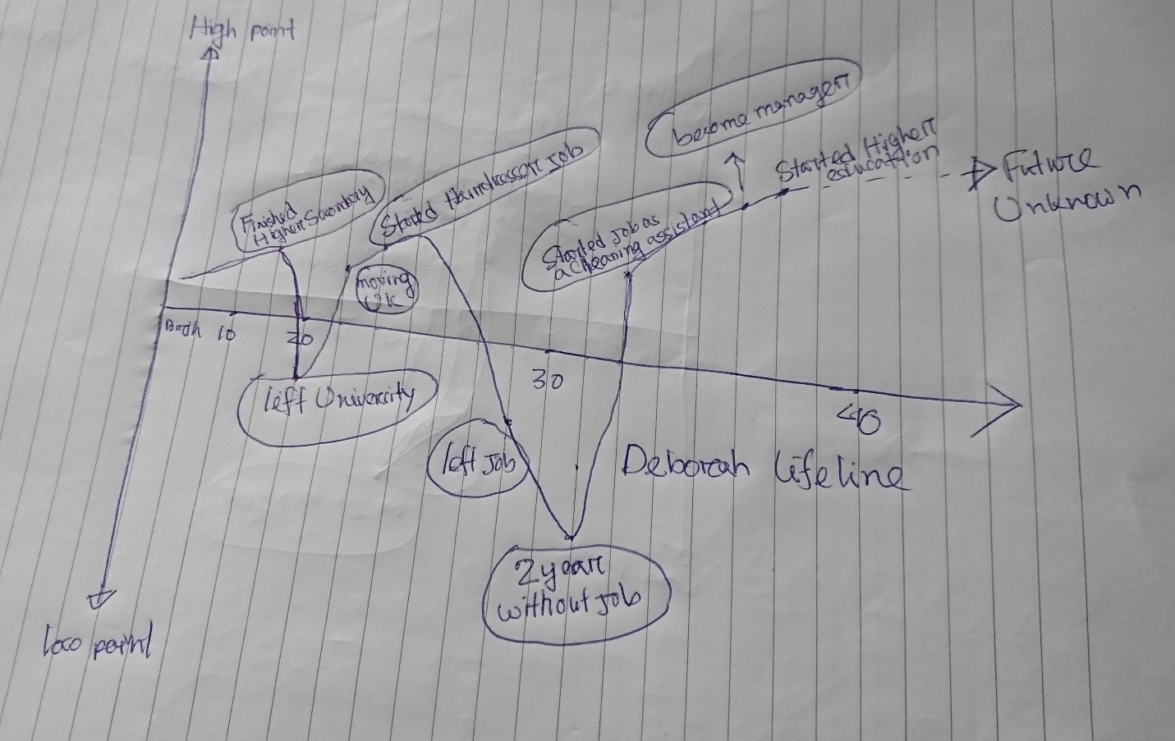
Lifeline Experience of Debora Souza

Self-Evaluation Review
Self-evaluation review is evaluating and understanding my aspirations; strengths; interests; drivers and other influences. It includes the personal values and principles that I aspire and follow in my daily life. Through this exercise, I will be better able to understand myself, which will guide me towards my next steps in life (Monsterca, 2018).
As human beings, we all have our own values, beliefs and attitudes that we have developed throughout the course of our lives. Our family, friends, community and the experiences we have had all contribute to our sense of who we are and how we view the world. Personal values are self-value that matter to an individual human being and it varies from person to person. For an individual personal value can be to lead a life with proper behavior and manner with others and for other individuals it can be leading a life with full of honesty and sincerity. For some people they might value to strong bonding among the family and for some people it can be the family’s ability to be honest and open with each other. Principles in life can be many and it also varies from person to person. Principles in life can be always doing something you love, focus on growth, think bigger than you are and using the power of your dreams etc.
For me personal values always matter and I follow them strongly. They are the guideline to my life and it makes me who I am today. Some of my core personal values are honesty, determination, loyalty, commitment and efficiency. These values are inspired from my friends and family members as they always taught me to become a person who is honest and loyal and always committed and perform at its best with superb efficiency. Therefore, I can say that my family and my surrounding friends are my inspiration that has slowly build up my core values. One rules that I always follow is that I respect others and expect others to respect me as well. This is one of the most important values that was influenced from my family and I learned from them that respect only comes from respecting others. My education institutions also played part to make me more consistent and efficient at any work I perform whether it is a group assignment or work related issues.

Self-Motivation Quiz
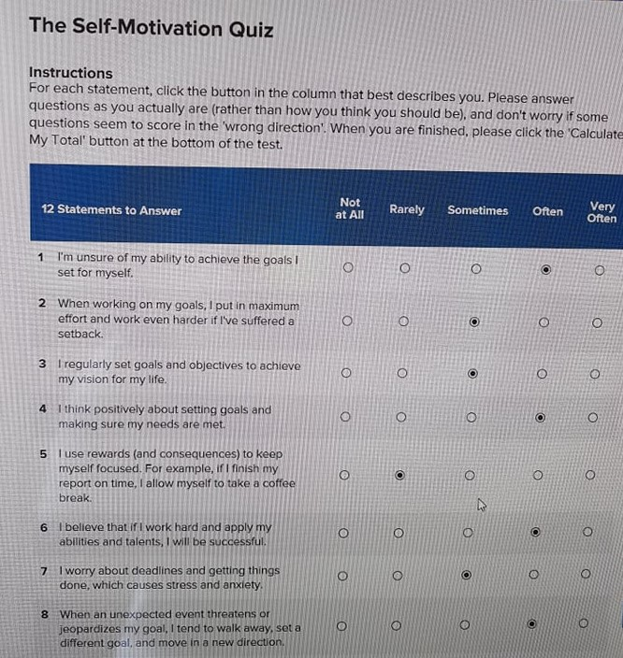
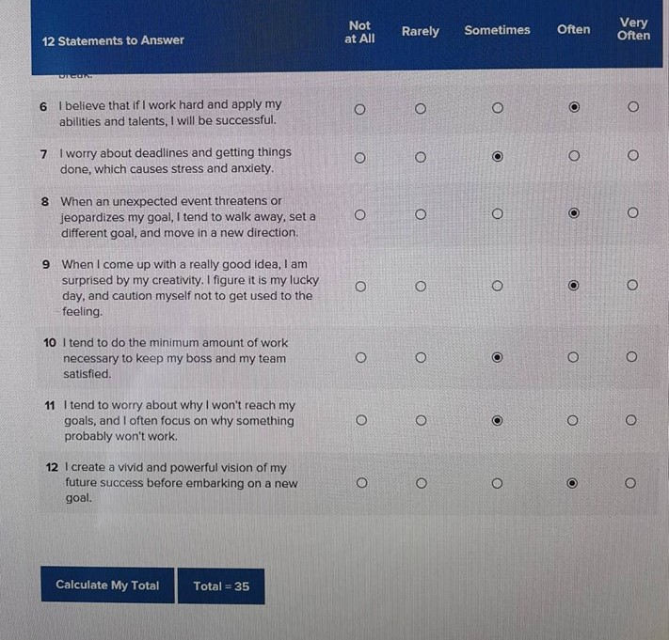

Research and learning styles
Learning has been defined by Cottrell (2015) as the acquisition of knowledge or skills through study, experience, or being taught.
According to Robert Gagne, learning is a change in human disposition or capability that persists over a period and is not simply ascribable to processes of growth.
The learning style will vary from one person to another and its is important to understand which method of learning works best for an individual. Many people learning from educational institution, many learns from friends and families and many will learn from real life experiences. Therefore, it is really important to understand our own learning styles and go according to a learning plan.
There are different types of learning styles invented by geniuses and these models will help to understand the best learning styles. Two important learning models are discussed below:
Honey and Mumford- This method of learning was invented by Peter Honey and Alan Mumford in 1986. Their work is inspired from and built upon Kolb’s learning styles model (Leaver, 2005). However, they produced their own Learning Styles Questionnaire (LSQ) because it was found that Kolb’s LSI had low validity with managers.
According to their learning style, they uses questionnaires that contains several questions instead of asking directly about the learning experience of an individual person. There are other models where asking questions directly had lower level of validity when questions were asked directly to the managers. Therefore, this model of learning is valid and effective as questionnaire are required to be filled by respondents as the questionnaires probes general behavioural tendencies.
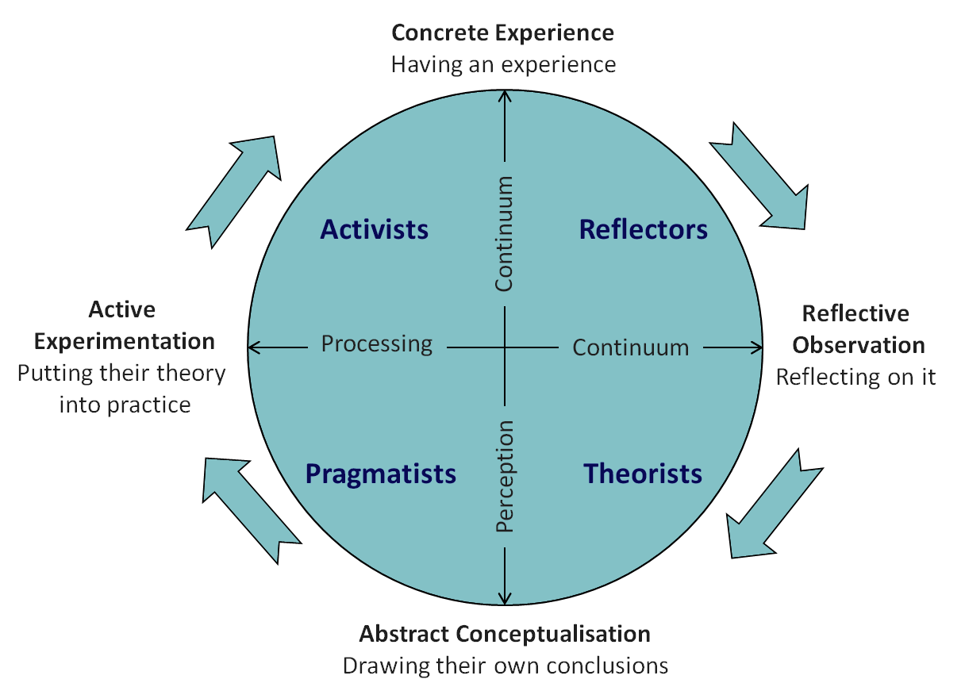

Fig: Honey and Mumford Learning Styles (Emtraineu, 2018)

The four learning styles are:
- Activists: They are the ones who learning by doing and they needs to get their hand filthy. The learning activities can be brainstorming, problem solving, group discussion, puzzles, competitions, role-play etc (Resourceselnio, 2017).
- Theorists: They require models, ideas and truths with a specific end goal to participate in the learning procedure. Their style of learning included models, statistics, stories, quotes, background information, applying concepts theoretically etc (Resourceselnio, 2017).
- Pragmatists: These people tries their best and needs to see how to put the learning into real life practices. They positively search out new ideas and take the first opportunity to experiment with applications (Resourceselnio, 2017).
- Reflectors: These individuals learn by watching and contemplating what happened. They does not involve themselves in any major act rather they learn by watching the encounters and experiences of others (Resourceselnio, 2017).
VARK Model- VARK is a questionnaire that helps your learning by suggesting the strategies you should be using. VARK has meaning of the individual words used such as visual, aural, read/write and kinaesthetic. The popularity of this concept grew dramatically during the 1970s and 1980s. VARK learning styles was also known as the Fleming model and now it is often referred to as VARK model (Verywellmindcom, 2018). Learners are identified by whether they have a preference for visual learning such as pictures, movies and diagrams, auditory learning such as music, discussion and lectures, reading and writing such as making lists, reading textbooks, taking notes or kinaesthetic learning such as movements, experiments and hands on activities.
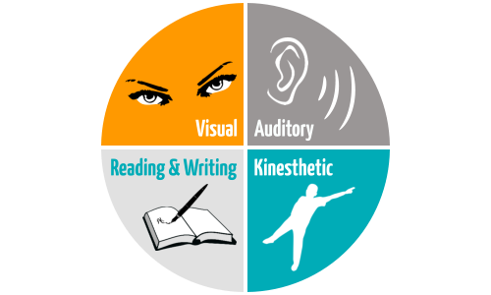
Fig: VARK model of learning (Mysimpleshowcom, 2016)

I am going to explain my learning style using the VARK model which was also known as the Fleming model. This model clearly helps me to represent the style of learning preferred by me. While filling out the VARK model questionnaire I found with the results that I am a kinaesthetic learner. The VARK model has four different learning styles and each learning style has some sort of impact in my life. I think visual and kinaesthetic learning style has more impact in my life. As a visual learner, I prefer to see and this helps me to remember well as I am better at observing everything around me. People who prefer this type of learning would rather see information presented in a visual rather than in written form (Mysimpleshowcom, 2016).
However, according to VARK questionnaire results I found out and believe that I am kinaesthetic learner as I usually prefer to learn by doing and experiencing. From my childhood to my professional life, I always learned better by getting myself involved in real life experiences. To learn something I make a plan for advance and I according to my plans and I cannot stay without doing anything for longer period as I am always eager to do something and learn from it at the same time. In my school days, I learned by doing my homework, assignments and role-plays and when I started my first job I learned to do better in that job role by gaining the practical experience of working for an organization. However, there are two more learning styles in the VARK model, which does not relate with me. The reading style of learning is something I do not prefer and the auditory learning is a best way of learning by hearing information and this learning is a good way to learn but I prefer on hands on experience so the kinaesthetic learning styles is what I prefer the most.

SWOT Analysis of Myself
Strength
- The main strength of myself is my ability of leadership. I gained this leadership ability by working in group during my school days and by working for an organization where I was a manager and lead a team of several employees. As a leader, I know how to motivate the employees and get the difficult work done by them within short amount of time.
- I am good at communicating with other. This skill is very important and works as my greatest strength as whenever I go and face new people, I am able to get along with them so easily by using proper communication skills. Learning this skill required me to meet new people and work with new people regularly during my job and hence I was able to develop my communication skills.
- I am energetic and efficient at my work, I do all the work with honesty, and integrity and these qualities are liked by everyone and acts as my greatest strength for my personal and professional life.
- Team work is another ability that I possess under myself and this skill is such as important skill, Without proper teamwork, achieving something great is often difficult and having this skill is one of my greatest strength, I was able to develop this skill by working in different groups during my school and university life.
Weakness
- The main weakness that I have inside me is the fear of unknown. I do not know what I am going to plan next in the upcoming years and I get immense fear thinking about the future so I keep on only focusing on current situation of my life. Therefore, not having proper plans for my future is a weakness for me.
- Although I have good communication skills and teamwork ability, but I have a bad habit of being short tempered. Therefore, when I feel angry with someone then I sometimes tend to lose control and say few unwanted words that can hurt the feelings of others and make things worse.
- I feel easily depressed and frustrated when things does not go according to plan. I spend so much time thinking about why then plan did not worked out and it takes a lot of time to forget and get back into normal life with new plans for the future. This is a great weakness for me as I should not waste so much time thinking about the negative things.
Opportunities
- One of the opportunity to me is that I am currently studying in my university and here I am able to learn new things and gather more theoretical knowledge that will develop my skills and abilities to perform well in my professional life.
- Another opportunity for me is to implement what I learn from the university into my professional life. As I am a student as well as a manager of MCS cleaning company, if I learning something new then I am able to try that out in the workplace and it can be new skills and management techniques which can make my job more easier and enjoyable.
Threats
- The real threat for me is managing both the student life as well as working life. Working both as full time student and manager in a cleaning company is a great pressure for me and can cause health issues for me due to extreme pressure of work and studies.
- The new students and potential skilled employees are threats for me as they might be a direct competitor for me. I might lose focus on improving my skills and abilities due to working and study pressure. However, my direct competitors might have better abilities and skills with good academic results and they might be a threat for me as they can easily replace me in the professional career life.

How I will improve my learning and my weaknesses using the opportunities available
To improve my learning I need to have a proper learning plan and I intend to learn from practical experiences of my life. As i am working as a manager of a cleaning company, I am regularly learning new things form my workplace by managing huge work and the staffs at the same time. I am learning a lot from my university as well and they are helping me to learn the theoretical aspects and skills required to do well in workplace. As I have working experience, I know which subject interests me and I am able to take courses that will help me with my life.
One of my weakness is the fear of unknown and not having a proper plan for my future. While studying in my university I learned that I should go with a plan and always follow that plan. Therefore, from now on I have a plan in me that I will keeping on working as manager and try my best to get promoted as a senior manager or join a new organization as senior manager as I have the experience inside my bag. The theoretical skills learned from the university can be easily implemented in my professional life and this is a great opportunity to learn new skills from one end and apply it on the other end to see the actual results in practical life. Finally, my weakness of being short tempered needs to be sorted out and this will take a lot of time and cannot change in one day. However, I have a long way to go in life and I will start to control myself from today and implement this in my workplace and also in my university classes. I may try to meet with people who had this issues of short tempered and now learned to control themselves and hence they will be able to help me out and teach me to control my temper during extreme work pressure and difficult situation.

Review of my understanding and expectations of the world of employment
In this world of employment, there is full of competition and employers are looking to recruit employees that are skilled and has good communication ability with others. The skills they look for are leadership skills, communication skills, time management skills, honesty and dedication and both soft skills and hard skills that are essential for a job role (Maund, Schriek & Tinkler, 2017). Sometimes the recruiter look for employees who has working experience in similar job role so that it will reduce their cost of training and orientation. Recruiters are setting up a job description, a personal specification and are depending on different selection methods to choose the best employees for the organization.
Job Description: The main purpose of a job description is to outline the main duties and responsibilities that are required in a particular job role. It also contains information about how the job is performed and the additional function requirements that given a clear idea to the employees who are looking for a job (Betterteamcom, 2018).
Personal Specification: The person specification is a description of the qualifications, skills, experience, knowledge and other attributes, which a candidate must possess to perform the job duties. A personal specification contains attainments, soft skills, job specific capabilities, personality traits and physical attributes (Betterteamcom, 2018).
Selection: The process of interviewing and evaluating candidates for a specific job and selecting an individual for employment based on certain criteria. The employers make selection based on different methods such as interviews, application forms and CV’s, online screen and shortlisting, ability and aptitude tests, presentations and group exercises (Businessjargonscom, 2016).

A Review my own Potential in Suitable Job Roles
Currently I am working as manager at MCS cleaning company where I manage the daily activities of the organization as well as the employees working for us. I have a future plan for an advancement in my career as I have gained a lot of experience in the field of working as a manager. According to my career plan I believe that I have three suitable job roles available for me such as Hotel manager, HR manager of a reputed business and General Shop manager. As I am currently working as manager at MSC cleaning company, my goal will be to join a new organization as the senior manager. The pre requirements of being the senior manager for me would be to work for MCS cleaning company as a manager for next couple of years and gain more working experience and learning new skills and knowledge from my university and apply them in practical life. As a result, I will be more cable of performing more effectively and efficiently as a role for the senior manager in a reputed organization.

CV FOR SENIOR MANAGER
Debora Souza
Address: London, UK
Mobile No : 010000000
e-mail : debora.souza@gmail.com

Career Summary:
Manager of MCS cleaning company and I am a manager of hotel and hostel.

Specialized in all housekeeper services and I am able to close the contract, prepare team and train the employees.

Employment History:
1. | Manager ( February 1, 2017 – Continuing)
MCS Cleaning Company
Duties/Responsibilities:
- Managing the employees
- Recruitment and Selection
- Close the contract and prepare them
- Taking training sessions of the employees
- Strategy implementation to increase the sales of the organization
2. | Hairdresser ( March 1, 2015 - October 31, 2016)
Style and Rock Hair Saloon
Duties/Responsibilities:
- Managing the clients
- Provide hairdressing services to clients
- Maintaining relation with clients
- Involve in new clients acquisition

Academic Qualification:
Exam Title | Concentration/Major | Institute | Result | Pas.Year | Duration
Bachelor of Business Administration (BBA) | Human Resource Management | University of Wales | CGPA:3.02 | In progress | 4
A Level | Business Studies | British Council | CGPA:2.6 | 2015 | 2
O Level | Economics | British Council | CGPA:3.6 | 2013 | 2

Language Proficiency:
Language | Reading | Writing | Speaking
English | High | High | High
French | High | High | High

Reference (s):
 |  | Reference: 01 | Reference: 02
Name | :
Organization | :
Designation | :
Address | :
Phone (Off.) | :

Evaluate the effectiveness of your personal contributions when working with others in your work place
Teamwork means working with a group of people to achieve a common goal or objective in a certain project, assignment, or complete a task in the most efficient and effective way (Cottrell, 2010).
While working at MCS cleaning company as a manager I have to use my skills, knowledge and communication skills to manage the daily activities of the organization. The skills and abilities that I mostly use are my management skills. I have to manage the employees and send them to serve the clients in the most efficient manner. I decide on which employees will be sent next for the cleaning order provided by the client based on their needs and wants. If I feel that an inexperienced worker who has joined recently is not suitable for a place then I send the experienced ones and this decision is taken by me based on the type of clients. Therefore, decision-making skills are important here and I have to make quick decision regarding any issues. I help my organization while recruitment and selection as well. I sometimes take part in the interview panel and choose employees based on the needs of the organization. Communication skill is very important part of my job description as I have to effectively communicate with my colleagues and other employees who work under me and motivate them to perform in an efficient way and this cannot be achieved without proper teamwork and leadership.
However, there are certain areas that needs to improve to become the senior manager and I believe that decision-making is one of them. As I am in charge of recruitment and selection and I also do the firing of the employees, I sometimes make poor decision due to work pressure and I sometimes had the habit of being short tempered which hampers the working environment and the daily activities of the organization.
Suitability
Ethical dilemmas are part of daily life and in the workplace in is very common. It is a decision-making problem between two possible moral imperatives, of which is neither unambiguously acceptable nor preferable (Cottrell, 2010). Recently I faced an ethical dilemma that kept me under pressure to come up with the right decision. Five of our junior employees were to be promote as senior employees and two of the most inefficient employees were needed to be fired from the organization. As it was a direct order from my boss so I had to come up with a decision. Although it was easy to decide, which five employees will be promoted based on their performances but firing two of them were the most difficult part as they had very good relation with me and they respected me a lot. They were not that inefficient either but the decision had to be made I had to finally fire them although I liked their work and respected them as well.
Many staff leave their job whenever they wish to and there are many reasons for that. One of them is when they have a bad boss and working under a bad boss means low work morale and motivation to do well. Another reason is lack of opportunity to get promoted and the salary factor plays a vital role for employees leaving the organization. In my organization, lack of opportunity to be promoted and have an increment in salary is the main reason for staffs to leave the job.

Short term, medium term and long-term goals
Goals can be short term, medium term and long term and every employee needs to have goals in their mind. My short-term goal is to improve my skills and knowledge regarding the management and the cleaning industry. My midterm goal is to join as the senior HR manager in a reputed organization as I am looking for a career progression after having working experience at MCS cleaning company. Finally, my long-term goal will always be to start my own business and start working as self-employed. As I know a lot about the cleaning company, I would like to start a cleaning company of my own in the future, if everything goes according to my plan. To achieve my goals in need my university degree and lots of experience of working as manager in different reputed organization, which will develop my inner skills and abilities.

Personal Development Plan (PDP)
Professional Career Development: It is developing an individual’s own skills and abilities based on the role to entirely understand the job role in hand and the way to improve in every way possible. It is the acquisition of skills and knowledge for career advancement, but it includes an element of personal development (Cottrell, 2010). There are many importance’s of professional career development as this will take an individual to progress from the current job to the new job role he or she desires. The professional development plan should be S.M.A.R.T (simple, measurable, achievable, realistic and timely).
Personal Development Plan: It is about establishing aims and objectives regarding what you want to achieve or where you want to go, in the short, medium or long-term in your career (Youtubecom, 2018). This plan includes the need for skills, knowledge and competence. According to my personal development plan, I have planned to improve my skills and knowledge regarding management and recruitment and selection of the employees. I will focus more on strategy making which will improve the sales of the organization and manage the organization more smoothly and efficiently. My plan includes doing courses in management and human resources in my university and applying them in real life scenarios. My plan will be to become competent enough to get a job as senior manager in a reputed organization.
Assessing the effectiveness of the PDP for your suitable roles
It is important to monitor the progress of personal and professional development. When you a have plan for your own development then it needs to be monitored routinely to understand how much you have progress and how much you are lacking behind. If the plan for progress is not effective enough then some alterations in the plan can be made with more effort for improvement.
Characteristics of an effective personal development plan includes (Cottrell, 2010).
- Gathering knowledge from a variety of source
- Reflecting on the gathered knowledge, self-learning, achievements.
- Make suitable personal development plans aimed at 360-degree development of self, career or education.
- Recording and analysing the achievements within the specified period.
My achievement through Personal Development Plan
Through my personal development plan. I am able to improve my skills regarding human resource management, recruitment and selection, time management, leadership, motivation and strategy building to increase sales. Although I have learned the theoretical parts from my university and undertaking different courses, I intend to implement in my workplace and see the results of my development so far.

Advantages of having Personal Development Plan
Having a development plan means I will provide me a clear idea about my strength and weakness and provide me an opportunity to improve my weakness and change myself. Having a plan means there will be a clear strategy and period to achieve the plan and reaching towards the success. It gives us self-awareness and a sense of direction to achieve all our goals and objectives (Youtubecom, 2018).
Disadvantages of not having Personal Development Plan
When there is not plan for personal and professional development then there will not be any sense of urgency and motivation to achieve something in the future. Without a plan, a person will not be able to understand how much he or she progressed to reach the goals and objectives required for success.
What I need to improve and what I will do differently in future when doing the plan
I think I need to focus more on improving my soft skills and hard skills which includes time management abilities, problem, solving abilities, quick decision making, ability to accept and learn from criticism. According to my plan I decided to wait for couple of years working for the same job then look for career progression. Now I feel like I should not wait that much as I have experience of working as a manager in my bucket and look for a position as senior manager in a reputed organization as soon as possible.

Conclusion
Professional career development is important for everyone and to achieve that, a proper planning is required to reach towards the success. There needs to be a plan for self-monitoring and evaluation of the progression of the plan and if the plan is not working as expected then changes should be made and more effort should be imposed for the success of the plan. We can take help from career specialists, teachers and mentors who will be able to guide us towards the right path for the career development.

References
- Betterteamcom. 2018. Betterteam. [Online]. [11 August 2018]. Available from: https://www.betterteam.com/job-descriptions
- Businessjargonscom. 2016. Business Jargons. [Online]. [11 August 2018]. Available from: https://businessjargons.com/selection.html
- Cottrell (2010). Skills for Success: The Personal Development Planning Handbook. : Palgrave MacMillan.
- Mind Tools Emtraineu. 2018. Emtraineu. [Online]. [11 August 2018]. Available from: http://www.emtrain.eu/learning-styles/
- Mysimpleshowcom. 2016. Mysimpleshow. [Online]. [11 August 2018]. Available from: https://www.mysimpleshow.com/learning-styles-the-vark-model/
- Maund, Schriek & Tinkler (2017). Certificate in Higher Education: Skills for the Workplace Student Yearbook. : Sage Publications.
- Monsterca. 2018. Monster Career Advice. [Online]. [11 August 2018]. Available from: https://www.monster.ca/career-advice/article/self-evaluation-during-performance-reviews
- Resourceselnio. 2017. ELN Resources. [Online]. [11 August 2018]. Available from: http://resources.eln.io/honey-and-mumford-learning-styles/
- Verywellmindcom. 2018. Verywell Mind. [Online]. [11 August 2018]. Available from: https://www.verywellmind.com/vark-learning-styles-2795156
- What is a Professional Development Plan ,Youtubecom. 2018. YouTube. [Online]. [11 August 2018]. Available from: https://www.youtube.com/watch?v=PRZcstlx6KQ

Appendix

Development plan

What do I want/need to learn? | What will I do to achieve this? | What resources or support will I need? | What will my success criteria be? | Target dates for review and completion
Management skills, Training and recruitment skills, critical decision making abilities | Take management courses in university, take help and consult with professionals, personal improvement through own research | My university, time and money for training and development courses | Success will be based on how I can implement them in my job as MCS cleaning company | Within next 6 months I will review and after 2 more months I am expecting for the completion

