

LEVEL 5

SEMESTER 1

MODULE CODE: SHSS5080
Desks to Dens
aSSESSMENT TYPE: Child observation
Assessment/Component: 2

COMPONENT WEIGHTING: 50%

WORD COUNT: 2500 WORDS

MODULE TUTOR: Heddwen Davies

Using your observations of children working outdoors in the Foundation Phase, carry out an in depth analysis of their interaction with the outdoor environment in their learning and play. Focus in particular on aspects of physical development and how their interaction with the environment contributes to the development of their physical literacy.

SUBMISSION DETAILS: January 17th, 2020.

Institute of Management and Health

School of Sport, Health & Outdoor Education

Assessment Feedback Sheet

Student No./Name: 1802463/ Mackenzie Davies
Module: Desks to dens
Module Code: SHSS5080

Personal Evaluation – to support your academic progress please complete the section below BEFORE submitting your work.
What do you consider to be the best aspects of this work? |  | I consider the layout and formatting to be the best aspects of my work.
Which aspects do you consider could have been improved in this piece of work? |  | The aspects of this work I could have improved on would have been my number of references.
What have you found most satisfying whilst undertaking this submission? |  | I have found the field work and visiting the schools the most satisfying whilst undertaking this assignment.
ASSESSMENT CRITERIA | Learning  Outcomes | GRADE
ASSESSMENT CRITERIA | Learning  Outcomes | Poor  < 20% | Weak  20-29% | Unsatisfactory  30-39% | Satisfactory  40 – 49% | Good  50 – 59% | Very Good  60 – 69% | Excellent  70 – 84% | Exceptional  85– 100% | %
Ability to observe and evaluate the role of the outdoors in children’s learning in Foundation Phase. | 2, 3 |  |  |  |  |  |  |  |  | 30%
Ability to reflect on the impact of movement and the environment on children’s learning | 3,4,5 |  |  |  |  |  |  |  |  | 30%
General plan and structure of answer |  |  |  |  |  |  |  |  |  | 20%
Range of sources of information. Referencing accuracy. |  |  |  |  |  |  |  |  |  | 20%
It is expected that students will present work that is proof read and follows the School Reference Guide and Assessment Checklist. Therefore a range of 0 – 10 marks will be deducted for non-completion of any of the points on the checklist below.

TUTOR COMMENTS:

Submission date: 17:01:’20  via Turnitin | Return date: 21:02:’20  (at least within 4 weeks) | Tutor: | Mark:

Assignment Checklist

- Please complete the Personal Evaluation section of the Assessment Feedback sheet, add your name and details, and paste the whole of this assignment document into the front of your assignment

- Submission is a single word file, clearly labelled with your name and module code
- Font style - Times New Roman, size -12 for text and 14 for headings
- Ink colour – black only
- Line spacing – 1.5 line spacing and 2cm- 2.5cm page margins
- Quotations more than three lines to be indented 1 line spacing
- One line space between paragraphs, paragraphs must be left aligned
- Pagination (your assignment should have page numbers)
- All tables and figures are internally referenced and have a title
- Word count checked and written at end of text (before references and any appendix)
- Assignment is within 10% of the word limit (excluding references and any appendices)
- All references in the text are included in the reference list
- Correct referencing following the Harvard style, as described in the Palgrave study skills book ‘Cite them Right’.
- Correct spelling using UK English
- Correct use of punctuation
- Grammar and syntax correct- double check anything that has a green line under it
- I have read my assignment out loud to myself and it makes sense and is easy to read
- Somebody else has read my work and it makes sense to him or her!
- I have checked and I have not plagiarised
Failure to follow these guidelines will cost you marks!
Observations of children working outdoors in the Foundation Phase

Introduction
Allowing children, the opportunity to free play with affordances from both indoor and outdoor environments creates a beneficial and lifelong impact towards their physical literacy journey. Physical literacy (PL) is the combination of locomotor, object control and balance skills. Margret Whitehead definition of Physical Literacy is “the motivation, confidence, physical competence, knowledge and understanding to value and take responsibility for engagement in physical activities for life.” (Physicalliteracy.cymru, 2020). Through the act of play children may not know that they are developing their PL skills as it’s an exciting activity to them. Many believe and understand play to be an act of enjoyment other than an act of importance. Theorists such as Lev Vygotsky have disagreed with this statement and argued that the importance of play is that it creates its own zone of proximal development (ZPD). ZPD is what Vygotsky believed to be the gap between what children can achieve unaided and what they can achieve with support and guidance. Affordances and the affordance theory were created by an American psychologist called James J. Gibson. He suggested that this term means what the environment can provide for the animal and what the animal can offer to the environment. Children need a variety of affordances from their early childhood, this is to ensure good motor development and PL skills. Some affordances you may find inside a classroom setting would be chairs, tables, paper, pens and books. For a child this might seem to limit their movements and use of space through constantly sitting, standing and other repetitive movements. The outdoors makes a unique contribution to physical literacy through naturally allowing more affordances for children to discover. The advantages of teaching children outdoors are endless, providing more space and natural objects there comes more opportunity for greater affordances, allowing the children to run, jump, jog, hop, and skip to mention a few movements through play, ZPD and adult led learning sessions. The outdoor areas surrounding these schools provides uneven terrain. This could be due to nature, trees, heeps of grass or man-made elements tarmark, pebble ground and so on. This is a positive affordance as it provides the children an opportunity to descover, learn and problem solve if they can not balance on uneven ground or by using other movement skills in the form of outdoor play. Natural objects can also slupply great benifits to children‘s physical development and imagiantaion. A child could see more than just a tree, they could invent a game, add a swing, play hide and seak, the possibilities are endless. This factor of endless possibilities of outdoor play and affordances is “enhancing childrens physical, social, emotional and conitive developement“ (Hart 1993). Some thoerists that support learning in an outdoor environment are Frederick Froebel and Margaret McMillan. Froebel emphasized learning through nature and believes in a holistic approach where there is a strong connection between man, nature and all things living. McMillan was also a supporter of Froebel’s theory, she believed that outdoor play would improve children’s health. Outdoor play supports all forms of fundamental motor skills by allowing children the use of mismatched objects to play with that wouldn’t necessarily be found inside a classroom. Letting young children to jump over, balance on, hide behind logs, collecting leaves, sticks and stones to make shapes in the ground or create and art sculpture outside are some of the possibility’s children could come up with. Fundamental motor skills (FMS) are beneficial to a child as it’s the infrastructure to their mountain of motor development allowing each child to travel up the mountain on their own path. FMS are the building blocks to more advanced movement skills following on to children playing sports and games, creating more motor competence. FMS gives children the abilities to gain better locomotor skills this meaning they will be moving their bodies from one point to another for example, running, hopping and skipping. FMS is also an opportunity to develop children’s object control and how they can throw, kick, catch, roll, bounce and strike, all key factors of team games and sports. Programs like Successful Kinesthetic Instruction for Pre-schoolers or SKIP suggests that these factors contribute to what standard of work the children provide as movements like object control impact a child’s fine motor skills level, how they perform their writing skills, how they sit-up during lessons in class and therefore their level of concentration in a classroom environment. Competency in FMS is necessary in order to be able to engage in sports. Through learning these key skills and braking through barriers at a young age it is likely that the children will then continue their physical literacy journey much further throughout their lives. Forest schools is a Scandinavian teaching method based by the ideas of Froebel where foundation phase children play with an underpinning of connecting with nature, time out in the fresh air and the environment. The benefits of children spending more time outdoors has a positive effect on their wellbeing. "Children think better on their feet than on their seat.” (Homan, 2018). Outdoor play could reduce stress and anxiety in children therefor a small section of the school day where they are free to play outdoors can improve self-esteem, mental health and wellbeing, improved concertation and a stronger ability to focus and learn when they come back into a classroom environment.

Methodology
As shown in appendix 1 my observational notes cover a wide range of information from both school A and B on their approaches to developing a more holistic form of teaching using both indoor and outdoor spaces provided. Both schools A and B understand the value of children experiencing adult led and child led learning activities in the foundation phase curriculum. The head of the foundation phase curriculum in school A had explained that her way of teaching stems from the Reggio Emilia theory. Reggio Emilia is a location in the north of Italy. This theory allows the children to contribute their ideas into the learning task, more possible outcomes from one learning topic and supplying learning tools available to children based on their ongoing interests. Ethnography is a type of reach method that I used during my visits to both school A and B in order to conduct filed notes, participant observations and analysing the children’s movements for a short amount of time in order to see what type of physical literacy children use while outdoors and how that compares to the physical literacy they use inside the classroom.

Main findings
The main findings I uncovered in school A was that the staff were all well researched on others learning theories and proud to be a part of a school that teaches children differently. As mentioned in appendix 1 the school has a unique layout of their classrooms. If the children were doing a child led activity, they could access the correct equipment they needed in a bucket close to that area and knew exactly what part of the class they needed to be at. The head of foundation phase explained that each class within the foundation phase has the same layout so children could recognise what activity they do where when they move year groups, so the transaction is less confusing for them as they are in familiar environment. The classrooms are also unique as the only colour inside the classrooms were very natural and the only art and other forms of decoration were what the children made themselves, this is based off the Reggio Emilia learning theory. This will give the children great confidence as they teachers want to display their art skills and hard work. During my visit to the school I observed an outdoor movement session where all the kids had to copy the teacher’s movements, imagining they are all fireworks. These movements included squatting, jumping, balancing, running and stretching. This was a great idea to help develop their fundamental motor skills and their physical literacy in general. Outdoor sessions such as these mentioned are beneficial for the developmental stages of the whole body, not only does it make the children use movements and body muscles they haven’t had to use before but it’s also good for their brain, core muscles, hand eye coordination, balance, mental health and aspects of social interaction with others in the class if it a team task in the outdoors. The teachers also used the space that the activity required effectively instead of doing it inside the classroom which they could have easily done they used an outdoor area allowing the children more space. At this school they have considered the children’s wellbeing though providing yoga sessions for all its pupils during school time just after the children have been outside to ease the change from a loud and chaotic environment to create a calmer learning environment inside the classroom. I visited this school a second time to coach as session of fundamental movement skills with objects like bats, balls, cones, pieces of material and the children had to move these objects form one area to another see appendix 1 for more details of that session. I felt that the children’s skills were advanced and had to make the little course I set out harder for them, I believe the session went well as all the children got involved and their feedback as all positive.

The main findings I uncovered in school B were that the outdoor area was very large and included a lot of equipment and storage useful for the children. They had bike and scooter stands encouraging the children to travel in more of an active way to and from school, see appendix 2. At this school the children are free to bring in any learning topic they are interested in and the teachers and staff will try and make a lesson on that topic for them. They used the outdoor areas for more than just physical play as I observed both science and mathematical lessons being taught outside, see appendix 1. At this location I also observed children playing in the wooded area of the school, they were climbing and jumping over pallets and wooded objects that had been put there purposely to be played with see appendix 2. Having such a creative outdoor area for the children to play in broadening their imagination and contributes to their physical literacy skills enhancing more than they would indoors due to the space, recourses and research the school have efficiently provided for the children. In comparison both schools contributed to adapting their lessons to the outdoors with the child interests at mind, through using different learning theory’s and allowing on broad different teaching ideas, more creative thinking and treating the children equally for them to also contribute their knowledge towards lessons. One theory I believe they have considered, would be the theory of multiple intelligences. This theory was developed by Howard Gardner who believed that there were only two intelligences, linguistic and logical mathematical that have been valued and tested for in modern secular schools and wanted to change the way educators thought about teaching to develop all round potential in students (Davis et al., 2011). There’s also Simon Nicholson’s theory of loose parts play. Loose parts theory is the thought of leaving random objects that you wouldn’t naturally give to a child to play with as a toy but inevitably they will play with them anyway. He proposed that this theory “empowered creativity” (Anon, n.d.) and that children should be given a variety of material in which they can achieve any form of play. For example, building things, stacking them, ability to move these objects, climb on them and so on. An ideal environment that offers this is the natural outdoors where you naturally move around, over and between trees, hills, stones, puddles but children will always pick up for example fallen leaves, small stones and jump in muddy puddles as they are naturally curious and creatively thinking about the outdoors. Although the outdoor areas were very different in size and layout in both schools, school B having a better outdoor area in my opinion, the two schools used their areas wisely ensuing children spend equal time inside and outside in order for the them to achieve better fundamental fine and gross motor skills and physical literacy skills.

Conclusion
In conclusion, the foundation phase curriculum is the positive turning point in our education system with a collective of seven areas of learning which are all interlinked with each other thought the school day. These areas of learning are a more holistic approach to teaching children with the underpins of the child’s wellbeing being the focus. Within these seven areas of learning teachers must also create the right balance as seen in appendix 3 of focused, enhanced and continues provision of the pupils to allow the teachers to activity witness what the child needs their support during what subject, in order to enhance their learning to the highest standards. The importance of play in terms of what it contributes to a child’s development is yet to be understood by many educators but with the heavy evidence of educational theorist this concept has been re-evaluated and teachers are valuing children’s free play time. The playful pedagogy allows young children to learn and develop both their fundamental moto skills and physical literacy through activities where their age and stages of learning are combined. Through children playing and using movements and problem-solving skills outdoors they are not only enhancing their physical development but also their cognitive development through being in a change of environments. Through moving differently, using more of your left arm than your right in a game or climbing wall outside for example will alert new cells in the brain, allowing more opportunity to learn. The evidence that I have witnessed through both literature and personal observations I believe there has been enough indication that a child benefits through both indoor and outdoor play during school. These environments contribute to the children’s physical literacy skills by allowing them the freedom through the holistic styled foundation phase curriculum to choose where they would like to learn an activity whether it be enhanced, focused or continues provision. By means of providing children two specific environments to learn within, the educators are allowing children to be more creative in the way they think, observe their surroundings and open to other forms of learning. Learning outdoors creates a platform for movement. What I mean by this is that it gives children the space they need to explore not only the areas and nature but what they can contribute to it, how they move, what they seek to find, how nature excites them personally and other affordances. Children’s physical literacy improves while they play outdoors by them needing to stretch that little further to get something, using smaller objects than they normally would in a classroom like pebbles or twigs. This in comparison to what the indoors may provide which would be objects within their reach, toys and utensils made for their age and abilities. I believe that an outdoor environment can provide that level of excitement where children have the motivation to try new learning activities where they can experiment with objects and ideas that nature provides, for example creating art out of fallen leaves when the seasons change, opening up about different learning topics like why do the seasons change.

Word count: 2,578 words

Reference list
Anon, (2020). [image] Available at: https://slideplayer.com/slide/6909778/ [Accessed 13 Jan. 2020].
Anon, (n.d.). Loose parts play. [online] Available at: https://www.pkc.gov.uk/media/37604/Let-the-Children-Play-Loose-Parts-Play/pdf/Let_the_Children_Play_-_Loose_Parts_Play.pdf?m=636113641055630000 [Accessed 14 Jan. 2020].
Davis, K., Christodoulou, J., Seider, S. and Gardner, H. (2011). The Theory of Multiple Intelligences. [online] Papers.ssrn.com. Available at: https://papers.ssrn.com/sol3/papers.cfm?abstract_id=2982593 [Accessed 14 Jan. 2020].
Homan, E. (2018). How Outdoor Play Improves Mental Health and Wellbeing. [online] Pentagon Play. Available at: https://www.pentagonplay.co.uk/news-and-info/outdoor-play-improves-mental-health [Accessed 7 Jan. 2020].
Physicalliteracy.cymru. (2020). What is Physical Literacy? – Wales Academy for Health and Physical Literacy. [online] Available at: https://physicalliteracy.cymru/what-is-physical-literacy/ [Accessed 5 Jan. 2020].

Appendices
Appendix 1: Observational notes
Ysgol Y Ddwylan, (SCHOOL A) 22/10/2019
- Yoga sessions just after the children have been outside to ease the change of location and create a calmer learning environment.
- Small group of children learning about different habitats in the sea by using a container outside filled with water and toy animals, the children would be asked by the teacher who they thought belonged in that environment and why they thought this.
- Outdoor aim game: Small group of children in a child led activity each time one of the children hit a target with a number on they would add or subtract it with the next number the next child hit creating a numeracy game.
- It was easy to see where the learning areas and child led areas of the classroom were as the layout was so clear.
- To help the development of the child’s motor skills they have plastic tweezers for the children to use to pick stuff up helping them use the same muscles in their hand as they would to write with.
- the only sense of decorations around the class were made by the children
- outdoor movement session
- Bug hotel, reading corner, art sessions outside.
Ysgol Ynestawe, (SCHOOL B) 26/11/2019
- Combined fine and gorse motor skills and numeracy through using rocks, leaves and sticks they had a sheet instructing how many items to get, what each item was worth and the children had to figure out how much the value of the objects to the nears 100, 1000 and 10000.
- While this activity was going on one of the pupils kept running off and running around playing with a small bouncy ball, he had brought into school he seemed more interested in playing than with the adult led activity.
- There was a science experiment outside to discover how to filter dirty water using different equipment.
- The children were imagining that the outdoor woods area was a restaurant/house in their free play time
- They had a forest school at the bottom of the yard, used logs and sticks to create a giant spider display area (see appendix 2)
- Outdoor fire pit in the forest school area
- There was an outside rock wall
- The school also had bike and scooter stands.
- Children get to choose the topic of the month.
- No homework
Ysgol Y Ddwylan (SCHOOL A) 10/12/2019
- Another university student and I led a session focusing on the children’s FMS where they had to move and object from one side of the room to the other, each time in a different way. For example, left to right: walking with the object balancing on a bat, right to left hopping on one foot, bouncing the object on the bat.
- After we delivered the session the children gave us positive feedback such as “I would do this activity again” and “ I liked the balls and bats that we used it was fun” they even realised what skills they were using during the activity “we balanced, jumped and moved a lot in this session”.
Appendix 2: Photos
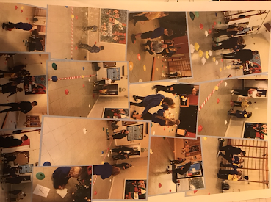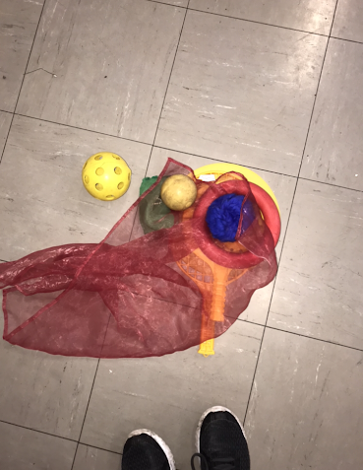
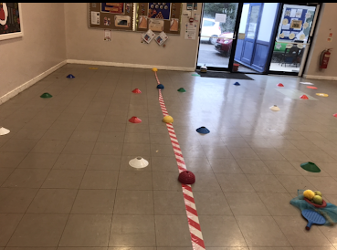

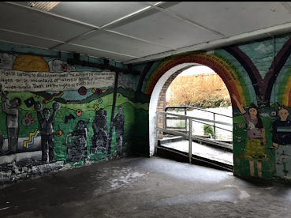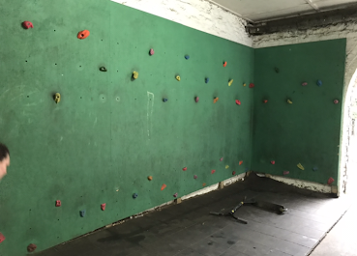
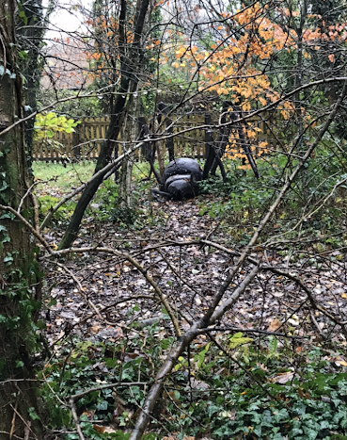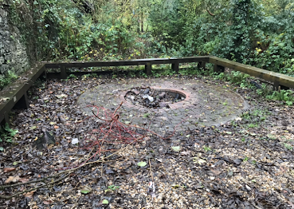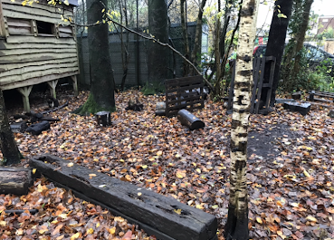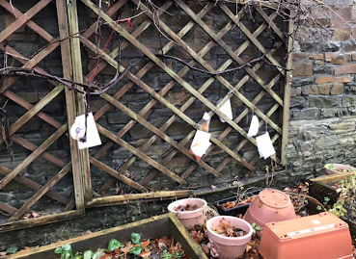
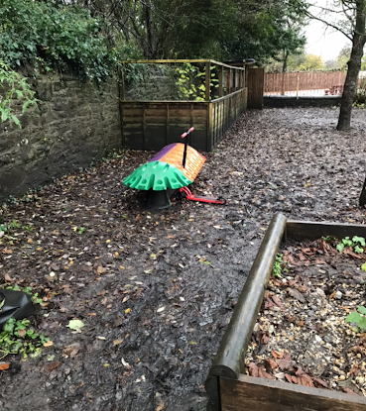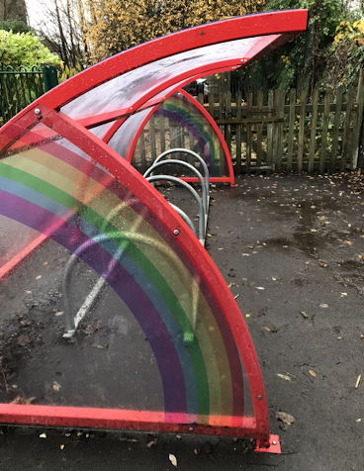
Appendix 3: Diagrams
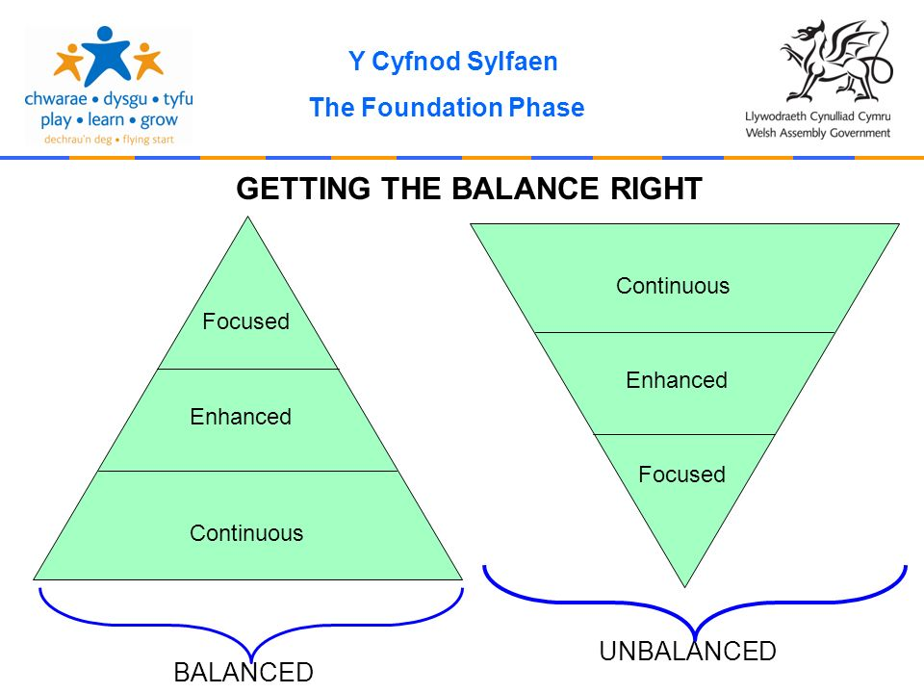
(Anon, 2020)

