

Module Code: LCHS7007
Module Name: Population Health and Digital Health Promotion
(Component 1)
Lecturer: Dr Ping Wu
Student Name: Rupna Begum
Student ID: 2329137

Table of Contents

Task-1: Blog 3
Blog 1: Technological Impact on Health Promotion Intervention 3
Public Health Problem & Its Concern: 3
Ways of Using Teletherapy in Health Promotion & Mental Health Problems: 4
Impact of the Tele-therapy in Health Promotion: 4
Adjustment of Tele-Therapy’s Shortfall: 4
References: 5
Blog 2: New Technology for Digital Health Promotion 6
Public Health Problem & its Concerns: 6
Newly Designed Tele-therapy app: 6
How “Mindwell” app used in Health Promotion: 7
Impact of “Mindwell” app in Health Promotion: 7
Adjusting the Shortfalls of “Mindwell” app: 7
References: 8
Task 2: Poster 9

Table of Figures:
Figure-1: Effect of mental problem 3
Figure-2: New Teletherapy app 6

Task-1: Blog

Blog 1: Technological Impact on Health Promotion Intervention

Public Health Problem & Its Concern:
Nowadays Mental Health Issues are one of the common public health problems. The majority of people are facing this problem and for this reason, they become frustrated and take suicidal attempts. There are various types of mental health issues, such as anxiety disorders, depression, bipolar disorder, post-traumatic stress disorder, schizophrenia, etc (McGorry et al.,2024).
Figure 1: Effect of Mental Problem
Source: Own.
Effect of Mental Health: According to Rosenstock, Numerous facets of a person's life might be significantly impacted by mental health issues. These consequences may affect relationships, employment, physical and mental health, and general quality of life (Rosenstock, 2017). In 2018, Cooper & Carver published a journal based on mental health problems. Where he pointed out that mental health problem creates depression and anxiety. It drives people to think about negative issues. It creates headaches, stomachaches, muscle tension, or fatigue. For this reason, the mental health problem is a crucial public health problem (Cooper & Carver, 2018). A research published in The Lancet Psychiatry (2024), about 54% of teletherapy users are young ages between 18-34 years (McGorry et al.,2024).

Ways of Using Teletherapy in Health Promotion & Mental Health Problems:
The chosen digital technologies are Teletherapy and Telehealth Platforms. These are two well-known digital technologies designed to treat mental health issues. Platforms for teletherapy give users quick access to self-help resources, educational resources, and mental health specialists. This makes mental health care more accessible, enabling people from different backgrounds to get treatment (Jing, 2016). This can inspire people to realize when they need support and lessen stigma. Other digital health services, such as wellness applications and health monitoring devices, can be combined with teletherapy. By removing geographic restrictions, teletherapy makes mental health care accessible to people living in remote or underdeveloped locations. Higher levels of engagement and treatment adherence may result from the flexibility to arrange sessions at convenient times (Cooper & Carver, 2018).

Impact of the Tele-therapy in Health Promotion:

Positive Effect of Tele-therapy:
- Tele-therapy increases the accessibility by reducing the geographical barriers. Anyone can get medical treatment online (Cooper & Carver, 2018).
- The patients can reach their doctor at any time. Besides, it is easier to make a treatment plan. People don't have to go to the doctor's chamber (Tabaei, 2022).
- A lot of people feel more at ease talking about delicate topics in their setting. Teletherapy's anonymity might lessen the stigma attached to getting mental health treatment.
- In 2018, Meta-Analysis published an article in Psychological Bulletin, which found that teletherapy is as effective as face-to-face treatment. The sample size of this study was 9000 respondents and about 93% of respondents strongly supported teletherapy (Proctor et al.,2018).

Negative Effect of Tele-therapy:
- Although not everyone has the necessary technology to receive teletherapy, they can make in-person visits to the doctor's chamber.
- The efficacy of treatment may be impacted if certain clients find it more difficult to build a therapeutic relationship with their therapist via a screen (Tabaei, 2022).

Adjustment of Tele-Therapy’s Shortfall:
There are some shortfalls of the tele-therapy technology and those need to be adjusted. To guarantee that people in underprivileged areas can use teletherapy services, create initiatives that subsidize internet prices or give them gadgets. Therapists should receive instruction on how to establish rapport in online environments (Tabaei, 2022). Before beginning video sessions, encourage therapists to make preliminary telephone calls. Comfort and trust may be established in this way.

References:
Cooper, C. and Carver, N. (2018). Problem-based learning in mental health nursing: The students' experience. International Journal of Mental Health Nursing, 21(2), pp.175–183. doi https://doi.org/10.1111/j.1447-0349.2011.00788.x.
Jing, B., Guangzhi, W., Cheng, O. and Hui, D., 2016, January. Tele-therapy system for cognitive disturbances. In 2005 IEEE Engineering in Medicine and Biology 27th Annual Conference (pp. 585-588). IEEE.
Kessler, R.C., Aguilar-Gaxiola, S., Alonso, J., Chatterji, S., Lee, S. and Üstün, T.B., 2022. The WHO World Mental Health (WMH) surveys. Die Psychiatrie, 6(01), pp.5-9.
McGorry, P.D., Mei, C., Dalal, N., Alvarez-Jimenez, M., Blakemore, S.J., Browne, V., Dooley, B., Hickie, I.B., Jones, P.B., McDaid, D. and Mihalopoulos, C., 2024. The Lancet Psychiatry Commission on Youth Mental Health. The Lancet Psychiatry, 11(9), pp.731-774.
Pierce, B.S., Perrin, P.B., Tyler, C.M., McKee, G.B. and Watson, J.D., 2021. The COVID-19 telepsychology revolution: A national study of pandemic-based changes in US mental health care delivery. American Psychologist, 76(1), p.14.
Proctor, B.J., Moghaddam, N., Vogt, W. and Das Nair, R., 2018. Telephone psychotherapy in multiple sclerosis: A systematic review and meta-analysis. Rehabilitation Psychology, 63(1), p.16.
Rosenstock, I.M. (2017). Why are People Conscious of Mental Health Services? Milbank Quarterly, [online] 83(4). doi https://doi.org/10.1111/j.1468-0009.2005.00425.x.
Tabaei, S., 2022. Challenges and benefits of tele-therapy and using digital world in art therapy practice: an integrative review. Com. press, 5(2), pp.60-73.

Blog 2: New Technology for Digital Health Promotion

Public Health Problem & its Concerns:
Mental Health Problem is a vital problem across the world. Many people are suffering from this problem. About 4% of people worldwide suffer from anxiety-related illnesses, and 5.0% suffer from depression (Cooper & Carver, 2018). According to the World Health Organization, the current suicide rate is very high. Every year more than 63,0000 people die from suicide (WHO, 2022). In 2000, a study was published based on mental health where it found that around 85% to 90% of suicidal cases occur because of mental illness (WHO, 2022). For this reason, this problem is becoming a great problem nowadays.
Mindwell App

Figure 2: New Teletherapy App
Source: Own.

Newly Designed Tele-therapy app:
To provide treatment for mental health problems, the newly designed tele-therapy app named-“Mindwell” can be used. In this app, the previous shortfalls of the existing apps have been removed so that it can provide better service to the users. The newly designed technology “Mindwell” is described below:
- User-Friendly Interface: It can create a platform that is easy to use and navigate so that customers of all ages and technological proficiency may utilize it with ease. Make sure the responsive platform works on a range of devices (Proctor et al., 2020).
- Increase Connectivity: It is necessary to work with neighborhood groups to offer high-speed internet and device access for free in underprivileged regions. This new app establishes mobile tele-therapy units that travel to local areas to provide tele-therapy services and in-person tech assistance (Aguilera, 2021).
- Robust Security Measures: In this app, HIPAA-compliant technology has been used which ensures encryption and security of the data. In this app, the clients can use blurred backgrounds to maintain their privacy during the session (Arean, 2022).

How “Mindwell” app used in Health Promotion:
In this newly designed teletherapy app “Mindwell”, a system has been implemented for the clients to provide feedback during the sessions. Based on the feedback, improvement will be done continuously. The clients can evaluate the therapist and it fosters accountability (Aguilera, 2021). The patients can get chat-based theory where they can feel secure. This app also facilitates group therapy sessions so that similar categories of patients can create bonding among them. The Mindwell app provides customized mental health plans to patients based on their initial assessment. Such type of customized facility optimizes the online theory service as well as improves emotional wellness (Nalongo Bina, 2021).
Impact of “Mindwell” app in Health Promotion:

Advantages of the Mindwell app: People feel shy to share their mental problems with others so by using tele-therapy they can easily share their problems and get treatment from home (Tabaei, 2022). In this newly modified app, the details of the doctor are provided so the patients can contact his/her preferred doctor. In the previous model this information was hidden (Jo et al., 2023). Besides, the patients can store their prescription in this app so they can use it for the next consultation.
Disadvantages of the Mindwell app: Many old people like to get face-to-face communication to get mental health treatment but in this app, it isn't possible (Proctor et al.,2018). Besides, the therapists who provide service in the tele-therapy app are not permanent so the patients don't get consistent service from them. They have to take treatment from different therapists which is not good for them. It is also difficult to get smooth access to the app because of internet issues (Arean, 2022).

Adjusting the Shortfalls of “Mindwell” app:
For older people, the Mindwell app company can offer Zoom meetings in exchange for a fee so that the patients can communicate with the doctor in person (Tabaei, 2022). The Mindwell app developer can make an agreement with the therapist for 3 years so that the patients can get consistent service.

References:
Aguilera, A., 2021. Digital technology and mental health interventions: Opportunities and challenges. Arbor, 191(771), p.a210.
Areán, P.A., Hoa Ly, K. and Andersson, G., 2022. Mobile technology for mental health assessment. Dialogues in clinical neuroscience, 18(2), pp.163-169.
Jo, E., Whitney-Jocelyn Kouaho, Schueller, S.M. and Epstein, D.A. (2023). Exploring User Perspectives and Ethical Experiences of Teletherapy Apps: A Qualitative Analysis of User Reviews (Preprint). JMIR mental health, 10(2), pp.e49684–e49684. doi:https://doi.org/10.2196/49684.
Nalongo Bina, K., 2021. The Impact and Future of Teletherapy in Mental Health Support.
Proctor, B.J., Moghaddam, N., Vogt, W. and Das Nair, R., 2020. Telephone psychotherapy in multiple sclerosis: A systematic review and meta-analysis. Rehabilitation Psychology, 63(1), p.16.
Tabaei, S., 2022. Challenges and benefits of tele-therapy and using digital world in art therapy practice: an integrative review. Com. press, 5(2), pp.60-73.
World Health Organization, 2022. The World Health Report 2001: Mental health: new understanding, new hope.

Task 2: Poster

The incorporation of digital technology interventions into healthcare has broad ramifications, influencing policies that support equity, improving both provider and patient education &stimulating research to enhance medical outcomes for a variety of communities
Given the size and complexity of the mental health issue, prompt and all-encompassing intervention techniques are required. To close treatment gaps, improve accessibility, lessen stigma, and offer individualized care, both digital and non-digital methods are essential. Public health systems may address mental health issues more successfully by combining various strategies, which will ultimately enhance the overall health of people. For Mindwell app, non-digital intervention is necessary because people are not that aware of the significance of using technology to get medical treatment.

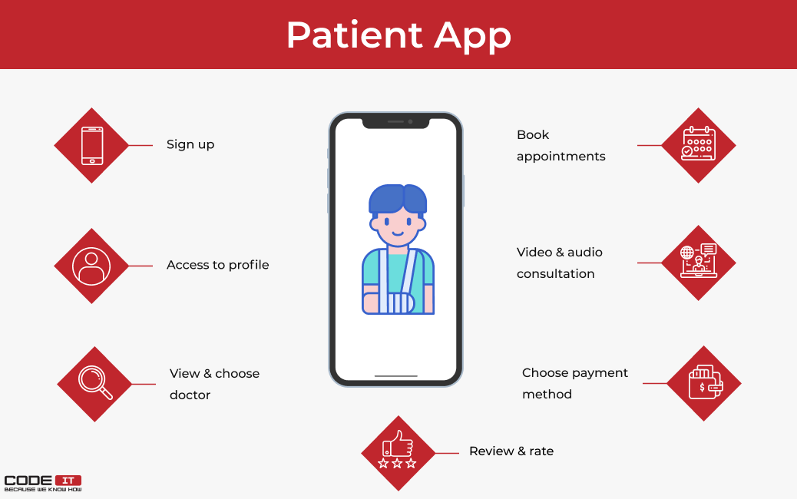
Expected Outcomes
Increase Awareness of Health Issues, Increased Engagement, Self-Management for Empowerment, Adoption of Healthier Practices.
Health promotion values and principles:
The Mindwell Tele-Therapy service can remove the geographical barrier and anyone can avail the service from anywhere at a reasonable cost.
The Interactive tools are used to encourage the people to engage actively.
To promote community engagement, this app can integrate local resources. There is a link between primary care providers and tele-therapy so that overall health treatment can be provided.
Advantages
By using tele-therapy people can easily share their problems and get treatment from home (Tabaei, 2022). In this newly modified app, the details of the doctor are provided so the patients can contact his/her preferred doctor (Jo et al., 2023). Besides, the patients can store their prescription in this app so they can use it for the next consultation.
Disadvantages
Face-to-face communication is absent
The therapists are not permanent
Difficult to get smooth access to the app because of internet issues (Arean, 2022).
Features of Mindwell
User-Friendly Interface, Increase Connectivity, Robust Security Measures,
Emergency Appointment request,
Real time audio communication

Application of Behavioral Change Theory:
One of the popular Behavioral change theories is the Health Belief Model which can be aligned with digital technology interventions.
Health Belief Model: By emphasizing personal beliefs and attitudes, the Health Belief Model is a psychological framework that explains and forecasts health behaviors.
Connecting with Digital Technology:
Perceived Susceptibility, Perceived Severity, Estimated Benefits, Considered Barriers, Alerts to activity
Mindwell
Mindwell

References:
Aboujaoude, E., Gega, L., Parish, M.B. and Hilty, D.M., 2020. Digital interventions in mental health: current status and future directions. Frontiers in psychiatry, 11, p.111.
Abraham, C. and Sheeran, P., 2019. The health belief model. Predicting health behavior, 2(1), pp.28-80.
Aguilera, A., 2021. Digital technology and mental health interventions: Opportunities and challenges. Arbor, 191(771), p.a210.
Borghouts, J., Eikey, E., Mark, G., De Leon, C., Schueller, S.M., Schneider, M., Stadnick, N., Zheng, K., Mukamel, D. and Sorkin, D.H., 2021. Barriers to and facilitators of user engagement with digital mental health interventions: systematic review. Journal of medical Internet research, 23(3), p.e24387.
Bucci, S., Lewis, S., Ainsworth, J., Haddock, G., Machin, M., Berry, K., Berry, N., Edge, D. and Emsley, R., 2018. Digital interventions in severe mental health problems: lessons from the Actissist development and trial. World Psychiatry, 17(2), p.230.
Fu, Z., Burger, H., Arjadi, R. and Bockting, C.L., 2020. Effectiveness of digital psychological interventions for mental health problems in low-income and middle-income countries: a systematic review and meta-analysis. The Lancet Psychiatry, 7(10), pp.851-864.
Grabowski, D., Aagaard-Hansen, J., Willing, I., and Jensen, B.B., 2017. Principled promotion of health: implementing five guiding health promotion principles for research-based prevention and management of diabetes. Societies, 7(2), p.10.
Gregg, J. and O'Hara, L., 2017. Values and principles are evident in current health promotion practices. Health Promotion Journal of Australia, 18(1), pp.7-11.
Hollis, C., Falconer, C.J., Martin, J.L., Whittington, C., Stockton, S., Glazebrook, C. and Davies, E.B., 2017. Annual Research Review: Digital health interventions for children and young people with mental health problems–a systematic and meta‐review. Journal of Child Psychology and Psychiatry, 58(4), pp.474-503.
Janz, N.K. and Becker, M.H., 2022. The health belief model: A decade later. Health Education Quarterly, 11(1), pp.1-47.
Lee, M.S., 2015. The principles and values of health promotion: building upon the Ottawa charter and related WHO documents. Korean Journal of Health Education and Promotion, 32(4), pp.1-11.
Lehtimaki, S., Martic, J., Wahl, B., Foster, K.T. and Schwalbe, N., 2021. Evidence on digital mental health interventions for adolescents and young people: a systematic overview. JMIR mental health, 8(4), p.e25847.
Rootman, I. ed., 2021. Evaluation in health promotion: principles and perspectives (No. 92). WHO Regional Office Europe.
Rosenstock, I.M., 2020. Health Belief Model.
Tabaei, S., 2022. Challenges and benefits of tele-therapy and using digital world in art therapy practice: an integrative review. Com. press, 5(2), pp.60-73.

