
APPENDIX GA36a

LEVEL 4 ASSESSMENT SPECIFICATION

Student name: | Dominic Sidoli | Student ID number: | 2413945
Programme: | BSc Supply Chain Management and Logistics
Module: | Lean Thinking
Module code: | ACMA 4019 | Contribution to Overall Module Assessment (%): | 100%
Lecturer: | Andrew Thorn | Internal Verifier: | Kelvin Lake
Assignment Title: | Applying Lean Principles | Word count (or equivalent): | 1,500 words
Submission deadline: | 19/03/2025 | Return date of provisional marks & written feedback: | 06/05/2025
Submission method: | All written assessments, where practical and possible, must be submitted via Turnitin unless otherwise instructed by the Lecturer. (Please DO NOT put this assessment specification into Turnitin or it will match many similarities with other students’ submissions.)  Alternative submission method (if applicable):  Late submission of the assessment will result in a late penalty mark:  Work which is submitted up to 1 week late will be capped at 40% for the first attempt and will be awarded a mark of 0% for re-assessment. Late submission penalties may be lifted only if there is an approved extenuating circumstances claim.  Work submitted more than 1 week late will be considered as a non-submission and will not be marked. The work may be considered as a submission for reassessment if offered by an Examining Board or if there is an approved extenuating circumstances claim.
Academic honesty / referencing: | Academic honesty is required. In the main body of your submission, you must give credit to authors on whose research and ideas your work is based. Append to your submission a reference list that indicates the books, articles, etc. that you have used, cited or quoted to complete this assessment.
Module Learning Outcomes
(from module syllabus)
Upon the successful completion of this module, the student should be able to:
- Identify, adapt and use a range of tools and techniques to investigate problems, assess risk, and analyse areas for improvement
- Evaluate the techniques and practices used in lean management to implement and maintain sustainable logistic operations.

TASK DESCRIPTION

RESEARCH | For this assessment, you can use Generative AI to support you in research, including searching for bibliography, using tools to summarise, compare and interrogate materials. | Yes ☒  No ☐
STRUCTURE | For this assessment, you can use Generative AI to support you in structuring your submission, including creating a draft argument structure, identifying parts and headings, etc. | Yes ☐  No ☒
PROOFREADING | For this assessment, you can use Generative AI to check your own text/creation for grammatical and syntactical mistakes, including rephrasing of your own work within specific standards. | Yes ☒  No ☐
WRITING | For this assessment, you can use Generative AI to create text for submission. | Yes ☐  No ☒
CREATIVE | For this assessment, you can use Generative AI to create creative materials, such as images. | Yes ☐  No ☒
PROGRAMING | For this assessment, you can use Generative AI to create and check code. | Yes ☐  No ☒
NONE | For this assessment, you are not allowed to use any type of Generative AI support. This includes research support, structure support, writing/proofreading support and creative support. | Yes ☐  No ☒

Introduction
Lean thinking is a strategic approach, with the aim of helping to eliminate waste and optimize efficiency within the everyday running of operations. For Safran seats GB supply chain operations, lean principles can drive significant improvements by reducing inefficiencies, streamlining certain processes, this can ultimately help enhance overall productivity.
This report will explore how lean thinking can be applied to Safran Seats GB supply chain to help minimize waste, enhance responsiveness and improve workflow. This can be done by helping to try and identify key inefficiencies, some of these affecting my company are excess/ not enough inventory, long lead times and transport delays. Once these issues are quantified their impact steps can be developed through data-driven solutions, helping enhance performance.
This report will propose actionable recommendations to help optimize supply chain operations. By hopefully implementing some of these changes, there may be a reduction in costs but also, importantly improve agility, ensuring Safran Seats remains competitive in the aerospace industry.
I will also look at the nine wastes, these include transportation, invent
.+tory, motion, waiting, overproduction, over processing, defects, skills (underutilized talent), and behavior waste, (Boyer, 2023) and how these can significantly impact productivity and operational costs.
Lean Thinking and the 9 Wastes:
Waste | Positives | Challenges of implementation
- Transportation – less movement of materials | - Lower risk of products getting lost/misplaced or damaged.  - Improves efficiency | - There may be a high initial investment  - Redesign of warehouse layouts
- Inventory | - Improves cash flow for business  - Reduction of excess stock | - Risk of running out of stock – maybe from an unexpected rise of demand
- Motion | - Improvement of productivity  - Reduction of fatigue | - The cost of initial training and maybe new equipment
- waiting | - Overall reduction in lead time  - Improvement of on time delivery – earning trust with customers | - May require significant technology investments and training.
- Overproduction | - Improvement of demand alignment  - Resource efficiency  - Waste reduction | - There is a risk of not keeping up with demand – if forecasting isn’t right
- Over processing | - Reduction in labor costs  - Improve brand reputation | - May be an initial resistance from long serving employees
- Defects | - Reduce the risk and cost of poor quality products  - Customers satisfaction increase | - Will require strong quality control measures
- Skills | - Increase in innovation – improving productivity  - Boost in employee engagement | - Needs an investment in employee training and development
- Environmental waste | - Lowers operational costs  - Improves sustainability – which is increasingly important | - An investment in eco-friendly products/equipment  - May require new suppliers
(@reagan, 2021) (Inachainge, 2023) (Timpson, 2021)
Wastes being investigated – The reduction of open inventory actions and improving solutions to minimise or eliminate production delays.
Goal statement –
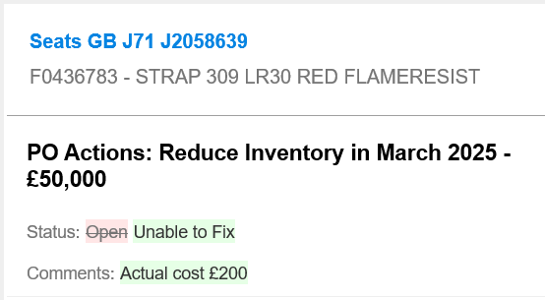
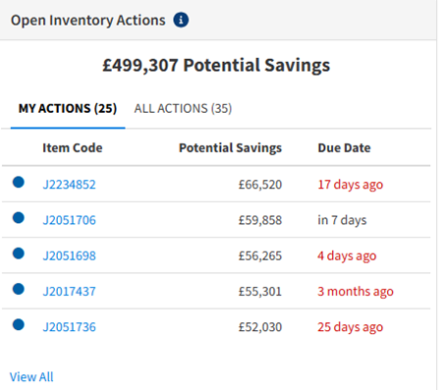
Reduce the number of open inventory actions allocated to an individual, which is causing delays to production. This has a potential saving of £499,307. This could also help reduce business waste making the purchasing department more efficient.

The use of Lean DNA’s functions will allow us help reduce inventory actions by utilizing a few reports -
Report #1 - Inventory Projection and Line of Balance
Report #2 - Optimize Inventory with Plan for Every Part (PFEP)
Report #3 - POs Where you Need to Take Action (Cancel, Split, Push Out)
Report #4 - Potential Inventory Projection Based on Reduction Opportunity (PFEP)
(LeanDNA, 2023)

Trying to tackle the problem of production delays is a bigger issue, firstly using root cause analysis (RCA) this helped to discover the root cause of the problem, helping to then identify appropriate solutions, this is a more effective way to systematically prevent and solve underlying issues. (Tableau, 2023).
From the RCA analysis there were a few main issues discovered. Firstly, it was the production delays. When inventory actions were being missed, like reordering or reallocating stock, components for shipsets were being missed, leading to manufacturing slowdowns, or in worst case situations “line stops”. Production delays can be costly and disruptive, so some of the solutions that could help, whilst looking at the nine wastes, firstly is to improve supply chain management. Using Real-time inventory tracking more, including FIFO, LIFO and JIT (Goramp.com, 2024). Another thing that could be implemented is to try and optimize workforce efficiency. This could be done cross train employees to allow cover of skill gaps, this could help stop so many actions being allocated to the wrong person, who won’t be able to solve the issue.
Another proposed improvement could be to enhance equipment and technology that is used. An investment in AI technology to help answer some of the regular inventory actions that occur regularly, this will also help efficiency. Also, an investment in IoT devices, these are devices that are nonstandard computing hardware -- such as sensors, actuators – they can connect wirelessly to a network and can transmit data, helping real time monitoring of stock. (Posey, 2023).
By streamlining production processes, this can also help in the improvement of production delays. By using lean manufacturing and six sigma to eliminate inefficiencies. Lean manufacturing is a production process based on maximsing productivity, well also trying to reduce waste at the same time, the lean principles identify wastes, as anything that doesn’t add value a customer is willing to pay for. (TWI, 2022). The benefits of implementing lean manufacturing can help reduce lead time, which is something that Safran is currently struggling with. But can also help reduce operating costs and improved product quality for our customers. Safran Seats GB could also look at implementing just in time production, which also help reduce waste, including time and materials. (University of Cambridge, 2016)
Another solution to help minimise production delays and reduced open inventory actions, could be find ways to improve communication and coordination. This could be done implementing a few different solutions. Some of the simpler ones could be implemented quicker than others. For example holding regular production meetings and shortage reports, this would mean there could be real time problem solving. Although QRQC meetings are held in individual departments, may be beneficial for some of these to be combined inter departmentally, allowing great understanding of issues other areas are facing within the business. QRQC meetings are well suited for the production in fast-paced manufacturing, which Safran Seats is. It allows for immediate detection and immediate resolutions which are essential to maintain production continuity and efficiency. (blog.proactioninternational.com, n.d.). The use of project management software could also be introduced, this allows progress to be tracked easier but is a more costly and harder to introduce.
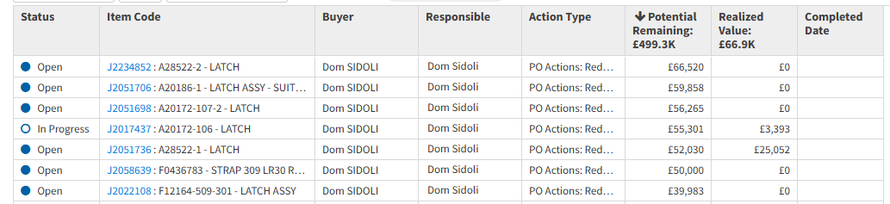

One more thing that could be done to reduce production delays and improve efficiency is to plan for contingencies, for example emergency staffing or alternative suppliers, This is one of the major issues facing Safran, is the issues with suppliers since the covid 19 pandemic and Russia’s invasion of Ukraine, so being able to develop backup plans for key risks could be a major positive for Safran. Could also use scenario planning, these could help anticipate potential distributions. Fathom states, creating a range of scenarios, you can identify potential risks, make informed decisions in your strategic planning, and stay agile in a changing environment. (www.fathomhq.com, n.d.).
Conclusion –
The reduction of open inventory actions is causing operational challenges for Safran Seats GB, affecting numerous parts of the business, including production delays, stockouts and shortages, inefficiencies in the supply chain and increased lead times. This will ultimately put our customer satisfaction at high risk. We have seen this recently with losing a big airline customer order for supplying business and first-class seats for their new airplane order.
Safran Seats’ commitment to reducing open inventory actions and enhancing solutions to minimize or ultimately eliminate production delays is crucial for helping the business to strive and help optimize efficiency, helping meet our customers high expectations and delivery targets. By implementing inventory management, innovative solutions and improving supply chain solutions Safran can reduce waste, streamline the overall production process thus, helping overall operational performance. These efforts although will take time to introduce and implement it will help improve on-time deliveries but will also strengthen our relationships with customers, help us gain new customers and reinforce our position as a leader in the aerospace seating industry.

References –
@reagan (2021). What is Lean Management in Supply Chain? | Leanscape Insights. [online] Available at: https://leanscape.io/lean-management-in-supply-chain/.
blog.proactioninternational.com. (n.d.). 10 Effective Problem-Solving Methods for Manufacturers. [online] Available at: https://blog.proactioninternational.com/en/problem-solving-methods-for-manufacturers.
Boyer, A.L. (2023). 9 Wastes of Lean Manufacturing. [online] Tulip. Available at: https://tulip.co/blog/9-wastes-of-lean-manufacturing/.
Goramp.com. (2024). What is Real-time Inventory Tracking? [online] Available at: https://www.goramp.com/glossary/real-time-inventory-tracking.
Inachainge (2023). How does lean apply throughout the supply chain? [online] Inchainge. Available at: https://inchainge.com/knowledge/supply-chain/larg-sc/.
LeanDNA. (2023). Critical supply chain reports for manufacturing excellence. [online] Available at: https://www.leandna.com/resources/a-critical-materials-report-guide-to-help-you-optimize-inventory/ [Accessed 19 Mar. 2025].
Posey, B. (2023). What are IoT Devices? - Definition from TechTarget.com. [online] IoT Agenda. Available at: https://www.techtarget.com/iotagenda/definition/IoT-device.
Tableau (2023). Root Cause Analysis Explained with Examples and Methods. [online] Tableau. Available at: https://www.tableau.com/en-gb/learn/articles/root-cause-analysis.
Timpson, J. (2021). There are 9 Wastes in the Lean Waste Wheel - Kaufman Global. [online] Kaufman Global. Available at: https://www.kaufmanglobal.com/lean-wastes-in-lean-operations/.
TWI (2022). What is Lean Manufacturing and the 5 Principles Used? [online] www.twi-global.com. Available at: https://www.twi-global.com/technical-knowledge/faqs/faq-what-is-lean-manufacturin
University of Cambridge (2016). JIT Just-in-Time manufacturing. [online] Cam.ac.uk. Available at: https://www.ifm.eng.cam.ac.uk/research/dstools/jit-just-in-time-manufacturing/.
www.fathomhq.com. (n.d.). How Scenario Planning Can Help Businesses Stay Ahead. [online] Available at: https://www.fathomhq.com/blog/how-scenario-planning-can-help-businesses-stay-ahead.

