KNOWLEDGE AND INFORMATION MANAGEMENT OF AMAZON.COM
Executive summary
This report covers the introduction of the organization along with the knowledge management theories which includes three theories which are Organizational KM theory, Techno-centric theory and Modern Management theory. The importance of Gathering, storing, sharing, and application and integrating knowledge in developing knowledge management practices is also reflected in this report. The report has also highlighted the potential challenges faced by “Amazon.com” while improving the KM practices within the organization. The study underpins the feasible solutions in order to mitigate the challenges in an appropriate manner.

Table of Contents
1. Introduction to report 4
2. Introduction of the organization Amazon.com 4
3. Explanation about the key knowledge management theories supporting in this report 5
3.1 Shedding light on organizational KM theory 5
3.2 Techno-centric theory 6
3.3 Modern Management theory 7
4. Critical demonstration of the significance of effective creation, storing, sharing, application and integration of information in terms of developing KM practises 8
4.1 Providing demonstration about the importance of the effective creation for good knowledge management development practices 8
4.2 Illustration of importance of storing information as a prerequisite for good knowledge management development practices 9
4.3 Elucidation of importance of sharing for developing good knowledge management practices 9
4.4 Evaluation of importance of application as well as integration of knowledge for ensuring good knowledge management development practices 10
5. Shedding light on the identified scenario of Amazon and illustration of academic theories for measuring effectiveness and information management Culture in Amazon 10
5.1 Describing the identified scenario of the organisation 10
5.2 Critical discussion of relevant alternative academic theories for explaining knowledge culture within the organisation for creating knowledge assets and maintaining effective customer relationships 11
6. Illustration of Amazon’s knowledge management challenges and providing suitable recommendation strengthening KM practises 13
Illustration of Amazon’s knowledge management challenges 13
Suitable recommendation strengthening KM practises 14
7. Conclusion 14
Task 2: Individual poster 14
1. Poster presentation title 15
2. Introduction 15
3. Purpose of poster presentation 15
4. Discussion regarding Amazon potential knowledge management challenges and offering feasible recommendation 15
Potential knowledge management challenges 15
Feasible recommendations 16
5. Evaluation of the proposed knowledge management framework for Amazon including showing its benefits and drawbacks 16
6. Conclusion 17
Reference List 18

1. Introduction to report
The knowledge and information management of an organization can be defined as the structuring, defining and sharing of knowledge of a company. In order to improve operational efficiency and to save and gain knowledge inside the organization, a company focuses on the “knowledge management process” or practices. The practice of knowledge as well as information management, including the creation of a culture of knowledge management can bring happiness to employees' faces. This report focuses on the knowledge management of Amazon.com’s for improving knowledge and information management within the Amazon Company. This report covers strong arguments on several topics such as providing explanations about the theories of KM or knowledge management. Demonstration about the importance of effective creation for good knowledge management development practices is also reflected in this report. The report illustrates the significance of the effectiveness of sharing and storing, applications and information to create a good knowledge management development within the company. The current knowledge and information management in Amazon.com have been critically illustrated through several academic theories which eventually help in measuring effective information management Culture in Amazon. The report has also shed light on the challenges regarding knowledge management practices faced by Amazon and provided suitable recommendations to overcome those challenges to develop its KM practices.

2. Introduction of the organization Amazon.com
In the crisis when the coronavirus spread all around the world, people faced a lot of challenges regarding living. In the wake of novel coronavirus along with enhancement of the death rate of the global citizens, the economic downturn has also been visualized which once again reminds external adversities induced by this health epidemic (Huang, 2021). In this current situation, the business chain of delivering products door to door has been devastated due to the pandemic. Many companies were abolished during this period due to the absence of selling products in the market. Though the majority of companies almost vanished, there were few exceptions of companies such as Amazon.com which survived in that situation. One of the giants of e-commerce is Amazon who delivers products to customers based on their requirements at their doorstep (Schrotenboer et al. 2021). For this reason, Amazon became the default retail during that crisis period. Amazon started to put focus on Knowledge management practices which in turn has helped the company to remain connected with the customers without any disturbance. At Amazon, staff members are given opportunities to give and exchange feedback regarding their work during any in-house meetings which in turn helps the company to strengthen its operational activities (Nytimes.com, 2021). This also reflects the ways Amazon.com has handled knowledge management practices. In order to meet the needs and fulfil customers' demands, the company introduced about 175000 new warehouses and engaged many more new workers to the organization from March to the middle of April 2020 (Unnu et al. 2021). Amazon puts emphasis and takes care of the customers' needs, delivering easily and quickly which leads them to achieve the goal of success. Apart from that Amazon though if the company becomes more punctual about the delivery and takes care of the customer’s order more adequately the reputation of the company will increase and thus the company started to research and study knowledge management.

3. Explanation about the key knowledge management theories supporting in this report

3.1 Shedding light on organizational KM theory
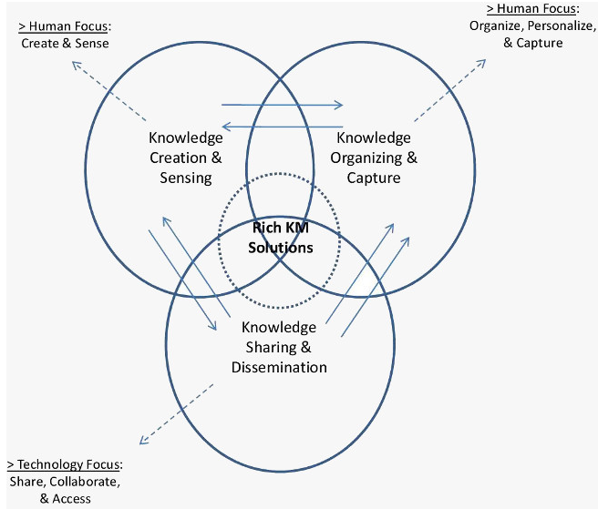
Figure 1: Organisational KM Theory
(Source:Allameh et al. 2017)
Knowledge management is the pivotal part of an organization that helps in sustaining business output through appropriate management of the workforce talent. In this context, Organizational KM theory is such a vital theoretical framework that has emphasized appropriately maintaining workforce talent. As per the views of (Allameh et al. 2017) this theory defines the structure, cultural design of an organization. It also explains knowledge creation and properly using the knowledge within an organization. The theory explains knowledge which a person gathers while communicating and interacting with another person for searching and solving issues. In essence, by applying the concept of organizational KM theory a company like Amazon could improve its efficiency in producing more products. Employers could manage a huge amount of work and find smart ways to handle loads of work pressure. By gaining knowledge from this theory, the service facilities of Amazon can be overseen in an appropriate manner (Tanjung et al. 2021). This theory also focuses on the development of relationships between key organizational parameters such as maintaining relationships with employees, keeping a focus on the hierarchy of authority, including overseeing other aspects such as goals, size, complexity and strategy of an organization. This theory helps to maintain the cognitive perspective of a worker. As per the views of (Khoreva et al. 2018), this theory says that sharing ideas can develop relationships between workers and which will help the people in attaining common goals. Practising organizational theory would eventually help Amazon to build the framework to fulfill its goals and objectives by appropriately handling workforce talent. Thus, in this way by practicing this theory, the e-commerce retail Giant Amazon can expand its production and sales in an effective way by exploiting internal knowledge of workers.

3.2 Techno-centric theory
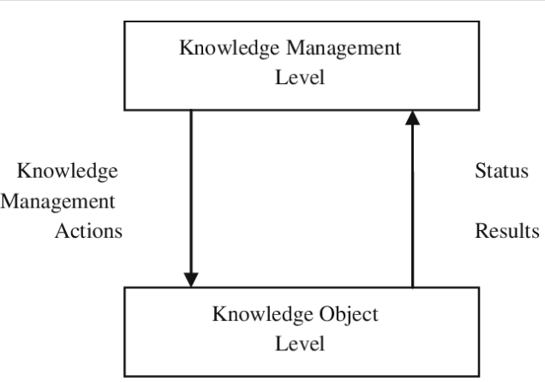
Figure 2: Techno-Centric Theory of Knowledge management
(Source: Israilidis et al. 2021)
In the current era without the use of technology an organization cannot move a bit in the business field. Inclusion of Technology is essential to store information and vital business data. As per the views of (Norström et al. 2020), being recognized as an e-com tech giant, Amazon.com needs to remember data regarding different matters such as number of production, number of employees working, which employee is holding which post and so on. Moreover, the company also needs to save information regarding the orders placed by customers and also the product details. In this context, by the application of this theory, a company like Amazon.com could enhance its designing process of technology facilitates knowledge flow and can store information by exploiting technological advancement and employee knowledge attributes (Rahimi, 2017). The theory also includes the people's impacts on company, process and technology on sharing knowledge. Thus, by putting emphasis on the Techno-centric theory, Amazon could develop internal talent of employees, correctly apply the talent, develop its information and knowledge management culture and thus the company will grow and sustain in the current state of economic downturn.

3.3 Modern Management theory
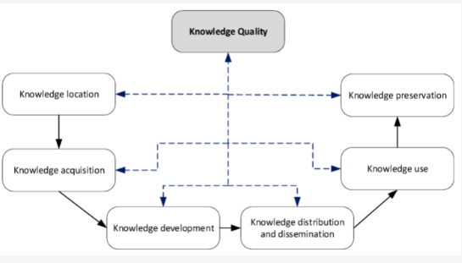
Figure 3: Modern management theory
(Source: Ferreira et al. 2018)
Based on the above figure, the knowledge quality has been interlinked with several other parameters such as “knowledge location, knowledge acquisition”, “knowledge development”, “knowledge distribution and dissemination”, “knowledge use”, including “knowledge preservation”. Thus, by establishing a strong network among the above-mentioned parameters a company can easily exploit their knowledge of their internal workforce which eventually allows an organization like Amazon to sustain their business and achieve more growth by developing KM practices.
The Modern Management Theory gives information about the handling of the employees in an organization. This theory helps the head of a company to understand the employees, delivering motivational thoughts to them and as a result of this; the employees would work in an enthusiastic manner. Thus, a peaceful environment will develop in the workplace. Based on the views of (Johnson et al. 2021), modern management theory helps a worker to develop supply management strategies, guidelines, and framework in a company. Modern Management theory helps to understand the emotions and thoughts of workers which in turn help in upgrading performance of the employees and increasing productivity. Thus by applying this theory Amazon can understand its employee’s emotion and could make the employees satisfied in their job by accurately exploiting their capabilities and talent.

4. Critical demonstration of the significance of effective creation, storing, sharing, application and integration of information in terms of developing KM practises

4.1 Providing demonstration about the importance of the effective creation for good knowledge management development practices
Knowledge is the glue which binds the gathered information and learning together. In the present situation, every company needs to focus on the knowledge management practices for developing the company more. A good knowledge management practice can provide several benefits to a company like it can make the workplace more efficient. Accordingly, more innovations can be done in a company. By gaining knowledge about the importance of KM practices, a company employee can make more meaningful and productive ideas about the company systems and their working skills will also develop. Additionally, the chance of error in a company becomes less due to the proper knowledge gained. As per the views of Artusi et al. (2020), Analysis, interpretation, Synthesization is prerequisites for a new employee in a company. The good knowledge gained through Km practices helps a company like Amazon.com to involve more clients in the company. An innovative company gets success only when its users know how to utilize it. The employees need to remain up to date about their company by studying about the company. The workers need to follow marketing activities, gather relevant knowledge related to the company for ensuring successful development of knowledge management practices within a workplace environment. In this context, the company owner needs to provide study material or a catalogue about the company to ensure knowledge development. Employees need to search about the company on websites to develop their knowledge. In this way, an organization can ensure knowledge management practices by exploiting existing knowledge of their workforce.

4.2 Illustration of importance of storing information as a prerequisite for good knowledge management development practices
Storing of knowledge or information is an important part of a company as it helps in running the company more smoothly. A person in the early days had to remember every information which they gathered but in the current scenario storing knowledge has become easy as people are developing and updating themselves through exploiting the contribution of technology. Nowadays, knowledge can be stored in the electronic and technical medium such as other electronic storage devices, which ensure appropriate storage of information. The data and information can also be written in the form of texts or emails. By storing knowledge a business can develop its decision making capacity, promote culture and innovation change, stimulate innovations and growth, encourage employees to work and so on (Muramalla et al. 2019). In this context a company would also be able to work with the stored data and can do new productions as per the needs of customers. By comparing the old ideas of production with the new one, employees or the existing workforce in Amazon can come up with a new creative plan and develop beneficial and attractive products. Thus, by maintaining this, Amazon.com could develop knowledge management practices.

4.3 Elucidation of importance of sharing for developing good knowledge management practices
The tendency of not sharing knowledge might be detrimental for an organization in terms of developing as well as reshaping their knowledge management practices. However, sharing data with others is equally important like gathering knowledge from relevant sources. Especially, in a company it is necessary as it helps to connect with every other employee. As per the views of Nagy et al. (2018), sharing data helps to make better performance in the company. In this context an employee can also become stronger professionally. Another importance of sharing knowledge is that it helps to save money during the training period, as the employee who has knowledge about the company can make the newcomer understand about the operational criteria of the company. Sharing information in the group discussion of a company can make the company make innovative creations (Nascimento et al. 2019). Spreading knowledge helps to clear misconceptions of employees regarding job matters. Implementing the prior knowledge to the current workplace might ensure sharing of knowledge and good development of knowledge management practices. In most cases it is found to be effective as companies like Amazon.com grow by using unique ideas. Thus, by using the idea of sharing information Amazon can make profit in its way.

4.4 Evaluation of importance of application as well as integration of knowledge for ensuring good knowledge management development practices
Utilizing the different ideas from the employee coming from a diversified environment can help a company like Amazon to come up with innovative ideas for producing unique products. In this context, the amalgamation of ideas makes the communication better among the workers working in the same workplace. According to Oloruntoyin et al. (2020), Integration of knowledge helps a company like Amazon to rectify its mistakes and errors, which in turn make its KM practices more superficial and effective. Integration of knowledge helps in improving profitability and opportunities for doing better in the market field. A company like Amazon can stay at the top ranking among the other businesses. Thus, integration of knowledge is important for ensuring good knowledge management development. Moreover, the Amazon Company can come up with new ideas for producing distinctive products by leveraging its good knowledge management practices.

5. Shedding light on the identified scenario of Amazon and illustration of academic theories for measuring effectiveness and information management Culture in Amazon

5.1 Describing the identified scenario of the organisation
Describing “AdaMEL” intervention in the light of the identified scenario
In the current situation of the COVID-19 pandemic, companies are being slowed down when it comes to enhancing productivity as well as expanding their business growth appropriately (Sulkowskiand Ignatowski, 2020). The famous tech giant “Amazon.com” has been exceptional in the current scenario of closing down businesses in wake of the current health epidemic. Organisations adopt smart techniques to accelerate their business growth in the most proficient manner leading to overcoming the impact of the recent pandemic scenario (Magistretti et al. 2019). The implementation of “AdaMEL” has helped the significant organisation to integrate all the essential data in terms of assisting “Amazon.com” to take technological advantage resulting in ensuring long term sustainability in the current market. A recent study states that this effective framework achieves “state-of-the-art outcomes with 8.21% improvement” leading to an impact on the business operations to be successful by mitigating the market requirements in an appropriate manner (Amazon.science, 2021). Along with that, this effective “deep-transferring learning framework”, “AdaMEL” assisted the tech giant to avoid probable challenges related to “differences in data and label distributions”. This particular technique helps the organisation to develop its "knowledge and information management" procedure in the most proficient manner.
Collaboration with “Tech- East”
In the context of having both technological as well as a competitive advantage, companies need to collaborate with emerging and successful business organisations (Fjeldstad and Snow, 2018). “Amazon.com” has been successful in terms of achieving its desired goal by taking effective initiatives in an appropriate manner. The famous organization has been partnered with “Tech-East” and is willing to host a programme that can help other small organizations to implement technological measures to accelerate their economic growth (Aboutamazon.co.uk, 2021). The association strategy with the organization “Tech East” has helped the company in a significant manner in improving the procedure of “knowledge and management”. The reason behind considering this technique is effective because “Tech- East” is a “community and network of digital technology business” (Aboutamazon.co.uk, 2021). This significant community assisted to provide technical support resulting in helping the tech-giant “Amazon.com” to develop its procedure of “Knowledge and information management” especially in the post-pandemic scenario.

5.2 Critical discussion of relevant alternative academic theories for explaining knowledge culture within the organisation for creating knowledge assets and maintaining effective customer relationships
Illustration of alternative academic theories of “Organizational KM Model”, “techno-centric” and “modern management theory” supporting the “knowledge and information management” within the organization
In terms of handling the market demands as well as customer requirements appropriately, companies can benefit from the “organizational KM theory”. This significant theory provides valuable information in terms of assisting an organization to develop their process of “knowledge and information management”. The famous technology organisation “Amazon.com” can forecast potential challenges and be prepared with proper precautions by adopting the significant theory. In addition to that, “techno-centric” and “modern management theory” can provide illustrative views based on which the tech-giant can avoid serious disruptions in their business operations and ensure its long term sustainability in the high-competitive market.
Wiig KM model
The significant “KM model” assists an organization to develop their procedure of “knowledge and information management” in an appropriate manner. The “Wiig KM Model” talks about four important steps such as “build knowledge”, “hold knowledge”, “pool knowledge” and "useful knowledge" as shown in the picture below (Elezi, 2018). Based on these factors, companies can acquire in-depth knowledge from external as well as internal sources and hold it in a strategic manner. The holding process of attaining knowledge has been covered by the significant model too by training the staff members of storing it in a “retrieval physical format” (Borah et al. 2021). Thus, being experienced by acquiring knowledge from this significant model, “Amazon.com” can improve its management process resulting in benefiting the company and overcoming the disaster situation of “COVID-19”.
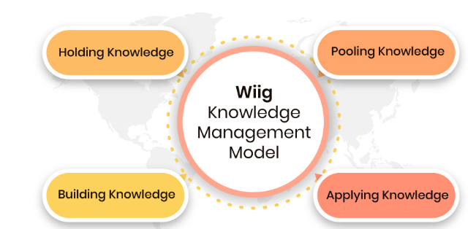
Figure 4: Wiig KM model
(Source: Elezi, 2018)
ZACK KM Model
Companies must forecast market requirements as well as customer needs by improving the procedure of “knowledge and information management”. The effective “ZACK KM Model” contributes in providing important information that can help an organisation to acquire a range of data regarding the business development resulting in benefiting the company to increase their economic growth (Jokanović et al. 2018). The model talks about five essential steps in improving the "KM System" of a company such as "acquisition", "Storage and retrieval", "refinement", "distribution" and “use or presentation” as shown in the picture below. In the context of developing the quality of attaining knowledge that benefits an organization to analyse their business performance and mitigate the market needs, following each of the steps of this significant model is crucial as each step is formed by pure logic. Based on this factor, information gathered from using this model can facilitate the business operation of a company. Thus, the adoption of the “ZACK KM model” is considered to be an essential tool for “Amazon.com” in terms of improving their “Knowledge and information management” system, especially in the current pandemic scenario.
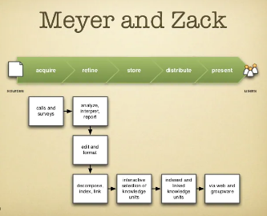
Figure 5: ZACK KM Model
(Source: Jokanović et al. 2018)

6. Illustration of Amazon’s knowledge management challenges and providing suitable recommendation strengthening KM practises

Illustration of Amazon’s knowledge management challenges
“Amazon.com” has accomplished its desired success by taking competitive as well as a technological advantage and has got ahead in the internal market. However, lack of management skills has compelled the significant company to face negative consequences such as customer dissatisfaction and employee dissatisfaction. Gathering information from the customer reviews it has been obtained that the customers are being unsatisfied due to the misbehaviour of the delivery partners of “Amazon.com”. Inefficiency in giving repetitive refunds has also been observed in the feedback of the customers of “Amazon.com” (Complaintsdepartment.co.uk, 2021). In essence, the tech giant needs to train its staff members efficiently in order to mitigate these customer complaints efficiently as well as focus on the customer feedback relevant to the delivery services. These factors signify the inefficiency in the managerial process of “Amazon.com” in terms of handling knowledge management attributes. Thus, it requires proper measures to improve KM practises in an appropriate manner. Lack of efficiency in “knowledge and information management” may lead to an adverse impact on the workplace environment of an organization (Al Shobaki et al. 2018). A recent study states that one of the staff members has been insulted by the company resulting in hampering the respiration of the technologically advanced organisation “Amazon.com” (Bbc.com, 2021). The company has been also accused for not treating their staff members well as well as not focusing on their well-being too. A recent article talks about the poor treatment and negligence attitude regarding the well-being of the employees raising questions on the management system of “Amazon.com” (Forbes.com, 2020). Numerous challenges like these have been faced or will be faced by the technologically advanced organisation “Amazon.com” if they will not be concerned about improving their “knowledge and information management” procedure in an appropriate manner.

Suitable recommendation strengthening KM practises
In terms of handling all the further consequences as well as forecasting all the market requirements, “Amazon.com” needs to take effective initiatives in the most proficient manner. According to Lacerenza et al. (2018), proper training needs to be provided to the staff members as well as enough capable candidates need to be recruited as high-authority members of these organisations along with gaining information from the above-mentioned models and theories. “Amazopn.com” must gather knowledge from the theories provided by the “BUKOWITZ and WILLIAMS knowledge management framework” in order to stabilise the “KM system” of the organisation. In addition to that, “synthesising knowledge” as one of the parts of the communication strategies can also be beneficial for the tech giant in strengthening its KM practises. Technological advancement is not enough when it comes to developing the process of “knowledge and information management” (Petrou et al. 2018). “Amazon.com” can be beneficial by following these techniques along with gaining information from other “KM efficient” business entities in terms of improving its KM practises.

7. Conclusion
Thus, it can be concluded that in terms of achieving the desired success as well as accelerating the business growth in a significant manner, an organisation,like “Amazon.com” needs to develop its KM practices. In addition to that, overcoming the losses due to COVID-19 impact, forecasting precautions in terms of strengthening the “knowledge and information management” system is also omnipotent. Effective theories from the above-mentioned models as well as other recommendations can also help the tech-giant to ensure its long term sustainability in the currency market even in the emergency period like post-pandemic scenario.

Task 2: Individual poster

1. Poster presentation title
“Practical Evaluation of the Proposed Knowledge Management Framework for Amazon”

2. Introduction
Companies can attain high positions in the national as well as international market by developing their “knowledge and information management”. Lack of efficiency in handling difficult times indicates the necessity of improving KM practises within an organisation. The poster will cover potential knowledge management challenges while accelerating business operations by “Amazon.com”. In addition to that, it will also talk about the feasible solutions in order to mitigate the challenges in a significant manner.

3. Purpose of poster presentation
The purpose of the “poster presentation” is to provide a brief overview of the current KM practises within the “Amazon.com” and effective techniques that has enabled the organisation to avoid adverse current pandemic effects. It also aims to deliver valuable information regarding the potential challenges faced by the tech giant due to inefficient KM department hampering the growth of the organisation. In addition to that, it also focuses on feasible solutions in order to mitigate the problems as well as identification of effective KM framework in terms of showing its benefits as well as drawbacks that can be faced by the organisation “Amazon.com”.

4. Discussion regarding Amazon potential knowledge management challenges and offering feasible recommendation

Potential knowledge management challenges
In terms of accelerating the business operations in a significant manner and developing its KM practises, “Amazon.com” can face serious knowledge management problems. For instance, “obsolete technology”, “employee motivation” and “easily accessible nature of the information” can pose a huge challenge to the organisation “Amazon.com” (Aboutamazon.co.uk, 2021).
The company “Amazon.com” has already been accused of its lack of management skills resulting in raising customer as well as employee complaints. Based on this factor, it is very necessary for the company to implement effective strategies in order to improve its “knowledge and information management system”.
In the current era of revolution of technological advanced activities of the organisations, “obsolete technology” can lead to adverse impact on the organisation such as “Amazon”. Innovative as well as effective measures need to be taken in terms of improving the KM practises within the organization (Dedeilia et al. 2020). Based on this factor, existing technical measures of “obsolete technologies” utilization can be a huge challenge for the company “Amazon.com’.
The achievement of an organisation relies on human power as well as a healthy workplace environment. Employee burnout bases or job dissatisfaction can be a huge obstacle while improving the practices regarding “knowledge and information management”. In essence, “Amazon.com” can focus on boosting employee morale in a significant manner while improving the KM practices within the organization.

Feasible recommendations
In terms of mitigating the challenges, companies like “Amazon.com” need to adopt the theory of effective KM models. For instance, “organisational KM theory”, “techno-centric theory”, “ZACK KM model” and many more can assist an organisation to improve the practises regarding the KM practises and forecast the needs of the consumers in a significant manner even in the emergency period like COVID-19 outbreak.
Companies need to enhance employee motivation by incentivizing them, helping to encounter the potential challenges while developing the KM procedure within the organisation (Friedrich et al. 2020). In addition to that, companies like “Amazon.com” need to follow the strategy of the successful business organisations having efficient “knowledge and information management” in order to gain valuable information and implement it in their business operations.

5. Evaluation of the proposed knowledge management framework for Amazon including showing its benefits and drawbacks
In terms of strengthening the KM practises within the organisation, the “BUKOWITZ and WILLIAMS’s knowledge management framework” can help a company in the most proficient manner. The significant model consists of seven stages such as “learn”, “contribute”, “get”, “asses”, “build or sustain”, “use” and “divest”.
Advantages
The significant framework aims to develop the ability of the organisation in taking the right decisions as well as increasing the customer satisfaction rate. In addition to that, BUKOWITZ and WILLIAMS knowledge management framework” focus on stimulating business growth as well as accelerating the process of delivery services resulting in benefiting the company like ''Amazon.com ``.
Disadvantages
The main disadvantage of adopting the significant framework is it is a time taking process due to which the outcomes from adopting this framework also delays (Volegzhanina et al. 2017). In order to have instant results in the development of the KM practises, the “BUKOWITZ and WILLIAMS knowledge management framework” does not seem to be promising enough for the company “Amazon.com”.

6. Conclusion
Thus, it can be concluded that effective initiatives must be taken by the organisation “Amazon.com” for mitigating the potential challenges in the KM practices within the organisation. In addition to that, drawbacks need to be considered by the significant tech giant while implementing the KM frameworks to bring development in the “knowledge and information management” procedure in terms of avoiding future consequences.

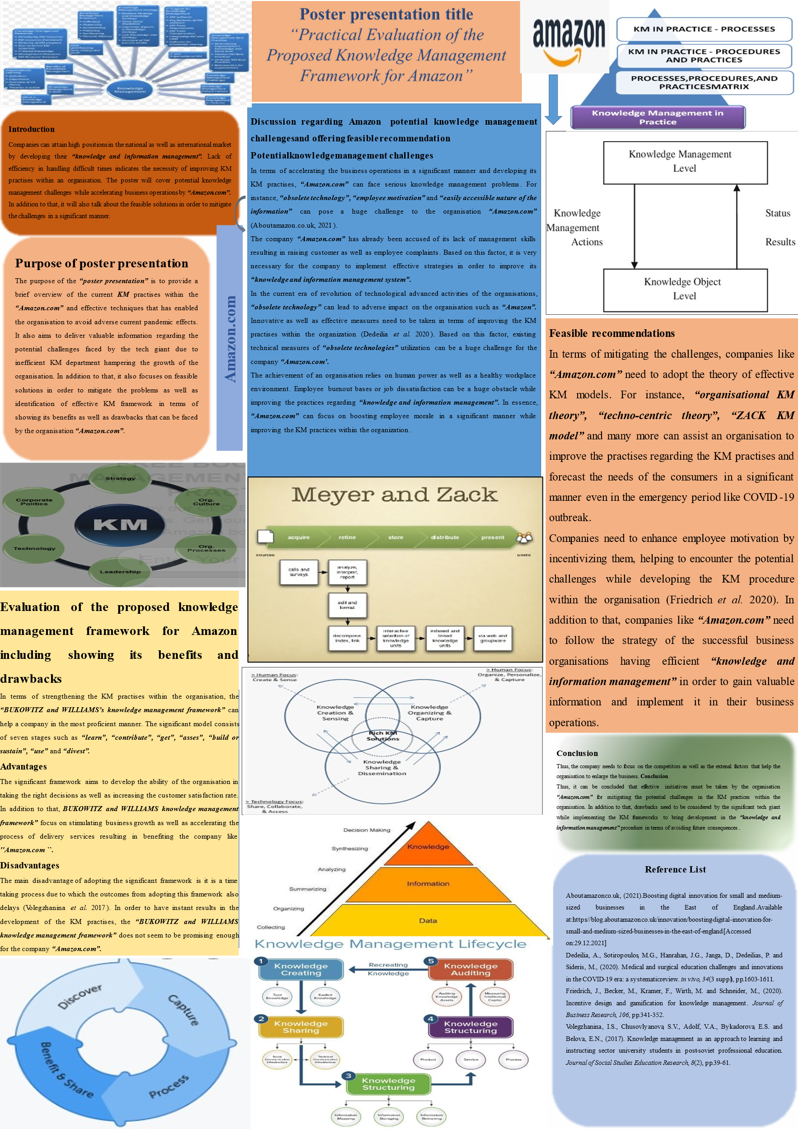

Reference List
Aboutamazon.co.uk, (2021).Boosting digital innovation for small and medium-sized businesses in the East of England.Available at:https://blog.aboutamazon.co.uk/innovation/boosting-digital-innovation-for-small-and-medium-sized-businesses-in-the-east-of-england[Accessed on:29.12.2021]
Al Shobaki, M.J., Abu-Naser, S.S., El Talla, S.A. and FarajAllah, A., (2018). The Intermediate Role of Knowledge and Information Management in the Relationship between Adopting the Strategy Criterion and Improving Overall Performance.
Allameh, S.M., Hosseini, S.H., Samadi, A. and Darikandeh, A., (2017). The relationship between intangible organisational capitals, knowledge management, and organisational learning. International Journal of Knowledge-Based Development, 8(3), pp.249-270.
Amazon.science, (2021).Deep transfer learning for multi-source entity linkage via domain adaptation.Available at:https://www.amazon.science/publications/deep-transfer-learning-for-multi-source-entity-linkage-via-domain-adaptation[Accessed on:29.12.2021]
Artusi, F. and Bellini, E., (2020). Design and the customer experience: the challenge of embodying new meaning in a new service. Creativity and Innovation Management, 29, pp.152-161.
Bbc.com, (2021).Amazon fight with workers: 'You're a cog in the system'.Available at:https://www.bbc.com/news/business-55927024[Accessed on:29.12.2021]
Borah, P.K., Phukan, B.R. and Raj, S., (2021). PRACTICAL APPLICATION OF KNOWLEDGE MANAGEMENT MODELS: ASSESSING EXISTING KM MODELS FROM THE PERSPECTIVE OF PRIVATE HOSPITALS OF NORTH EAST INDIA. PalArch's Journal of Archaeology of Egypt/Egyptology, 18(10), pp.818-834.
Complaintsdepartment.co.uk, (2021).Amazon (UK).Available at:https://www.complaintsdepartment.co.uk/amazon-uk/[Accessed on:29.12.2021]
Dedeilia, A., Sotiropoulos, M.G., Hanrahan, J.G., Janga, D., Dedeilias, P. and Sideris, M., (2020). Medical and surgical education challenges and innovations in the COVID-19 era: a systematic review. in vivo, 34(3 suppl), pp.1603-1611.
Elezi, E., (2018). A guiding conceptual framework for individualized knowledge management model building.
Ferreira, J., Mueller, J. and Papa, A., (2018). Strategic knowledge management: theory, practice and future challenges. Journal of Knowledge Management.
Fjeldstad, Ø.D. and Snow, C.C.,(2018). Business models and organization design. Long range planning, 51(1), pp.32-39.
Forbes.com, (2020).Amazon Faces A Crucible Moment With Employees.Available at:https://www.forbes.com/sites/deniselyohn/2020/06/02/amazon-faces-a-crucible-moment-with-employees/[Accessed on:29.12.2021]
Friedrich, J., Becker, M., Kramer, F., Wirth, M. and Schneider, M., (2020). Incentive design and gamification for knowledge management. Journal of Business Research, 106, pp.341-352.
Huang, P.H., (2021). Pandemic Emotions: The Good, The Bad, and The Unconscious—Implications for Public Health, Financial Economics, Law, and Leadership. Northwestern Journal of Law & Social Policy, 16(2), p.81.
Israilidis, J., Odusanya, K. and Mazhar, M.U., (2021). Exploring knowledge management perspectives in smart city research: A review and future research agenda. International Journal of Information Management, 56, p.101989.
Johnson, F., Leenders, M.R. and Flynn, A.E., (2021). Purchasing and supply management. McGraw-Hill Companies, Inc.
Jokanović, B.T., Okanović, A.V. and Lalić, B., (2018). Knowledge management diagnosis in Vojvodina firms by using Bukowitz and Williams model. Industrija, 46(4).
Khoreva, V. and Wechtler, H., (2018). HR practices and employee performance: the mediating role of well-being. Employee Relations.
Lacerenza, C.N., Marlow, S.L., Tannenbaum, S.I. and Salas, E., (2018). Team development interventions: Evidence-based approaches for improving teamwork. American Psychologist, 73(4), p.517.
Magistretti, S., Dell’Era, C. and Petruzzelli, A.M., (2019). How intelligent is Watson? Enabling digital transformation through artificial intelligence. Business Horizons, 62(6), pp.819-829.
Muramalla, V.S.S.R. and Al-Hazza, A.M., (2019). Entrepreneurial strategies and factors stimulate the business of tech startups. International Journal of Financial Research, 10(3).
Nagy, J., Oláh, J., Erdei, E., Máté, D. and Popp, J., (2018). The role and impact of Industry 4.0 and the internet of things on the business strategy of the value chain—the case of Hungary. Sustainability, 10(10), p.3491.
Nascimento, D.L.M., Alencastro, V., Quelhas, O.L.G., Caiado, R.G.G., Garza-Reyes, J.A., Rocha-Lona, L. and Tortorella, G., (2019). Exploring Industry 4.0 technologies to enable circular economy practices in a manufacturing context: A business model proposal. Journal of Manufacturing Technology Management.
Norström, A.V., Cvitanovic, C., Löf, M.F., West, S., Wyborn, C., Balvanera, P., Bednarek, A.T., Bennett, E.M., Biggs, R., de Bremond, A. and Campbell, B.M., (2020). Principles for knowledge co-production in sustainability research. Nature Sustainability, 3(3), pp.182-190.
Nytimes.com, (2021) Inside Amazon: Wrestling Big Ideas in a Bruising Workplace.Available at:https://www.nytimes.com/2015/08/16/technology/inside-amazon-wrestling-big-ideas-in-a-bruising-workplace.html Accessed on: 29. 12.2021
Oloruntoyin, S.T., (2020). Integration of Knowledge Management and E-Learning Technologies in Academic Institutions. Journal of Islam and Science, 7(2), pp.88-93.
Petrou, P., Demerouti, E. and Schaufeli, W.B., (2018). Crafting the change: The role of employee job crafting behaviors for successful organizational change. Journal of Management, 44(5), pp.1766-1792.
Rahimi, R., (2017). Customer relationship management (people, process and technology) and organisational culture in hotels: Which traits matter?. International Journal of Contemporary Hospitality Management.
Schrotenboer, A.H., Broek, M.A., Buijs, P. and Ulmer, M.W., (2021). Fighting the E-commerce Giants: Efficient Routing and Effective Consolidation for Local Delivery Platforms. arXiv preprint arXiv:2108.12608.
Sulkowski, L. and Ignatowski, G., (2020). Impact of COVID-19 pandemic on organization of religious behaviour in different Christian denominations in Poland. Religions, 11(5), p.254.
Tanjung, A.R., Simanjorang, E.F., Prayoga, Y. and Limbong, C.H., (2021). The Effect of Company Image, Service Quality, and Completeness of Facilities on Customer Satisfaction In Bank Muamalat Rantau Prapat. Budapest International Research and Critics Institute (BIRCI-Journal): Humanities and Social Sciences, 4(2), pp.3032-3038.
Unnu, K. and Pazour, J., (2021). Evaluating on-demand warehousing via dynamic facility location models. IISE Transactions, (just-accepted), pp.1-22.
Volegzhanina, I.S., Chusovlyanova, S.V., Adolf, V.A., Bykadorova, E.S. and Belova, E.N., (2017). Knowledge management as an approach to learning and instructing sector university students in post-soviet professional education. Journal of Social Studies Education Research, 8(2), pp.39-61.

