
MY Reflective Portfolio
Professional and Career Development

SERENA PARTRIDGE
2027003
OLUBUKOLA ADEGBITE
BMSW4005
Table of Contents

INTRODUCTION 2
SWOT ANALYSIS 3
What is SWOT Analysis? 3
THE PERSONALITY TEST 4
What is the personality test? 4
LEARNING AND TRAINING DEVELOPMENT 5
What is learning and development? 5
Honey and Mumford- the 4 learning styles 5
Neil Fleming + the VARK learning styles 6
CONCLUSION 6
A REFLECTION ON MY LEARNING 7
What is Jasper reflective model? 7
Open Book Assessment 7
REFERENCES 10

INTRODUCTION

The purpose of this portfolio is to reflect on how I have developed from the beginning of this module and what I have learned.
I will be evaluating my own skills and competencies using two of the analytical tools that we have been taught as well as self – awareness themes we have learned in this module. For this, I will be using Personal SWOT Analysis and the 16PF Personality test.
Also, as an appointed manager I will also be assessing the learning and development of my staff both present and future. I will do this by assessing and evaluating the Honey & Mumford, Kolb and Neil Fleming learning styles that we have been taught.
Lastly, I will assess and reflect on my learning in regard to the open book assessment, the mock interview, UK and employment legislation and any other topics I have learned during this module using Gibbs reflective cycle.

SWOT ANALYSIS

What is SWOT Analysis?

SWOT Analysis is a framework that was created by Albert Humphrey in the 1960s. It is “a commonly used tool for strategic planning, is traditionally a form of brainstorming” (Phadermrod, Crowder and Wills, 2017).
SWOT Analysis has four groups: Strengths, Weaknesses, Opportunities and Threats. This is a great tool for a person to assess themselves and plan their career.
Below is my personal SWOT Analysis
STRENGTHS  - Communication  - Leadership  - Passionate  - Reliable  - Health and Social Care level 4  - Understanding | WEAKNESSES  - Lack of experience in my chosen career.  - Lack of knowledge  - Over thinking  - Deadlines
OPPORTUNITIES  - Training and development  - Planning ahead  - Promotions | THREATS  - Experience in my chosen career  - Impatient  - Short deadlines  - Lack of progression

Upon looking at my SWOT Analysis, I can see that although my strengths are commendable, there is still much room for development in order to turn my weaknesses into strengths and to also assess my threats in order to overcome them to progress.

THE PERSONALITY TEST

What is the personality test?

The 16 Personality Factors Test was originally the Myers-Briggs Type Indicator which was created in the 1920s by Myers-Briggs. It was originally based on five scales (16personalities, 2022). It was then further developed on by Raymond Cattell, who developed a further 11 personality traits thus creating the 16 Personality Factor Test (betterhelp, 2021).
“The 5th edition of 16 PF questionnaire standardised by Cattell is the basis for determining personality characteristics which means the acceptance of all 16 items identified and proposed by Cattell” (Mateus et al,. 2021).
According to the 16PF Personality Test, my personality fits the Mediator personality type.
People that are Meditators are associated with being introverted, idealistic, creative, and driven by high values.
Upon evaluation i feel that these traits reflect me accurately, I tend to distance myself from others and observe what is going on around me. I also class myself as idealistic, I tend to aim high (sometimes too high) and believe that I have high standards. I like to think that I am creative and have good creative ideas. I have strong principles and high morals and try to stick to them as much as possible, while having empathy to individual circumstances.

LEARNING AND TRAINING DEVELOPMENT

I have been appointed as a manager within the social care sector. As part of my responsibilities, I will be assessing the learning and development training of my staff both present and future. For this I will be using Honey & Mumford, Neil Fleming & Kolb learning styles and theories, I will explain what they are and evaluate why I think they would be better suited for this task.

What is learning and development?
Learning and development is defined as “a systematic process to enhance an employee's skills, knowledge, and competency, resulting in better performance in a work setting” (AIHR, 2022), it is used to enhance a person’s knowledge and further develop their skills within their position.
Honey and Mumford- the 4 learning styles
Honey & Mumford (1982) and Kolb (1984) learning styles claim to predict behavioural choices individuals tend to make (Van den Berg, 2015).
Development of the Kolb learning cycle theory, Will look at how a person approaches a task, then how they think or react to a task.
The learning styles consist of:
- Activist - Likes to do, work with others, gain new experiences.
- Theorist - Focuses on logic and deep understanding.
- Pragmatist - Take part in practical activities that they can link to their daily experiences.
- Reflector - Learn from others, feel confident in what they need to do before taking action.
These learning styles cam each reflect different learning and problem-solving activities which makes it an appropriate model because learning is not ‘one size fits all’. By using a learning style suited to a person, it may help them learn easier as well as helping them become more engaged. This means that as an employee they will also feel more satisfied and valued as a part of the company. As a manager, effective learning will also save costs in the long-term whether it is having employees with higher skill sets and therefore having to recruit less or avoiding mistakes that would be costly to fix.
However, one criticism of this may be that it is difficult to assess whether only having 4 learning styles is a limitation, as it is unlikely that the whole population could be categorised into such a small number of groups.

Neil Fleming + the VARK learning styles

Similarly, the theory also looks at 4 types of learning styles, but Fleming takes a psychological approach. The categories are:
- Visual - takes in information through images.
- Auditory - use listening, sound, and repetition to learn.
- Read - associated with reading and writing to absorb information, possibly through books or notes.
- Kinaesthetic - also called ‘tactile learning’ but often involves taking physical action.
Using this model can be advantageous due to these learning styles being quite versatile. In contrast, approximately only 39% of people who take the VARK test fit best into one single category (Kharb, et. al, 2013), which means that within a large company the results would not be accurate for a majority of employees. This may further hinder the learning process if people are not learning in the best way for them. On the other hand, the variation in options may mean that multiple approaches can be used by a single person to consolidate learning.

CONCLUSION

Upon evaluation, for training and development in the social care sector, I feel that both Honey & Mumford and Neil Fleming learning models would be appropriate for the staffs learning and development. The reason being that it is important to ask if putting people into one category based on how they learn is limiting their potential. Nonetheless, looking at the differing learning styles of employees is beneficial as it allows for flexibility in the activities that can be used for learning. New experiences in learning can help maintain a sense of fulfilment.

A REFLECTION ON MY LEARNING

For this part of my report, I will be using Gibbs’ reflective cycle to assess and reflect on my learning in this module. I will be reflecting on the open book assessment and the mock interview. As well as UK employment legislation.

What is Jasper reflective model?

The Jasper reflective model was created by Jasper in 2013, it is used to gain an understanding from experience. purpose is (libguides.hull, 2021). The ERA model as it is known, stands for Experience, Reflection and Action.
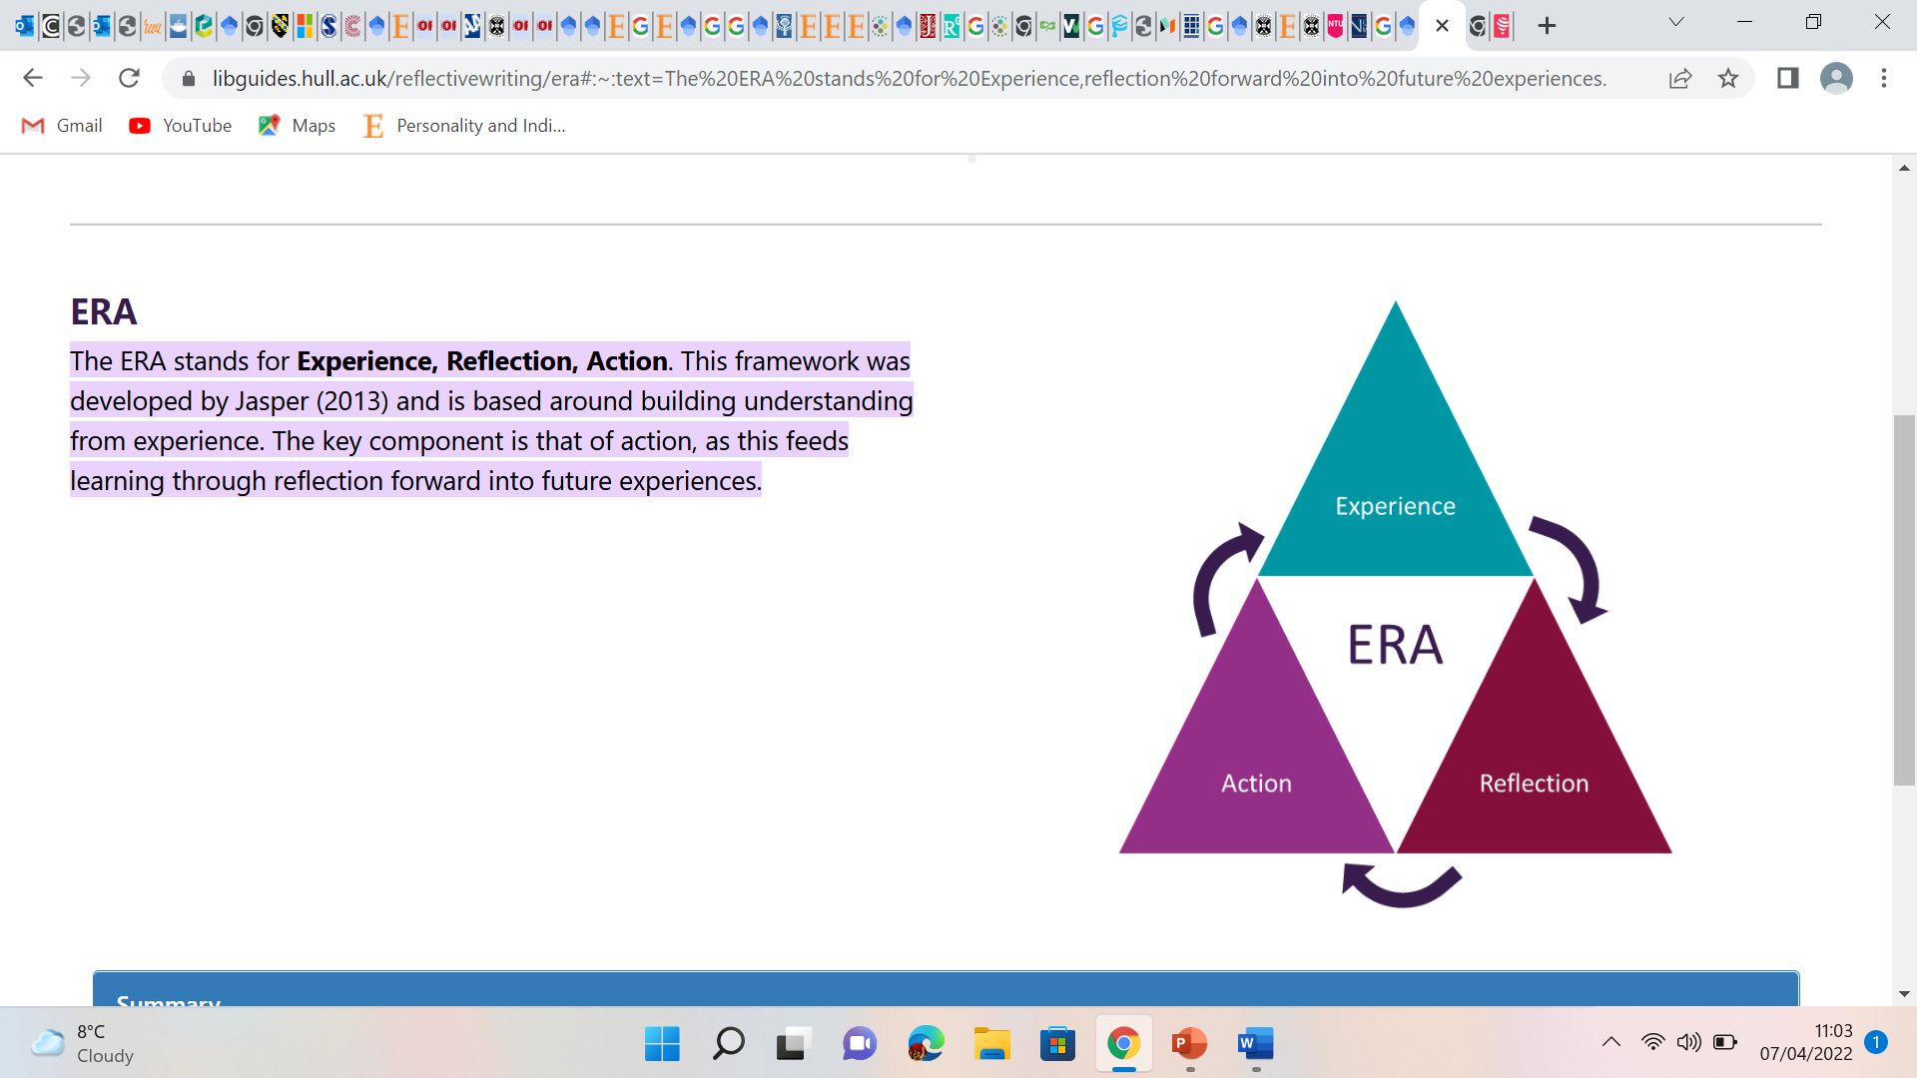

To reflect on an experience, the Jasper reflective model looks at three stages:
- EXPERIENCE
- REFLECTION
- ACTION

Open Book Assessment

“Open book assessments are designed to allow students access to supporting materials such as notes, textbooks, summaries and other resources while answering the questions set” (NTU, 2020).

Experience:
For the open book assessment, we were given a case study to read. We were then given a question to answer with any relevant references (to name five sources of stress). We were given two hours to complete the question.
For the initial assessment I felt confident in what I had to do, I understood what was being asked. I managed to almost complete the assessment in just over an hour and was very happy with my work. I was feeling happy with the work I had done and was relieved that I had managed to complete it within the time given, I was confident that this was a good piece of work.
Just as I was about to save my work, ready to upload it to Turnitin, my laptop crashed and turned off. I started to panic as I had done all of that work and it had all just disappeared.
My laptop restarted and I found my work, but the file was corrupted and would not open, I was so upset that I broke down crying. At first, I was upset, then I became worried that I would fail the module because I had not completed the open book assessment in the time allocated. I spoke to my tutor and explained what had happened. She allowed me the two hours to complete the assessment again. Although I did manage to redo the assessment and submitted it, my provisional marks were lower than what I expected. I can only put this down to it not being the same or used the same references I had previously used the first time.
Reflection:
Upon reflection, I could have handled the situation better. Once my laptop had crashed, I should have spoken to my tutor instead of crying. This would have allowed me to start again without feeling too much pressure, then my work may have been to the same standard it was the first time, and I may have gotten a higher mark.
Action:
If anything like this was to happen again, I would remain calm, wait for my laptop to reboot and speak to my tutor. I feel that the way I reacted caused me to stress more which delayed redoing the assessment. I feel that my standard of work would have been much better if I had remained calm.
Mock Interview
A mock interview is a tool that is used as a “training practice which utilizes simulation of an actual job interview in order to prepare the candidate for the real thing” (Talentlyft, 2022).
Experience:
I had a mock interview with my lecturer via Microsoft teams.
I thought I would be confident as I felt well prepared and had done some research on the company prior to the interview. I actually felt really nervous but tried to remain confident, I misunderstood one of the questions that I was asked. This threw me off a little bit as I felt unpreprepared however, I felt the interview overall went well. I received feedback for my interview and received 11/15 marks.
Reflection:
Upon reflection I feel that I could have been more prepared. One of the things I did not do is really sell myself for the position. I should have prepared more and be better prepared for all possible questions.
Action:
In the future I will identify my strengths and really sell myself to the company I am applying for. I have not had a proper interview for quite some time, so this was a new experience for me. I now know where the areas are that i need to improve on.
UK employment legislation
“Employment law regulates the relationship between employers and employees. It governs what employers can expect from employees, what employers can ask employees to do, and employees’ rights at work” (CIPD, 2022)
Experience:
We were taught about UK law legislation, what is and who it is there for. We also learned all of the supporting laws for example: Equality Act 2010, Employment Rights Act 1996 and the Data Protection Act 2018. Aswell as Holiday entitlement.
Reflection:
This was very useful information as most of this was not known to me. I was unaware that if you have worked for an employer for less than two years, your rights are not the same as if you have worked for your employer two years or more.
Action:
I feel that now being aware of the UK legislation laws will help me a great deal in the future. Whether I work for a company of even become self-employed, all of the information regarding the UK legislation laws will be beneficial to me and I intend to use them going forward.

REFERENCES

16personalities, 2022. CORE THEORY OUR FRAMEWORK [online] Available at: https://www.16personalities.com/articles/our-theory [Accessed 2 April 2022].
Academy to innovate HR, 2022. What is learning and development? [online] Available at: https://www.aihr.com/blog/learning-and-development/#What [Accessed 4 April 2022].
betterhelp, 2021. Raymond Cattell And His Theory Of Personality [online] Available at: https://www.betterhelp.com/advice/psychologists/raymond-cattell-and-his-theory-of-personality/ [Accessed 2 April 2022].
CIPD, 2022. Employment Law [online] Available at: https://www.cipd.co.uk/knowledge/fundamentals/emp-law#gref [Accessed 04 April 2022].
Kharb, P., Samanta, P. P., Jindal, M., & Singh, V. (2013, June). The Learning Styles and the Preferred Teaching—Learning Strategies of First Year Medical Students. Journal of Clinical and Diagnostic Research, 7(6), pp.1089-1092
libguides.hull.ac.uk, 2021. Reflective Writing:ERA [online] Available at: https://libguides.hull.ac.uk/reflectivewriting/era#:~:text=The%20ERA%20stands%20for%20Experience,reflection%20forward%20into%20future%20experiences [Accessed 4 April 2022].
Markkanen, P., Välimäki, M., Anttila, M. and Kuuskorpi, M., 2020. A reflective cycle: Understanding challenging situations in a school setting. Educational Research, 62(1), pp.46-62.
Mateus, C., Campis, R., Aguaded, I., Parody, A. and Ruiz, F., 2021. Analysis of personality traits and academic performance in higher education at a Colombian university. Heliyon, 7(5), p.e06998.
McLeod, S., 2017. Kolb's learning styles and experiential learning cycle. Simply psychology, 5.
Nottingham Trent University, 2020. Online open book assessments [online]. Nottingham. Available at: https://www.ntu.ac.uk/__data/assets/pdf_file/0025/1229074/online-open-book-assessments.pdf [Accessed 6 April 2022].
Phadermrod, B., Crowder, R.M. and Wills, G.B., 2019. Importance-performance analysis based SWOT analysis. International Journal of Information Management, 44, pp.194-203.
SK, M.S. and HELENA, M.T.C., 2017. Styles of Learning Based on the Research of Fernald, Keller, Orton, Gillingham, Stillman, Montessori and Neil D Fleming. International Journal for Innovative Research in Multidisciplinary Field, 3(4), pp.17-25.
Stander, J., Grimmer, K. and Brink, Y., 2019. Learning styles of physiotherapists: a systematic scoping review. BMC medical education, 19(1), pp.1-9.
Talentlyft, 2022. What is a mock interview [online] Available at: https://www.talentlyft.com/en/resources/what-is-mock-interview [Accessed 7 April 2022].
Van Den Berg, H., 2015. Changes in learning styles induced by practical training. Learning and Individual Differences, 40, pp.84-89.

