Interpreting Space

Environmental Art

For this module, ‘Visual Enquiry’, I have decided to focus my studying upon Environmental Art. Personally, I feel very strongly about this subject, and would like to highlight the environment in our very own community throughout this course of study. The site in which I have chosen to research is the Swansea Environment Centre, located in Pier Street.
Location of Swansea Environment Centre
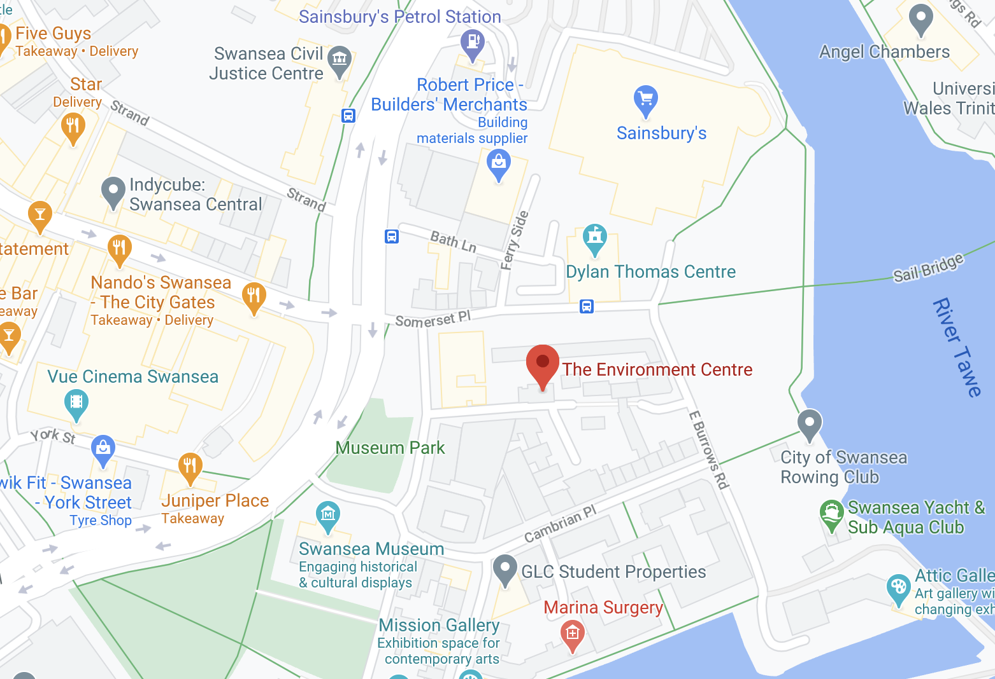
The centre was founded and formed in 1994 by the Swansea Environmental Forum, who to this day are based within the location. One year later, the Prince of Wales opened the building to the public. The building was built under eco-design principles, reusing and recycling old material. Within the website for the centre, it states “We’ve seen the documentaries, the news and the science. For our local environment (and ourselves) we need to tackle pollution of our air, waters, and land”.
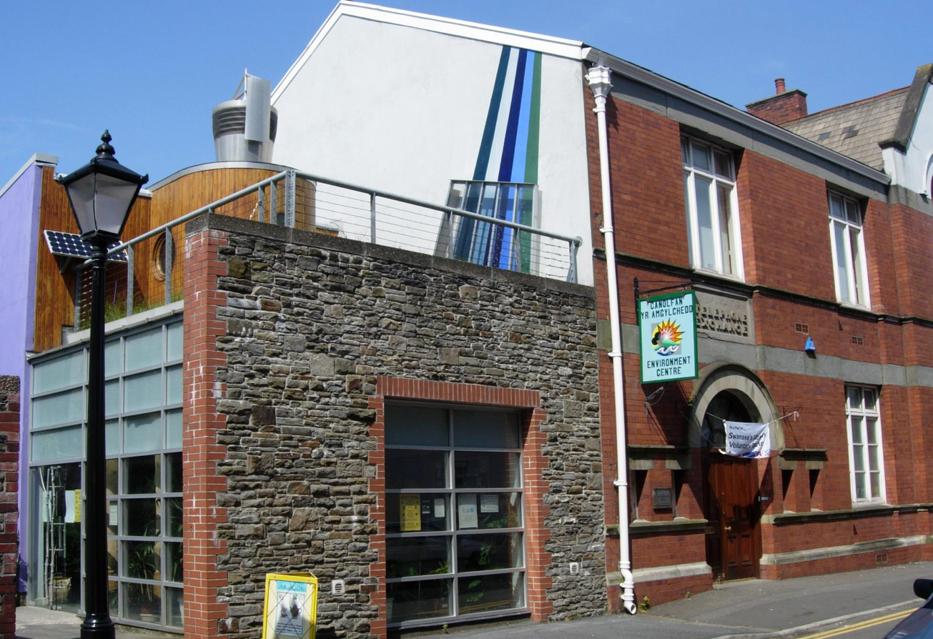
This site is so significant as it brings awareness and volunteering to our community. It’s one thing to talk about the environmental issues and another to react. The site allows members of the community to rent rooms within the centre to hold exhibitions, organisations, meetings etc. The rooms are most often used for individuals who undertake work that is environmental, or community based.
Swansea Environment Centre, Pier Street
The organisation keeps regular updates on their social media pages informing the community about upcoming opportunities everyone is able to participate in. For instance, back during the summer there was a ‘Swansea Marina and Beach Clean’, litter picking across the coast in order to raise awareness and get members of the public involved.
Enclosed in my body of work, I will be exploring the community and area of the centre, relating my work to its subject matter. As time progresses, plastic pollution is enlarging. Every year around 100,000 marine creatures die because of ocean waste, which is a massive number for something that can be prevented. I will be focusing upon Swansea beach and the surrounding marina. I hope my work can allow the audience to connect with the images and allow them to feel encouraged to make a difference.
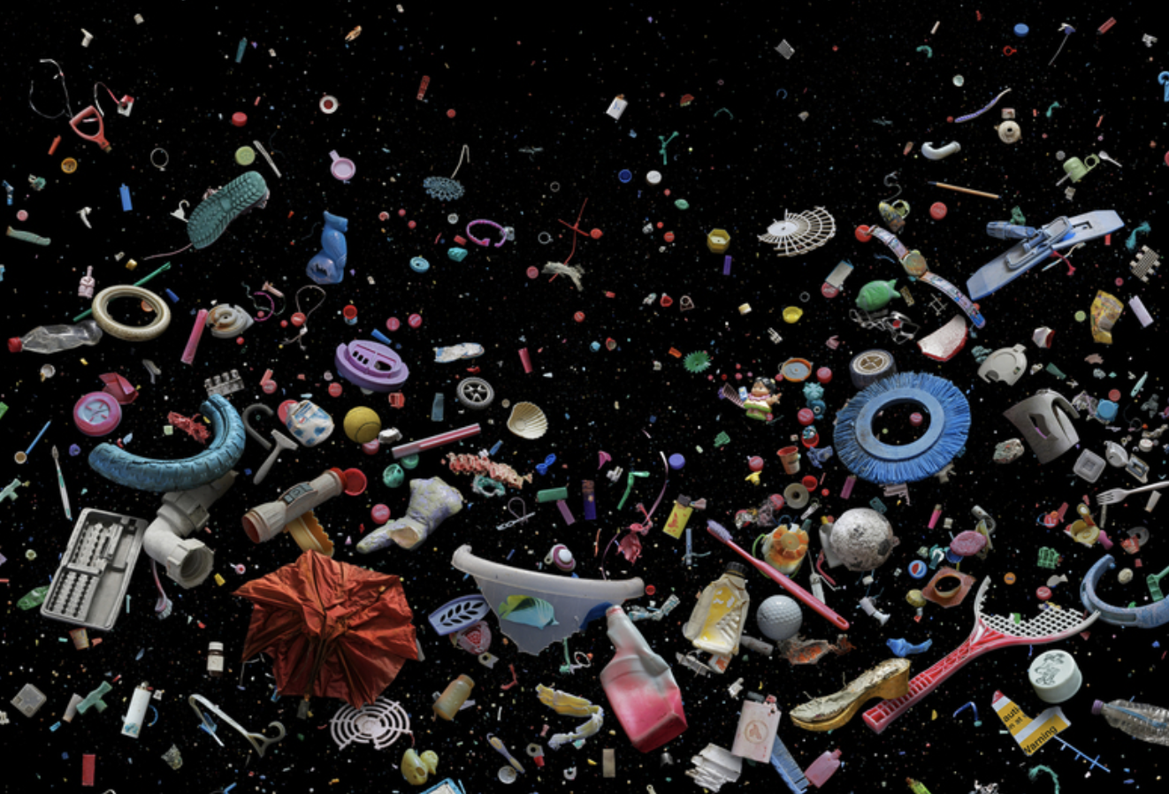
Two artists I am using as a source of inspiration include Mandy Barker and Andrew Hughes. These photographers both approach plastic pollution in unique ways, beginning with Mandy Barker. Mandy is most known for working with plastic debris to create the most aesthetically pleasing photographs.
Our Plastic Ocean – Mandy Barker

The colour contrasts between the black background are so beautiful and mesmerising. Each individual item was found as waste, which Mandy collected to photograph - each responsible for damaging our environment. Personally, I love the setup of this image. It’s completely set apart from the rest and really grasps your attention, showing plastic waste in a new light.
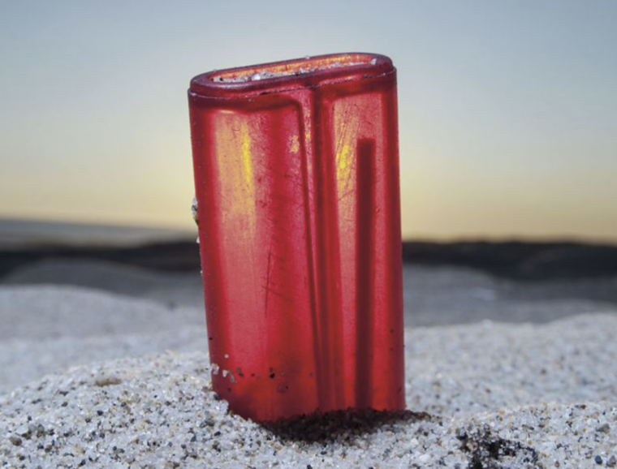
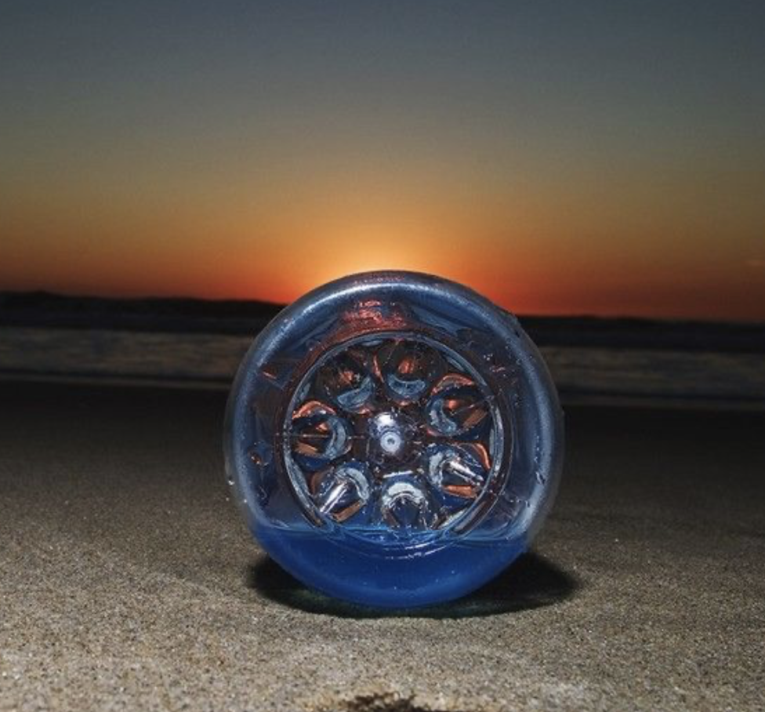
Moving onto Andrew Hughes, he captures litter from a different perspective, allowing the objects to appear really bold and clear.

In 1991, photographer Andrew Hughes began capturing waste he found along various beaches, after surfing along the coast of South Wales.
These images are so aesthetically pleasing to the eye. The colour of the object stands out in comparison to the background. I really like how the sky in the background also plays a big part in the final image, with the different colour tones. Due to the angle and position of the camera, the objects photographed appear large. This could potentially be a metaphor. The problem, which is pollution, is very big, indicating why the objects have been made to look larger.
To summarise, I have taken into consideration my artist research in order to inspire my body of work. As previously stated, my site was located in Swansea Marina. I ventured down and photographed ‘the environment’. This included Swansea beach, as well as the surrounding marina. When walking along the beach, I encountered various amounts of litter – which I photographed and collected. I captured my images from the way in which I perceive the area. The majority of my photos include litter found on the beach. I experimented with depth of field to allow the litter to be the main foreground subject, as well as various different low angles and exposures.
Overall, I’m very pleased with how my final photos turned out. I have thoroughly enjoyed learning and researching my site of choice – allowing myself to find an local organisation that brings awareness to something so important.

