

Written Report-
Business Plan – Marketing Agency
By
Svetla Angelova Aleksandrova
Student ID: 2029252
Course: Business and Management
Module: Entrepreneurship (LCBB5001)
Module Leader: Vasilios Tavlaridis
UWTSD
08/07/2022

Contents
O 3
verview of the business idea and its service 3
O 4
wnership and legal format of the start-up 4
M 5
anagement of the company (owner, employees, and requirements for external professional service/experts) 5
E 6
valuation of the business idea by using the SWOT analysis model 6
A 7
ssessment of the current external environment by using the PESTEL analysis model 7
I 11
dentification of the key marketing factors by using the 4P’s of marketing mix model 11
E 12
xplanation of the target market and the marketing strategies the company will adopt to reach their costumers 12
A 13
cash flow forecast for the first 12 months 13
Reference list: 14

O

verview of the business idea and its service

The report presents a business plan for a marketing agency based in Birmingham, United Kingdom. The firm’s mission is to assist not only start-ups and small organisations that want to grow more and reach a larger audience and clientele, but also companies that have been on the market for a long term and have a well-known brand. The company will be responsible for direct marketing, social media marketing, applying for courses and help filling SFE documents. (Morris, 2011, p. 186)
Consistently, research on the competitive advantage of small businesses has highlighted the significance of marketing, strategic positioning and entrepreneurship as crucial determinants for business survival and expansion. The firm’s ability to identify and operate in a certain market niche allows it to exploit a variety of specialities and provides protection against larger competitors. Nevertheless, despite the universal acknowledgment of the relevance of the marketing idea, the precise marketing activities and competencies that contribute most significantly to company performance for small and medium – sized businesses must be defined (SME’s). (Walsh, Lipinski, 2009)
According to research in the United Kingdom, for profit enterprises anticipate that their marketing expenditures will increase by more than 10% during the next 12 months. Overall, survey data suggest that British marketers has assumed a more strategic role. (Guttmann ,2022)
During a poll of marketing leaders in the United Kingdom conducted in January 2022, it was determined that spending on digital marketing by profit organizations would increase by 28.29% over the next 12 months compared to the previous year. (Guttmann, 2022).
The chosen company name is Aleksandrova 21 LTD.
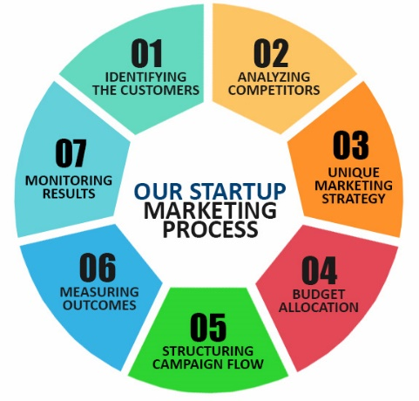(DCi,2022)

O

wnership and legal format of the start-up

The study states that the Marketing Agency will be a limited liability business. The first reason the company will be a limited company is because partners and sole traders are legally tied to the business, but the limited company is a separate “person” in the eyes of the law, it has its own liabilities and obligations that are separate from those of its owners, directors and employees. (Morris,2011, p.95)
Improved reputation/credibly and confidence are crucial in business, and a limited liability company’s professional appearance helps instil confidence in the business. Some clients, notably major organisations and those in the financial industry, prefer to engage exclusively with limited liability companies, while others openly refuse to do business with unincorporated businesses. Therefore, establishing a limited company can present commercial options that would not otherwise exist which benefits the future of the firm. (Smith,2021).


(RM Media Ltd,2022)

M

anagement of the company (owner, employees, and requirements for external professional service/experts)

Marketing Agency – Aleksandrova 21 LTD- Svetla Aleksandrova is the director and has a degree BA- Business and Management and BMA- Marketing and experience in costumer services and advertising goods and services and good leader skills.
The director must utilise these marketing talents to establish a brand, explain that brand, identify a target market and sell things within that market for the firm to be successful. (Indeed, Editorial Team,2021)
The firm’s founding team will consist of a finance specialist, accountant, marketing executive, digital and marketing officer and sales and marketing assistant.


(Dreamstime, 2022)

(Hiclipart, 2022)

E

valuation of the business idea by using the SWOT analysis model

SWOT analysis – definition
An effective scenario analysis technique, SWOT Analysis is used in the disciplines of marketing, public relations, advertising as well as in any other area that requires strategic planning. Analysing the "strengths," "weaknesses," "opportunities," and "threats" of a firm, an organisation, a plan, or a project is done using this technique. (Gurel,2017)

STRENGHTS  - The price will be cheaper from the other firms, and it also include a packet with full service.  - Experience with the advertising, experience with costumer services  - Passion for the marketing  - Geographical advantages- the service can be provided online  (Kenton,2021) | WEAKNESES  - The marketing agency is new and not establish  - The advertising, web design, graphic design, social media marketing, branding and well known on the market and are used from the competitors  - Not enough capital  (Kenton,2021)
OPPURTUNITIES  - The costumer’s service is operated online and that give an opportunity to expand the demand  - Easy accessibility, work from virtual office -which saves money and time  - The firm can introduce in the social medias  (Kenton,2021) | THREATS  - Licences to start-up the businesses  - High level of competitors on the market  - Increasing taxis  (Kenton,2021)

A

ssessment of the current external environment by using the PESTEL analysis model

The goal of the PESTEL analysis is to encourage the corporation to take a broader view of the economic and business environment. All enterprises are components of the economy, a bigger system. Performing a PESTEL analysis enables the firm to consider all relevant elements that could affect its success or failure. The acronym PESTEL represents the following factors: (Political, Economic, Social and cultural, Technological, Environment and Legal) 'Political,' 'Economic,' 'Social,' and 'Technology' are the key components of the analysis. The potential concerns to analyse may fill volumes and still barely touch the surface, thus this talk focuses on the technique. The specifics will vary depending on the company, its industry, and the countries in which it operates. The PESTLE study enables a management to determine the macroeconomic elements that are most likely to influence the business's future development. The identification of future macroeconomic variables of relevance and the development of several scenarios enables the manager to better predict the strategic decisions required to ensure the business's viability. (Alanzi,2018)
Political Factors

- BREXIT- Following the Brexit, broadcasters with headquarters in the UK that offer services to EU clients may now need to obtain rights clearance separately in each member state that their signal reaches, however it may be possible to set up an EU base from which broadcasts will continue to benefit from the “country- of-origin- principle” or “one-stop shop”. (Dresden,2021). This will result the firm having to spend extra time and money on completing out documentation, such as licencing and meeting extended deadlines.

- Government support to the industry and organization- The UK government advised that marketing prices should be “cut” and that marketing services should be used less, which could deeply damage for the UK economy and this industry. (Carroll,2022)

- Fiscal policy- Fiscal policy is rarely employed in UK. In theory, the government may employ fiscal policy to calm economic cycles but adjusting tax rates lessen inflationary pressures presents political changes. The government often defers to monetary policy and the Bank of England for economic management. (Pettinger,2017). This has a good effect on the company, as it reduces bureaucracy and costs.
Environmental Factors
Environmental protection laws-
- T16 waste exemption- toner and ink cartridge disposal. It cannot treat waste toner or ink cartridges that are classified as hazardous waste in order to dispose of them in a landfill or by incineration. At any time, the company can store and cure up to 150 tonnes of cartridges. The treatment must be administrated outside. The garbed must be disposed of in an area with sealed drainage. (Environment Agency, 2014)
The firm it will be affected from this law, while creating physical advertising (such a posters) for companies.

- Plastic Packing Tax- Starting in April 2022, there will be a tax on plastic packaging that is less than 30% made from recycle plastic. At first, the price per tonne of plastic packing will be set at GBP200. The tax will now apply to the importation of filled plastic containers, and there will be a minimum threshold of ten tonnes of plastic containers. (Coxall and Souter, 2021)
The firm it will be affect by using plastic materials for the creating the advertising products.

- Availability of non-renewable goods- Electricity- In 2022, the average price per kWh of electricity for a business will be 17.73 pence. Business that uses energy will also have to pay VAT at the current rate of 20%. The Climate Change Levy is another green tax that a business must pay (CLL). (Business Electricity Prices,2022). The company will be affecting by the increasing of the electricity prices.

Social Factors

- Purchasing Habits- A poll done in March 2022 in the UK, found thar costumers are likely to spend less on almost all types of shopping, except for groceries, where a net 15% of respondents say they plan to spend more. Bits expected to spend the least on eating out and going out between March 2022 and March 2023. (Statista,2022) The most significant aspect of how individuals purchase items are that the business is learning more about how those items will function over time. It can also inform of the most popular styles, smells, features and sizes which can help it to select where to invest the majority of the company’s funds. ((Morley, 2022) This outcome is favourable for the company since indicates that competitors will seek to enhance product demand through advertising.

- Population – The population is one of the most influential sociological influences on marketing, as an increase in population boosts market demand for goods and services. (StudiousGuy,2022) The population of the UK is anticipated to expand by 2.1 million to 69.2 million by the middle of 2030, a 3.2% increase. (Office of National Statistic,2020)

- Attitudes toward green or ecological products – The results of the multiple linear regression analysis showed that how consumers felt about the role of the government and how they felt about the environment affected how they felt about green products. More research showed that personal norms were the most important factor in how people felt about green products. (Tan and Lao,2010)

Technological Factors

- Growing virtual usage – Marketing research has never been easier. Virtually all businesses and costumers have internet connection. Tools such as client relationship management systems are gaining popularity. There has been a substantial increase in both social media marketing and website marketing. These marketing channels require monitoring, analysis and personalization. Other companies do this for each product and costumers. (Lycas,2020).That will negatively affect the direct marketing, which company will use for advertising, but in other hand it will make it easier and available to do costumer research, in short period and less costs.

- Cranial impact and face recognition- the global market for cranial implants is anticipated to expand at a CAGR of 5.53% between 2017 and 2021. It is possible that marketers may be able to track and interact with their costumers’ using chips implanted in their bodies or devices. Facial recognition enables the identification of nearby potential customers. It would enhance the sales effort, by compiling information on the prospect’s purchasing history, providing additional leverage to engage prospective clients during network opportunities such as corporate events. The adoption of this technology is projected between 2025 and 2030. (NetScribes,2018)

- Internet accessibility- 13 nations have a little or no Internet accessibility, such as Belarus, Burma, China, Cuba, Egypt and others. (WorldAtlas,2022) That affects the company negatively, and make the online marketing- advertising difficult or even impossible for these countries.

Legal Factors

- Advertising codes of practices-
Non-broadcast media- the CAP non-broadcast code has rules about advertising that is not show on TV like print and online ads, sales promotions, and direct marketing. Business must follow the code’s rules about advertising to children, offending people and political advertising. (GOV.UK)
Broadcast media (like TV and Radio). The company must follow the CAP broadcast code, which covers things like taste, decency and product placement. Business must follow rules about how accurate and honest they are, and they also have rules about things like scheduling. (GOV.UK)

- GDPR- The guide to the General Data Protection Regulation has information about consent, an explanation of the company and costumer’s rights under GDPR, description of special category and criminal offence data and advice on how to protect children’s data. (GOV.UK,2018) Lawfulness, fairness and transparency are important parts that may affect business. The company must make sure that the uses of the data are based on contest or legitimate interest and that the costumer or prospect has all the information they need. (DMA,2018)

- The other licences which company will needs it will be authorized and considered.

Economic Factors

- Inflation- The UK’S annual inflation rate jumped to 9,1% in May 2021 from 9% the previous month, which was in line with market predictions and the highest level since 1982(Office for National Statistic, 2022). Inflation has diverse implications on economic indicators and company operations. Its consequences on the value of fixed assets and earing are one of the most significant issues. (Illes, 2010)

- Interest Rate- In June 2022, the Bank of England increased its benchmark interest rate by25 basis points to 1,25%. This was the fifth straight rate increase, raising borrowing prices to their highest level in 13 years (Bank of England,2022). When interest rates are endogenous, they are various equilibria, but higher interest rate equilibria suggest more and better loan. Negative selection diminishes the stimulative effects of monetary policy, and zero interest rates may cause banks to hoard funds. Multiple extensions and robustness checks are carried out. (Dosis,2020)
- Unemployment/Employment- The unemployment rate in the UK decreased from December 2021 to February 2022, while the employment rate remained practically stable and the economic inactivity rate grew, compared to the previous three- months period (September to November 2021). (Watson,2022). The low unemployment rate necessitates that company managers know how to properly negatively impact the firm. (WGU,2019)

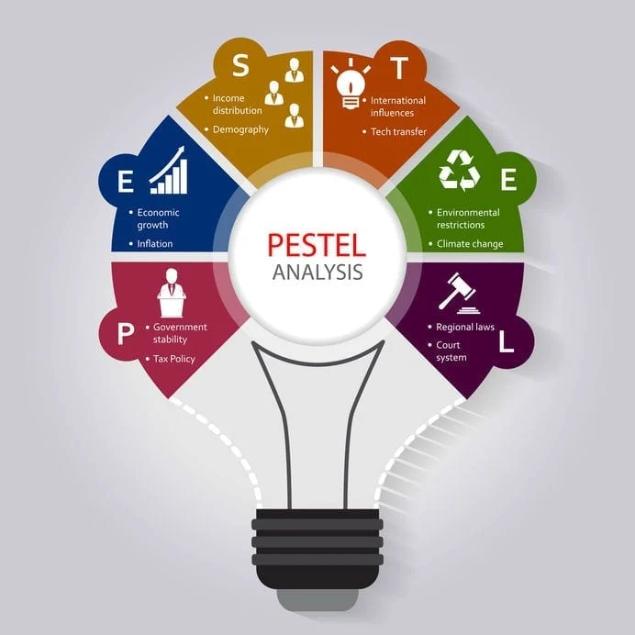
(Hirai, 2022)

dentification of the key marketing factors by using the 4P’s of marketing mix model

I
A company’s marketing mix is the collection of controllable, tactical marketing instruments it employs to achieve the desired response from its target market. Most marketers divide their marketing mix into four categories: product, pricing, promotion and place (or distribution). (Barringer and Ireland, 2021, p.421). Marketing efforts at a company are not complete without figuring out what things are going to be sold. The most crucial quality of a product(service), as emphasised is that it provides value to its target customers. (Barringer and Ireland, 2021, p.422)
- Product - The company will provide advertising services to businesses in the university sector (higher education courses) and special services- applying for the courses in this institutions and filling SFE documents. The company will deliver the most effective marketing services, the team has great expertise working in Europe and the United Kingdom and possesses a blend of marketing methods that will land each new client and skyrocket the companies' profits.
- Price- The business will charge a special price for its services. The organization trains service technicians to cross-sell additional services. It will also implement a customer loyalty programme to reward long-term customers with cheaper rates and offer coupons to first-time customers. The price for one student(service) will be 700£.
- Promotion- Most of the new business is generated through the company's website; thus, all marketing efforts should be directed on increasing its traffic. The promotional mix of the company consists of social media advertising, direct marketing, and digital marketing.
- Place- The company will have a Virtual Office, based in the heart of Birmingham (Central), where the costumers and other stakeholders can contact the company via email and letters.

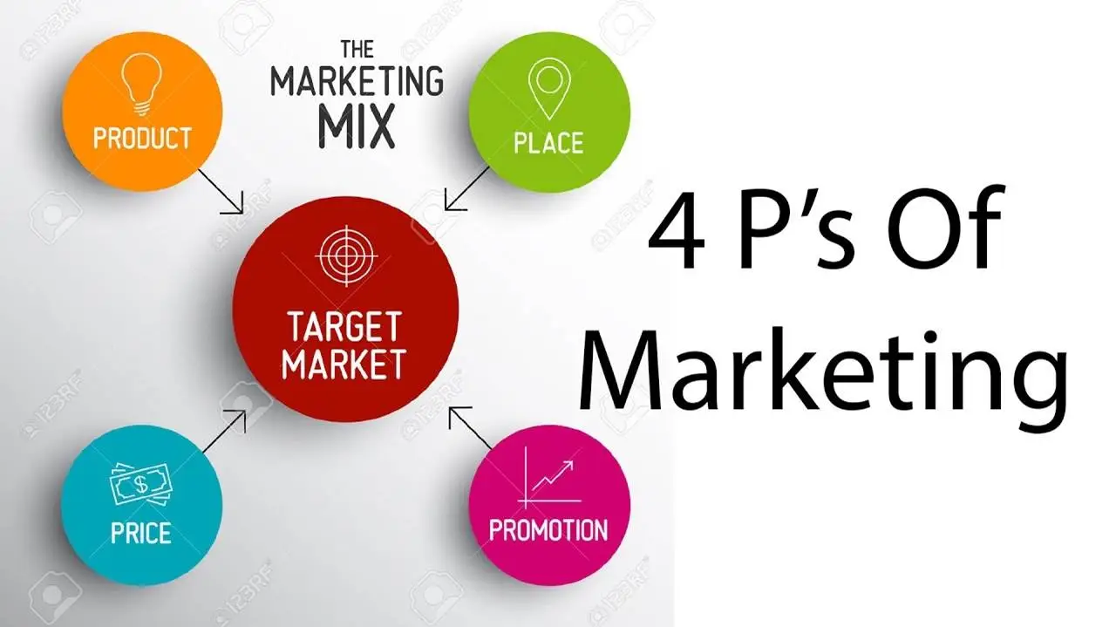(Farhan S.,2019)

xplanation of the target market and the marketing strategies the company will adopt to reach their costumers

E

The company's potential clients will be private organisations that provide adult higher education courses. There are sixteen universities in Birmingham, where the company provides its services. Birmingham is a popular destination for international students considering where to study in the United Kingdom. (University of Guro,2022)
Many universities operate online, which provides opportunities to expand service locations.
In 2018–19, 2.38 million students were enrolled in higher education institutions in the United Kingdom. Undergraduate: 1.80 million Postgraduate: 0.59 million Full time: 1.88 million Part time: 0.5 million Students from the United Kingdom: 1,9 million. (Universities United Kingdom, 2021)


(CCsalespro, 2022)

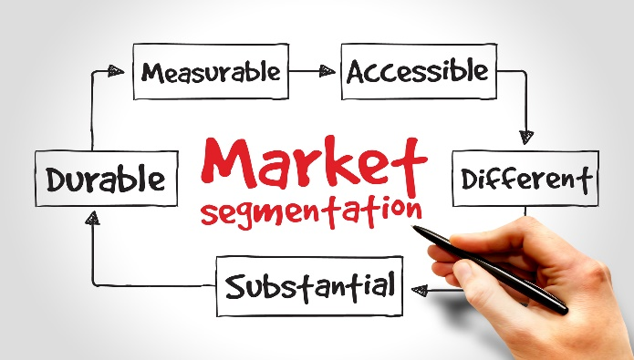
(Frue K., 2022)

A

cash flow forecast for the first 12 months

Table 1-
*Equipment includes computers, printer, paper, ink. (Table 1)
*Other costs include Staff benefits (costa cards, gym membership), electricity (Table 1)

Based on the calculation the yearly expenses will cost the company 128614,42£. The monthly costs will be 10717,87£. The one payment costs will be 3344,99£. The start-up available capital it will be 50 000£ (minus 3344,99£), the company can run the business for 4 months and 11 days which doesn’t includes any incomes and investments inflows in the company.
Table 2
Table 2 shows the sales forecast from September 2022 to August 2023. There will be sold 62(services), each costing 700£. The total amount which will be earned for that period it will be 130 200£, which will cover the fixed costs and make profit of 1585,58£.

Reference list:
- 5 Emerging technology trends in marketing and sales, 2 February, Available at: https://www.netscribes.com/emerging-technologies-in-marketing/ (Accessed:03/07/2022)
- Accounting Finance Service Bank Insurance, bank transparent background PNG clipart (2022), Available at: Free download | Accounting Finance Service Bank Insurance, bank transparent background PNG clipart | HiClipart (Accessed:08/07/2022)
- Alanzi S. (2018), Pestle Analysis Introduction, September, Available at: https://www.researchgate.net/publication/327871826_Pestle_Analysis_Introduction (Accessed:08/07/2022)
- Are There Countries Without Internet Access? (2022), Available at: Are There Countries Without Internet Access? - WorldAtlas (Accessed:03/07/2022)
- Bank of England, United Kingdom Interest Rate, Trading Economics, Available at: https://tradingeconomics.com/united-kingdom/interest-rate (Accessed:28/06/2022)
- Barringer, B. R. and Ireland, R. D. (2021) Entrepreneurship: Successfully Launching New Ventures, eBook, Updated 6e, Global Edition. [BibliU version] 6th ed. Harlow, Pearson Education.
- Carroll N. (2022), Government advice to cut marketing may be ‘deeply damaging’ for UK economy, industry says, N. Carroll, 30th June, Available at: https://www.marketingweek.com/government-demonising-marketing/ (Accessed:03/7/2022)
- Coxall M. and Souter K. (2021), Environmental Law and Practice in the UK (England and Wales): Overview, 17th November, Available at: https://uk.practicallaw.thomsonreuters.com/6-503-1654?contextData=(sc.Default)&transitionType=Default&firstPage=true#co_anchor_a446206 (Accessed:03/07/022)
- DCi (2022), Marketing Services for Startups, Available: https://www.dotcominfoway.com/internet-marketing/website-marketing-for-startups/ (Accessed:29/06/2022)
- Diverse People Working and Marketing Concepts(2022), Available at: Diverse People Working and Marketing Concepts Stock Photo - Image of human, internet: 44902800 (dreamstime.com) (Accessed:08/07/2022)
- Dosis A. (2020), Interest Rates and Selection Along Business Cycle, February, SSRN Electronic Journal, Available at: https://www.researchgate.net/publication/340556765_Interest_Rates_and_Selection_Along_the_Business_Cycle (Accessed:29/06/2022)
- Dresden B. (2021), What is the impact of Brexit in the Advertising, Market and Media sectors?, B. Dresden, 18th August, Available at: https://www.lewissilkin.com/en/insights/what-is-the-impact-of-brexit-in-the-advertising-market-and-media-sectors (Accessed:03/07/2022)
- Effect of low unemployment rates on businesses(2019), Available at : https://eur01.safelinks.protection.outlook.com/?url=https%3A%2F%2Fwww.wgu.edu%2Fblog%2Feffects-low-unemployment-rates-businesses1905.html%23close&data=05%7C01%7Cs.aleksandrova%40uwtsd.ac.uk%7C4f2507161da644aa8bb808da59e132fc%7C4e0f11f9046e45059cb8db2152311e21%7C0%7C0%7C637921120991614197%7CUnknown%7CTWFpbGZsb3d8eyJWIjoiMC4wLjAwMDAiLCJQIjoiV2luMzIiLCJBTiI6Ik1haWwiLCJXVCI6Mn0%3D%7C3000%7C%7C%7C&sdata=PYMXdVGtIvakbLHsweG7CjO8pV%2FT8wACxDFQcYC5R5Q%3D&reserved=0 (Accessed:29/06/2022)
- Enrolment (2022), Available at: Enrolment | UWTSD (Accessed: 06/07/2022)
- Environment Agency (2014), T16 waste exemption: treating waste toner and ink cartridges, 28th April, Available at: https://www.gov.uk/guidance/waste-exemption-t16-treating-waste-toner-and-ink-cartridges (Accessed:03/07/2022)
- Factors That Affect Marketing and Advertising(2022), Available at: https://studiousguy.com/factors-affect-marketing-advertising/#:~:text=The%20population%20is%20also%20one%20of%20the%20primary,inflation%2C%20interest%20rates%2C%20exchange%20rates%2C%20recession%20and%20taxes. (Accessed:03/07/2022)
- Frue K. (2022)https://pestleanalysis.com/author/kfrue/ Market Segmentation Analysis: Definition and Examples, 27th October, Available at: https://pestleanalysis.com/market-segmentation-analysis/ (Accessed:08/07/2022)
- Guidance Guide to the General Data Protection Regulation, 25th May, Available at: Guide to the General Data Protection Regulation - GOV.UK (www.gov.uk) (Accessed:04/07/2022)
- Gurel E., SWOT ANALYSIS: A THEORETICAL REVIEW (2017), August, Available at: https://www.researchgate.net/publication/319367788_SWOT_ANALYSIS_A_THEORETICAL_REVIEW (Accessed:08/07/2022)
- Guttmann A., Change in overall and digital marketing spending in for-profit companies in the United Kingdom (UK) in 2022, by type, A. Guttmann, 25 March, Available at: https://www.statista.com/statistics/1230829/change-marketing-spending-uk/ (Accessed: 21 June 2022)
- Guttmann A., Marketing in the United Kingdom- statistic and facts, A. Guttmann, 17 February, Available at: https://www.statista.com/topics/9016/marketing-in-the-united-kingdom/#topicHeader__wrapper (Accessed: 21 June 2022)
- Higher education in numbers, 16th December, Available at: Higher education in numbers (universitiesuk.ac.uk) (Accessed:06/07/2022)
- Hirai A. (2022), Put Your PESTEL to the Mettle, Available at: https://www.caycon.com/blog/put-your-pestel-to-the-mettle (Accessed:08/07/2022)
- Identify Your Target Market (2022), Available at: https://www.ccsalespro.com/identify-target-market/ (Accessed:08/07/2022)
- Illes M. (2010), The effects of inflation on Business Profits and Business Assets, M. Illes, January, Available: https://www.researchgate.net/publication/262066406_The_Effects_of_Inflation_on_Business_Profits_and_Business_Assets (Accessed:29/06/2022)
- Kenton W., (2021), Strength, Weakness, Opportunity, and Threat (SWOT) Analysis, C. Murry, 11th November, Available: https://www.investopedia.com/terms/s/swot.asp (Accessed:28/06/2022)
- Lau T. and Tan B., Attitude towards the Environment and Green Products: Consumers' Perspective, January, Available at: https://www.researchgate.net/publication/228500580_Attitude_towards_the_Environment_and_Green_Products_Consumers'_Perspective (Accessed:03/07/2022)
- Lycas A. (2020), The Impact of New Technology on Marketing, 22th September, Available at: https://www.digitaldoughnut.com/articles/2020/september-2020/the-impact-of-new-technology-on-marketing (Accessed:03/07/2022)
- Marketer Skills: Definition and Examples (2021), 25th June, Available at: https://uk.indeed.com/career-advice/career-development/marketer-skills (Accessed:29/06/2022)
- Marketing and advertising: the law, Available at: Marketing and advertising: the law: Advertising codes of practice - GOV.UK (www.gov.uk) (Accessed:04/07/2022)
- Morley M. (2022), How Consumer Behaviour Influences an organization, Available at: https://smallbusiness.chron.com/consumer-behavior-influences-organization-31799.html (Accessed:29/06/2022)
- Morris M., (2011), Starting a Successful Business, 7th edition, Kogan Page
- Net spending intention of consumers in the United Kingdom (UK) between March 2021 and March 2022, by category, Available at : https://www.statista.com/statistics/1304288/consumer-spending-intention-by-category-uk/ (Accessed:29/06/2022)
- Office for National Statistic, United Kingdom Inflation Rate, Trading Economics, May, Available at: https://tradingeconomics.com/united-kingdom/inflation-cpi (Accessed: 28/06/2022)
- Overview of the UK population: 2020(2020), Available at: https://www.ons.gov.uk/peoplepopulationandcommunity/populationandmigration/populationestimates/articles/overviewoftheukpopulation/2020 (Accessed:03/07/2022)
- Pettinger T. (2017), Monetary and Fiscal Policy in the UK, 18th December, Available at: https://www.economicshelp.org/blog/113/uk-economy/monetary-and-fiscal-policy-in-the-uk/#:~:text=Fiscal%20Policy%20in%20UK.%20Fiscal%20policy%20is%20not,changing%20tax%20rates%20just%20to%20reduce%20inflationary%20pressures. (Accessed:03/07/2022)
- Rahman S., (2015) Report about advertising agency, BRAC Business School, Available at: https://core.ac.uk/download/pdf/61806327.pdf (Accessed:21 June 2022)
- Smith J., What are the main advantages of a limited company? , J. Smith, 1 March, Available at: https://www.crunch.co.uk/knowledge-limited-company/what-are-the-main-advantages-of-a-limited-company (Accessed:21 June 2022)
- The Blue Diamond Gallery (2022), Available at: https://www.thebluediamondgallery.com/tablet/l/limited-company.html (Accessed:08/07/2022)
- Universities in Birmingham, England UK- Rankings & Reviews - All 7 Universities in Birmingham | Rankings & Reviews 2022 (universityguru.com), (Accesssed:06/07/2022)
- Walsh M. F., Lipinski J., The role of the marketing function in small and medium sized enterprises, Journal of Small Business and Enterprise Development, 23 October, Available at: https://www.emerald.com/insight/content/doi/10.1108/14626000911000929/full/html , (Accessed: 21 June 2022)
- Watson B. (2022), Employment in the UK: April 2022, 12th April, Available at: https://www.ons.gov.uk/employmentandlabourmarket/peopleinwork/employmentandemployeetypes/bulletins/employmentintheuk/april2022#:~:text=The%20UK%20unemployment%20rate%20was,below%20pre%2Dcoronavirus%20pandemic%20levels. (Accessed: 29/06/2022)
- What are the average business electricity prices per kWh in 2022? Available at: https://www.businesselectricityprices.org.uk/cost-per-kwh/ (Accessed:03/07/2022)
- What is GDPR and why is important? (2018), 2 May, Available at: What is GDPR and Why is it Important? | DMA (Accessed:04/07/2022)

