
Marketing Management
(LCMB7024)
Assessment 1: Marketing Environment Analysis

- Name: Shubh Bansibhai Modi
- Student ID: 2509172
- Faculty: Jayalakshmi Gopalkrishnan
- Program: MBA International Business
- Module: Human Capital Management
- Module Number: LCMB7024
- Words: 2500

Table of Contents
1. Introduction: 3
2. Task 1: Critical Analysis of the Macro Marketing Environment 4
2.1 Overview of the Macro Marketing Environment 4
Refer to theoretical frameworks such as PESTEL to contextualise the analysis. 4
2.2 Selection of Two External Macro Marketing Actors 4
Identify and justify the selection of two external actors (e.g., technological, environmental, political, economic, social, or legal). 4
Critical Analysis of Social and Legal Factors 4
2.3 Critical Analysis of Social and Legal Factors 6
Analyse how these changes impact pioneering and follower organisations differently and create opportunities and threats within the industry. 6
Identify the key strategic implications for both pioneers and followers. 8
Support the critical analysis with data and business examples. 8
3. Task 2: Strategic Responses of Pioneering and Follower 9
Pioneering Organisations’ Strategic Responses 9
Apply relevant strategic models such as: 10
Ansoff’s Growth Matrix 10
Strategic Models Applied to Tinder & Grindr 10
Porter’s Generic Strategies 10
Support the analysis with industry examples. 10
3.3 Follower Organisations’ Strategic Responses 11
Ansoff’s Growth Matrix 11
Porter’s Generic Strategies 12
Industry Examples Supporting Follower Strategies 12
Conclusion: 13
Reference: 13

1. Introduction:
In today’s dynamic and globally integrated business environment, businesses face the challenge of adapting to the rapidly shifting consumer behaviour and expectations in the marketplace. The marketing function, in particular, has transcended the boundaries of the ad, requiring greater insight into the broader environmental context, as well as the key individual behavioural trends underpinning decision-making. The use of tools, like the PESTEL environmental scan, provides businesses with the necessary insights into the key externally-driven forces, ranging from political, through economic, social, technological, environmental, to legal, that largely influence consumer attitude and marketplace trends today (Kotler et al., 2022). On the other hand, the relationship between the individuals in the marketplace, like customers, competitors, suppliers, as well as the organisation itself, also has the capacity to shape the manner in which people make sense of value in the marketplace (Jobber & Ellis-Chadwick, 2021).

In people-driven industries, like the dating platform, understanding the behavioural trends provides managers with the necessary insights toward anticipating opportunities, threats, as well as developing an ethical approach to marketing.

2. Task 1: Critical Analysis of the Macro Marketing Environment

2.1 Overview of the Macro Marketing Environment
The macro-environment is viewed as all the external factors related to politics, economics, social reality, technology, and environmental issues, among others, whose role is to influence business processes to ascertain how to go about business. This is mainly because organizations do not have any control to influence these factors but have major impacts on marketing planning for dating apps such as Tinder, Grindr, Bumble, and Hinge among others.
Political and legal factors shape data management, inclusivity, and safety on platforms, while social trends like increasing demands for authenticity and connectivity shape user behaviour on platforms (Sumter et al., 2023). Economic factors shape user interest in paying for enhanced functionality, while technology development, especially AI technology, makes matching safe and personalised.

Refer to theoretical frameworks such as PESTEL to contextualise the analysis.
- Political: Government policies, political stability, corruption, and trade regulations.
- Economic: Economic growth rates, interest rates, inflation, exchange rates, and disposable income.
- Socio-cultural: Demographics, lifestyle trends, cultural norms, and consumer attitudes.
- Technological: R&D activity, innovation pace, automation, and technological incentives.
- Environmental: Ecological and environmental aspects, such as climate change, waste disposal, and sustainability regulations.
- Legal: Laws, standards, and legal requirements, including competition law, employment law, and health and safety.

2.2 Selection of Two External Macro Marketing Actors

Identify and justify the selection of two external actors (e.g., technological, environmental, political, economic, social, or legal).
In the online dating industry, social and legal factors of the macro-environment largely influence strategy formulation. On social grounds, evolving perceptions of dating online or dating itself continue to remain crucial for dating apps. For instance, Grindr is primarily accessed by LGBTQ+ communities, and social acceptance largely affects overall user engagement. (Sumter et al., 2023) Tinder, Bumble, or Hinge continue to remain influenced by evolving dating trends among individuals seeking safety as well as genuine dating opportunities on online platforms; thus, new features to combat this have been developed.
Legally speaking, dating apps remain subject to strict laws and regulations focusing on data protection, harassment, and user age verification

Critical Analysis of Social and Legal Factors

Social Factors
Pioneering apps like Grindr or Tinder are faced with demands to comply with dynamic norms associated with online dating and inclusiveness among the LGBTQ+ community.
- It is necessary for them to respond to human-related behaviours such as safety concerns, harassment, and demands for respectful conduct (Sumter et al., 2023).
- •Bumble or Hinge-type of Follower apps can utilise all these social trends by focusing on safe and user-friendly platforms, such as female-friendly platforms or positively interactive platforms.

Legal Factors
- Grindr and Tinder have daunting scenarios because of laws surrounding data privacy, harassment laws, and regulations for user-generated content internationally.
- Bumble and Hinge should utilise legal requirements to their advantage to position themselves as trustworthy and reliable dating platforms.
- "It is worth noting, however, that if leader apps innovate at a faster pace to meet new demands emerging from the law, another challenge for 'follower' apps is 'market irrelevance’ (Smith, 2022)”.
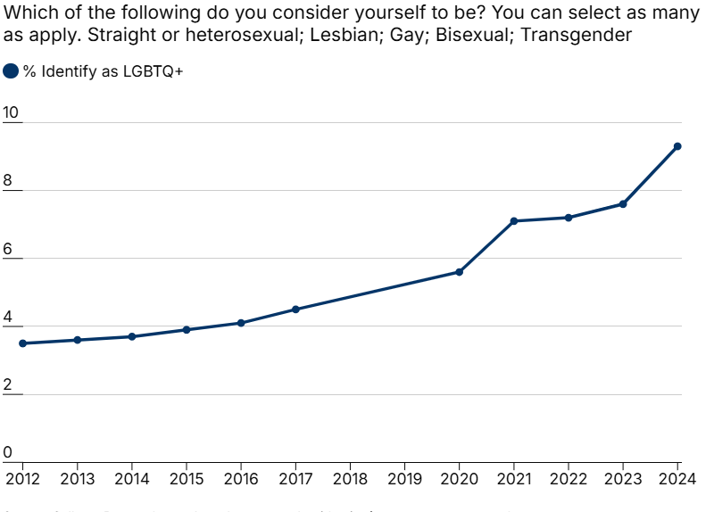

Fig 1, Source: Daily Mail - news, sport, celebrity, science and health stories

Actor | Opportunities | Threats
Pioneers (Grindr, Tinder) | Brand loyalty, market leadership | Legal fines, reputational risk
Followers (Bumble, Hinge) | Niche differentiation, safer image | Being outpaced by pioneers

2.3 Critical Analysis of Social and Legal Factors

Analyse how these changes impact pioneering and follower organisations differently and create opportunities and threats within the industry.

Social Factors
- Pioneering apps like Grindr and Tinder are under pressure to adapt to evolving social norms on dating online and being inclusive to the LGBTQ+ community.
- They also have to respond to human behaviour such as safety concerns, harassment, or the need for respectful communication (Sumter et al., 2023).
- Follower apps like those offered by Bumble or Hinge can use these social trends to point to potentially acceptable environments, such as 'women first' or user interaction aligned positively.

Legal Factors
- Grindr and Tinder face complex legal challenges due to international regulations on data privacy, harassment, and content moderation, risking fines, bans, or reputational damage.
- Bumble and Hinge have the advantage of making their need to comply with laws a big selling point for trust and reliability.
- However, if new apps become innovative at a rapid pace to respond to demands for laws, secondary apps may have difficulties sustaining market viability (Smith, 2022).

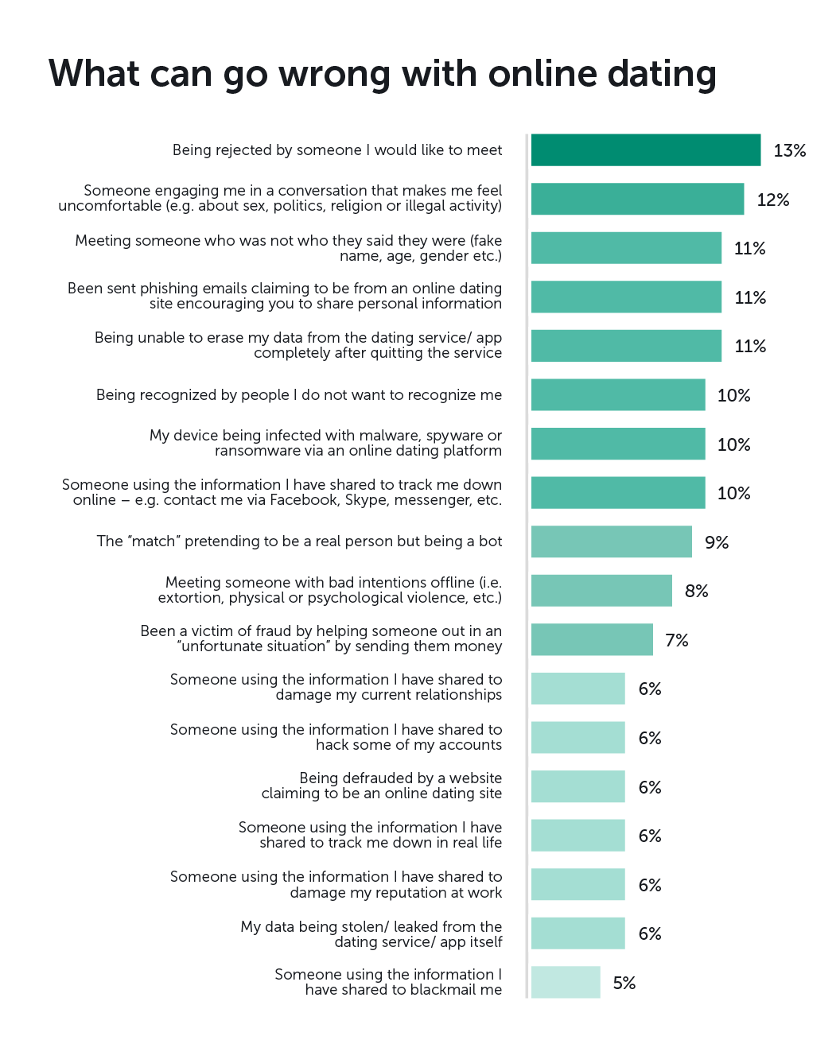

Fig 2, Source: Kaspersky Daily

Identify the key strategic implications for both pioneers and followers.
Pioneers (e.g., Tinder, Grindr):
- Innovation leadership: companies have to keep pushing new ideas forward. They need to do this nonstop to hold onto that first-mover edge. Users count on seeing fresh features and different kinds of experiences from them. (Kotler et al., 2022).
- Trust and safety: Carry a lot of weight in this space. Leaders face high responsibility when it comes to setting standards across the industry. This covers privacy protections, ways to stop harassment, and rules for ethical interactions.
- Cultural Adaptation: Need to navigate diverse political and social environments, particularly for sensitive user groups like LGBTQ+ communities.
Followers (e.g., Bumble, Hinge):
- Differentiation: Differentiation requires building value that stands out from the crowd. Think about things like communication tailored for women first or matchmaking centred on real relationships. These approaches help in competing more effectively against others.
- Adaptive Learning: lets followers pick up on what works and what does not. They can watch the pioneers closely for successes and failures. Then they refine their own product features and marketing plans based on those observations.
- Human-Centric Marketing: Must the spotlight be on connecting emotionally with people? It stresses inclusivity, too, along with smooth user experiences overall. The aim here is to foster trust and encourage long-term loyalty among users.

Support the critical analysis with data and business examples.
- User Base and Engagement: In 2022, Tinder had more than 75 million monthly active users all over the world. This number really points to the strong interest people have in quick, casual ways to connect with others (Smith, 2022). It makes clear that easy technology along with the basic human need for social ties, pushes more folks toward these apps.
- Revenue and Premium Services: Bumble brought in 730 million dollars that same year from things like subscriptions and purchases inside the app. That revenue shows users will spend money on better features focused on safety and giving people more control (Bumble, 2023).
- Safety and Inclusivity Measures: Grindr added safety tools right in the app, plus ways to build community support. These steps help keep LGBTQ+ users safe. They show how putting people first in design builds up trust, especially in tricky social situations (Sumter et al., 2023).
- Behavioural Trends: Studies indicate that 59 percent of people who date online care more about real authenticity and deeper talks than just random hookups. This trend shapes Hinge's whole approach with its "designed to be deleted" idea (Smith, 2022).
- Global Variations: Places like the UAE have rules that limit these platforms. So companies have to adjust to local culture and laws. All this stresses why marketers need to stay sharp on political and legal issues in their plans.
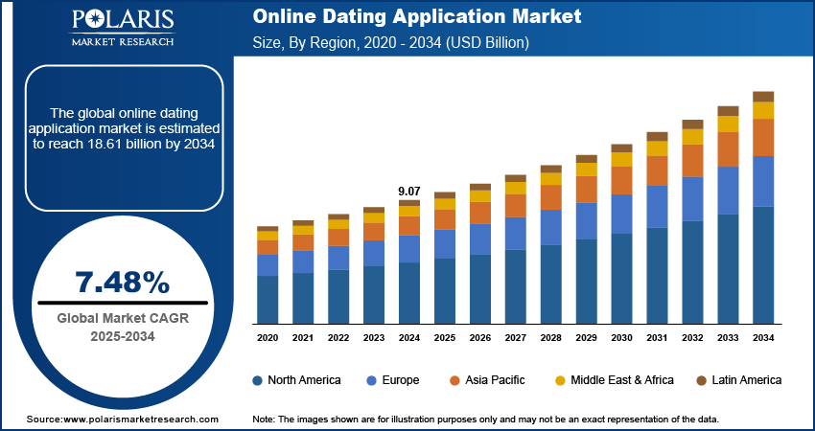

Fig 3, Source: Region -Market Forecast, 2025 – 2034

3. Task 2: Strategic Responses of Pioneering and Follower

Pioneering Organisations’ Strategic Responses
- industry standards by proactively addressing external pressures and adapting to the changing behaviors of contemporary users. As users place greater emphasis on emotional safety, authenticity, and respectful engagement, these companies invest in technological tools that foster trust. For example, Tinder implemented AI-powered prompts such as “Are You Sure?” and a photo-verification badge to mitigate harassment and catfishing, thereby meeting user expectations for safer digital interactions (Smith, 2022).
- Addressing Political and Social Challenges: Grindr is subject to unique external risks as it serves the queer community, particularly in countries and regions that limit same-sex relationships. The company is responding with its own travel safety notifications and region-specific privacy practices to keep at-risk users safe (Sumter et al., 2023). The stance taken above shows a human-centred response that can only be grounded in care, empathy, and the user being safe.

- Capturing the Opportunity of Technology: Trailblazers are inquiring into potential applications of advanced algorithms and AI-driven matching that serve to support the human inclination for compatibility and emotional connection. Tinder is effectively building a new set of behaviours with these machine learning suggestions of compatibility (Kotler et al., 2022).

Apply relevant strategic models such as:

Ansoff’s Growth Matrix

Strategic Models Applied to Tinder & Grindr
- Market Penetration – Strengthening Core Users: Tinder continues to increase engagement through a series of features called Swipe Surge that entice existing users to are now more users engaged than ever. Again, this is reflective of people's need to connect immediately and have some social rush (Smith,2022).
- Product Development – Building New Features for Evolving Behaviours: Grindr has built video calls and more advanced filters to the platform. The original purpose was to meet the needs of the users to create safer, more user-driven experiences, as well as users identifying with or wanting spaces where being LGBTQ+ was affirmed( Sumter et al., 2023).
- Market Development – Expansion into New Markets. In markets such as India, Tinder has adjusted to cultural expectations about the use of dating services by promoting safe and inclusive dating norms and recognising that relationship contexts are shaped not only by personal values but also by local norms (Kotler et al, 2022).
- Diversification – Moving Outside of Dating Both apps are exploring engagement as part of their communities, with Grindr using an event listing function for LGBTQ+ events and Tinder's social discovery module.

Porter’s Generic Strategies
- Cost Leadership – Free Core Features Tinder still provides free access more widely than any other app to ensure that everyone can participate—that dating has become more democratic and behaviourally inclusive (Smith, 2022).
- Differentiation – Unique Experience for Distinct User Needs
Grindr differentiates the app through hyper-local proximity matching focused on LGBTQ+ users, but also recognises those unique behaviours that include building a community identity and establishing safety features.
- Focus Strategy – Serving Niche Relationship Preferences
Grindr focuses on LGBTQ+ communities more than Tinder's mainstream audience, which targets casual or flexible relationships. Both, therefore, build strategies on real human behaviours of identity, attraction, and belongingness.

Support the analysis with industry examples.

Industry Examples Supporting the Strategic Analysis
- Tinder – Market Penetration through Behaviour-Driven Features
Tinder's Swipe Surge feature amplifies user visibility, match rates, and site engagement experience for users during busy periods. Tinder's aim to boost user experience aligns with human behaviour as users engage with and "swipe" on users whom they believe are online and responsive. Smith (2022).
- Grindr – Product Development for Safety and Authentic Connection
Grindr has introduced a video chat function and safety features that go beyond privacy. Grindr has acknowledged that there are instances where users may face political and/or social risks while dating offline. Grindr's video, chat, and privacy features self-admittedly enhance the experience for users who engage in LGBTQ+ dating and who reside in parts of the world that may be socially dangerous for them to express their identity (Sumter et al., 2023).
- Tinder – Market Development Through Cultural Localisation
Tinder's introduction of consent campaigns and safety guidelines developed in India localised Tinder to align with social expectations around dating. This position aligns with Kotler et al. (2022) that global brands will only grow and exist in harmony with local cultural behaviours and values.
- Grindr – Focus Strategy Driven by Community Identity
Grindr's functionalities for LGBTQ+ community engagements and hyper-local matching endorse Porter's focus strategy. Grindr's app is distinctly suited for well-defined-focused groupings with class-specific behavioural desires such as privacy needs, belonging.

3.3 Follower Organisations’ Strategic Responses

Critically assess how follower organisations adapt their strategies to sustain competitiveness.

Follower Organisations’ Strategic Responses
- Prioritising Safety and Empowerment (Bumble)
Bumble shifts its strategy towards a women-first communication-related strategy that directly relates to user behaviours with safety and female engagement in a dating application. The desire to humanise the dating experience, while developing a respectful and emotionally secure mechanism, is Bumble's space. The AI harassment detection strategy developed by Bumble further guarantees trust by addressing safety concerns and the real human desire for security (Sumter et al., 2023).
- Differentiation Through Relationship Intentionality (Hinge)
Hinge claims to be "Designed to be deleted," to change user experience fatigue that arose from shallow swiping on pioneering apps. The response reflects behavioural research, where a reported 59% of users do not want casual encounters, but prefer interactions that develop longer-lasting relationships (Smith, 2022).
- Filling Behavioural Gaps Left by Pioneers
Both entities examine prominent dating platforms (i.e., Tinder and Grindr) emotional deficiencies, such as safety issues and superficially connected experiences, and develop targeted strategies against the affective constructs of modern relationships.

Ansoff’s Growth Matrix

Strategic Models Applied to Bumble & Hinge
- Market Penetration – Deepening Trust and Safety (Bumble)
Bumble enhances trust by adding additional safety elements to their application (e.g., AI-based harassment detection and photo verification), deepening trust to existing users (Sumter et al., 2023).
- Product Development – Prompts & Personality Tools (Hinge)
Hinge creates unique personality-based prompts, vocal notes, and video features to facilitate seemingly more natural, human-based conversations and interaction in response to user demand for authenticity (Smith, 2022).
- Market Development – Global Cultural Adaptation (Bumble)
Bumble went so far as to modify (or adapt) marketing to regional gender norms, meeting cultural expectations related to dating and communication.

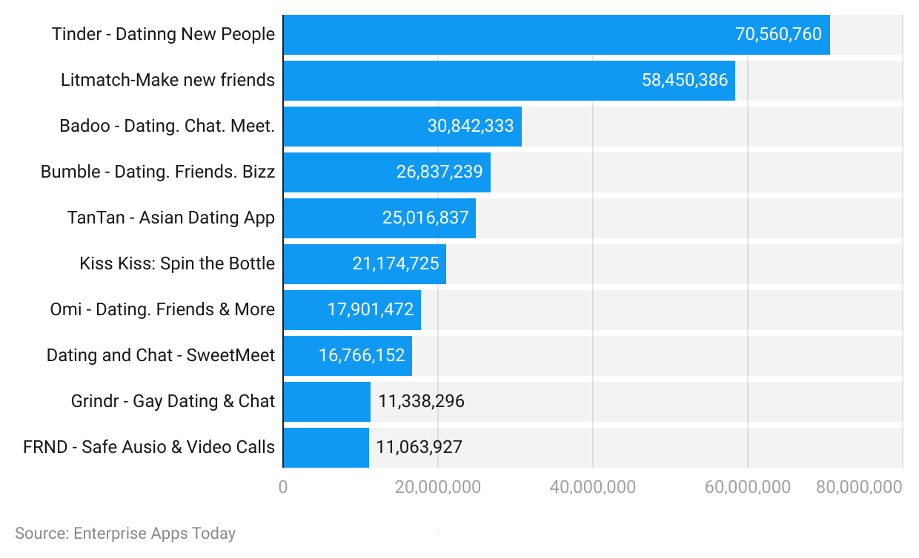

Fig 4, Source: Enterprise Apps Today

Porter’s Generic Strategies
- Differentiation – Emotional Experience (Hinge)
Hinge differentiates from other dating apps by offering a dating app experience focused on meaningful relationships and emotional compatibility, particularly designed for users who are tired of endless "swiping" in other dating scenarios.
- Focus Strategy – Women-First Model (Bumble)
Bumble is focused on a candle strategy by providing and supporting users who value safety, empowerment, and a respectful user experience.
- In both cases, intentional use of behavioural insight – safety, authenticity, emotional connection – operationalises each app's strategies to encourage sustainability.

Industry Examples Supporting Follower Strategies
- Bumble – Safety and Empowerment in Action
Bumble's women-first communication model acts immediately to the prevalent sociocultural phenomenon of online harassment. In 2022, Bumble released “Safety Alerts,” an AI built into the app that monitors all messages for offensive language, knowing users are either pretending to be or lying about their identity. It is a fantastic example of the human-centred style approach to emotional safety and respect for women experiencing vulnerability with dating apps (Sumter et al., 2023).
- Hinge – Designed for Meaningful Relationships
Hinge's strategies and experiences reinforce their focus to prompt in-depth conversations - by requiring user engagement through prompts, voice notes, and "We Met" post-match prompts, and monitoring the match quality through the questioning of in-depth conversations. Hinge's user behaviours - users knew that the intention of deep conversations promoted the chances for a longer-term relationship - align with the research showing that nearly 59% of online daters prefer meaningful relationships, not a casual experience (Smith, 2022).

Conclusion:
The strategic climate of the online dating sector exemplifies that both pioneers and follower firms must adapt to the constantly changing macro and micro environment influenced by technological change, cultural shifts, regulatory pressures, and ultimately consumer behaviour. Pioneers like Tinder and Grindr adapt to these dynamics both reactively by innovating early, moving the industry forward, and addressing challenges related to safety, inclusivity, and authenticity, from deploying AI-enabled safety prompts to culturally tailored marketing campaigns. These strategies illuminate the need for a deep understanding of emotional needs, self-expression, and behaviours that emerge and differ in communities around the world. Conversely, follower firms like Bumble and Hinge continue to compete by fulfilling the gaps left by pioneers. They inform their human-centred strategies around themes of empowerment, meaningful connection, and trust. Bumble's women-first model and AI harassment detection options are directed entirely towards user emotional safety concerns, while Hinge's design about intentionality is appealing to the user desire to combat exhaustion with the swiping culture and discourse.
In summary, the dating app industry is an example of a dynamic interaction between innovation, behaviour, and strategy, where organisations are successful when they listen to their users, ethically respond, and curate digital experiences that are grounded in the reality of digitally mediated social relationships.

Reference:
Sumter, S. R., Valkenburg, P. M., & Peter, J. (2023). Love in the Digital Age.
Smith, A. (2022). Pew Research Center Report on Online Dating.
Johnson, G., Whittington, R. and Scholes, K. (2020) Exploring Strategy. 12th edn. Harlow: Pearson Education.
Aguilar, F. J. (1967) 'Scanning the Business Environment'. Long Range Planning, vol. 1, no. 1, pp. 26–30.
Sumter, S.R., Valkenburg, P.M. & Peter, J., 2023. Love in the Digital Age: How Dating Apps Shape Social Interaction. Journal of Social and Personal Relationships. Available at: https://journals.sagepub.com/doi/full/10.1177/02654075231104105 [Accessed 19 Nov 2025].
UK Government, 2018. Data Protection Act 2018. Legislation.gov.uk. Available at: https://www.legislation.gov.uk/ukpga/2018/12/contents [Accessed 19 Nov 2025].
Pew Research Center, 2022. Dating Apps and the Transformation of Modern Courtship. Available at: https://www.pewresearch.org/social-trends/2022/03/16/dating-apps-and-modern-courtship/ [Accessed 19 Nov 2025].
Sumter, S. R., Valkenburg, P. M., & Peter, J. (2023). Love in the Digital Age: How Dating Apps Shape Social Interaction. Journal of Social and Personal Relationships.
Smith, A. (2022). Dating Apps and the Transformation of Modern Courtship. Pew Research Center Report.
Sumter, S. R., Valkenburg, P. M., & Peter, J. (2023). Love in the Digital Age: How Dating Apps Shape Social Interaction. Journal of Social and Personal Relationships.
Kotler, P., Keller, K., Goodman, M., & Hansen, T. (2022). Marketing Management.
Sumter, S. R., Valkenburg, P. M., & Peter, J. (2023). Love in the Digital Age.
Bumble (2023). Annual Financial Report.
Smith, A. (2022). Pew Research Center Report on Online Dating.
Sumter, S. R., Valkenburg, P. M., & Peter, J. (2023). Love in the Digital Age.

