Leadership & Management
Team Selection, Formation, and Leadership.

Author – William Thomas
Organization - UWTSD
City - Swansea

Abstract – This paper will explore the recruitment and management process of the project. The paper will outline solutions on how to motivate a team effectively, monitor teams or individuals’ progression effectively and nine common leadership approaches that might be used to best fit the situation. The paper will provide an executive summary, one that was directly from the NHS Wales Informatics Services and one that was created.

Introduction
This report will cover information on leadership, management and how it’s important. Leadership can be used in many different varieties such as an explorer cutting a path through the jungle, which allows others to follow or an executive which develops a company strategy to beat the competition. The report will cover information on how to recruit/select staff for the criteria given which is experience towards the sort of area the project is in such as tech or nature, can the person work well with others, etc. The project is being funded by NHS Wales Informatics Service. The project is all digital which requires the new recruits to have some sort of programming knowledge. Other aspects of the report are team motivation, tracking the team’s progression into the project as a whole and individually.

Information about the project [1-2]

Project Information –
The Project is being funded by the NHS Wales Informatics Service. The project is addressing the use of analytics on health data. The employees must have some type of programming knowledge to create the project. The project must be played out for the current employees and new employees to follow such as creating a program in which the health service can import and export medical data from a private secure database. NHS Wales Informatics Service delivers the digital health services needed for modern patient care. They supply over 70 software services to users across NHS Wales. The aim of the company is to provide every health care professional access to digital medical files for their patients across campuses and accessible 24/7 with layers of security to protect the person as it’s all confidential information. NHS Wales Informatics Service has three main branches and two small branches in the United Kingdom which employees a total of around 600 employees. [1] [2]

Additional Information –
Each employee must keep all files confidential to protect user’s data. The NHS Wales is a major corporation with a large amount of medical data which needs to be secure and accessible only to the correct medical personnel. If there was a data breach, then millions of health records could be leaked online or modified.

Summary –
To summarize this section, the project has been funded for NHS Wales Informatics Service. It’s a digital service which allows hospitals and clinics to access patients information. Which is stored on a private secure server so only authorized personnel can access it and modify it. This means that if the patient goes to another hospital due to another reason they can access the patient's medical history digitally which saves a lot of time rather than waiting for a hard copy to be sent to the hospital or the patient to remember every illness they may have.

The role of the manager [3]

Manager –
The manager has many responsibilities such as –
- Planning – To plan out any obstacle, to keep workflow going.
- Organizing – To organize the workspace area for maximum work efficiency for the employees.
- Implementing – Implement changes to the workplace to increase work efficiency.
- Direct – having direct communication with the employees to ensure they have the necessary tools for maximum efficiency.
- Monitor – To monitor the employees’ workflow, this will provide information on which employee does the least amount of work around the workplace and an investigation would be started on into how they can be changed for them to produce more work.
- Evaluate – The manager must evaluate each employee separately such as having one to one meetings with them to talk about what they would think would boost work efficiency around the workplace and also the manager would have a copy of their company evaluation report for the individual to assess them and ask them, how can they improve on this.
- Health and Safety for themselves and the employees.
- Communication – The manager must have great communication with all the employees and vice-versa. [3]

Team –
The team must always feel as they can approach the manager with questions, no matter how ridiculous the question maybe. If the employee doesn’t approach the manager for numerous reasons, this would lead to a lack of work ethic and workflow.

Staff Recruitment and selection [4-8]
Currently, the project team consists of five out of ten employees, in-which are uniformly male around the age of 25 to 35 years old. From this information, some recruitment ideas have been created to recruit efficient and productive workers that will work well with the previous five workers. Each of the workers will have to agree to the terms of public sector equality duty also known as (PSED). This means that the company that is Swansea App Synthesis Ltd has in-forced the policy, stops discrimination around the workplace also known as the Equality Act.

The starting point of recruitment – [4] [5]
The starting point of the recruitment plan is that looking at the previous sort of employees the current employees have worked with in the past and see if the same employees can return if they were not busy or if they didn’t break any of the companies policies to get fired. Looking at the employees previous work history gives an outline on what sort of person they worked with in the past and if it was a productive outcome or the pair/group wasn’t productive such as pairing the 25 year old male with a 51 year old male just for there to be lack of work efficiency since the 51 year old might hate working with young adults since they might lack some experience in some areas so they are always asking for help. [4] [5]

Understanding the needs of the employee –
Before starting the recruitment process, understanding the needs of in-which the new employee will be responsible for and what work they will be doing. This means that the manager must write down a list of what the new employee will be responsible for such as creating a company database or creating a company website. The application must have a differentiated job description that gets more people engaged in applying for the project, writing some realistic expectations of the new employee such as knowing python programming.

Job description –[6][7]
The job description must be clear and list all the responsibilities that the employee will be forced to part-take or follow. An example of this would be that Public Sector Equality Duty (PSED) would be listed on the application so someone who cannot abide by this policy cannot partake in this application. The job description must provide information where the job will take place such as it’s an on-site job or remote job where the person can partake in the project at home and the equipment they need will be sent there. There are five areas in which the job description must follow –
- Job Title – A simple job title such as network engineer rather than networking troubleshooting and support staff will confuse the applicant less as they might believe they job title comes with extra responsibilities and perks but it’s just another networking engineering perk, some might not even apply if it’s got the same salary as other jobs and a lot more responsibilities of the employees are needed than just using a standard title to define the role of the job.[6]
- Job Summary – The job summary must explain, what the job entails such as what the applicant will have to do but the job summary must contain attention-grabbing details, to make the applicant excited and it makes the job seem unique. [7]
- Responsibilities – The description must cover the day to day activities of the position and outline all the core responsibility of the position.
- Qualification – A list of qualifications for this position must be covered with a list of additional qualifications that might benefit the company in the future.
- Additional Information – Information must be covered on how the company operates and how it’s unique compared to other companies. For example, this company follows public sector equality duty also known as PSED.

Conducting Interviews – [8]
Conducting interviews is an important step when recruiting new employees, this allows the recruiter to directly to talk to the applicant, so they can be asked additional questions, do they have any questions about the job, do they know anything about the company and its history. This step is typically done either over the phone or an on-site interview is conducted. [8]

Selecting the applicants –
The manager must know to select five new employees that he/she conducted interviews with over the phone or in-person. The manager will be basing this off, their qualifications, work history and first impressions.

Training – [9]
New employees tend to have company training where they learn where the equipment is around the building and how to operate the equipment. Each employee must complete training to ensure that they know how to operate the equipment and no person could sue the company for not training the staff on how the equipment was meant to be used properly. [9]

Statistical information –[10] [11] [12]
There is an on-going pay gap between men and women. There are many reasons for this such as depending on the job some women get paid more than men but in other jobs, some men get paid more than women. This is due to the nature of the job is could be more harmful to women than a man, it could be the amount of work the employees do. There are many factors in which the person's wage is calculated, some more fairly than others but does this come under the equality act for gender discrimination, possibly but like stated above it’s all dependent on the job and the amount of work the employee puts in. An example of this would be health and social care, women typically get paid a higher rate than men but in construction it’s reverse. [10] [11] [12]

Public Sector Equality Duty (PSED) –[13] [14]
Public companies tend to enforce the use of public sector equality duty rather than private companies. Public Sector Equality Duty means that any decision or changes to the policies of the company must abide by the equality act. This means that the company cannot target selected people such as their age, disability, gender reassignment, marriage and civil partnership, race, religion, sexual orientation. The Equality act was created in 2010 and it states that all major companies must comply with its standards. This makes the workplace less of a hostile environment. This also means that more people can obtain jobs who wouldn’t of normally have gotten the job that they applied for. Equality around the workplace means that all employees, no matter who they are or what position they may hold must all be treated the same and that is with respect. [13] [14]

Summary –
To summarize this section, the manager is the role leader for the team that he/she instructs to accomplish a series of goals/tasks. If the manager doesn’t have a clear understanding of the goals/tasks and how to complete them then this could lead to problems. The manager must make sure that each employee is completing the tasks at a steady pace otherwise if one employee or more falls behind it could be problematic in the short-term or long-term such as missing the deadline of the project. Public sector equality duty is enforced on the company which means that all current and new employees must not be biased towards a certain stereotype which includes age, race and more, which is all covered under the equality act 2010. This section also talks about the recruitment process from creating a job description, interview process and training the employee.

Team- motivation [15] [16] [17]

Why is team motivation important?
Team motivation can increase productive around the workplace as employees tend to be more motivated to work harder and faster when there is a bonus or rewards at the end. This can also fail if there are constant rewards, which are not worth the effort, the manager should invest some money and create a bonus or reward once every few months to boost morale. [15]

Method 1 – To motivate a team –
Using rewards and paycheck bonuses, the employee would feel more motivated to complete the task sooner and increase work efficiency. This can also be used to allow employees to compete against the office to increase the whole workflow of the entire office. [16]

Method 2 – To motivate a team –
Some managers don’t get involved with the employees, in the terms of assisting them during the project, if the manager starts assisting each or most of the employees in his/her spare time then this would help with the completion time of the project and that shows the employees that the manager is also part of the team and approachable. This could motivate a team.

Method 3 – To motivate a team –
If the manager comes into work with a negative attitude it can have a negative effect on the work environment and employees. The manager should always be positive in the workplace as it can boost team morale.

Additional information –
Attempting to boost team morale can be a trial and error process, some methods work, and others don’t depend on the method used and the team that you are trying to motivate. This means that setting a reward for IT professionals would necessarily be a tech-related prize or something everyone would enjoy and aim to achieve but something such as a free gym membership might be less appealing which wouldn’t boost team morale on a massive scale but a few employees might be tempted to win the reward. The manager should use an easy and fair system to track each employee’s progress towards the rewards or whatever they are trying to achieve but if the same employees keep constantly winning then this would mean that the employees who don’t win anything would be less mutated to even participate [17]

Summary –
To summarize this section, team motivation is very important as it allows the team leader to boost morale around the workplace and making progress towards the goal a lot sooner. There are many methods of motivating a team and some work whilst some don’t. Constantly trying to motivate a team can sometimes have a negative effect on the workplace as it can create a hostile environment since all the employees will be competing against each other, this will create delays and issues within the workplace.

Leadership Approaches [18] [19] [20]
- Leadership Styles –
There are many leadership styles in-which the leader can operate with. Since there are so many to list, only the common ones which will be listed, which is a total of nine leadership styles –
- Transformational Leadership – Typically inspire staff by creating an environment of intellectual stimulation.
- Transactional Leadership – Establishes a clear chain of command utilizing a carrot & stick approach to management activities.
- Servant Leadership – Prefers power-sharing models of authority & encourages collective decision making.
- Autocratic Leadership – Have significant control over staff, rarely considers worker suggestions or share of power.
- Laissez-faire Leadership – Characterized by their hands-off approach, allowing employees to get on with tasks as they see fit.
- Democratic Leadership – Participative leadership, leaders often ask for input from team members before making a final decision.
- Bureaucratic Leadership – Implemented in highly regulated environments, with strict adherence to the rules are important.
- Charismatic Leadership – Relies heavily on the positive charm &personality of the leader in question.
- Situational Leadership – A theory that the best leaders utilize a range of different styles depending on the environment. [18]

- Leadership Approaches –
The leader must work with the team and allow them to provide feedback on how they feel the workplace can be changed to benefit the production of the company. The feedback can be anonymous and left in a suggestions box where the leader collects after a certain period and based on that feedback attempts to make those changes. This allows not just the leader to have an opinion on how the project operates but the employees will also have an opinion to give. The employees are the working force of the company and they should be the ones be compensated for their amount of work, which means a pay raise or reward. If the leader made all the changes to the office without the opinion of the employees, it could reduce the production of work. Some changes could be that the employees require a bigger workspace and there are more available unused rooms around the building in which they can use and be less distracted. [19]
- Implementing the changes –
The leader would act on the feedback from what the employees have provided by any large change would require the company’s permissions rather than the team leaders to ensure it can happen. The leader would need to assess each feedback given by the employees on the merits such as doe this offer any significant benefits to the company and the employee, does this have a high or low cost and does this work with all the policies that the company has enforced. [20]

- Summary –
To summarize this section, a leader must act on the feedback given by the employees and attempt to enforce it if it helps with work production, it’s in the project's budget and it doesn’t affect any of the company’s policies. There are nine common leadership styles listed which a leader can use and adapt to their situation. Some leader traits are great for certain scenarios such as having a democratic leadership in for the project would help as the employees can have their opinion before any changes are made to the project, workforce or workplace.

Monitoring the Team’s Progression [21] [22] [23]
- Key Performance Indicators –
Key Performance Indicators also are known as (KPIs) aim to improve the understanding of how the urgent care system is performing overall and drive up performance to ensure patients receive the best possible clinical outcomes and this done through a more balanced consideration that more accurately reflects the three domains of quality. [21]
- NHS Key Performance Indicators –
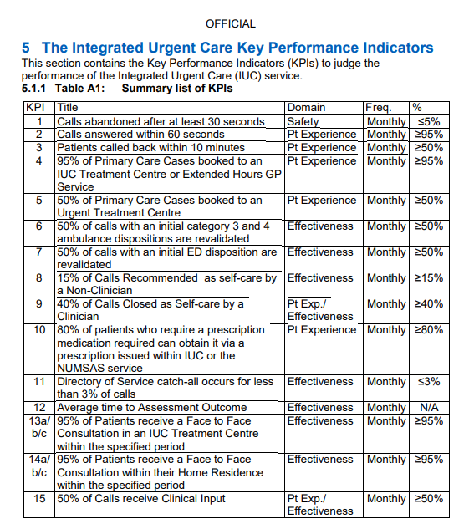
This is a list of all 15 Key Performance Indicators that the NHS Wales Informatics Service have enforced. The image above shows a summary of all of them such as title (Information), KPI number it’s assigned to, Domain such as Safety or Effectiveness. The frequency which is always monthly with the performance indicator value in the percentage column. Some KPIs are measured against average time. [22]
- The most effective performance metrics –
- Presence – The employee should finish a decent amount of work during the day before heading home otherwise if the employee, just heads home claiming they had finished the work, they are a detractor.
- Leadership – The leadership role as known as “taking the initiative” over someone else. Leadership involves boosting the morale of others and making sure the employees have the necessary tools to complete the tasks they have been hired to do.
- Hourly Commitment – The number of time people spend in your offices indicates how committed they are to the project. The employee should attend all work hours and stay for additional hours in-case they fall behind.
- Work quality – Some employees believe that the faster the project is completed they can move onto the next but this may be true but it comes at a cost of having the current project lack in work quality as the required amount of time into certain areas have been reduced. Think of it has as a programmer is creating large programming over the week, but he/she decides to speed-write the code to massively reduce work time. There might be errors towards the end which will cause major troubleshooting times.
- Personal development – Bringing in new opportunities for the employees to partake in might boost morale since they might have wanted to attempt something like that and add it to their resumes. Try to incentivize personal development through discussions, courses, conferences, and organized seminars.
- Daily coaching – Having one on one talks with the employee about their daily routine, motivation, personal goals, and performance. This allows the leader to have a much better understanding of the employee. [23]
- Monitoring Individual Employee’s Performance –
- Annual Employee Review – Checking the feedback of the employee’s history such as the amount of time they have spent at the company, on the project, working on in the project. Number of hours spent in the office (Can be accessed via timecards etc.)
- Employee badge – The employee must scan their badge on a certain RFID reader machine for it to log the entry time and leaving the office time which will access how long the employee was in the office for.
- Monitoring the Team’s Performance –
- Viewing the project as a whole – This can be done online or offline. There are sites/applications such as Trello which allows companies to create a development board which allows them to add task by task and assign the correct employees to each of them. This is synced online and on mobile.
- Summary –
To summarize this section, Key Performance Indicators allows performance reviews to be developed and show if there are any outliers. The NHS Wales Informatics Service has 15 different KPIs enforced. This section lists some methods of tracking an individual’s progress towards the project or tracking the whole teams progress to find out if the project will be completed on time and what still needs to be completed.

Executive Summary [24]
- NHS Wales Informatics Service Executive Summary–
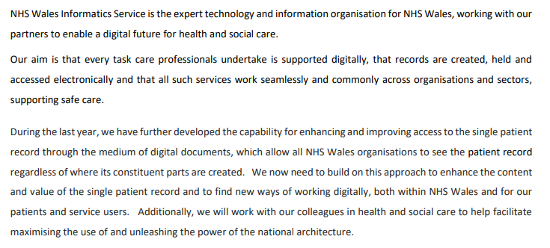
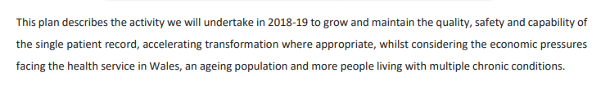
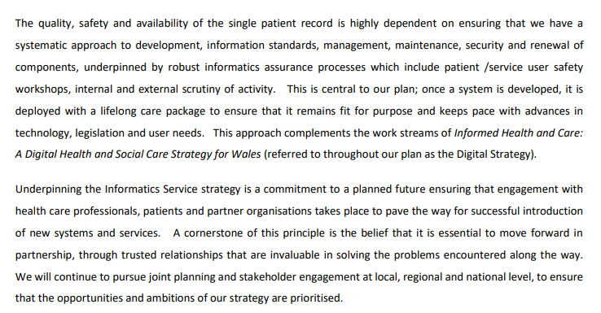
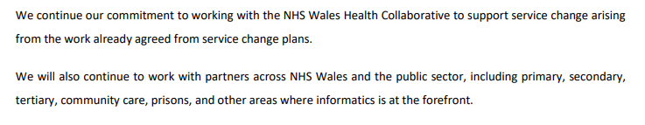[24]
- Executive Summary –
This report provides an analysis and evaluation of recruiting and managing a project for NHS Wales Informatics Service. Methods of analysis include equality inside of a workplace, analysis on what motivates a team and analysis on leadership approaches. Results of this data show that there are nine common leadership styles, which all have different advantages and disadvantages. The report finds that the leader isn’t the one person who makes the decisions as the employees can also make decisions otherwise if the leader made many changes that the employees didn’t ask for or it causes a negative effect for the employees then this could cause lack of motivation. Recommendations, improve communication between the employees and leader, attempt different motivation tactics, when recruiting, add a lot of requirements, benefits, and qualifications to it so the applicant can understand the job better and what goes with it. Some limitations of the report would be that not all team motivation tactics would motivate the team but another team it might, it’s a trial and error process such as finding the correct leader to manage the team.

- Summary –
To summarize this section, a copy of the NHS Wales Informatics Service Executive Summary was placed into the report, an executive summary for the report was created. An executive summary is a short document that summarizes a longer report or proposal.

Conclusion
In conclusion of this report, the report covers the project information that was given such as the company that has funded the project, the leader must recruit an additional five new recruits into the project, they must also work with the five employees already placed onto the project. The recruits must follow the equality act and have no discrimination of any kind in the workplace. This is covered under the public sector equality duty (PSED). This report covers the manager responsibilities around the workplace, how to recruit new employees for the project and how to determinate which person to accept if there are so many applicants such as who has more qualifications etc. Team motivation is important as it boosts team morale around the workplace and production of the work. If the employee is working slowly because of certain reasons, then team motivation could boost their spirits which will boost the production of work. They are nine common leadership approaches which the leader can use around the workplace to better fit the situation that they are in. This report lists methods on how to track the progression of the team and each individual employee to see how much the project has progressed and how has put the most effort into the project. This will also show if the project would be completed on time.

References

- NHS Wales Informatics Service – about page
http://www.wales.nhs.uk/nwis/aboutus
Time/Date accessed – 15:29 20/04/2019
- NHS Wales Informatics Service – working for us page
http://www.wales.nhs.uk/nwis/page/52708
Time/Date accessed – 15:34 20/04/2019
- S. Yu, L. Liu, and M. Fu, "The Application Research on Knowledge Management of Project Manager," 2009 International Conference on Information Management, Innovation Management and Industrial Engineering, Xi'an, 2009, pp. 340-343.
https://ieeexplore-ieee-org.ezproxy.uwtsd.ac.uk/document/5369179
Time/Date accessed – 23:01 21/04/2019
- Gary Rees and Ray French, Leading, Managing and Developing People, 3rd edition, CIPD 2010
https://www2.cipd.co.uk/NR/rdonlyres/01F95685-76C9-4C96-B291-3D5CD4DE1BE5/0/9781843982579_sc.pdf
Time/Date accessed – 09:34 22/04/2019
- CIMA Breaking Glass: strategies for tomorrow’s leaders, 2010
https://www.cimaglobal.com/Documents/Thought_leadership_docs/2010-08-09-women_in_leadership_report.pdf
Time/Date accessed – 09:45 22/04/2019
- Lever recruitment process
https://www.lever.co/recruiting-resources/articles/recruitment-process
Time/Date accessed – 09:48 22/04/2019
- Indeed, Job description
https://www.indeed.co.uk/hire/how-to-write-a-job-description
Time/Date accessed – 09:50 22/04/2019
- H. Chaudhari, N. Yadav, and Y. Shukla, "A predictive analysis on job recruitment," International Conference on Recent Trends in Engineering, Science & Technology - (ICRTEST 2016), Hyderabad, 2016, pp. 1-5.
https://ieeexplore-ieee-org.ezproxy.uwtsd.ac.uk/document/8360599
Time/Date accessed – 09:53 22/04/2019
- Z. Wang, X. Tang and D. Chen, "A Resume Recommendation Model for Online Recruitment," 2015 11th International Conference on Semantics, Knowledge, and Grids (SKG), Beijing, 2015, pp. 256-259.
https://ieeexplore-ieee-org.ezproxy.uwtsd.ac.uk/document/7429390
Time/Date accessed – 09:56 22/04/2019

- Chwarae Teg Briefing Paper, Women and the Economy, January 2015
https://www.cteg.org.uk/wp-content/uploads/2015/02/chwarae-teg-policy-women-and-the-economy-1-1-DT-en.pdf
Time/Date accessed – 09:58 22/04/2019
- H. Wax, "Waging a Battle for Gender Equity: Swiss Advocates Balancing Male and Female Strengths," in IEEE Women in Engineering Magazine, vol. 7, no. 1, pp. 26-29, June 2013.
https://ieeexplore-ieee-org.ezproxy.uwtsd.ac.uk/document/6482173
Time/Date accessed – 11:43 22/04/2019
- L. Antonie, A. D'Angelo, G. Grewal, and M. Plesca, "Analyzing the Gender Wage Gap in Ontario's Public Sector," 2015 IEEE 14th International Conference on Machine Learning and Applications (ICMLA), Miami, FL, 2015, pp. 465-470.
https://ieeexplore-ieee-org.ezproxy.uwtsd.ac.uk/document/7424359
Time/Date accessed – 11:56 22/04/2019
- EHCR The Essential Guide to the Public Sector Equality Duty: An overview for listed public authorities in Wales
https://www.equalityhumanrights.com/sites/default/files/essential_guide_to_the_public_sector_equality_duty_wales.pdf
Time/Date accessed – 13:04 22/04/2019
- Acas working for everyone
http://www.acas.org.uk/index.aspx?articleid=5990
Time/Date accessed – 13:31 22/04/2019
- Graeff, Claude L. (1997), ‘Evolution of Situational Leadership Theory: A Critical Review’, Leadership Quarterly, 8(2), pp153-170
https://pdfs.semanticscholar.org/8b27/266ca1612c960570b786af068e9f5c99c098.pdf
Time/Date accessed – 11:03 23/04/2019
- P. Chen, C. Chern and C. Chen, "Software Project Team Characteristics and Team Performance: Team Motivation as a Moderator," 2012 19th Asia-Pacific Software Engineering Conference, Hong Kong, 2012, pp. 565-570.
doi: 10.1109/APSEC.2012.152
https://ieeexplore-ieee-org.ezproxy.uwtsd.ac.uk/document/6462711
Time/Date accessed – 11:15 23/04/2019
- W. Lee, "An integrated model of team motivation and worker skills for a computer-based project management simulation," 2013 Winter Simulations Conference (WSC), Washington, DC, 2013, pp. 3133-3144.
doi: 10.1109/WSC.2013.6721680
https://ieeexplore-ieee-org.ezproxy.uwtsd.ac.uk/document/6721680
Time/Date accessed – 11:42 23/04/2019

- TEC The executive connection
https://tec.com.au/resource/9-common-leadership-styles-which-type-of-leader-are-you/
Time/Date accessed – 11:50 23/04/2019
- CPID UK
https://www.cipd.co.uk/knowledge/strategy/leadership/factsheet
Time/Date accessed – 14:12 23/04/2019
- S. Jing and C. Juhong, "Core enterprise leadership style, inter-organizational trust, and cooperation performance," 2013 6th International Conference on Information Management, Innovation Management and Industrial Engineering, Xi'an, 2013, pp. 429-432.
doi: 10.1109/ICIII.2013.6703611
https://ieeexplore-ieee-org.ezproxy.uwtsd.ac.uk/document/6703611
Time/Date accessed – 14:43 23/04/2019
- NHS England’s Official Website –
https://www.england.nhs.uk/urgent-emergency-care/nhs-111/resources/
Time/Date accessed – 13:02 26/04/2019
- NHS England’s Official Website –
https://www.england.nhs.uk/wp-content/uploads/2018/06/integrated-urgent-care-key-performance-indicators-quality-standards.pdf
Time/Date accessed – 13:13 26/04/2019
- Azendoo
https://blog.azendoo.com/6-metrics-for-measuring-team-member-performance/
Time/Date accessed – 18:43 26/04/2019
- NHS Wales Informatics Service Annual Summary
http://www.wales.nhs.uk/sitesplus/documents/956/PLN-NWIS%20Annual%20Corporate%20Plan%202018-19%20V5web.pdf
Time/Date accessed – 15:40 29/04/2019

