MODULE TITLE: FRONT OFFICE OPERATIONS

M4X01920

ASSIGNMENT TITLE:

STUDENT NAME: IOSIF DANIEL STAN

STUDENT ID NUMBER: 1815337

LECTURER NAME: DR.JAHANZEEB QURASHI

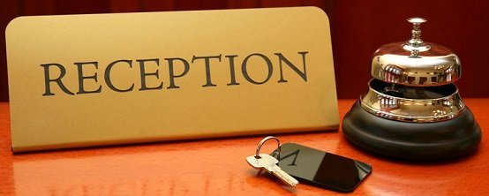


Table of Content

Introduction……………………….………………………. 3

Functions of accommodation units……………………4

The communication between the management of the reception compartment and the component sections……………………………………………………..4

Horizontal intercompartmental organizational communication…………………………………………….5

Conclusion………………………………..………………..8

References………………………………………..………..9

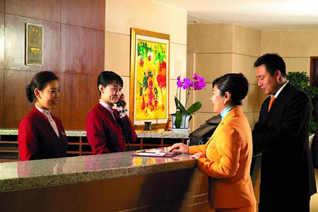

Introduction

Hotels or comparable gadgets are characterised through the usage of their arrangement on rooms, respecting a minimal amount of rooms, having a unique manage organization and providing properly defined offerings that encompass room company, cleansing, sanitation facilities, and so on. "Secondly, the hotel might also is defined as an corporation whose essential enterprise is to offer accommodation facilities for the majority and which also can offer customers with one or greater of the following services: food, room cleaning, reception offerings, laundry or use of some Specific offerings Another point of view is the inn as an status quo wherein, on price, travelers can live, as well as feed and have amusing.
To provide customers with a considerable variety of services, a lodge is commonly divided into several departments, each having wonderful functions and attributions. For the clean and harmonious operation of a motel, it's miles crucial for the distinctive departments to paintings together.
The hotel enterprise activates, through the services offered, in the tourist market. In accordance with the general acceptance, this is represented by "the totality of transactions (sale-purchase documents) whose object constitutes the tourist products, viewed in connection with the relations they generate and the geographical space and even the time in which they are carried out". In the opinion of Philip Kotler, the market generally represents “the totality of economic persons or units that buy or can be determined to buy a product or service.

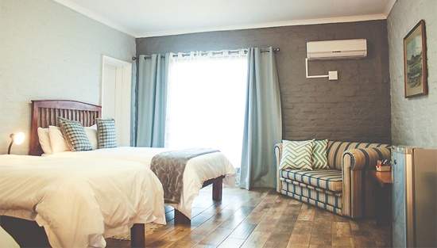
Functions of accommodation units

The contribution of the hotel activities to the development of the tourist activities resides from the physiological needs for rest and comfort of the man during the travel and the tourist stay. Generally, the man devotes in the 24-hour cycle of one day about 7-8 hours of sleep and some about several hours of eating. If at this time there are added other necessities of the modern man, it results that more than half of the holiday time of a tourist arrived in the resort is consumed within the tourist objectives. To meet these requirements, the accommodation objectives can fulfil certain complex functions, among which can be mentioned:
- the actual function of accommodation
- complementary functions related to completing the accommodation functions and for spending time with passengers
- productive functions, imposed by the processes of preparing the client's food
- commercial functions, meant to ensure the supply of the client with a series of necessary goods during the stay
- information functions:

1. The communication between the management of the reception compartment and the component sections

Head of reception communicates:

- Rules and regulations specific to the reception activity
- Working formations
- The coordinates of the sale, reservation and overbooking policy
- Actions that require special preparations and measures
- Special measures established in certain situations
- Special treatments for the clients of the house and VIPs
- Complaints and other issues that have been reported

The reception staff communicates to the reception manager the following information:

- Specific operating indicators

- Daily booking situation

- Special requests that exceed the competence of the reception workers

- Particular situations

- Personal problems

2. Horizontal intercompartmental organizational communication

By the nature of the activity, the reception is linked through organizational communication channels with:

• The floor (housekeeping) compartment (service)

• Sales (marketing) department (service, office)

• Restoration department (service)

• The ethnic (maintenance) compartment (service)
• Compartment providing additional services: agreement, treatment, sports bases, transport, rental

2.1. Communication between reception and floor:

• The situation of the rooms at the beginning of the hotel day

• Arrivals of tourists during the hotel day

• Unannounced departures

• Customer departures after 12 o'clock

• Particular situations

• Special treatments for the clients of the house and VIPs

• The defects claimed

• Requests for mounting the extra bed

• Customers' special requests and preferences

2.2 Communication between the floor and the reception

• Governance report on the situation of the rooms (before 12 noon)

• Particular situations

• The defects detected and the requests for their correction

• Consumption from the refrigerated minibar

• Vouchers for additional services

• Forgotten objects

2.3. Communication between the reception and the technical compartment

The relationship with this department implies from the reception:

• Communication of faults and all problems found in rooms or other spaces by the floor or reception staff.

• Collaboration for the purpose of putting into operation and exploiting some installations and equipment specific to the activity from the reception.

• The technical department informs the reception about the possibilities of remediation or the temporary inability to remedy, the time needed for the remedy, the completion of the remedy.
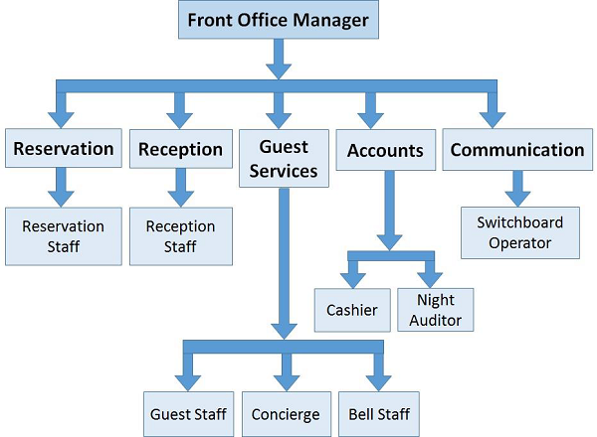

In the case of organizing a larger, international hotel, we distinguish even three levels of organization, namely:
- the corporate level
-the level of management of the respective hotel
- the operational level of the hotel

The Organization may be defined, in fashionable, as a device of coordinated sports of a set of human beings, who cooperate for the fulfilment of a common cause, being granted yes to a positive authority.
An inn may be taken into consideration for the achievement of a not unusual purpose, being run by the usage of a fine authority:
-It is set up to attain superb goals, which includes accommodation and meals offerings. So, it is easy to reap earnings;
-Plans and coordinates the sports of the personnel or for accomplishing the goals;
-The group of workers is divided into functional departments every having its personal vicinity of authority and responsibility.

The Organizational Structure
Except for terribly combined character type inns, circle of relative’s unique hotel sports is fulfilled inside a few offerings or departments.
The issuer is a group of people who carry out homogeneous or complementary operations, fulfil a selected characteristic inside the resort and act underneath the control of a person in charge (carrier supervisor).
Service corporations shape departments, and all departments shape the hotel itself.
Within the offerings can be fashioned cubicles, offices, sections, brigades, events, and many others.
The grouping of employees into offerings and departments is done in keeping with several standards:
1. The distinction of the interest, constant with which we differentiate amongst offerings and operational departments and offerings and purposeful departments. Operational departments and services are folks who make sure the immediate provision of resort offerings. Operational activities precise to a hotel are those of lodging and meals, telecommunications, condominium rooms, hairdressing salons, swimming pool, sauna, gym, flower save, etc.
The practical departments and services are collateral however unavailable to the hotel's operation, specially administration, advertising and marketing, renovation.
2. Extent of authority. In order to reveal what this criterion of differentiation of the carrier and the hotel departments consists, we are able to gift a few synonymous phrases, respectively the manipulate norm, the quantity of subordinates at once or the hierarchical weight. This criterion relies upon at the quantity of the attributions as well as the duty of each control framework. Thus, not like a department head or even a service head, a director (branch head) has exceptional responsibilities besides the ones of coordination and manipulate of subordinates.
Generally, the higher the hierarchical stage, the greater time allocated to the responsibilities of forecasting and enterprise have a extra weight, to the detriment of the obligations of coordination and control, and to them, the activities of coordination and manage have a greater complex individual.
We distinguish notions which includes:
- The efficiency threshold that applies to the directors and provider heads, where the most range of coordinators is 5.
-The supervisory unit this is executed in the offerings, this is in the variety 10-30.
3. Hotel potential, framing class, and plenty of others.
The organizational form inside a lodge is decisively induced via the complexity of the motel, the scale and fashion of operation. In a lodge of modest class and with exceedingly small potential, the organizational structure does no longer increase specific troubles.
In the ones situations, the principle of multiplying the attributions for each character worker, however in particular for the hotel manager (boss) is applied.
A big, luxury inn will carry out many more sports, and every worker can have one-of-a-type duties.
The corporation of the pastime within a resort depends specially on the scale of the hotel. One of the predominant differences is that in a big inn the manager is regularly the owner, while the employees is precisely specialized, at the same time as in a small motel an employee performs numerous sports.

Conclusion

In closing I think that the front office has the main operation as that’s where everything starts, as you walk in a hotel first thing you see is the front office (reception) there you ask them what you need or where exactly the rooms, restaurant and pool is. From the reception you can get anything you need for example in some hotel you can get your towel from there but most of them the receptionist tells the maids to do it. So, as I said the reception is the most important place in the hotel.




References

- Lupu, N., 2010, Hotel - - Economy and management, 6th Edition, All Beck Publishing House, Bucharest, p.8

- Kotler, Ph., 2008, Marketing Management, Teora Publishing House, Bucharest, p. 349

- Kotler, Ph., 2008, Principles of Marketing, Teora Publishing House, Bucharest, p. 94 Sava, C., 2007, Strategies for developing the tourism activity, Euro Stampa Publishing House, Bucharest, p. 117

- Sava, C., 2008, Tourism in the context of sustainable regional development, Eurostampa Publishing House Bucharest, p. 126 Olteanu, V., 2008, Services Marketing, Ecomar Publishing House, Bucharest, p. 111

- Cristureanu, C., 1992, Economics and politics of international tourism, Abeona Publishing House, Bucharest, page 106 Gherasim, T., 2000, Tourism Marketing, Economic Publishing House, Bucharest p. 79

- Lupu, N., 2010, Hotel - Economy and management, 6th edition, All Beck Publishing House, Bucharest, p.51

