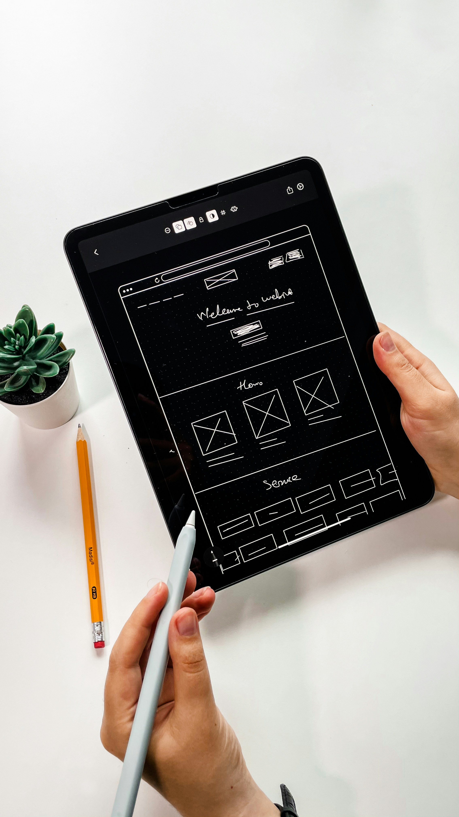  Usability Engineering  ACCB6017 | Ahnaf Hossain  2232354  University Of Wales Trinity Saint David

Table of Contents
1. Introduction 2
2. Personas and user experience requirements 2
3. Information gathering and requirements elicitation 4
Requirements and MoSCoW prioritisation 4
4. Designing for Usability 4
5. Storyboard wireframe: main menu screen 5
6. Prototype Feedback 6
6.1 Positive Feedback 6
6.2 Negative Feedback and Unexpected Observations 7
Conclusion 8
References (IEEE style) 9
APPENDIX 10

1. Introduction
This report describes the first round of user requirements and wireframe prototyping for a mobile game loosely based on the board-game CLUEDO. The imagined premise is that a senior university leader has been mysteriously murdered, and the player must deduce who, with what object, and in which generic campus location was responsible. This assignment’s aim is not to deliver a full game implementation, but to instead show a usability-led design process: through creation of personas, elicitation of user and experience requirements, construction of an initial wireframe storyboard, and collection of early usability feedback.
Usability is defined as per the ISO 9241-11 standard: the extent to which specified users can use a product to achieve specified goals with effectiveness, efficiency and satisfaction in a specified context of use [1]. This report therefore focuses on mobile interaction constraints, accessibility for a broad age range (18–60), and support for both novice and experienced gamers. The main theoretical background includes well-established usability engineering and interaction design literature such as Nielsen’s writings on usability engineering and heuristics [2], [3], Preece, Rogers and Sharp’s interaction design guidelines [4], and Garrett’s user experience framework [5].
The prototype is intentionally low-fidelity at this stage: a single monochrome main-menu wireframe which sets the look and feel for subsequent screens. Later assignment work will develop this into a coloured, multi-screen design; however, even this initial wireframe must by now already incorporate the key usability and user-experience decisions.

2. Personas and user experience requirements
Four personas were developed to represent the range of users in the university community. Personas synthesise user research and design assumptions into concrete “archetypes” which support reasoning about user needs and scenarios [5]. Each persona is presented with a short scenario and associated user and experience requirements.
Persona 1 – Emma Hughes (19, First-Year Student)
- Tech-savvy undergraduate studying Applied Computing.
- Plays casual mobile games during commutes and between lectures.
- Scenario: opens the game while waiting for class; wants to start instantly without reading long instructions.
- User requirements: quick access to Play, fast time-to-first-action, one-handed portrait use.
- Experience requirements: sense of mystery, immediate progress feedback, smooth first-time experience to avoid overwhelm.

Persona 2 – Rhys Morgan (28, Postgraduate + Staff Support Worker)
- Uses an iPhone; plays short games during work breaks.
- Has red–green colour-blindness and relies on high-contrast interfaces.
- Scenario: opens the game during a 10-minute break; needs the UI to be instantly clear.
- User requirements: adjustable audio, colour-independent icons, legible text.
- Experience requirements: efficient navigation, minimal steps, concise “How to play.”

Persona 3 – Aisha Patel (35, Distance Learner)
- Works full-time; studies remotely; unfamiliar with campus layout.
- Mild dyslexia; prefers clean typography and short text blocks.
- Scenario: tries the game after seeing it on a course forum; needs generic, non-campus-specific explanations.
- User requirements: instructions that avoid real building names; short, chunked help text.
- Experience requirements: feeling included as a remote learner; not disadvantaged by limited campus knowledge.

Persona 4 – David Lewis (56, Administrative Staff)
- Uses a smartphone mainly for basic tasks; low confidence with games.
- Small touch targets and complex menus frustrate him.
- Scenario: opens the game during lunch; decides quickly whether the menu looks simple or confusing.
- User requirements: large buttons, minimal menu options, clear labels.
- Experience requirements: low cognitive load, sense of simplicity, easy access to exit/settings.

Common requirements can be seen across these personas, such as an uncluttered main menu, immediate access to playing the game, a clearly signposted help area, and visible but non-obtrusive access to settings and audio controls. These are later formalised with MoSCoW prioritisation in Appendix A.

3. Information gathering and requirements elicitation
As it would have required ethical approval, no formal user data was collected at this stage, but some initial observations were gathered from short, unstructured discussions with some other students about their use of mobile devices, typical games, any accessibility requirements, and the time they would have available for an 8-10 minute whodunit. Interaction-design research suggests that lightweight initial user enquiry of this type can be appropriate when more formal methods are infeasible, and, when corroborated with secondary sources, can provide useful information on observed patterns and trends [4], [6].
A short review of HCI (Human–Computer Interaction) and game-design literature provided some background and support for these informal observations, with multiple sources reporting that clear feedback, quick interaction loops and simple, consistent controls are key to engagement and accessibility in usable systems [2], [9]. The key patterns identified from this combination of enquiry and literature will inform the initial high-level requirements.

Requirements and MoSCoW prioritisation

The observations and insights were documented as functional and experiential requirements and organised with the MoSCoW prioritisation method to help manage scope in these early stages of development [4]. Essential requirements are clear and prominent call-to-action for the Play button, an easy-to-find “How to Play” option, icons for common functions (sound and settings) that are easily recognisable, and use of touch targets that follow basic ergonomic and usability guidelines, such as Fitts’s Law linking target size and error rate [7], [8].
Secondary requirements help support a minimalist user interface and one-handed and portrait mode use, as well as presentation of help information in concise, readable steps. Desirable but non-essential features at this stage include a difficulty setting or cosmetic themes; these will be deferred to future versions of the system. More complex and high-cost features, such as online multiplayer or more detailed and extensive map layouts of real campus buildings, were considered out of scope at this stage to avoid introducing excessive complexity.
The complete MoSCoW requirements table is available in Appendix A.

4. Designing for Usability
The design of the wireframe is based on a human-centred approach, taking well established usability principles into account. It provides a minimal, easily understandable entry point to the application. ISO 9241-210 mentions the importance of “developing an understanding of the users, their tasks and their environment, defining and prioritising requirements, and evaluating the designs as early ideas” even at low fidelity [13]. This screen therefore represents the initial structural concept that will be iterated on and expanded in Part 2.
As a first design sketch of this stage, the emphasis was put on structure over aesthetic design, in line with the Garrett’s user-experience framework [5]. Nielsen’s heuristics were also taken into consideration: the interface is kept clean with not too many objects on screen, the next step is made obvious, and familiar icons for sound and settings were chosen, addressing consistency issues, in particular, to “make the user experience smoother and the learning effort smaller” [3].
Mobile ergonomics also informed the choices. For example, big centrally placed buttons allow for easy, accurate tapping and one-handed operation, in line with Fitts’s Law and the research on increasing target size to reduce time and improve accuracy of tasks [7], [8]. On the other hand, the two icons for sound and settings on the side tab are still easily accessible but less prominent, thus leaving the user’s attention on the central task.
Accessibility was a core focus of the design decisions that were made in order to achieve simplicity. For example, all information, especially text and icons, is not conveyed by colour alone. Whitespace is used to increase readability. The limited number of options reduces the cognitive effort required from the user. All these are in line with usability heuristics and standards, in particular, that interfaces need to remain usable for a wide range of abilities and experience levels [1], [13].
In summary, the wireframe design prioritises clear structure, unambiguous navigation and low cognitive effort.

5. Storyboard wireframe: main menu screen

The single wireframe shows the structural entry point into the game. It is also the visual template for the future screens to be made in Part 2 of the assignment. The wireframe is drawn in portrait orientation and in a rounded-corner device frame, showing a smartphone context.
At the top and bottom of the screen there are generous blank margins to frame the interface and minimise clutter. In the centre there are two horizontally aligned, pill-shaped buttons stacked vertically. The top button has the text label “Play” and the bottom one “How to play”. The buttons mimic the rounded edges of the device, creating a unified visual language. The typography is simple and bold, which supports readability for users with mild vision impairments.

On the right side of the screen a vertical tab sticks inwards. It contains two icons, a speaker icon on top and a cog (gear) icon on the bottom. This tab visually conveys the idea of a slide-out panel, from which further configuration options could be accessed. The icons are clearly recognisable silhouettes, still identifiable without colour.
From a narrative point of view, pressing the “Play” button would switch to the still-to-be-designed game setup screen where the player chooses a role and the investigation begins. Tapping the “How to play” button would bring up a few short steps with concise instructions about the murder-mystery mechanics and basic controls. The storyboard supports two main early flows: immediate play for users who are familiar with the genre or have a gamepad (Emma and Rhys) and asking for instructions for other users (Aisha and David).
This approach is aligned with the playcentric game-design principles, which advise quick access to the core loop while still allowing optional learning material [10]. By keeping the main menu simple, this wireframe maximises the probability that first-time players will advance fast enough to at least have a sense of the core mystery, a well-established principle of mobile-game usability and engagement [9], [12].

6. Prototype Feedback

6.1 Positive Feedback
The most common reaction to the wireframe was positive, with participants frequently using adjectives such as “clean”, “simple”, and “easy to follow”. In particular, the “Play” button being the first thing visible confirmed to users that they could start the game without having to drill into menus and read instructions. This validated the initial approach of making entry to the game obvious, matching research on the value of clearly signposting next steps for first-time interactions [9].
Users also said that having a limited number of items on screen supported their exploration of the app, suggesting that the restricted controls could help users to reduce cognitive load. The positioning of the sound and settings icons in a narrow panel on the left was generally praised. Participants said that they felt it made sense for these controls to be separate from the primary action and that this arrangement helped to make it clear where to start. This would appear to support recommendations from usability engineering that configuration features should be easy to reach but out of the way so as not to compete with the main flow of interactions [2].
A number of users who gave positive feedback also said that they felt that the interface would not intimidate someone with low digital confidence, and that it would be suitable for anyone who may not be used to playing mobile games. This included several comments that one would not be afraid to try the game with parents or grandparents. It was also suggested that it would be simple enough for someone with minimal digital experience to try out. Quotes such as “I’d feel confident giving this to someone who doesn’t game much” suggested that this was a shared view among users. This supports the hypothesis that low-clutter interfaces, by stripping away extraneous information, could provide a positive first impression for both inexperienced and expert users [4].
Participants also gave positive feedback regarding potential users with accessibility needs, for example, those with vision impairments or physical disabilities that could affect how they used a touchscreen. For example, a participant noted that the interface made sense because they were not required to deduce which option was which based on the colour coding, with the use of shapes, text labels and clear positioning being more significant. This could be considered to support the inclusion of redundant cues to support understanding of an interface and recommendations on making meaningful use of colour differences.
In summary, the positive reactions to the wireframe suggest that even as a single-screen prototype, the interface communicates the core values of simplicity, clarity and low-friction entry as intended. It also appears to match expectations of the personas outlined previously.

6.2 Negative Feedback and Unexpected Observations
Negative and constructive feedback from the test participants is also included, starting with the most frequent observations. The biggest criticism was that from the screen alone it was not immediately clear to participants what type of game or experience one was getting. The first screen is effectively a menu with no title, logo or short description, which meant that some users felt that the game could be of almost any category and were simply starting. This is not surprising for a first wireframe and was offset by the positive comments above, but this does suggest that it is important for even the most low-fidelity screens to include a basic level of narrative content in order to frame the user in the context of use.
The second area of feedback that was not anticipated was a question over the left-hand side panel. Participants wanted to know whether the entire tab was one interactive area or if the speaker and cog icons were tappable separately. This is a function of the side panel being a very simple shape without outlines, shadows or other markers that might indicate where a user can tap or press. It is a common issue when testing with low-fidelity prototypes that actions are not understood because there is no explicit affordance for them. This is an area where such simple testing is valuable, as the discovery of these ambiguities in wireframes can help to validate that more detailed design work resolves these issues. It is also not unique to this test, as research into user interfaces for games also finds that users can often make incorrect assumptions about whether they can interact with an element or in which order if the boundaries are not clearly shown [11],
The final unexpected feedback related to the gap between the “Play” and “How to Play” buttons, with one participant noting that they had a larger hand and that the gap might still not be enough to avoid accidentally tapping the wrong area. This participant went on to say that this would be a risk if they were holding the device and walking, perhaps if they were on their way to join a group playing together. This would suggest that the suggested use of the game may need further consideration in terms of which hand size and device is being supported. In terms of research, it would also tie into Fitts’s Law, which suggests that larger and better-spaced targets help reduce the chance of errors [7], [8]. This is an issue which should be tested on multiple screen sizes, particularly as part of tapping accuracy and other direct interaction performance.
A smaller group of participants also noted that they would like additional guidance as to which option was intended first. For example, the word “Play” suggests pressing it immediately, but would it be sensible for some users to select “How to Play” first? This would suggest that there is value in adding in some micro-guidance using text, layout, and potentially short introductory prompts for users who like more direct onboarding.

Conclusion
This report has presented the early user-centred design work for a mobile, university-themed mystery game. Personas were created for and based on four student and staff users of different ages, abilities and technology confidence levels. User requirements and experience requirements were defined and extracted from these personas and prioritised using the MoSCoW method. They were focused on a simple and accessible main menu, with unambiguous actions and configuration controls which do not interrupt play.

Guided by standards and texts on usability engineering, human-centred design and game UX, a single low-fidelity wireframe for the main menu screen was created. It was designed in line with principles of ISO 9241-11 and ISO 9241-210, Nielsen’s heuristics, Fitts’s Law and playcentric game design. Informal peer review showed that it is easy to read and navigate, and also suggested some opportunities for improvement like thematic signalling and making affordances more clear.

While only one screen has been presented, this early work has established a robust structure to build upon in the coloured prototype of the extended game to be developed in the next assignment. Anchoring even this small part of the interface in usability engineering principles and user-centred design thinking will set the project up to create an engaging, inclusive and successful mystery game experience in future iterations.

References (IEEE style)
[1] ISO 9241-11:2018, Ergonomics of Human-System Interaction – Part 11: Usability: Definitions and Concepts. Geneva, Switzerland: International Organization for Standardization, 2018.
[2] J. Nielsen, Usability Engineering. San Francisco, CA, USA: Morgan Kaufmann, 1993.
[3] J. Nielsen and R. L. Mack, Eds., Usability Inspection Methods. New York, NY, USA: Wiley, 1994.
[4] H. Sharp, Y. Rogers, and J. Preece, Interaction Design: Beyond Human-Computer Interaction, 5th ed. Hoboken, NJ, USA: Wiley, 2019.
[5] J. J. Garrett, The Elements of User Experience: User-Centered Design for the Web and Beyond, 2nd ed. Berkeley, CA, USA: New Riders, 2011.
[6] J. Lazar, J. H. Feng, and H. Hochheiser, Research Methods in Human-Computer Interaction, 2nd ed. Cambridge, MA, USA: Morgan Kaufmann, 2017.
[7] P. M. Fitts, “The information capacity of the human motor system in controlling the amplitude of movement,” J. Exp. Psychol., vol. 47, no. 6, pp. 381–391, 1954.
[8] I. S. MacKenzie, “Fitts’ law,” in Human-Computer Interaction: Handbook, various eds. (online chapter), 2018.
[9] L. Barnett et al., “First time user experiences in mobile games,” tech. rep., 2018.
[10] T. Fullerton, Game Design Workshop: A Playcentric Approach to Creating Innovative Games, 3rd ed. New York, NY, USA: A K Peters/CRC Press, 2014.
[11] K. Radhakrishnan et al., “Usability testing of a sensor-controlled digital game to improve medication adherence,” Games Health J., vol. 9, no. 1, pp. 29–38, 2020.
[12] E. A. Olivieira Vieira, A. C. da Silviera, and R. X. Martins, “(PDF) heuristic evaluation on Usability of Educational Games: A Systematic Review,” ResearchGate, https://www.researchgate.net/publication/337018628_Heuristic_Evaluation_on_Usability_of_Educational_Games_A_Systematic_Review (accessed Nov. 13, 2025).
[13] ISO 9241-210:2019, Ergonomics of Human-System Interaction – Part 210: Human-Centred Design for Interactive Systems. Geneva, Switzerland: International Organization for Standardization, 2019.
[14] M. Carrión-Toro et al., “Rethinking usability in serious games: Designing an evaluation tool,” Appl. Sci., vol. 15, no. 18, Art. no. 10084, 2025.
[15] E. Gonzalez-Holland et al., “Examination of the use of Nielsen’s 10 usability heuristics,” in Proc. Hum. Factors Ergonom. Soc. Annu. Meeting, vol. 61, no. 1, pp. 1456–1460, 2017.

APPENDIX


