Menu Design

Student Name: Saiful Alam
ID: 2016943
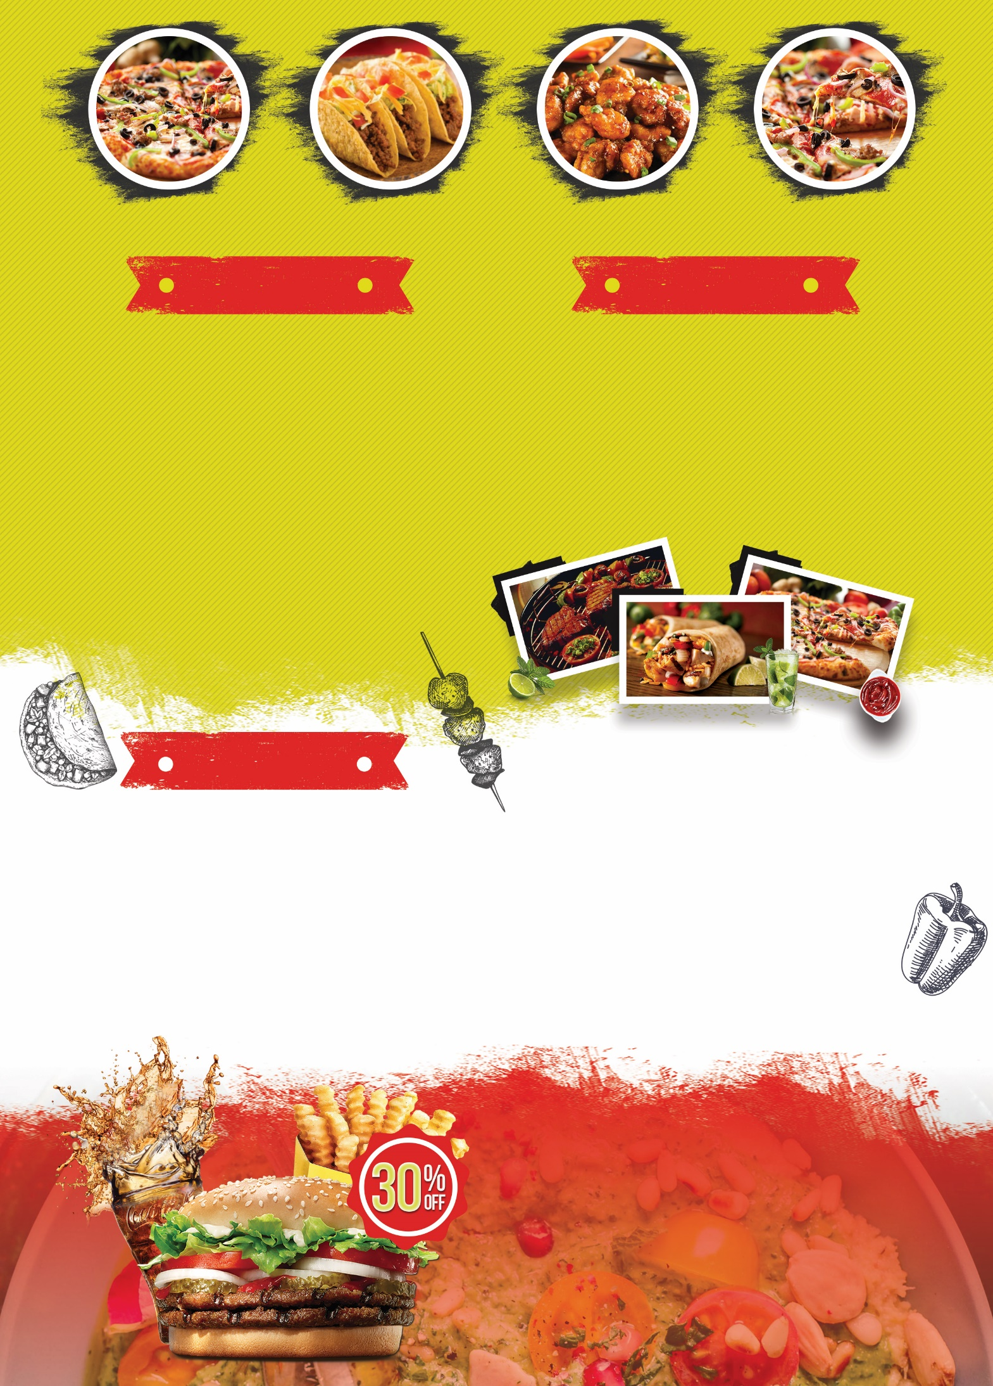
£9
£7.5
£8
Duck Dime (Winter Special Duck recipe served with lettuce leaf and spiced sauce. High Protien, low carbohydrated food.)
Gewurztraminers (Italian Alcoholic drink contains 30% alcohol per 175 ml bottle)
Vouvrays (Alcoholic drink, Imported from France. Slight sweeet of reislings. Contains mid level alcohol per sewrving of 75 ml bottle.)

Trinity Hotel Call at: +44 137 324 075 09, Swansea, South Wales

Notes: A separate menu will be provided for ill, adults and kids with convenient and healthy food options. If you have any issues with the menu, please contact us by the number given above. Some requests can’t be properly followed owing to a few service alterations made due to Covid-19. but we can assure to fulfil the requirements when we get notified at least 1 hour before the meal is served. The online customers must provide the food identification code to the reception for taking the meal.
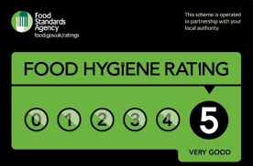
Fish Shots (Boiled fish mixed with dry herbs, freshly chopped coriander leaves, spices with the filling of Mozzarella cheese cubes inside.) (**Not suitable for allergic patients)
Sharpham Pinot Noir (An alcoholic drink made of berries. Contains 18% alcohol per glass)
Sauvignon Blanc (Alcoholic drink, Imported from Spain. Contains 23% alcohol per glass serve.)

£7
£4
£9

£8
£7
£4
Dorie Crumbs( Deep-fried juicy Dorie fillet garnished with fresh lemon zest and served along with golden potato crisps and special Trinity dip) (Total Fat 18 gm, Cholesterol 133 gm, Potassium 213 mg, Vitamin C, Vitamin A 0%, Sugar 48 gm)
Pinot Gris (World class red wine. Contains 70% alcohol per 120 ml bottle)
Bacchus (Aromatic wine imported from Germany. Contains 25% alcohol)

Order from UberEats will avail 30% discount
Set menu 03

£7

£6
£4
£3

Prawn Toast (Baked pieces of bread with toppings of prawn mixture, shredded parmesan cheese and fresh herbs *Might instigate the allergy)
Topa Beans (White beans diligently cooked with aromatic spices filled in oats-made cups garnished with mint and coriander leaves) (Saturated fat 19 gm, Sodium 24 gm, Potassium 559 gm, Cabohydrate 61 mg)
Cream Crunch (Butter fried vermicelli layered with fresh cream, blackberry sauce and garnished with finely chopped dry pistachio)
Red Zinfandel (Dry with notes of berries and chocolate) (Total Fat 31g, Cholesterol 8 mg, Protien 4.9 g, Caffein 21 mg)
Set Menu 02
Set menu 01

References
Good Housekeeping. 2022. Experts reveal the best wine pairings for classic British meals. [online] Available at: <https://www.goodhousekeeping.com/uk/food/a568818/best-food-and-wine-pairings/> [Accessed 8 February 2022].
Gunawardena, D. and Sarathchandra, K., 2020, March. BestDish: A Digital Menu and Food Item Recommendation System for Restaurants in the Hotel Sector. In 2020 International Conference on Image Processing and Robotics (ICIP) (pp. 1-7). IEEE.
Milli, M., 2020, June. Menu development and analysis. In The fourth biennial and international conference on “Tourism and hotel industry in southeast Asia & Indo-China: Development, marketing and sustainability (pp. 24-26).
Mohammed Baiomy, A.E.A., Jones, E., El-Din Elias, A.N. and Diana, R.T., 2019. Menus as Marketing Tools: Developing a Resort Hotel Restaurant Menu Typology. J Tourism Res Hospitality 2: 2. of, 10, p.2.
Wei, L., 2020. Reform of the “Wine Culture and Tasting” Course Based on the Professional Skill Level Certificate Exploration.

