Josh Naylor
2114259 4 May 2022
Introduction to Web and Database Concepts

Table of Contents
Context diagram 2
Relationship Diagram 3
ERD 4
DFD 5
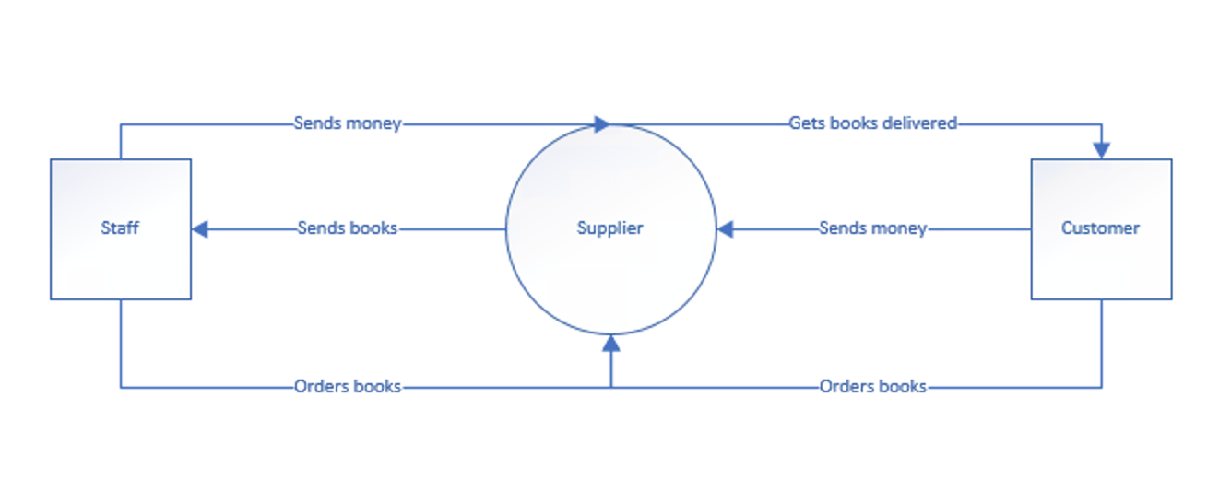 5
Forms 5
Author 5
Book stock 6
Books 6
Customer Details 7
Main menu 8
Orders 8
Staff 9
Brief user guide 10

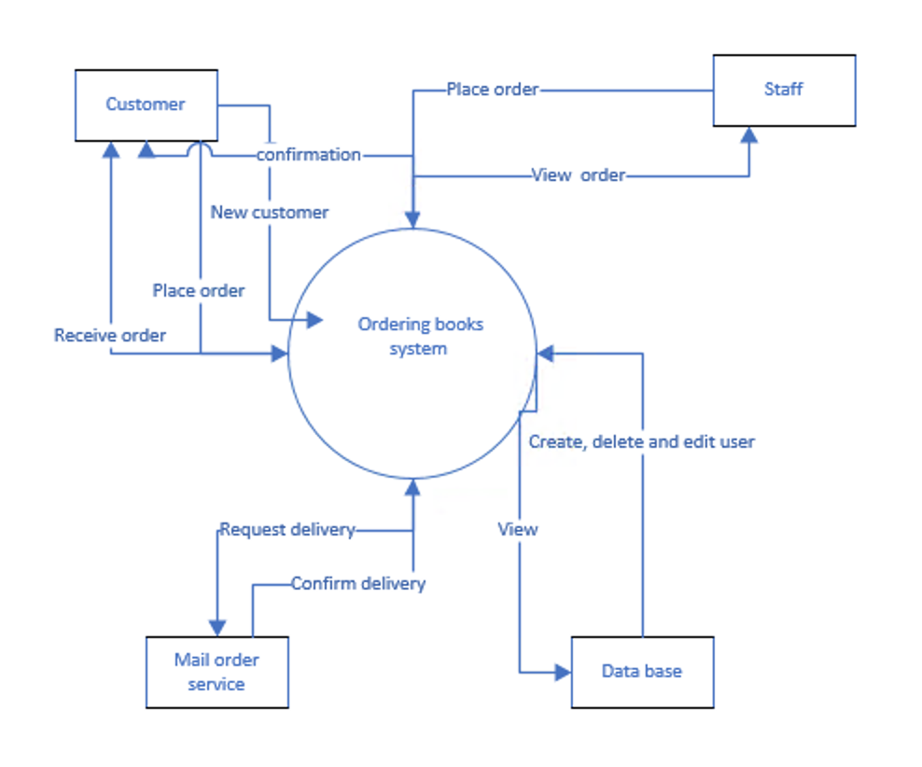
Context diagram

Relationship Diagram

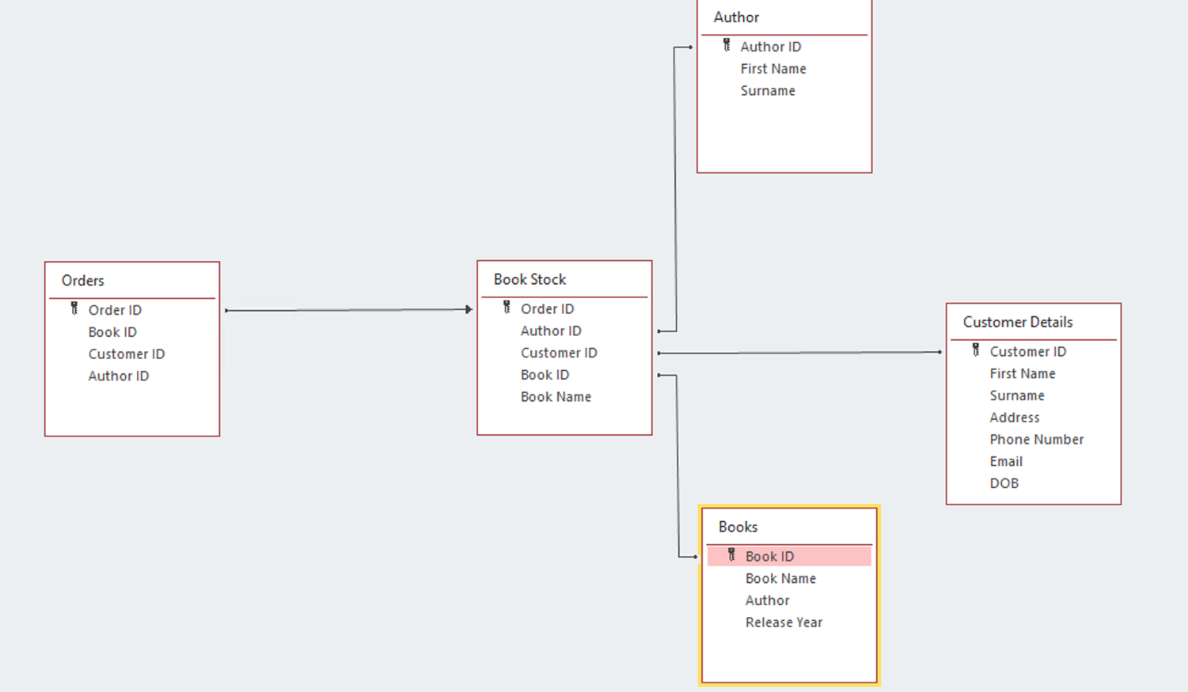

ERD
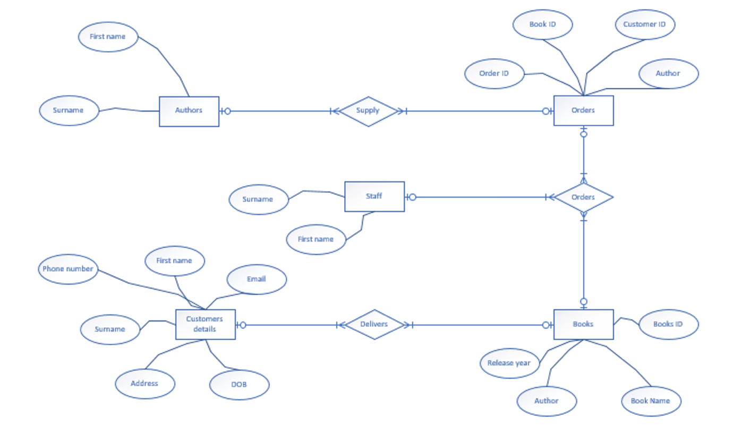

DFD

Forms

Author

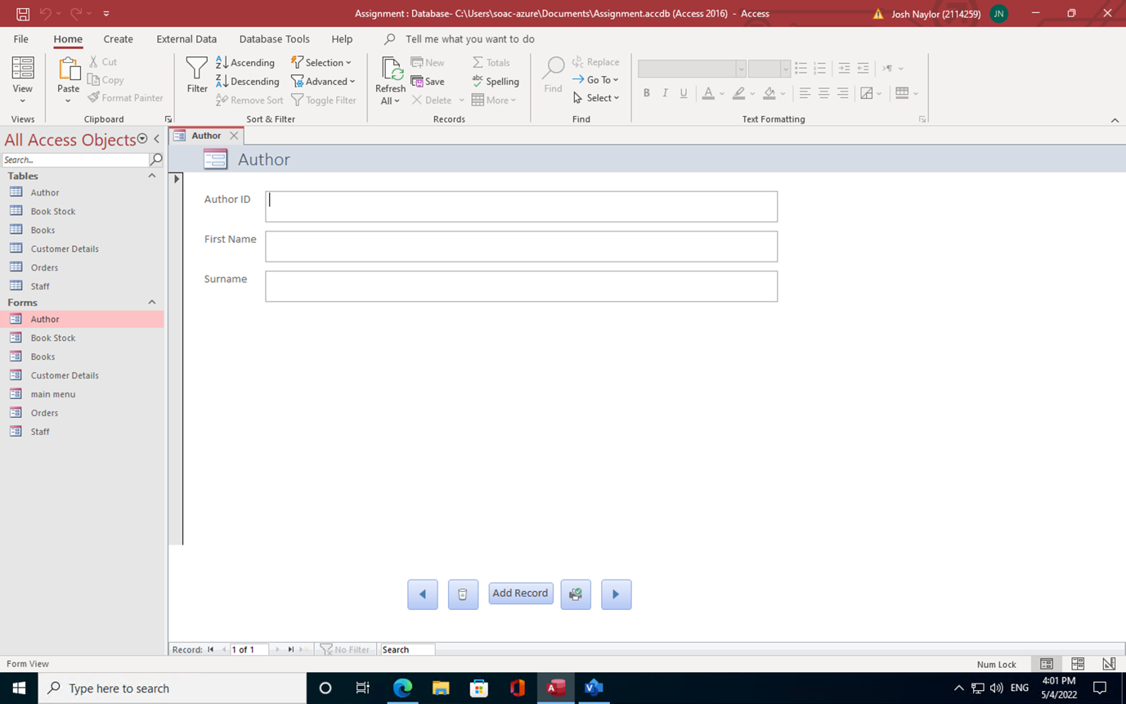

Book stock
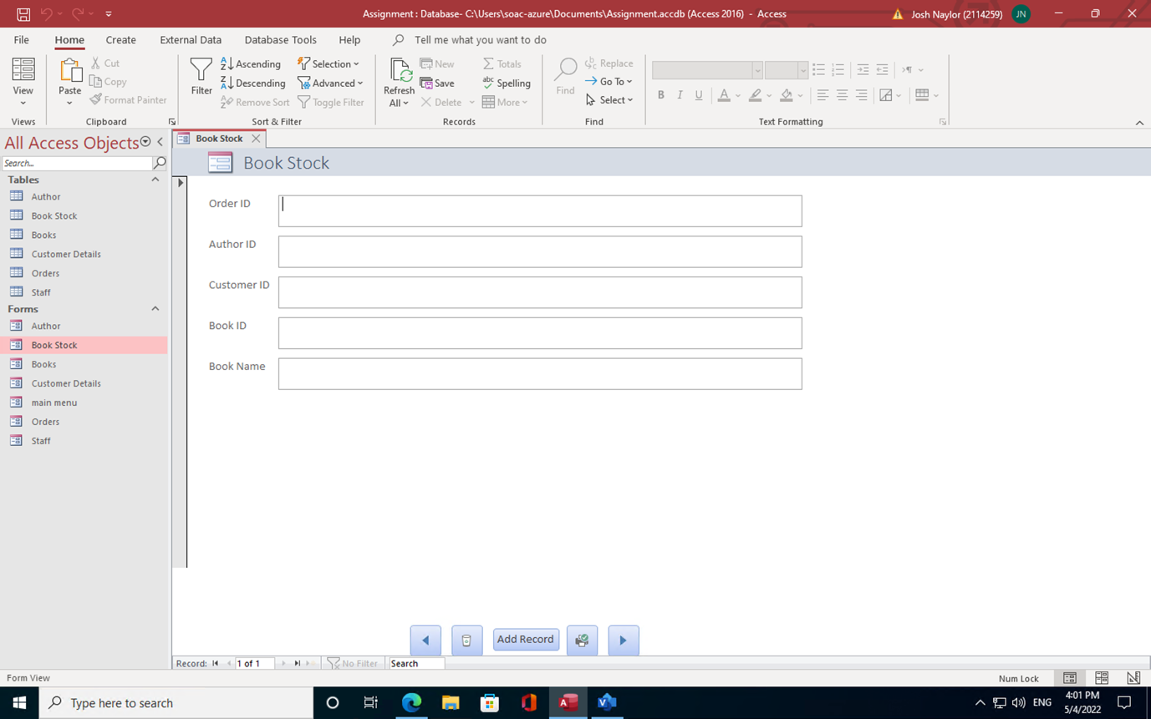

Books

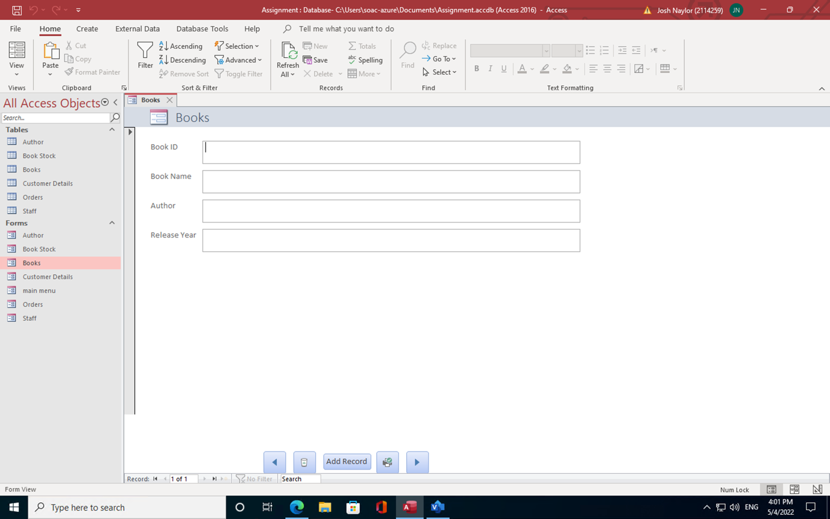

Customer Details
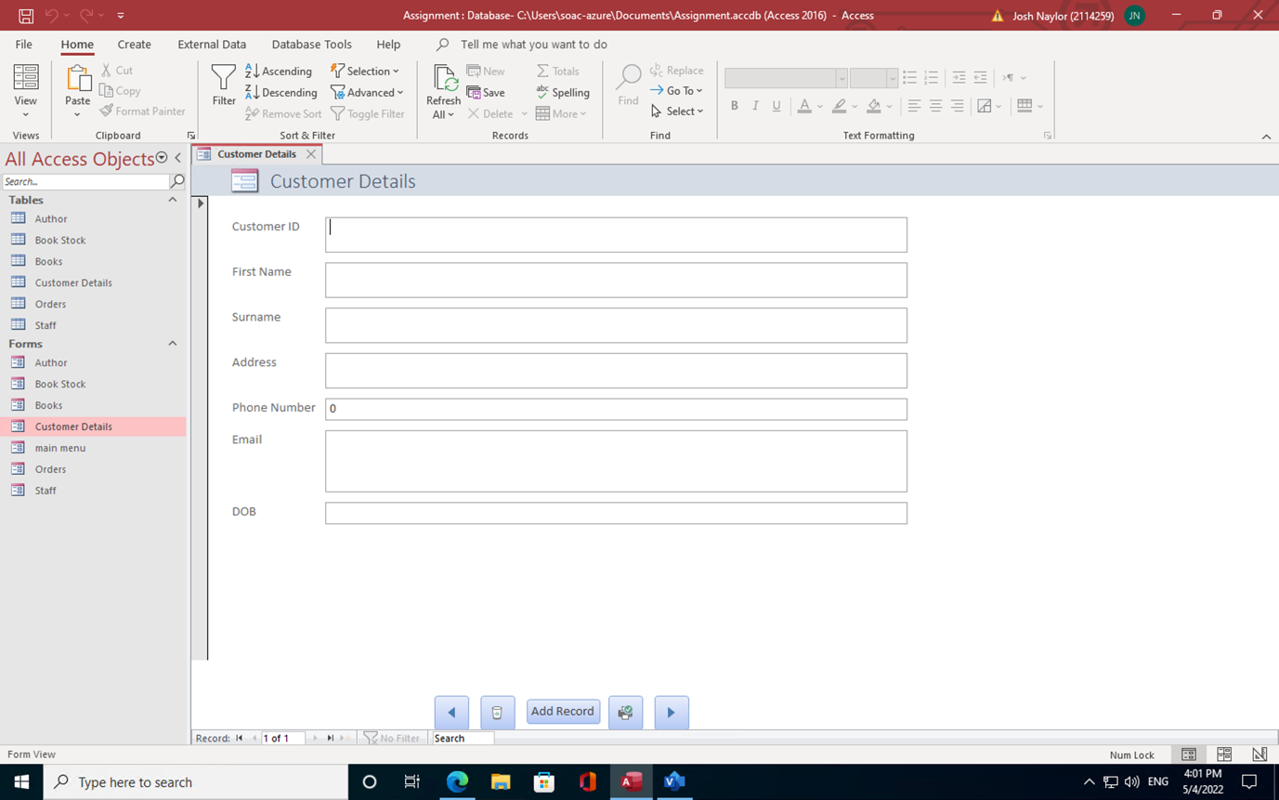

Main menu
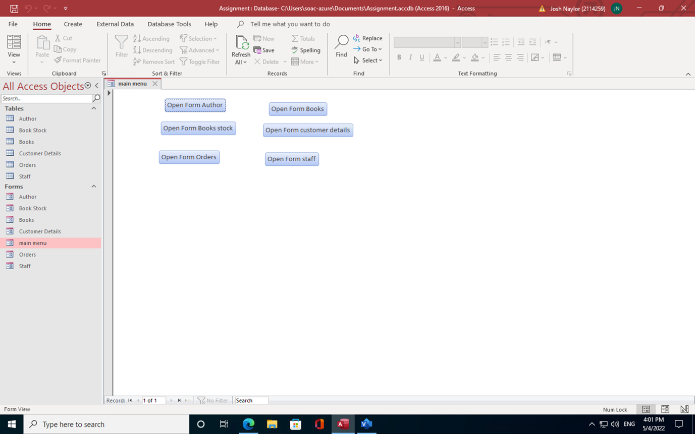

Orders

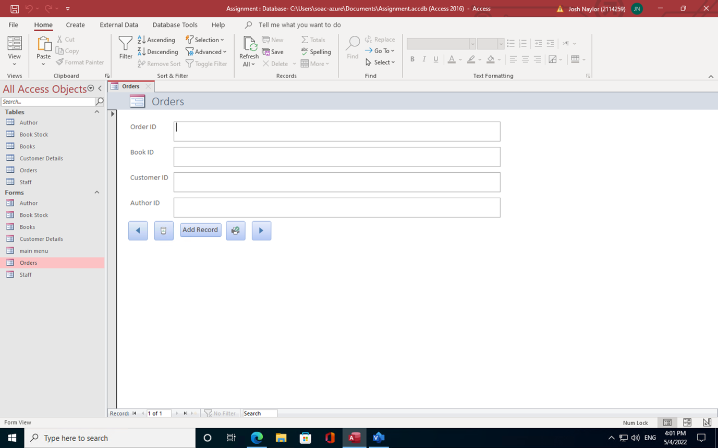

Staff

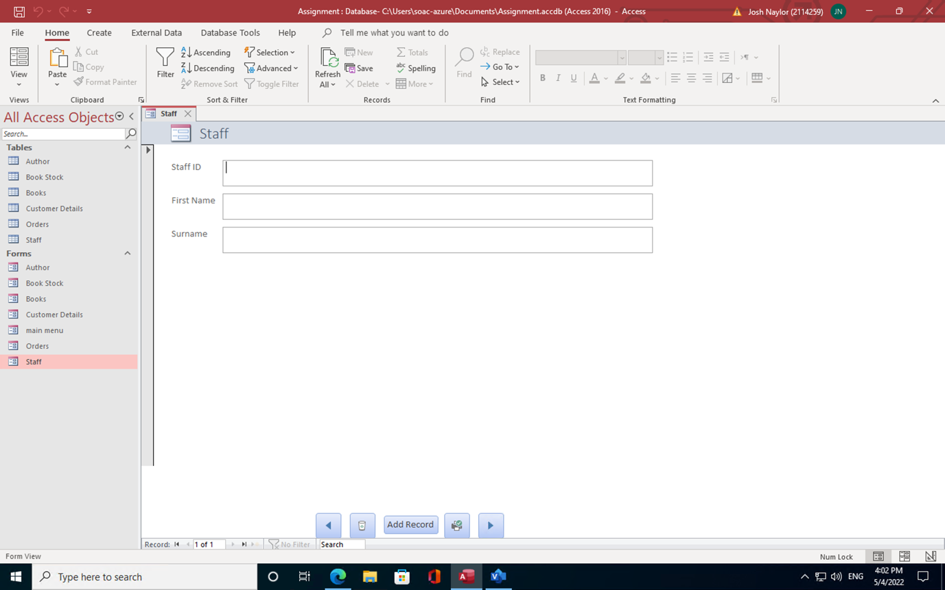

Brief user guide
To control the forms there are 4 different buttons at the bottom of the page and you can use them to go forward on a record, go back on a record, add a record, delete a record, and print out a record. You can also do this in the tables on the left-hand side of the screen and you can do more in the tables section than the form as you are limited to use the five buttons.

