

Student Name: Vrushabh Rakeshbhai Patel
Student ID: 2528085
Programme: Master of Business Administration
Module Name: Strategic management
Module Code: LCMB7003
Lecturer’s Name: Dr. Ghulam Mujtaba
Word count: 5183
Assignment Title: STRATEGIC MANAGEMENT CONSULTANCY REPORT: EVALUATING THE STRATEGIC POSITION OF GREGGS PLC IN THE UK FOOD-TO-GO RETAIL MARKET AND RECOMMENDING SUSTAINABLE COMPETITIVE STRATEGIE

Executive Summary
This consultancy report evaluates the strategic position of Greggs plc within the UK food-to-go retail market and recommends strategies to strengthen its competitive advantage. The analysis is used to measure Greggs' internal capabilities and the external environment by using the PESTEL framework, Porter's five forces, VRIO, SWOT and Corporate Social Responsibility (CSR), Balanced Scorecard, Ansoff Matrix and SAFe framework. The results show that Greggs has a high level of brand equity and operational efficiency, and benefit from an integrated supply chain but is under growing competitive, economic and sustainability pressures. Therefore, a strategy for product development towards healthy, innovative and digitally enabled products, which would help strengthen their long-term growth, customer value and sustainable competitive position, is recommended.

Table of Contents
INTRODUCTION 4
SECTION 1: REPORT 5
1.1 Organisational Context and Overview 5
1.1.1 Company Background 5
1.1.2 Mission, Vision and Core Values 5
1.1.3 Business Model 6
1.1.4 Industry Overview, Competitors and Market Position 7
1.2 External and Internal Analysis 9
1.2.1 External Environment Analysis (PESTEL Analysis) 9
1.2.2 Industry Analysis (Porter's Five Forces) 11
1.2.3 Internal Environment (VRIO) 13
1.2.4 SWOT Analysis 14
1.3 Comprehensive and Holistic View of Greggs 15
1.3.1 Corporate Social Responsibility (CSR) 15
1.3.2 Balanced Scorecard Analysis 16
1.4 Strategic Choices and Implementation 17
1.4.1 Current Competitive Strategy 17
1.4.2 Strategic Options (Ansoff Matrix) 18
1.4.3 Strategic Evaluation (SAFe Framework) 19
1.4.4 Recommended Strategy 20
1.4.5 Strategy Implementation 20
1.4.6 Implementation Challenges and Mitigation 21
1.5 Conclusion 21
SECTION 2: REFLECTIVE ACCOUNT (GIBBS' REFLECTIVE CYCLE) 21
2.1 Description 21
2.3 Evaluation 22
2.4 Analysis 22
2.5 Conclusion 23
2.6 Action Plan 23
REFERENCES 25

INTRODUCTION
Strategic management allows organisations to align internal capabilities and resources with external market conditions to create sustainable competitive advantage and long-term value (Mccall, 2024). Strategic management consultants are essential in today's competitive retail landscape, offering evidence-based analysis, quantifying organisational performance, identifying strategic issues, and suggesting solutions that increase competitiveness and business growth. This report attempts to examine the current strategic positioning of Greggs plc and the effectiveness of their strategies in the UK food-to-go retail market.

Figure 1: Greggs Logo
Source: (Greggs, 2025)
The UK market has been chosen as the main operating environment for Greggs, as it accounts for the majority of revenues and is characterised by high levels of competition, changing consumer preferences, digitalisation, inflation and greater expectations for sustainability. By targeting a single geographical market, a stronger and context-specific strategic assessment can be made. The report is structured to analyze Greggs' organisational context, external environment and internal environment, corporate social responsibility, operational performance with the Balanced Scorecard, strategic options, challenges in implementation and recommendations, then reflective account using Gibbs' Reflective Cycle.

SECTION 1: REPORT

1.1 Organisational Context and Overview

1.1.1 Company Background
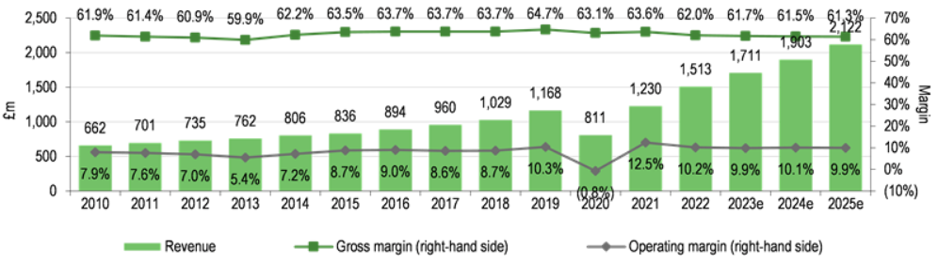
Figure 2: Greggs Revenue and Profitability
Source: (Pointon, 2023)
Greggs plc started its operations in 1939 with John Gregg in Newcastle upon Tyne and has changed from being a local family bakery to UK's largest food-to-go business by adapting and evolving its operations constantly (Greggs, 2025). In order to meet the changing lifestyles of consumers, the company's success has been in its convenience, cost, and product innovation in addition to traditional bakery products. A scale-driven growth strategy helped Greggs to build a strong, large-scale business with over 2600 stores by the end of 2025, for a revenue of £2.1mn (Figure 2) (Greggs, 2025; Pointon, 2023). However, expanding store numbers alone is insufficient for sustaining competitive advantage, as rivals continue investing heavily in digital capabilities and premium customer experiences. To achieve long run success therefore Greggs needs to find a balance of efficiency and continual innovation.

1.1.2 Mission, Vision and Core Values
Greggs' mission is to make great-quality food affordable and accessible for everyone, while its vision focuses on becoming customers' first choice for food-on-the-go (Greggs, 2023). The strategic work areas of digital transformation, employee wellbeing and sustainability are driven by core values, such as respect, integrity and responsibility, and customer focus (Greggs, 2023). Looking ahead, however, stakeholder trust depends on the translation of these values into measurable operational performance, rather than being mere wishful thinking, especially given the growing intensification of stakeholder expectations on the ESG.

1.1.3 Business Model
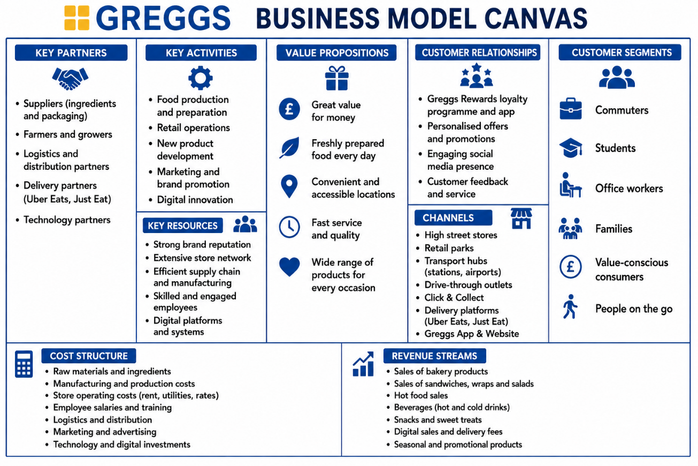
Figure 3: Business Model Canvas (Greggs)
Source: (Created by Author)
As illustrated in Figure 3, Greggs uses a vertically integrated, high-volume business model in route sale to commuters, office workers, students and value-conscious consumers. Revenue comes in bakery products, hot food, beverages, and digital ordering and delivery partnerships (Hirth, Boons and Doherty, 2021). It is also widely distributed with high street outlets, good transport connections and drive through outlets, providing increased convenience and market accessibility. The integrated supply chain allows Greggs to control the quality, efficiency and flexibility of the supply chain, as opposed to many independent bakeries which rely on third party suppliers. This is an operating model designed for a hybrid competitive approach, where both cost leadership and strategic product innovation, digital convenience, and seasonal menu development accompany each other (Hirth, Boons and Doherty, 2021).

1.1.4 Industry Overview, Competitors and Market Position
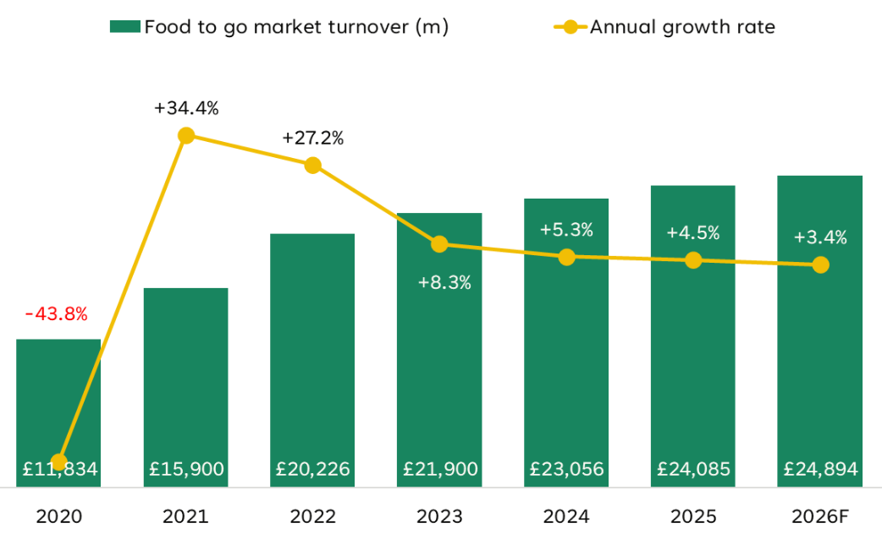
Figure 4: UK Food-To-Go Market
Source: (Castrillo, 2026)
Figure 4 illustrates the UK food-to-go market which exceeds £24 billion in 2026 and continues expanding due to increasing demand for convenience, takeaway consumption and digital ordering (Castrillo, 2026). Rapid inflation and shifting consumer tastes, however, have added fuel to the fire of price competition throughout the industry. Independent bakeries, Starbucks, Costa Coffee, Pret A Manger and Subway are also competitive brands with different competitive strategies as detailed in Table 1 (Hoenink et al., 2024). As shown in Figure 5, Greggs sees a competitive advantage over premium competition, which differentiates by the experience of the customer and price, through its value for money products that meet high-quality standards and are convenient. Extensive retail network, established brand equity and vertically integrated operations limit the ability to imitate.
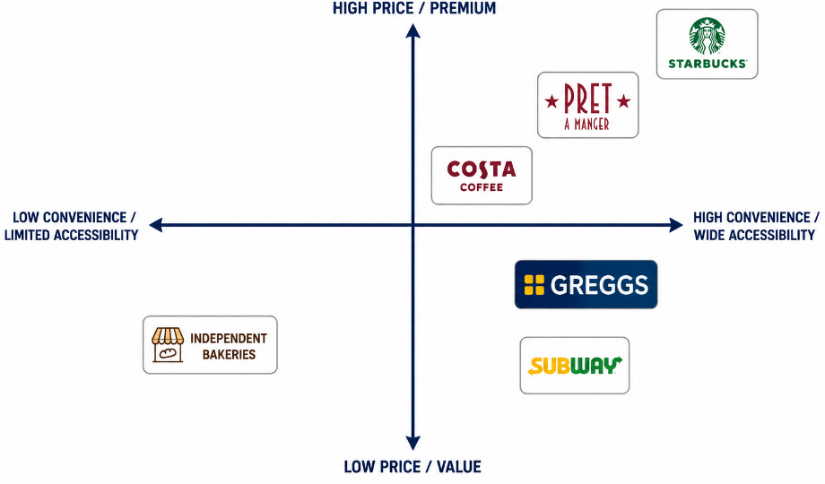
Figure 5: Greggs Competitive Positioning Map
Source: (Created by Author)
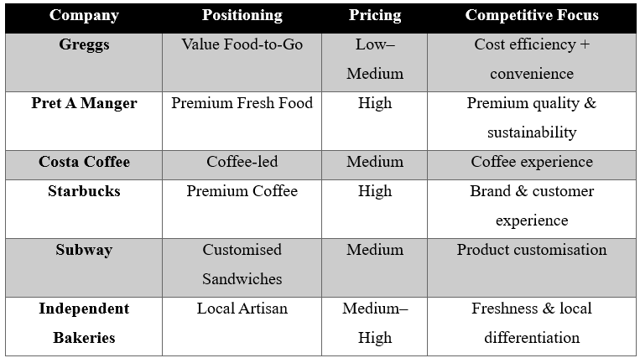
Table 1: Competitor Comparison
But to sustain the market-leading position will be dependent on continued investments in digital innovation, and better product development and sustainability efforts that are becoming increasingly transient (Hoenink et al., 2024). A comparison with Greggs, illustrated in Table 1, reveals that it has more hybrid elements than competing high-end and niche brands, ranging from the price tag (affordability) to the convenience of its offering. Overall, Greggs' strategic position is strong, but future competitiveness will be tied to their efforts to adapt to a market that continues to change, rather than relying on their past achievements.

1.2 External and Internal Analysis

1.2.1 External Environment Analysis (PESTEL Analysis)
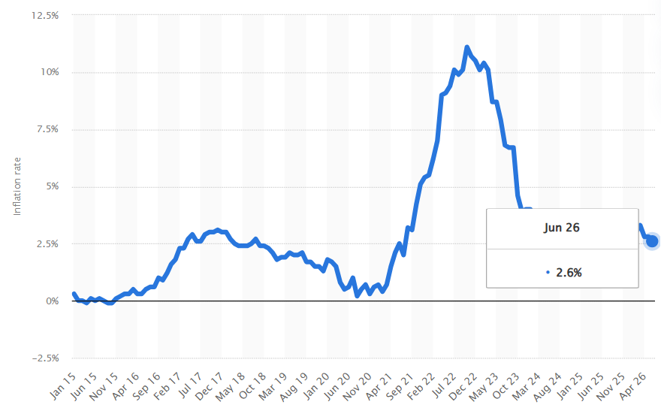
Figure 6: PESTEL Analysis
Source: (Statista, 2026)
Factors | Analysis
Political | The UK food to go market keeps changing, with ongoing policy changes to market that are healthy, safe and environmentally friendly. The UK food retailing sector will see improved packaging and Extended Producer Responsibility (EPR) to help drive up costs for compliance, whilst providing new business opportunities for investing in packaging reuse and food waste reduction (Legault and Okcu, 2026). Operating margins would be under strain, but Greggs' existing sustainability program enables the chain to better reach adaptations than are smaller rivals, and could increase long-term competitive advantage with regulators' readiness.
Economic | The UK economy remains characterised by persistent inflationary pressures and cautious consumer spending. Domestic cost pressures have persisted with the UK CPI 2.6% higher in June 2026, as shown in Figure 6 (Statista, 2026). Therefore, Greggs might utilize a method of "low prices" which is strategic during times of economic insecurity. Continual operational efficiency and optimisation of supply chain are essential to profitability given the squeeze on profit margins due to continuing labour, energy and ingredient cost inflation pressures.
Social | Consumer lifestyle is changing and favouring ease, speed and better foods. Demand for convenient food-to-go products is continuing to be driven by a growing UK population (around 69.8 million in 2026) (Office for National Statistics, 2025). At the same time, more people are conscious of the foods they eat and what they should be eating, which has led to retailers offering larger menus of healthy meals and more sustainably sourced items (Miller et al., 2021). These developments offer an opportunity for Greggs to broaden its product offering, but if it fails to react then it could impact on customer loyalty, especially in younger and health-conscious markets.
Technological | The digitalisation of business processes is changing the way businesses and customers interact, and making business more efficient. Mobile ordering, Click & Collect, loyalty programmes and delivery partnerships are other ways Greggs is building its digital presence. Moreover, AI-driven demand prediction and inventory management can help cut down on waste and enhance product availability (Verma, 2024). However, if competitors spend on technologies, their sustainability in competitive advantage diminishes and requires innovation over increments.
Environmental | Sustainability is no longer a good thing to do in business; it is a necessity to reduce carbon emissions, reduce food wastage, and decrease the amount of packing materials using plastic. The company's efforts towards investing in recyclable packaging and its Net Zero strategies improve corporate image and make operations resilient to future changes (Greggs, 2024). However, climate-related disruptions to agricultural supply chains may increase raw material costs and sourcing risks.
Legal | Performance is affected by the laws of the UK around food safety, employment, minimum wage rise and reporting of ESG information (Sandberg, Alnoor and Tiberius, 2022). Although stricter laws increase the cost of doing business, good governance reduces legal risks and increases stakeholder confidence.
Table 2: PESTEL Analysis
Overall, the PESTEL analysis highlights that Greggs is running in a highly dynamic external environment. Growing demand for affordable convenience food, digital innovation and sustainability leadership, and the other principal opportunities are inflation, regulatory change, and intensifying competition. From a strategic perspective, Greggs must secure sustainable competitive advantage in the changing global food-to-go market by maximising the strengths of its cost-efficient operating model and shifting momentum towards the adoption of new digital technologies, cleaner product offerings and carbon reduction efforts.

1.2.2 Industry Analysis (Porter's Five Forces)
Porter's Five Forces is a strategic tool used to assess the intensity of a specific industry's competition and attractiveness by examining the five forces (Porter, 1980). Figure 7 presents Porter's Five Forces analysis of Greggs within the UK food-to-go retail industry.
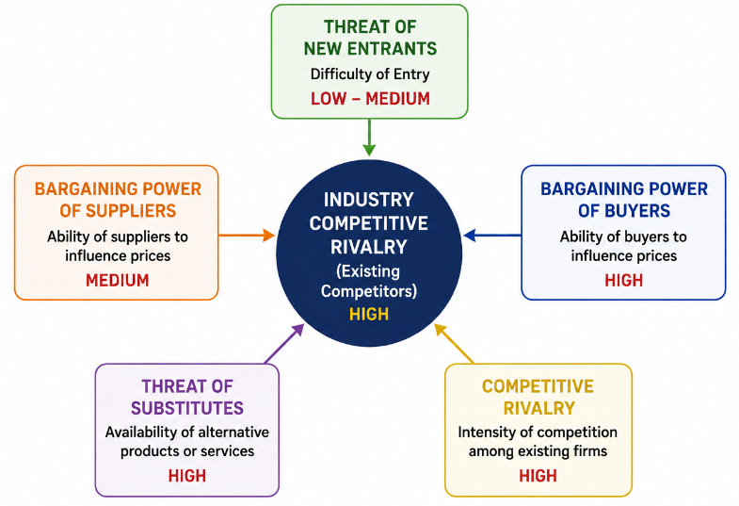
Figure 7: Porter's Five Forces
Source: (Created by Author)
Threat of New Entrants (Low–Medium): Capital requirements for independent cafés are relatively low, but there is a significant capital expenditure required to build a recognisable brand, an economy of scale similar to Greggs, and a vertically integrated supply chain, before entering the market (Ferreira, 2016). The number of Greggs' stores combined with its brand recognition make it difficult for new competitors to gain market share quickly.
Bargaining Power of Suppliers (Medium): Greggs buys ingredients from a number of suppliers and has an integrated manufacturing and distribution system, which limits its reliance on any single supplier. However, the price fluctuations of agricultural commodities and of energy have increased supplier influence, especially when supply chains are disrupted (Mardenli, Sackmann and Rhein, 2023).
Bargaining Power of Buyers (High): UK consumers have a wide choice across Greggs, Pret A Manger, Costa Coffee, Starbucks, Subway, Supermarkets and Independent bakeries. Low switching costs allow customers to shift suppliers easily for various reasons, such as price, convenience or product quality (Pick and Eisend, 2014). Therefore, Greggs are always required to provide value, innovation and service quality in order to maintain customer retention.
Threat of Substitutes (High): Supermarket meal deals, food prepared at home, and convenience stores or food delivery sites are readily available alternatives (Creel et al., 2008). As a greater proportion of consumers are turning to healthier eating, substitute risk rises, and Greggs are further challenged to offer healthy products on their menus, without raising prices.
Competitive Rivalry (High): Competition is intense due to market saturation, aggressive pricing, continuous product innovation and expanding digital capabilities among leading retailers. Premium brands stake out a competitive proposition on quality and experience, Greggs differentiates on value pricing and convenience and control direct competition, yet not total competitive pressure.
Industry Attractiveness (Medium): The overall attractiveness of the UK food-to-go market is medium. Despite the continuing growth of demand, profitability is subject to the strong buyer power, and its intense competitors and substitute threats (Baird et al., 2024). The competitive strengths Greggs does have, however, are mostly because of the ubiquity of its stores and an operating model and supply chain that are cost efficient. In strategic terms, continued efforts in digital innovation, additional improvements to product and operational efficiency are critical to maintaining long term market leadership.

1.2.3 Internal Environment (VRIO)
The VRIO model is used to measure if the resources and capabilities of an organisation have the capability to establish a sustainable competitive advantage by measuring its value, rarity, inimitability and organisation (Barney, 1991).
Resource/Capability | V | R | I | O | Competitive Implication
Brand Reputation | ✓ | ✓ | ✓ | ✓ | Sustained competitive advantage
Store Network | ✓ | ✓ | ✓ | ✓ | Sustained competitive advantage
Supply Chain | ✓ | ✓ | ✓ | ✓ | Sustained competitive advantage
Digital Capability | ✓ | ✗ | ✗ | ✓ | Competitive parity
Human Resources | ✓ | ✗ | ✗ | ✓ | Temporary advantage
Innovation | ✓ | ✓ | ✗ | ✓ | Temporary advantage
Financial Resources | ✓ | ✗ | ✗ | ✓ | Competitive parity
Operational Efficiency | ✓ | ✓ | ✓ | ✓ | Sustained competitive advantage
Table 3: VRIO Matrix
Table 3 demonstrates that Greggs has several resources that can be used as leverage for their market leadership making it strategically valuable. The brand reputation, wide store footprint, vertically integrated supply chain and operational efficiency meet all the VRIO criteria and make them a competitive advantage that would be hard to duplicate for the competition. These attributes enable the cost leadership in the customers' convenience and nationwide availability. Conversely, digital competence and funding are no differentiators anymore as competitors have already heavily invested in digital platforms and have financial depth similarities (Fernández et al., 2023). Similarly, while continuous product innovation adds value to customers, a seasonal product launch may be copied relatively soon, with low long-term value. For Greggs, principal assets are the seamless integration of operations, brand loyalty, and an efficient distribution system, while key strategic weaknesses are its lack of digital leadership and the need for ongoing innovation investment to maintain market competitiveness.

1.2.4 SWOT Analysis
Strengths | Weaknesses
- Strong brand reputation and customer loyalty (The Strategy Story, 2023).  - Extensive UK store network ensuring high accessibility.  - Vertically integrated supply chain supporting cost efficiency.  - Effective operational efficiency and value pricing.  - Continuous product innovation and digital ordering capabilities. | - Heavy dependence on the UK market limits geographical diversification.  - Digital capabilities can be replicated by competitors.  - Rising operating costs reduce profit margins.  - Limited premium product differentiation compared with specialist competitors.
Opportunities | Threats
- Growing demand for convenient and affordable food-to-go.  - Expansion of healthier menu options and plant-based products (The Strategy Story, 2023).  - Greater use of AI and digital technologies to improve customer experience.  - Sustainability initiatives can strengthen brand reputation and customer trust. | - Intense competition from cafés, supermarkets and independent bakeries (The Strategy Story, 2023).  - Inflation and supply chain disruptions increasing operating costs.  - Changing consumer preferences towards healthier alternatives.  - Tightening environmental and food regulations increasing compliance costs.
Table 3: SWOT Analysis
Table 3 illustrates the SWOT analysis which demonstrates a strong alignment between Greggs' internal capabilities and external market opportunities. The company's brand ability, strong supply chain and operational efficiency make it a good business to capitalise on the trend of buying food from convenience stores that focus on value (Hirth, Boons and Doherty, 2021). However, external threats identified in the PESTEL and Five Forces analyses, particularly inflation, competitive rivalry and regulatory pressures, may weaken profitability if strategic adaptation is delayed. By identifying and building on its strengths Greggs has the opportunity to further boost digital innovation, improve product health, sustainability efforts and lessen reliance on the domestic market and enhance organisational resilience. This strategic alignment will strengthen a long-term competitive and sustainable growth within the food-to-go industry in the UK.

1.3 Comprehensive and Holistic View of Greggs

1.3.1 Corporate Social Responsibility (CSR)
Corporate Social Responsibility (CSR) is about an organisation's efforts to generate economic value and to respond to its environmental, social and governance (ESG) obligations (Wirba, 2023). Combined, these initiatives encompass CSR values, aiming to embed CSR in Greggs' wider growth strategy, from the Net Zero emissions to sustainable packaging, to food waste minimisation, to responsible sourcing, to employee wellbeing to community engagement. This alignment aligns with the company's mission to create affordable, high-quality food that is accessible and builds trust in the company.
Environmentally, Greggs has pledged to attain its Net Zero targets for GHG emissions by 2040, and has continued to invest in renewable energy, recyclable packaging and waste minimisation (Greggs, 2024). During 2025, over 99% of surplus food from company-managed shops was redistributed or diverted from landfill, demonstrating measurable progress in resource efficiency (Greggs Foundation, 2026). These programs help organizations become more sustainable in their operations, mitigate disposal expenses, and add to positive brand image. However, achieving Net Zero will require decarbonisation across suppliers and logistics, where direct organisational control is comparatively limited, Socially, the Greggs Foundation can help to fund breakfast clubs and community programmes feeding over 75,000 children a day in the UK (Greggs Foundation, 2026). Meanwhile, employee well-being is a component of employee engagement and operational performance, as are investments in apprenticeship and career development. As wages continue to rise and available labour is becoming scarce however, it will still continue to draw in staff and this will require constant effort and investment.
Greggs' governance is improved by responsible sourcing, ethical procurement and transparent sustainability reporting. The practices reduce the risk to reputation and regulatory risk, and leverage the increased consumer demand for ESG performance. Better reporting on the carbon footprint and biodiversity effects of suppliers, however, would help improve accountability and stakeholder confidence more (Gualandris et al., 2015). In addition, Greggs' CSR approach has been well aligned with its business goals in terms of ability to differentiate its brand, bolster operational resiliency and build long-term value creation. Rather than functioning solely as a reputational initiative, CSR contributes directly to cost efficiency, customer loyalty and competitive advantage (Chi and Phan, 2026). However, continuing the gains will require faster progress in decarbonising supply chains, more innovation on healthier products and greater ambition on measurable ESG goals. Overall, Greggs' CSR strategy is considered as a strategic capability that sustain Greggs growth, but continuous improvement is required as the expectations and regulations of Greggs stakeholders continue to change over time.

1.3.2 Balanced Scorecard Analysis
The Balanced Scorecard translates organisational strategy into measurable financial and non-financial objectives, allowing Greggs to track its strategic performance and ensure that its mission, operations and long term growth were in alignment (Kaplan and Norton, 1992).
Perspective | SMART Objective | KPI | Target | Strategic Initiative | Evaluation
Financial | Increase sustainable profitability by 8% by 2028 while maintaining value pricing. | Revenue growth; Operating margin; Return on Capital Employed (ROCE). | Revenue growth ≥8%; Operating margin ≥10%. | Expand high-margin menu items, optimise supply chain and improve cost efficiency. | Supports financial resilience but requires effective cost management amid inflation.
Customer | Improve customer satisfaction and loyalty by 2028. | Customer satisfaction score; Repeat purchase rate; Greggs App users. | Satisfaction >90%; Repeat customers +10%. | Expand digital loyalty programme, healthier menu options and personalised promotions. | Strengthens brand loyalty and differentiation in a highly competitive market.
Internal Business Processes | Improve operational efficiency and sustainability by 2028. | Food waste; On-time product availability; Order fulfilment accuracy. | Reduce food waste by 15%; Product availability >98%. | AI demand forecasting, inventory optimisation and recyclable packaging initiatives. | Enhances cost efficiency while supporting environmental objectives and service quality.
Learning and Growth | Enhance workforce capability and innovation by 2028. | Employee engagement; Training hours; Internal promotion rate. | Engagement >85%; ≥20 training hours annually; Internal promotions >60%. | Leadership development, digital skills training and employee wellbeing programmes. | Develops organisational capability, innovation and long-term competitive advantage.
Table 4: Balanced Scorecard Analysis
The Balanced Scorecard presents evidence that Greggs' strategic goals are not just financial, but incorporate the aspects of customer value, operational excellence and organisational learning (Fabac, 2022). The proposed SMART objectives, measurable KPIs and targeted initiatives support continuous performance monitoring and strengthens alignment between the company's mission and long-term commitment. However, the ability to meet these objectives requires constant investments in digital innovation, workforce capability and sustainability efforts (Fabac, 2022). This makes the Balanced Scorecard an effective strategic management framework, which provides evidence-based Greggs' decision-making processes and enhances sustainable competitive advantage in the changing food-to-go market within the UK.

1.4 Strategic Choices and Implementation

1.4.1 Current Competitive Strategy
Porter's (1985) Generic Strategies indicate that organisations establish competitive advantage by cost leadership, differentiation and focus. Greggs primarily adopts a hybrid strategy, combining cost leadership with selective differentiation. The previous PESTEL, VRIO and SWOT analysis has shown that the company's vertical integration of its supply chain, size of its store network and efficient operation allows it to provide the customer low prices and differentiate it from its competitors by using product innovation, ordering online, seasonal menus and convenience. By blending these strategic strengths, Greggs can appeal to a wide range of customers and stay competitive in challenging economic climates.
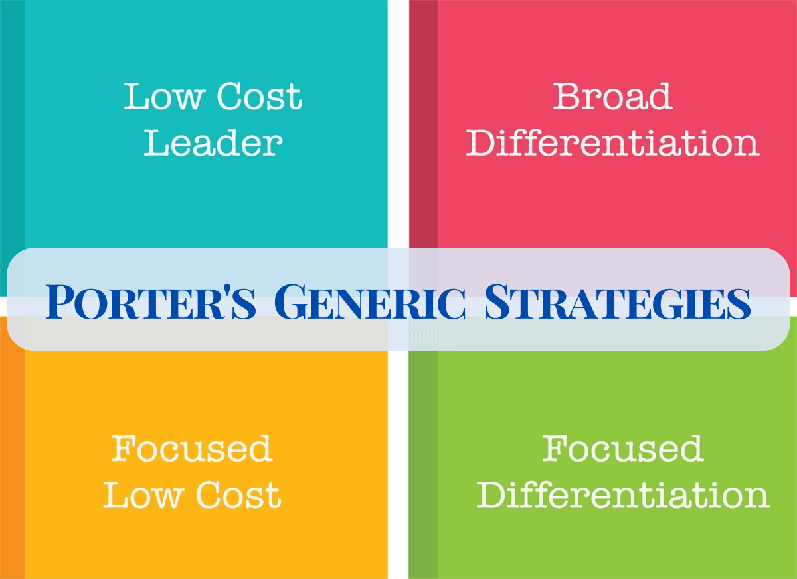
Figure 8: Porter's Generic Strategies
Source: (Jurevicius, 2025)
However, the viability of this approach is threatened by the growing investments of the competition in digital technologies, improvements to the health of their products, and advances to the customer experience. Hence, gaining market leadership through cost efficiency is not likely to be durable (Jerab and Mabrouk 2023). The company needs to continue to be innovative, invest in sustainability and continue to draw from the UK market its and keep its unique selling proposition and competitive edge.

1.4.2 Strategic Options (Ansoff Matrix)
The Ansoff Matrix identifies three strategic growth options for Greggs, illustrated in Table 5.
Strategy | Example | Risk | Suitability
Market Penetration | Loyalty App, promotions, digital ordering | Low | High
Product Development | Healthier, high-protein, plant-based and seasonal products | Medium | Very High
Market Development | International expansion | High | Medium
Table 5: Strategic Options
Market penetration activities include loyalty strategies, promotional activities and enhancing digital ordering. This strategy is not particularly risky as it is based on a well-known brand and customer base used by Greggs. However, mature markets can limit growth potential (Loredana, 2017). Product development entails development of healthier, high-protein plant-based and seasonal products to meet rising consumer demand. While this necessitates investment in developing the product and marketing it, it closely fits greater health awareness and aids differentiation without substantially changing Greggs' business model.
However, market development via international expansion may provide for diversification of income and away from reliance on the UK market. However, increased investment needs, consumer characteristics and operational difficulties bring added implementation risk (Loredana, 2017). Overall, the product development strategy offers greatest strategic potential while taking advantage of the company's competitive strengths, aligning with a customer preference for change, and building long-term value while managing strategic risk levels.

1.4.3 Strategic Evaluation (SAFe Framework)
SAFe Criteria | Evaluation
Suitability | High
Acceptability | High
Feasibility | High
Table 6: Strategic Evaluation
The SAFe framework was used to assess the recommended product development strategy (Whittington et al., 2019). It is a suitable option as the stated business opportunities that emerged from the PESTEL and SWOT analysis are directly addressed such as increasing demand for healthier food, digitalisation and shifting consumer preferences. Besides, it helps Greggs' sustainability goals and enhances its competitive advantage. The acceptability is high, with customers enjoying more healthy and well-rounded menus, employees learning new skills, maximizing revenue for shareholders, and communities benefiting from ongoing support of responsible sourcing and choices for healthier foods. This means that the strategy adds value to many stakeholders and drives long-term business goals (Muslim, 2025).
The financial resources, vertically integrated supply chain, brand reputation and wide network of local stores across the UK and digital infrastructure that Greggs has are favourable factors for implementation, making the feasibility high. This internal fortitude minimises execution risk and aids product deployment. Overall, the SAFe evaluation reveals a strategic viability and potential for sustainable competitive advantage of the proposed product development strategy.

1.4.4 Recommended Strategy
Based on the preceding analyses, product development is the most appropriate strategy for Greggs. The PESTEL analysis shows that customer demand is now moving towards healthier and sustainable foods, while the VRIO analysis shows that Greggs excels at the brand level, has an integrated supply chain and operational efficiency, making new product development a reality (Barney, 1991). Secondly, the SWOT and Five Forces analyses proved that business needs continuous innovation to curb from strong competitive rivalry and product substitution threats (Porter, 1980). Greggs' adoption of healthier, plant-based, high-protein and seasonal menus, backed by digital ordering and loyalty platforms is also aligned with its CSR strategies and Balanced Scorecard targets for customer satisfaction and sustainable growth (Kaplan & Norton, 1992). Consequently, this strategy strengthens customer value, reinforces market differentiation and creates sustainable competitive advantage through continuous innovation and long-term strategic alignment (Johnson et al., 2011).

1.4.5 Strategy Implementation
Area | Action
Leadership | Executive sponsor to oversee implementation
Technology | AI demand forecasting and digital ordering enhancements
Finance | Allocate investment budget for product development and marketing
HR | Employee training on new products and customer service
Marketing | Digital campaigns promoting healthier menu options
KPIs | Revenue growth, customer satisfaction, food waste reduction
Table 7: Strategy Implementation
Effective leadership is key, along with investment and involvement of stakeholders (Waligo, Clarke and Hawkins, 2014). Greggs need to increase digital infrastructure, use artificial intelligence (AI) for stock management, and train their staff fully to deliver consistent services. A staged rollout program for 18 months with continuous monitoring of KPIs will afford the opportunity to evaluate and take corrective action as needed, and limit disruption of operations while optimising strategic results.

1.4.6 Implementation Challenges and Mitigation
Potential difficulties with implementation include changing technology, intense competition, supply chain difficulties, employee resistance and inflation. This may affect product releases, could lead to higher operating costs and leave a reduction in product implementation's gains (Ogawa and Piller, 2006). To address these challenges, Greggs must diversify the suppliers, work on the change management program by establishing a training and communication plan, continually invest in digital technologies and monitor its performance with clear KPIs. The organisation will be agile through regular engagement with stakeholders and periodic strategic reviews, ensuring Greggs is able to proactively react to different market behaviours and maintain their competitive edge over the long-term.

1.5 Conclusion
The overall study indicates that, with reputation, vertically aligned supply chain and its efficiency, Greggs' strategic position remains good in the UK food-to-go market and typology. Consumer preferences, competitiveness and customer expectations regarding sustainability, however, demand constant strategic changes. The integrated result of the PESTEL and Porter's Five Forces analysis, VRIO, SWOT analysis, CSR and the Balanced Scorecard analysis has identified a product development strategy. Thus, the organisation can secure further competitive advantage and customer value, to help to establish sustainable growth and long-term organisation resilience while continuing to develop Greggs' more long-term capability.

SECTION 2: REFLECTIVE ACCOUNT (GIBBS' REFLECTIVE CYCLE)
The Reflective Cycle developed by Gibbs (1988) is a methodology used to critically reflect on experiences and it shows how to improve learning outcomes, professional development and future consultancy activity.
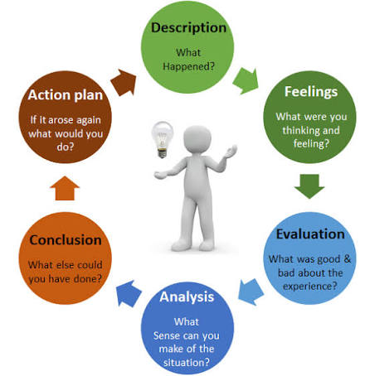
Figure 9: Gibbs' Reflective Cycle
Source: (Dutta, 2023)

2.1 Description
In this consultancy report, an organized evaluation of Greggs plc is undertaken in relation to its strategic position in the UK food-to-go retail industry. In terms of the research methodology employed, the consultancy report includes the study of secondary data which is collected from Greggs’ annual reports, corporate social responsibility reports, academic literature, governmental sources, and industry reports to critically assess the external environment, internal capabilities, and strategic effectiveness of the organization. The chosen strategic management tools include PESTLE analysis, Porter’s Five Forces model, VRIO framework, SWOT analysis, Corporate Social Responsibility (CSR) tool, Balanced Scorecard, and SAFe framework. These strategic management tools are not used in isolation but in combination, to provide evidence-based recommendations to the company’s Board of Directors. It is consistent with the duties of a strategic management consultant whose core skills include objective analysis and critical judgment when facing complex business problems (Spender, 2014).
2.2 Feelings
Initially, it seemed like strategic management was about the choice of correct business strategies. However, as the research progressed, I recognised that effective consultancy requires considerably more than recommending growth opportunities. Gibbs (1988) argues that reflective learning encourages individuals to question their assumptions and improve future professional practice. Applying this principle, it became clear that any strategic choices have to be based on evidence rather than on people's opinions. Initially, it was hard to combine several strategies because each framework has a different approach to the organisation. However, analysing Greggs through several frameworks helped to develop confidence in understanding the complex nature of business data and gave respect to making decisions using evidence. Thus, it became clear that strategy has to be understood as the process of connecting organisational, stakeholder, and market aspects together.

2.3 Evaluation
There were several strengths identified in relation to the research process. The extensive use of academic literature in combination with current organizational and industry data increased the validity of the strategic analysis performed. By utilizing a variety of different frameworks, a thorough analysis of the strategic position of Greggs was possible beyond the scope of using only one analytical tool. However, there were some difficulties in relation to the process as well. Some frameworks produced similar results, making the possibility of repeating the information provided more likely and requiring its proper integration. In addition, the reliance on secondary data made it impossible to access any managerial information, which had to be assumed based on available data. Moon (2004) argues that critical reflection implies not only an evaluation of the strengths but also weaknesses of one's own learning process. Thus, reflection helped identify the significance of critical assessment of the sources of information and avoidance of descriptive analysis when providing strategic recommendations.

2.4 Analysis
This experience has really helped me to understand how theories about strategic management can be incorporated in order to make consultancy decisions based on evidence. According to Kolb (1984), meaningful learning takes place when experiences are transformed into knowledge, Gibbs (1988) concluded that critical reflection helps for continuous professional development. Given these principles, I spotted that there is no single strategic model that gives a total picture of an organisation's performance. PESTEL, for instance, uncovered external opportunities and threats (Johnson et al., 2011), while VRIO clarified how Greggs' internal resources contributed to the development of its competitive advantage (Barney, 1991). SWOT analysis helped to summarize the above results, whereas the Balanced Scorecard helped to transform the priorities in measurable goals and performance indicators (Kaplan & Norton, 1992). The most significant lesson for me was the realization of the fact that strategic models work best when they are used in combination rather than in isolation from each other, thus allowing making a coherent, evidence-based, and strategically sound recommendation. I got a chance to develop my abilities of analytical reasoning, which meant that I had to criticize some concepts, make comparisons between alternative strategies, and support my opinions with relevant and logical arguments. As a result, I became more confident in providing consultancy services that involve critical evaluation, strategic synthesis and evidence-based decision making in complex and dynamic business environment.

2.5 Conclusion
In conclusion, this consultancy report has increased my understanding of strategic management and my reflective practice skills. The exercise has shown that good consultancy is not only about theoretical understanding but rather about the ability to apply knowledge by analyzing the situation and making recommendations based on the findings. This research reflection has improved my knowledge of how the interaction between the internal abilities of an organization, its market environment, and expectations of stakeholders affects its performance. Most importantly, I have gained skills of objective assessment of strategic problems. It has therefore made me ready to take up new consultancy assignments in future with a systematic, Analytical and evidence Based approach when solving organisational problems.

2.6 Action Plan
To strengthen my future consultancy practice, I will implement a SMART action plan. I will thoroughly examine no less than two strategic management Journal articles on a weekly basis in the next three months, for a total of six, and develop sound arguments based on evidence to decide on competing theories and make evidence-based recommendations. In the coming 6 months, I am going to finish a certified online course in strategic analysis or business analytics, targeting growth in my consultancy and data-interpretation abilities. I will use at least 4 strategic frameworks in future assignments and back my recommendations with recent academic and industry-related evidence. I will also obtain feedback from the tutor on any significant assessment and outline three actions for enhancement following each submission in the Gibbs' Reflective Cycle. These measurable actions will enhance the analytical capacity, critical thinking and professional consultancy skills.

REFERENCES
Baird, K., Nuhu, N. and Jiao, L. (2024). The effect of Porter’s competitive forces on competitive advantage and organisational performance and the moderating role of management accounting practices. Journal of management control, 35, pp.303–332. doi:10.1007/s00187-024-00375-4.
Barney, J. (1991). Firm resources and sustained competitive advantage. Journal of Management, 17(1), pp.99–120. doi:https://doi.org/10.1177/014920639101700108.
Castrillo, M.R. (2026). UK food-to-go market size, growth and share statistics 2026. [online] Lumina Intelligence. Available at: https://www.lumina-intelligence.com/blog/uk-food-to-go-market-size-growth-and-share-statistics-2026/ [Accessed 7 Aug. 2026].
Chi, H.-K. and Phan, H.-T. (2026). The impact of CSR on reputation, image, and identification in customer loyalty: The moderating role of customer commitment. Cogent Business &amp; Management, 13(1). doi:10.1080/23311975.2026.2630434.
Creel, J.S., Sharkey, J.R., McIntosh, A., Anding, J. and Huber, J.C. (2008). Availability of healthier options in traditional and nontraditional rural fast-food outlets. BMC Public Health, 8(1). doi:10.1186/1471-2458-8-395.
Dutta, S. (2023). Gibbs” reflective cycle (adapted from Gibbs, 1988). [online] ResearchGate. Available at: https://www.researchgate.net/figure/Gibbs-reflective-cycle-Adapted-from-Gibbs-1988_fig1_371536633 [Accessed 7 Aug. 2026].
Fabac, R. (2022). Digital balanced scorecard system as a supporting strategy for digital transformation. Sustainability, [online] 14(15), p.9690. doi:10.3390/su14159690.
Fernández, M.B., Ramírez-Montoya, M.S., Ibarra-Vazquez, G. and Patiño, A. (2023). Digital competency as a key to the financial inclusion of young people in complex scenarios: A focus groups study. Citizenship, Social and Economics Education, [online] 22(1). doi:10.1177/14788047231170083.
Ferreira, J. (2016). Café nation? Exploring the growth of the UK café industry. Area, [online] 49(1), pp.69–76. doi:10.1111/area.12285.
Gibbs, G. (1988). Learning by doing: A guide to teaching and learning methods. Further Education Unit. [online] Available at: https://cir.nii.ac.jp/crid/1571417125052979584 [Accessed 8 Aug. 2026].
Greggs (2023). Greggs corporate | about us. [online] corporate.greggs.co.uk. Available at: https://corporate.greggs.co.uk/about-us [Accessed 8 Aug. 2026].
Greggs (2024). Greggs corporate | making our planet safer. [online] corporate.greggs.co.uk. Available at: https://corporate.greggs.co.uk/doing-good/making-our-planet-safer [Accessed 8 Aug. 2026].
Greggs (2025). Greggs. [online] @GreggsOfficial. Available at: https://www.greggs.com/ [Accessed 8 Aug. 2026].
Greggs Foundation (2026). Greggs foundation | Impact Report. [online] www.greggsfoundation.org.uk. Available at: https://www.greggsfoundation.org.uk/about/impact-report [Accessed 7 Aug. 2026].
Gualandris, J., Klassen, R.D., Vachon, S. and Kalchschmidt, M. (2015). Sustainable evaluation and verification in supply chains: Aligning and leveraging accountability to stakeholders. Journal of Operations Management, 38(1), pp.1–13. doi:10.1016/j.jom.2015.06.002.
Hirth, S., Boons, F. and Doherty, B. (2021). Unpacking food to go: Packaging and food waste of on the go provisioning practices in the UK. Geoforum, 126(0016–7185), pp.115–125. doi:10.1016/j.geoforum.2021.07.022.
Hoenink, J., Cerny, C., Mahoney, C. and Pajda, N. (2024). Fuel us, don’t fool us: Big food & our communities: Where are food chains expanding? (Out-of-home #1). Cam.ac.uk. [online] doi:https://doi.org/10.17863/CAM.115571.
Jerab, D. and Mabrouk, T. (2023). Achieving competitive advantage through cost leadership strategy: Strategies for sustainable success. [online] Social Science Research Network. Rochester, NY. doi:10.2139/ssrn.4574945.
Johnson, G., Whittington, R., Scholes, K., Angwin, D. and Regnér, P., (2011). Exploring strategy. London, UK: Financial Times Prentice Hall.
Jurevicius, O. (2025). Porter’s (three) generic strategies explained - SM insight. [online] Strategic Management Insight. Available at: https://strategicmanagementinsight.com/tools/porters-three-generic-strategies/ [Accessed 7 Aug. 2026].
Kaplan, R.S. and Norton, D.P. (1992). The balanced scorecard—Measures that drive performance. [online] Harvard Business Review. Available at: https://hbr.org/1992/01/the-balanced-scorecard-measures-that-drive-performance-2 [Accessed 8 Aug. 2026].
Kolb, D. (1984). Experiential learning: Experience as the source of learning and development. [online] Available at: http://carleton-wp-production.s3.amazonaws.com/uploads/sites/313/2022/12/Experiential_Learning_Experience_As_The_Source_Of_-1.pdf [Accessed 8 Aug. 2026].
Legault, E. and Okcu, B. (2026). Extended producer responsibility in food packaging: Exploring the compliance process. [online] Lub.lu.se. Available at: https://lup.lub.lu.se/student-papers/search/publication/9241944 [Accessed 7 Aug. 2026].
Loredana, E.M. (2017). The use of ansoff matrix in the field of business. Annals - Economy Series, [online] 2Special, pp.141–149. Available at: https://ideas.repec.org/a/cbu/jrnlec/y2017v2specialp141-149.html [Accessed 8 Aug. 2026].
Mardenli, A., Sackmann, D. and Rhein, S. (2023). Current challenges in agricultural supply chains: An empirical assessment based on expert perspectives. Transportation research procedia, 73, pp.66–76. doi:10.1016/j.trpro.2023.11.893.
Mccall, A. (2024). Strategic management and competitive advantage. [online] Available at: https://www.researchgate.net/profile/Andrei-Mccall-2/publication/386050766_Strategic_Management_and_Competitive_Advantage/links/67413cd9868c966b9326074f/Strategic-Management-and-Competitive-Advantage.pdf [Accessed 8 Aug. 2026].
Miller, K.B., Eckberg, J.O., Decker, E.A. and Marinangeli, C.P.F. (2021). Role of food industry in promoting healthy and sustainable diets. Nutrients, [online] 13(8), p.2740. doi:10.3390/nu13082740.
Moon, J., 2004. A handbook of reflective and experiential learning. Routledge Falmer.
Muslim, M. (2025). The dilemma between shareholder value and long-term business sustainability. Advances in Management & Financial Reporting, 3(1), pp.15–29. doi:10.60079/amfr.v3i1.427.
Office for National Statistics (2025). Population estimates for the UK, England, Wales, Scotland and Northern Ireland. [online] Ons.gov.uk. Office for National Statistics. Available at: https://www.ons.gov.uk/peoplepopulationandcommunity/populationandmigration/populationestimates/bulletins/annualmidyearpopulationestimates/mid2024 [Accessed 8 Aug. 2026].
Ogawa, S. and Piller, F.T., (2006). Reducing the risks of new product development. MIT Sloan management review, 47(2), p.65.
Pick, D. and Eisend, M. (2014). Buyers’ perceived switching costs and switching: A meta-analytic assessment of their antecedents. Journal of the Academy of Marketing Science, 42(2), pp.186–204. doi:10.1007/s11747-013-0349-2.
Pointon, R. (2023). Greggs — Profits on the go. [online] Edison Group. Available at: https://www.edisongroup.com/research/profits-on-the-go/32145/ [Accessed 7 Aug. 2026].
Porter, M.E. (1980). Techniques for analyzing industries and competitors. Competitive Strategy. New York: Free, 1, p.76.
Porter, M.E. (1985). Competitive advantage-creative and sustaining want more papers like this? [online] Available at: https://www.academia.edu/download/43857184/Competitive_Advantage-_creative_and_sustaining.pdf [Accessed 8 Aug. 2026].
Sandberg, H., Alnoor, A. and Tiberius, V. (2022). Environmental, social, and governance ratings and financial performance: Evidence from the European food industry. Business Strategy and the Environment, 32(4), pp.2471–2489. doi:10.1002/bse.3259.
Spender, J.C. (2014). Business strategy: Managing uncertainty, opportunity, and enterprise. [online] Google Books. Available at: https://books.google.com/books?hl=en&lr=&id=RNxMAgAAQBAJ&oi=fnd&pg=PP1&dq=It+is+consistent+with+the+duties+of+a+strategic+management+consultant+whose+core+skills+include+objective+analysis+and+critical+judgment+when+facing+complex+business+problems.&ots=74lF_2OtqJ&sig=ngK_0Yxsx_npwMZvbd54U0XuqCY [Accessed 7 Aug. 2026].
Statista (2026). UK inflation rate 2026. [online] Statista. Available at: https://www.statista.com/statistics/306648/inflation-rate-consumer-price-index-cpi-united-kingdom-uk/?srsltid=AfmBOooMYLpfMMLrmICc_C1EV9hOlsGypTQ1stVsJqztj8qH8RN2aRga [Accessed 7 Aug. 2026].
The Strategy Story (2023). Greggs SWOT analysis. [online] The Strategy Story. Available at: https://thestrategystory.com/blog/greggs-swot-analysis/ [Accessed 8 Aug. 2026].
Verma, P. (2024). Transforming Supply Chains Through AI: Demand Forecasting, Inventory Management, and Dynamic Optimization. [online] Available at: https://www.researchgate.net/profile/Pradeep-Verma-23/publication/385098771_Transforming_Supply_Chains_Through_AI_Demand_Forecasting_Inventory_Management_and_Dynamic_Optimization/links/67167d9f035917754c125b54/Transforming-Supply-Chains-Through-AI-Demand-Forecasting-Inventory-Management-and-Dynamic-Optimization.pdf [Accessed 7 Aug. 2026].
Waligo, V.M., Clarke, J. and Hawkins, R. (2014). The ‘leadership–stakeholder involvement capacity’ nexus in stakeholder management. Journal of Business Research, 67(7), pp.1342–1352. doi:10.1016/j.jbusres.2013.08.019.
Whittington, R., Regnér, P., Johnson, G., Angwin, D. and Scholes, K., (2019). Exploring strategy. Pearson UK.
Wirba, A.V. (2023). Corporate social responsibility (CSR): The role of government in promoting CSR. Corporate Social Responsibility (CSR): the Role of Government in Promoting CSR, 15(2), pp.1–27. doi:https://doi.org/10.1007/s13132-023-01185-0.

