Comparison of PC and mobile platform

By Martyna Grek
P149796
Module M6X02045

University of Wales Trinity Saint David
Creative Computer Games Design

Table of contents
Table of contents 2
List of Figures 3
Abstract 4
Introduction 4
The history of PC and mobile platforms 4
PC User Interface 9
Mobile Interface 11
Market 11
Fortnite PC vs Mobile 13
The Sims 4 vs the Sims Mobile 16
Conclusion 22
Bibliography 23

List of Figures
Figure 1 Lode Runner game https://www.youtube.com/watch?v=uac8tyv0zeQ
Figure 2 2018 Global Games Market report https://newzoo.com/insights/articles/global-games-market-reaches-137-9-billion-in-2018-mobile-games-take-half/
Figure 3 2012-2021 Global Games Market https://newzoo.com/insights/articles/global-games-market-reaches-137-9-billion-in-2018-mobile-games-take-half/
Figure 4 Fortnite mobile vs PC graphics https://www.youtube.com/watch?v=6xRAlPAhHtI
Figure 5 Fortnite PC interface https://www.malavida.com/en/soft/fortnite/#gref
Figure 6 Fortnite mobile interface http://fortnite.wikia.com/wiki/File:Fortnite_Mobile_interface.png
Figure 7 The Sims mobile creating character
https://www.touchtapplay.com/the-sims-mobile-how-to-change-your-appearance-customize-your-character/
Figure 8 The Sims 4 creating character
https://www.rockpapershotgun.com/2014/08/19/the-sims-4-demo-character-creator/
Figure 9 The Sims mobile creating house
https://forums.thesims.com/en_US/discussion/917887/show-your-house-in-the-sims-mobile-thread
Figure 10 The Sims 4 house
http://simscommunity.info/2015/11/30/the-sims-4-how-to-build-a-simple-modern-house/
Figure 11 The Sims mobile gameplay
https://toucharcade.com/2018/03/12/the-sims-mobile-guide-to-relationships-how-to-get-married-have-kids-and-more/
Figure 12 The Sims 4 gameplay https://simsvip.com/2017/09/29/spice-sims-4-gameplay/
Figure 13 The Sims mobile interface https://www.theverge.com/2018/3/10/17097196/the-sims-mobile-focused-version-gaming-maxis-android-ios
Figure 14 The Sims 4 Interface
https://www.youtube.com/watch?v=9TwSadUoS4U

Abstract
This paper will look at the differences on PC and Mobile platforms, by comparing it’s history, interface, market and games created on both platforms.

Introduction

Computer games were very popular, however, along with new technology, mobile devices are at the forefront of the global gaming market. Nowadays, more people reach for the phone to play something than a computer. Earlier, smartphones could not compete with computers because their technologies were behind. Games created for phones were much worse, but now smartphones are treated equally with computers, and even the same games are created on both platforms. More and more games are being created for mobile devices, for example Fortnite; Battle Royale, ARK Survival Evolved or PlayerUnknown's Battlegrounds (PUBG). Also, the very popular The Sims series is created for both computers and smartphones. This document will analyze the history of both platforms in detail, pay attention to how they are built, what the global market looks like and also the games that are created on PC and mobile devices.

The history of PC and mobile platforms
Mobile games are associated today with phones or tablets, but in the past, the peak of mobility were other, larger size consoles, and nobody even thought about playing in the open air. Although the real revolution came from the Far East and began with a device called GameBoy, the first portable consoles appeared at the turn of the 1970s and 1980s.

Microvision
Microvision created by Smiths Engineering debuted in 1979. It was distributed by Milton-Bradley, also known as MB. Unfortunately, the Microvision console existed on the market for only two years. The reasons for her failure were poor performance and few available games. The Japanese console – Epoch Game Pocket Computer also met failure five years later. Her LCD screen displayed the image with a resolution of 75 x 64 pixels, and the library of games limited to five productions.

Nintendo Game & Watch
The real hit was a series of miniature devices called Game & Watch produced by Nintendo. Gunpei Yokoi came up with this idea - during a journey by subway he noticed how one of the businessmen who was going to work had fun with a calculator. Each Game & Watch console had one game built in and an alarm clock - that's where the name came from. In addition to proprietary titles, games were also created to advertise the most popular Nintendo titles. That's when mobile, simplified versions of hits such as Donkey Kong and Mario Bros were created. In total, 60 varieties of this device were created, and the last ones were produced in 1991. Game & Watch series was such a big hit that some characters from these games can also be found today in titles from Nintendo.

Nintendo Game Boy
The third generation of consoles was deprived of portable devices. The revolution took place during the next generation and came again from the Far East. Nintendo not only saved the industry by launching a large NES console, but also built the foundations for mobile systems. GameBoy very quickly gained competition in the form of consoles Atari Lynx and Sega Game Gear, but it was the most convenient and most of all the cheapest. The bizarre green and black Game Boy colur palette is already a legend. The Nintendo Game Boy released one of the largest series in the world – Pokemon. The success of the console also included the presence of ports, or portable versions of major hits from NES, such as Contra and The Legend of Zelda. Game Boy has a version with a colour display, as well as a smaller version called GameBoy Pocket.

Atari Lynx
Despite the huge technical advantage over Game Boy, the portable Atari quickly disappeared in the shadow of Game Boy. Even a colourful picture did not help her. Lynx devoured it’s batteries in four hours, which compared to Game Boy’s 35 hours of battery life, was very bad. Bad titles also did not help and ultimately the Atari device turned out to be the least popular portable console of this generation. Lynx went to just one million recipients, and Game Boy – up to 119 million. Sega Game Gear sold ten times better than Lynx, but because of its appearance, cumbersome and yet undiscovered Sega brand did not cope with the competition. It did not even help to use the entire library of games from Mega Drive using a special adapter. There was also a portable TurboGraphx-16 version called TurboExpress, and although it supported all games from its older version and sold better than Lynx, it quickly fell into oblivion due to the poor technical design and speed of battery consumption.

Sega Nomad and Bandai WonderSwan
During the fifth generation, GameBoy continued to reign with subsequent models, but several new consoles appeared on the mobile market. Sega was the first who tried. Released in November 1995, the Nomad console had a built-in TV output, allowing it to be used as a stationary device at the same time. Due to backward compatibility, Nomad appeared on the market, having up to 500 games from Genesis. Unfortunately, the new Sega device was also extremely delicate. Every sudden movement of the hand caused unpleasant disturbances. In addition, a small screen, battery absorption and lack of exclusive games, contributed to the fact that the console never left the US.
WonderSwan created by Gunpei Yokoi - creator of Game & Watch, who after leaving Nintendo started his own company. Bandai was responsible for the distribution of the device. WonderSwan has been a huge success in Japan, but has never appeared outside its borders.

Tiger R-Zone and Game.com
Tiger Electronics, which previously manufactured devices similar to the old Game & Watch, entered the competition. That's how the Tiger R-Zone console was created, which unfortunately was not successful. A few years later, the company released Game.com, which is an efficient combination of a palmtop and a portable gaming device. It was the first console with a touch screen and the possibility of connecting to the Internet via a modem. Although Tiger has tried to port several major titles, such as Resident Evil 2, Duke Nukem 3D and the Mortal Kombat Trilogy, then Games.com, despite its innovation, was also not successful.

Nintendo Virtual Boy and SNK Neo Geo Pocket
The Japanese tried to strike the imagination of the audience by offering three-dimensional graphics. Virtual Boy consisted of a controller and goggles displaying a stereoscopic image. However, this device has been shown to cause vomiting and dizziness. The image displayed in two colours - red and black. Virtual Boy did not succeed - only 21 titles were released for this console.The first device created by NeoGeo, NeoGeo Pocket, was not successful due to the monochrome display. After the release of only 10 games, it was decided to produce an improved version of NeoGeo Pocket with the addition of colour added, and that's what improved these consoles very much. The system was famous for quite nice, though minimalistic ports of the company's blockbuster hits from its most famous series, like The King of Fighters and Samurai Shodown.

Nintendo Game Boy Advance and Micro
Nintendo created a phenomenal gaming device, which in 2001 continued the Game Boy line. Advance was provided with a great display, so that the image seen on the portable device has never looked so good. The only drawback was its large size. All these problems were repaired with the appearance of the SP version two years later. Another version - the Micro version was a tiny console, not much bigger than a pack of cigarettes with much better image quality.

Nokia N-Gage
N-Gage created by Nokia was able to generate graphics comparable in quality to PlayStation, but the device was not successful because of a higher price than GameBoy and a poor design. Nokia decided to release a refreshed version of the console at a lower price, but it was not able to attract customers.

Sony Playstation Portable
PlayStation Portable, or PSP in short, was more like an exclusive gadget than a toy for children. Games, unlike other consoles of this type, were sold on small disks, which made Sony try to revolutionize the market. Unfortunately, this format was not accepted due to the low disk capacity. The PSP has been quite successful, selling 80 million units worldwide.

Nintendo DS
Nintendo DS in an ingenious way used two screens in games, one of which was operated using a stylus. The creators gave the audience a mass of various titles and the DS turned out to be a device for everyone: from hardcore players, to lovers of simple tapping onto the screen. The console with it’s upgraded design, became a slim and comfortable device, also in the XL version with a larger screen. Almost 160 million copies sold are enough to indicate the popularity of the DS.

Nintendo 3DS and Sony PlayStation Vita
Mobile games today constitute a huge percentage of the total gaming market in the world. Their value for 2018 is estimated at approx. $ 70.3bn (51% of the global market), and the Newzoo report shows that the biggest part of the games market is owned by mobile phones, when PC platform generates only 24% of the global market. Soon, phones will be the most technologically advanced devices used for video games.
One of the biggest breakthroughs in the history of smartphone games was (in 2009) the game ”Angry Birds”. Angry Birds has gained recognition thanks to the successful combination of addictive gameplay, fun style and low prices. The work of Rovio, a Finnish company not widely known, was so popular that it was transferred to other platforms - computers and video consoles. The characters from the game went to movies, TV series, mugs, T-shirts and thousands of other gadgets. The game was the first case of a successful transfer from a small screen to a big one. An even bigger breakthrough, including technological and social, was the appearance of Pokemon Go. It was a real phenomenon. Pokemon Go uses augmented reality - you have to catch monsters located in different places in your area by using your smartphone. The game in which almost everyone played, quickly won the hearts of users.

When it comes to computer history, it differs from the history of mobile devices because mobile devices are different and computers for a long time looked the same and have had the same components. When new mobile devices come out with new technology just like the AR, computers only have new, improved parts.

For years of computer development, their appearance did not resemble what today we associate with the modern PC. What counted above all was the conversion power, which for many years was increasing effectively. Technical problems did not allow scientists and constructors to think about design. The revolution took place in 1971, when the first microprocessor in the world was patented. This discovery allowed to reduce the volume of the computer without losing its computing power. However, we owe wide access to computers to Jobs and Wozniak, who were the first to develop what we today call a "PC" or personal computer in 1977. At that time, the appearance was not yet very important, but with the development of science, more and more often looked towards compactness and design were more in the forefront. The monitor Apple II allowed users to access files and run tasks using terminal. The monitor display also allowed users to write code in low or high-level languages. This revolution brought the creation of Apple Computers and started the personal computers market.

The graphical user interface was implemented on new personal computers in the mid 1980s. The graphical user interface was already created before by Xerox in the 1960s, however the company was not interested in computer market. In 1990s, the operating system Windows have been created and became the new standard of computers.

In 1981 was created the world’s first laptop computer Epson HX-20, however the first commercially successful laptop was released in 1983 TRS-80 Model 100 released by Tandy. Soon other competitors followed this design and released other versions of computer laptop, such as Sharp’s PC-5000(1983) and Toshiba’s 16-bit T-1100(1985).

Internet and Windows operating system caused very fast development of personal computers.However, for a long time, computer cases were designed in a similar style. Beige and a simple solid shape have become standard for many years. The change of trend in the approach to the appearance and ergonomics of computers is brought by 1998, when the premiere of the iMac computer took place. The first time, a different color scheme was used for both the housing and the keyboard. From that moment on, manufacturers are beginning to introduce visual elements built of plastic and transparent materials. The era of design and design begins in the world of computers.

Nowadays, the appearance, ergonomics and original design of our personal computer often has the same meaning as its power. On the market, we can find cases that with their appearance and functionality are nothing like the standard grey cases, delighting with their design people for whom aesthetics is very important in life.

Today's technologies in the field of communication with their achievements outweigh the computer and multimedia technologies. And it's not just that modern phones are almost like computers, but computers will never be phones. It is also about the fact that modern mobile phones, or smartphones, with their functionality match the computers, and work without them is practically impossible today. The prices of modern smartphones are comparable to laptops or computers.

PC User Interface
The primary control mechanism for using computer was keyboard, and despite the technology evolution, the keyboard remained roughly constant. UI design was always very important in games and we can see it by how the keyboard inputs have been used, for example commands such as ‘fire’ or ‘jump’ have been bound to the spacebar key which was the most accessible input on the keyboard.
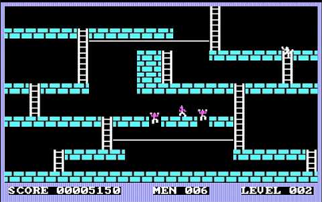
Figure 1 Lode Runner
Other keys, such as arrow have been used to move the character, for example in the game Lode Runner (1983) the player could use left and right arrow keys to move the character left and right and use up and down arrows to climb the ladders. The interesting feature of interface designed in Lode Runner was that the character could climb immediately when the player used up or down command while moving the character left or right. This feature allow the player to use another command before first was executed so the character didn’t need to stop, and this is great example of good UI design to make the user experience smooth.The keyboard was also used in the role-playing games, such as Ultima III where letter keys have been bound to specific commands, for example ‘A’ for ‘Attack’ or ‘I’ to ‘Ignite’ a torch. Some of the games, such as Zork (1980) used an entirely text-based interfaces where the the player had to type out different phrases for example, ‘’get knife’’. Some of the games developed visual interfaces and added animated graphics.
Other control mechanism used in PC games was joystick, some of them had only one button and newer versions had two. Joysticks could give the player more console-like experience. Some games required only joystick to play, however other games could support both – joystick and keyboard, for example Karateka (1984).
Mouse is another control mechanism, which just like keyboard – remained rough constant. Mouse was very important in evolution of user interface. Combination of graphical user interface (GUI) allowed the user to move a cursor across the screen and give commands to the computer. Some computer games are designed to be playable by using only the mouse, for example Civilisation V which is mouse-driven turn based strategy game.
Laptops interface controls are similar to those of deskop computers. They support mouse devices, however they also have built in mouse-like controls and touchpads, They also have built in keyboards. Nowadays, laptops also have touch screens.

Mobile Interface
Mobile user interface differs very much from the user interface of the PC platform.
Mobile devices are much smaller than PC and they don’t have separate control mechanisms such as mouse or keyboard. Mobile phones and tablets are using touch screen controls, and because of their size designers must consider usability, readability and consistency of mobile UI. Also, because of its size there is no enough room for big text labels on everything and all the symbols must be smaller. Mobile interfaces can be more complicated to design as it must be designed on different applications.

Doctor Hurama is considered the inventor of the touch screen. While working as a lecturer at the University of Kentucky, he developed an invention that he called the "Touch Sensor". It has been patented under the name "Elograph".

Market

The latest information based on the Newzoo report says that it was mobile games that dominated the global gaming market.

‘’Mobile gaming will continue to be the largest segment following 10 years of double-digit growth since the first iPhone was launched in 2007. In total, mobile revenues will grow +25.5% year on year to reach $70.3 billion. This means that for the first time, more than half of all game revenues will come from the mobile segment. Smartphones will account for 80% of this, or $56.4 billion, with the remaining 20% coming from tablets. Console gaming is the second-largest segment generating $34.6 billion in 2018, while PC games will bring in $32.9 billion.’’ Wijman, 2018
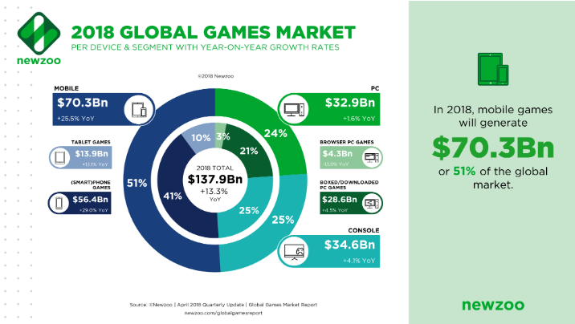
Figure 2 2018 Global Games Market

According to this report, PC games will generate £32.9Bn, what is 24% of the global market. On the basis of this report it is easy to say that playing on a mobile platform is much more popular than on a PC.
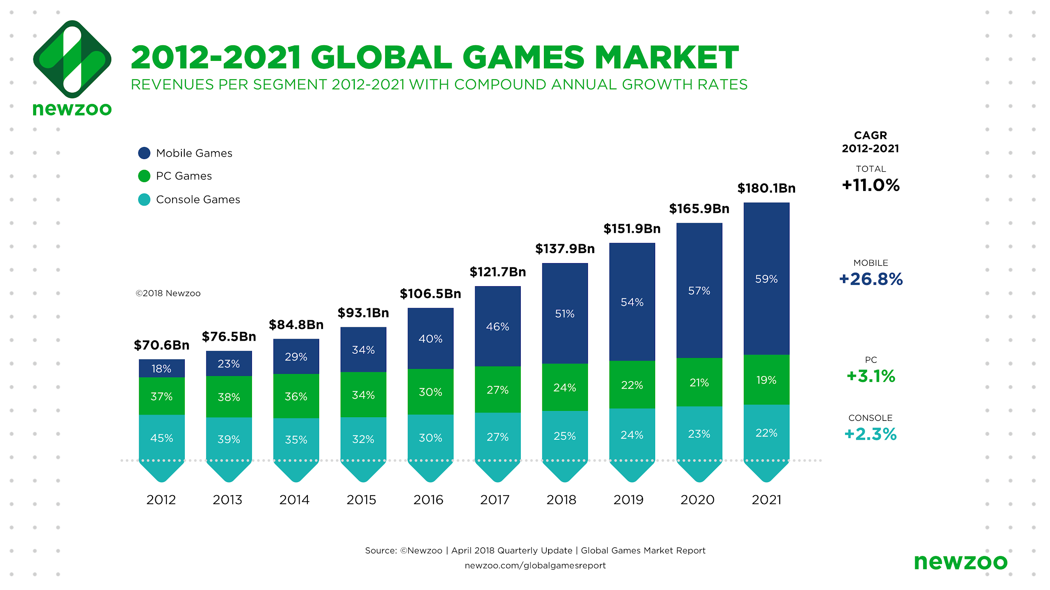
Figure 3 2012-2021 Global Games Market
Since 2012, the mobile platform has grown very much and its value in the global market has increased significantly leaving other platforms back.

‘’In the coming years, mobile game revenue growth will continue to outpace the overall games market, growing to $106.4 billion in 2021. By then, smartphone and tablet games combined will generate 59% of revenues in the entire market.’’ Wijman, 2018

Fortnite PC vs Mobile

The game in co-operative mode is based on research, gathering resources, building fortified buildings and fighting waves of attacking monsters. Players can work together to collect items needed to build a fort, which is later used to defend against attacking opponents. In-game boxes and in-game items are generated randomly on the map, and players receive different types of firearms, such as a shotgun or a sniper rifle, as well as whites, such as a saber or a katana.In the multiplayer mode (Fortnite Battle Royale), a few dozen players participate (up to 100), in which they fight each other until one person or team remains on the map. This mode was released in September 2017 and is developed independently by Epic Games, which separated him from the previous cooperation game. This game is based on free-to-play.The most impressive is to ensure that Fortnite Battle Royale enables cross-platform gameplay between all devices on which they can be run. Fortnite is constantly gaining popularity among players.

Despite the fact that the game is available on different platforms, Fortnite differences on each system.
- Graphics
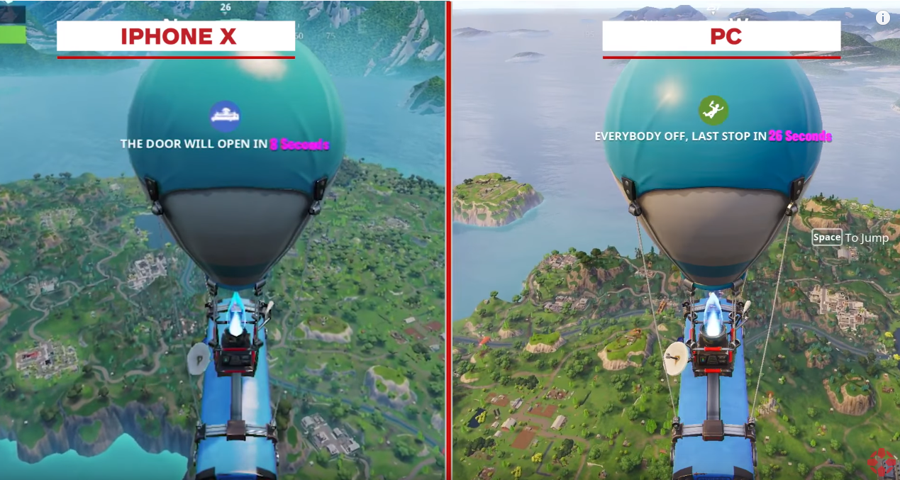
Figure 4 Fortnite mobile vs PC graphics
The PC platform allows the player to set the graphics depending on the computer, it can be higher or lower, unfortunately, players who play on the mobile platform do not have this possibility. The game looks good on both devices, but the PC wins.On mobile, Fortnite isn’t nearly as sharp and the textures are very blocky out. Also, the colours on PC version look more bright than on mobile and there is much more details to see in the environment.
- Controls
On PC, the player can use mouse and keyboard, however on mobile device the player must use touch screen. A player have much more control by using keyboard and a mouse, for example when aiming.
- Keybinds
When it comes to keybinds, the PC platform wins because it has a keyboard and mouse. Mobile platform don’t have the option to keybind through Fortnite’s control settings so players must rely on getting used to the buttons. Keybind, for example allow the player to instantly switch to a weapon in any slot with the press of a key. On mobile consoles the player have to go through all keys, for example from 1 to 4 to switch the weapon.
- Framerate
PC is able to run higher than 60 frames per second, however a smartphone have limited framerate and have very often frame drops.
- Screen size
As technology gotten more sophisticated screens have gotten larger and now the screen size has a significant effect on the user experience. Mobile phones and tablet’s screens are much smaller than monitors so on PC a player can have better experience while playing and also see much more details.

Fortnite User Interface PC vs Mobile
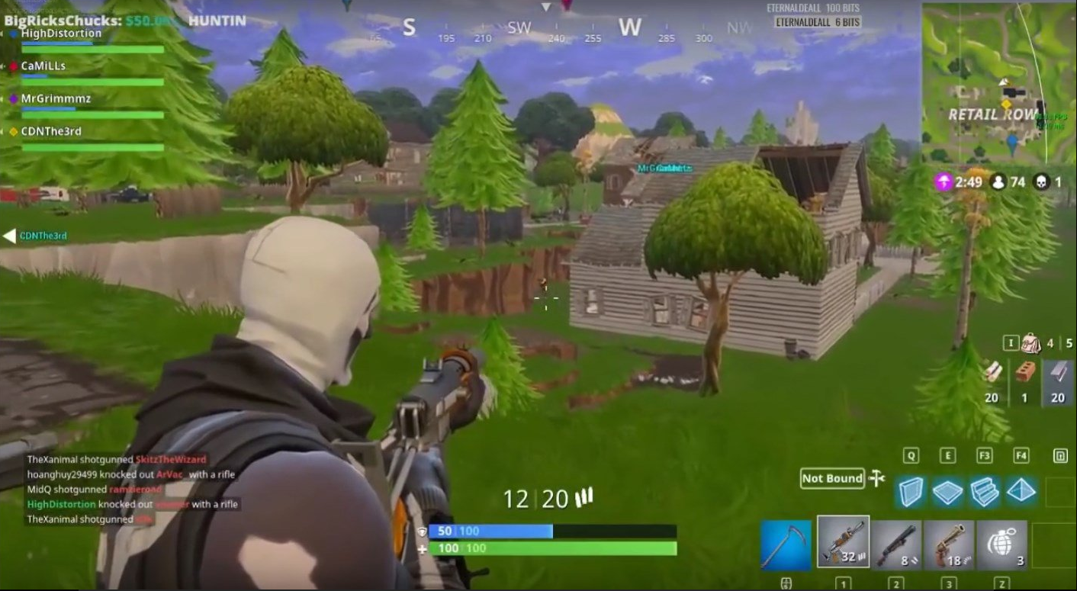
Figure 5 Fortnite PC interface 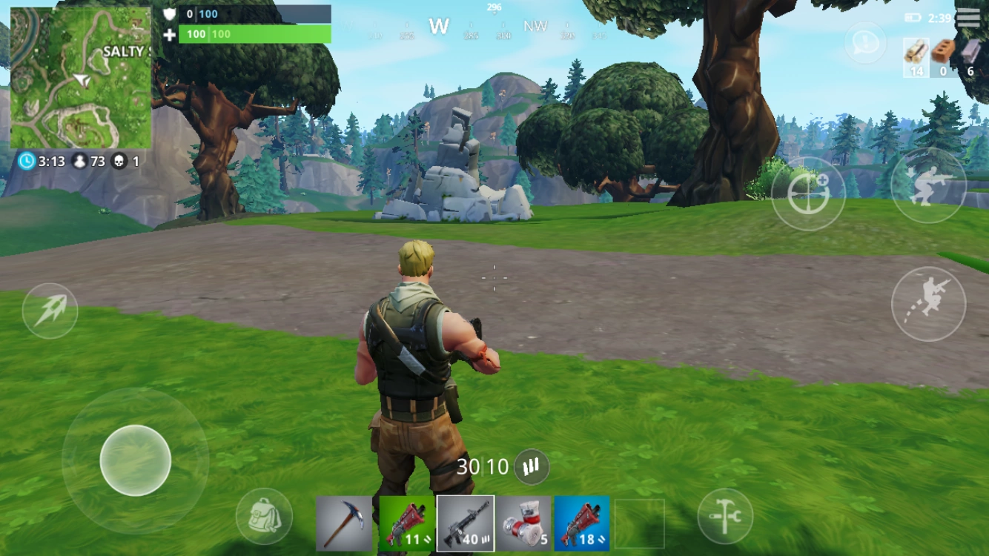
Figure 6 Fortnite mobile interface
Fortnite’s PC version interface look much more complicated than mobile version. There is much more icons and options. On PC version we can see the minimap is in the right corner, health bars are in the middle and weapons are in the right corner. There is also a chat. Mobile version shows different controls of the character, weapons are in the center, minimap is on the left and health bars are by the minimap.

The Sims 4 vs the Sims Mobile

The Sims 4 is a computer simulation game, being the fourth part of the Sims series in which players control the lives of virtual people. The game was developed by Maxis and released by Electronic Arts on September 2, 2014 for personal computers. The sims mobile is a mobile version of the popular The Sims series.

Creating a character
In the mobile version at the very beginning the game asks the player to create a sim, the virtual equivalent of a human. There are a lot of creative options, including modifications to the width of the nose, the height of the forehead, the level of muscles and the weight of the character being created. The game offers a rich character wizard and wardrobe selection, however, some pieces of clothing are blocked and the player must unlock them during the game.
the sims 4 game allows the player to edit literally every part of the body, from stop to nose. the player can easily change the position of the eyes, the size of the lips, ears or nose, change the thickness of the lips, the position of eyebrows, protrudes the chin, and even the size of the iris. Creating characters for both platforms is very rich, but the PC version is much richer and offers a lot more options. There is also no limit for clothes - the player has every dress available.
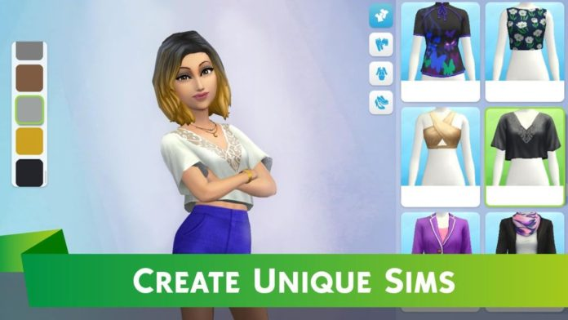
Figure 7 The Sims mobile creating character


Figure 8 The Sims 4 creating character

Creating a house
The build mode in the mobile version is very limited, many pieces of furniture are blocked and the player has to unlock them during the game. The rooms can only be in the shape of a rectangle which the player can extend or reduce, there are no higher floors or swimming pools. Comparing to this, the player in The Sims 4 can create a house in any shape with more than one floors and can build a swimming pool. Also the furniture is not locked.

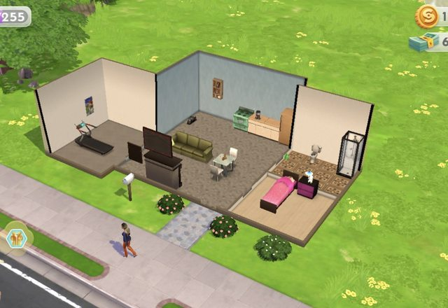
Figure 9 The Sims mobile creating house

Figure 10 The Sims 4 house

Gameplay

In the mobile version, the game is based on doing quests, missions and events. They can be associated with a hobby (eg guitar playing), a career (eg going to work) and relationships with other sims (eg spending time together at home). The equipment then offers special interactions that add a different number of points to the player. Collecting them, successively shortens the time needed to complete the task. By sending a sim to work in a cafe, the player can simply turn off the phone and return to play a few hours later - the game uses real time, so here the player can not just speed up the time as in the PC version. The mobile game has very large limits, in the PC version the player can do whatever he wants, does not have to do tasks if he does not want and the time in the game can always accelerate.

Figure 11 The Sims mobile gameplay

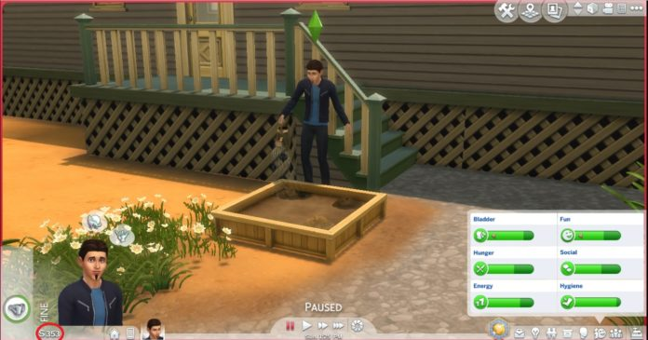
Figure 12 The Sims 4 gameplay

Interface
The interface created for The Sims mobile is much simpler than the one for PC versions, it also has much less options. We can find elements such as progress bar, points and money, as well as a character avatar. On PC version there are much more options, such as speed, gallery, building mode, money and options associated with the character, such as its avatar or needs.

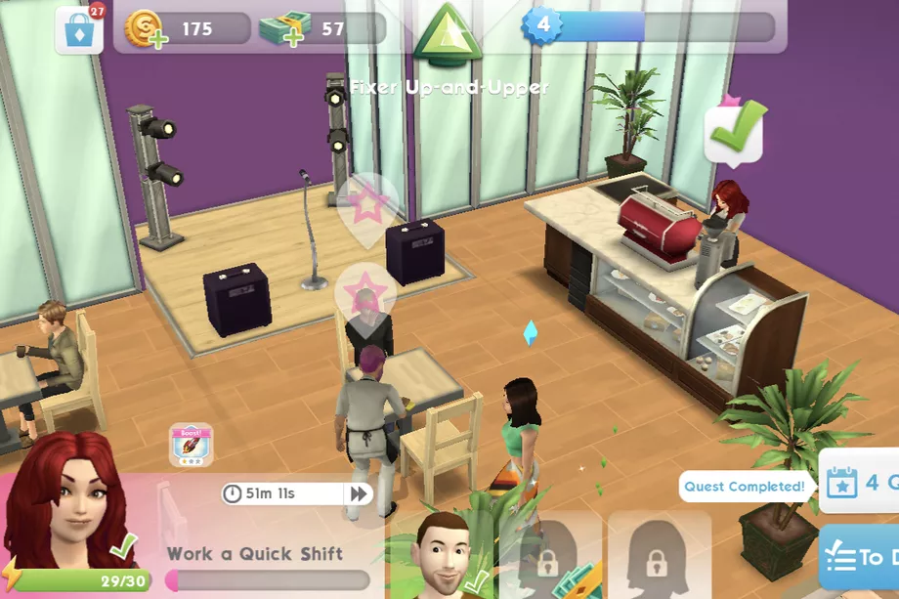
Figure 13 The Sims mobile interface

Figure 14 The Sims 4 Interface

Conclusion

It is certain that mobile games run on the global gaming market. This is due to the growing technology that allows smartphones to fit computers, but also that they are everywhere and they can be used everywhere, so people can play games while they are traveling or even while working. At this moment, mobile games can not provide the same quality as games created on PC, but the technology is moving forward and the quality of games created for mobile devices is very high compared to those from a few years ago. Based on the history of personal computers, their design has not changed much in recent years, but the phones are still evolving.The same games created for phones have a lot of limits, it varies in graphics but also in gameplay. Based on the above examples, the gameplay in Fortnite on both platforms is not much different, the game is the same, however, character control and graphics are much different, while in The Sims, the mobile version is completely different from the one on PC and has a lot of limits, even if the theme is kept.Their interface is also different. The fact that the developers are designing the same games both on PC and on mobile devices also shows that phones may soon exceed computers in their technology.

Bibliography
Books
Novak, J. (2013). Game development essentials. 2nd ed. Clifton Park, N.Y.: Delmar, pp.21-25.
Novak, J. (2013). Game development essentials. 2nd ed. Clifton Park, N.Y.: Delmar, pp.26-34.

Online
Lamble, R. (2017). The evolution of handheld videogaming in 17 consoles. [online] Den of Geek. Available at: https://www.denofgeek.com/uk/games/handhelds/53361/the-evolution-of-handheld-videogaming-in-17-consoles [Accessed 28 Nov. 2018].
Edwards, B. (2009). 30 Years of Handheld Game Systems. [online] PCWorld. Available at: https://www.pcworld.com/article/183679/evolution_of_portable_gaming.html#slide1 [Accessed 28 Nov. 2018].
Knight, D. (2014). Personal Computer History: 1975-1984. [online] Low End Mac. Available at: http://lowendmac.com/2014/personal-computer-history-the-first-25-years/ [Accessed 4 Dec. 2018].
Encyclopedia Britannica. (n.d.). Personal computer | technology. [online] Available at: https://www.britannica.com/technology/personal-computer [Accessed 6 Dec. 2018].
History Learning Site. (n.d.). The Personal Computer - History Learning Site. [online] Available at: https://www.historylearningsite.co.uk/inventions-and-discoveries-of-the-twentieth-century/the-personal-computer/ [Accessed 7 Dec. 2018].
Touchscreen Wiki. (n.d.). History. [online] Available at: http://touchscreen.wikia.com/wiki/History [Accessed 14 Dec. 2018].
Rouse, M. (2015). What is mobile UI (mobile user interface)? - Definition from WhatIs.com. [online] SearchMobileComputing. Available at: https://searchmobilecomputing.techtarget.com/definition/mobile-UI-mobile-user-interface [Accessed 15 Dec. 2018].
Wijman, T. and 2018, T. (2018). Global Games Market Revenues 2018 | Per Region & Segment | Newzoo. [online] Newzoo. Available at: https://newzoo.com/insights/articles/global-games-market-reaches-137-9-billion-in-2018-mobile-games-take-half/ [Accessed 19 Dec. 2018].
Parent Zone. (2018). Fortnite: everything you need to know about the popular game. [online] Available at: https://parentzone.org.uk/article/fortnite-everything-you-need-know-about-online-game [Accessed 3 Jan. 2019].
Arts, E. (n.d.). The Sims 4 Features Overview - The Sims 4 Official Site. [online] Electronic Arts Inc. Available at: https://www.ea.com/games/the-sims/the-sims-4/pc/features/overview [Accessed 5 Jan. 2019].
IGN. (2014). The Sims 4 Review - IGN. [online] Available at: https://uk.ign.com/articles/2014/09/02/the-sims-4-review [Accessed 5 Jan. 2019].
Farokhmanesh, M. (2018). The Sims Mobile offers a more focused, accessible version than any before it. [online] The Verge. Available at: https://www.theverge.com/2018/3/10/17097196/the-sims-mobile-focused-version-gaming-maxis-android-ios [Accessed 6 Jan. 2019].

Videos
IGN, (2018) Fortnite Graphics Comparison: iOS vs. PC. [Online Video] Available at: https://www.youtube.com/watch?v=6xRAlPAhHtI [Accessed 3 Jan. 2019].

TheGamer, (2018) 10 Ways Fortnite Is Different Between Playstation, Xbox, Switch, PC and Mobile. [Online Video] Available at: https://www.youtube.com/watch?v=xLJ3Z5zxya8&t=456s [Accessed 3 Jan. 2019].
Techzamazing, (2018) Fortnite PC vs MOBILE - GAMEPLAY [Online Video] Available at: https://www.youtube.com/watch?v=PTvAobfth4w&t=23s [Accessed 3 Jan. 2019].
rachybop, (2017) The Sims Mobile vs The Sims 4.[Online Video] Available at: https://www.youtube.com/watch?v=WREn3xQGtLI&t=38s [Accessed 6 Jan. 2019].
TapGameplay, (2018) The Sims Mobile - Gameplay Walkthrough Part 1 (iOS, Android)
.[Online Video] Available at: https://www.youtube.com/watch?v=w0ItV0eYbGA [Accessed 6 Jan. 2019].

