Skills for the Workplace
Module Assignment Submission
Student Name: | Mohammed Imran Hurt
Student Number: | 1710177
Module No: | BMSK4005
Module Title: | Professional Career Development

Statement of Confirmation of Authenticity
By the act of making this submission, the student declares that this is the work of the student named above. The work has not, in whole or in part, been knowingly presented elsewhere for assessment, or where assessment has been built on a previous assessment, this has been identified. Where materials have been used from other sources it has been properly acknowledged. If this statement is untrue, the student acknowledges that an assessment offence has been committed.
Attention is drawn to the plagiarism and unfair practice policies of both the University and of ILM.

Table of Contents

Section 1: Know how to identify development needs 3
1.1 Identify learning styles for self and another 3
1.2 Use a simple technique for identifying development needs for self & another 4
1.3 Identify potential barriers to learning for self and another. 5
1.4 Explain how these barriers to learning can be overcome.
1.5 Support Network
1.6 Plan of Action
1.7 Monitor Progress 6
Section 2: Know how to develop self & others to achieve organisational objectives 6
2.1 Analyse learning/development options to meet needs of self & another. 6
2.2 Identify support mechanisms for the development of self & another 6
2.3 Prepare development plans for yourself and another person 7
2.4 Method used to monitor the development of self & another. 8
Section 3: Know how to prepare for the recruitment process 8
Reflection on the recruitment process 8
3.1 Description 8
3.2 Feelings 9
3.3 Evaluation 9
3.4 Analysis 9
3.5 Conclusion 9
3.6 Action Plan 9
References 10
Appendix A 10
Appendix B 10
Appendix C 10
Appendix D 10

Section 1: Know how to identify development needs

1.1 Identify learning styles for self and another
I work in a small Mental Health Facility in Cardiff. I hold the position of Senior Support Worker. In this role I Supervise and mentor the team of Support workers completing their supervisions and aiding the Manager to complete their PDR assessments. Throughout the COVID pandemic the unit has struggled due to a lack of staff and recruitment. Due to staff shortages there are often a lack of Medication Trained staff on site leading to delays for our clients and operational difficulties. Aiding staff to achieve further training would greatly aid the Unit so it is vital to learn staff's preferred learning style. This would improve the time in which it takes staff to train and make staff more willing to accept further training modules.To improve my personal performance and that of my staff my colleague Jameel Beddi and myself undertook a Learning development test to identify our preferred learning styles.
The most widely adopted approach to Learning Styles is Honey and Mumfords (1986)

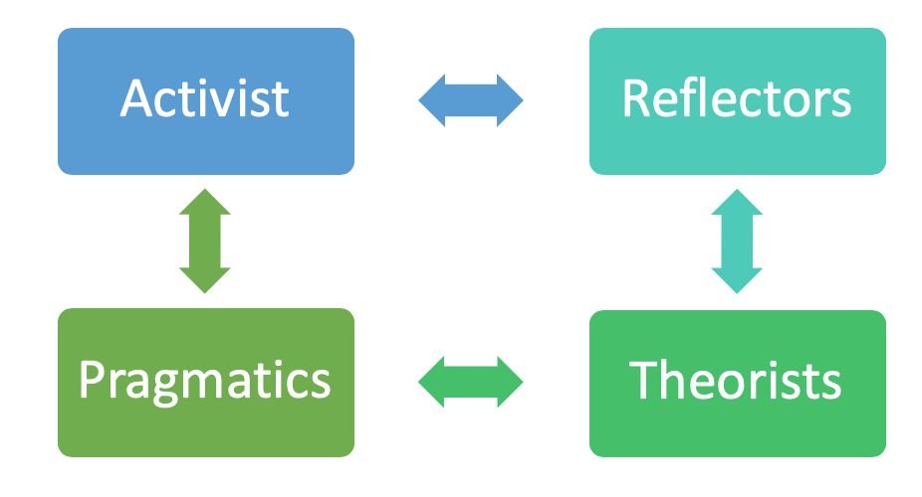

The questionnaire was designed to show people which learning style is most beneficial to them and would allow them to learn faster.
- Activists live in the here and now and are very much doers rather than thinkers, they learn from experience rather than planning
- Reflectors will like to plan carefully and consider their next action, they may be reserved in goup discussions preferring to hear the opinions of others before voicing their opinions.
- Theorists will use previously successful methods or models in their quest for perfection, they are usually rigid in their adherence to these principles.
- Pragmatists are enthusiastic in their approach like Activists however they will use a previously used plan or idea in a more measured approach .
Jameel Beddi and I took the Honey and Mumford test and it was discovered that Jameel Beddi was an Activist and I was a Pragmatist, which are compatible learning styles as we both like to learn visually and through practice / demonstration. In order to speed up our medication training it should be arranged for a practical demonstration of the meds Policy and procedures with somebody demonstrating the medication count rather than being provided with documentation of the procedures as this will improve our learning.
We also took the Vark test as another tool in order to assess our best learning style. Piping (2005) stated in his study that Vark can enhance students' understanding as well as raise learning motivation and interest amongst students. Upon completion of the Vark questionnaire it was shown that JB and myself both had the preferred learning style of Kinesthetic, which is a practical hands-on approach through demonstration and teaching of Past experiences. This reinforced what Honey and Mumford said that a more practical approach was needed in our training. After consultation with our Manager he arranged to demonstrate practically all the procedures such as booking in medication and disposing of out of date medication.
Finally I completed the Dantec personality test which is a test to assess the best possible .The acronym VARK stands for Visual, Aural, Read/write, and Kinesthetic sensory modalities that are used for learning information. Fleming and Mills (1992) suggested four modalities that seemed to reflect the experiences of the students and teachers. I tested in the Concrete Experience group which reinforced the other two tests that I would benefit from a practical learning experience. A Concrete experience means you’re dealing with the here and now and processing information based on what you see, hear, think, feel, and taste. “It is what it is.” anon

1.2 Use a simple technique for identifying development needs for self & another

In order to improve our performance a SWOT analysis was created listing our strengths and weaknesses so that we assess what areas require improvement and what support can be offered i.e. mentoring , training .
Swot analysis makes you analyse your strengths and weaknesses and is usually used in the primary stages of decision making in order to guide the decision making process. It is divided into four sections:
- Strengths, your characteristics that give you an advantages over others which are usually internal factors
- Weaknesses, your weaknesses that puts you at a disadvantage to others which are normally external factors
- Opportunities, chances to improve yourself or the situation that you are analysing which are normally external factors
- Threats, are normally external factors which can negatively impact on you or the situation you are analysing

With this in mind my colleague and I individually completed the Swot analysis charts with our work performance in mind.

SWOT Mohammed Hurt

STRENGTHS  Experienced  Team Player  Copes well in crisis | WEAKNESSES  Lacking In IT skills  Paperwork  Organisational Skills
OPPORTUNITIES  Will Improve IT skills with practice  Completing Medication Training  Entering Management Training | THREATS  COVID  Change of job  Sickness  Unit may close due to lack of staff  Clients may be re housed if recruitment does not take place

SWOT Jameel Beddi

STRENGTHS  Great IT skills  Team Player  Positive attitude completing tasks | WEAKNESSES  Inexperienced  Nervous with aggressive clients  No medication training  Poor sickness record

OPPORTUNITIES  Complete level 2 in Health and social care  Complete Medication Training  Gain experience | THREATS  COVID  Change of job  Sickness  Relocation if the Unit loses any more clients

Following completing the SWOT analysis I found that I was lacking in the more traditional office skills such as typing, computer skills and as well as the organisational aspects of my job role. These include typing monthly reports on my clients as well as typing the reports on the staff within my core team for which I must write supervisions and PDR (Performance and Development Review). I hope that completing this Course, Skills in the Workplace will help me with these aspects of my job. Also with completion of University Courses I will hopefully enter the management training program therefore turning weaknesses into opportunities. I found completing The SWOT analysis very insightful so I Decided to complete further Analysis in the form of Johari Window.
A Johari Window is a psychological test designed to Aid self awareness and improvement. The test involves taking information from self analysis like a SWOT test and discussing a discovery in order to seek the advice and guidance of others to improve yourself. It is vital to be honest with yourself and others as well as completing the test with someone you trust.
It was created by Joseph Luft and Harry Ingham (1955) it is a tool that has an emphasis on skills such as behaviour, empathy, co-operation, inter group development and interpersonal development. It is a model that is easy to use because of its simplicity and also because it can be applied in a variety of situations and environments. It helps work on the following characteristics:

- personal development
- improving communications
- interpersonal relationships
- group dynamics
- Self Awareness
- team development; and
- inter group relationships
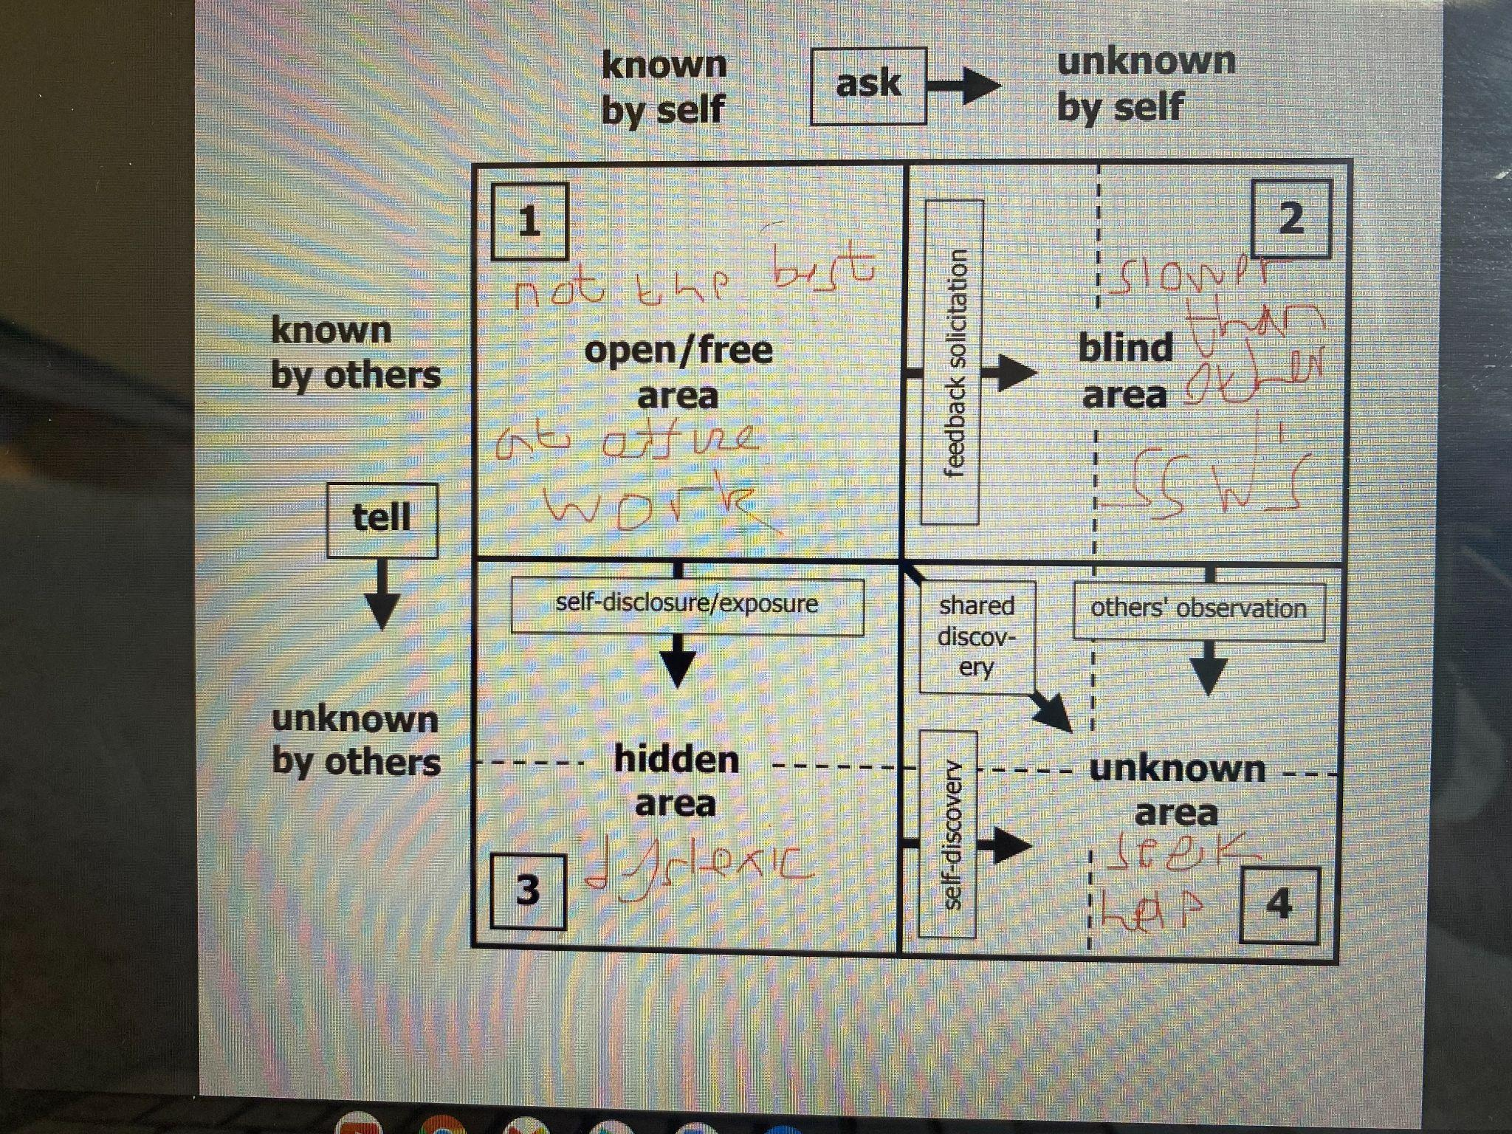
Completing the Johari window was an enlightening experience. I discussed that I find the office work aspects of my job harder to complete. Discussing a Blind area’s Jameel stated that I take longer to complete the office based tasks then my other two counterparts and this can sometimes impact the unit as I spend less time on the floor supervising the clients. I exposed a hidden area informing him that I was dyslexic which impacts the time it takes me to read the work spreadsheets such as the financial spreadsheets and rota spreadsheets We then both agreed it would benefit myself the clients and other workers if I sought aid with this i.e. colored screens and dyslexic aids etc. It felt good to discuss and hear evaluation from someone whose opinion I trusted, however the downside is that I did felt uncomfortable discussing personal undisclosed information with my subordinate. I perhaps felt more comfortable as at the moment he is not in my supervision group however there is the chance he will move to my group and that may affect the dynamics of supervisor and supervisee.

1.3 Identify potential barriers to learning for self and another.

COVID 19 has changed the whole world over the past through years and the care industry is no different. Staff numbers have dropped as well as the complications in moving clients between different services and complicated and prolonged the procedure. For example the process of moving a client from a mental health hospital to a care home has been delayed or postponed. We still have had clients moving on or home so this means that our clients have dropped from 7 to 3 meaning staff have had to be redeployed to other homes.
With support workers being redeployed obviously this massively affects Jameel's ability to train as he will not be on the premises. Also our Company uses in-house training companies. I myself have gained level 2 and 3 in Health and Social care due to these methods. Due to Covid restrictions these visits have slowed down or stopped. Jameel is currently attempting to gain his Level Two in Health and Social care but this is moving very slowly as the trainers are unable to visit the house.

Currently the unit is understaffed with 7 staff caring for four clients twenty four hours at day, three hundred and sixty five days in a year. This means two staff work by day and two by night which can be very demanding. Once the client's care has been completed such as administration of medication and supervision of meal preparation then there are legally required tasks such as completion of notes and environmental checks must be completed. Also a barrier for myself is the completion of monthly reports must be written on each client which is also a very time consuming process. This leaves little time for staff training as for example we both require Medication training which consists of two parts, firstly a completion of elearning tests which is a time consuming process taking many hours to complete the seven units and then observation by a Senior member of staff administering Medication and completing daily medication counts to insure there have not been any medication errors. Both theses are long processes requiring many hours which currently they do not have as two staff are doing the tasks completed normally of between three to four staff. JB also faces the additional barrier of his sickness record which is quite extensive.

1.4 Explain how these barriers to learning can be overcome.

The company is currently actively involved in a recruitment process to employ new support workers to work on the unit. If extra staff are employed this will relieve the pressure on staff and lower the amount of tasks which must be completed each day. Since the COVID pandemic staff numbers throughout the care industry have fallen due to many factors including increased risk of catching the virus (your bubble is dramatically increased) and increased wages in professions you can work at home with. If the employer Ludlow Street Healthcare increased our wages this might speed up the recruitment process and more staff employed extra time would be free up in our working days. With extra time available more training days can be allocated making the time to train significantly reduced. With more staff available to cover the floor senior staff can be freed up from their daily tasks and allocated as trainers mentoring us on medication training which would make the Supervision section of the training faster so we can be signed off sooner.
JB has had supervision with both his Senior Support Worker and his Manager regarding his absences from work. This mentoring has appeared to be successful as both his sickness and timekeeping has improved. If he continues in this new manner he will complete his training around 20 % quicker as he had an absence rate of around 20%.
Since the Pandemic the world has changed in the way we live and carry out business. Zoom and Teams meeting have become the new normal and if the work based training company adopts these more than this would aid to speed up Jameel's training.

1.5 Support Network
In order to achieve our Goals we of course need support, it would be impossible to achieve these goals independently . We need to be taught as well as be given the opportunity and the time to learn. I realised how much help I required when I completed a GO MAD thinking external triangle. 1998 Andy Gilbert (1998) set up a research project to answer the following question,“What is the simplest way of explaining the success process that people naturally use when making a difference?”He created a think tank so that a practical and easy to understand framework for success, The Framework was made up of seven key principles that link together to make a thinking system to form the Go M.A.D.® Results Framework.

Involve Others
Family, tutor, Peers,my Boss, My colleagues
External Triangle
Achieve Qualifications
Medication Training
Join Managment Training

Plan Prioritise
Attend sessions ,
Pass assignment
Graduate

Following this I decided to formulate a triangle fo Jameel so it would help him realise his needs and prioritise his plans after discussions with Jameel. Jameel stated this had helped him to prioritise what was required for his personal improvement. He also informed me that it had helped him focus on his goals and how to achieve them.

External Triangle
Involve Others
Family, Senior Support Worker, Manager, Training Officer person who signs off Meds
Plan Prioritise
Complete Medication Training
Complete Health and Social Care Level 2
Become a Senior Support Worker
Mentor others

1.6 Plan of Action

In order to move forward in Myself and Jameel's Training a Smart tool was drawn up inorder to focus on the situation and help seek a solution. SMART is an acronym that can be used to guide you to achieve your goals.
It was created by Peter Drucker(1981) in concept. In order to be successful you must make sure your goals are clear and reachable, each one should be:
- Specific (simple, sensible, significant).
- Measurable (meaningful, motivating).
- Achievable (agreed, attainable).
- Relevant (reasonable, realistic and resourced, results-based).
- Time bound (time-based, time limited, time/cost limited, timely, time-sensitive).
Therefore I created the following Table

S  Specific | M  Measurable | A  Attainable | R  Realistic | T  Time Bound
Myself and Jameel Finish  Medication training | To have all elearning completed and tasks signed off | To complete within one month | Full attendance in work will be required to achieve this | To be completed before 2022!

Having created and analysed the smart chart it was decided that what would aid the process would be to focus on completion of our medication training. In order to achieve this task we would need to have full attendance to the remaining shifts in December . Jameel has previously had poor attendance which has improved following mentoring from his Manager and his Senior Support Worker. Continuing this mentoring appears to be vital in achieving our goals. Completion of all elearning which can only be completed on shift on the Company network, Liaising with the manager to have extra staff on shifts so allotted training periods could be set which should make this target more achievable.

Section 2: Know how to develop self & others to achieve organisational objectives

2.1 Analyse learning/development options to meet needs of self & another.

David Kolb (1984) developed his learning style inventory. Kolb's revolutionary learning theory works on two levels: a four-stage cycle of learning and four separate learning styles. A large portion of Kolb’s theory is about the learner’s internal cognitive processes. In Kolb’s theory, the impetus for the development of new concepts is provided by new experiences.
“Learning is the process whereby knowledge is created through the transformation of experience” (Kolb, 1984)
1. Concrete Experience - a new experience or situation is encountered, or a reinterpretation of existing experience.
2. Reflective Observation of the New Experience - of particular importance are any inconsistencies between experience and understanding.
3. Abstract Conceptualization reflection gives rise to a new idea, or a modification of an existing abstract concept (the person has learned from their experience).
4. Active Experimentation - the learner applies their idea(s) to the world around them to see what happens.

Following our personalized learning test myself and Jameel, we are both Concrete learners and would benefit from a practical demonstration which our minds would find easier to process and make the learning experience a pleasant rewarding experience. This is not the only model however
Gibbs' Reflective Cycle was created by Graham Gibbs (1988) to give structure to learning from experiences. It examines experiences, and given its cyclic nature lends itself particularly well to repeated experiences, allowing you to learn and plan from things that either went well or didn’t go well. It contains 6 stages:
- Description of the experience
- Feelings and thoughts about the experience
- Evaluation of the experience, both good and bad
- Analysis to make sense of the situation
- Conclusion about what you learned and what you could have done differently
- Action plan for how you would deal with similar situations in the future, or general changes you might find appropriate.
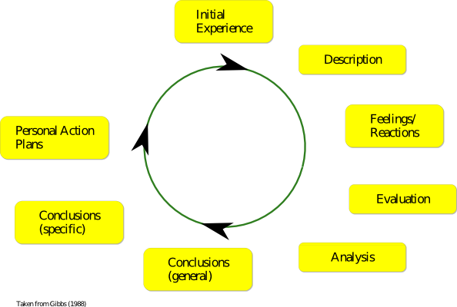

2.2 Identify support mechanisms for the development of self & another
Our workplace Ludlow Street Healthcare is a very supportive employer. Our company actively encourages us to train as much as possible . I myself have gained level 2 and 3 QCF in health and Social Care. My colleagues have trained also so can support us in our training as we have all been in the same boat. Management can help arrange extra courses such as I am enrolled in an extra Epilepsy course.
All this study cannot happen without the support of your family as time lost at home needs the support of your family i.e. childcare or lift to college.

2.3 Prepare development plans for yourself and another person

Part 1: Personal Analysis
See SWOT Analysis in 1.2

Part 2: Setting Goals

What do I want to learn? | What do I have to do? | What support and resources will I need? | How will I measure success? | Target Date for Review
Medication Training | Complete  Online  Modules | Online training  Staff advice  Company resources | Passing the modules | One week
Epilepsy training | Request to be entered on the Course | Two training days  Online company workbooks | Passing the course | 3 months
Skills in the Workplace level  4 | Continue to attend the course | Lecturer  Classmates  Moodle | Passing the course | 1 year

Part 3: Personal Objectives

Short Term Goals (next 12 months)
Complete Medication Training
Complete Skills in the Workplace Course

Medium Term Goals (2-3 years)
Complete Leadership and Management Degree
Enter Management Training Program

Long Term Goals (3-5 years)
Manage my own Mental Health Unit
Change jobs to work in a less challenging management environment

2.4 Method used to monitor the development of myself and other
Our workplace Ludlow Street Healthcare is a very supportive employer. Every employee receives a monthly supervision as a minimum. If a staff member is assaulted or abused ( a sadly frequent event) extra supervisions are offered as well as a 3 monthly Performance Development Review carried out by Seniors of Managers. Additional support can be sought from the HR or training department. External companies train the staff in QCF qualifications in Health and Social care. All these networks can be used to support both Jameel and I .

Section 3: Know how to prepare for the recruitment process

Reflection on the recruitment process

The recruitment process can be an arduous experience. I will use Gibbs model to analysis I will describe a distressing interview I had in the past and what I learnt from it.

3.1 Description
Although my Interview years ago was successful it was not a pleasant experience. Initially I was waiting in the lobby for my interview to start and I was left listening to unknown voices screaming and swearing for ten minutes . I was then called to The office area for my actual interview Which went well but after the question stage of the interview I was taken to tour the unit. Upon arriving at the unit security door I heard loud screams of “help, help” and screams of pain. The manager went to see what happened and left me listening to the screams for 5 minutes. After which I was informed it was too dangerous to enter the unit and the interview .

3.2 Feelings
Although I was experienced in mental health and was expected to work in a challenging environment I do not think leaving me listening to people screaming on two occasions was very constructive and left me with a poor first impression and made me feel what am I signing up to?
Later after I started I meet the person who was screaming because they were being bitten by an Client because they were instructed to move him from by the door lock because I was to do a tour so I felt guilty about this.
3.3 Evaluation
Although listening to the screaming was traumatic I still accepted the job as I love working in mental health and was used to working in challenging environments

3.4 Analysis
As a company though I believe we should be more aware of how and where we conduct interviews. I doubt whether anyone new to the industry would have returned to the unit . We have to be more mindful of people's feelings and one of the main drawbacks of staff who have worked in our industry for a long time than you can become insensitive to things like this.

3.5 Conclusion

I believe part of the reasons for the companies massive turn over with staff is the induction / interview process and I believe this should be changed in order to better support new starters. Improvements in this would aid in the retention of staff which benefits all. I have heard other members of staff have had similar experiences , one of my favorite Nurses always tells the story of how I was the first person she met in company as someone was trying to assault her when she waited for her interview and I stopped them.

3.6 Action Plan
- Contact Company Welfare Officer
- Explain the circumstances
- See If other staff have had similar Experiences
- Consult with HR over where and when interviews take place

References

Go MAD Thinking. 2021. About - Go MAD Thinking. [online] Available at: <https://gomadthinking.com/about/> [Accessed 2 December 2021].

Mindtools.com. 2021. SMART Goals: – How to Make Your Goals Achievable. [online] Available at: <https://www.mindtools.com/pages/article/smart-goals.htm> [Accessed 2 December 2021].
2021. VARK. [online] Available at: <https://whatismylearningstyle.weebly.com/vark.html> [Accessed 27 November 2021].

Self Awareness. 2021. Self Awareness. [online] Available at: <https://www.selfawareness.org.uk/news/understanding-the-johari-window-model> [Accessed 1 December 2021].
Simplypsychology.org. 2021. [online] Available at: <https://www.simplypsychology.org/learning-kolb.html> [Accessed 2 December 2021].

The University of Edinburgh. 2021. Gibbs' Reflective Cycle. [online] Available at: <https://www.ed.ac.uk/reflection/reflectors-toolkit/reflecting-on-experience/gibbs-reflective-cycle> [Accessed 2 December 2021].

VARK - A Guide to Learning Styles. 2021. [online] Available at: <https://vark-learn.com/introduction-to-vark/the-vark-modalities/> [Accessed 27 November 2021].

Verywell Mind. 2021. Are You a Visual, Auditory, Reading/Writing, or Tactile Learner?. [online] Available at: <https://www.verywellmind.com/vark-learning-styles-2795156> [Accessed 27 November 2021].

Appendix A
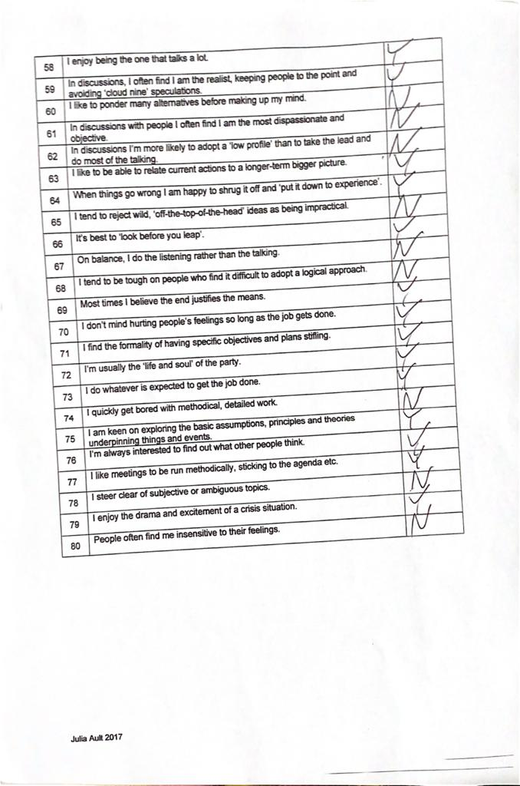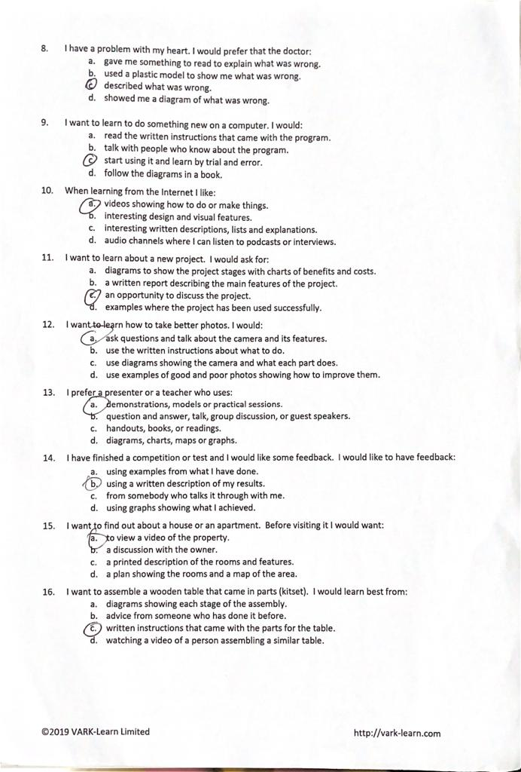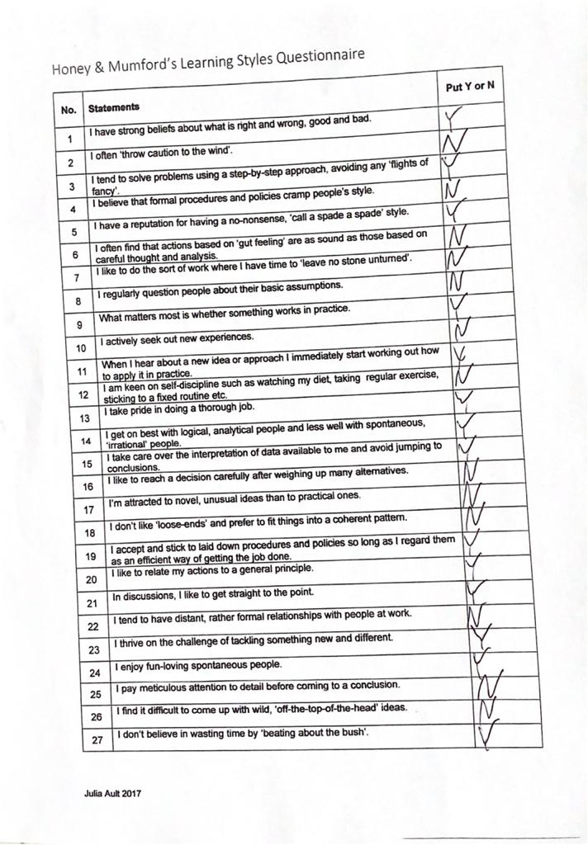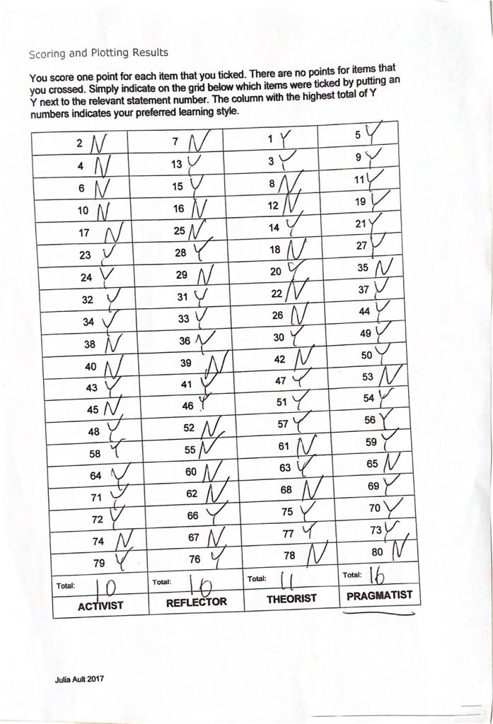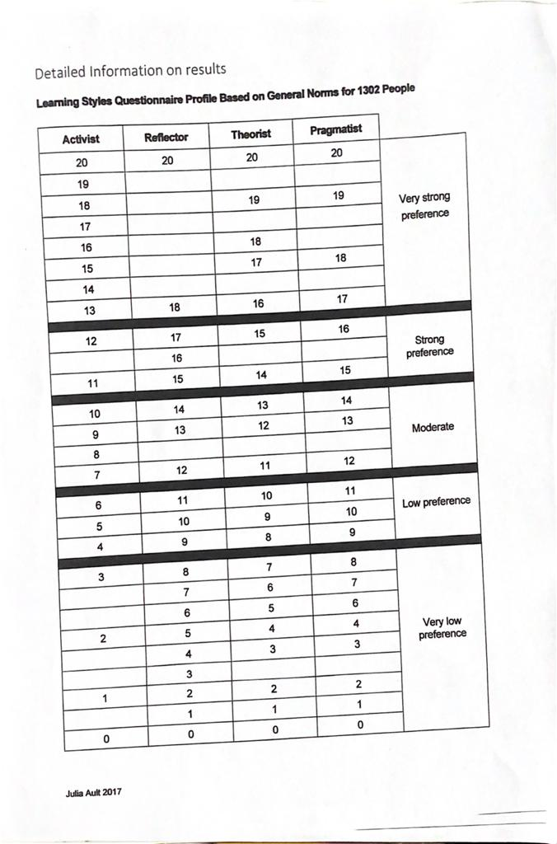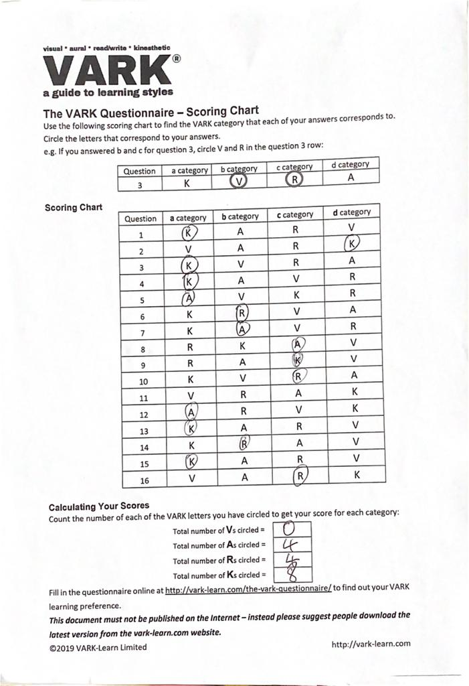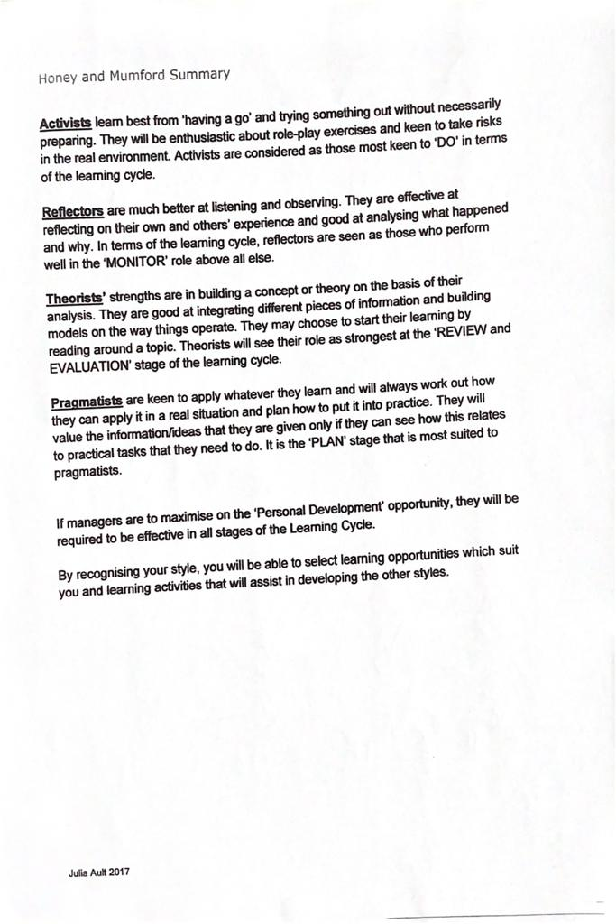
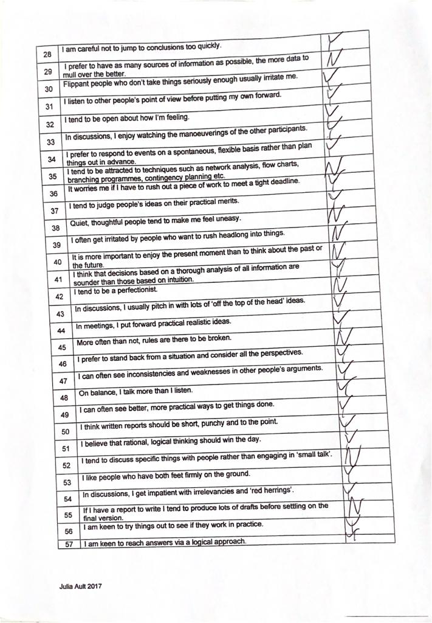

Appendix B



