University of Wales Trinity Saint David

Motorsport Engineering

Structural & Fluid Analysis

ACHA6010

Application of CAE Processes

William Hare

2219871

Table of Contents
Introduction 3
Methodology 3
Modelling and Assembly 3
Rigid Dynamics 4
Thermal Study 5
Static Structural 6
Deformation 6
Stress 6
Optimizing and improvement 7
Thermal Comparison 8
Cast Iron 8
Stainless Steel 8
Static Structural 9
Deformation 9
Stress 10
Validation 11
Deformation 11
Stress 11
Mesh Independence Study 12
Boundary Conditions 13
Conclusion 13
References 14

Introduction
In modern engineering design, Computer-Aided Engineering (CAE) tools play a critical role in modelling, analysing, and optimising complex systems (Stroia, 2020). This assignment aims to simulate the process of testing a real-world system within a computational environment, highlighting both the capabilities and constraints of CAE. By taking steps that include component assembly, kinematic analysis and structural evaluation, this project seeks to replicate key aspects of the engineering design cycle. Using ANSYS software, a kinematic analysis will be conducted to derive realistic operating loads, followed by a static structural assessment of a selected component, considering thermal and mechanical effects. Through model refinement, the component's structural performance and fatigue life will be enhanced while optimizing its mass. Additionally, validation testing will be performed using a simplified test case to compare analytical solutions with ANSYS results, including a mesh independence study and an evaluation of boundary condition influences. The collection of this work will be a comprehensive report that not only documents the findings but also assesses the role of CAE tools in engineering, providing insights into their advantages and limitations.

Methodology
This assignment will utilise ANSYS, a software for finite element analysis (FEA) and simulation, to model, analyse, and optimise a real-world system. ANSYS is chosen for its capabilities in kinematic analysis, structural assessment, and optimisation, which align with the project objectives (Chen, 2018). The process begins with creating a realistic assembly of five components, ensuring accurate geometry to support reliable simulations. A kinematic analysis will then simulate operating conditions to generate realistic loading data, which will inform a detailed static structural analysis of a selected component (Soni, 1982). This analysis will incorporate realistic boundary conditions, material properties, and thermal effects to assess stress, deformation, and potential failure points.
Following this, design optimisation using ANSYS tools will refine the selected component, enhancing its structural performance and fatigue life while minimizing mass. Validation testing, which ensures the testing methods are accurate, will compare ANSYS results with analytical solutions derived from fundamental principles by a mesh independence study to ensure simulation accuracy (Barbero, 2017). This report will integrate findings, including detailed visualisations, to discuss the role and limitations of CAE tools in engineering design. This approach leverages ANSYS's comprehensive capabilities to replicate a real-world design process and achieve optimised, validated outcomes.

Modelling and Assembly
The model chosen is a crankshaft with piston assembly. This has been chosen for its range of parts and the motion and conditions of its working environment. The assembly experiences high pressure loads (3 to 7 MPa) and forces (approximately 7000N) in addition to high thermal conditions (250 to 400 ˚C) (Mirwald, 1975; Hoffman, 2003; Olems, 2000).
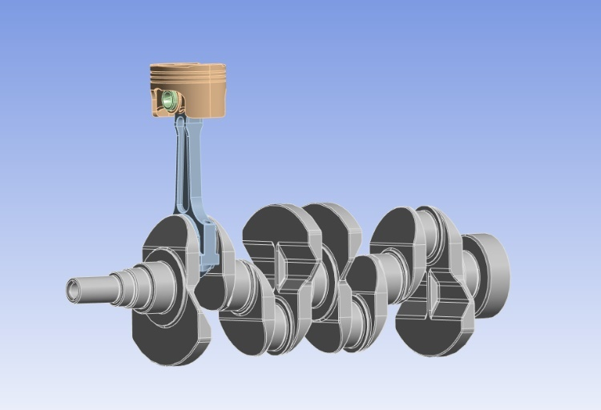
(Figure 1 – Engine Assembly)

Rigid Dynamics
The aim of this section was to conduct a kinematics analysis of the assembly in ANSYS to generate a realistic set of loading conditions. A kinematics analysis of a crankshaft and piston mechanism involves studying the motion and geometry of the system without considering forces or masses (Nigus, 2015). Firstly, the rigid dynamics tile was selected in Ansys Workbench where the engineering data is to be chosen and selected. Once a material had been chosen the geometry of the assembly model was to be imported.
In the model editor, joints were established between each of the components to allow them to revolve, simulating the assembly’s real-world motion. Figure 2 shown below displays the 6 joints connecting the components with the piston and crankshaft having a joint with ground. This simulates both components being fixed to only allow movement in a particular axis. For the piston, it is fixed to movement In the Y axis based on the orientation of the assembly and would be fixed by the piston cylinder. For the crankshaft, it only allows rotation in the Z axis due to it being fixed in the engine block.
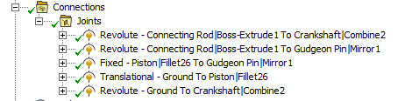
(Figure 2 – Assembly Joints)
Using a rotational velocity of 4000RPM, the forces acting on the piston crown were analysed in which the largest force was taken for a motion ratio study ready for a static structural test. Figure 3 shows the graph produced from running the assembly configuration at the velocity mentioned above.
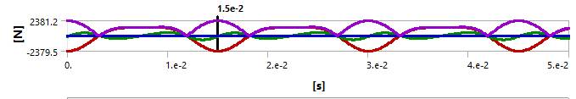
(Figure 3 – Forces Acting on Piston)
From the graph it can be seen that the force oscillates as the piston completes its movement cycle. It shows the three forces of the X, Y and Z axis. The Z-force which represents the axial direction aligned with the piston movement shows the largest amplitude and is periodic. This force is primarily due to the combustion pressure acting on the piston crown and the inertia forces generated during the piston's reciprocating motion. The X and Y forces represent lateral and transverse forces on the piston. These are smaller in magnitude and are likely caused by side thrust as the connecting rod transmits angular motion to linear motion. The Z-direction forces dominate the loading on the piston crown, and these forces are critical for structural and thermal analyses as they set the motion ratio used in the static structural tests (Douglas, 2006). The piston must withstand these forces without failure due to fatigue or thermal stress as this will be what the piston will be subject to (Geng, 2005).

Thermal Study
A thermal study is an analysis that examines the temperature distribution, thermal stresses, and heat transfer characteristics in the piston head during engine operation (Manson, 1953). Pistons in internal combustion engines are subjected to high-temperature gases from combustion, and a thermal study helps assess the piston’s ability to withstand these conditions without failure (Lu, 2017).
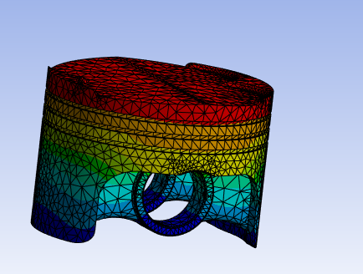 | 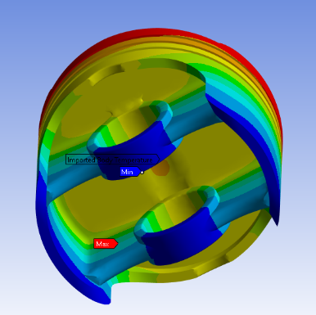 | 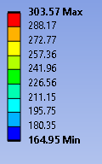
(Figure 4 – Thermal Conditions of an Al 6061 T6 Piston)

Figure 4 shows the thermal study done on the piston crown along with a temperature key. The material that was chosen as a control was an Aluminium 6061 T6 alloy as this is commonly used for use as a piston crown (Satyanarayana, 2016). The piston crown was isolated during this section as this was the component that was being used to optimize its functionality. It can be seen that the maximum temperature that the piston experiences is 303.57˚C, found at the top of the crown with the minimum being 164.95˚C, found underneath. The highest recorded temperatures are shown towards the top of the crown as it is closets to where the fuel gets ignited. The lowest temperature was then recorded was at the bottom of the piston as the heat was transferred away into the cylinder.

Static Structural
A Static Structural test analyses a system or component under static loads. Examples of these include forces, pressures, moments, or boundary conditions applied to the system that do not vary with time (Sroka, 2015). The test calculates quantities like Stresses (e.g. principal stress), strains (e.g., elastic, plastic strain) and deformations (displacement under load) (Kolhe, 2020). The purpose of this test is to assess the system's structural integrity and mechanical performance under specified loading conditions (Mourelatos, 2001).

Deformation
A deformations test in a static structural analysis of a piston crown evaluates how the piston crown deforms under applied loads or boundary conditions. It is used to analyse the mechanical behaviour of the piston crown in response to forces such as combustion pressure, thermal loads, and constraints (Pelosi, 2012).
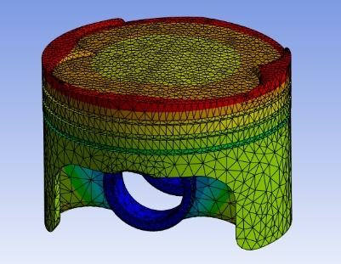 | 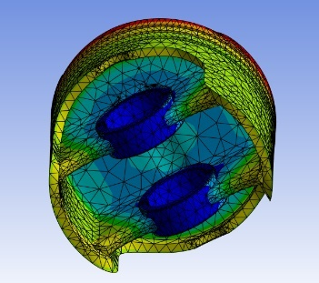  (Figure 5 – Deformation of an Al 6061 T6 Piston) | 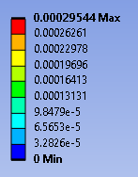

The images above (figure 5) show the deformation of the piston crown of Aluminium 6061 T6. Held in place by a fixed support where the pin would sit and with a pressure of 1.05e07Pa applied to all surfaces in top of the crown, readings of the piston deformation can be seen showing the areas of the piston most likely to fail under the pressure. During engine operation, the piston is exposed to high pressures from the combustion process, especially near the centre or at regions where the flame front focuses energy (Pelosi, 2011). If the material of the piston crown has a lower yield strength at high temperatures, it may deform more significantly in the hottest zones. For aluminium alloys, for example, their strength decreases substantially with increasing temperature, making them more prone to deformation under combined thermal and mechanical loading (Seikh, 2023).

Stress
A stress test in a static structural analysis of a piston crown focuses on evaluating the stresses induced in the piston crown when subjected to static loads, such as combustion pressure and thermal loading. It is used to ensure the piston crown can endure operating conditions without experiencing material failure (Lu, 2017).
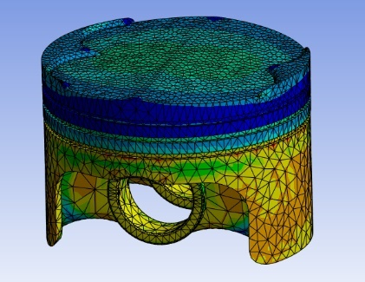 | 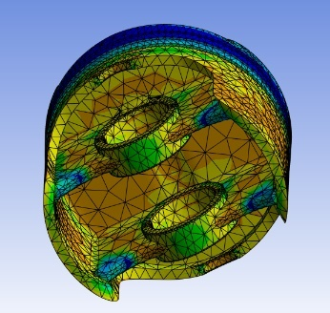  (Figure 6 – Stress of an Al 6061 T6 Piston) | 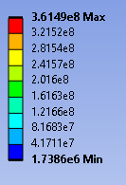

Figure 6 shows the stress that the piston goes through. The colour key on the right indicates the stress values, ranging from a minimum of 1.7386 MPa to a maximum of 361.49 MPa. The top surface experiences a relatively high amount of stress due to the pressures acting on this surface. Stress concentration is common through the pin holes due to the interaction between the gudgeon pin and the connecting rod. The piston skirt experiences a high amount of stress as the piston crown carries high combustion pressures, which transfer loads through the piston structure to the skirt. According to (Kumar, 1989) with this particular aluminium alloy having a yield strength of 280 MPa most of the piston is within the acceptable limit. However, parts of the skirt and the underside may experience failure given the data calculated through the simulation.

Optimizing and improvement
To achieve optimal performance, an iterative design approach was employed. Finite Element Analysis (FEA) results were analysed after each simulation to identify regions of high stress, excessive deformation, or undesirable thermal gradients (Amaral, 2005). The performance of Al 6061 T6 is to be tested in comparison to Cast Iron and Stainless Steel, two other common materials of piston crowns. The specific materials are Cast iron, nodular graphite, EN GJS 500 7 and Stainless steel, austenitic, AISI 317, annealed.
Some properties to note for the materials are listed below in the table found using Granta Edupak, 2022.
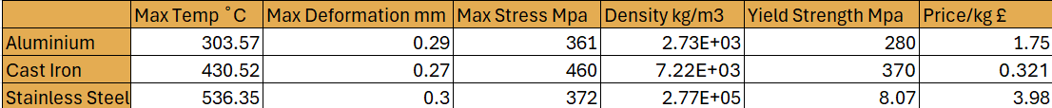
(Figure 7 – Table of Material Properties)

Thermal Comparison

Cast Iron
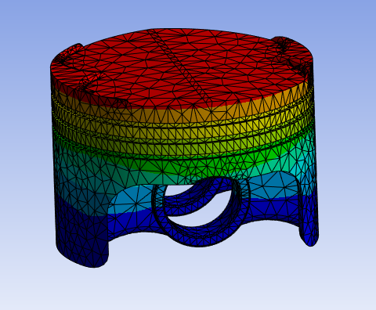 | 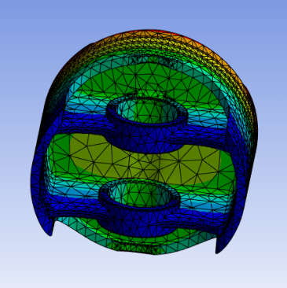 | 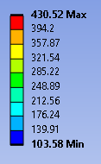
(Figure 8 – Thermal Conditions of Cast Iron Piston)
Figure 8 shows the thermal results using Cast Iron. The piston crown shows the highest temperature (430.52°C) because it directly faces the combustion chamber and absorbs the most heat from the burning gases. The temperature decreases gradually from the crown to the skirt. This gradient is due to heat dissipation as the piston transfers heat to the cylinder walls and through lubrication (Pelosi, 2012). The lowest temperatures (103.58°C) are concentrated at the skirt, where heat dissipation is higher due to contact with cooler components like the cylinder walls. The piston crown is the most thermally stressed area due to high temperatures. Prolonged exposure to such high temperatures can lead to; thermal fatigue in the material or thermal expansion, which can cause deformation (Piancastelli, 2012).

Stainless Steel
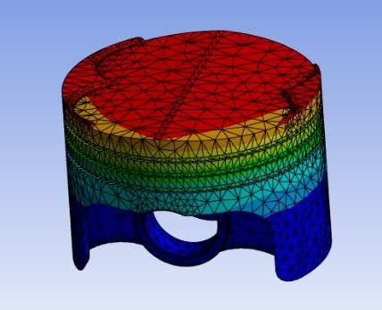 | 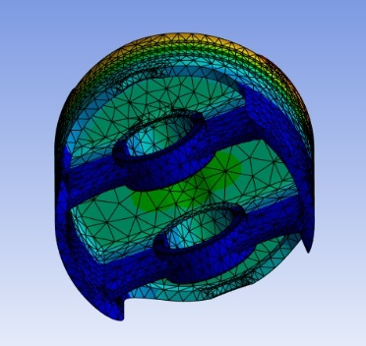 | 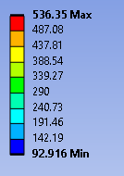
(Figure 9 – Thermal Condition of Stainless-Steel Piston)
In comparison with Cast Iron, figure 9 shows the thermal conditions experienced by the Stainless-Steel alloy. The piston crown shows the highest temperature (536.35°C) due to it directly facing the combustion chamber, absorbing the most heat. The temperature decreases gradually from the crown to the skirt. This is due to heat dissipation as the piston transfers heat to the cylinder walls. The lowest temperature is 92.92°C which is found at the bottom of the skirt and around the pin holes.

Static Structural

Deformation

Cast Iron
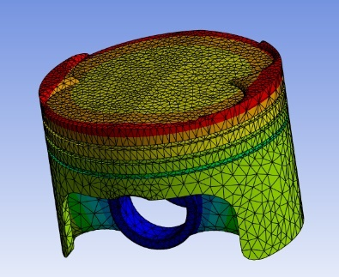 | 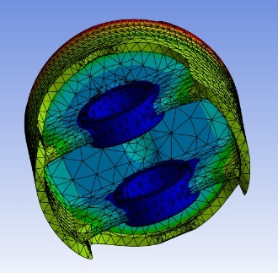 | 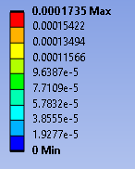
(Figure 10 – Deformation of Cast Iron Piston)
The deformation of cast iron shows a maximum deformation of 0.17mm around the edge of the top face of the piston crown with this value decreasing as you go down the piston skirt to 0.0096mm at the bottom. Under the piston experiences very little deformation to none at all around the pin holes similarly to that of the aluminium alloy although experiencing less deformation.

Stainless Steel
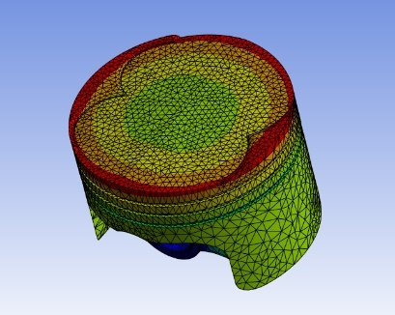 | 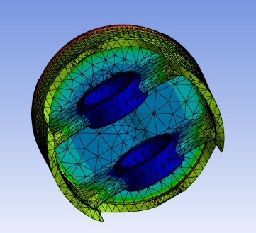 | 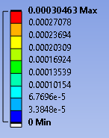
(Figure 11 – Deformation of Stainless-Steel Piston)
Stainless steel again shows the same trend to aluminium and cast iron. However stainless steel shows the largest amount of deformation at 0.305mm around the edge of the piston top face. While stainless steel can have high strength, its yield strength can be lower than that of cast iron, especially at elevated temperatures, explaining why it shows the highest deformation.

Stress

Cast Iron
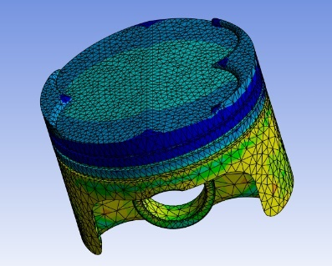 | 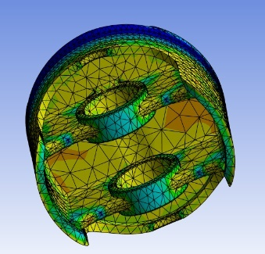  (Figure 12 – Stress of Cast Iron Piston) | 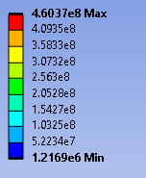

The stress of cast iron shows a maximum value of 460MPa and a minimum value of 1.22MPa. Under the piston experiences very little deformation to none at all around the pin holes similarly to that of the aluminium alloy although experiencing less deformation. Cast Iron experiences a larger maximum value of stress whilst a lower minimum value. This is due to the fundamental differences in their material properties, particularly their microstructure, elasticity, and failure characteristics (Sjögren, 2005). For example, cast iron has a higher elastic modulus than aluminium, which means it deforms less elastically under the same load. This rigidity leads to sharper stress gradients, causing both higher maximum stresses in regions of high load and lower minimum stresses in regions of low load (Calbureanu, 2013).

Stainless Steel
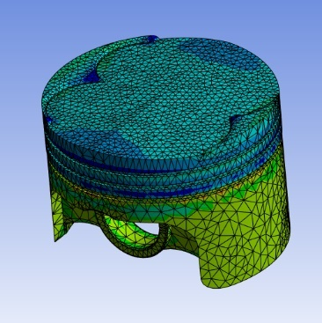 | 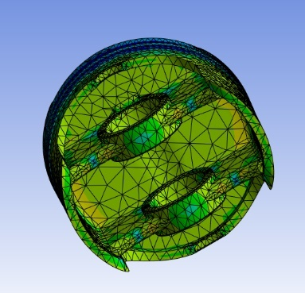  (Figure 13 - Stress of Stainless-Steel Piston) | 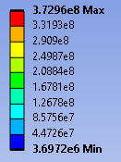

Stainless steel experiences a lower maximum and higher minimum stress compared to both aluminium and cast iron with its maximum being 373MPa whilst its minimum being 1.69MPa. Stainless steel generally has a higher elastic modulus than aluminium but lower than cast iron. This means it is stiffer than aluminium, leading to less elastic deformation under stress, but not as stiff as cast iron. It is also more ductile and tougher than cast iron, meaning it can absorb more energy and deform plastically to relieve stress (Hilhorst, 2023). As a result, the minimum stress tends to be higher because stainless steel can spread out the stresses more evenly across its structure.

Validation
To validate simulation accuracy in ANSYS, a simple cantilever beam subjected to a uniform load is analysed. Analytical results are calculated using fundamental beam theory (Bennati, 2009), and a comparison is made with FEA results to ensure reliability. Additional studies (mesh independence and boundary condition influence) are conducted to enhance confidence in the simulation.

Deformation
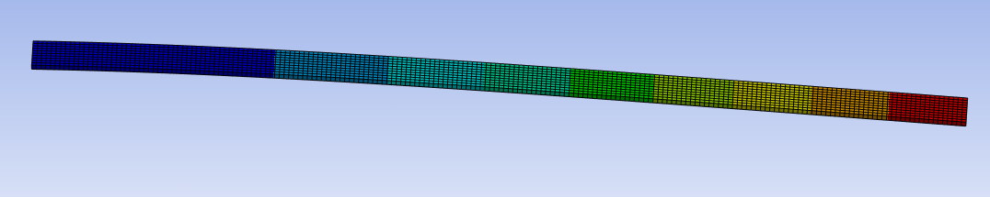
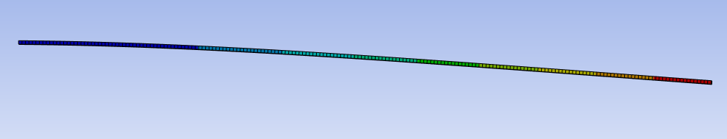
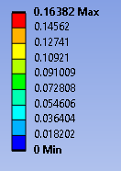
(Figure 14 – Deformation of Cantilever Beam)
The deflection curve for a cantilever beam under a uniform load typically shows a parabolic shape, with the deflection being greatest at the free end and zero at the fixed end.
As the uniform load is applied, the beam begins to bend downward. The amount of bending depends on the magnitude of the load and the stiffness of the beam. The deflection is more pronounced at the free end and diminishes towards the fixed end. The beam's deflection follows a parabolic curve. The greatest deflection happens at the free end (where the load is applied) and is zero at the fixed support.

Stress
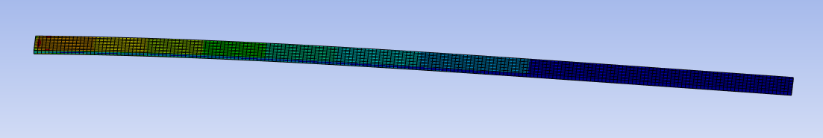
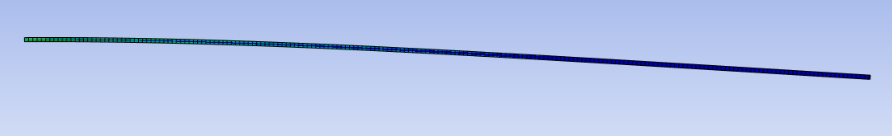
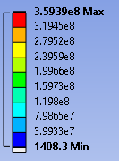
(Figure 15 – Stress of Cantilever Beam)
When the uniform load is gradually applied across the beam the beam will deflect and bend. As the load increases, the beam begins to bend downward as described previously. The internal bending stress increases, especially near the fixed support. It will experience tensile stress at the top fibres and compressive stress at the bottom fibres. The stress is greatest at the fixed support, where the bending moment is maximum (359MPa). This is because the bending moment causes the material fibres near the fixed end to experience the most deformation (Spencer, 2007). As you move towards the free end of the beam, the bending moment decreases, and so does the internal stress. At the free end, the stress approaches zero because the bending moment becomes zero there.

Mesh Independence Study
In FEA, mesh sizing plays a crucial role in determining the accuracy of simulation results (Cao, 2023). Conducting a mesh independence study involves refining the mesh until further refinement no longer significantly changes the results, indicating that the solution is independent of the mesh. A study by Almohammadi, 2013 states that coarser meshes may yield inaccurate results either underestimating or overestimating deflection and stress. Finer meshes improve accuracy but increase computational cost.
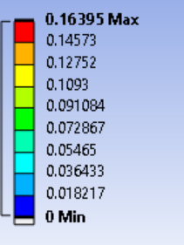
(Figure 16 – Results of a 0.002m Mesh)
Figure 16 is the results of a mesh refinement where the original mesh of 0.005m was changed to 0.002m. As you can see from the image, if you compare it to that of figure 14 you can see change to the maximum deformation showing that the original mesh wasn’t the most accurate that it could be.
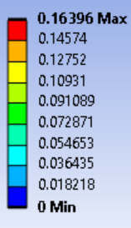
(Figure 17 – Results of a 0.001m Mesh)
Figure 17 is again another mesh refinement where the element size was changes to 0.001m which again shows a change to the maximum deformation. Other refinements were tested at 0.0009m and 0.0008m however no further change in values were seen meaning that a mesh element size of 0.001m provides the most accurate results, proving the statement by Almohammadi, 2013.

Boundary Conditions
Boundary conditions in simulations specify how the system interacts with its environment and what constraints are applied. They determine factors such as fixed supports, symmetry constraints, loads and forces and contact conditions (Gherbi, 2018). Influence how the simulation behaves and, thus, the results. If they are not set up correctly or realistically, the results may not reflect the actual physical behaviour (Tabaddor, 2000). The boundary conditions in the cantilever beam model include the fixed support which was applied to the left of the beam and a downward load which was applied to the top surface of the beam.

Conclusion
In conclusion, after running the three materials aluminium, cast iron and stainless steel through the various structural and thermal condition tests a preferred material can be chosen based off the results. While some materials may have more idealistic properties than other during a certain part of the tests, they may not be best purposed in others. The most suitable material choice from all the data gathered would be the cast iron. Cast iron has the highest yield strength (370 MPa) and a significant max temperature tolerance (430.52°C), making it capable of withstanding the high temperatures and stresses within the engine cylinder, as shown by Chemezov, 2018. Its deformation is the lowest among the three options (0.27 mm), indicating better mechanical stability under load. Though it is heavier, it is much more cost-effective (£0.321/kg) than stainless steel and suitable for high-load applications like piston crowns as seen in figure 7 (Granta, 2022).
Another reasonable choice would be the aluminium. However, despite it being lightweight, has the lowest maximum temperature tolerance (303.57°C) and yield strength (280 MPa). These factors make it less durable in high-temperature, high-stress environments typical for a piston crown (Tucker, 2010).

References
Almohammadi, K.M., Ingham, D.B., Ma, L. and Pourkashan, M., 2013. Computational fluid dynamics (CFD) mesh independency techniques for a straight blade vertical axis wind turbine. Energy, 58, pp.483-493.
Amaral, N., Rencis, J.J. and Rong, Y., 2005. Development of a finite element analysis tool for fixture design integrity verification and optimisation. The International Journal of Advanced Manufacturing Technology, 25, pp.409-419.
Barbero, E.J. and Shahbazi, M., 2017. Determination of material properties for ANSYS progressive damage analysis of laminated composites. Composite Structures, 176, pp.768-779.
Bennati, S., Colleluori, M., Corigliano, D. and Valvo, P.S., 2009. An enhanced beam-theory model of the asymmetric double cantilever beam (ADCB) test for composite laminates. Composites Science and Technology, 69(11-12), pp.1735-1745.
Calbureanu, M.X., Malciu, R., Tutunea, D., Ionescu, A. and Lungu, M., 2013. The finite element analysis of the thermal stress distribution of a piston head. International journal of mechanics, 7(4), pp.467-474.
Cao, B., Zhang, N., Fu, Z., Dong, R., Chen, T., Zhang, W., Tong, L., Wang, Z., Ma, M., Song, Z. and Pan, F., 2023. Studying the Influence of Finite Element Mesh Size on the Accuracy of Ventricular Tachycardia Simulation. Reviews in Cardiovascular Medicine, 24(12), p.351.
Chemezov, D., Smirnova, L. and Bogomolova, E., 2018. Metal mold casting of cast iron and aluminium pistons. ISJ Theoretical & Applied Science, 05 (61), pp.132-141.
Chen, X. and Liu, Y., 2018. Finite element modeling and simulation with ANSYS Workbench. CRC press.
Douglas, J., 2006, September. Strong-motion records selection for structural testing. In First European Conference on Earthquake Engineering and Seismology (a joint event of the 13th ECEE & 30th General Assembly of the ESC) (pp. Paper-Number).
Geng, Z. and Chen, J., 2005. Investigation into piston-slap-induced vibration for engine condition simulation and monitoring. Journal of sound and vibration, 282(3-5), pp.735-751.
Gherbi, A., Dahmani, L. and Boudjemia, A., 2018. Study on two way reinforced concrete slab using ANSYS with different boundary conditions and loading. International Journal of Civil and Environmental Engineering, 12(12), pp.1151-1156.
Granta EduPack 2022 R2 software, Granta Design Limited, Cambridge, UK, 2022.
Hilhorst, A., Jacques, P.J. and Pardoen, T., 2023. Towards the best strength, ductility, and toughness combination: High entropy alloys are excellent, stainless steels are exceptional. Acta Materialia, 260, p.119280.
Hoffman, R.M., Sudjianto, A., Du, X. and Stout, J., 2003. Robust piston design and optimization using piston secondary motion analysis (No. 2003-01-0148). SAE Technical Paper.
Kolhe, R.G., Kokate, P.V., Kashid, S.D. and Kadu, A., 2020. Static, Modal & Thermal Analysis of Engine Block. International Journal of Engineering Research & Technology, 9(8).
Kumar, R. and Garg, S.B.L., 1989. Effect of yield strength and single tensile overload cycles on effective stress intensity range ratio in 6061-T6 Al-alloy. Engineering Fracture Mechanics, 34(2), pp.403-412.
Li, C.H., 1982. Piston thermal deformation and friction considerations (No. 820086). SAE Technical Paper.
Lu, Y., Zhang, X., Xiang, P. and Dong, D., 2017. Analysis of thermal temperature fields and thermal stress under steady temperature field of diesel engine piston. Applied thermal engineering, 113, pp.796-812.
Manson, S.S., 1953. Behavior of materials under conditions of thermal stress (Vol. 2933). National Advisory Committee for Aeronautics.
Mirwald, P.W., Getting, I.C. and Kennedy, G.C., 1975. Low‐friction cell for piston‐cylinder high‐pressure apparatus. Journal of Geophysical Research, 80(11), pp.1519-1525.
Mourelatos, Z.P., 2001. A crankshaft system model for structural dynamic analysis of internal combustion engines. Computers & Structures, 79(20-21), pp.2009-2027.
Nigus, H., 2015. Kinematics and load formulation of engine crank mechanism. Mechanics, Materials Science & Engineering Journal.
Olems, L., 2000. Investigations of the temperature behaviour of the piston cylinder assembly in axial piston pumps. International Journal of Fluid Power, 1(1), pp.27-39.
Pelosi, M. and Ivantysynova, M., 2011, January. Surface deformations enable high pressure operation of axial piston pumps. In Dynamic Systems and Control Conference (Vol. 54754, pp. 193-200).
Pelosi, M. and Ivantysynova, M., 2012. Heat transfer and thermal elastic deformation analysis on the piston/cylinder interface of axial piston machines.
Piancastelli, L., Frizziero, L., Morganti, E. and Pezzuti, E., 2012. Method for evaluating the durability of aircraft piston engines. Walailak Journal of Science and Technology, 9(4), pp.425-431.
Satyanarayana, I. and Renuka, D., 2016. Design and analysis of piston and piston rings with cast iron, aluminium alloy and cast steel materials. IJISET—Int J Innov Sci Eng Technol.
Seikh, Z., Sekh, M., Kunar, S., Kibria, G., Haque, R. and Haidar, S., 2023, September. A study on various applications of aluminium metal matrix composites. In AIP Conference Proceedings (Vol. 2764, No. 1). AIP Publishing.
Sjögren, T. and Svensson, I.L., 2005. Studying elastic deformation behaviour of cast irons by acoustic emission. International Journal of Cast Metals Research, 18(4), pp.249-256.
Soni, A.H., Sullivan Jr, J.A., Patwardhan, A.G., Gudavalli, M.R. and Chitwood, J., 1982. Kinematic analysis and simulation of vertebral motion under static load—Part I: kinematic analysis.
Spencer, A.J.M. and Soldatos, K.P., 2007. Finite deformations of fibre-reinforced elastic solids with fibre bending stiffness. International Journal of Non-Linear Mechanics, 42(2), pp.355-368.
Sroka, Z.J. and Dziedzioch, D., 2015. Mechanical load of piston applied in downsized engine. Archives of Civil and Mechanical Engineering, 15(3), pp.663-667.
Stroia, M.D., Moşteanu, D.E., Virca, I., Răduca, E., Popescu, C. and Haţiegan, C., 2020. Case studies for automotive components using CAD and CAE techniques. In Journal of Physics: Conference Series (Vol. 1426, No. 1, p. 012047). IOP Publishing.
Tabaddor, M., 2000. Influence of nonlinear boundary conditions on the single-mode response of a cantilever beam. International Journal of Solids and Structures, 37(36), pp.4915-4931.
Tucker, M.T., Horstemeyer, M.F., Whittington, W.R., Solanki, K.N. and Gullett, P.M., 2010. The effect of varying strain rates and stress states on the plasticity, damage, and fracture of aluminum alloys. Mechanics of materials, 42(10), pp.895-907.

