Investigation of Series and Parallel RLC circuits

Table of Contents
Abstract 1
Introduction 2
Simulation Setup 2
Results 3
Discussion 9
Conclusion 10
References………………………………………………………………………………………………………………………………………10

Abstract
From this investigation it has been shown that the same three components set up in a series and then a parallel configuration has vastly different results with regards to frequency response. The numbers produced from AC Theory in the Results section were exactly the same as the numbers obtained from the simulation using Proteus software. This shows that the circuits are very predictable, reliable and accurate leading to their use in high precision applications. With the values given by the assignment brief the series RLC circuit saw a voltage increase of at least 2.1 Volts at resonant frequency. The parallel RLC saw the supply current drop to zero at resonance as the inductor starts to charge the capacitor and the capacitor begins to build up an electromagnetic field in the inductor which holds a charge. The conclusion of this investigation is that these RLC circuits are very well suited to their uses.
Introduction
In this exercise and report I will be creating and analysing two different resonance circuits. The circuits I will be creating are called Resonance R L C circuits, they are made up of a resistor, an inductor and a capacitor. I will be creating one resonant circuit in series and another in parallel. A circuit is in series when there is only one path through all components, in this type of circuit the current flowing through every component remains the same while the voltage is the sum of voltage drops across each component [1]. In a parallel circuit the voltage is common across the entire circuit but the current is divided at any junction points [2] As shown in [3], these RLC circuits form a harmonic oscillator and have a number of uses like radio and television tuning, signal processing and communication systems, voltage magnification and inductive heating. To create these circuits I will be using a design software called Proteus Design Software. Proteus was created by a company called Labcenter Electronics Ltd. And according to their website [4] Proteus is a schematic capture, PCB layout and circuit simulation software, I will be using the circuit simulation functionality for this exercise. I will be measuring the voltages across the components and plotting a graph of the results, I will also be using AC theory to work out the results. When I have simulated both circuits I will be comparing the results and graphs against my theoretical results.
Simulation Setup
For this exercise I will be simulating a series RLC circuit and a parallel RLC circuit. In both circuits I will be using the exact same components within the software, the only difference will be that one is laid out in series and the other laid out in parallel. To get my values for each component the assignment has asked me to use my student number. My student number is 2013049, the assignment states that the first two numbers are my resistor value in ohms, the second two numbers are my capacitor value in micro Farads and the last three numbers are my inductor value in milli Henrys. R= 20 Ω, C= 13 µF, L= 049 mH. I will be using the same alternating current generator for both circuits at 1 Volt peak to peak at a frequency of 100Hz, this will give an amplitude of 0.5 Volts. I will be taking voltage measurements across the resistor, the inductor and the capacitor at a range of frequencies from 100Hz up to the maximum of 20kHz or 20,000Hz. When I have set up the circuit I will then plot two graphs showing attenuation against frequency for both circuits. Below is a snapshot of the circuit I have put together in Proteus. As you can see the resistor is showing 20 ohms, the inductor is at 49 milli Henrys and the capacitor is at 13 micro Farads.

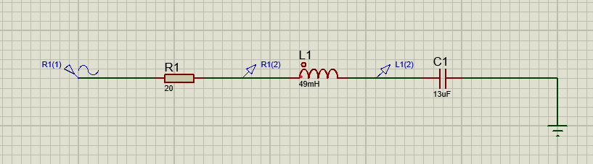
Figure 1 Circuit 1 - Series RLC circuit

Because the first circuit as seen above in Figure 1 is laid out in series, the current across all three components will be the same but will change with the changing frequencies, for this reason the voltage drop across every component will also change with the changing frequency. I will be measuring the voltage drop across each component in the circuit, I will be placing a voltage probe after the resistor to measure the voltage across the resistor, a probe after the inductor to measure the voltage across the inductor and finally I will place a ground terminal after the capacitor to measure the voltage across the capacitor. I will then plot the graphs mentioned before, determine the resonant frequency and compare these results with the results obtained using basic Alternating Current Theory.

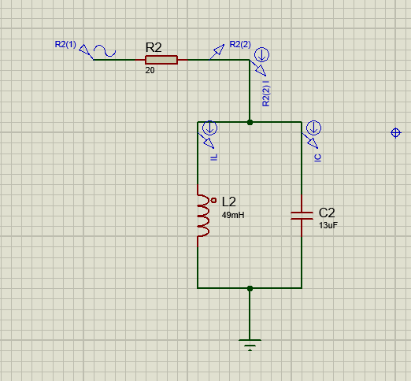

Figure 2 Circuit 2 - Parallel RLC Circuit

As shown in Figure 2above the circuit is laid out in parallel but every component value is exactly the same as Figure 1. Because of the nature of parallel circuits the current flowing through each of the components will be different and will change with frequency. As the current changes the inductor and capacitor reactance will vary along with voltage drops. In this circuit energy will be passed back and forth between the capacitor and inductor, this will make voltage reading confusing to look at so I will therefore be taking mainly current readings. One voltage probe and one current probe have been placed after the resistor and a current probe just before both the inductor and capacitor. I will be plotting the graphs mentioned before for this graph and comparing my results with results obtained from basic Alternating Current theory. Using AC Theory values can be obtained for the resonant frequency, the reactance of both the inductor and capacitor, circuit impedance, circuit current and the voltage for each component.
Results
As the current generator is set to 100Hz, this is the frequency (f) that will be used in all equations.

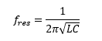

Figure 3 Equation for finding resonant frequency

Using Figure 3 the resonant frequency of the circuit can be determined, for this particular circuit the frequency is 199.4115988 Hz.
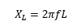

Figure 4 Equation for the reactance of the Inductor (XL)

Using Figure 4 the reactance of the inductor is shown as 30.78760801 Ω.
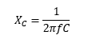
Figure 5 Equation for the reactance of the capacitor (XC)

Using Figure 5 the reactance of the capacitor is shown as 122.4268793 Ω.
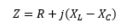
Figure 6 Equation for the Impedance of a circuit (Z)

The reactance values of both circuits will be different so by using Figure 6, the Impedance for the series circuit is 20-j91.639271296278 Ω, the total impedance for the parallel circuit is 20+j41.1311735232432 Ω.
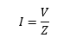
Figure 7 Equation for the current of the circuit (A)

Using Figure 7 to calculate the current will give two answers, the magnitude and phase of the current. This is due to the Impedance values (Z) containing complex numbers. For the series circuit the current magnitude is 0.127937 A and the phase is 77.68842 degrees. For the parallel circuit the current magnitude is 0.262376 A and the phase is -64.0687 degrees. By using a spreadsheet to input all the data, the following graphs were produced.
Figure 8 Equations to calculate the voltage drop across each component

Using the equations in Figure 8 for the parallel circuit I have calculated Vr as 2.29 - j4.72, Vl as 3.53 – j7.26 and Vc as 14.05 – j28.89. For the series circuit I have calculated Vr as 0.55 + j2.50, Vl as 0.84 + j3.85 and Vc as 3.34 + j15.30.

Figure 9 Graph of attenuation vs frequency for a series RLC circuit

Figure 10 Graph of attenuation vs frequency for a parallel RLC circuit

Figure 11 Graph of Vc + Vl vs frequency
Figure 12 Graph showing series RLC circuit output Voltage vs frequency

Figure 13 Graph showing series circuit current vs frequency

Figure 14 Graph showing parallel circuit current vs frequency

Figure 15 Graph showing parallel circuit output voltage vs frequency

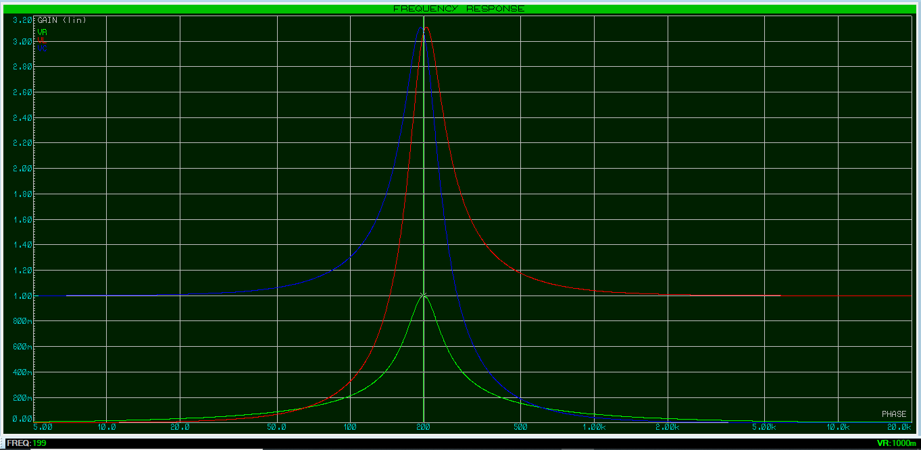
Figure 15 Simulated frequency response graph for series RLC circuit
Figure 16 Simulated frequency response graph for series RLC circuit

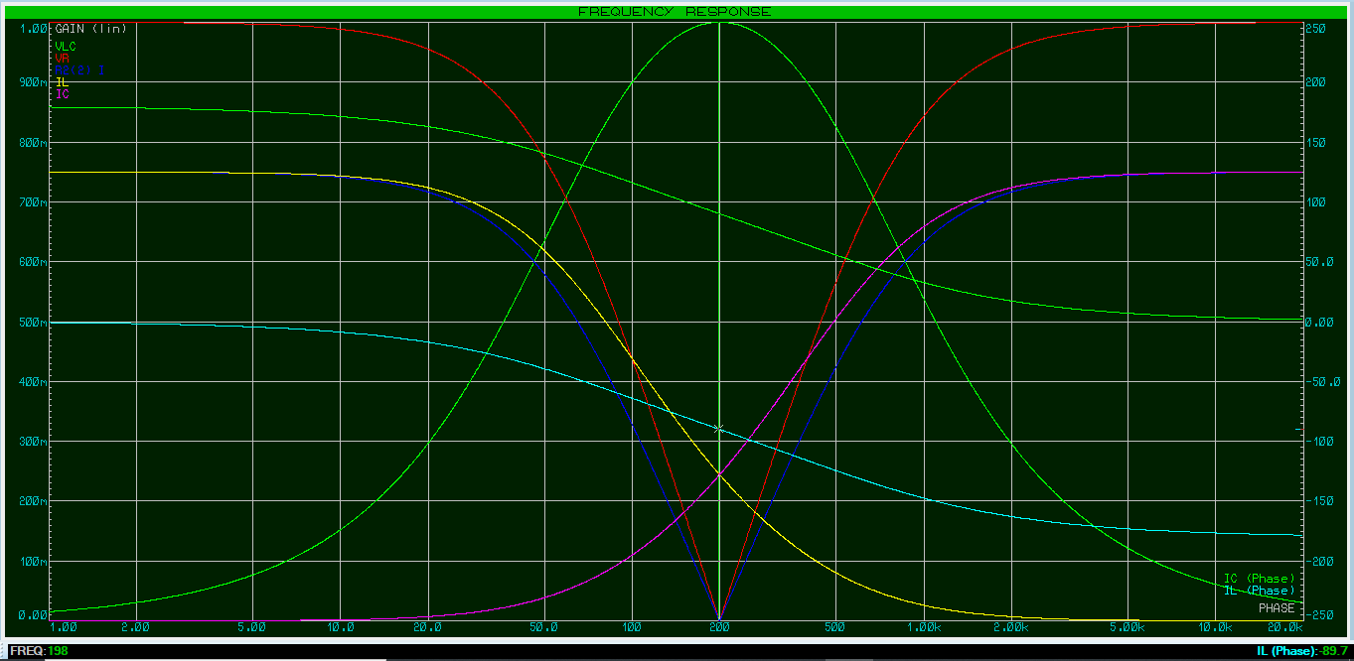
Figure 16 Simulated frequency response graph for a parallel RLC circuit
Figure 17 Simulated frequency response graph for parallel RLC circuit

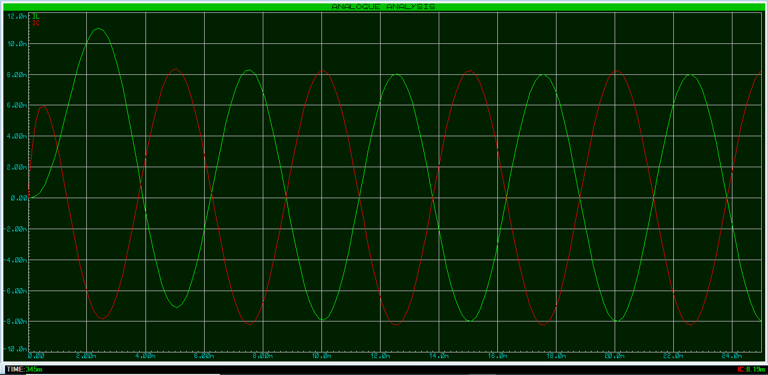
Figure 18 Simulated analogue analysis graph showing inductor and capacitor current
Discussion
The first point to consider is the resonant frequency of both RLC circuits. By looking at the simulated graphs of Figure 15 and Figure 16 the resonant frequency happens on or just before 200Hz, the frequency was worked out to be 199.4115988 Hz. As we can see the software is very accurate and the calculations were also correct. In Figure 15 the voltage across each component is represented, the green line represents the voltage across the resistor, the red line represents the voltage across the inductor and the blue line represents the voltage across the capacitor. As the frequency approaches resonance, the voltage across all components spike upwards, from the 1 volt supply there is 1 volt across the resistor but 3.1 volt across the inductor and capacitor. This is a typical characteristic of series RLC circuits as they are referred to as voltage amplifiers [3]. Using Figure 15 the Q factor can be worked out by dividing the resonant frequency by the bandwidth, this gives a Q factor of 2.98. Figure 12 shows that as the voltage increases approaching resonance so does the current up to 0.6 Amps. Figure 12 also shows that during the current increase approaching resonance there is a 180 degree phase shift from 90 degrees to -90 degrees. Figure 13 shows what happens to the current in a parallel circuit at resonance, it shows that there is a steady current of 0.6 Amps but as resonance is approached the current drops to zero then climbs back up to 0.6 Amps. In Figure 14 It shows that the opposite happens to the output voltage as we start at close to zero, climb to the input voltage at resonance and then drop back down to almost zero. Figure 16 is a frequency response for the parallel circuit, the first green line is very similar to Figure 14 and shows the voltage across the inductor and capacitor as it rises to 1 volt at resonance then falls back to almost zero. The dark blue line represents the current after the resistor, its shows the same as Figure 13 so it shows that the ac theory calculations were fairly accurate. The red line shows that the voltage across the resistor goes from 1 to 0 at resonance mirroring the current. The yellow line shows the inductor current and the purple line shows the capacitor current, at resonance the two currents cross over meaning that they are both equal which is the definition of a resonant frequency. In this instance the inductor is charged and as the frequency approaches resonance the inductor draws less current, the opposite is true for the capacitor, it starts off drawing minimal current then increases at resonance. The light blue represents inductor phase difference between the supply and component current and the second green line represents the capacitor phase difference between the supply and component current. We can see that the inductor phase starts at zero, passes through 90 degrees at resonance then ends up around 180 degrees. The current in the capacitor is always 180 degrees apart from the inductor current, it starts at around 180 degrees, passes through 90 degrees at resonance then end up around zero degrees. Figure 17 shows the current values in the inductor and capacitor, it shows that as the current in one component rises the current in the other component falls. What is happening is the current used to charge the capacitor is being drawn from the inductor and the current being used to build up a magnetic field within the inductor is being drawn from the capacitor. These two components are essentially feeding off of each other as it was shown in Figure 16 that the supply current is at a minimum at resonance. This feature is useful in the circuits use as a radio transmitter and receiver tuner. The frequency can be used to filter out every other frequency and only play the selected station.
Conclusion
In this simulation it has been shown that given the component values of R = 20 Ω, C = 13 µF and L = 49 mH the resonant frequency is 199.4115988 Hz. In a series RLC circuit the voltage across all components increases sharply when approaching resonance then decreases equally as sharply while moving away from resonance. At resonance there is a 180 degree phase shift in the current of the series circuit. In a parallel RLC circuit the input current drops to zero approaching resonance because the main components that are drawing current start feeding off of each other instead of the supply current. At resonance as the inductor is drained the capacitor is charged and this process is repeated over and over [5].

References

[1] | allaboutcircuits.com, "Simple Series Circuits," allaboutcircuits.com, [Online]. Available: https://www.allaboutcircuits.com/textbook/direct-current/chpt-5/simple-series-circuits/.
[2] | allaboutcircuits.com, "Simple Parallel Circuits," allaboutcircuits.com, [Online]. Available: https://www.allaboutcircuits.com/textbook/direct-current/chpt-5/simple-parallel-circuits/.
[3] | Elprocus, "Guide on Resonant RLC Circuits Working and Applications," Elprocus, 2013-2021. [Online]. Available: https://www.elprocus.com/guide-on-resonant-rlc-circuits-working-and-application/.
[4] | L. E. Ltd., "Home," Labcenter Electronics Ltd., [Online]. Available: https://www.labcenter.com/.
[5] | S. Mosey, "UWTSD Moodle Course: L4 Electrical and Electronic Principles ACDB4002," University of Wales Trinity Saint David, 2021. [Online]. Available: https://moodle.uwtsd.ac.uk/course/view.php?id=2013.

