Academic and Employability Skills
Student Name: Alpesh Machhi Student No: 2022470
Lecturer: Timothy Hopkins

Introduction


- Employment is referred to as the state of being employed for an individual in an enterprise (Bakhshi, et al., 2017).
- The study is focused on analyzing my intended career option, which is the Airline Station Manager.
- The study evaluates the requirement of academic and employability skill required for an Airline Station Manager role.

2

Intended Career Option


- Airline Station Manager is referred to the person who have the responsibility of looking after a particular Airline and Ground handling operations such as customer service and ramp services and cargo services with in aviation.
- Airline Station Manager helps the airline by making sure flights leaves on time from the handling station so airline does not make any losses financially.
- Airline station manager handles the stuff requirements for each ground handling services.
3

Literature of academic and employability skill


- The Airline Station Manager needs to have academic skills of using different technologies self-service desks, self-service kiosks, self-service gate services and IT skills.
- The Airline Station Manager to have the employability skills such as communication, time management, customer management, financial management of station, staff management and adaptability for managing the operations,
4

Academic skill

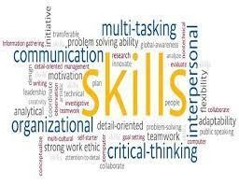
- Academic skill is described as the collection of study, which encourages a student to become an efficient learner (Owens & Lilly, 2017).
- To become an Airline Station Manager, I need to have the academic skill and knowledge related to different technologies used in today’s airline industry.
- I need to know about advanced technology like, computing skills, Machine learning which can help me in improving business operation.
5

Employability skills

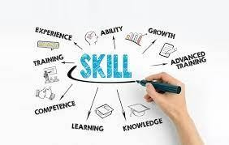
- Employability skill is defined as the transferrable skill that helps an individual get employment (Bhagra & Sharma, 2018).
- To get the job of Airline Station Manager, I need to develop problem solving skill which encourage me in taking appropriate decision in operation, improve my communication verbally and non-verbally.
- I have to be adoptive towards the technologies which are being used across the Airport industry in the present time.

6

Conclusion

  - I have chosen the career option of Airline Station Manager for my future.
  - I need to develop academic knowledge related to advanced new technology of Airport environment.
  - To get the Airline Station Manager, I need to have employability skill like
communication, problem solving, and adaptability and time management.

7

Reference

- Bakhshi, H., Downing, J., Osborne, M. & Schneider, P., 2017. The future of skills: Employment in 2030.
02 ed. London: Pearson, ISBN: 978-0-992-42595-1 .
- https://www.skybrary.aero/index.php/Ground_Handling [online visited on 12APRIL2021] Airline ground handling information
- https://www.greatsampleresume.com/job-description/examples/aviation/airline-station-manager [online visited on 12April2021] Airline Station Manager.
- https://maktubaat.wordpress.com/2014/11/09/airline-station-manager-roles-and-responsibilities/ [Online visited on 12April2021] employability skills

8

